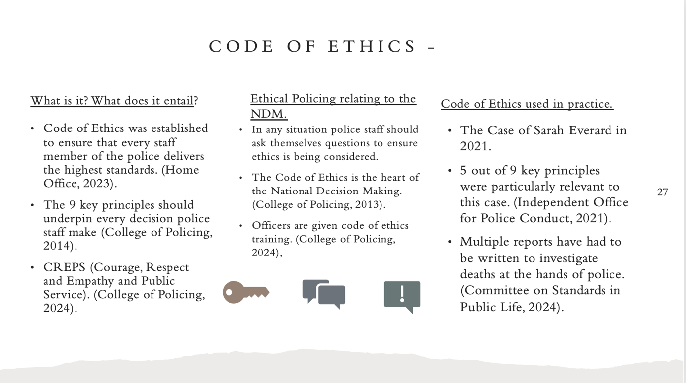
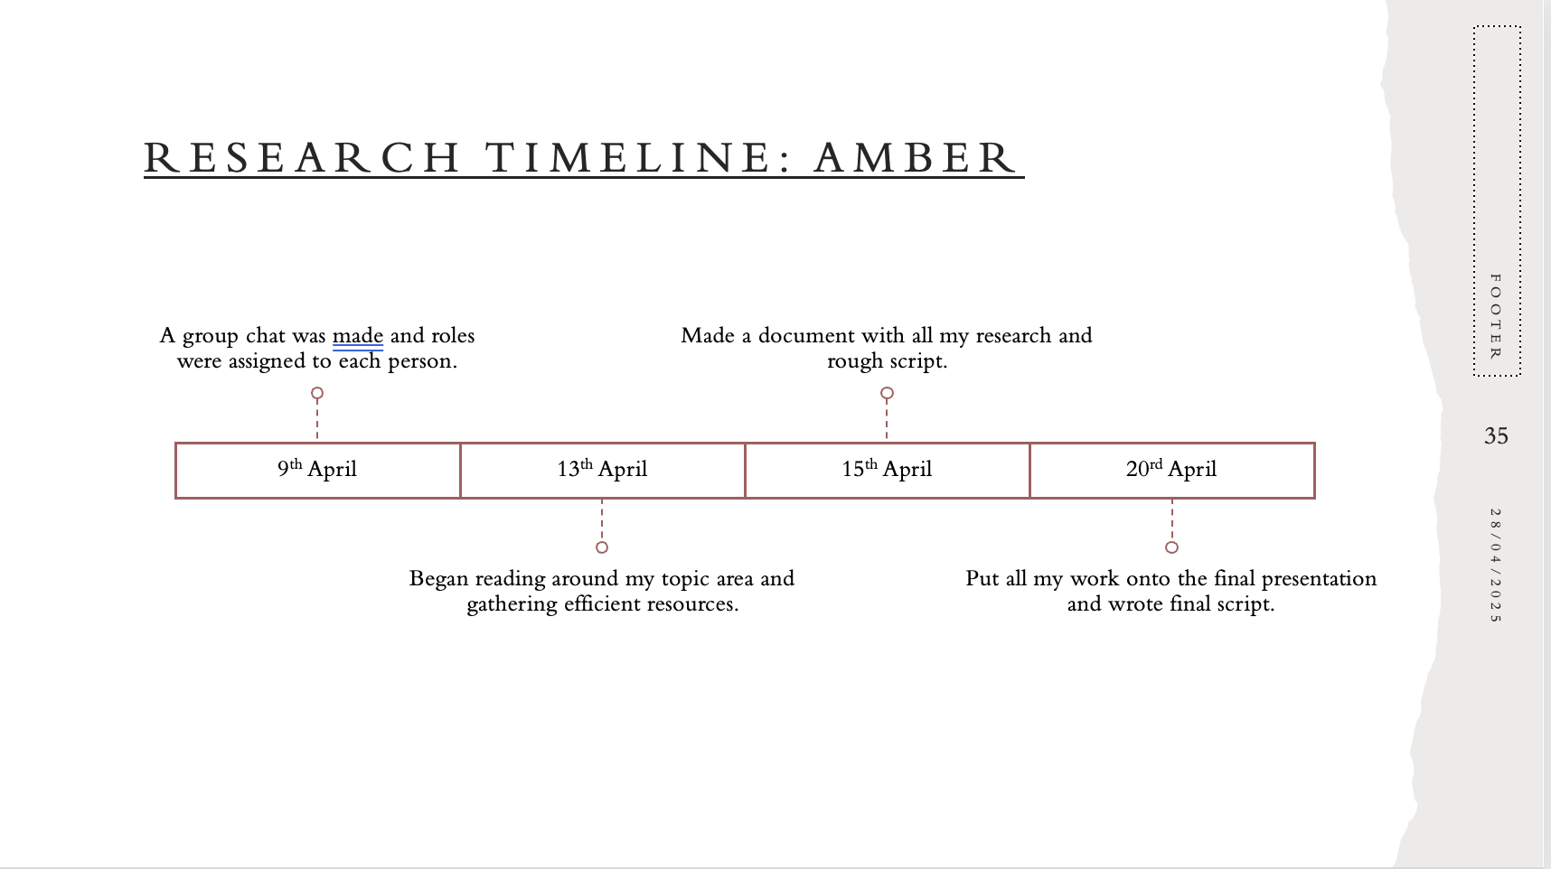

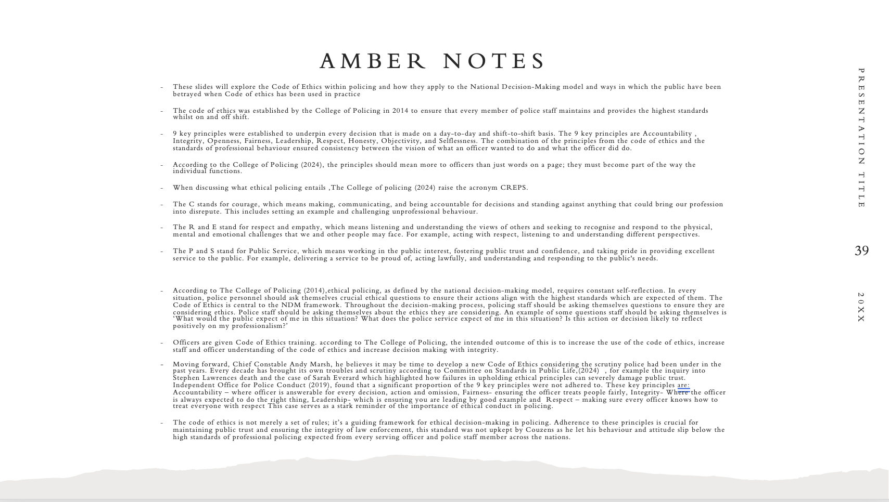

Reference List:
- BBC News (2024) Sarah Everard: BBC documentary recalls police learning killer was met officer Available at:https://www.bbc.co.uk/news/uk-england-london-68466660 (Accessed: 13th April)
- College of Policing (2014) Code of Ethics: Supporting Documents Available at:https://assets.college.police.uk/s3fs-public/2021-02/code_of_ethics_summary.pdf (Accessed: 13^{h} April)
- College of Policing (2024) Decision-Making with integrity – code of Ethics training Available at:https://www.college.police.uk/support-forces/practices/decision-making-integrity-code-ethics-training (Accessed: 13th April)
- College of Policing (2024) Ethical Policing Principles Available at: https://www.college.police.uk/ethics/code-of-ethics/principles (Accessed: 15th April)
- College of Policing (2024) National Decision Model Available at:https://www.college.police.uk/app/national-decision-model/national-decision-model (Accessed: 15th April)
- Committee on Standards in Public Life ‘ A new code of ethics for policing’ 21 March. Available at:https://cspl.blog.gov.uk/2024/03/21/a-new-code-of-ethics-for-policing/ (Accessed: 14th April)
- Home Office (2024) Angiolini Inquiry Part 1 Report Available at:https://www.gov.uk/government/publications/angiolini-inquiry-part-1-report (Accessed: 20th April)
- Home Office (2023) Ethical Policing: code of practice (accessible) Available at:https://www.gov.uk/government/publications/ethical-policing-code-of-practice/ethical-policing-code-of-practice-accessible (Accessed: 17th April)
- Independent Office for Police Conduct (2021) Investigations into allegations of discriminatory and inappropriate comments made by Metropolitan police officer within a WhatsApp groupchat between March and October 2019 Available at: https://www.policeconduct.gov.uk/sites/default/files/documents/Operation%20Argens%20final%20report%20-%20publication%20copy.pdf (Accessed: 18th April)

