Creative Project Reflection Report

"Luminous Insight: Artificial Intelligence in Art"

Shuqiao Zhang(SQ)
2324275
03.09.2024

Introduction

Art has long been regarded as the most direct expression of human emotion and creativity. However, with the rapid development and widespread application of artificial intelligence (AI) technology, the role of AI in artistic creation has garnered significant attention and sparked heated discussions. In particular, the distinctions and evaluation criteria between AI-generated artworks and those created by human artists have become a focal point for both the art and technology communities (Boden, M.A., 2016). This study aims to explore the differences in public evaluation of AI-generated art versus human-created art, seeking to uncover the potential role of AI in artistic creation and its level of acceptance in the public mind (Guckelsberger, C. et al., 2017).

This project presents carefully curated art exhibitions showcasing collaborative works by AI and human artists. The artworks on display include traditional oil paintings as well as visual art pieces generated by AI systems. The exhibition design considers the different ways in which artworks are perceived under varying lighting conditions, especially under specific UV light where a hidden AI signature becomes visible. This design aims to explore the audience's initial reactions to the artworks and how their attitudes shift upon learning about the creator behind each piece.

To ensure objectivity in the research, the exhibition features anonymous feedback stations where visitors can share their immediate impressions and artistic evaluations without knowing the background of the artworks' creation. Later, when the involvement of AI is revealed, the audience is invited to share their thoughts and opinions on AI art once more.

The significance of this study lies not only in examining the public’s acceptance of AI-generated art but also in understanding the role that AI technology can play in artistic creation. As technology advances, AI’s ability to create visually stunning artworks without direct human intervention is rapidly improving. This progress challenges traditional notions that the creator of an artwork must be human, offering an opportunity to rethink the very essence of art (Kemp, M., 1998). Against this backdrop, the questions raised by this research are particularly crucial: If a piece of art can move and resonate with its audience, does its value still depend on the identity of its creator?

The methodology of this study is grounded in phenomenological theory, employing qualitative analysis to deeply explore the shifts in audience perceptions. This includes content analysis of feedback provided by visitors at different stages of the exhibition, as well as systematic organization and evaluation of the data using social science statistical methods. Furthermore, the research integrates art history and aesthetic theory to offer a more comprehensive interpretation of the cultural and social factors underlying public reactions.

By conducting an in-depth analysis of public evaluations, this study aims to provide a new perspective on the collaboration between AI and humans in the field of artistic creation. This insight will not only help artists, art institutions, and technology developers better understand the potential applications of AI in the art world but will also offer the public an opportunity to rethink and appreciate AI art. Additionally, the findings of this study are expected to influence trends in the art market and media industries, particularly in the areas of media content and production.

References to concepts (Literature reviews)
Phenomenological hermeneutics provides a profound framework for interpreting personal life experiences, with a particular focus on the unique narratives that emerge at the intersection of society, science, and technology. This approach is rooted in Edmund Husserl's phenomenological philosophy, which centers on lived experiences prior to any theoretical abstraction (Husserl, 1970). It is further enriched by Hans-Georg Gadamer’s hermeneutics, which emphasizes understanding through historical and cultural contexts (Gadamer, 2004). In the context of artificial intelligence and video art, this methodology allows us to explore how individual artists and audiences perceive and interact with new technologies during the creative process.

In exploring the key concepts of the "Luminous Insight: Artificial Intelligence in Art" project, it is essential first to define "art." Traditionally, art has been considered an activity that expresses human emotions, thoughts, and visual beauty through specific mediums such as painting, sculpture, and music. Aristotle emphasized in his Poetics that art is an imitation of nature, revealing truth and beauty through this imitation (Aristotle, Poetics, c. 335 BCE). However, with the development of modernism and postmodernism, the definition of art has gradually moved away from strict aesthetic standards toward a more open and inclusive understanding. As Danto discusses in The Transfiguration of the Commonplace, art has become increasingly diverse and subjective (Danto, A. C., 1981). From personal experience, this broader definition makes art more vibrant and accessible to the public, allowing for the integration of diverse cultures and individual experiences, thus enriching the variety and depth of artistic works.

Closely related to the definition of art is the concept of "beauty." Kant, in his Critique of Judgment, posited that beauty is a form of purposeless pleasure, emphasizing the subjective nature of aesthetic experience (Kant, Critique of Judgment, 1790). This understanding leads us to recognize that beauty is an individual perceptual experience, deeply intertwined with personal emotions and cultural backgrounds. Practically, this suggests that art is inherently subjective and diverse, with each person potentially experiencing a work of art in completely different ways. This diversity is a critical value of art itself.

The introduction of new technologies into the realm of art has historically been accompanied by challenges and controversies（Gadamer, H.G., 2004）. Walter Benjamin, in The Work of Art in the Age of Mechanical Reproduction, analyzed how reproduction technologies altered the essence of art, particularly by stripping away the "aura" or uniqueness of artworks (Benjamin, W., 1935). The influence of AI on creative processes subtly permeates various aspects of art. For example, David McCormack and Oliver Bown's research on creative agencies in the art world shows that AI is often seen as an assistant or collaborator, enhancing the creative capacities of human artists (McCormack & Bown, 2009). Similarly, Margaret A. Boden（2004）, in The Creative Mind: Myths and Mechanisms, discusses creativity as an information-processing phenomenon, where AI, as an algorithmic tool, can simulate and generate innovative ideas and art forms. Boden highlights AI's potential in creating new artistic patterns and styles.

However, the introduction of AI is also seen as a potential threat to traditional artistic creation, particularly in its capacity to replace human creativity. Artists' acceptance of AI presents a critical area for phenomenological inquiry, as the integration of technology brings both opportunities and challenges. Technological anxiety, which involves the unease, fear, or concern people feel in response to technological advancements, is a phenomenon that can be deeply understood through the lens of phenomenological hermeneutics（Ihde, D., 1990.）. Heidegger（1977） argues that modern technology leads to a "concealment" (Verstellung), where the true essence of things is obscured, and only their functionality or utility is recognized. This concealment can induce anxiety as it deprives individuals of the experience of connecting with the essence of things, leading to a sense of existential loss and a lack of control.

Nevertheless, from my observation, while such technology may provoke concerns in traditional art domains, it also opens up new forms of artistic expression and provides unprecedented creative possibilities. Luke Dormehl’s related research discusses how artists leverage AI to push the boundaries of creativity while grappling with fears of obsolescence and loss of control in the creative process (Dormehl, 2018). This juxtaposition captures the dual-edged nature of technology in the creative field, resonating with the phenomenological inquiry into how technology impacts human self-understanding and artistic expression.

Despite these concerns, AI art, as an emerging art form, is gradually gaining recognition. McCormack and colleagues have pointed out that AI demonstrates significant potential in creating new artistic forms and styles (McCormack, J., et al. 2020). However, public and media acceptance of AI art is complex and variable. This acceptance is influenced not only by the excitement surrounding technological innovation but also by concerns over the potential erosion of traditional artistic values.

Audience reactions to AI art provide another valuable perspective. Edmund Husserl proposed returning to the direct experience of things. In the context of AI art, this means focusing on how audiences perceive the performance and function of AI directly from the artwork itself, rather than through theoretical frameworks or preconceived biases. This approach underscores the importance of "pure experience" in understanding audience reactions.

Hans-Georg Gadamer suggested that understanding is a dialogical process embedded in historical and cultural contexts. The audience's interpretation and reaction to AI art can be seen as a form of dialogue with the artwork, influenced by their own historical and cultural backgrounds. Gadamer's theory offers a framework for analyzing how this dialogue shapes the audience's interpretation and reaction to AI-generated art.

Sherry Turkle’s research into the psychological and social dynamics of technological interaction reveals how audiences perceive AI’s contribution to art (Turkle, 2011). Her work illustrates the complex relationship in which technology can be both captivating and alienating, affecting how audiences engage with and interpret AI-generated content. The emergence of new technologies inherently deepens the avenues for creators, enabling them to produce more refined works. However, AI as a powerful alternative tool has also affected societal perceptions. For some viewers, these changes are seen as negative or unsettling, influencing how they engage with and interpret AI-generated content. This aligns with the phenomenological investigation into the nature of audience experience and expectations.

In my personal experience, I have found that education and open discussion can effectively increase public acceptance of AI art, helping them to understand and appreciate the unique value and aesthetics of this emerging art form. Through these means, we can facilitate a broader appreciation for AI's role in art, ensuring that it is recognized not as a threat but as a new avenue for creative exploration and expression.

Practical work

Project Overview
"Luminous Insight: Artificial Intelligence in Art" is an innovative visual art project that combines traditional acrylic painting techniques with contemporary artificial intelligence technology. Under UV lighting, the AI logo will be displayed, providing viewers with an ever-changing perception of art. It aims to explore the public's perception of art created by AI and works created by humans. This exhibition aims to stimulate thinking and discussion about the evolving relationship between technology and art, and challenge traditional concepts of creativity and creation in the digital age.

Historical and theoretical background

The application of artificial intelligence in visual arts began in the late 1950s with computer graphics and algorithmic art, but it wasn't until the recent advent of deep learning technologies that AI's full potential in artistic creation was truly unleashed. Particularly in fields like photography and painting, AI has demonstrated an ability to reinterpret traditional art forms and even create entirely new genres. As noted by Paul in his book Digital Art and Meaning, the involvement of AI has not only transformed the methods of producing artworks but has also posted significant challenges to conventional concepts of artistic creation (Paul, C., 2011).

Acrylic painting, as a modern painting material, has been favored by modern artists since the 1940s because of its fast-drying speed and high color saturation. According to Pozzi's description, acrylic painting allows artists to experiment and express more freely, which is similar to the application of AI in art, both emphasizing innovation and breaking through traditional boundaries (Pozzi, F. et al. 2021).

In the realm of AI art exhibitions, recent showcases like “AI: More than Human” in London and “Thinking Machines: Art and Design in the Computer Age” in New York have demonstrated the public’s keen interest and enthusiastic response to AI-generated artworks. These exhibitions not only highlight the extensive application of AI technology in artistic creation , traced how computers changed aesthetics and hierarchies, but also reflect the audience's growing acceptance of the fusion of new technologies with traditional art forms. Exhibition critics often emphasize that while technological intervention opens up new possibilities for art, the essence of art remains rooted in the conveyance of emotion and human experience—an aspect that no technology can fully replace。.

Influence and inspiration

This project is deeply inspired by the integration of technology in modern art and aims to explore new territories in artistic creation by combining AI with traditional painting techniques. By doing so, the project not only challenges the conventional boundaries of art but also provides a platform for viewers to engage directly with the artwork, thereby enhancing the multidimensionality and interactivity of the art experience.

In recent years, the application of AI in artistic creation has evolved from experimental attempts to a highly influential genre within the art world. As Christiane Paul discusses in her book Digital Art, the development of AI art has not only driven innovation in artistic forms but has also sparked extensive debates about authorship, artistic merit, and audience engagement (Paul, C., 2002). These discussions have provided theoretical support for this project, guiding my exploration of the synergy between AI and traditional painting techniques.

The history of interactive art demonstrates that artists have long sought to enhance audience engagement through the incorporation of technology. For instance, Rafael Lozano-Hemmer’s interactive installation artworks allow the audience's actions to directly influence the display of the work, emphasizing the interactivity between the viewer and the artwork (Bishop, C., 2012). This concept of participatory art has inspired my use of UV-sensitive paint and audience interaction within this project.

The use of UV-reactive invisible paint was far from an arbitrary choice; it was deeply inspired by the anti-counterfeiting technology employed in the verification of Chinese currency. One of the security features integrated into the design of the Chinese renminbi is a special watermark that remains hidden under normal conditions but becomes visible under UV light. This ingenious design combines everyday concealment with conditional visibility, providing an effective means of authenticating the currency's legitimacy（Bai, S., Lin, Y., Wang, X. et al，2024）. Drawing from this concept, I incorporated UV-reactive invisible paint into the artwork to explore and express the theme of "unveiling the truth." Under regular lighting, these paintings appear as traditional acrylic works; however, when exposed to UV light, hidden layers—such as the "AI ART" emblem—are revealed, offering a completely new visual and cognitive experience. This design is not merely an innovation in traditional painting techniques but also serves as a metaphor for the notion that, in the digital age, truth is often obscured from plain sight, requiring deeper exploration and the appropriate "tools" to uncover it.

Concept (idea) development

"Luminous Insight: Artificial Intelligence in Art" is an innovative visual art project that seeks to explore new frontiers in artistic creation by merging traditional acrylic painting techniques with contemporary artificial intelligence technology. The conceptual foundation of this project stems from a deep understanding of both modern artistic methodologies and classical art practices, with the aim of challenging and expanding the boundaries between art and technology（Boden, M.A., 2016）..

Research indicates that renowned artworks often establish fixed visual and emotional expectations within the minds of viewers. As Donald Preziosi discusses in his book The Art of Art History: A Critical Anthology, famous artworks throughout history have not only shaped public perceptions of art but have also reinforced stereotypes about what constitutes "high art" (Preziosi, D., 1998). This phenomenon is particularly evident in art education and media, where iconic pieces like the Mona Lisa and Sunflowers are frequently used as stand-ins for the concept of art itself, subtly guiding and even narrowing the aesthetic preferences of the public.

In this project, I selected the classic painting Girl with a Pearl Earring as the primary source of inspiration, and by incorporating a modern element—the VR headset—I aimed to explore and challenge the impact of blending the traditional with the contemporary on the audience’s perception. This design choice was made not only to innovate the form of artistic expression but also to encourage viewers to reassess their preconceived notions of traditional artworks.

Furthermore, according to Neil Harris in his research, the social impact of an artwork is not determined solely by its inherent qualities but is rather the result of its reception and interpretation within a socio-cultural context (Harris, N., 2001). Building on this theory, the project integrates AI technology and interactive elements into the creation of traditional art to disrupt the conventional norms of "what art is," guiding the audience to discover and appreciate the diversity and multidimensionality of art.

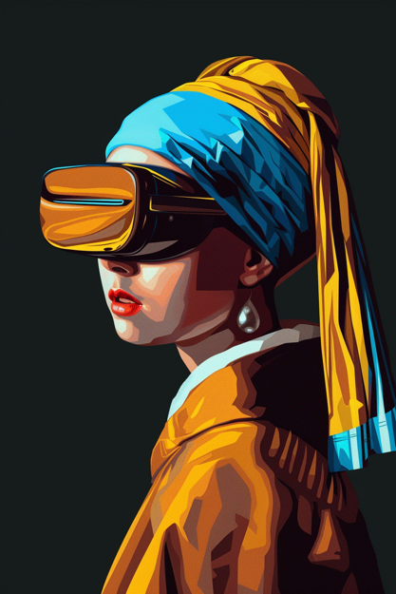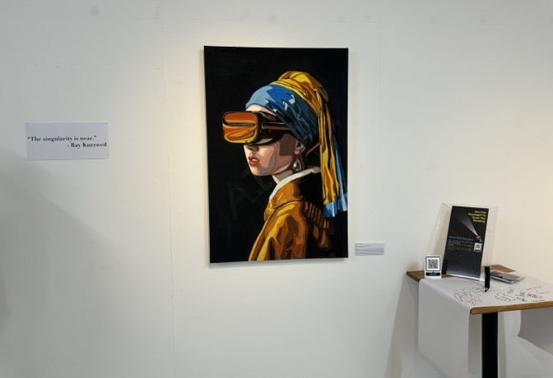

Materials and Technologies
In the "Luminous Insight: Artificial Intelligence in Art" project, we meticulously selected two essential materials: acrylic paint and invisible fluorescent paint. Acrylic paint, renowned for its quick-drying properties, vibrant colors, and excellent stability, has become a staple in modern visual arts. Its versatility allows artists to rapidly bring their creative visions to life and to layer their works with complex, multi-dimensional effects (Mayer, R., 1991).

Moreover, the invisible fluorescent paint used in this project plays a pivotal role by revealing previously hidden patterns or text when exposed to ultraviolet light, offering viewers a uniquely interactive experience. This technological enhancement not only imbues the artwork with an element of mystery but also exemplifies the evolving role of technology in contemporary artistic expression, pushing the boundaries of audience perception (Kuhn, A., 2012).

Process Documentation

The entire creation process was a transformation from the digital realm to the physical, encompassing multiple steps and the application of various techniques:

AI Image Generation: The process began with inputting the initial concept into Midjourney, followed by multiple iterations to refine and optimize the image until a satisfactory result was achieved. Each iteration involved fine-tuning parameters to precisely control color and detail. Throughout this phase, I experimented extensively with various prompts to guide the AI's output.

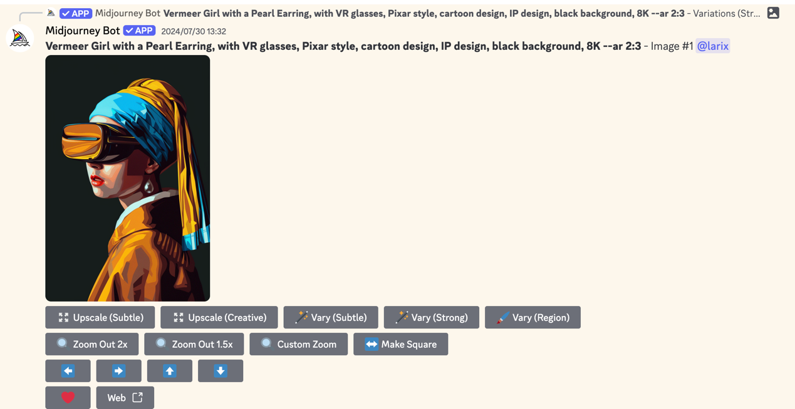

Image Review and Selection: From the numerous generated images, I selected the one that best aligned with the project’s theme. This selection process required a combination of artistic intuition and technical evaluation. I opted for an image that would translate well to acrylic on canvas, focusing on a style conducive to hand-painting. The chosen image featured vibrant colors with high contrast for aesthetic appeal and decorative potential. Additionally, the composition was inspired by the classic arrangement found in Girl with a Pearl Earring.

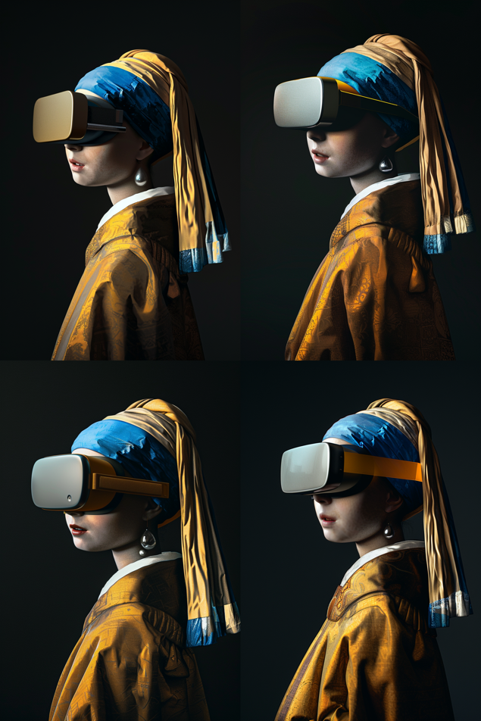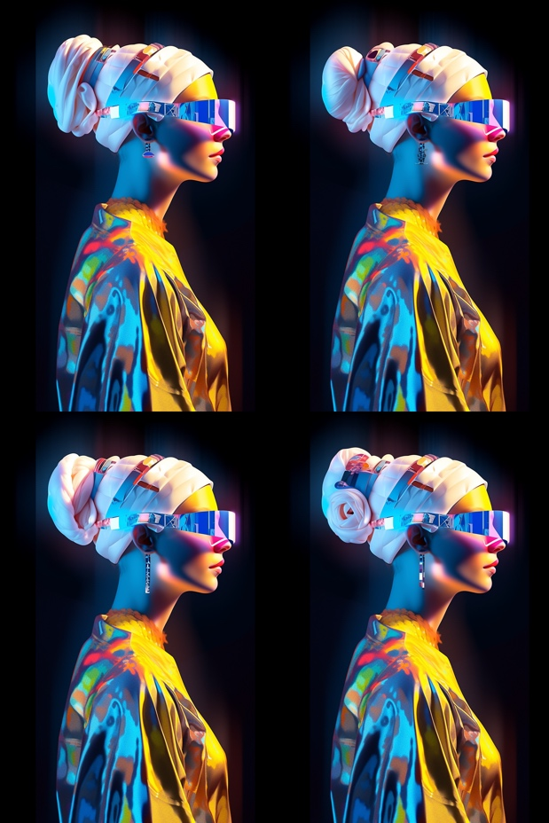
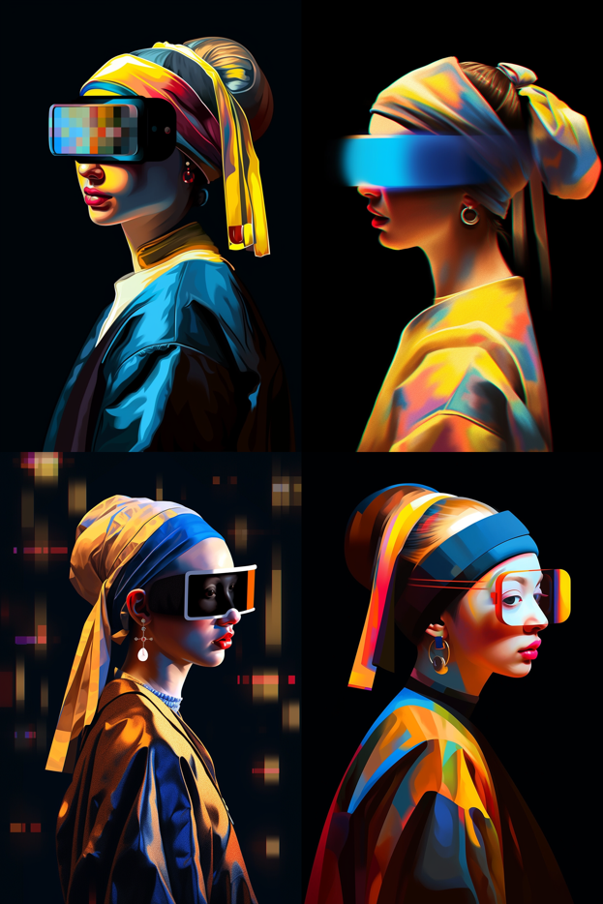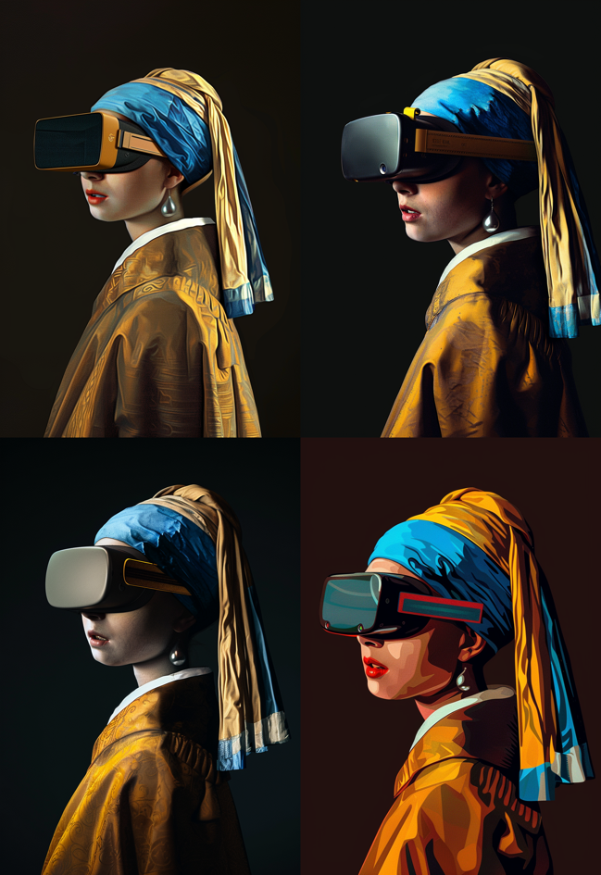
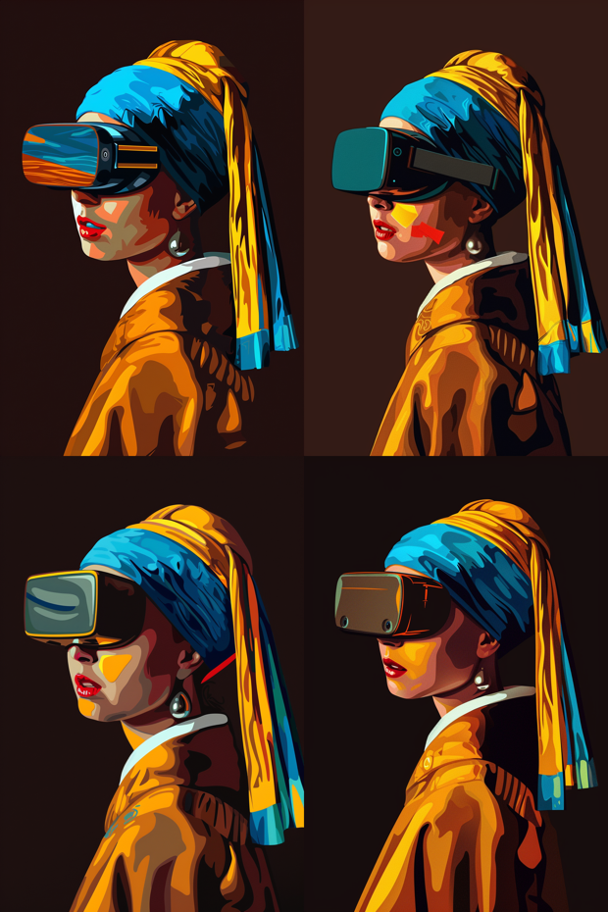

Hand-Painting Process: The selected AI-generated image was then transferred onto canvas, where I meticulously hand-painted it uses acrylics. During this phase, I paid close attention to preserving the unique textures and layers characteristic of hand painting, while also adjusting certain details to enhance the overall impact of the piece.
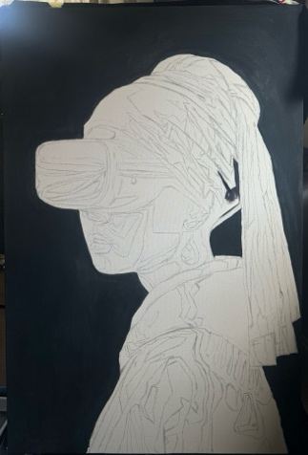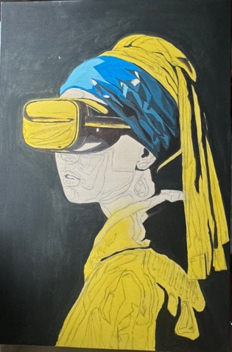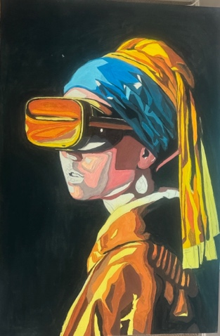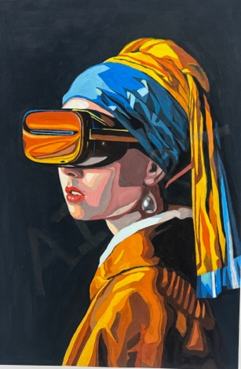

UV Watermark Addition: Upon completing the painting, I carefully added an invisible "AI ART" watermark using UV-sensitive paint. This element remained hidden under normal lighting conditions, only becoming visible under UV light.
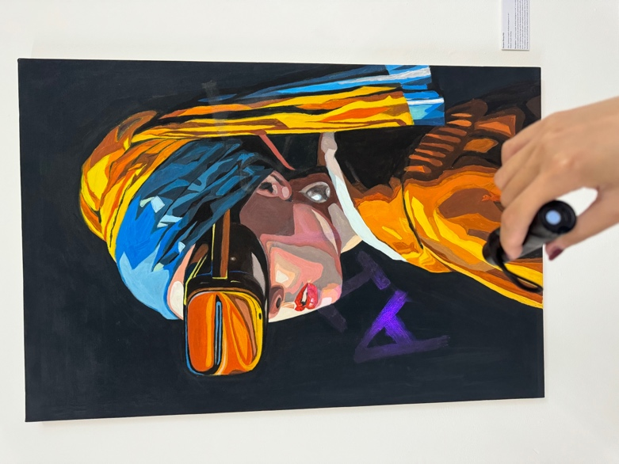

Exhibition Setup: At the exhibition venue, I strategically placed UV flashlights and informational plaques to guide visitors on how to interact with the artwork and discover the hidden elements. Additionally, I prepared QR codes linked to the project’s webpage, offering more background on the creation process and a questionnaire to gather audience feedback. A long white paper was laid out on a table, accompanied by various watercolor pens, inviting visitors to freely express their attitudes and opinions on the paper.
Opening and Audience Interaction: On the day of the exhibition opening, I provided an explanatory sign next to my artwork that detailed the creative concept and technical aspects of the project. I engaged with visitors by answering their questions and observed how they interacted with the piece, gathering valuable feedback through these interactions.

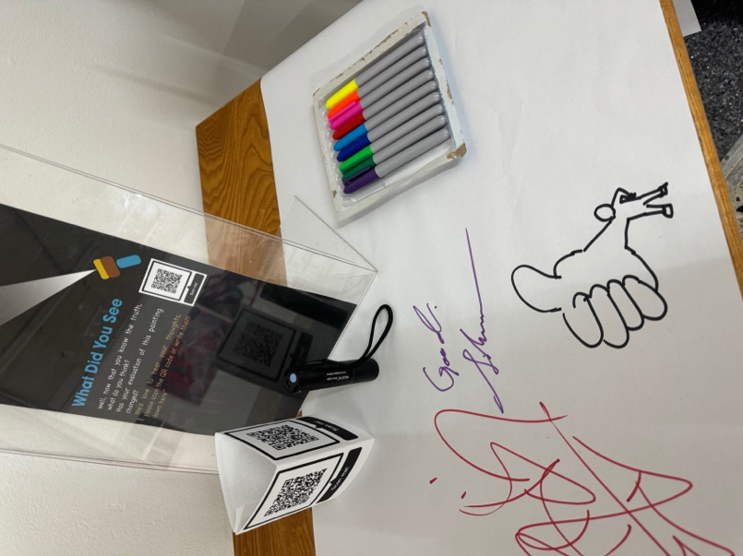

Personal reflection

While planning and executing the "Luminous Insight: Artificial Intelligence in Art" project, I encountered several unexpected challenges that significantly enriched my professional knowledge and problem-solving strategies. One of the first issues arose from the discrepancy between the anticipated drying time of the acrylic paint and the actual drying process. This variation necessitated adjustments to the exhibition setup schedule. I realized that environmental factors, such as humidity and temperature, had a much greater impact on the drying speed than I had initially anticipated. This experience highlighted the need to account for environmental control more carefully in future projects.

Additionally, although QR codes were strategically placed throughout the exhibition to provide visitors with more information and to collect their feedback, I observed that most attendees preferred to engage directly with the UV light interactive elements rather than scanning the QR codes. This observation suggests that in future exhibitions, I need to design more intuitive and engaging ways to encourage deeper interaction and feedback from the audience.

These lessons underscored the importance of being adaptable as a curator, constantly tuning into the audience’s behavior and being ready to modify interactive elements to enhance engagement and enrich the overall experience. The process taught me that a successful exhibition requires not only careful planning but also the flexibility to adjust in real-time based on how visitors interact with the artwork. This adaptability will be crucial in ensuring that future projects resonate more deeply with their audience, leading to a more meaningful and immersive experience。

Discussion

Interpret and synthesize anticipated findings in the context of the literature review

The project "Luminous Insight: Artificial Intelligence in Art" aims to uncover profound insights into the fusion of AI with traditional art forms, shedding light on the complex interplay between technology and creativity. Historically, the definitions of art and beauty have evolved from rigidly structured concepts to more open and fluid interpretations (Kant, I. 1790), particularly in response to challenges posed by new technologies (Gombrich, E. H.1950). This historical context provides a valuable framework for understanding the reception of AI-generated art.

Traditionally, the value of art has often been tied to its originality and the manual skill of its creator. However, as Walter Benjamin discussed in The Work of Art in the Age of Mechanical Reproduction, the advent of mechanical reproduction technology fundamentally altered the notion of an artwork's "aura" or "authenticity," prompting a reevaluation of the role and function of art (Benjamin, W., 1935). In a similar vein, the emergence of AI art challenges the traditional processes of art creation and the uniqueness of artistic works, echoing Benjamin's arguments.

In contemporary media and public discourse, AI's role in art is frequently portrayed as a double-edged sword, with the potential both to enrich artistic expression and to threaten the traditional role of the artist. Studies by Boden and Edmonds explore the use of AI in generative art and how it serves as a new creative tool that expands the boundaries of artistic practice (Boden, M.A., Edmonds, E.A, 2009). In the "Luminous Insight" project, we anticipate that public acceptance of AI art will reflect this expansion of the traditional boundaries of art.

Moreover, the expected findings will also delve into how AI influences the social function of art. McCormack and d'Inverno suggest that art, as a social machine, plays a crucial role in provoking discussion and reflection, and AI-generated art introduces new avenues for challenging and expanding these discussions (McCormack, J., d'Inverno, M，2012). Against this backdrop, the project aims to assess how AI, through novel forms of expression and interactivity, impacts the audience's experience of art and its potential contributions to the social value of art.

2. Explore the relationship between actual work and reporting

In this project, "Luminous Insight: Artificial Intelligence in Art," I drew heavily on the guidance from the literature review, particularly focusing on phenomenological methodology and the exploration of non-traditional materials, to experiment with how combining AI technology with acrylic painting—a non-traditional medium—can bring new perspectives and depth to traditional art forms. Merleau-Ponty, in his seminal work Phenomenology of Perception, posited that art is a way of perceiving the world, capable of revealing aspects of everyday life that often go unnoticed (Merleau-Ponty, 1962). This theory informed my approach in using AI art to transcend the limitations of traditional painting, pushing the boundaries of artistic expression toward more diverse and multifaceted forms.

By employing AI as a creative tool, we can not only explore visual effects that are difficult to achieve through conventional painting but also re-evaluate the use of painting materials and the cost-effectiveness of art production through technological intervention. As Fisher discusses in The Aesthetics of Design, the introduction of new technologies not only alters the production costs of artworks but also offers new ways to conceive and realize artistic ideas (Fisher, 2013). In this project, the use of AI significantly reduced the time and physical material costs traditionally associated with painting, while simultaneously opening new possibilities for exploring the frontiers of visual art through technological means.

Moreover, the relationship between the practical work of the project and the theoretical discussions presented in the report is evident in how the actual creative process and the final artwork embody the theories and ideas referenced in the literature. For example, the creation and presentation of the work in this project reflect Heidegger's ideas on the relationship between technology and art as articulated in The Origin of the Work of Art. Heidegger suggests that art can serve as a bridge between technology and human perception, revealing deeper truths about our existence (Heidegger, 1950). By integrating AI with traditional painting techniques, this project seeks to demonstrate how new technological tools can enhance the expressive power and emotional impact of art, while also exploring how this fusion influences audience perception and the evaluation of art.

3 Reflect on the creativity of the project

The "Luminous Insight: Artificial Intelligence in Art" project showcases remarkable originality and creativity across conceptual, aesthetic, and executional levels. By integrating artificial intelligence with traditional painting techniques, the project challenges conventional modes of artistic expression and expands the conceptual boundaries of art. As John Dewey emphasized in Art as Experience, the essence of art lies in the re-creation and communication of experience, and this project precisely achieves that through the incorporation of new technologies (Dewey, J., 1934).

The project's aesthetic innovation is evident in the use of invisible fluorescent paint and UV light technology, which not only alters the way audiences interact with the artwork but also adds layers of multidimensional interpretation. This artistic choice directly influences how the artwork conveys ideas, emotions, and narratives, offering viewers a novel artistic experience that bridges traditional art with modern technology. As Arthur Danto observed in his exploration of changes within the art world, when the interaction between artwork and audience becomes more complex, the narrative and emotional expression within the art also become deeper and more diverse (Danto, A. C.,1981).

In terms of execution, the projects carefully designed interactive elements transform the audience from passive spectators into active participants in the art experience. This approach not only demonstrates creativity but also aligns with contemporary trends in art education, which emphasize the importance of participation and experience in deepening the impact of art education (Eisner, E. W., 2002).

4 Future Directions and Problem Reflections

As artificial intelligence technology continues to advance rapidly and find increasingly widespread applications, the future trajectory of AI art holds significant potential and presents various challenges. From an interdisciplinary perspective, AI art has the capacity to foster the integration of technology with various forms of art, particularly in fields like film, music, and performing arts. As noted by Stiny and Gips in Shape Grammars and the Generative Specification of Painting and Sculpture, algorithms can be used to create new artistic forms, which could lead to innovative visual expressions in the advertising and media industries (Stiny, G., & Gips, J., 1972).

Moreover, the commercial potential of AI art is becoming increasingly apparent. According to an analysis by McCormack and colleagues in Creative Applications of Artificial Intelligence: Promises and Challenges, AI can assist artists in efficiently generating customized content, which is especially valuable in the advertising and media sectors (McCormack, J., Gifford, T., & Hutchings, P., 2020). In the field of education, the application of AI art also introduces new tools and methods for traditional art instruction, enhancing creativity and engagement among students.

However, the development of AI art brings with it ethical considerations that cannot be overlooked. As Boden discusses in The Philosophy of Artificial Intelligence, the creation of art by AI raises important questions about authorship and the attribution of creative ownership (Boden, M.A., 1990). Future research will need to explore how to strike a balance between respecting the traditional values of art and encouraging technological innovation, while also establishing appropriate legal and ethical frameworks to guide the development and application of AI in art. Margaret Boden further elaborates on this in Mind as Machine: A History of Cognitive Science, noting that AI's role as a tool or collaborator in the creative process blurs the conventional notions of creative ownership (Boden, M.A., 2006). She points out that as AI systems become capable of independently generating artworks, the relationship between the artist and AI, as well as the ownership of the resulting works, becomes a critical issue that must be addressed.

Additionally, the process of AI art creation, particularly its use of existing works without explicit permission, raises ethical and legal concerns regarding intellectual property. As Paul B. Jaskot discusses in his article on AI and art creation, AI's ability to "learn" from and re-create existing artworks without clear authorization could lead to copyright infringements, with current laws not fully equipped to handle the challenges posed by this emerging technology (Jaskot, P.B., 2018).

To address these ethical issues, it is recommended that more explicit legal frameworks be established to regulate the use of AI in the art domain. First, the ownership of AI-generated artworks needs to be clearly defined, with potential solutions including assigning ownership to the AI's developer, operator, or a separate entity altogether. Secondly, regarding the use of existing artistic resources by AI, developers should be required to obtain necessary permissions before "training" AI systems, thereby protecting the copyrights and interests of original creators.

Furthermore, the public's acceptance of AI art is also an important ethical consideration. Society's acceptance of new technology typically takes time, and through education and public discourse, we can help the public better understand the value and potential of AI art. This approach can facilitate the healthy development of innovative technologies while respecting the rich traditions of art.

Conclusion

In the Luminous Insight: Artificial Intelligence project, we explore new areas of artistic expression by combining traditional acrylic painting techniques with cutting-edge artificial intelligence technology. This project not only shows how technology can extend the boundaries of art, but also explores how this integration can change the audience's experience of art, reflecting the core idea of phenomenology: art is a way of perceiving the world that can reveal hidden truths and new dimensions of understanding.
From an interdisciplinary perspective, the introduction of artificial intelligence art is not only a revolution in the art world, but also has far-reaching implications for industries such as education, advertising, media, and therapy. Ethical and legal issues are also important considerations that cannot be avoided in our project. With the widespread adoption of AI technology and the increasing prominence of copyright issues in art, establishing a clear ethical and legal framework is essential to protect the rights of creators and promote the healthy development of technology and art.

In summary, the "Luminous Insight" project is not only an exploration of the application of AI in visual art, but also a manifestation of phenomenological theory in modern art. Through this new form of artistic expression, we can reveal hidden aesthetic dimensions and trigger deep reflection and discussion on art, technology, and human perception in the global context of the fusion of these fields.

Reference list
- Aristotle, c. 335 BCE. Poetics. Translated by S.H. Butcher.
- Bai, S., Lin, Y., Wang, X. et al. A high security coding and anti-counterfeiting method based on the nonlinear magnetization response of superparamagnetic nanomaterials. Sci Rep 14, 15360 (2024). https://doi.org/10.1038/s41598-024-65450-1
- Benjamin, W., 1935. The Work of Art in the Age of Mechanical Reproduction. Translated by J.A. Underwood, 2008. London: Penguin Books.
- Boden, M.A., 2004. The Creative Mind: Myths and Mechanisms. 2nd ed. London: Routledge.
- Boden, M.A., 2016. AI, Its Nature and Future. Oxford: Oxford University Press.
- Boden, M.A., 2016. AI and Creativity. Oxford: Oxford University Press.
- Bishop, C., 2012. Artificial Hells: Participatory Art and the Politics of Spectatorship. London: Verso Books.
- Danto, A.C., 1981. The Transfiguration of the Commonplace: A Philosophy of Art. Cambridge, MA: Harvard University Press.
- Dormehl, L., 2018. The Formula: How Algorithms Solve All Our Problems... and Create More. Penguin, London.
- Gadamer, H.G., 2004. Truth and Method. 2nd revised edition. Translated by J. Weinsheimer and D.G. Marshall. London: Continuum.
- Guckelsberger, C., Salge, C., and Gow, J., 2017. 'Evaluating the aesthetics of end-user applications', Journal of Systems and Software, 134, pp. 108-127.
- Harris, N., 2001. Cultural Excursions: Marketing Appetites and Cultural Tastes in Modern America. Chicago: University of Chicago Press.
- Ihde, D., 1990. Technology and the Lifeworld: From Garden to Earth. Bloomington: Indiana University Press.
- Kant, I., 1790. Critique of Judgment. Translated by J.C. Meredith, 2007. Oxford: Oxford University Press.
- Heidegger, M., 1977. The Question Concerning Technology, and Other Essays. Translated by W. Lovitt. New York: Harper & Row.
- Husserl, E., 1970. The Crisis of European Sciences and Transcendental Phenomenology: An Introduction to Phenomenological Philosophy. Northwestern University Press, Evanston.
- Kuhn, A., 2012. Science and the Creative Arts. London: University Press.
- Kemp, M., 1998. The Science of Art: Optical Themes in Western Art from Brunelleschi to Seurat. New Haven: Yale University Press.
- Mayer, R., 1991. The Artist's Handbook of Materials and Techniques. 5th ed. New York: Viking.
- McCormack, J. and Bown, O., 2009. 'Life’s What You Make: Niche Construction and Evolutionary Art', in Proceedings of the 10th European Conference on Artificial Life: Reframing Intelligence, Redefining Life, pp. 528-535.
- McCormack, J., Gifford, T., and Hutchings, P., 2020. 'Creative Applications of Artificial Intelligence: Promises and Challenges', Leonardo, 53(1), pp.58-62. DOI: 10.1162/leon_a_01798.
- Paul, C. (2002) ‘Renderings of Digital Art’, Leonardo (Oxford), 35(5), pp. 471–484. Available at: https://doi.org/10.1162/002409402320774303.
- Pozzi, F. et al. (2021) ‘A pioneer of acrylic painting: new insights into Carmen Herrera’s studio practice’, Heritage science, 9(1), pp. 131–131. Available at: https://doi.org/10.1186/s40494-021-00603-3.
- Preziosi, D., 1998. The Art of Art History: A Critical Anthology. Oxford: Oxford University Press.
- Turkle, S., 2011. Alone Together: Why We Expect More from Technology and Less from Each Other. Basic Books, New York

