Workbook- Specialised Performance Practice Jaimee Fraser-Ivett

I decided to take on this module due to my interest in theatrical performances I had seen which utilised actor-musicianship. The definition of actor-musicianship is ‘ A Performer who combines performance with playing a musical instrument’ (GetintolondonTheatre/2024)
I have always adored shows and performers that use their instrumental talents on stage. One of my favourite musicals of all time is ‘Amalie’ , a modern musical that is based upon the 2001 French movie. (Hartshorn - Hook Productions, 2024)
This production opened in the UK shortly before the Covid-19 pandemic , and featured an ensemble of actors who used their instruments as an extension of their characters.
The musical ‘Once’ , adapted from the 2001 movie-musical of the same name , utilises the music style of folk , and follows a lead character named ‘Guy’ who falls in love with ‘Girl’ over the course of a few music-filled days. This musical draws its music style from folk , and has a band onstage at all times. The character of ‘Guy’ plays a guitar and accompanies his own solos. ‘Girl’ meanwhile, plays the piano , which is used to good effect when she sings the haunting solo ‘The Hill’ In this song the piano becomes as much a character as ‘Girl’ is as it musicalizes the rise and fall of her thoughts. (London Theatre , 2024) Spawning from this musical was a folk band called ‘The phoenix collective’, a group of actor-musicians who took their talent, skill and love of Irish folk music , and created a band which played much of the UK and had a residency at the Phoenix Theatre , where ‘Once’ had played.
To begin with this module , we discussed what instruments we could currently play. I had experience with a ukulele at school , and had played instruments such as the drums in previous shows , but my main instrument was my voice. Within the class we had performers who could play the flute , the bass guitar and the didgeridoo. It was a great starting point in creating our final piece , knowing that we had creatives among us who had knowledge of such different and varied instruments.

The Name of the Game
As a collective we decided to name our piece ‘What it means to be Human’, as all of our current topics of interest and monologues detailed the very intricacies of the human experience. We workshopped our piece being a self-help manual for a passing alien to discover , but eventually decided that keeping it as realistic and low-key as possible was the way to go. As we only had twelve minutes to perform our piece , we had to be as precise as possible and this meant cutting some brilliant monologues and pieces of music.
Eventually , this working title fell away as our piece evolved and changed , and it became the title of ‘Sonder’. By definition , to sonder is ‘to he feeling one has on realising that every other individual one sees has a life as full and real as one’s own, in which they are the central character and others, including oneself, have secondary or insignificant roles’ (Dictionary.com , 2024) , and we realised this suited our piece much better as every character believes they are the main voice until they collectively come together at the end.
We created an opening for our characters , as it seemed odd to suddenly jump straight into a monologue with no context. Our characters entered the scene visibly unsure of what their instrument was , a clear symbolism of a disconnect between instrument and actor. My character , a version of myself , arranges everyone with their corresponding instrument and the show can begin. When creating this piece we discovered that having each character introduce themselves separately was quite time consuming , and took a large chunk of time from our 12 minute overall piece. We fixed this issue by having all characters come on at the same time and merge the introductions , quickening the pace and giving time to other areas of the piece.
We created our setlist. 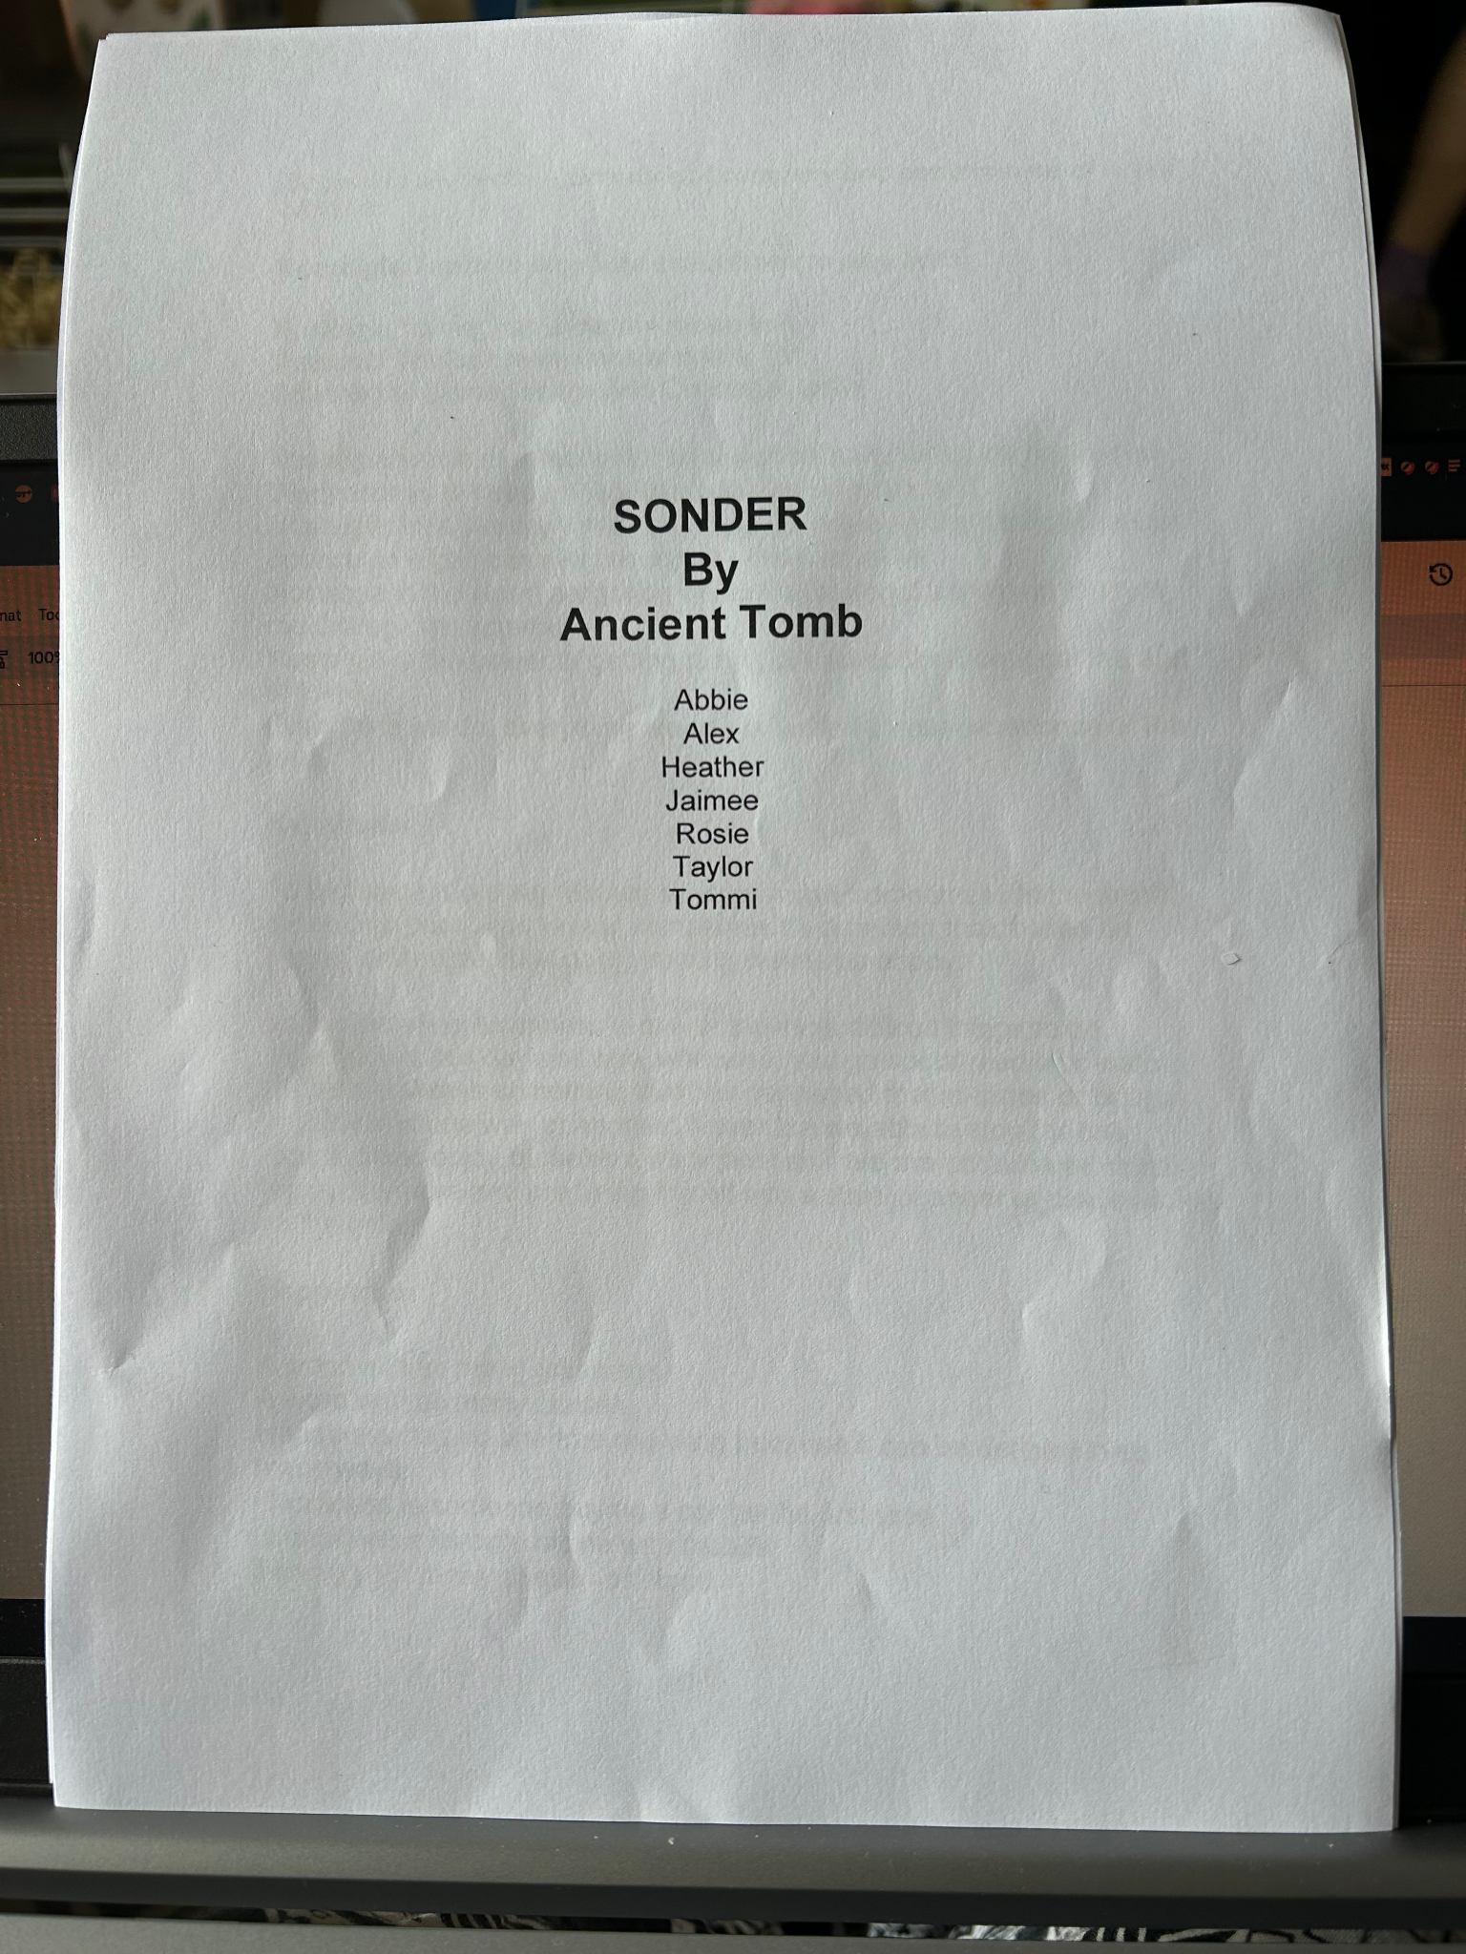 (Ancient Tomb, 2024)
We put together all themes that connected , such as identity and mental health, so that the storyline could form a cohesive narrative.
A drawback of having so many incredible pieces of work is that our short performance of twelve minutes gets taken up incredibly quickly. In fact , we had only created three fully realised pieces before our twelve minutes was up. Luckily , we were given a full half an hour to give our piece the time it needed to breathe. This allowed us to create a life for each piece we created.
The story we had begun to create focused on characters who struggled with their baggage. They meet in a meeting , an AA (Actor’s anonymous) meeting , to be precise. Whilst here , they connect with their fellow performers and let go of their pain and anguish. We ended the piece with a monologue about stars and the beauty of the universe , signalling that all characters had found their inner happiness.
As this was an actor-musician module, all of the pieces combined acting with some form of music. But this couldn’t be background or incidental music , something you’d hear in the transitions between scenes. The music here had to be the living , breathing embodiment of our characters , something we cling to despite their world falling apart. For example, ‘Taylor’s’ main instrument is the flute , and it became a symbol of childlike joy and wonder as she played it during my monologues on nostalgia and growing up. Once my character makes the discovery that she can keep her childlike joy whilst still living in the moment , ‘Taylor’s’ character hands me her flute in a moment of heartbreaking understanding. That childlike music can never play for her again.
As our characters grew and developed , so did the monologues they told and instruments they played. Initially , ‘Alex’s’ guitar was something he used to force his ideals and self-repression onto others , then it morphed into a tool to shield himself away with. This also was the case for ‘Taylor’ , who’s flute shielded her from her own mental health struggles. My main instrument was my voice , and my character’s journey began with a quiet and reserved soft hum in the opening sequence , and then gradually grew to a joyful song once my character had found her voice through friendship and acceptance.
When creating our character work , I decided to use the practitioner Anne Bogart as a reference for my work because in her teachings she uses kinesthetic response , which I used when workshopping and improvising our transition scenes. For example , a moment in the show in which ‘Tommi’ frightens my character out of her monologue was a genuine reaction which we decided to keep in as it fitted the story well. (Viewpoints by Bogart (Ann Bogart) 2005)
As a devised piece , we drafted and edited our story and script until a natural narrative found its way into the show , a cohesive storyline that started in a university band practice meeting , had character arcs and moments to grow , and a circular ending that reprises the opening. My character grew from a childhood-loving entity to a fully fleshed out creation that lived , breathed and existed inside this universe. I decided to make this change as it co-existed alongside the changes my fellow actors were making to their characters , but also to create a believable linear experience in which the fictionalised ‘Jaimee’ could grow and become a better person.
Something that was brought in at a fairly early stage of our project was the concept of soundscapes. We had used soundscapes as warm ups in the rehearsal room , and it seemed a waste not to take this into the performance with us. Our soundscape was reminiscent of a day at the beach , with vocal sounds creating birds and instruments creating sand and crashing waves. Soundscapes were , for me , one of the most exciting and interesting parts of learning the craft on this module. Making a circle of sound which represents one specific thing is something I will take with me beyond university , as I believe it is not just a brilliant warmup , but also a transitional device to help us move the scene along.
The Performance
I believe the show was a wonderful realisation of the brilliant work we had created over the past five weeks.
The monologues were complimented by music that fed into its story , and flowed effortlessly into songs that had been beautifully crafted for our production by our own hands.
Moments got laughs that we weren’t expecting; such as ‘Rosie’ bringing out a Doc Hudson car from the movie ‘Cars’ for a visual joke and the audience exploding into laughter. (Cars/2006) Or the wholesome moment when ‘Rosie’ and ‘Heather’ realised they both had matching ‘Ghostbuster’ outfits. (Ghostbsuters, Harold Ramis , 1984)
Moments that were purely fiction suddenly became reality during the show , too. The hug I gave ‘Taylor’ in every rehearsal after the events of her monologue ‘Listen’ took on a new meaning when my character told her ‘I’d always be her friend’ , knowing that in real life she’d be leaving soon.
The moment at the end in which all of our characters reprise the song we created at the beginning had a new resonance when we knew we’d be finishing with this module , and this group , forever.
Overall , I believe this module has been successful and produced a grand piece of theatre that we will look back on and be proud of.
Final thoughts;
From bringing this module as a performer who would label herself a singer and little else , being a part of Ancient Tomb has given me the confidence to call myself an actor-musician , as I now feel i’ve the ability to put together a strong piece of music that uses both voice and instrument , and is successful in telling a story. Going forward , I will put my newfound knowledge to good use by continuing on with creating musical pieces for voice , and I hope to learn more instruments in the coming months so I can musicalize my pieces and feel confident to call myself an ‘actor-musician’ for future auditions.
Once an ancient tomb , always an ancient tomb.

References
https://getintotheatre.org/blog/what-does-an-actor-musician-do/#:~:text=An%20Actor%20Musician%20is%20a,with%20playing%20a%20musical%20instrument.- What is an actor-muso?
https://ameliethemusical.com/ - Amelie the musical
https://phoenix.londontheatres.co.uk/once/ - Once the musical
https://www.dictionary.com/browse/sonder - Definition of Sonder
https://stilluntitledproject.wordpress.com/wp-content/uploads/2014/11/anne-bogart-and-tina-landau-the-viewpoints-book.pdf - Ann Bogart
https://www.imdb.com/title/tt0087332/ - Ghostbusters
https://en.wikipedia.org/wiki/Doc_Hudson- Cars (2006) Doc Hudson

