

Managing Enterprise in the 21st Century

Business Plan

Crystal Hair



Submission Date: 23/11/2025
Lecturer: Charles Oham
Student: Diana Hitel

Executive Summary

Crystal Hair will open in Canary Wharf, a location with high footfall and strong demand from working professionals who regularly invest in premium hair services. The business requires £3,000 startup capital to cover training, tools, products, rental, insurance, transport, and utilities. With an average turnover of £4,050 per month (£48,600 per year) and annual expenses of only £10,500, the business is projected to achieve a net profit of £38,100 per year. The break-even point is low at £10,500, meaning the business becomes profitable quickly and operates with a strong 78% profit margin, making it highly sustainable and financially secure in its first year.

Table of Contents
Executive Summary 1
Table of ContentsError: Reference source not found 3
Business Concept 3
Product Description 4
Short-Term Objectives (less than a year) 6
Long-Term Objectives (More than a year) 6
Market Analysis and Marketing Plan 6
Market Analysis (Competitors, Customers, Target Groups) 6
PESTEL Analysis 7
SWOT Analysis 8
Marketing Mix (4Ps) 8
Management Team 8
Management Team and Their Background 8
Organisational Chart 9
Financial Plan (One Year) 9
Sources of Finance 9
Cash Flow Forecast 10
Sales Forecast 10
Cost of Production Forecast 10
Break Even Analysis 10
Operations and Management Plan 10
Reference List 11

Business Concept
BUSINESS DESCRIPTION
Business Idea: CrystalHair
CrystalHair will focus on hair restoration treatments for women and girls using two advanced methods:
- Cold restoration – deeply nourishes and strengthens damaged hair.
- Hot laser crystallization – uses gentle laser heat to seal nutrients inside the hair, leaving it smooth, shiny, and healthy.
Our clients will be women and girls aged 12 and older who want to restore or improve their hair health. Because products are formaldehyde-free and safe, they can also be used for young clients whose hair needs gentle, non-toxic care. The studio will be located in Canary Wharf, E14 9TS (London) — a vibrant and modern district. The opening is planned for March 2025, just before the holiday season — a perfect time for clients to refresh their look and feel renewed. Many people, especially women and teenage girls, experience hair damage due to stress, pollution, and chemical treatments. My salon is dedicated to restoring natural beauty and confidence through safe, innovative, and eco-friendly methods that protect both hair and overall health. Each client will receive a personalized consultation to determine the best treatment plan. The salon will promote its services through Instagram, TikTok, client recommendations, and collaborations with clean-beauty influencers to reach a wide and loyal audience. At the beginning, I plan to rent a chair or space in an existing salon. Since I will work independently, there will be no staff costs at first. This setup allows me to build my client base step by step while keeping expenses low and manageable.

Product Description

I provide professional and safe hair restoration treatments that improve the health, strength, and appearance of the hair. My services include:
- Laser Hair Crystallization
- Nanoquartz Treatment
- Cold Hair Restoration

Business Objectives

Short-Term Objectives (less than a year)
- To start hair treatment operations in March 2026 with one chair in a hair salon in Canary Wharf and build a client flow of 45 – 50 customers per month.
- Register my business as a Sole Trader in February 2026, including completing all paperwork and securing public liability insurance.
- Grow my client base by August 2026 by posting weekly content on Instagram and TikTok to reach 1000 followers and attract at least 20 regular clients.
- Purchase an innovative laser device for oil mist hair treatments by July 2026 to upgrade the quality of my service and improve treatment results.

Long-Term Objectives (More than a year)
- Create and launch my own hair-care product line in December 2027 by researching suppliers, testing products, and preparing them for sale to clients.
- Open my own small hair studio in March 2028 after building a stable client base and securing a suitable location.

Market Analysis and Marketing Plan

Market Analysis (Competitors, Customers, Target Groups)
Competitor Analysis Since my main clients are women who care about beauty and healthy hair, I can identify my target group as women aged 18–45, including professionals in East London, pregnant and breastfeeding women, and also children from 8 years old who can safely receive non-toxic hair restoration treatments.
In Canary Wharf, Blossom Beauty Studio offers cold hair restoration and gentle treatments without harsh chemicals. Their services are popular among families, because they are safe even for children. However, they mostly provide light care treatments, while my business will offer deeper and more advanced hair restoration methods, which can give longer-lasting results.
In Stratford, Lumière Hair & Beauty provides treatments such as nanoplasty and hair botox. They have many clients and a strong reputation, but because they are busy, the service may feel less personalised. My business will focus on one-to-one consultations and treatments for each client.
In Ilford, Belle Amé Salon offers similar restoration services at more affordable prices. However, their approach is more mass-market. My business will position itself as a more specialised, premium, and health-focused service, using safe, formaldehyde-free products.
Since my main clients are women interested in beauty and healthy hair, I can define my target group as women aged 18–45. This includes pregnant and breastfeeding women, and children from age 8 who can safely receive non-toxic hair restoration treatments. London has a population of 9 million people, including 4.6 million women, which creates a large potential market for my services. Approximately 1.5 to 2 million of them are potential clients who may use professional hair-restoration services such as keratin, botox, nanoplasty, or laser treatments.

PESTEL Analysis

To understand the environment in which my business will operate, I have completed a PESTEL analysis. This helps me identify the political, economic, social, technological, environmental, and legal factors that may influence opening my hair-restoration service in London, especially in Canary Wharf.
PESTEL Analysis
P — Political
Canary Wharf—is good location for small businesses because the local council (Tower Hamlets) supports new business owner. They have a Business Growth Team that gives advice, workshops, and help for people starting services. The Canary Wharf Group also supports local projects and business activities. This makes the area safe and supportive for opening a small beauty business.
E — Economic
Canary Wharf has many working professionals who regularly spend money on beauty and hair services. Even if some offices change, many large companies still stay in the area, keeping customer flow stable. There is also new government and private investment in Canary Wharf, showing good long-term economic growth
S — Social
There is a strong social trend in the UK towards natural, healthy, and well-maintained hair.
Customers value professional advice and visible results. Online reviews and social media play an important role in building trust and attracting clients.
T — Technological
Hair restoration technology is growing fast. I'm using new methods like laser crystallisation and formaldehyde-free products make treatments safer and more effective. This helps my business offer modern, high-quality services that attract clients looking for innovation.
E – Environmental
More customers prefer treatments that are safe, eco-friendly, and free from harsh chemicals. Using non-toxic formulas and reducing waste supports environmental expectations and builds trust with clients.
L — Legal
The business will be officially registered through gov.uk. I will register my business as a Sole Trader and follow UK rules for hygiene, safety, and insurance.

SWOT Analysis
This SWOT analysis helps me clearly understand my strengths, weaknesses, opportunities, and threats as I develop my hair-restoration service. It shows what I already do well, what I need to improve, and what external factors can support or challenge my business in East London.
SWOT Analysis
Strengths:  New start-up businesses, however, hair treatment with high levels of self-motivation.  I’m stress resistant; when in stressful situations, I do not explode, but remain calm and composed, which helps me work professionally with clients.  Even though I don’t have much experience in this field, I have good technical skills in hair restoration. | Weaknesses:  I’ll use a digital booking system and plan my working schedule weekly to approve my time management  Fear of taking risks, but with self-motivation I will fdo it step by step to achieve success  Losing interest quickly if results aren’t immediate  Easily distracted  Impatient  Sensitive to criticism
Opportunities:  Large city with high client demand  Strong local resources and beauty industry network  Promising location with good transport access  Ability to grow skills and expand services  More time flexibility (no children’s responsibilities) | Threats:  Strong competition in the beauty industry  Trends and beauty standards change quickly  New technologies and techniques develop fast

Marketing Mix (4Ps)

Product – My hair restoration service uses safe, high-quality products to deliver long-lasting results for 5–8 months. Each client receives a personalized consultation, including a hair damage assessment, to determine the most effective procedure for their needs.
Price £130–£250 depending on hair length and treatment type.
Promotion – “Before and after” videos shared on TikTok and Instagram to showcase real results.
Place – Canary Wharf – serving professionals who value healthy, beautiful hair.

Management Team

Management Team and Their Background
I will register my business as a sole trader since I’ll be working on my own. This makes things simple and easy to manage. In the future, if my client base grows, I can bring on part-time staff. While a Limited Company offers extra protection, starting as a sole trader is the best fit for me right now.

Organisational Chart

Owner
Diana Hitel

Manager
Diana Hitel

Specialist
Diana Hitel

Assistant
(part-time staff, to be hired later)

Legal Structure
Chrystal Hair will operate as a sole trader business. At the first stage, I will work independently and rent a chair within an existing salon in Canary Wharf. As a sole trader, I will be personally responsible for managing all aspects of the business, including bookings, customer service, and finances.

Financial Plan (One Year)

Sources of Finance
My business will be financed through personal savings and reinvesting monthly profits. Because I rent a chair instead of opening a full salon, my start-up costs are low, which allows me to cover expenses without external loans.

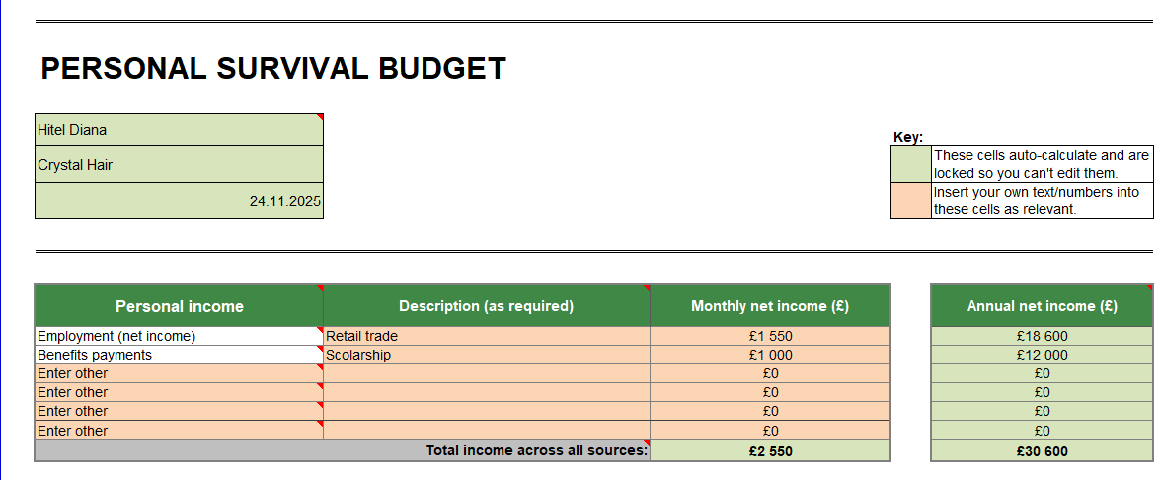

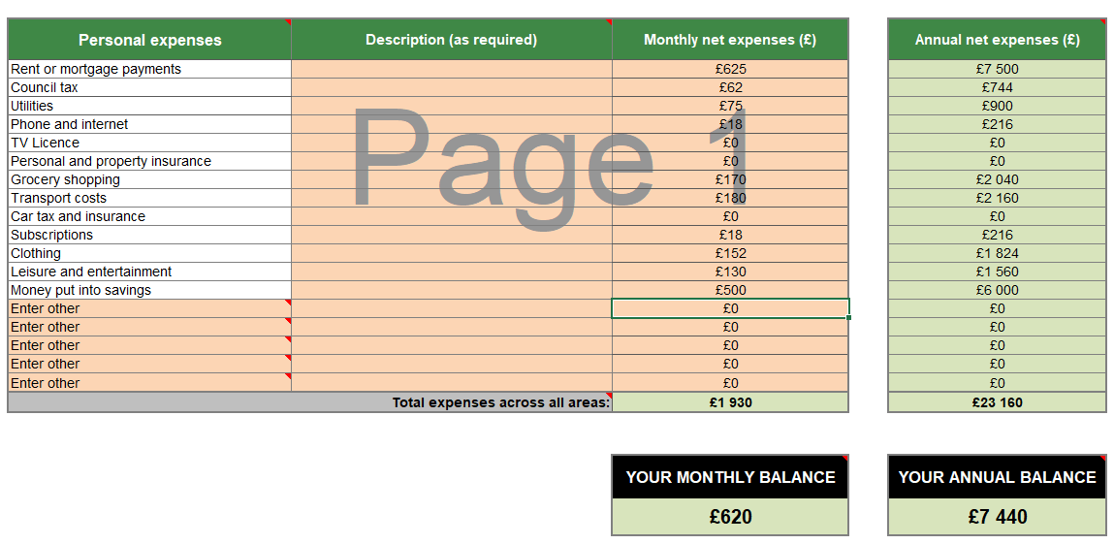

Cash Flow Forecast
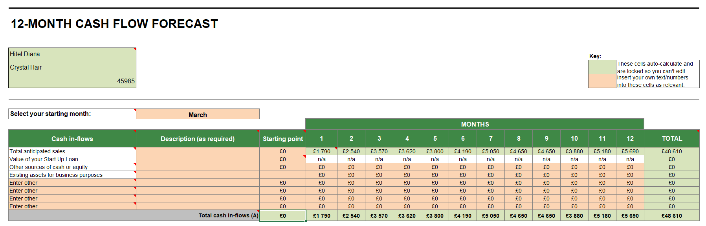

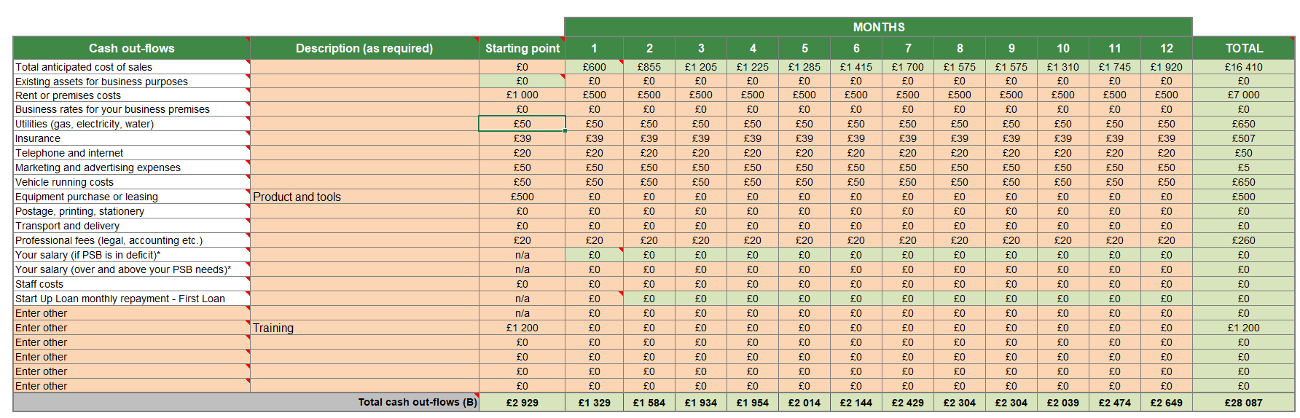


Sales Forecast

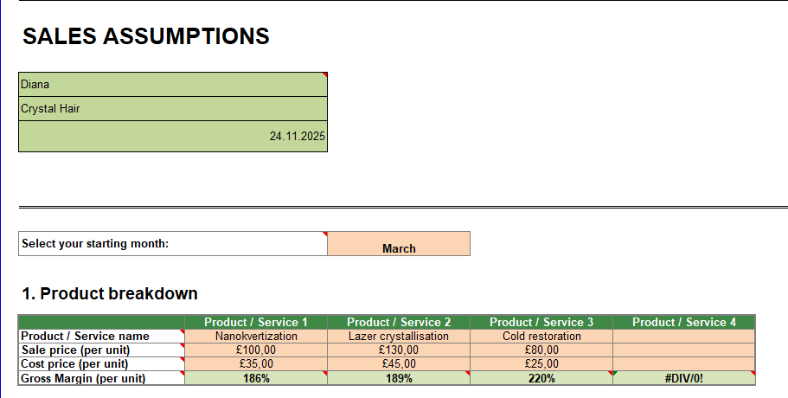

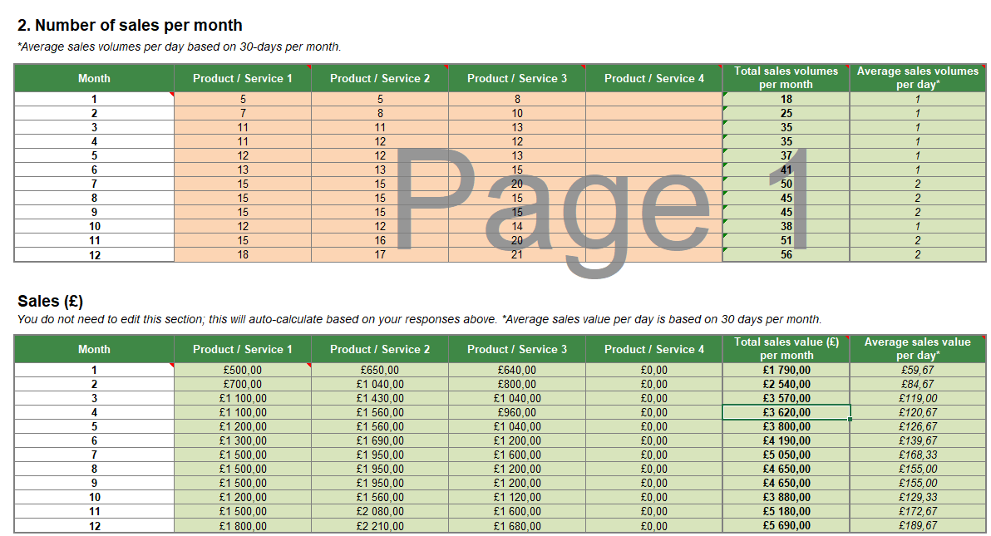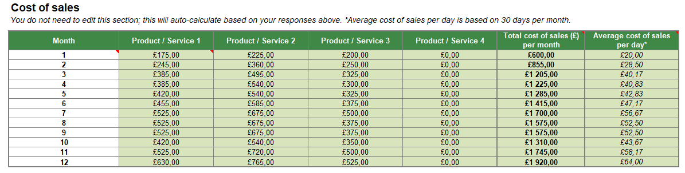

Cost of Production Forecast

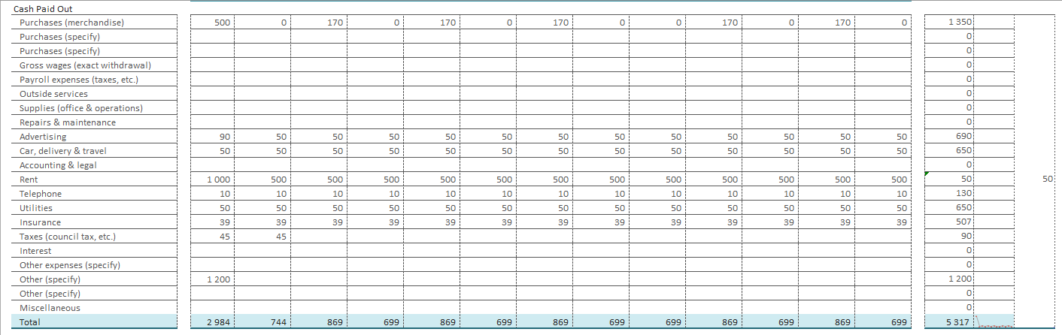

Break Even Analysis

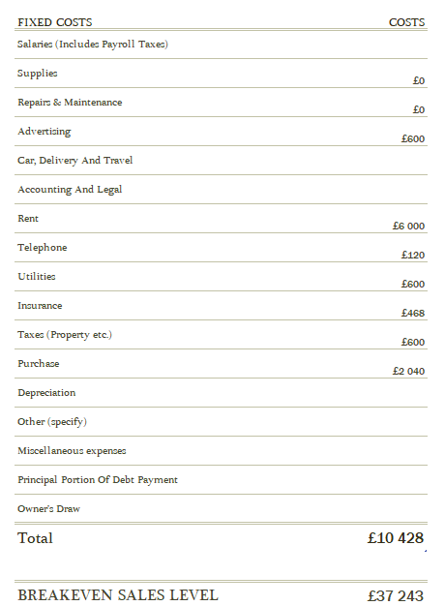

Operations and Management Plan

To attract clients, I will offer promotions, discounts for birthdays and holidays, and gift certificates for friends and family. I plan to work 4 days a week at first to grow my client base and promote my business. I will keep my main job to have some starting money, and later I will work full-time on my business. In the future, I want to hire a part-time worker when I have more clients.

Reference List

- Tower Hamlets(2025) Business Support Online @
https://www.towerhamlets.gov.uk/lgnl/business/business_support_and_advice/Business-Growth-Team.aspx (Accessed: 19 November 2025)
- GOV.UK – Register as a sole trader
GOV.UK (2024) Set up as a sole trader. Available at: https://www.gov.uk/set-up-sole-trader (Accessed: 19 November 2025)
- Office for National Statistics – London population and demographics
Office for National Statistics (2024) Population estimates for London. Available at: https://www.ons.gov.uk (https://www.ons.gov.uk/) (Accessed: 24 November 2025).
- Statista – UK beauty industry and haircare market data
Statista (2024) Hair care market in the United Kingdom – Statistics & Facts. Available at: https://www.statista.com (https://www.statista.com/ )(Accessed: 24 November 2025).

