SWOT (Strengths, Weaknesses, Opportunities and Threats
Knowledge of the internal strengths and weaknesses, along with the opportunities and threats – SWOT – facing a business, project or programme can paint a broad picture of its current status. This proactive analysis leads to a richer understanding and avoids relying on habit or instinct, helping leaders and managers to make informed decisions about the actions available to them.
Conducting a SWOT analysis can be useful for lots of contexts, including:
- problem solving
- planning
- competitor evaluation
- personal-development planning
- strategic decision making, such as entering a new sector or launching a new product

When to use a SWOT analysis
SWOT analyses are popular because of their ease of use and flexibility in highlighting where project or business ideas are strong and/or vulnerable, and where there are opportunities to explore.
The SWOT Analysis Tool helps you to analyse and explore your position through both internal and external lenses. While it could be applied at any stage of a planning process, it is most suitable at the start, or at a significant point of review. This is because it is important to assess and understand the current situation before committing to a sensible and sustainable course of action.
A SWOT analysis can be performed on a project, service or product, a sector, an organisation or even on an individual in the form of personal development planning. When done properly, a SWOT analysis will give you a clear picture of the most important factors that can influence the survival and sustainability of your activity.
For convenience – to save you reading sentences like ‘the strengths of your service/product/project/sector/activity’ – within this activity we will use ‘project’ as a general term to cover all the activities to which a SWOT analysis might be applied.

Exploring the environment of a project
Every project or development activity operates within a context of internal and external influences.
Most interactions with a project or development activity take place within the internal environment. Internal factors are generally within your control, and can be altered to suit the needs/influences coming from the external environment.
Factors in the external environment around a project are generally outside of your direct control.

Activity one
Below is a list of factors that could affect a project. Imagine this is your own project and, for each factor, indicate whether you think it is internal (something you can control or manage), or if it is more likely to be external (something outside of your influence).
- Society, culture and politics - Internal or External
- Pricing - Internal or External
- Knowledge (of team members) - Internal or External
- Competitor activity - Internal or External
- Value for money - Internal or External
- Economic climate - Internal or External
- Legislation - Internal or External
- Product quality - Internal or External
- Technology - Internal or External
- People and skills (team members) - Internal or External
- Reputation - Internal or External

Activity two
Read through the case study and conduct a SWOT analysis to create a snap shot of the current situation to help Syed consider the decision.

Case study 1: Syed’s business opportunity
Syed runs his own enterprise in an area on the outskirts of Dhaka, Bangladesh. He manages a collective of people with disabilities who make Bangladeshi puppets in a traditional style, mainly selling to tourists through local shops, and pays them a basic salary as well as a profit share. The puppets are all made to Syed’s own designs, and are quite different to the standard items in most tourist stores. His quirky designs and their popularity with shoppers have come to the attention of Muhammad, who runs a relatively large factory producing puppets and other tourist-friendly wares. Muhammad approaches Syed to suggest that he buy his enterprise, including his designs, and that Syed and his employees all come and work at Muhammad’s factory. He is offering a lot of money, and Syed doesn’t know whether he wants to maintain his independence or go for the security offered by a lump cash sum and guaranteed employment.

Answer
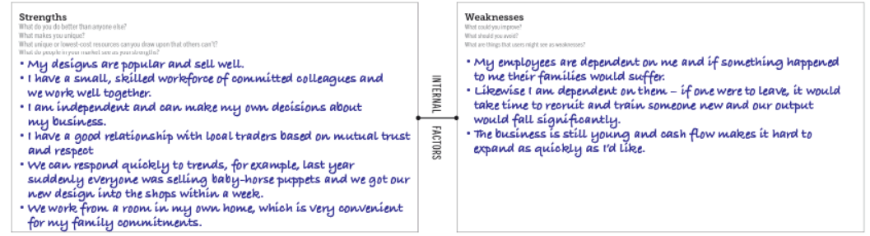
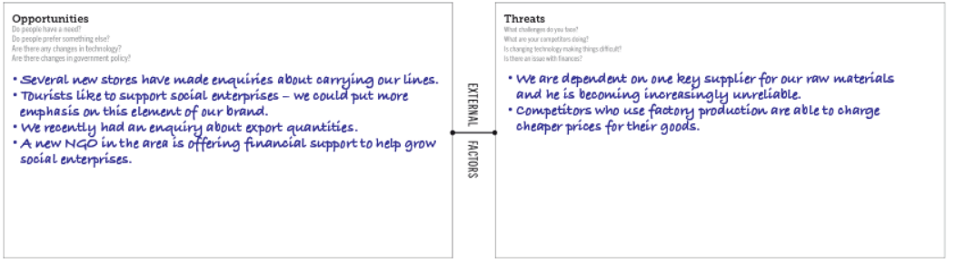
Activity three
Looking at the case study above, including Syed’s SWOT analysis, imagine you are helping Syed make his decision. What points would you highlight? Would you recommend him to sell to Muhammad? Make some notes in answer to this question below.
My answer to help students
Syed has provided some interesting information in his SWOT analysis. By taking a realistic look at his business as it is, he can decide what is most likely to make sense for its future. There’s no absolute right or wrong here (there rarely is in this sort of decision-making), but based on the information given I would advise Syed not to sell. These are the key points I would highlight:
- Syed has a lot of strengths, mainly based on the very fact that the organisation is small and under his management.
- Being dependent on one supplier is always a risk, especially now they are becoming unreliable. However, there’s no reason he couldn’t identify other suppliers and shop around to get a good deal and spread the risk by regularly using two or three.
- Syed has said that cash flow is a weakness that stops him from expanding. It sounds like now would be a great time to explore the financial support from the new NGO, as this would enable him to respond to some of the other opportunities (new shops and the potential for export) at his own pace and under his control.
- If he expands, perhaps he could take on some new employees part time? If he has, say, four employees who work half time rather than two who work full time, he has spread the risk of his dependency – if someone is ill or leaves, one or more of the others might be able to increase their hours.
- If he agrees to Muhammad’s offer, he will lose his independence and have to commute to a different workplace. Will the people he works with be able to commute, or in practical terms will this mean they become unemployed (and how might he feel about that)? More people will see and buy his designs, but will his name or mark be on them?
- What if he explores the opportunities for expansion that the SWOT analysis has highlighted, and then considers whether the offer looks tempting?
Finally, I would perhaps suggest that this isn’t a yes or no decision, and there might be a way that Syed could maintain all his strengths but still work in partnership with Muhammad. He could create some designs especially for Muhammad’s factory, and/or draw on some of his resources in exchange for design expertise. At this point, a SWOT analysis of the potential partnership could be a useful decision-making tool.

