Visual Studies (Studio day) 8th oct
Whole group

Distorting and breaking up an image
Making Books

Finding ways to make reimagine your imagery/ primary research is a vital step to making new discoveries as designers. As you work through these introductory sessions you are beginning to develop the seed of a potential idea. As discussed in the module briefing these are not finished and final pieces but ways to consider working and develop at the design and making stage. Today is about breaking up, distorting your image and applying it in different ways.

Starting with the pre-cut strips of paper, bring them back together to form a sheet.
Secure with tape or gum strip on a drawing board.
Plot your imagery across the joined sheets.
- For your first drawing: Use Indian ink and black pens begin to explore the imagery, through tonal variations and pattern.
- For the second drawing: Use colour ink and pen to explore the imagery, through tonal variations and pattern.
- Small groups will be making some quick books on rotation throughout the session. Using some of the painted strips will be ideal to make the pages, alongside add ins and fold outs of additional papers and drawings.

Both methods are a good way to force the hand when breaking up an image. Remember we are gathering visual imagery to feed design and the next stage.

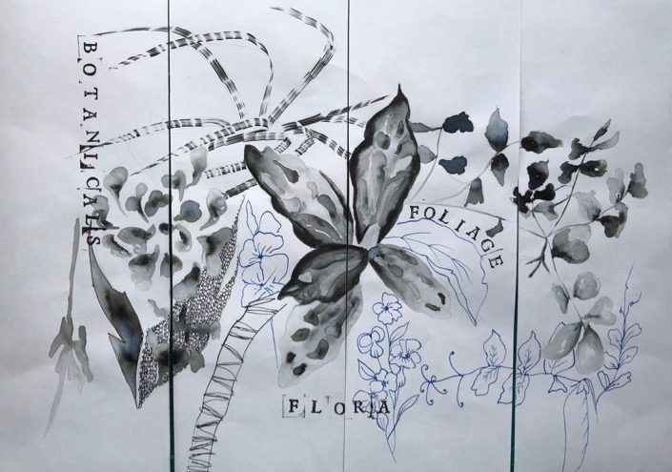

Good Books for inspiration…
Making Books: a guide to making handcrafted books, Simon Goode.
Bound: 15 beautiful bookbinding projects, Rachel Hazell.
How to Make Books: Cut and stitch your way to a one of a kind book, Esther, K Smith.

