Reflective Account of St Fagans
This reflective account is about my visit to Saint Fagans, the National Museum of Wales.
When I first arrived at Saint Fagans I was greeted with this grey, lifeless 1970s style building, however, when I entered this almost brutalist monolith I found a pleasant modern interior. After being talked to by my lecturer, my first visit was to the gallery, this housed hundreds of artifacts throughout Welsh history. I was interested to find grave markers from Strata Florida Abbey in Ceredigion, I found this interesting as this was where I had visited last week with the university. There were many other artifacts that I found intriguing such as Bones from a Neolithic Tomb in Mid Wales that dates from around 3700 BC, as well as the different ways that people have commemorated deceased loved ones such as using decorative plates and shells. It was also interesting to find artifacts of Welsh Sport such as the shirts worn by rugby players from the 1999 Rugby World Cup, which was hosted here in the United Kingdom. Other artifacts of Welsh Sport include hats and balls used in Rugby in the early 20th century. Overall, I found the gallery to be fascinating with its hundreds of artifacts spanning thousands of years and though all aspects of Welsh life. However, I was a bit disappointed that I was unable to access the other part of the gallery, but this was due to a burglary a week prior to my arrival, where Welsh gold artifacts were stolen.
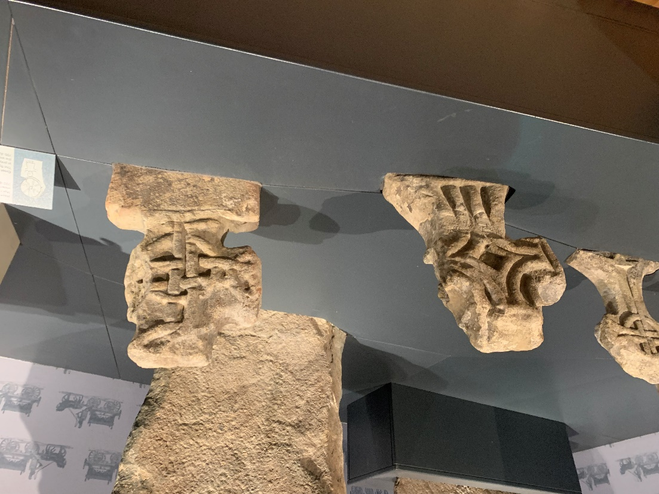
Grave Markers from Strata Florida Abbey
After visiting the gallery, I walked to an area which housed old shops, the Vulcan Hotel and the workmen’s institute. From prior research I found out that the Vulcan Hotel had come from Cardiff and was first registered as an Ale House in 1853, I had also found out that the interior of the Vulcan Hotel is set in 1915 after major renovations were made to the building. The interior is also set in 1915 as the Museum were able to interview the daughter of the landlord that ran the Vulcan Hotel in 1915. I then travelled to the Workmen’s institute, which was opposite the Vulcan Hotel. Stepping into the Workmen’s institute was like walking into the early 20th century, each room was like stepping into a time capsule, perfectly preserved in the early 1900s. In one room there was old newspaper articles from the time that were laid out so that people could read them. When I went upstairs there was a large hall with a film playing, this film explained the history of the building and its removal and relocation process from Oakdale, near Caerphilly, to the National Museum of Wales in Cardiff.
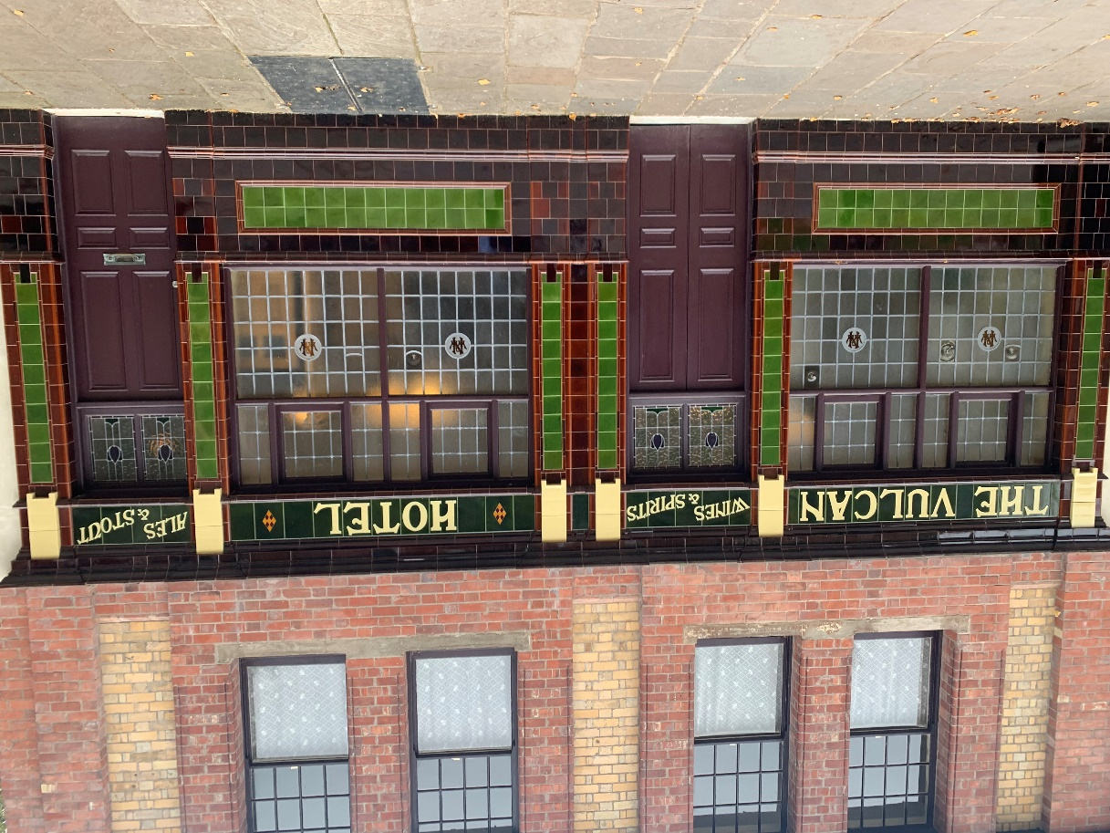
The Vulcan Hotel

I doubled back on myself after visiting the Workmen’s institute to visit a thatched circular stone building that was situated just off of the main path. I learnt from an information board outside the building that it was called the Cockpit and had been used for cock fighting until its abolition in the mid 1800s. Walking into the building was both interesting and a bit disappointing at the same time, as on the one hand it was interesting to see how the cock fighting would have been laid out with a circular raised section in the middle where the cocks would be fighting and the stands around the outside. However, on the other hand, I found that it was a bit disappointing as there wasn’t much to see inside.
I continued to double back on myself and walked past the 1970s monolith towards St Fagans castle. After walking out from the tunnel I was surprised to see a vast manmade landscape. When walking into St Fagans I was amazed by the luxury that I saw, the rooms were full of wood, leather and patterned carpet. In one room there is a pair of antlers hanging above the door as a symbol of wealth. From prior research I had learned that the castle is set in the late 1800s to the early 1900s as the father of the Earl of Plymouth had lived here during this period. The furnishings throughout the castle showed the immense wealth that the father of the Earl of Plymouth had. The upstairs part to St Fagans castle was unfortunately closed due to work and renovations.
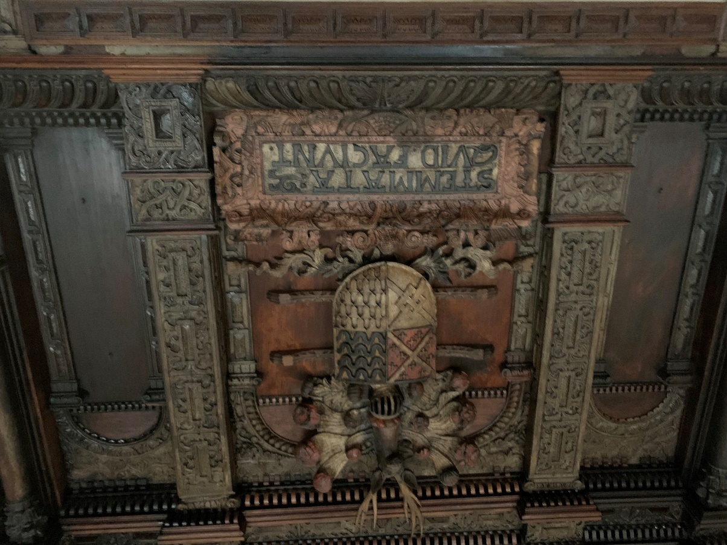
Woodwork Coat of Arms from St Fagans Castle

I was also intrigued by the difference between the English part of the National Museum of Wales and the Welsh part. I found that the museum portrayed Welsh history as very rural, working class, and an interconnected community, whereas the English part of the museum was portrayed as wealthy and luxurious.
After visiting the castle slowly walked through the beautifully landscaped gardens and travelled back to the Welsh part of the museum. I then walked to what I discovered to be my favourite part of the museum, this was a row of terraced houses each one set in a different period of time starting with the early 1800s and ending with the mid 1980s. I discovered this to be my favourite part of the museum as it is an interactive experience of living conditions of people through time. There was also a prefab house just around the corner from these terraced houses but I was disappointed to find out that I was unable to go inside.
Overall, my visit to St Fagans, the National Museum of Wales, was amazing and intriguing. It shows all aspects of Welsh life as well as giving the history of Welsh life in an interactive form. I discovered Welsh history in a way I never thought I would. It was one of the best visits I have ever had and there were very few disappointments at the museum.

Bibliography

- Amgueddfa Cymru, St Fagans National Museum of History, 2025, <https://museum.wales/stfagans/>, [Accessed: 24th October 2025]

Authors Own
Amgueddfa Cymru, St Fagans National Museum of History, 2025, <https://museum.wales/stfagans/>, [Accessed: 24th October 2025]
Ibid: Amgueddfa Cymru, St Fagans National Museum of History, 2025, <https://museum.wales/stfagans/>, [Accessed: 24th October 2025]
Authors Own
Ibid: Amgueddfa Cymru, St Fagans National Museum of History, 2025, <https://museum.wales/stfagans/>, [Accessed: 24th October 2025]
Authors Own

