INTRODUCTION TO DATA BASE CONCEPTS.

STUDENT DETAILS.
NAME: ALBERT BOADI
STUDENT ID: 2517968
MODULE: DATABASE SYSTEM (LEVEL 4)
LECTURE: SADHANA JHA
Table of Contents:
Student details
Table of contents
Introduction
Scenario analysis
Entity relationship diagram (ERD)
Data structure design
Normalization (up to third normal form)
Sample data
Queries
Forms and reports
Validation and testing
Reflection
Conclusion
References
Appendices

3. Introduction.
3.1 Overview

AutoPark Management System is a city-wide parking service responsible for managing multiple parking locations. The current manual system used by the organisation has created several operational problems, including misplaced records, duplicate information, inaccurate payment tracking, and inefficient allocation of parking spaces. These issues reduce the organisation’s ability to manage parking facilities effectively and provide a good customer experience.
To overcome these challenges, AutoPark Management System intends to implement a centralised database using Microsoft Access. The database will store and manage information relating to customers, vehicles, parking sites, parking slots, bookings, and payment transactions. By automating these processes, the organisation will improve data accuracy, reduce administrative workload, and generate reports that support management decision-making.

3.2 Purpose of the Database.
The purpose of the proposed database is to provide an efficient and reliable information management system that:
● Stores customer information securely.
● Records vehicle ownership details.
● Manages parking locations and available parking spaces.
● Tracks vehicle bookings and parking history.
● Records payment transactions.
● Produces reports showing occupancy rates, revenue, and customer activity.
● Maintains data integrity by reducing redundancy through database normalisation.
The implementation of this database will improve operational efficiency while ensuring correct and consistent information across all parking sites.

4. Scenario Analysis.
4.1 Business Requirements

Based on the scenario, the database must allow the company to:
● Register customers.
● Store vehicle information.
● Manage several parking sites.
● Record every parking space.
● Create parking bookings.
● Process customer payments.
● Monitor parking occupancy.
● Generate management reports.
● Prevent duplicate records.
● Ensure exact data through relationships and constraints.

4.2 Entity Identification.

The following entities have been found.
Customer
Stores information about vehicle owners.
Attributes
● CustomerID (Primary Key)
● FirstName
● LastName
● PhoneNumber
● Email
● Address

Vehicle
Stores information about customer vehicles.
Attributes
● VehicleID (Primary Key)
● RegistrationNumber
● VehicleMake
● VehicleModel
● VehicleColour
● CustomerID (Foreign Key)
Relationship:
One customer can own many vehicles.

ParkingSite
Stores information about each parking location.
Attributes
● SiteID (Primary Key)
● SiteName
● SiteAddress
● TotalSpaces

ParkingSlot
Stores information for every parking space.
Attributes
● SlotID (Primary Key)
● SlotNumber
● SlotType
● Status
● SiteID (Foreign Key)
Relationship:
One parking site holds many parking slots.

Booking
Records every parking reservation.
Attributes
● BookingID (Primary Key)
● BookingDate
● StartTime
● EndTime
● VehicleID (Foreign Key)
● SlotID (Foreign Key)
Relationship:
A booking belongs to one vehicle and one parking slot.

Payment
Stores customer payment information.
Attributes
● PaymentID (Primary Key)
● BookingID (Foreign Key)
● PaymentDate
● Amount
● PaymentMethod
● PaymentStatus
Relationship:
Each booking has one payment record.

4.3 Entity Relationships.
Relationship | Cardinality
Customer-vehicle | One-to-many
Parking site- Parking slot | One-to-many
Vehicle-booking | One-to-many
Parking slot-booking | One-to-many
Booking-payment | One-to-one

The relationships ensure the database accurately represent real-world business operations while supporting references integrity.

5. Entity Relationship Diagram (ERD).
5.1 ERD Overview

The Entity Relationship Diagram (ERD) stands for the database structure for the AutoPark Management System. It shows the main entities, their attributes, primary keys (PK), foreign keys (FK), and the relationships between tables.
The ERD has been designed using a relational database approach to ensure data is organised efficiently and follows database design principles. Each entity stands for a real-world object within the parking management system, while relationships define how information is connected between entities.

5.2 AutoPark Management System ERD.

+------------------------+
| CUSTOMER |
+------------------------+
| PK CustomerID
| FirstName
| LastName
| PhoneNumber
| Email
| Address
+------------------------+
|
| 1: Many
|
|
+------------------------+
| VEHICLE |
+------------------------+
| PK VehicleID |
| RegistrationNumber |
| VehicleMake |
| VehicleModel |
| VehicleColour |
| FK CustomerID |
+------------------------+
|
| 1: Many
|
|
+------------------------+
| BOOKING |
+------------------------+
| PK BookingID |
| BookingDate |
| StartTime |
| EndTime |
| FK VehicleID |
| FK SlotID |
+------------------------+
|
| 1: 1
|
|
+------------------------+
| PAYMENT |
+------------------------+
| PK PaymentID |
| PaymentDate |
| Amount |
| PaymentMethod |
| PaymentStatus |
| FK BookingID |
+------------------------+

+------------------------+
| PARKING_SITE |
+------------------------+
| PK SiteID |
| SiteName |
| SiteAddress |
| TotalSpaces |
+------------------------+
|
| 1: Many
|
|
+------------------------+
| PARKING_SLOT |
+------------------------+
| PK SlotID |
| SlotNumber |
| SlotType |
| Status |
| FK SiteID |
+------------------------+
|
| 1: Many
|
|
BOOKING

5.3 Entity Relationship Description.

Customer and Vehicle Relationship
Relationship: One-to-Many (1:M)
A single customer can own multiple vehicles, but each vehicle belongs to only one registered customer.
Example:
● Customer 001 → Vehicle A, Vehicle B
● Vehicle A → Customer 001
Foreign Key:
Vehicle.CustomerID references Customer.CustomerID

Parking Site and Parking Slot Relationship
Relationship: One-to-Many (1:M)
A parking site holds multiple parking slots. Each parking slot belongs to only one parking site.
Example:
● Site 001 → Slot 1, Slot 2, Slot 3
● Slot 1 → Site 001
Foreign Key:
ParkingSlot.SiteID references ParkingSite.SiteID

Vehicle and Booking Relationship
Relationship: One-to-Many (1:M)
A vehicle can have multiple parking bookings over time. Each booking is associated with one vehicle.
Example:
● Vehicle AB12CDE → Booking 001, Booking 002
Foreign Key:
Booking.VehicleID references Vehicle.VehicleID

Parking Slot and Booking Relationship
Relationship: One-to-Many (1:M)
A parking slot can appear in many bookings over time, but each booking uses one specific parking slot.
Example:
● Slot 101 → Booking 001, Booking 005
Foreign Key:
Booking.SlotID references ParkingSlot.SlotID

Booking and Payment Relationship
Relationship: One-to-One (1:1)
Each booking must have one payment record, and each payment belongs to one booking.
Example:
● Booking 001 → Payment 001
Foreign Key:
Payment.BookingID references Booking.BookingID

5.4 Cardinality summary.
Relationship | Cardinality | Explanation
Customer-vehicle | 1:M | One customer can own many vehicle
Parking site-parking sot | 1:M | One site contains many booking slot
Vehicle- booking | 1:M | One vehicle can create many bookings
Parking slot- booking | 1:M | One slot can be booked many times
Booking- payment | 1:1 | One booking has one payment

5.5 ERD Design Justification.

The ERD design reduces data duplication and improves database efficiency by separating information into related tables. Customer information is stored independently from vehicle information, while booking records connect vehicles with available parking spaces.

Primary keys are used to uniquely name every record, while foreign keys show relationships between entities and support referential integrity. This prevents invalid data entry, such as creating a booking for a vehicle or parking slot that does not exist.

The ERD also supports future expansion of the AutoPark system by allowing more features such as membership plans, penalty charges, employee management, and automated payment processing without redesigning the entire database.

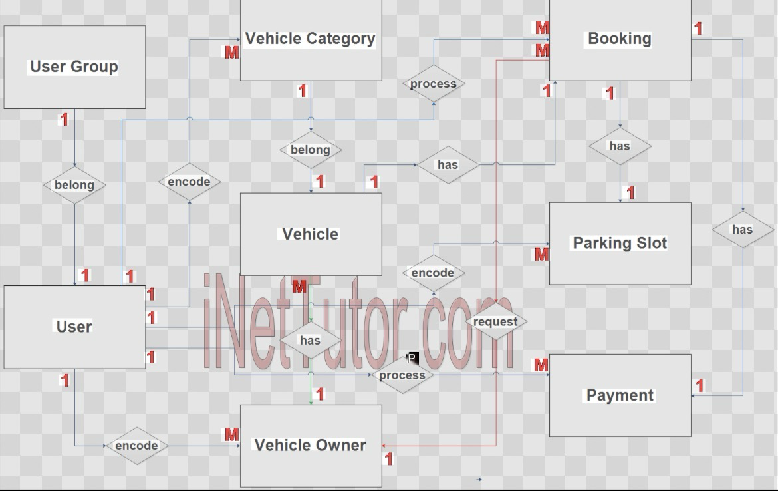

6. Query Development.
The database contains tables such as customers, vehicle, parking site, parking slot and payment. The following query demonstrates how the system can be used.
QUERY 1-Display all activities booking
Purpose: shows vehicle that are currently parked.
SQL
SELECT Bookings.BookingID,
Customers.FullName,
Vehicles.RegistrationNumber,
ParkingSlots.SlotNumber,
Bookings.EntryTime
FROM ((Bookings
INNER JOIN Customers ON Bookings.CustomerID = Customers.CustomerID)
INNER JOIN Vehicles ON Bookings.VehicleID = Vehicles.VehicleID)
INNER JOIN ParkingSlots ON Bookings.SlotID = ParkingSlots.SlotID
WHERE Bookings.ExitTime IS NULL;

Expected Results: list all vehicle currently occupied a parking space.

Query 2-find available parking slot
SQL
SELECT SlotNumber
FROM ParkingSlots
WHERE Status = "Available";

Expected result: Display all free parking spaces

Query 3-Total payment received
SQL
SELECT Sum (AmountPaid) AS TotalRevenue
FROM Payments;

Expected result: show the total income generated

Query 4-customer payment history.
SQL
SELECT Customers.FullName,
Payments.PaymentDate,
Payments.AmountPaid
FROM Customers
INNER JOIN Payments
ON Customers.CustomerID = Payments.CustomerID;

Expected result: display each customer payment history

Query 5- vehicle by parking site
SQL
SELECT Customers.FullName,
Payments.PaymentDate,
Payments.AmountPaid
FROM Customers
INNER JOIN Payments
ON Customers.CustomerID = Payments.CustomerID;

Expected result: shows which vehicle are parked at each site.

7. Validation and testing.
The database was tested to ensure it meets the system requirements.

Test | Expected result | Actual result | Status
Added new customer | Customer record saves successfully | Customer added | Pass
Add a vehicle | Vehicle linked to customer | Vehicle stored correctly | Pass
Creat a booking | Booking created worth valid customer, vehicle and slot | Booking created | Pass
Record a payment | Payment saved and linked | Payment recorded | Pass
View available parking slot | Only available slot displayed | Correct slot shown | Pass
Generate revenue query | Total payment calculated correctly | Correct total display | Pass
Attempts booking with invalid customer id | Database rejects invalid records | Error message displayed | Pass

Testing Summary.
The database was tested using Microsoft Access. All tables, relationships, forms, and queries worked as expected. Referential integrity prevented invalid records from being entered, ensuring data accuracy. The sample data produced the correct outputs, demonstrating that the AutoPark Management System satisfies the functional requirements. Future improvements could include automated parking fee calculation, online payment integration, and real-time parking space updates.

