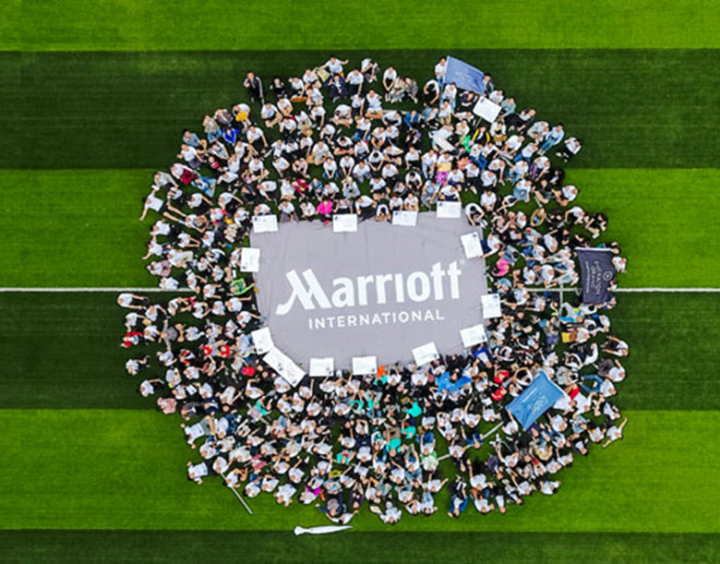  MArriott international  “The HR Officer’s Career Path at Marriott International” | Lecturer: Nandish Patel  Module: BMSW5102  Student: Andrei Alexandru Agopian (1905498)  Developing Relationships and Workplace Achievements  

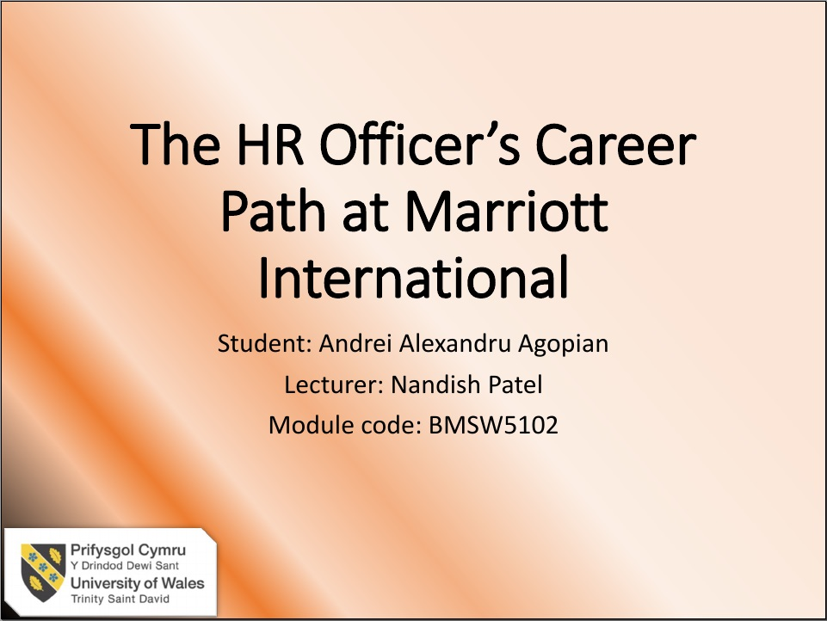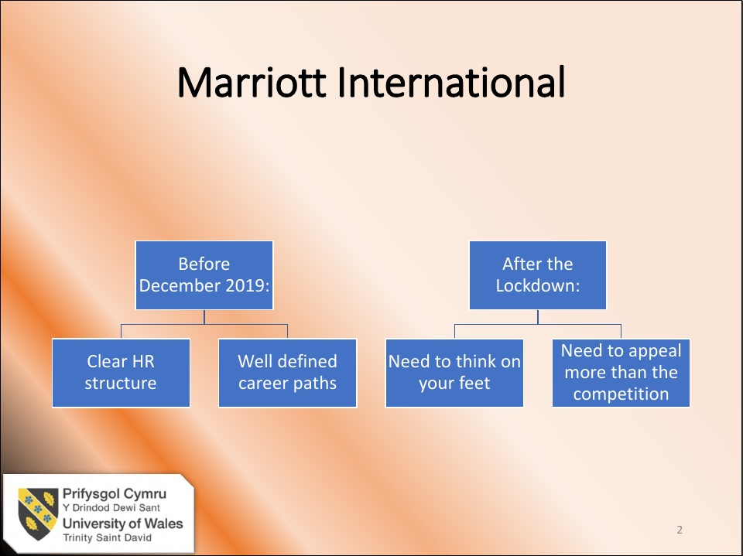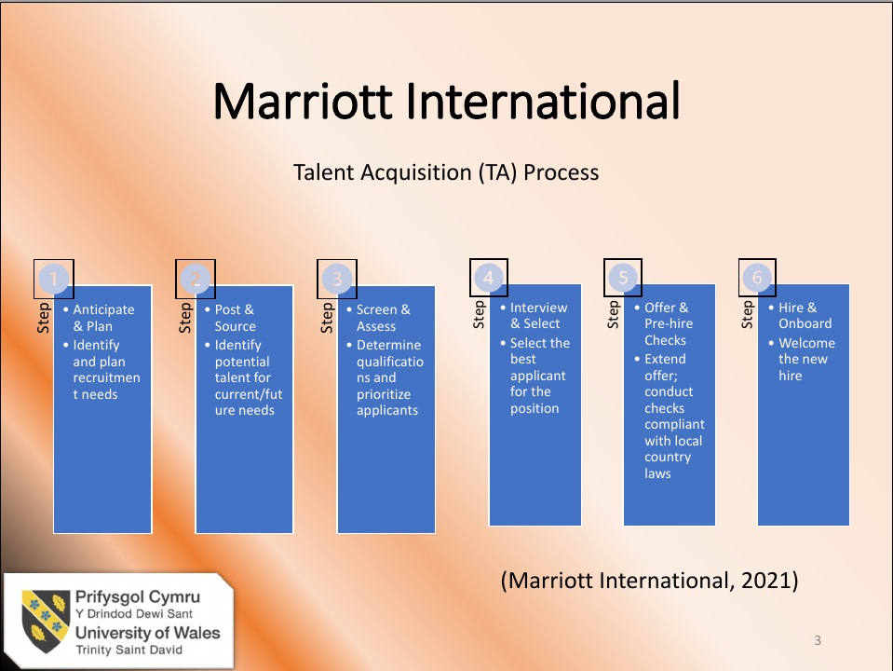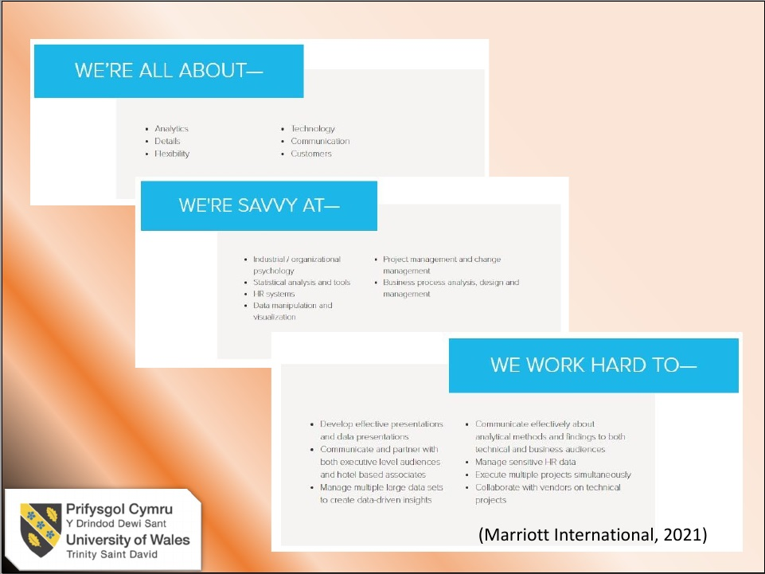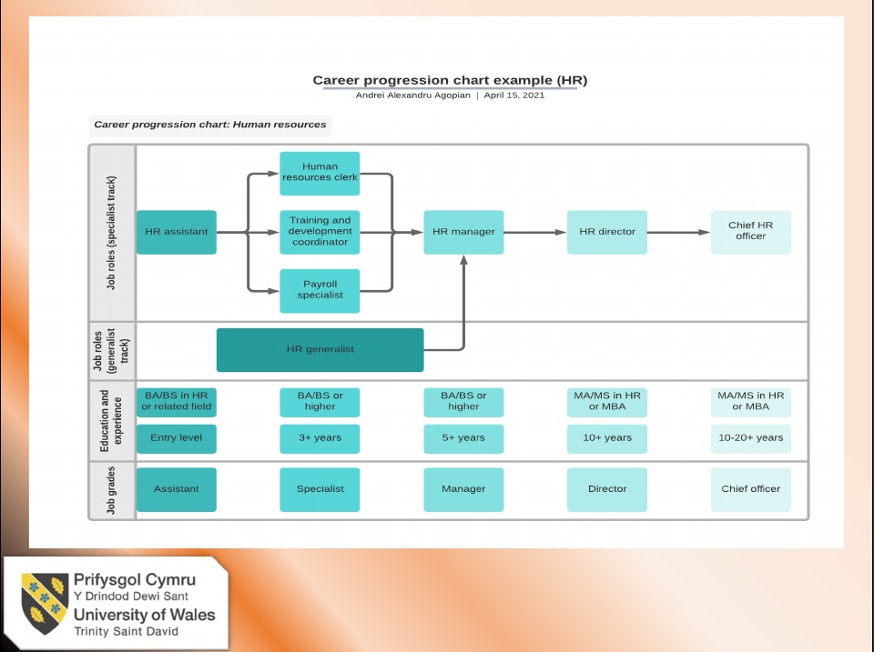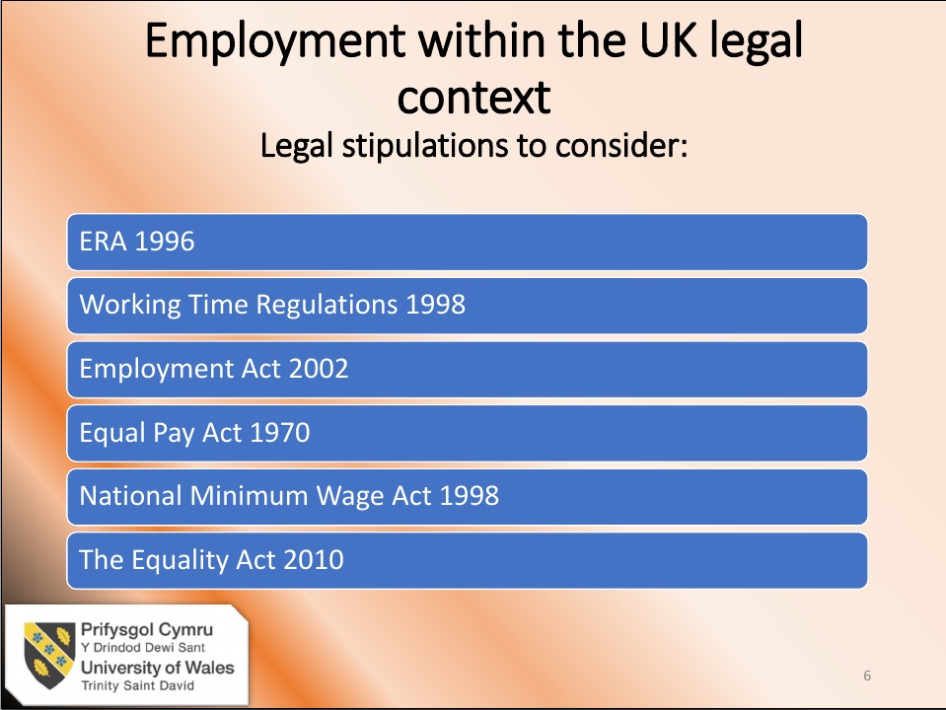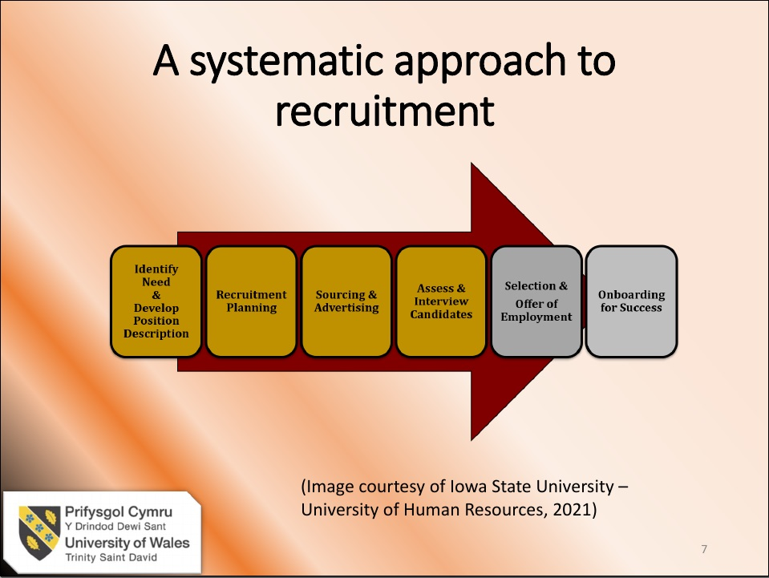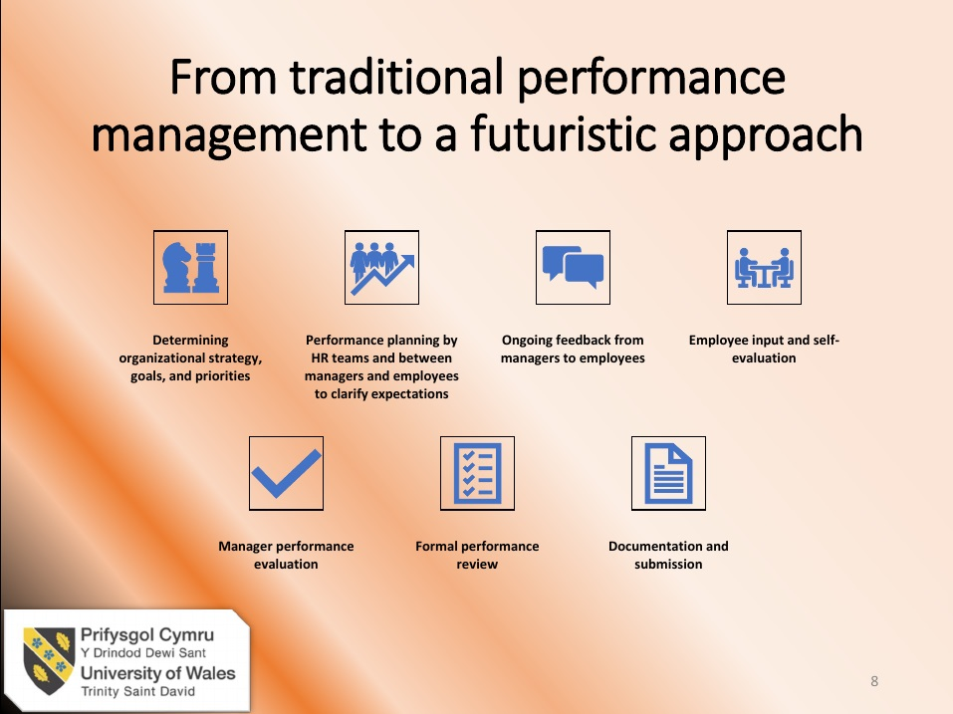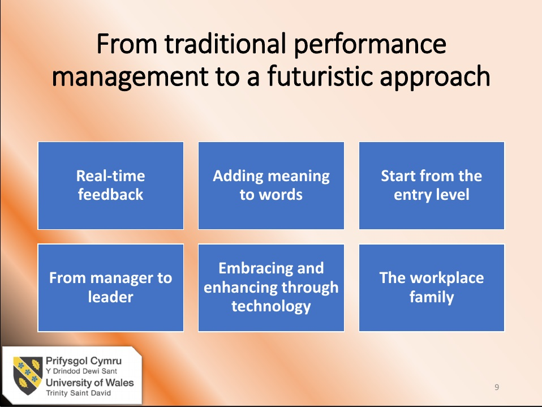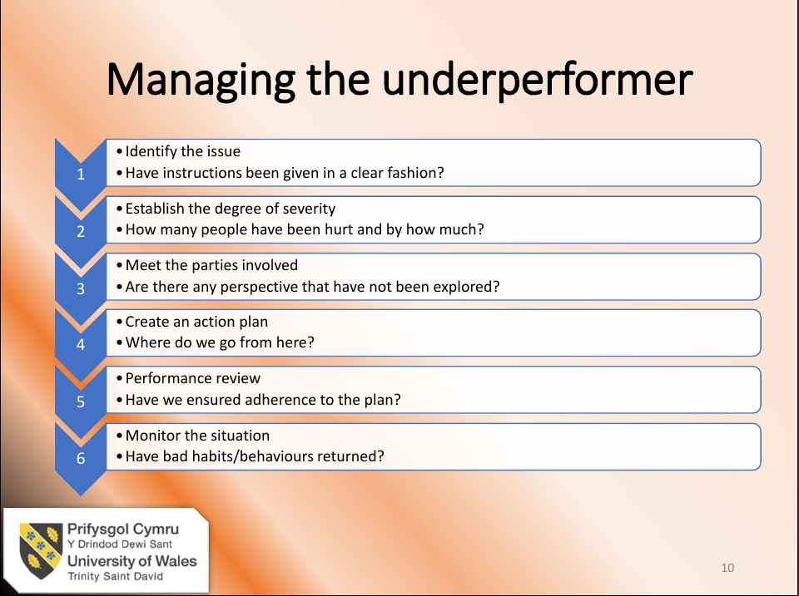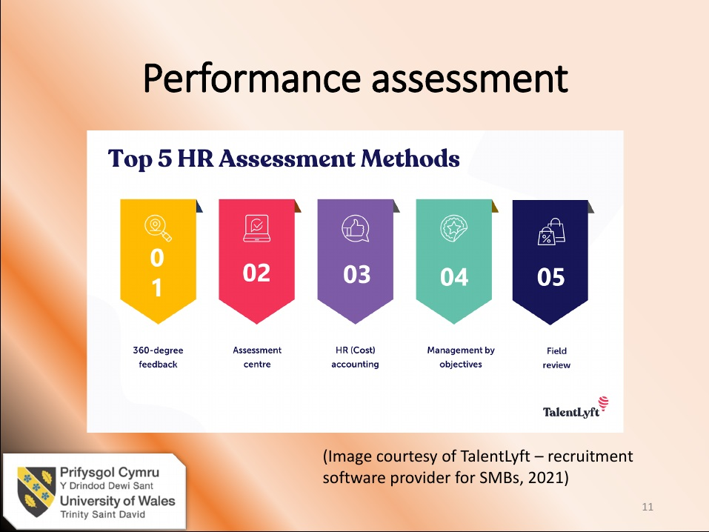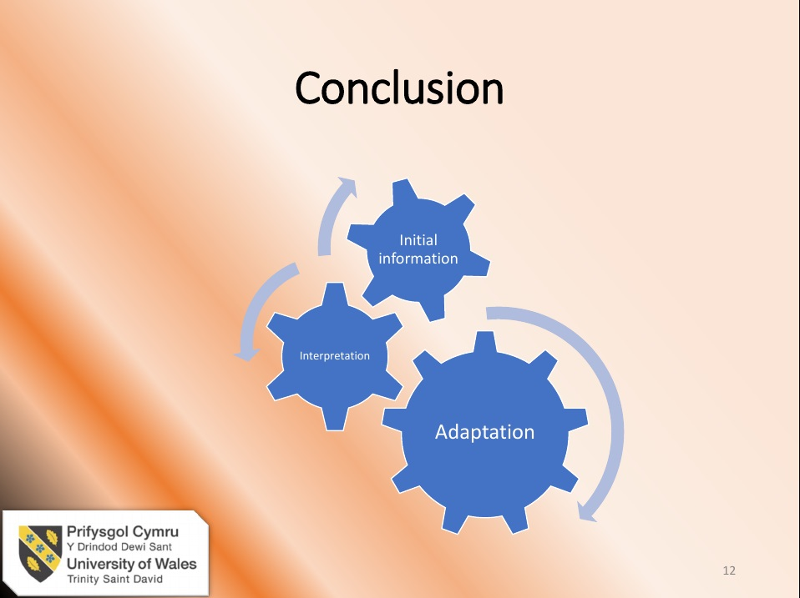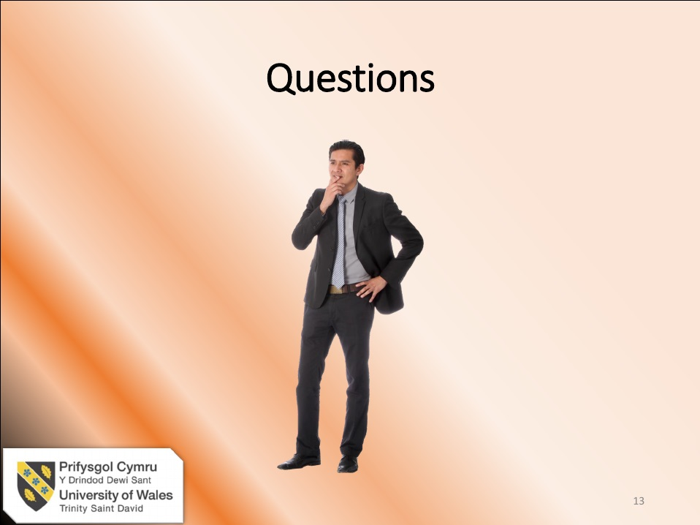

Speaker’s Notes:

Slide 1 and 2, page 1
Good morning esteemed members of the board and thank you for granting me the opportunity to conduct this presentation. Rest assured, all my effort has been invested in delivering a product both informational, as well as dynamic.
I would like to start off by highlighting the fact that we are at a turning point in our history and any future planning must take in account how our society has been shaped by events outside our sphere of control. Of course, I am referring here to Covid19, the lockdowns, the drastic reduction in travel, and the negative financial outcome.
We are here today to see what those changes have meant for the HR aspect of Marriott International and whether we can position ourselves better for the future.

Slide 3 and 4, page 2
In slide 3 we see how the Talent Acquisition process works within our company and from there we can extrapolate the main characteristics a suitable HR officer should have.
Going back to previous statements relating to the duality of the environment we are in, historically, our focus was on an implementer and developer. An HR professional was an agile individual who closely interacted with other departments, a person with a keen sense of health and safety and equality in the workplace. Their activities spanned from preparing handbooks and onboarding packages to developing teaching tools, policies and all that is relevant to the normal daily operations. As explained in slide 4, we are all about: data gathering, technology, communication, and customers. We take pride in being able to provide insightful and attractive presentations, develop and manage projects, and maintaining HR systems. Moreover, we work hard to multitask and respect timelines (Kumar, 2010).
Based on our current framework, and as you can see from the page titled “Annex B” in your handout package, the distinguished panel, can form their opinions on my own performance within the company, and upon those, they can, hopefully, add more weight to my final recommendations.

Slide 5 and 6, page 3
Slide 5
Here we can see the traditional career path of a person inclined towards the human aspect of managing people. Most people will start off as an intern, and then slowly, work their way up the corporate ladder to achieve a director position. Perhaps, given enough time, one might even aspire to be an HR officer, also known as the VP of Human Resources.
However, the standard ladder might need to be rewritten: the need for cost-saving combined with an increased efficiency of the HR software available, will most definitely make certain positions redundant. What an owner must consider, however, is that a stable work environment still requires that certain functions are still completed optimally, things such as:
- Hiring and selecting staff
- Managing performance
- Providing and delivering training materials
- Ensure continuation in fulfilling job roles
- Looking after compensation and benefits
- Maintaining and operating relevant software
- Providing accurate and relevant data to ensure decreased decision time.
Perhaps the main takeaway here in the Covid context, is the need for constant data gathering and swift adaptation to a far more fluid environment than in the past. Our job is to identify a training need before it arises and to ensure a low attrition level by creating a familial environment for the worker in lieu of the ability to sustain financial incentives (Dundon & Wilkinson, 2020).

Slide 6
Furthermore, we must take in consideration the legal aspect surrounding the work environment. Starting with the ERA – Employment Rights Act of 1996, Working Time Regulations 1998, and the Employment Act of 2002, we clearly see the need for a confident and up to date HR officer in the workplace – by protecting the employee, we ultimately protect the employer. Of course, when it comes to remuneration, we have the Equal Pay Act 1970 and the National Minimum Wage Act of 1998.

Slide 7, page 4
Here we have a representation of the classic recruitment process, be that for Marriott or for most other organization. As we can see, it starts with information collection: was a need for new staff created by a departure or a change in the volume of work? The main concern here is to thread carefully despite the stringent times we live in – we mustn’t make haste to cover a position that has become redundant, while at the same time, faced with budgetary pressure, avoid hiring someone which may turn out to be the person to bring in much needed revenue. The next stage is recruitment planning – here we look at what could attract talent to us and motivation factors. A strong emphasis on our core values is needed – we must put out the right message. This leads us to sourcing and advertising where we seek the best answer for promoting our job advert and ensuring a diverse and rich pool of people. Once these steps are completed, it is time to interview the candidates. This is one of the stages which best highlights the role of the HR officer through the need to design interview frameworks and evaluate accurately and efficiently the results. This then blends into the next stage of providing an offer of employment to a successful candidate, followed by the onboarding process (Boella & Gross-Turner, 2013).

Slide 8, page 4
Slide 9, page 5
Slide 8 is an illustration of the traditional stages in performance management as initially determining organizational strategy, followed by performance planning, feedback, encouragement of initiative, manager duties, formal performance review, and finally, documentation of the process.
Slide 9 on the other hand, paves the way for the future where there is a need for real-time feedback, meaningful conversation (a deeper focus on employee self-actualization), a bottom-up approach, better trained managers, updating systems and ensuring staff embrace technology, and emphasis on the workplace family (Carnall, 1990).

Slide 10, page 5
Here we look at how to manage the underperformer and first and foremost, we look at identifying the issue. Then we establish the degree of severity and explore all the perspectives of the matter, followed by the creation of an action plan. All this is supplemented by a performance review and periodical monitoring of the employee discussed.

Slide 11, page 6
Slide 11 compliments Slide 10, by showcasing the most used – and as such, voted most suitable – performance assessments methods.

Slide 12, page 6
In conclusion, our recommendation leans towards a focus on the employee and fulfilling their desires. In an environment that profiles itself to be highly volatile, having reliable and adaptable associates outweighs rigorous standard operating procedures (Beckhard & Harris, 1987). If we were to allow our business to have the same revolving door as the hotel entrance, we would end up with an overworked and insufficient HR department, and most likely, failing to adhere to government guidelines (King, 2009).

References

Beckhard , R. & Harris, R., 1987. Organisational Transitions: Managing Complex Change. Wokingham: Addison-Wesley.

Bertalanffy, L. v., 1951. Problems of General Systems Theory : A New Approach to the Unity of Science. National Library of Medicine, 23(4), pp. 302-312.

Boella, M. J. & Gross-Turner, S., 2013. Human Resource Management in the Hospitality Industry. London: Routledge.

Carnall, C. A., 1990. Managing Change in Organisations. London: Pearson Education Limited.

Connelly, G., 2000. Careers in Human Resource Management. London: Kogan Page.

Dundon, T. & Wilkinson, A., 2020. Case Studies in Work, Employment and Human Resource
Management. Cheltenham: Edward Elgar Publishing.

Fine, S. A. & Cronshaw, S. F., 1999. Functional Job Analysis. Abingdon: Taylor & Francis.

Handy, C., 1993. Understanding Organizations. 4th ed. New York: Oxford University Press.

Kast, F., Kast, F. E. & Rosenzweig, J. E., 1985. Organization and Management. New York : McGraw-Hill.

King, P. W., 2009. Climbing Maslow's Pyramid. Kibworth: Troubador Publishing Limited.

Kotter, J. P. & Cohen, D. S., 2012. The Heart of Change. 5th ed. Boston: Harvard Business Review Press.

Kumar, R., 2010. Human Resource Management. Delhi: I.K. International Publishing House Pvt. Limited.

Luhman, N., 1995. Social Systems. 6th ed. Palo Alto: Stanford University Press.

Maslow, A. H., 2019. A Theory of Human Motivation. New Delhi: General Press.

Mayo, E., 1933. The human problems of an industrial civilisation. New York: Macmillan.

Miller, E. J. & Rice , A. K., 1967. Systems of Organisation. London: Tavistock Publications.

Schein, E. H. & Bennis, W. G., 1965. Personal and Organisational Change Through Group Methods: The Laboratory Approach. New York: John Wiley & Sons.

Taylor, F. W., 2016. The Principles of Scientific Management. New York: Cosimo Inc..

Waters, T. & Waters, D., 2015. Weber's Rationalism and Modern Society. New York: Palgrave Macmillan .

Appendix

Appendix_B

