
Strategic Management
Case study of eBay

2021
Matthew Kelleher-1710425
LCMB7003- Dr Gladius Kulothungan

Contents
1.0 Introduction to Strategic Management 3
1.1 Background of eBay 3
1.2 eBay Key Success Factors 4
2.0 PESTLE Analysis of eBay 4
Political 4
Economic 4
Social/Cultural 5
Technology 5
Legal 5
Environment 6
3.0 Porter’s five-force analysis of eBay 6
Bargaining power of buyers: High 6
Bargaining power of suppliers: Low 7
Threat of new entrants: Moderate 7
Threat of substitutes: low 7
Competitive rivalry in the industry: Medium to high 7
4.0 Porter’s Value Chain Analysis of eBay 8
Inbound Logistic 8
Operations 8
Outbound Logistic 9
Marketing and Sales 9
Service 9
Procurement 9
Technology Development 9
Human Resource Management (HRM) 9
Firm Infrastructure 9
4.1 SWOT Analysis of eBay 10
Strength 10
Weaknesses 10
Opportunities 11
Threats 11
5.0 McKinsey 7’s Model 11
Hard Elements 11
Strategy 11
Systems 11
Soft Elements 12
Skills 12
Staff 12
Style 12
Shared Value 12
6.0 Porters Generic Strategies of eBay 12
7.0 Ansoff matrix of eBay 13
Market Penetration 14
Market Development 14
Product development 14
Diversification 14
8.0 Green strategy and Corporate Social Responsibility 14
9.0 Conclusion 15
References 16

1.0 Introduction to Strategic Management
For organisations to remain competitive in today’s environment which is unstable due to issues such as coronavirus, managers of the company must implement strategic management (Teece, 2019). Strategic management is not only the set of actions and decisions of management which influence the performance in the long run of the organisation (Linden, 2021) but the protection of the organisation from serious mistakes and errors which are unnecessary and prevents economic devastations (Sicora, 2017). Strategic thinking should be encouraged by managers when managing due to the importance of the business process which helps improve the effectiveness of the organisational performance management (Teece, 2019). This is emphasised by (Mohammed, 2021) who claims, strategical thinking directs towards making decisions logically, understanding roles of power, importance in the change of organisational management and policies. In previous years, scholars have highlighted the importance of strategic thinking and how it is required at different stages of the company due to it providing the means to explore complex situations which allows the company to gain an understanding in-depth alongside defining actions the company can focus on to achieve goals that have been set (Smriti et al, 2021; Teece, 2019; Nwanekezie et al, 2021). In order for the organisation to develop in a timely response against challenges in the business environment, strategic thinking is needed. According to Nwanekezie et al (2021) and Teece (2019), the process of strategic management involves conducting environmental scanning, strategic formulation, strategic implementation, also evaluation and control.
The purpose of this report is to conduct a strategic analysis of the central issues that eBay have encountered were dealt with. A demonstration of how eBay achieved a competitive advantage over competitors through strategic management and choices. Concepts, techniques, and theoretical frameworks such as PESTLE Analysis, Porter’s five-force analysis, Porter’s Value Chain, SWOT Analysis, McKinsey 7’s model and more will be used to highlight central issues eBay have encountered and demonstrate eBay’s competitive advantage.

Background of eBay
eBay is an e-commerce organisation that connects sellers and buyers through their marketplace. eBay categorise products through multiple categories, some of eBay’s major products are electronics, clothing, sporting goods, health and beauty, jewellery, video consoles and games, baby products, office equipment, collectables, antiques and more (Brynjolfsson et al, 2019). According to eBay (2020), StubHub was acquired by Viagogo in 2020 for the sum of $4.05b in cash, eBay also completed the transfer of their classified business to Adventia in 2021. eBay are a leading company in global commerce and through their marketplace platforms that allow millions of sellers and buyers to communicate and connect around the globe in 190 markets. eBay platforms consist of eBay online marketplace which can be accessed at www.ebay.co.uk and localised counterparts, these Include off-platform businesses in Japan, Turkey, and South Korea, also eBay’s mobile app. eBay platforms offer the user an online experience that can be accessed through laptops, desktops, tablets, smartphones, mobile app, and eBay application programme interfaces (Narang and Shankar, 2019). eBay platform offers sellers and buyers a variety of choices to sell or buy goods through different delivery formats, item condition, and listing formats (Mckie et al, 2018).
According to MarketLine (2021), for the FY2019, eBay reported $10.800m in revenues, this was an increase on the FY2018 of 0.5%. eBay FY2019 operations net margin was recorded at 16.5%, compared to FY2018, where the net margin was recorded at 23.5%. during the second quarter of 2020 eBay recorded revenues of $2,865m which was an increase over the year by 20.7%.

1.2 eBay Key Success Factors
eBay were the first movers in the e-commerce market online retail industry with their innovative pricing concept of auctions (Reinartz, 2018). Due to eBay pricing concept, buyers are able to determine the price they are willing to pay for the product. A main advantage for eBay is that the company does not rely on the prices of product or inventory. For example, eBay offer and provide the service and platform where individuals can choose if they would like to sale or buy products (Gregg and Parthasarathy, 2017). Due to eBay being an online company and business there is distinctive advantage on profits and growth as it can be accessed worldwide. Also, there are no fees that are hidden to the buyer, purchases can be made at no extra costs, and the site can be accessed by anyone that has an internet connection (Tu et al, 2019).
According to Shen (2020) eBay provide an environment for compelling trading between B2B, B2C, and C2C. Interactive software that is used by eBay which allows buyers and sellers to engage dynamically in business transactions which are not possible in convenient retail markets. eBay have progressed and improved the site and maintenance in recent years adding more categories and widening search criteria for business and customers to allocate and locate products alongside adding buy now features (Mezzanotti and Simcoe, 2019).

2.0 PESTLE Analysis of eBay
To analyse the external factors that can have an impact on eBay investments or projects, a PESTLE analysis will be implemented. PESTLE analysis is a strategic planning tool that is used by organisations as it provides a framework to understanding influences within the external business environment. Parameters in the external environment are clustered into six variable such as Political, Economic, Social, Technology, Legal and Environment (Christodoulou and Cullinane, 2019).

Political
In 2020, Digital Service Tax (DST) was introduced in the UK, US, and other parts of the world. This poses as a threat to eBay due to in the UK DST is charged at 2% on revenues over £25m (Gov.uk, 2021), this will result in lower profits, increased tax, and could also affect the revenue as individuals may find alternative marketplaces to sell products/services (Vella, 2019). However, eBay have stated to sellers and buyers that the company will pay the DST and not include this bill in new hidden fees, unlike competitors Amazon (Kunert, 2020).

Economic
At present, Global Gross Domestic Product has current dropped to approximately £85Bb due to the current and ongoing Coronavirus Pandemic which has critically wounded the economy but should grow to approximately £125b in 2026 as shown below (O’Neil, 2021). This poses as a threat to eBay due to lack of products and service produced means there will be less sellers selling new products/services. However, during the pandemic eBay showed a 13% to 18% on year to year (2019-2020) revenues sales, this was a growth from £2.75b to £2.8b (Fuscaldo, 2020).
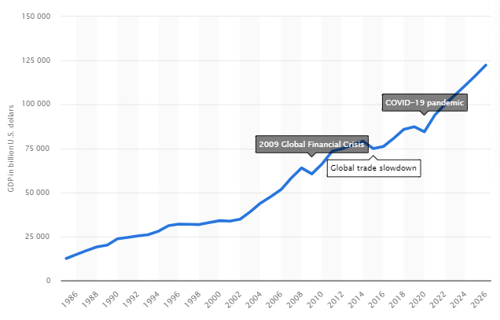
Global GDP from 1986-2006 (O’Neil, 2021)

Social/Cultural
During the current Coronavirus individuals buying behaviours have changed with more individuals shopping online rather than instore (Sharma and Jhamb, 2020). This poses as an opportunity for eBay due to individuals are using online retail and marketplaces to purchase products/services. eBay have recently improved their website to improve and enhance certain categories, so they are easier accessible for buyers/sellers. eBay have also added new features to its original revenue model where buyers can purchase at a fixed price or auction rather than just an auction marketplace (Hardy et al, 2018).

Technology
In the past decade, mobile phone devices have become more technically enhanced allowing individuals to access the internet from the palm of their hands. In recent years more individuals are using mobile devices rather than desktops/laptops to buy/sell. This can pose as a threat to eBay as buyers/sellers have access to multiple opposing companies. However, eBay have the opportunity to enhance their mobile app and stay connected with users/sellers at all times.
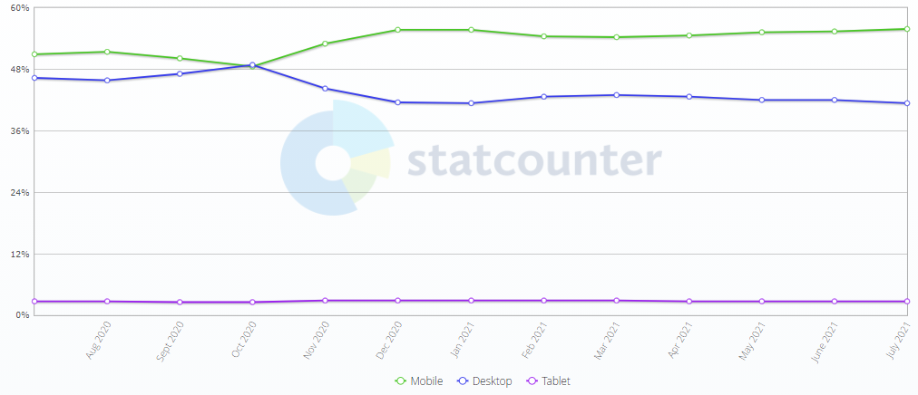
Mobile vs Desktop Vs Tablet sales worldwide (StatCounter, 2021).

Legal
Laws, rules, and regulations vary in each country and this can pose as a threat to eBay if these are not followed. E-commerce increasing in developing countries can lead to new regulations and litigations. For example, previously mentioned DST tax has been enacted and if eBay fail to pay, they will face legal consequences.

Environment
Individual’s environmental conservation interests have increased in the past decade with individuals preferring green and sustainable online retail marketplaces. This poses as an opportunity for eBay for several reasons, firstly, individuals do not have to travel to buy/sell products as they are all in the one marketplace and get send through one trip meaning less emission and pollution. Secondly, buyers/sellers can purchase/sell used items that would be disposed of and affect the environment (eBay Inc, 2021).

3.0 Porter’s five-force analysis of eBay
To analyse the e-commerce and online retailer industry in which eBay operate a Porters Five Force Analysis (PFFA) will be implemented. According to Pervan et al (2021), PFFA is an analytical model used by companies to understand the influences within the industry that can affect competitive advantage and profits of the company, characteristics within the industry are primary determinants for performance. According to Sadq et al (2018), there are five basic factors which state influences of the competition in the industry which are: Competition in the industry, potential of new entries in the industry, power of suppliers, power of customers and threat of substitute product or service.

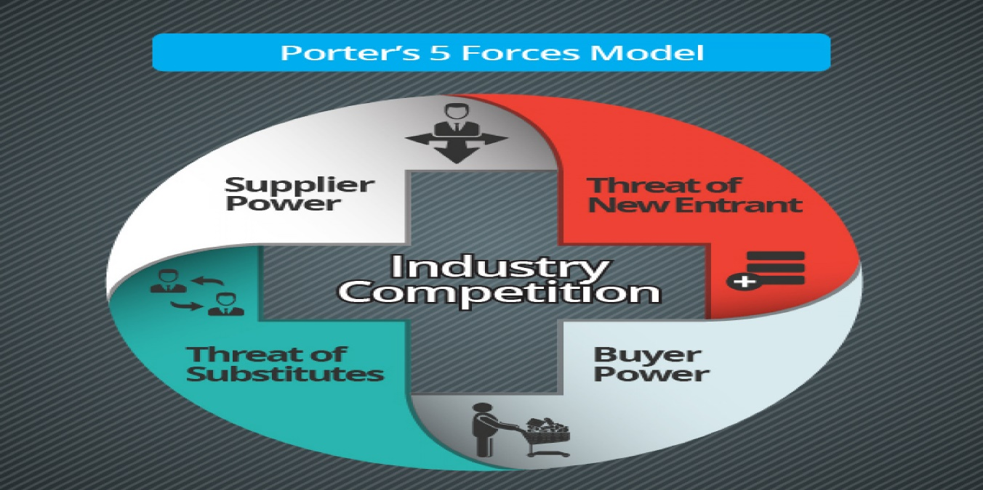
Porters five-force analysis (James, 2021).

Bargaining power of buyers: High
Bargain power of the buyers refers to the buyers/purchasers influence on the company. According to Ya’acob et al (2021), there are several ways buyers can threaten and influence the e-commerce industry through the power of bargaining decrease in prices or increase in costs through the demand of better-quality products. Customers of eBay can influence the online marketplace due to their high bargaining power. Due to the number of businesses that operate online and cater for the wants and needs of the customer the customers now have various options and alternative business to select and use. According to Tayade (2021), there has been a 40% increase in e-commerce since the covid-19 pandemic. eBay have to compete with multiple retailers offline and online which can affect the market share of eBay. Customers of eBay can access and purchase from a wide variety and range of sources such as Amazon, Etsy, Alibaba, and more (Jap et al, 2021) that can cater for the desires, wants, and needs of the customers such as better deals, prices, and faster delivery options (Kago et al, 2018). Overall, customers tilt the odds in their favour of wielding power. However, eBay mitigate some risks due to the variety and range of services and products which are available on eBay at different prices and conditions for customers to purchase (Tu et al, 2019).

Bargaining power of suppliers: Low
Bargaining power of suppliers relates to the control and bargaining power that the suppliers have on the resources over the company. According to Goyal (2021), when the number of suppliers is low and the products which are offered are distinctive and can threaten the industry moving forward, gives the supplier high power. Through eBay’s platform millions of sellers can post and sale their products or service to buyers. eBay are provided with many options of suppliers due to individuals and businesses posting the same products. This indicates that bargain power of suppliers is limited and the power/control is with eBay. However, sellers can post their products on alternative sites making the sellers choice of site is the business in control.

Threat of new entrants: Moderate
The threat of new entrants to eBay depends on the barrier level of entry and how new entrants react which determines the barrier threats of entries within an industry. According to Ya’acob et al (2021), new entrants which can enter an industry and become competitive identifies that barriers are low to enter this industry. According to Wellner and Lakotta (2020), earning potentials are limited by the threat of entry within the industry. Improved earnings within an industry attracts new companies which bring increased capabilities and new capabilities when contesting for a share of the market, this puts pressure on costs and prices. However, Technology reduces the entry barrier in the online retail sector. Companies which have sufficient funds and invest in technology can develop its own e-commerce platform (Sekhar et al, 2019), this has been proven by companies which include Snapdeal, Flipkart and Alibaba at international and national levels. In addition, PayPal are a key player in payments online and was owned by eBay for many years. However, eBay are now in the process of developing their own online payment system (Dawson, 2020). Key players who are already established which include Amazon, Apple, and Google can use finance and technology to increase their market share if they decide to. For the reasons given above the threats of new entrants for eBay is high.

Threat of substitutes: low
According to Goyal (2021), the threat of substitutes refers to substitute products that are developed and sold by competitors which give the customer the same satisfaction when purchasing. eBay threat of substitute is low due to eBay sell a range and variety of products which moderates arising threats for competitors substitute products. While competitors sell products which are similar, eBay have the power and position to expand listings on their platform and produce more products, this allows eBay to adapt to trends that change as they happen.

Competitive rivalry in the industry: Medium to high
According to Goyal (2021), intensity in the way which companies compete amongst one another determines potential profit within the industry. eBay competitive rivalry within the industry is moderate to high due to eBay facing competition from online and offline retailers. In the Uk during the pandemic there have been several brands and retailers who have entered the e-commerce industry (Pantano et al, 2020). There are multiple situations that have to be accounted for when competing against competitors and not only the product range which include pricing, customer service, access, and more (Liu and Atuahene-Gima, 2018). eBay also face competition in online payments which is forecasted to intensify. Key players such as Samsung, Apple Pay, Google Pay, and others have introduced online payment methods which are simplified for the customer to use.

4.0 Porter’s Value Chain Analysis of eBay
According to Simatupang et al (2018), Porter’s value chain is a methological method to analyse the growth of the companies competitive advantage and consists of several activities which build and create value for the company. According to Flanagan et al (2018), these activities conclude the companies total value, the margin shown in the illustration below is equivalent as value added. Koc and Bozdaq (2017), the model is divided into two sections which are “primary activities” and “support activities”, primary activities consist of “inbound logistics, outbound logistics, marketing and sales, and operational sales” where as support activities consist of “procurement, technology development, human resource management, and firm infrastructure”.
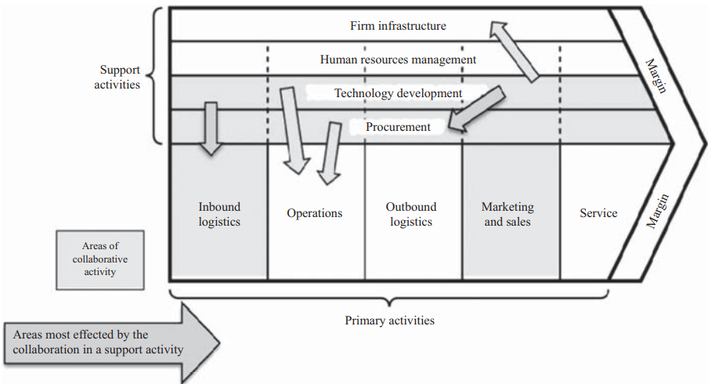
Porters Value Chain (Flanagan et al, 2018).

Inbound Logistic
eBay operate in the e-commerce online retail industry as a online platform for buyers and sellers. Sellers can list products, provide descriptions and add photos. The seller can also choose the method in which they want to sell their product, for example, auction or fixed price. Auctions are conducted with the idea that buyers can place bids on products for a fixed time rather then until there was no bids (old school auction). Sellers specify the auction conditions and time period. Bidding in auctions become active more near the end time and can rise the price of product. This can be affected through programs that use automated snipping methods to bid, creating an involving and interesting environment.

Operations
Over the years eBay have improved strategies for gaining a competitive advantage through their operations. Before the millennium eBay had minimal listing categories for products to be sold. More products were being made available on the platform by sellers such as collectibles and antiques and there were not the appropriate listing categories, this prompted eBay to advance and develop a range and variety of listings for majority of products (Silva et al, 2018). eBay do not have to consult with the community as it does not manufacture products and is a virtual platform for transactions to be made for buyers and sellers.

Outbound Logistic
eBay do not manufacture or store products they solely operate as an online auction marketplace. This allows eBay to not have to worry about the delivery of products as this is the buyer duty. eBay do not send products through a supply chain to retailers, whole-seller or final customer.

Marketing and Sales
eBay’s essential challenges were to establish a marketplace which enforces trust amongst buyers and sellers. eBay use a feedback system which enhances and builds a strong reputation between users, users have access to multiple tools that allow transactions to be secure. Sales that are made outside of eBay’s platform is a concern for the company, as it generates revenues through fees from online sales.

Service
eBay have flourished and built a community which are analogous in relation to the current situation in society today. Buyers and sellers interact with one another under established expectations and rules, excluding service areas which include complaints handling, installation, training, after-sale services, and more.

Procurement
eBay do not have to worry about procurement due to the company do not purchase goods, materials, or services. eBay secure low-cost prices and obtain all qualities of products. eBay provide the platform for users to trade and do not handle the product being sold, this decreases inventory costs for eBay (Greenstein—Messica and Rokach, 2018).

Technology Development
eBay operate as an online marketplace for both buyers and sellers, making technology a key aspect for gaining a competitive advantage. eBay have integrated and innovated online options to reduce costs and sustain while protecting the company’s competitive advantage (Mahmud, 2021). This has included lean manufacturing, technological developments, custom relationship management and internet marketing activities. According to (Dawson, 2020), currently eBay are developing an online payment method that can be used by users for transactions on their marketplace and ensures users with a safe transaction. Previously eBay have improved listing categories to be broader and options to buy now (Gryc, 2020).

Human Resource Management (HRM)
Employees of any company are vital resources that are expensive to train and acquire. Human resource managers in the company conduct activities such as rewards and remuneration, training and development, and recruitment and selection (eBay Inc, 2021). eBay’s company mission and objectives are the key principles which drive eBay’s Human resource strategy. eBay have developed a strategy which has built a community based on the privacy of users, trust and fairness between traders. eBay also offer training to employees, buyers and sellers (eBay Export, 2021).

Firm Infrastructure
According to (Hernandez et al, 2018), firm infrastructure consists and is determined through strategic and corporate planning which include multiple mechanisms and management information systems to control and plan, for example, the accounting department.
eBay have developed a marketplace online which is similar to how newspapers operate in their classified sections. For example, eBay facilitate the transactions between buyers and sellers but do not maintain or hold the product which is being sold at any time (Greenstein—Messica and Rokach, 2018).

4.1 SWOT Analysis of eBay
According to Thajer et al (2020), Swot analysis is tool that evaluates the company’s Strategic positioning. The model consists of four factors which include “Strengths, Weaknesses, Opportunities and Threats. Strengths and weaknesses can be identified though internally analysing eBay whereas opportunities and threats are identified through analysing the company’s environment. Strengths and weaknesses will signify eBay’s competitive advantage, for example, lower overheads, innovating the service or product, and availability of unique new technology. Opportunities and threats are factors which represent in eBay’s environment, these can be advantages such as funds issued by the government, emergence in new markets and development in society which are positive. Disadvantages that can be identified are legal restrictions, new competitors, requirements, and market shrinkage. Below is a SWOT Analysis of eBay.

Strength
eBay are known globally for being one of the largest e-commerce online retailers for individuals to sell products through a bidding process. eBay interact with over 180 million users (Statista, 2021), creating advertisement for businesses and sellers which attracts users to the platform. eBay do not have the issue of directly competing with merchants as revenue is generated through the sales of products, making eBay invulnerable against competition (Gorog, 2019). eBay also allows global shipping as buyers and sellers are connected in different countries, this develops a wen of commerce at a large sell between buyers and sellers. eBay have multiple feedback channels that allow trust to be built between sellers and buyers and prevents fraud. Subconscious decisions can be based on the fact of usernames and feedback has proven this is in the past. There are several ways sellers can sell products. For example, there is the buy it now option, bidding auction for a time period and offers can accepted if a buyer places the amount that is acceptable by the seller (.

Weaknesses
Counterfeit products that are sold on eBay are a serious problem to the company. According to Vongthip and Na Nakorn (2017), eBay were sued by Luis Vuitton due to counterfeit products being sold on eBay. In addition, eBay have cracked down on counterfeit products but not all counterfeits can be identified, this puts fear into buyers. eBay also have to deal with fraudsters who use the sight to swindle credit card details out of buyers (Elshaar and Sadauoi, 2020), damaging eBay’s brand image. The internet can crash and this could cause major problems for eBay as a internet connection is needed to access the platform (Schraten, 2019). However, as technology becomes more advanced, quality of connection becomes enhanced. eBay do not have control over product quality the quality of product is based on if it is new, used or broken. However, this can look bad on eBay and decrease sales.

Opportunities
There are many opportunities for eBay within the industry to gain a competitive advantage as seen in the table above. Over the years, eBay have acquired several companies such as Gumtree.co.uk and PayPal and are likely to purchase more companies which will gain eBay more share of the market (Park and Allui, 2019). eBay can expand in new markets such as China and India as they are developing countries and wealth is increasing (Sarkodie and Strezov, 2019). eBay can also develop increased market penetration in countries such as Western Europe and US. A major factor to this development would be to increase knowledge and use of mobile app. eBay do not require a membership to use the platform like Amazon (eBay Inc, 2021), this can increase customers for eBay due to lower cost fees when switching.

Threats
Due to low barriers of entry into the industry, eBay have to fend off multiple competitors who can offer service similar and for a lower fee such as Amazon, Etsy and more (Mahmud, 2021), decreasing sellers that use the platform. Amazon are a major competitor of eBay and the company is expanding constantly with products available (Mahmud, 2021). Amazon also guarantees that products sold are off good quality, unlike eBay, this could influence customers to boycott eBay for Amazon. eBay have larger sale rates during holiday seasons which creates months that have weaker revenues (eBay Inc, 2021). This indicates that throughout the year the revenue of eBay fluctuates depending on the season. eBay also have the issue of hackers and fraudsters as this puts fears into users (Stringham, 2020). However, as technology advances security advances this can prevent information being stolen in the future and the sell of counterfeit products.

5.0 McKinsey 7’s Model
To analyse how eBay align business elements to achieve increased effectiveness, McKinsey’s 7’s framework will be implanted. According to (Putra et al, 2019), McKinsey’s 7’s consists of hard and soft elements, the hard elements include structure, systems, and strategy whereas soft elements include style, shared values, skills and staff.
[ADD IMAGE]

Hard Elements

Strategy
eBay business strategy can be seen as the first mover approach as the company was on of the original e-commerce sites which was developed by Pierre Omidayer in 1995 (Manning et al, 2020). According to (Lee et al, 2017), eBay have benefitted from being the first mover and are one of the largest e-commerce sites worldwide, having a wide selection of products. However, in the past few years eBay strategy has changed and shifted to a online retailer as well as an auction site which is heavily dominated by competitors Amazon (Greg and Parthasarathy, 2017).

Systems
eBay have multiple systems which are critical to the company’s operations, these include employee training, selection and recruitment of employees, payment systems and more. eBay monitors the efficiency of these systems in a sophisticated manner to increase cost efficiency while enhancing the effectiveness of operations in general (Comberg and Vivek, 2017).

Soft Elements

Skills
eBay operate in the global market and as an e-commerce business and competitions is high. eBay success is due to the innovation and introduction of new services or features that are added to the platform (Mezzanotti and Simcoe, 2019). Therefore, having the ability to be innovative and think differently while being creative and resourceful shows the importance for long term growth of eBay.

Staff
eBay employ approximately 12,700 employees globally in 2020, which was a decline by 4.5% (Macrotrends, 2021). There are a range of techniques and motivational methods that eBay use such as creating an organisational culture that encourages creativity alongside incentives which are intangible, and tangible are offered (Dinnerstein et al, 2018).

Style
The founder of eBay Pierre Omidayer is seen as a visionary leader who influences positive leadership practices within the company (Manning et al, 2020). According to (Hapsari et al, 2019), a leader can be clarified as a individual who supports customers and employees with the most up-to-date technology such as eBay mobile app, which increase share returns for investors and increase the growth of eBay.

Shared Value
eBay promote shared value in their strategic management which enhances creativity amongst employees at all levels. Some of eBay values include excellent customer service, embracing change and being innovative, build relationships, pursue learning and growth, and more (Bahar et al, 2021).

6.0 Porters Generic Strategies of eBay
Generic strategies are gen to strategic planning that are adopted by any firm in any market or industry to improve their competitive performance. According to Mita et al (2017), generic strategies are tactics related to strategic planning which can be adopted by eBay to improve and increase competitive performance. According to Subrahmanyam and Azad (2019), Porters Generic Strategy model consists of cost leadership, differentiation, and focus as the company’s three basic choices. Cost leadership strategy is acquired through businesses organising and controlling value through activities to lower the cost for the product or service in the industry (Doyran, 2020). Differentiation strategy is developed though persuading the customers that the company have a superior product that is better than competitors (Agbejule, 2021). Focus strategies are directed at a market segment for the product instead of a whole market (Doyran, 2020). According to Agbejule (2021), hybrid strategies offer differentiation in some form without requesting premium prices. Companies intend to cut costs in business units which are not as important in the customers perspective through the development of competencies that lower the price to be affordable while offering unique features. Differentiation strategy involves offering a product or service which is distinctive and unique compared to competitors which the consumer values in broader market segments (Kabeyi, 2018).
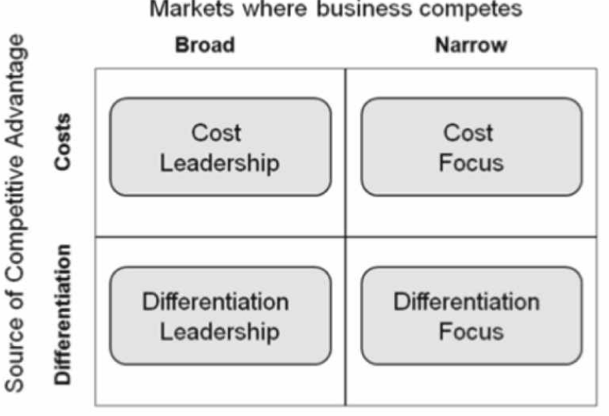
Porter’s generic strategies (Subrahmanyam and Azad, 2019).
eBay adopt a cost leadership generic strategy. eBay have developed and maintained a competitive advantage which is based on minimising costs, which transfers to increased profit margins or lowered prices. For example, eBay’s cost leadership strategy relates to technologies which minimise variable and fixed costs in global e-commerce operations. eBay buyers and sellers are attracted to eBay’s online marketplace due to the pricing strategy which is used by eBay, allowing customers to bid and pay the price they believe is acceptable. According to (Chen et al, 2018), companies that use cost leadership strategies strengthen their business against their competitions. eBay’s cost leadership strategy for their global e-commerce platform involves lowering prices or widening margins of profit. eBay continue to integrate the latest technology for the scale of economies (Tu et al, 2019). Significantly eBay requires advanced and the latest technology to gain competitive advantage over competitors. eBay also aim to increase the amount of users which trade on eBay’s marketplace. Cost leadership strategy used by eBay also spread the fixed costs for listings which increase the amount of users and increases profit margins through offering competitive prices to the buyer and sellers who use the online marketplace (Reinartz, 2019). eBay manage their cost leadership strategy through balancing prices, meeting profit goals and the attractiveness of auction transactions online (Tu et al, 2019).

7.0 Ansoff matrix of eBay
To formulate strategies for future growth an Ansoff matrix will be implemented. eBay management can formulate new strategies based on four elements of concern which are Market penetration, new product development, new market development, and diversification (Kurniawan et al, 2019). eBay long-term growth strategies relating to the four elements are discussed below.
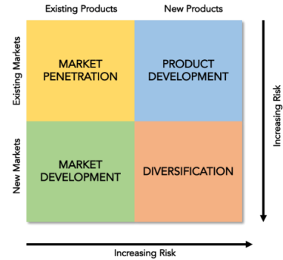
Ansoff Matrix (Handrian and Mansoor, 2021)

Market Penetration
Market penetration strategy can be adopted by eBay to gain the competitions market, improve service or product quality while convincing loyal customers to use products or service frequently, and to increase eBay market share (Soltani-Fesaghandis and Pooya, 2018). In regard to market penetration strategy and eBay, eBay can implement an aggressive approach to promote business through pricing strategies which are effective. For example, eBay can provide sellers discounts on the sale of products and decrease listing costs. Recently, eBay have announced following the new DST law, that the company will pay the expenses and customers will not pay the tax through hidden fees (Dawson, 2020).

Market Development
Market development explores opportunities within new segments and entice new customers and users within the market that exists already and global markets (Mukangai and Muthoni, 2021). eBay provide training to buyers and sellers and have enforced development activities which relate to sales (Zott and Amit, 2017). However, previously eBay have failed to analyse certain ventures such as in China which have had a negative impact (Senadzo, 2019). Amazon on the other hand have introduce their platform and service in over 10 countries and are competitive (Douine et al, 2020).

Product development
According to kalogiannidis and Mavratzas (2020), product development strategy relates to eBay developing products which are innovative and cater for the market eBay exist in, this usually requires extensive research, expansion, and innovative development of product range of eBay. eBay are a huge online platform which facilitate for sellers to sell virtually any product or service, have evolved over the years in product related data from sellers to intensify the experience for users (Park and Allui, 2019). This strategy aims to identify a better understanding of capabilities to access and process a catalogue of items that is accessible globally. Over the years eBay have added extra features to the platform relating to listing to make discovering specific items easier for the user (Dulaney and Wiese, 2017).

Diversification
According to Syuzeva and Zheltenkov (2021), diversification strategy involves eBay adding products that are new which open new markets through adding to their product range. eBay are an online auction and retail marketplace which have acquired companies such as Gumtree, PayPal, and Skype which all have similar strategies that have been successful (eBay Inc, 2021). eBay have also identified customer potential and allow them to use diversification platforms to operate and provide a competitive advantage.

8.0 Green strategy and Corporate Social Responsibility
eBay empower users both buyers and sellers to support worldwide charities. According to eBay Inc (2021), in 2020, eBay raised approximately $120 million through the Covid-19 Pandemic by empowering buyers and sellers to donate and purchase products that donate to charities. In addition, eBay help to develop and build communities to become thriving and vibrant. eBay support business that are small, communities which are untapped, covid-10 relief programs, and more. According to eBay Inc (2021), eBay green strategy goal is to achieve 100% usage of renewable energy by 2025. eBay integrate in their data centre and offices best practices to reduce the footprint of the environment. eBay were recognised for the company’s sustainability and commitment and business responsibility on the “North American Indices and were ranked on the CDP A list”.

9.0 Conclusion
This assignment analysed several models that highlighted strengths, weakeness, threats and opportunities for eBay. As the first mover to the e-commerce industry, eBay have implemented many strategies over the year which has grown the organisation. eBay are known Globally through the expansion in different regions and innovation on their service. Listings have changed from solely an auction site to an online retailer where over 180 million users connect. eBay have acquired many subsidiaries in the past to innovate a safer platform in which to use so that users feel safe. eBay are a company who have strategies in place for different departments and areas of the company with the intention to grow more. eBay expect to be using 100% green electric by 2025 and are expected to release a new method of paying for items which is monitored through the company for saver measures

References
Agbejule, A. (2021) ‘The effects of uncertainty and use of management control system upon strategic priorities and performance: an exploratory study of Finnish firms’, Journal of Research in Administrative Sciences, 10 (1), pp. 1-12.
Bahar, B. Trinquecoste, J. F. Bressolles, G. (2021) ‘Commitment in online communities: the key role of opinion leaders. Decisions Marketing’, (2), pp. 213-227.
Brynjolfsson, E. Hui, X. Liu, M. (2019) ‘Does machine translation affect internal trade? Evidence from a large digital platform’, Management Science, 65 (12), pp. 5549-5460.
Chen, C. J. Guo, R. S. Hsiao, Y. C. Chen, K. L. (2018) ‘How business strategy in non-financial firms moderates the curvilinear effects of corporate social responsibility and irresponsibility on corporate financial performance’, Journal of Business Research, 92, pp. 154-167.
Christodoulou, A. Cullinane, K. (2019) ‘Identifying the main opportunities and challenges from the implementation of a port energy management system: a SWOT/PESTLE analysis’, Sustainability, 11, pp. 1-15.
Comberg, C. Velamuri, V. K. (2017) ‘The introduction of a competing business model: the case of eBay’, International Journal of Technology Management, 73 (1), pp. 39-64.
Dawson, C. (2020) eBay will not pass UK digital service tax to SMEs. Available at: https://tamebay.com/2020/08/ebay-will-not-pass-uk-digital-services-tax-sellers.html [Accessed: 3rd September 2021].
Dawson, C. (2020) New eBay payments experience coming to the UK this summer. Available at: https://tamebay.com/2020/02/new-ebay-payments-experience-coming-to-the-uk-this-summer.html [Accessed: 7th September 2021].
Dinerstein, M. Einav, L. Levin, J. Sundaresan, N. (2018) ‘Consumer price search and platform design in internet commerce’, American Economic Review, 108 (7), pp. 1820-1859.
Douine, M. Lambert, Y. Musset, L. Hiwat, H. Blume, L. R. Marchesini, P. Moresco, G. G. Cox, H. Sanchez, J. F. Villegas, L. de Santi, V. P. (2020) ‘Malaria in gold miners in the Guianas and the Amazon: current knowledge and challenges’, Current Tropical Medicine Reports, 7 (2), pp. 37-47.
Doyran, M. A. (2020) ‘Cost leadership, differentiation or focus: A study of corporate financial Strategy at Levi Strauss’, Rutgers Business Review, 5 (3), pp. 272-293.
Dulaney, E. A. Wiese, M. D. (2017) ‘An Updated Look at the Factors Contributing to the Final Selling Price of Auctioned Gift Cards’, Journal of Internet Commerce, 16 (3), pp. 309-322.
eBay (2020) eBay Annual Report. Available at: https://d18rn0p25nwr6d.cloudfront.net/CIK-0001065088/87327974-cd28-426c-8f94-69d3e6aae74e.pdf [Accessed: 20th August 2021].
eBay Export (2021) welcome to eBay training program for new sellers. Available at: https://export.ebay.com/en/seller-training-program/ [Accessed: 4th September 2021].
eBay Inc (2021) Form 10-k. Available at: https://d18rn0p25nwr6d.cloudfront.net/CIK-0001065088/87327974-cd28-426c-8f94-69d3e6aae74e.pdf [Accessed: 4th August 2021].
eBay Inc (2021) Our history. Available at: https://www.ebayinc.com/company/our-history/ [Accessed: 3rd September 2021].
eBay Inc (2021) what are the slow months for selling on eBay?. Available at: https://community.ebay.com/t5/Archive-Clothing-Shoes/What-are-the-slow-months-for-selling-on-ebay/td-p/18630787 [Accessed: 8th September 2021].
Elshaar, S. Sadaoui, S. (2020) ‘Semi-supervised classification of fraud data in commercial auctions’, Applied Artificial Intelligence, 34 (1), pp. 47-63.
Flanagan, D. J. Lepisto, A. Ofstein, L. F. (2018) ‘Coopetition among nascent craft breweries: a value chain analysis’, Journal of Small Business and Enterprise Development, 25 (1), pp. 2-16.
Fuscaldo, D. (2020) eBay orders surge during pandemic; raises outlook for second quarter. Available at: https://www.fool.com/investing/2020/06/04/ebay-orders-surge-during-pandemic-raises-outlook-f.aspx [Accessed: 4th August 2020].
Görög, G. (2019) ‘Is the sharing economy socially responsible? Case study examination about sharing economy companies with the help of stakeholder theory’, International Journal of Business and Globalisation, 23(3), pp. 401-419.
Gov.uk (2021) Digital services taxes. Available at: https://www.gov.uk/government/publications/introduction-of-the-digital-services-tax/digital-services-tax [Accessed: 4th August 2021].
Goyal, A. (2020) ‘A critical analysis of Porter’s 5 forces model of competitive advantage’, Journal of Emerging Technologies and Innovative Research, 7 (7), pp. 149-152.
Greenstein-Messica, A. Rokach, L. (2018) ‘Personal price aware multi-seller recommender system: Evidence from eBay’, Knowledge-Based Systems, 150, pp. 14-26.
Gregg, D. Parthasarathy, M. (2017) ‘Factors affecting the long-term survival of eBay ventures: a longitundinal study’, Small Business Economics, 49 (2), pp. 405-419.
Gryc, W. E. (2020) ‘Revenue in first-price auctions with a buy-out price and risk-averse bidders’, Journal of Economics, 129 (2), pp. 103-142.
Handrian, A. C. Mansoor, A. Z. (2021) ‘Proposed business strategy for a nonformal architecture-related education start up-up (case study: Klass Academy)’, European Journal of Business and Management Research, 6 (3), pp. 133-136.
Hapsari, C. Stoffers, J. Gunawan, A. (2019) ‘The influence of generational diversity management and leader–member exchange on innovative work behaviors mediated by employee engagement’, Journal of Asia-Pacific Business, 20 (2), pp. 125-139.
Hardy, J. Powell, H. Macrury, I. (2018) The Advertising Handbook. Routledge: New York.
Hernandez, R. Belton, B. Reardon, T. Hu, C. Zhang, X. Ahmed, A. (2018) ‘The “quiet revolution” in the aquaculture value chain in Bangladesh’, Aquaculture, 493, pp. 456-468.
Jap, S. D. Gibson, W. Zmuda, D. (2021) ‘Winning the new channel war on Amazon and third-party platforms’, Business Horizon, in press, pp. 1-29.
James, S. (2021) Porter’s 5 force model. Available at: https://visual.ly/community/Infographics/animals/porter%E2%80%99s-5-forces-model [Accessed: 21st August 2021].
Kabeyi, M. J. B. (2018) ‘Michael Porter’s five competitive forces and generetic strategies, market segmentation strategy and case study of competition in global smartphone manufacturing industry’, International Journal of Applied Research, 4 (10), pp. 39-45.
Kago, Z. W. Gichunge, E. M. Baimwera, B. (2018) ‘Relationship between competitive strategies and organizational performance of petroleum companies in Kenya’, International Academic Journal of Human Resource and Business Administration, 3 (2), pp. 407-429.
Kalogiannidis, S. Mavratzas, S. (2020) ‘Impact of Marketing mix strategies effective product development issues in MNCs/Retail’, International Journal of Business Marketing and Management, 5 (12), pp. 118-125.
Klunert, P. (2020) eBay won’t pass UK Digital Service Tax costs on to third-party-sellers – unlike Amazon, which simply can’t afford it. Available at: https://www.theregister.com/2020/08/13/ebay_not_passing_on_digital/ [Accessed: 4th August 2021].
Koc, T. Bozdag, E. (2017) ‘Measuring the degree of novelty of innovation based on Porter's value chain approach’, European Journal of Operational Research, 257 (2), pp. 559-567.
Kurniawan, D. Iswahyudin, M. D. Suciati, T. R. (2020) ‘SWOT analysis and Ansoff Matrix in creative food industry business development: A study on creative food business “Komala”’, Open Access Indonesia Journal of Social Sciences, 3 (2), pp. 69-76.
Lee, D. Choi, K. Hwang, K. (2017) ‘First-mover and second-mover advantages in a bilateral duopoly’, The Korean Economic Review, 33 (1), pp. 35-53.
Liu, W. Atuahene-Gima, K. (2018) ‘Enhancing product innovation performance in a dysfunctional competitive environment: The roles of competitive strategies and market-based assets’, Industrial Marketing Management, 73, pp. 7-20.
Macrotrends (2021) eBay: number of employees 2006-2021. Available at: https://www.macrotrends.net/stocks/charts/EBAY/ebay/number-of-employees#:~:text=Interactive%20chart%20of%20EBay%20%28EBAY%29%20annual%20worldwide%20employee,2018%20was%2014%2C000%2C%20a%200.71%25%20decline%20from%202017. [Accessed: 7th September 2021].
Mahmud, M. (2021) ‘Case Comparison of Major Digital Business Platforms: Amazon, AliExpress and eBay’, Turkish Journal of Computer and Mathematics Education, 12 (3), pp. 5801-5808.
Manning, P. Baker, N. Stokes, P. (2020)‘The ethical challenge of Big Tech’s “disruptive philanthropy”’, International Studies of Management & Organization, 50 (3), pp. 271-290.
MarketLine (2021) Online Retail in the United States. Available at: file:///C:/Users/HP/Downloads/MarketLineIC_UnitedStatesOnlineRetail_200821.pdf [Accessed: 20th August 2021].
Mckie, E. C. Ferguson, M. E. Galbreth, M. R. Venkataraman, S. (2018) ‘How do consumers choose between multiple product generations and conditions? An empirical study of iPad sales on eBay’, Production and Operations Management, 27 (8), pp. 1574-1594.
Mezzanotti, F. Simcoe, T. (2019) ‘Patent policy and American innovation after eBay: An empirical examination’, Research Policy, 48 (5), pp. 1271-1281.
Mita, G. O. Ochie’ng, I. Mwebi, R. (2017) ‘Influence of generic strategies on performance of metal works SME businesses in Naivasha Town’, International Academic Journal of Human Resource and Business Administration, 2 (3), pp. 477-500.
Mohammed, I. (2021) ‘Management processes as antecedents of organisational performance: A literature review’, Texila International Journal of Management, 7 (1), pp. 1-6.
Mukangai, W. I. Muthoni, M. E. (2021) ‘The effect of market development on sale performance of agro-based dealers in Nairobi City Country, Kenya’, Journal of Marketing and Communication, 4 (1), pp. 23-35.
Narang, U. Shankar, V. (2019) ‘Mobile app introduction and online and offline purchases and product returns’, Marketing Science, 38 (5), pp. 756-772.
Nwanekezie, K. Noble, B. Poelzer, G. (2021) ‘Transition-based strategic environmental assessment’, Environmental Impact Assessment Review, 91, pp. 1-10.
O’Neil, A. (2021) Global Gross Domestic Product (GDP) at current prices from 1985-2026. Available at: https://www.statista.com/statistics/268750/global-gross-domestic-product-gdp/#:~:text=In%202019%2C%20global%20GDP%20amounted%20to%20about%2087.55,services%20produced%20in%20a%20country%2C%20often%20measured%20annually [Accessed: 4th August 2021].
Pantano, E. Pizzi, G. Scarpi, D. Dennis, C. (2020) ‘Competing during a pandemic? Retailers’ ups and downs during the COVID-19 outbreak’, Journal of Business Research, 116, pp. 209-213.
Park, Y. E. Allui, A. (2019) ‘eBay: Smart Entry Strategy into the Korean Market Through M&A and its Post-Merger Integration’, The Journal of Distribution Science, 17 (1), pp. 47-56.
Pervan, M. Curak, M. Kramaric, P. (2017) ‘The Influence of industry characteristics and dynamic capabilities on firms’ profitability’, International Journal of Financial Studies, 6 (4), pp. 1-19.
Putra, R. P. Syah, T. Y. R. Pusaka, S. Indradewa, R. (2019) ‘Human resources implementation using the McKinsey 7S method for business startup: Duck nugget frozen food’, Journal of Multidisciplinary Academic, 3 (3), pp. 11-14.
Reinartz, W. (2018) ‘eBay: transforming an auction house into a retailing platform’, NIM Marketing Intelligence Review, 11 (1), pp. 55-59.
Sadq, Z. M. Sabir, H. N. Saeed, V. S. H. (2018) ‘Analysing the Amazon success strategies’, Journal of Process Management- New Technologies, International, 6 (4), pp. 65-70.
Sarkodie, S. A. Strezov, V. (2019) ‘Effect of foreign direct investments, economic development and energy consumption on greenhouse gas emissions in developing countries’, Science of the Total Environment, 646, pp. 862-871.
Schraten, J. (2019) ‘The economic sociology of digitalised payment services’, Przegląd Socjologiczny, 68 (2), pp. 107-131.
Sekhar, C. Karthikeyan, M. Divakaran, A. Deyi, Z. (2019) ‘Performance of e-Commerce business in India and China’, International Journal of Agricultural Sciences, 15 (1), pp. 195-211.
Sharma, A. Jhamb, D. (2020) ‘Changing consumer behaviours towards online shopping- an impact of covid 19’, Academy of Marketing Studies Journal, 24 (3), pp. 1-11.
Sicora, A. (2017) ‘Reflective practice, risk and mistakes in social media’, Journal of Social Work Practice, 31 (4), pp. 491-502.
Silva, A. T. Moro, S. Rita, P. Cortez, P. (2018) ‘Unveiling the features of successful eBay smartphone sellers’, Journal of Retailing and Consumer Services, 43, pp.311-324.
Shen, R. (2020) ‘The comparative history and development of E-commerce in China and the United states’, Journal of Mathematical Finance, 10 (3), pp. 483-498.
Simatupang, T. M. Piboonrungroj, P. Williams, S. J. (2017) ‘The emergence of value chain thinking’, International Journal of value chain management, 8 (1), pp. 40-57.
Smriti, V. Dhir, S. Dhir, S. (2021) ‘Strategic thinking in a professional environment: a review of the literature’, International Journal Business Innovation and Research, 25 (2), pp. 260-284.
Soltani-Fesaghandis, G. Pooya, A. (2018) ‘Design of an artificial intelligence system for predicting success of new product development and selecting proper market-product strategy in the food industry’, International Food and Agribusiness management Review, 21 (7), pp. 847-864.
StatCounter (2021) Desktop vs mobile vs tablet market share worldwide. Available at: https://gs.statcounter.com/platform-market-share/desktop-mobile-tablet [Accessed: 4th August 2021].
Statista (2021) Number of eBay’s total active buyers from 1st quarter 2010 to 2nd quarter 2021. Available at: https://www.statista.com/statistics/242235/number-of-ebays-total-active-users/#:~:text=How%20many%20people%20use%20eBay%3F%20This%20statistic%20shows,In%20Q2%2F2019%2C%20eBay%20reached%20180%20million%20active%20users. [Accessed: 8th September 2021].
Stringham, E. P. Clark, J. R. (2020) ‘The crucial role of financial intermediaries for facilitating trade among strangers’, The Review of Austrian Economics, 33 (3), pp. 349-361.
Subrahmanyam, S. Azad, S. (2019) ‘Carrefour’s competitive strategy- cost leadership and differentiation: A case study’, Pacific Business Review International, 11 (8), pp. 137-144.
Syuzeva, O. Zheltenkov, A. (2021) ‘Problems of choosing strategies for diversifying companies’, E3s Web of Conferences, 284, pp. 1-10.
Tayde, P. N. (2021) ‘Covid-19 and its impact om e-commerce in India-A critical study’, EPRA International Journal of Economics, Business and Management Studies, 8 (3), pp. 51-53.
Teece, D. J. (2019) ‘A capability theory of the firm: an economics and (strategic) management perspective, New Zealand Economic Papers, 53 (1), pp. 1-43.
Thajer, A. Sommersguter-Reichmann, M. Loffler-Stastka, H. (2020) ‘Implementing a clinical research department to support pediatric studies: A SWOT analysis’, International Journal of Environmental Research and Public Health, 7, pp. 1-16.
Tu, Y. Tung, Y. A. Goes, P. (2019) ‘Effective selling strategies for online auctions on eBay: a comprehensive approach with CART model’, International Journal of Business Information Systems, 30 (2), pp. 125-151.
Vella, J. (2019) ‘Digital services taxes: principles as double-edged sword’, National Tax Journal, 72 (4), pp. 821-838.
Vongthip, V. Na Nakorn, P. N. (2017) ‘Internet Service Providers and its Role of Hosting User Generated Content under the United Kingdom and European Union Regime’, PSAKU International Journal of Interdisciplinary Research, 6 (2), pp. 22-28.
Wellner, S. Lakotta, J. (2020) ‘Porter's Five Forces in the German railway industry’, Journal of Rail Transport Planning and Management, 14, pp. 1-11.
Ya’acob, F. F. Y. Isamail, M. Z. Ghul, Z. H. Alpandi, R. M. Abdullah, S. M. M. (2021) ‘The competitiveness analysis of edible bird nest industry in Malaysia: applying porter’s five force’, Journal of Tourism, Hospitality and Environment Management, 6 (23), pp. 79-92.
Zott, C. Amit, R. (2017) ‘Business model innovation: How to create value in a digital world’, NIM Marketing Intelligence Review, 9 (1), p. 18.

