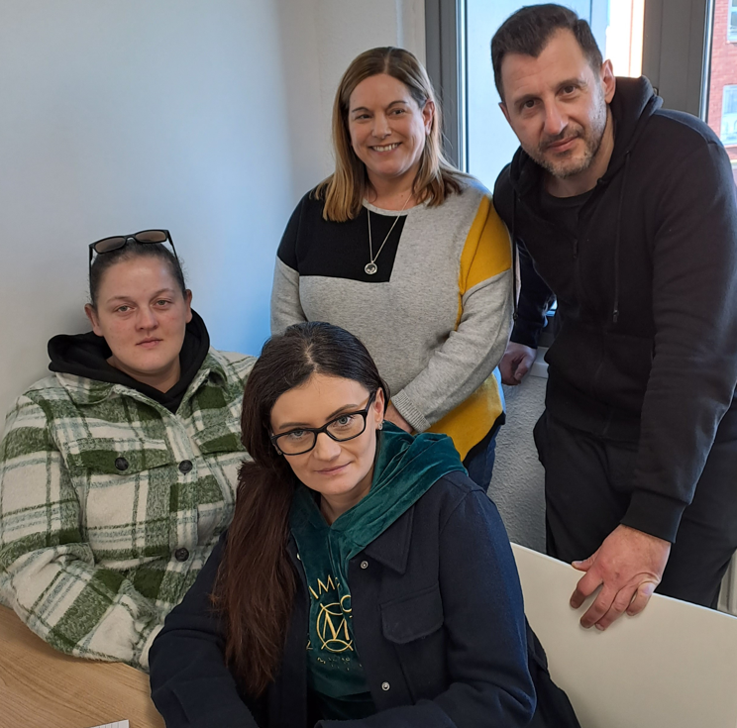
EFFECTIVE TEAMWORK
TEAM ROLE COMPOSITION
GROUP ASSIGNMENT
20 MARCH 202
1650 WORDS
BY
CHRIS BIKOS

INTRODUCTION
We will cover team role composition and how it affects the team's overall structure and learn how to operate effectively
I’ll be basing my assignment on Tuckman’s Theory and Belbin’s Roles.
We will go over each theory's meanings as well as our own strengths, weaknesses, challenges, and how we overcame them.
To improve their odds of landing a work placement, university students need to develop their critical thinking and problem-solving abilities (Rodzalan et al. 2020, p. 134-145)
This is undoubtedly true: in order to function effectively as a team member and to work towards a common goal, you must be able to think critically and solve problems.

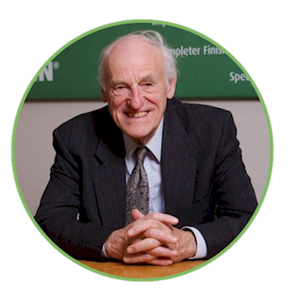

(Delvaux, 2017)
The Belbin Team Role is a behavioural test, it was devised by Raymond Meredith Belbin to measure preference for nine Team Roles. The Inventory assesses how an individual behaves in a team environment.

Praise and acknowledgment are essential for satisfying one's need for social acceptance at work. These expressions can take the form of compliments, thanks, encouraging comments, and other displays of appreciation (Bergin and Jimmieson, 2020, p. 148-164)
Within the group, we are always praising and encouraging one another. Although there is constructive criticism, we know and believe that it is in the team's best interests. The team also works well together and communicates well, were having a great time!
There are nine Belbin Team Roles, and our group has talked about and decided on which role we have chosen as individuals:
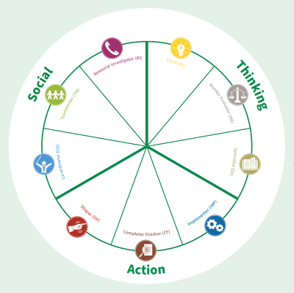
Marta
Chris
Sarah Allison

You can see that we divided it into three sections: social, thinking, and action. In our team composition, we have roles and individuals in each of those three sections.

Chris (I) is the Coordinator, establishes roles and work limits based on individual skills, and concentrates people on their strongest areas. I used to go into automatic pilot because I've worked in management positions before, which, to be honest, created conflict with Sarah.
Sarah is the Shaper, the Task Leader, and she works to turn thoughts into choices and deeds. She does listen but does not fully consider what is being said when ideas are put forward by the rest of the team.
Allison is the Implementor; she converts decisions into clear-cut, doable actions that people can carry out and has a practical plan of action that is required. She would need to gain confidence as she is quiet and lacks much self-assurance when trying to make a point.
Marta is the Monitor Evaluator; gives the team a logical perspective, renders impartial decisions as needed, and dispassionately evaluates its possibilities. Marta’s weakness is that she can occasionally lack motivation, be too critical, and be unable to motivate others.
So, as you can see from the above summary of the roles on our team, during the team composition process, some of us were silent while others had strong personalities. It might be said that the composition was heavy-handed on both sides.

All of us need to be able to constantly learn, unlearn, and relearn to adjust to how the world actually is as it changes (Hess, 2020, p. 18-20). If we want to succeed, we must change and evolve along with the rest of the world.
In many operations management settings, teamwork skills are crucial and can be developed through formal education and real-world experiences (Garcia-Palao and Oltra-Mestre, 2019, p. 205-222)
It takes courage (and self-awareness) to request honest feedback, even if self-awareness is understanding oneself without the assistance of others. We all realise what needs to be done, even if there is criticism in the group.

What causes some teams to succeed while others don't? You must understand what actually motivates team effectiveness if you are a team leader, team member, senior leader, or consultant (Tannenbaum and Scott, 2021).
In our group chat or in class, we constantly urge one another to encourage teamwork. Even merely messaging one another to check on everyone's well-being. We begin to trust and care for one another after we get to know one another, the effectiveness of the team depends on this.

Tuckman’s Theory
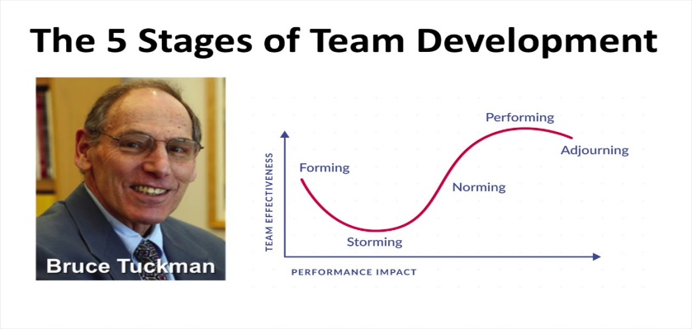
(Zeducation, 2021)
The five stages of Team Development
Our experiences have shown that teamwork is crucial because it is closely linked to group growth and is associated with a variety of positive traits, including professionalism and teamwork effectiveness (Vaida, 2021, p.91-110).
This cannot be further from the truth! We must maintain professionalism when receiving criticism if we are to thrive as a team.
Tuckman proposed that a team goes through five stages in its life cycle. At each level, the team dynamics drastically shift from times of inefficiency and unease to times of high performance.
I believe the team has had individual coaching in the past, but teamwork is challenging for them, based on what I have seen.
We must pay careful attention to how team members, managers, and leaders interact, gather, and work together, and we must make sure that everyone is aware of the negative effects our unproductive work habits have on others' productivity (Crowley, 2018)

Tuckman's Theory has five stages, which are as follows:
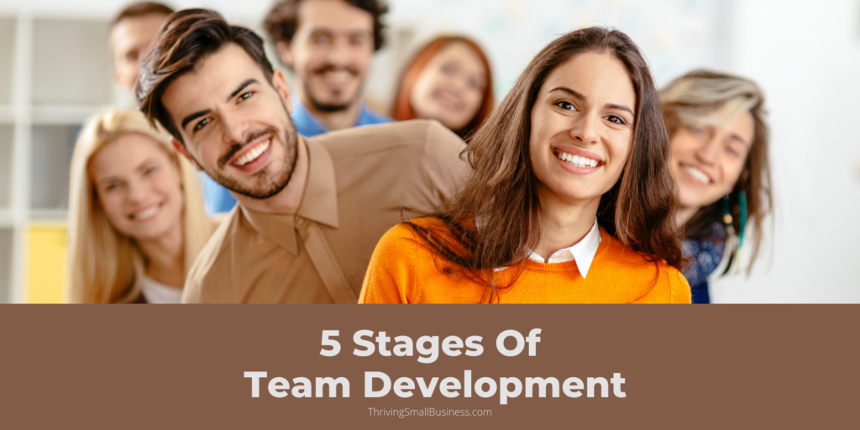
(Lotich, 2022)
- Forming - Team members will get to know one another during the forming stage and will be paying attention to each other and the leader.
- Storming - Competition for positions among team members and individuals in the team could emotionally object to the task.
- Norming - The team will agree on the usual norms and expectations of being a group member once the issues from the storming stage have been settled.
- Performing - Action and completion are hallmarks of this stage, which is the achievement stage. The team is likely to take the initiative and won't need management or incentive.
- Adjourning - The team's purpose for being is gradually realised, which can create a void that is challenging to fill.
We’ll examine these phases in further detail in the section that follows, as well as how I have implemented them in my group assignment:

STAGE 1 – FORMING
I will be paying close attention to the forming stage of Tuckman’s Theory because that's where the composition of the team is built.
Bednar and Ljudvigova (2020) state that for a start-up to function as a team, everyone must come together to work towards a shared objective, and that is exactly the quality of leadership.
For this task, our lecturer offered us the responsibility to select our own team. We had a minor advantage because we had previously gotten to know one another from working on the first two modules together.
After selecting our team and participating in a few activities, we immediately knew who would be responsible for what in the task. Therefore, we essentially sat in our teams and watched one another, as well as what each person said and did.

STAGE 2 – STORMING
Due to their organisation and understanding of the assignment's requirements, I believe it was obvious that Sarah would serve as our leader from the start. I would be chosen as the Coordinator, Marta would be the Monitor Evaluator, and Allison the Implementor.
Due to their reserved personalities, Marta, our Monitor Evaluator, and Implementor Allison were initially challenging to comprehend.
However, this does not imply that there was no conflict. I believe there may have been some reservations or unsure members when we decided what our individual roles would be (according to the Belbin method), but after careful discussion, we were all happy with the outcome.

STAGE 3 – NORMING
We are now focusing on completing the upcoming assignment after defining individual team roles and resolving the minor issue we had. Additionally, we set up a WhatsApp Group chat where we are exchanging ideas and supporting one another. As Willis (2018, p.72-76) states, the performance of team members and feedback go hand in hand.
In order to debate concepts as a group, we also arrived early a few times before our lecture. We now know that to complete the assignment within the specified timeframe, there will be less discussion and more action.

STAGE 4 – PERFORMING
We are all fully committed to finishing the assignment as a team, especially our leader, who has the great motto "whatever it takes"!
Our leader will be in charge of gathering the PowerPoint slides from the team members and compiling them into one presentation to give to the lecturer.
The success of any endeavour depends on the team's ability to work together successfully in today's globalised world, in addition to the professionalism and other personal qualities of each employee ( Isaikina and Navalna, 2022, p.59-66)
Although there was conflict at first, we now get along well and are aware of our respective duties as well as what must be done and by when in order to accomplish our goal.

STAGE 5 – ADJOURNING (OR MOURNING)
We will remain in the same class until the completion of the course, but in terms of the mourning side of it, I'm confident that because of the bond we have formed, we will still be able to support and counsel one another.
CONCLUSION
“Coming together is a beginning, staying together is progress, and working together is success.” - Henry Ford (no date)
What a great quote that pretty much captures what it takes to succeed as a team. Even though there were difficulties and challenges within the group, we excelled, pushed, and encouraged one another throughout the experience, and I am convinced that we prevailed.

Reference List

Bednar, R. and Ljudvigova I. (2020) Belbin team roles in a start-up team, SHS Web of Conferences.

Bergin, A.J. and Jimmieson, N.L. (2020) The importance of supervisor emotion recognition for praise and recognition for employees with psychological strain, England: Routledge; Anxiety, stress, and coping.
Crowley, D. (2018) Smart teams: communicate, congregate, collaborate : how to work better together, Wiley.

Delvaux, C. (2017) AN INTERVIEW WITH MEREDITH BELBIN: THE FATHER OF TEAM ROLES, Available at Thrust — Blog [commercial innovation] - An interview with Meredith Belbin: the father of Team Roles (thrustteam.com) (Accessed: 10 March 2023).

Garcia-Palao, C. and Oltra-Mestre, M.J. (2019) Improving teamworking competence through action learning. Experiences in operations management education, Lancaster: Routledge; Action learning.
Hess, E.D. (2020) Seven "Old-School" Workplace Strengths That Are Now Weaknesses, Leadership Excellence; Aurora.
Isaikina, O. and Navalna, M. (2022) The role of effective communication in the process of forming a cohesive and motivated team, Hryhorii Skovoroda University.
Lotich, P. (2022) 5 Stages Of Team Development, Available at: 5 Stages of Team Development – The Thriving Small Business (Accessed: 11 March 2023).
Rodzalan, S.A. et al. (2020) Factors Influencing the Improvement of Students’ Critical Thinking and Problem-Solving Skill: An Industrial Training Intervention, Kassel University Press.

Tannenbaum, S. (2021) Teams That Work: The Seven Drivers of Team Effectiveness, Oxford Scholarship - Oxford University Press: Psychology.
Vaida, S. (2021), GROUP DEVELOPMENT STAGES. A BRIEF COMPARATIVE ANALYSIS OF VARIOUS MODELS, Studia Universitatis Babes-Bolyai.
Willis, D. (2018) LEADING A TEAM, Rough Notes; Indianapolis.
Zeducation, (2021) Bruce Tuckman’s 5 Stages of Team Development, Available at Bruce Tuckman's 5 Stages of Team Development - YouTube (Accessed: 12 March 2023).

