Business Plan

Aurora Atelier Parfums Ltd
Module: Enterprise and Entrepreneurship
Student Name: Denisa Ioana Ivanciu
Student ID: 2510153
Lecturer: Richard Ashaye
Submission Date: 27/07/2026

Executive Summary
Aurora Atelier Perfumes Ltd is a London-based niche fragrance company specialising in luxury, gender-inclusive perfumes that combine premium quality with sustainable business practices (Mintel, 2025). The company aims to meet the growing consumer demand for unique fragrances by offering small-batch eau de perfumes and perfume oils made from responsibly sourced ingredients (Karen Gilbert, 2024) and packaged using environmentally friendly materials (IFRA, 2025). By focusing on craftsmanship, transparency, and sustainability, Aurora Atelier Perfumes differentiates itself from both traditional luxury perfume houses and low-cost imitation brands (Data Bridge Market Research, 2024).
The UK fragrance market continues to grow despite increasing competition, driven by consumer interest in niche perfumes, personalised products and ethical purchasing decisions (Technavio, 2025). Aurora Atelier Perfumes will target consumers aged 25–45 with medium to high disposable incomes who value originality, product quality and sustainable luxury (Mintel, 2025).
An initial investment of £150,000 will fund product development, inventory, branding, digital marketing and working capital. The company expects to generate approximately £275,000 in first-year revenue (Data Bridge Market Research, 2024), while building brand recognition and establishing a loyal customer base. Long-term growth will be achieved through expansion into European markets, increased wholesale partnerships and the introduction of refillable products that support the company’s commitment to environmental responsibility (IFRA, 2025).
+

Table of Contents
- Executive Summary
- Business Overview
  - Management Structure/product and/or services
- Market Research
  - Industry overview
  - Target marketing
  - Competitor analysis
- Marketing Communications
- PASTEL analysis
- SWOT Analysis
- Financial Plan
  - Start-up cost
  - Fixed cost
  - Variable costs and break-even/ profit and loss forecast
- Conclusion
- Reference List

1. Business Overview
Aurora Atelier Perfumes Ltd is a private limited company established in London to create high-quality fragrances that combine luxury, sustainability and individuality (Karen Gilbert, 2024). The business was founded in response to increasing consumer demand for perfumes that are ethically produced, gender-inclusive and offer a distinctive alternative to mass-market brands (Mintel, 2025). Unlike many designer fragrances, Aurora Atelier Perfumes focuses on small-batch production, carefully selected ingredients and transparent sourcing, enabling customers to enjoy premium products while supporting environmentally responsible practices (IFRA, 2025).
The company’s mission is to create timeless fragrances that allow customers to express their individuality while promoting sustainable consumption. Its vision is to become one of the UK’s leading independent fragrance houses, recognised for innovation, craftsmanship and environmental responsibility (Technavio, 2025).
Aurora Atelier Perfumes will launch with four signature Eau de Parfums, complemented by perfume oils and a discovery set that allows customers to experience the collection before committing to a full-size purchase. This strategy reduces the perceived risk of buying fragrance online (Mintel, 2025) and encourages repeat purchases through customer satisfaction.

1a. Product and/or Service
Aurora Atelier Parfums Ltd is a London-based luxury fragrance business specialising in premium, gender-inclusive perfumes. The company will launch with four signature Eau de Parfums, perfume oils, and a discovery set that allows customers to sample the fragrances before purchasing a full-sized bottle (Karen Gilber, 2024). The products are made using high-quality, responsibly sourced ingredients and are packaged in recyclable and refillable bottles to promote sustainability. Sales will be made primarily through the company’s e-commerce website, with additional revenue generated through boutique retailers and pop-up events.

Management Structure
Aurora Atelier Parfums Ltd will be managed by three directors, each responsible for a key area of the business:
- Managing Director – oversees business operations, finance and strategic decision-making.
- Creative & Product Director – responsible for fragrance development, product quality and supplier relationships.
- Marketing & Sales Director – manages digital marketing, social media, branding, customer engagement and sales growth.
As the business expands, additional employees will be recruited to support customer service, marketing and day-to-day operations.
The business will operate as a Private Limited Company (Ltd) because this legal structure provides limited liability protection for shareholders, enhances business credibility and offers greater opportunities to secure external investment. The company will initially be managed by three experienced directors responsible for creative development, operations and marketing. As the business expands, additional employees will be recruited to support customer service, content creation and business operatio (Data Bridge Market Research,2024).
Aurora Atelier Parfums’ unique selling proposition (USP) lies in combining luxury-quality fragrances with sustainable business practices at an accessible premium price (Mintel,2025). By offering refillable packaging, transparent ingredient information and personalised customer experiences, the company aims to build long-term customer loyalty while differentiating itself in an increasingly competitive fragrance market.

2. Market Research

Industry Overview
The UK fragrance industry is one of the largest beauty markets in Europe and continues to experience steady growth despite economic uncertainty (Mintel,2025). Consumers are increasingly seeking premium fragrances that offer originality, long-lasting performance, and sustainable production methods. This trend has encouraged the rapid growth of niche perfume brands, which compete by offering distinctive scents and authentic brand stories rather than relying solely on celebrity endorsements or luxury fashion labels.
Digital shopping has also transformed the perfume industry. Many consumers now research products online before buying, making social media, customer reviews, and influencer recommendations highly influential in purchasing decisions. Aurora Atelier Parfums will take advantage of this trend by adopting a direct-to-consumer business model alongside carefully selected boutique retail partnerships (Technavio,2025).

Target Market
Aurora Atelier Parfums primarily targets men and women aged 25 to 45 who have medium to high disposable incomes and appreciate premium lifestyle products. These consumers typically live in urban areas, are active on social media, and are interested in fashion, wellness, and sustainability. They are willing to pay more for products that reflect their personal identity and ethical values (Mintel,2025).
A secondary target market includes gift buyers, fragrance enthusiasts, and corporate clients seeking luxury gifting solutions. By offering discovery sets and refill options, the business can appeal to both first-time customers and loyal repeat purchasers.

Competitor Analysis
Aurora Atelier Perfumes operates within the premium niche fragrance sector, competing with brands such as Le Labo, Byredo and Diptyque. These companies have established strong reputations for craftsmanship and exclusivity but generally charge significantly higher prices. Aurora Atelier Perfumes aims to position itself as a more accessible premium alternative without compromising product quality (Mintel,2025).
Unlike mass-market designer fragrances, Aurora Atelier Perfumes emphasises transparency, sustainable sourcing and refillable packaging. These features create a clear competitive advantage among environmentally conscious consumers while strengthening customer loyalty through ethical business practices.

PESTEL Analysis
Political: The UK cosmetics industry is regulated to ensure consumer safety. Aurora Atelier Parfums must comply with the UK Cosmetics Regulation, product labelling requirements and safety assessments before fragrances can be sold. Compliance increases operating costs but also builds customer trust and protects the brand’s reputation (IFRA, 2025).
Economic: Rising living costs have increased consumer price sensitivity, encouraging many shoppers to seek greater value for money. However, premium fragrance sales remain resilient because consumers often view luxury perfumes as affordable indulgences. Aurora Atelier Perfumes will balance premium quality with competitive pricing to remain attractive during changing economic conditions.
Social: Consumer preferences are shifting towards gender-neutral fragrances, sustainable packaging and authentic brand stories. Buyers increasingly support businesses that demonstrate environmental responsibility and ethical sourcing. This social trend strongly supports Aurora Atelier Perfumes business model.
Technological: Advances in e-commerce, artificial intelligence and digital marketing provide opportunities to personalise customer experiences. The business will use targeted advertising, email marketing and fragrance quizzes to improve customer engagement and increase conversion rates.
Environmental: Sustainability has become a major purchasing factor within the cosmetics industry. Aurora Atelier Perfumes will minimise environmental impact through recyclable packaging, refillable bottles and responsibly sourced ingredients, helping reduce waste while strengthening its brand reputation.
Legal: Compliance with UK cosmetic regulations, data protection legislation and International Fragrance Association (IFRA) standards is essential. Meeting these legal requirements protects both customers and the business while supporting long-term growth.
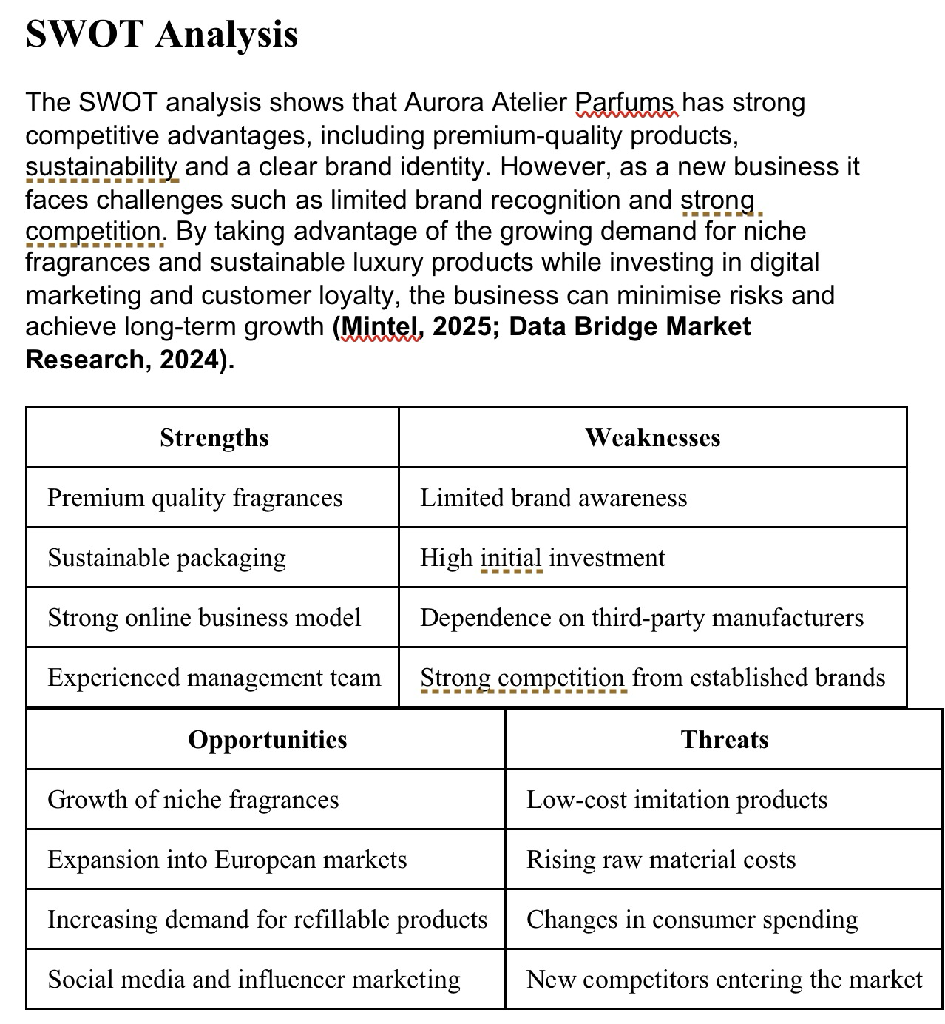

3. Marketing Communications
Aurora Atelier Parfums will adopt an integrated marketing communications strategy to build brand awareness, attract new customers and encourage long-term loyalty. As a new entrant to the premium fragrance market, the business will focus primarily on digital marketing, supported by public relations, influencer partnerships and experiential marketing (Technavio,2025).
Social media will be the company’s primary promotional channel. Platforms such as Instagram, TikTok and Pinterest will be used to showcase the brand’s products through high-quality photography, behind-the-scenes content and educational posts about fragrance ingredients and sustainability. Consistent posting and user-generated content will help strengthen brand identity while encouraging customer engagement.
Influencer marketing will play a significant role in the launch strategy. Aurora Atelier Parfums will collaborate with micro-influencers in the beauty and lifestyle sectors, as they typically achieve higher engagement rates and are perceived as more authentic than celebrity influencers. Product gifting and honest reviews will increase credibility while introducing the brand to new audiences (Data Bridge Market Research,2024).
The company will also invest in search engine optimisation (SEO) and paid digital advertising through Google Ads and Meta platforms. These campaigns will target consumers actively searching for luxury fragrances, increasing website traffic and conversion rates. Email marketing will support customer retention by promoting new product launches, exclusive offers and personalised fragrance recommendations.
Pricing has been carefully positioned within the accessible luxury segment. This strategy reflects the premium quality of the products while remaining more affordable than many established niche perfume brands. Discovery sets will reduce the perceived risk of online fragrance purchases and encourage customers to purchase full-sized bottles.
To encourage repeat purchases, Aurora Atelier Parfums will introduce a customer loyalty programme offering reward points, early access to limited-edition collections and discounts on refill purchases. This approach strengthens customer relationships while supporting the company’s sustainability objectives.
Overall, the marketing strategy combines digital innovation with customer experience to establish a recognisable luxury brand capable of competing within the growing niche fragrance market.

4. Financial Plan
Aurora Atelier Parfums requires an initial investment of £150,000 to establish the business and support its first year of operations. The funding will be used to finance product development, inventory, packaging, branding, digital marketing and working capital. The investment will consist of founder contributions, private investors and a government-backed Start Up Loan (Mintel,2025).
The business expects to generate approximately £275,000 in revenue during its first year of trading. While a modest operating loss is anticipated during the launch phase due to marketing expenditure and brand development, profitability is expected during the second year as customer awareness increases and fixed costs are spread across higher sales volumes.
The pricing strategy has been developed to maintain healthy profit margins while remaining competitive within the premium fragrance market. Revenue will be generated through direct online sales, boutique wholesale partnerships, discovery sets, perfume oils and limited-edition collections. Diversifying income streams reduces financial risk and creates opportunities for future expansion.
Cash flow will be managed carefully through inventory forecasting, controlled operating expenses and regular financial monitoring. Wholesale orders and online sales will provide consistent revenue throughout the year, while seasonal product launches and gift collections are expected to increase sales during peak trading periods.
As the business grows, profits will be reinvested into marketing, product innovation and international expansion. Long-term financial objectives include expanding into European markets, increasing wholesale partnerships and developing refill products that improve both customer retention and environmental sustainability.
The financial forecasts demonstrate that Aurora Atelier Parfums has the potential to become a profitable and sustainable business through careful financial planning, premium product positioning and strong customer relationships.
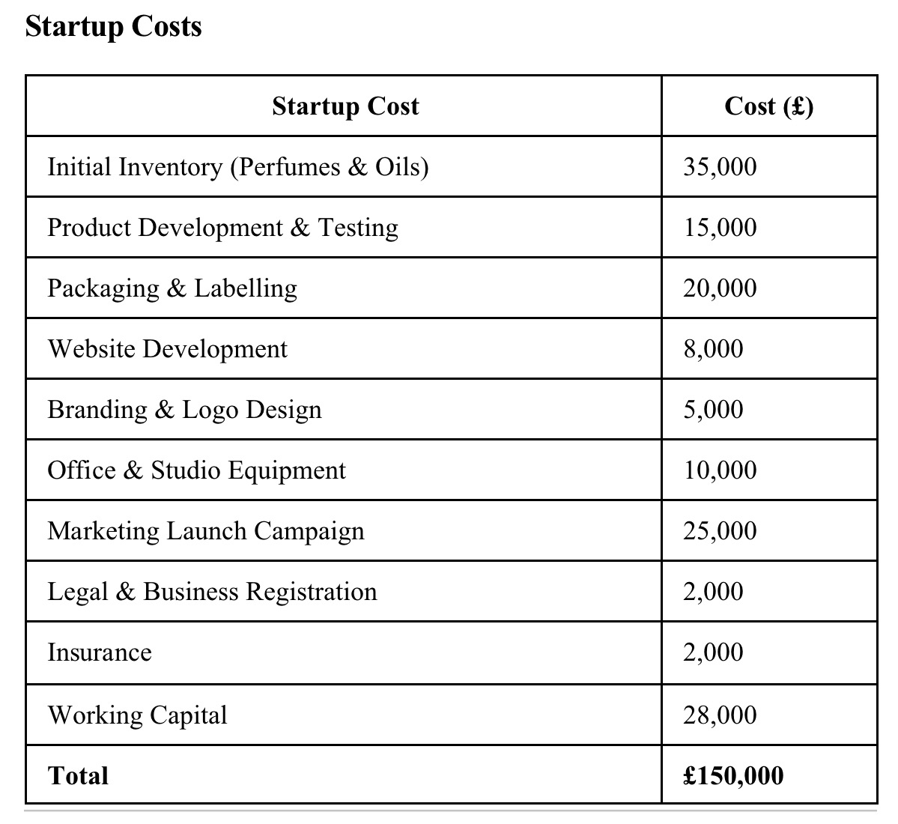

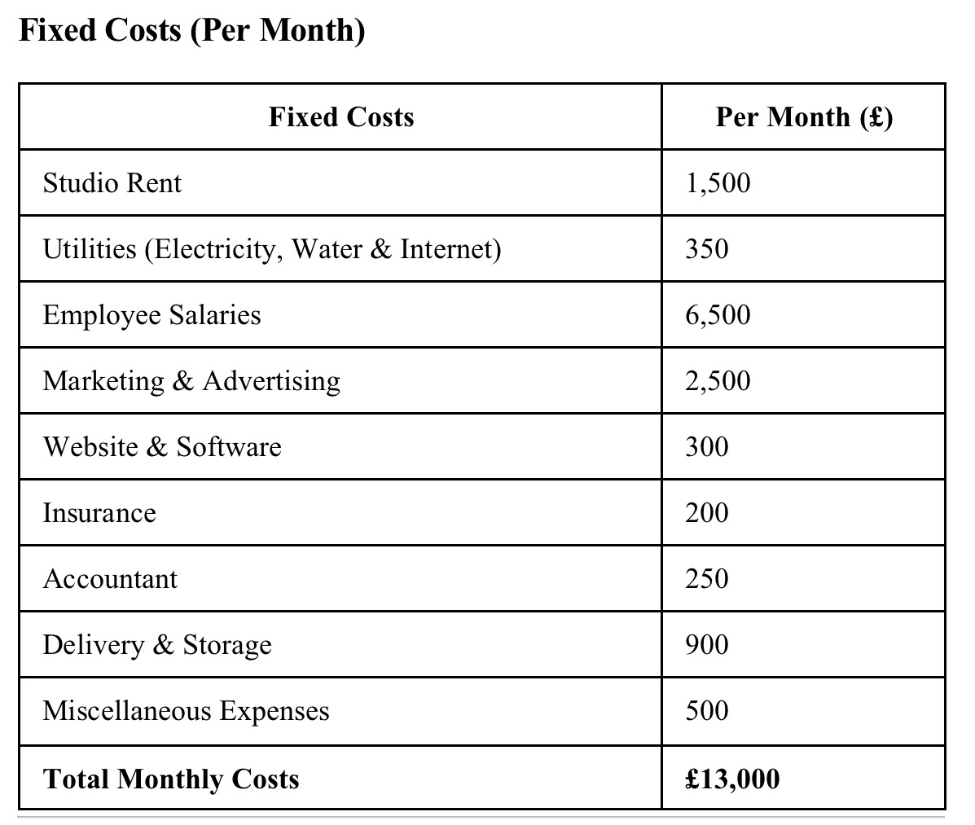

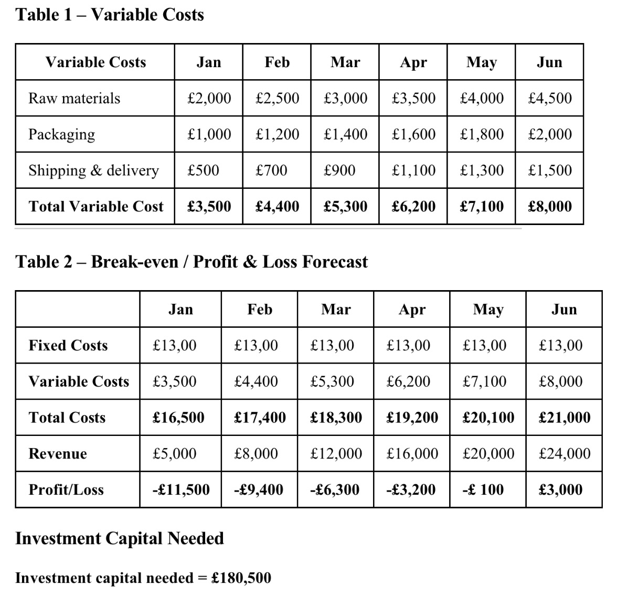

Conclusion
Aurora Atelier Parfums has the potential to establish itself as a successful business within the growing UK niche fragrance industry. The company combines premium-quality products with sustainable business practices, creating a clear competitive advantage in a market where consumers increasingly value authenticity and environmental responsibility.
Comprehensive market research demonstrates strong demand for gender-inclusive luxury fragrances and supports the proposed marketing strategy. By focusing on digital marketing, influencer partnerships and direct-to-consumer sales, the business can build a loyal customer base while maintaining strong profit margins.
Although competition within the fragrance industry is intense, Aurora Atelier Parfums is well positioned to succeed through its distinctive product offering, ethical values and long-term growth strategy. With appropriate funding and effective management, the business has the potential to achieve sustainable growth and become a recognised premium fragrance brand within the UK and European markets.

References (Harvard Style)
Data Bridge Market Research (2024) Global Perfume Market Size, Share and Forecast.
Karen Gilbert (2024) Creating a Perfume Brand on a Limited Budget.
Mintel (2025) UK Fragrances Market Report.
Technavio (2025) US Perfume Market Analysis and Forecast.
International Fragrance Association (IFRA) (2025) IFRA Standards.
Mariotti, S., & Glackin, C., (2017). Entrepreneurship: Starting and Operating A Small Business, 4th Edition, Pearson.
PESTLE analysis | CIPD

