LV6 Contemporary Themes
– Conference Learning Log

Student Name: | Dayna Mehandzhiyska

Week 1 | Monday June 22nd, 2020
Planning:

- To distribute the roles within the team
- Together to choose topic of the event
- Weekly team briefing meetings setting up
- Weekly tasks given to each of the group members in order to finish before the date

Organising:

- SWOT of each participant has been performed to properly position the roles within the group.

- Team selection –

Marketing and promotion of the event; technical - media partnerships, promotional materials, social media, website – Dayna

Project manager – Volen

Planning – any cases related to the organization of an event - with the venue itself, catering, necessary conference equipment, transport services, decoration, etc. – Stoyanka

Volunteers; administration -budget, preparation of a database of guests and visitors, main contact person, ticket sales (depending on the event), creation of online registration or registration for participation in the event - Milena

Managing:

- After discussion within the team a budgeting plan has been established
- Support offered from management team

Marketing:

- To create marketing plan
- To create website, mail and social media
- To share ideas with the rest of the group
- To plan and create presentation

Problems/Resolution Action Plan :

- Difficulty with the dividing of the responsibilities
- Some members missing the weekly meeting because of personal reasons

Focus for the Week:

- Conference to be set up
- Construct the idea as a whole, theme and topic
- Divide groups and responsibilities

Student Signature:

__________________________________

Date:
22/06/2020
_________________________________

Week 2 | Monday June 29th , 2020
Planning:

To choose event theme
To discuss the organisation and schedule breaks
To choose and invite guest speaker
To choose event venue

Organising:

Structure for the event has been created.

Structure of the conference: 9:00 am Welcome the guests | 9:30 introduction | 10:00 Presentation | 11:00 Coffee break | 11:30 Conclusion and Q & A | 12:30 End
Theme: Innovation integration

Guest speaker: Chris Barton

Managing:

- Tracking of all expenses; forecast expenditures
budget constraints were set, and everyone agreed to adhere to them

- From a marketing point of view, both the theme and the name of our event correspond to and are in tune with the industry and the field to which they are directed and accordingly make everyone talk about it.

Marketing:

- Logo of the company created
- Website of the team event company had been made
- Pages in social media created e.g. Facebook, Instagram and Twitter
- PowerPoint presentation discussed with the group members
- Invitations for the guests of the conference are in progress

Problems/Resolution Action Plan :

Planning team failed with finding a venue for the event.

Focus for the Week:

- Choosing the right venue
- Marketing team: To create invitations and email list with guests where invitations will be sent

Student Signature:

__________________________________

Date:
29/06/2020
_________________________________

Week 3 | Monday July 6th , 2020
Planning:

- Discussing different catering companies
- Plan invitations outlook
- Administration team was involved in choosing the right venue.

Organising:

- The set deadlines have been met
- Progress checking of each team

Managing:

- date, location, names of influential speakers and guests and which leading industry representatives will be present to be shared on the website.
- Management team assigned administration to help the planners with the decision regarding the choosing of venue

Marketing:

- Invitations are still in progress
- Production of flyers
- Mailing and contacting different guests
- Work on the website

Problems/Resolution Action Plan :

Marketing team failed to meet the deadline regarding the invitations.

Focus for the Week:

- Finding venue for the event
- Discussion about website content
- How effectively to solve the problem with the invitations

Student Signature:

__________________________________

Date:
06/07/2020
_________________________________

Week 4 | Monday July 13th , 2020
Planning:

- Catering company has been chosen
- Accommodation for our guest speaker

Organising:

Deadlines were met

Managing:

- Administration and marketing were assigned together to work through ticket sales
- Invitations were sent
- Tickets open for sale on our website

Marketing:

- Invitations were created by marketing team
- Promotional video for the website

Problems/Resolution Action Plan :

We did not have any problems

Focus for the Week:

- To make a decision on tickets
- Marketing team to create VIP guest list and send them invitations

Student Signature:

__________________________________

Date:
13/07/2020
_________________________________

Week 5 | Monday July 20th , 2020
Planning:

- Administration team to create expenses list to define final price
- Marketing team to work on the website layout

Organising:

Organised discussion about posters with marketing team

Managing:

- Project manager got involved in the creation of content for our social media pages including short promotional video

Marketing:

- Deadline for invitations and list of important guests met
- our marketing team contacted directly designers who created a branded stage, panel and other type of distinctive signs
- Social media platforms presence and content sharing
- Final work updating the website

Problems/Resolution Action Plan :

Presentation deadline not met

Focus for the Week:

Review presentation and discuss possible improvements

Student Signature:

__________________________________

Date:
20/07/2020
_________________________________

Week 6 – Final Week | Monday July 27th, 2020
Planning:

All deadlines were met

Organising:

Volunteers responsible team member final works

Managing:

Collaboration between project manager and marketing team was successful, the presentation was created

Marketing:

Final updates and improvements of the website

Problems/Resolution Action Plan :

No problems

Focus for the Week:

Final works – website/ social media

Student Signature:

__________________________________

Date:
27/07/2020
_________________________________

Conference Review | Planning; Organisation; Management; Marketing of the Event and Conference Delivery

Only four people were assigned for each group, which normally would be enough. However, we met difficulties in decision making and collaborating together as we were lacking an active leader that would navigate the whole working process. Even though I had identified the need of leader I could not take over the position.

There was more than enough time given, and we did not have problems to meet the deadlines.

Given the current situation and the impossibility the project to be realized, we did our best to make this poject-imitation as good as it can be.

Week 1

- Roles were distributed accordingly within the team, after discussion, each participant used SWOT analysis to help and choose the most suitable role.
- Budget was discussed and established
- We faced some difficulties as the person responsible for the administration was not present and slightly delayed our work.
- after making sure that there were no other similar events on and around this day, we chose 27th of august as the date of the event, making sure that our target group would be available.

For years, Eventry have been engaging with our target audience in a number of ways, including organising and facilitating monthly discussions. When we had the concept of hosting a conference, we shared it with thousands of our target audiences on a few different social media platforms, and the response was as very favourable.

Our event is aimed at hotel owners who wants to boost their business by investing money in innovative technologies. We have planned to first invite larger and more important companies, and then to announce the event on our website and social media platforms, after that to launch tickets for sale, our target group are owners of small and medium businesses, including owners of Air BNB
___________________________________________________________________________________________

Week 2

- The team discussed and created convenient structure of the event where the marketing team agreed to take care of the presentation. We estimated that the appropriate duration for the event will be three hours and this gives the opportunity, the speakers and presenters to be able to hold the attention of the participants as at the end after their coffee break we will give an opportunity for interactive Q and A , where all participants could show interest and learn more about the product.
- Choosing of name and topic of the event – As EVENTRY company has been recruited by successful tech company called RS PRO, producing face recognition door handles, our team decided that appropriate theme of our event will be ‘Innovation integration in the hospitality industry’.
- Guest speaker of our event will be Chris Barton – founder and CEO of Guard company
- Marketing team was up to date with all the tasks regarding the creation of social media platforms and logo. In order to reach our audience through the development and implementation of a regular communication plan, our marketing team was able to quickly and easily send personalized messages to our target group. We took advantage of the social media monitoring software. We tracked who used our "hashtag" which is called #InnovationIntegration, who shared photos from our event and noted attendance.
- we will give discounts to readers or omissions for the event and we will make a list and write to the people that we think are appropriate to share our event on their blogs
- Planning team could not meet the deadline and could not find appropriate venue.

___________________________________________________________________________________________

Week 3

- As planning team has failed with the finding of venue, our administration team members took care of this task and found and agreed price for an appropriate meeting room. The venue of the event and the food are the two biggest things in the costs of organizing our event. When choosing a venue for the event, there are many things to consider, but it is especially important to consider the hidden costs, which is why we chose a venue that will not cost us much as our administration team negotiates a good price. Also, the hall is well equipped which will save us money from the budget and has high speed internet. As It is important to pay attention to the location, we have chosen the most convenient for all the guests we have invited. Senate house is the administrative centre of the University of London, which is located in the main era of Bloomsbury. The place is on walking distance from four main stations Euston Square, Goodge Street, Russell Square and Tottenham Court Road.
One of the main challenges of larger conferences is seeking Wi-Fi facilities that can meet the needs of so many participants. There's no question that the performance of Wi-Fi is increasing at locations, particularly in London and other major cities, although it's worth having an honest understanding of Wi-Fi capabilities. Many of the venues today offer free Wi-Fi and this was one of our major concern which helped us in finding the right place.
- Catering company was found by planning team. In order to save unnecessary expenses instead of hiring waiters and service, we decided to provide the food at a buffet during the breaks where guests can enjoy food and drinks freely.
- Marketing team has failed to create invitations; more work on the website has been done; mailing list created

___________________________________________________________________________________________

Week 4

- Administration and marketing teams were assigned to work on ticket sales. They decided that small part of our exclusive invitations will be send to the VIP guests (big brands hotels) earlier, afterwards tickets will be available for sale on our website for any other small or large hospitality businesses. We needed something that was convenient-to-use and simple-to-maintain. We started to look at a few various options, including our own site selling tickets. In the end we decided to do both, Eventbrite and our website. Eventbrite has become a self-service website for tickets. amongst their many services they have to offer, the users can add different types of tickets, set start and finish time for purchases, give discounts and keep a record of attendees. Discount a limited amount of tickets on an early bird 's trip. This would be early in the development of our conference until the special guest is announced.
- Marketing team created video for the website; Invitation for our special guests were sent timely
- Team discussion was proceeded regarding the photographer of the event, where a member of the marketing team agreed to take on this task, as he has experience in the field, and this will give us the opportunity to spend resources from the budget in another direction.
- We met all set deadlines

___________________________________________________________________________________________

Week 5

- Administration team was to create list with our expenses so far, for the formulation of final price for the event, so we could check and track if the budged was exceeded
- More work needed to be done on the website layout
- Marketing team organised discussion regarding posters they were preparing, decision where they could be put for optimal advantage
- Marketing team could not meet the set deadline for the presentation, management decided to help and work together
- Management team made decision to be involved in the social media presence, as creating different engaging content including video

___________________________________________________________________________________________

Week 6

- All deadlines were met
- Final update of the website was made by marketing team
- Presentation was created by management and marketing
- After the event we are planning to gather feedback by making short videos of the participants in which they share what they have experienced, short surveys is also an option.
- The team responsible for the volunteers make sure the technique was tested in advance to have time to react in case of a problem; signs are available - places for food, places for meetings etc. It's better to get early access to the location because then you can analyse the property and plan a thorough plan in advance. this is why our team organised a walk-through for our external caterers and other vendors, so they are also familiar with the area, the location of the kitchen, and so on.

After the event we will make sure to send a special thank you mails to speakers and volunteers. Our team discussed that it could also contribute positively by sending an email to participants with a collection of slide shows, videos as well as other day-related resources.

To:_____,

We are Eventry company working in partnership with RS pro
We want to launch and popularise a unique product developed by forward thinkers.

Our conference special guest will be Chris Burton
We invite all interested small or big hospitality businesses to come, participate, and experience the future of hospitality technology. We will be glad to give you the right tools to evolve and advance your business



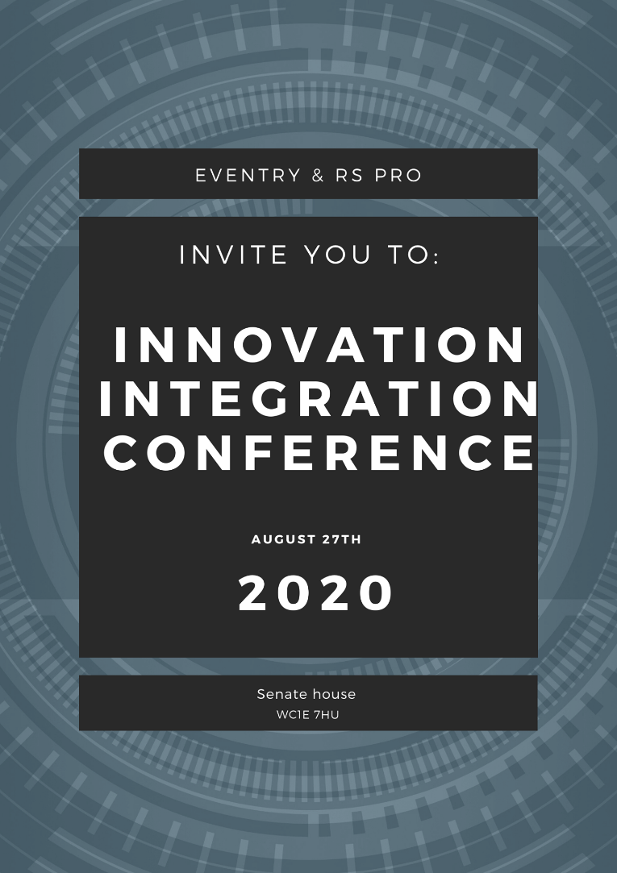








https://eventrycompany.wixsite.com/website





