Module name: Leading and Implementing Workplace Change
Module code: BMSW6103_LON
Student Name: Andreea Elena Popa
Student ID: 2115854

Leading and Implementing Workplace Change
Table of Contents
Introduction 3
1. Current State of the Company 3
2. Personal Involvement and Relationship with the Company 3
3. Recent/Current Change Initiative 4
4. Analysis of Recent History and External Environment 7
5. Evaluation of Change Management Models 13
6. Leadership Styles and Organisational Culture 14
7. Proposed Change Management Plan 15
Conclusion 19
Recommendations 20
Reference list 21

Introduction
In the contemporary business world, competition is reaching the sky where bringing subversive changes has become necessary for almost all organisations, regardless of their sizes and types. Bringing a change usually has an all-rounder impact on an organisation, which leads to changes both inside and outside the organisation. Ranging from designing a new product to transforming the service delivery system, the evolution of every phase depends on changes (Diaz-Iglesias et al. 2021). An effective change management plan is fundamentally directed by the leaders of an organisation. Leaders play a key role in ensuring the entire organisation and its employees get accustomed to the change that the organisation has been planning to bring. This assessment is aimed at establishing an effective change management process along with the most relatable leadership style of Tesco. The reason for choosing Tesco is that it comprises the largest chain of retailers in the UK and across the world. Effective leaders are held accountable to ensure a higher degree of adaptability and flexibility among employees in the organisation so that they can seamlessly comprehend the change and cope with relative challenges (Bagga et al. 2023). Maintaining inclusivity across the organisation to ensure employee engagement is the core essentiality of leaders in the organisation.

1. Current State of the Company
Since 1984, Tesco has been serving the retail industry in the UK, which is now pronounced as the largest retail chain on a global basis (Tesco, 2024). Approximately all types of people have been known to be the target market of Tesco. Only in the UK and in the Republic of Ireland, Tesco has been operating more than 4270 stores as of 2024 (Statista, 2024). Tesco offers all types of retail products, such as clothes, books, furniture, electronics, internet, telecom, petrol, software, toys, packaged food, software, households, groceries, home decor, financial services, and many more (Tesco, 2024). According to the global stock market report, Tesco earned approximately ₤66.50 billion pounds up to the second quarter of 2024 (Macro Trends, 2024). Inferring from the past financial data, it is evident that Tesco has been growing even after having a number of controversial cases due to incorporating some effective changes with the evolving nature of contemporary market states.

2. Personal Involvement and Relationship with the Company
I have been working as a Management Trainee at Tesco for the last 6 months. Since the beginning of my professional journey in Tesco, I have addressed a number of reasons for change in Tesco. I have found that the degree of internal conflicts is comparatively higher amongst colleagues. It is evident that Tesco took strategic action while expanding globally across both offline as well as online markets, there have been several conflicting scenarios regarding employee engagement. This, in turn, Tesco to experience a decline in employee morale, which reelected through its performance. Being a part of the operations team, I have also discovered that the company was facing severe instability in its financial gains due to employee-management conflicts. The pay rate was one of the core issues that Tesco was facing while aiming to improve employee performance to ensure the company's orientation towards customers.
In addition, a number of economic issues were there that led the company towards adapting to changes, such as The Great Recession of 2008-2009, COVID-19, The Russia-Ukraine War, and many more. These have increased the rate of inflation, and for this reason, the UK economy faced several fluctuations in the rate of interest, GDP growth rate, national economic turnover, and many more (Macro Trends, 2024). This fluctuating climate of the UK economy has severely affected the overall economic turnover of Tesco. Apart from that, the retail market in the UK has become highly competitive due to the growing number of businesses in the operating market. This is because the UK market is highly driven by the industrial area, which has been increasing the degree of intensity of the market. Evaluating all these reasons, it is evident that Tesco is at a higher degree of urge to bring change that can contribute to enhancing the level of competitiveness of Tesco in the UK’s retail industry.

3. Recent/Current Change Initiative
Tesco Plc. is a British multinational grocery and general merchandise retailer in England and is recognised as the third-largest retailer and third-largest brand based on gross revenues across the world. According to the market evaluation report, it has been declared that Tesco has captured the largest Market share in the UK and it recognises the need for change due to existing business losses. In this regard, Tesco has undergone significant global expansion since 1990 and now it operates within 12 countries (Tesco, 2023). In terms of the change initiatives, in 2023-2024, Tesco has recently undertaken its commitment to attaining net zero emissions across the value chain by 2050. This initiative holds major changes towards sustainability, encompassing comprehensive shifting in technology, operations, and strategic partnerships.
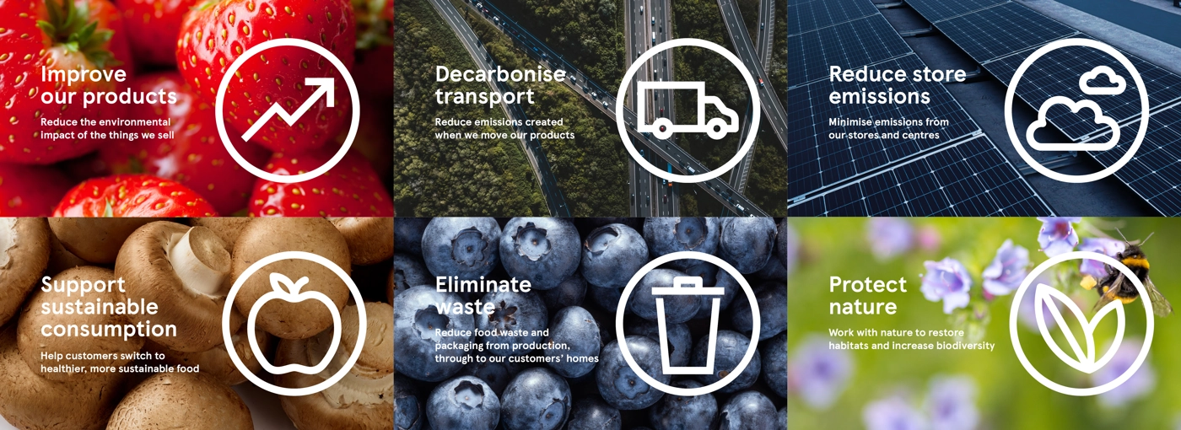
Figure 1: Net Zero target of Tesco by SBTi
(Source: Tesco PLC, 2023)
In terms of the changing initiative, Tesco focuses on sustainability and aims to achieve “carbon neutrality” by 2035 and achieve net zero across our full value chain which is aligned with a 1.5°C trajectory, by 2050. Additionally, Tesco (2023), reported that Tesco has become one of the first companies which have the Forests, Land, and Agriculture (FLAG) and non-FLAG need zero targets which are validated by the Science Based Targets Initiative (SBTi) and recognised as a leading global authority on science-based climate target for its best practices. This validation positions Tesco as one of the first FTSE 100 companies to align its goals with the Paris Agreement’s 1.5°C target (Tesco PLC., 2023). Tesco has set a goal to achieve net zero emissions in its own operations by 2035 and across its entire footprint, including supply chain and products, by 2050. In addition, in 2023/24, Tesco achieved a 61% reduction in complete emissions from the sustainability operation compared to the 2015 baseline which decreased the 2025 target of a 60% reduction (Tesco, 2023).
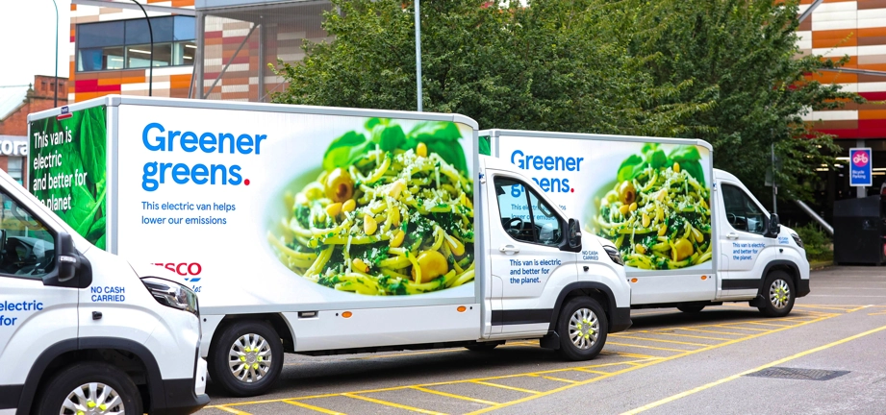
Figure 2: Reducing emissions by using low-carbon alternatives
(Source: Tesco, 2023)
Additionally, in terms of technology-changing initiatives, Tesco has transformed to 100% renewable electricity which enhances the reduction of carbon footprint across its global operations. Moreover, Disco is investing in electrifying its vehicle fleet including electric home delivery vans and hydrogen fuel cells which helps in reducing emissions from logistics and transportation and is a major part of the operational emissions of Tesco.

Figure 3: Reducing electricity by Electrification of Transport
(Source: Tesco, 2023)
Furthermore, in the context of recent changing initiatives, Tesco has introduced a sustainability-linked financing instrument including revolving credit facilities and sustainability-linked bonds financial initiative. It holds to the specific environment, social and government targets to reduce greenhouse gas emissions and develop diversity metrics. Thereafter, the two sustainability link bonds which were launched in 2020 and 2021 generated around £750 million and £400 million which supports suppliers to employ climate best practices in their value chain operations (Tesco, 2023). Hence, in changing the initiative of Tesco, it has committed to zero emissions by 2050 which is recognised as a comprehensive initiative involving significant changes in technology, operations and supplier collaboration. It reflects the dedication of Tesco Plc. to enhancing its sustainability in its value chain operations and achieving long-term environmental goals to attract partnerships across the world.

4. Analysis of Recent History and External Environment
PESTLE Analysis
Factors | Descriptions | Opportunity\Threat
Political | - The uncertainty of the UK political environment has been influenced by Brexit which decreased it has been declared that the overall sales of the retailers in the country (Partington, 2019). | Threat
Economical | - In 2023, it has been declared that the UK has experienced an 8 % food inflammation rate and the UK food sector has been recognised as the fastest growing rate in the retail and food sector (Refer to) (Clark, 2024b).  - The cost of products and raw materials in the business has gone up dramatically as a result of the food inflation situation in the UK. Therefore, these circumstances have significantly contributed to Tesco's declining earnings. On the other hand, Tesco's growing need for high-quality but less expensive products has forced them to cut their values, which has further decreased the company's profits. 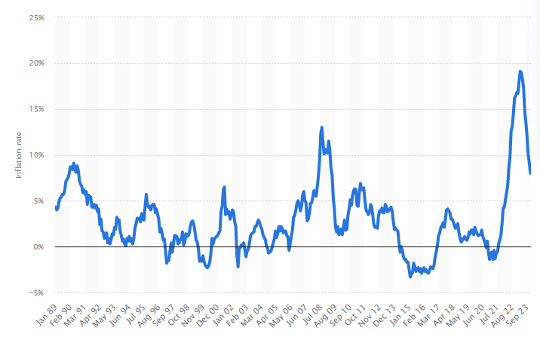  Figure 4.1: UK food inflation 2023  (Source: Clark, 2024) | Threat
Social | - In 2023, approximately 50% of UK consumers preferred more valuable products due to the inflammation rate within the UK reach led to 74% of people not purchasing any premium or luxury food products within the country (Bedford, 2023a). | Threat
Technological | - Artificial Intelligence is commonly used in the UK retail industry to manage data and analytics. Among other fields, AI is especially common in customer service, e-commerce, and warehouse management. AI is being used by UK shops to increase productivity and improve consumer experiences ​(Sabanoglu, 2019). In this regard due to the immense application of the eye, disco has allowed artificial intelligence to effectively manage their operation and generated significant revenue growth.  - The UK retailers have been facing challenges due to the digital transformation of the business, in this regard 36% of the UK retailers encountered a lack of digital skills eternally which has been recognised as the major challenge for digital transformation. In addition, the scarcity of communication and soiled departments have been identified as another challenge by 16% within the UK retailing business organisation (Sabanoglu, 2021).  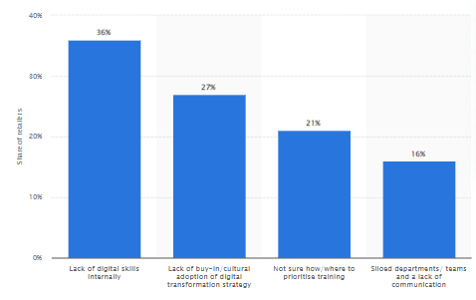  Figure 4.2: Challenges in the digital transformation of retail businesses in the UK  (Source: Sabanoglu, 2021) | Opportunity
Legal | - Health and Safety at Work Act 1974, by this law, governs employees and ensures the health, safety, and welfare of employees and the public (The Government of United Kingdom, 2024). In this context, Tesco implements these policies in its business operations to maintain safe working environments.  - The Employment Rights Act of 1996, this act ensures employees' rights and demonstrates areas such as unfair dismissal, redundancy, and workplace discrimination (The Government of United Kingdom, 2024). In this consideration, the HR policies of Tesco aligned with the Employment Rights Act to maintain fair treatment of employees. | Opportunity
Environmental | - Climate Change Act 2008, this act introduced legally binding targets for reducing greenhouse gas emissions (The UK Government, 2020). In this regard, in 2023-2024, Tesco Plc. Aims to reduce greenhouse gas emissions and sets a goal to achieve net zero across its value chain by 2050 (Tesco, 2023).  - Waste Electrical and Electronic Equipment (WEEE) Regulations 2013. These regulations mandate the proper disposal and recycling of electronic waste (The UK Government, 2020). Tesco offers recycling services for electrical goods in compliance with these regulations by implementing electric home delivery vans and hydrogen fuel cells in its value chain (Tesco, 2023). | Opportunity
Table 1: PESTLE Analysis
(Source: Created by learner)
Porter’s Five Force Analysis of Tesco:
Factors | Descriptions | Impact
Bargaining power of suppliers | Tesco has established direct relationships with leading grocery and food supply firms in the UK and around the globe (Tesco Plc, 2022). This extensive network of enhanced suppliers enables Tesco to significantly decrease its supply chain risk and evaluate the lower bargaining power of its suppliers | Low
Bargaining power of customers | The increasing inflation rate of UK retailers decreases customer demand as consumers prefer more affordable products (The Guardian, 2023). Consequently, customers have numerous options to choose from different retailers hence the bargaining part of customers in the UK is high. | High
Threats of New Entrants | The UK retail sector is highly dynamic and fragmented as well as it constitutes various players which hold a significant place in the market (Global Data, 2023). However, it has the largest market share in the UK retail industry and is a leading player this dominance reduces the threat of the new market of Tesco plc, due to its strong presence in the UK market. | Low
Threats of Alternative Products | Supermarkets dominate the UK retail sector by providing quality products at affordable prices (Smith, 2022). In this regard, Tesco is rated as one of the most valuable brands in the UK retail market which directly leads to a lower threat from its substitute products | Low
Competitive Rivalry | The leading UK retailers include Sainsbury’s, IKEA, Next, Primark, Curry’s, and B&Q (Global Data, 2023). In this context, Tesco encountered major competition from its rivals such as Sainsbury’s, Morrison’s, Asda, and Lidl (Race and Hooker, 2023).  Tesco, Sainsbury’s and rivals say they are not making too much money. | High
Table 2: Five Force Analysis of Tesco
(Source: Created by learner)

5. Evaluation of Change Management Models
Incorporating an appropriate change management model is necessary while bringing a change. This is because a change management model helps to ensure a systematic implementation of the change with greater success. The most preferable change management models are Nudge's Theory of Leading a Change and Kurt Lewin’s Change Management Model. Nudge theory comprises 4 stages, which are Preparation, Motivation, Ability, and Simplicity (Afshar Jalili, 2020). Preparation refers to ensuring people inside the organisation are aware of the effectiveness of the change along with its needs. Nudges help to increase the degree of employee motivation to ensure inclusivity and employee engagement to a greater extent. Nudge theory also enables leaders to develop skills, resources, and knowledge of employees so that they can perform a particular behaviour according to the change. Making everything simplified associated with a change is one of the most significant features of Nudge theory (Bauer et al. 2022). Therefore, nudges help leaders to ensure employee preparedness, a higher degree of motivation, and their capabilities so that they seamlessly comprehend the change and accept relative challenges in an optimistic manner.
On the other hand, Kurt Lewin’s Change Management Model is specific to three core stages, which are Unfreeze, Change, and Refreeze (Agyei, 2021). The accountable leader Unfreeze the current operating state of employees so that they understand the need for and efficiency of the change inside the organisation. In this phase, leaders provide training and development sessions to increase people’s adaptability and flexibility towards changes and also motivate them to stay involved throughout the change process (Rosdiana and Aslami, 2022). The Change phase consists of leading the change and introducing relative evolutions across the organisation in both internal as well as external environments (Burnes, 2020). Leaders drive employee performance according to the introduced change in the Refreeze phase where they monitor whether there are any issues associated with the implemented change (Agyei, 2021).
Speculating the case scenario of Tesco, the company approaches a systematic process to lead a change from both organisational as well as individual perspectives. This, in turn, leads Tesco to incorporate the gamification approach to ensure people behave in line with the introduced change. It is, therefore, evident that the Nudge Theory to Lead a Change is typically implemented as a change management model in Tesco. Nudges have been helping Tesco simplify the overall change process in terms of offering lower prices to ensure a huge target market, focusing on customers’ choices and preferences, implementing open communication, and maintaining a committed approach to leadership (Tesco, 2024). Nudges have been found effective for the organisation, as these increase people’s ability to perform more seamlessly so that success can be brought to a greater extent (Tikotsky et al. 2020). With this assistance, Tesco and its people have become more efficient in adapting to green technology and the latest innovations that can be conveyed to the market in terms of a huge rate of Return on Investment (ROI). Committed leadership practices in Tesco play a crucial role in ensuring people’s development consistently which helps increase their adaptability to changes.

6. Leadership Styles and Organisational Culture
Tesco PLC has employed several leadership skills over the past few years which reflect its significant goals and adapting to the market conditions. In this regard, Tesco Plc possesses a combination of transformational, transactional, and servant leadership styles. According to Steinmann, Klug and Maier (2019, pp- 1), Transformational leadership is a style where leaders motivate and inspire their followers to attain exceptional results which fosters the leadership capabilities of the followers. This approach emphasises visions, change and innovation. In the context of Tesco, the recent CEOs of Tesco, Dave Lewis and Ken Murphy, have exemplified transformational leadership, who served as CEOs from 2014-2020. His leadership prioritises significant transformation strategies that elevate customer experience, reduce costs, and foster innovation. In this regard, his notable initiative was the "Big Price Drop" campaign, aimed at reorganising the market position of Tesco (Tesco PLC., 2023).
In addition, Transactional leadership prioritises the exchanges that occur between its leaders and their followers by implementing a system of rewards and penalties to ensure the performance of the organisation. The “Every Little Helps” slogan of Tesco drives employees to address specific performance targets, and the company implements structured reward systems to recognize and incentivize staff achievements (Tesco Plc., 2009). Moreover, servant leadership centred around the role of leaders as a servant by priority meeting the needs of the team and organisation above their own. This leadership style prioritises Tesco's commitment to staff training and development as well as, its various community-focused initiatives.
Based on the organisational culture, Tesco has its core values which focus on serving communities, the planet, and customers better every day. In this regard, Tesco has become one of the leading organisations that have the Forests, Land, and Agriculture (FLAG) and non-FLAG required zero targets (Tesco, 2023). Moreover, Tesco Plc. also values its colleagues and employees, treating them well to ensure the proper achievement of goals and performance. In this context, Grant, O’Connor and Studholme (2019), claimed that the “creation of community at the workplace” fosters democracy, cooperation, diversity, common purpose, and inclusion within the organisation. Thereafter, Tesco (2018), revealed that Tesco launched “a new colleague administration role” It is in charge of protecting the personnel and helping the management teams in the organization's functional stores. Hence, improving an inclusive work caters for creativity and innovation which helps the continued transition of change management initiatives within the organisation.

7. Proposed Change Management Plan
Lewin’s change management model can be used to improve the company’s operations. The application of three steps, unfreeze, change and refreeze can ensure that the company is able to implement proper steps for mitigating the challenges efficiently.
Unfreeze
The first stage of Lewin’s change management model is the involvement of the organisation in the acceptance of the desired change as and when it is necessary. In terms of meeting the customer needs and demands, Tesco might be a bit short as far as the implementation of technology is concerned. For instance, the company has been strongly aimed at implementing technological change initiatives to ensure that carbon emissions from logistics are being reduced. However, the company has not initiated any major change in its technology to help the customers become familiar with the products that the company offers. Therefore, a technological change can be implemented within the company to ensure that the employees are able to work more productively and undergo a reduction in their overall workload.
Change
The change stage is where the employees of an organisation resolve their levels of uncertainty and look forward to doing things in a newer way. The change that the company can bring in its operations is the implementation of Robotic store assistants to assist the customers. From the findings of Song and Kim (2022), robotic store assistants might offer information on the products to guide the customers to specific store sections and propose any personalised recommendations based on their preferences. However, Tesco needs to provide a training and development plan and a communication plan for the change to take place efficiently.
Staff training and development plan
Level of Knowledge | Type of Knowledge
Level of Knowledge | Technical knowledge and literacy skills | Interpersonal skills | Conceptual and integrative abilities
Basic knowledge | Rotating jobs and direct help from the employees | Formal courses, role-play and lectures | Simulation and case studies.
Technical knowledge | Receiving help directly from the manager | Receiving help from the managers regarding the courses taught in the training sessions. | Case studies, YouTube tutorials and job rotation.
Efficiency in operations | Help from the managers and tutoring in the workplace. | Workplace tutoring and help from the managers. | Simulations and case studies.
Table 3: Staff Training and Development Plan
(Source: Created by the learner)
From the above staff training and development plan, help from the managers employees and trainers in the training sessions. To ensure that the employees are able to use the robotic store assistants, both basic and technical knowledge are required to be upskilled. Furthermore, it is also required for the employees to enhance efficiency in their operations before they can improve their skills. According to the comments of Riyanto et al. (2021), employee training in change management helps in motivating employees and can also improve overall productivity. For the change to be successful, it is important for the company to contribute to the success of the organisation by adapting to the change requirements and upskilling its processes. Furthermore, to ensure that the change is communicated efficiently to the management team and the employees, a communication plan also needs to be implemented to make sure that the employees adapt to it efficiently.
Communication plan
Stakeholders | Deliverables | Frequency | Priority | Owner | Preferred method of delivery
Employees | Update on the change | Daily | High | Line Managers | Team meeting
Managers | Updates on the staff | Weekly | High | Board of Directors | Emails
Board of Directors | Update on the change’s progress | Monthly | High | CEO | Conference
Executives | Update on the operations | Weekly | High | Board of Directors | Team meeting.
Table 4: Communication plan
(Source: Created by the learner)
The above communication plan is a demonstration that there will be a communication pattern based on hierarchy levels. Change management communication is useful in providing an explanation of the roles of the employees, improving the engagement of the employees and increasing the success of the changes (Errida and Lotfi, 2021). It will also allow the employees working at Tesco to enhance their critical thinking skills and allow for the feedback process. Furthermore, a communication plan will also avoid any resistance to change that might take place in the company.
Refreeze
The refreeze stage helps in internalising or institutionalising the changes after they have been confirmed in the previous stage which is the change stage. In this stage, the actual change within the context of Tesco is going to be implemented. In alignment with the context of Tesco’s operations, the usage of robotic store assistants can be useful in improving the operations of the company. However, for monitoring the change, it is recommended to provide an evaluation plan on the success criteria of the change. For instance, strategic objectives and outcomes can be measured every month or year to find out if the change implementation has been a success or not.
Evaluation plan
Strategic Objectives | Outcomes | Target | Frequency
To improve customer satisfaction rates | Customers may be satisfied if the implementation is successful. | 30% | Monthly
To improve the efficiency of the robotic store assistants | Robotic store assistants can guide the customers throughout the store to pick a product based on their choice along with recommendations. | 35% | Monthly
To increase the capability of the employees to maintain and use the robotic store assistants. | Employees might achieve proficiency in handling automated tasks. | 40% | Monthly
Table 5: Evaluation Plan
(Source: Created by the learner)
The above evaluation plan indicates the strategic objectives that will be achieved with the help of the change process implemented. Conducting an evaluation of the change management implemented can be useful in the determination of whether the desired goals have been achieved or not. Similarly, it will help the company in identifying if the strategic objectives are being achieved or not based on the effort applied by the employees (Reinholz and Andrews, 2020). Apart from the evaluation plan, it is also important in the identification of the elements that support change and the barriers that can sustain change. It can also ensure that leadership strategies can be implemented and Tesco can use a reward system for the employees who are able to adapt to the changes and escalate in their performance levels.

Conclusion
The study strives to prove that organisational change is important for almost all types of organisations to cope with the growing level of market competition. This study has focused on the management process and the contributions of leaders to lead a change in Tesco. In the UK, the retail market has a huge number of businesses across the UK’s retail industry. It is, therefore, evident for Tesco to lead a successful change to maintain its commitments towards the target market. In this respect, the organisation established a highly committed approach to leadership so that the effectiveness of its change practices can be brought to greater success. Tesco has long been serving the retail industry with a huge range of products as well as services, therefore, paying deep attention to leadership practices and leading changes are significantly important for the company. In this response, Tesco has largely promoted the transformational leadership style to ensure long-term employee engagement.

Recommendations
Looking at the effectiveness and strategic actions of Tesco, it is evident that the company still has some shortcomings because of its size. Managing a global business is a vast matter that significantly needs a strong and effective leadership approach that directly supports the overall management system. In this respect, Tesco can recommend certain strategic actions that can help both the organisation as well as its leaders to introduce a change with greater success, and those can be as follows:
- Tesco needs to implement multiple leadership styles according to the environment of the global operating market. This would help the company to ensure that the variability of leadership styles can seamlessly comply with the operating market so that changes can be designed and implemented accordingly.
- Tesco must implement the situational leadership style so that behavioural practices of leaders as well as employees can be evolved in accordance with situational requirements. Situational leadership would contribute to creating a continuous learning approach amongst employees so that they can stay prepared for every change and challenge with greater adaptability.
- Creating a consistent training and development programme is a must that Tesco would need to increase the degree of employee’s ability so that they remain more curious according to the upcoming change.

Reference list
Afshar Jalili, Y. (2020) ‘I rather share my knowledge: Applying gamification approach and nudge theory to develop an incentive system.’ VINE Journal of Information and Knowledge Management Systems, 50(2), pp.203-217.
Agyei, I.T. (2021) ‘Simulating HRM Technology Operations in Contemporary Retailing.’ International Journal of New Practices in Management and Engineering, 10(02), pp.10-14.
Bagga, S.K., Gera, S. and Haque, S.N. (2023). ‘The mediating role of organizational culture: Transformational leadership and change management in virtual teams.’ Asia Pacific Management Review, 28(2), pp.120-131.
Bauer, J.M., Aarestrup, S.C., Hansen, P.G. and Reisch, L.A. (2022). ‘Nudging more sustainable grocery purchases: Behavioural innovations in a supermarket setting.’ Technological Forecasting and Social Change, 179, p.121605.
Bedford, E. (2023). Tesco’s statutory operating profit in the UK and Ireland 2014/15-2022/23. [online] Statista. Available at: <https://www.statista.com/statistics/1078203/tesco-s-statutory-operating-profit-in-the-uk-and-ireland/> [Accessed on 10th July 2024].
Burnes, B. (2020) ‘The origins of Lewin’s three-step model of change.’ The Journal of Applied Behavioral Science, 56(1), pp.32-59.
Clark, D. (2024). UK food and drink inflation rate 2023. [online] Statista. Available at: <https://www.statista.com/statistics/285109/cpi-food-and-drink/#:~:text=The%20inflation%20rate%20for%20food> [Accessed on 10th July 2024].
Diaz-Iglesias, S., Carlos, U.R.J., Blanco-Gonzalez, A. and Orden-Cruz, C. (2021). ‘Theoretical framework for sustainability, corporate social responsibility and change management.’ J. Sustain. Sci. Manag, 16, pp.315-332.
Errida, A. and Lotfi, B. (2021) ‘The determinants of organizational change management success: Literature review and case study.’ International Journal of Engineering Business Management, 13, p.18479790211016273.
Global Data (2023). United Kingdom (UK) Retail Market Size by Sector and Channel Including Online Retail, Key Players and Forecast to 2027. [online] www.globaldata.com. Available at: <https://www.globaldata.com/store/report/uk-retail-market-analysis/> [Accessed on 10th July 2024].
Grant, A. M., O’Connor, S. A. and Studholme, I. (2019) ‘Towards a Positive Psychology of Buildings and Workplace Community:the Positive Built Workplace Environment’, International Journal of Applied Positive Psychology, 4(1-2), pp. 67–89. doi: https://doi.org/10.1007/s41042-019-00019-2.
Macro Trends (2024). Tesco Revenue 2010-2024 | TSCDY. Available at: https://www.macrotrends.net/stocks/charts/TSCDY/tesco/revenue#:~:text=Tesco%20annual%20revenue%20for%202024,a%2012.15%25%20increase%20from%202021. [Accessed on 10 July 2024]
Partington, R. (2019). UK retailers suffer weaker sales due to Brexit uncertainty. [online] the Guardian. Available at: <https://www.theguardian.com/business/2019/mar/05/uk-retailers-suffer-weaker-sales-due-to-brexit-uncertainty> [Accessed on 10th July 2024].
Race, M. and Hooker, L. (2023). Tesco, Sainsbury’s and rivals say they are not making too much money. BBC News. [online] 26 Jun. Available at: <https://www.bbc.com/news/business-66019190> [Accessed on 10th July 2024].
Reinholz, D.L. and Andrews, T.C. (2020) ‘Change theory and theory of change: what’s the difference anyway?’ International Journal of STEM Education, 7, pp.1-12.
Riyanto, S., Endri, E. and Herlisha, N. (2021) ‘Effect of work motivation and job satisfaction on employee performance: Mediating role of employee engagement.’ Problems and Perspectives in Management, 19(3), p.162.
Rosdiana, N. and Aslami, N. (2022) ‘The Main Models of Change Management in Kurt Lewin's Thinking.’ Jurnal Akuntansi, Manajemen dan Bisnis Digital, 1(2), pp.251-256.
Sabanoglu, T. (2019). Artifical Intelligence: areas of use in UK retail 2019. [online] Statista. Available at: <https://www.statista.com/statistics/1026052/artificial-intelligence-retailers-area-of-use-in-the-united-kingdom-uk/> [Accessed on 10th July 2024].
Sabanoglu, T. (2021). Digital transformation challenges in UK retail businesses 2019 | Statista. [online] Statista. Available at: <https://www.statista.com/statistics/1015823/challenges-retailers-see-in-digital-transformation-united-kingdom-uk/.>[Accessed on 10 July 2024]
Smith, P. (2022). Topic: Retail trade in the UK. [online] Statista. Available at: <https://www.statista.com/topics/8671/retail-trade-in-the-uk/#topicOverview> [Accessed on 10th July 2024].
Song, C.S. and Kim, Y.K. (2022) ‘The role of the human-robot interaction in consumers’ acceptance of humanoid retail service robots.’ Journal of Business Research, 146, pp.489-503.
Statista (2024). Tesco PLC - statistics & facts. Available at: https://www.statista.com/topics/3807/tesco-plc/ [Accessed on 10 July 2024]
Steinmann, B., Klug, H.J.P. and Maier, G.W. (2019). The Path Is the goal: How Transformational Leaders Enhance Followers’ Job Attitudes and Proactive Behavior. Frontiers in Psychology, [online] 9(2338). doi:https://doi.org/10.3389/fpsyg.2018.02338.
Tesco (2022) Culture | Tesco Careers, Tesco-careers.com. Available at: <https://www.tesco-careers.com/explore-our-world/our-culture/>[Accessed on 10 July 2024]
Tesco (2023). Corporate Responsibility Review. [online] Available at: <https://www.tescoplc.com/media/iksjndde/cr_report_may2004.pdf.> [Accessed on 10 July 2024]
Tesco (2024). Tesco PLC: About Us. Available at: https://www.tescoplc.com/about [Accessed on 10 July 2024]
Tesco Plc (2022). Tesco UK Stores LTD - first tier food and grocery non-food sites. [online] Tesco Plc. Available at: <https://www.tescoplc.com/media/blofvbq0/primary-supplier-list_jan-2022.pdf> [Accessed on 10th July 2024].
Tesco PLC (2023). Five Year Record. [online] Tesco PLC. Available at: <https://www.tescoplc.com/investors/reports-results-and-presentations/financial-performance/five-year-record.>[Accessed on 10 July 2024]
Tesco Plc. (2009). Tesco. [online] Available at: <https://www.tescoplc.com/media/whyf4qco/tesco_cr_review_2009.pdf.>[Accessed on 10 July 2024]
Tesco Plc. (2022). Annual Report and Financial Statements 2022. Available at <https://www.tescoplc.com/media/759057/tesco-annual-report-2022.pdf.>[Accessed on 10 July 2024]
Tesco PLC. (2023). Tesco’s ambitious net zero targets validated by Science Based Targets Initiative. [online] www.tescoplc.com. Available at: <https://www.tescoplc.com/tesco-s-ambitious-net-zero-targets-validated-by-science-based-targets-initiative/.>[Accessed on 10 July 2024]
The government of United Kingdom (2024). Health and Safety at Work Act 1974. [online] Hse.gov.uk. Available at: <https://www.hse.gov.uk/legislation/hswa.htm.>[Accessed on 10 July 2024]
The Guardian (2023). UK retailers face weak demand and a barrage of increased costs. The Guardian. [online] 18 Dec. Available at: <https://www.theguardian.com/business/2023/dec/18/uk-retailers-face-weak-demand-and-a-barrage-of-increased-costs> [Accessed on 10th July 2024].
The UK Government (2020). What is the 2008 Climate Change Act? [online] Grantham Research Institute on climate change and the environment. Available at: <https://www.lse.ac.uk/granthaminstitute/explainers/what-is-the-2008-climate-change-act/.>[Accessed on 10 July 2024]
Tikotsky, A., Pe'er, E. and Feldman, Y. (2020) ‘Which nudges do businesses like? Managers’ attitudes towards nudges directed at their business or at their customers.’ Journal of Economic Behavior & Organization, 170, pp.43-51.

