Title: The effects of Making Tax Digital on small and medium manufacturing enterprises in South Wales

Dissertation Research Proposal

1. Introduction
1.1 Rationale
1.2 Aims and Objectives
1.3 Background and literature review

2. Research Design
2.1 Methodology
2.2 Philosophies
2.3 Research Approaches
2.4 Research Strategies
2.5 Research Choices
2.6 Time Horizon
2.7 Sample
2.8 Data Collection Method
2.9 Limitations
2.9.1 Time Management and Sample
2.9.2 Ethical Considerations

3. Reliability and Validity

4. Resources and Planning
4.1 Resources
4.2 Gantt Chart

5. References

- Introduction

This dissertation research project has been designed to provide an insight into a recent tax regulation, which was launched by a government in 2016. The dissertation will hopefully uncover in full the implications of MTD in South Wales area. The findings of the research will assist in understanding how manufacturing SMEs will adopt to the new tax initiative.

  - Rationale

The HMRC’s aims to increase the efficiency of tax administration with the introduction of Making Tax Digital, will potentially have a great impact on accounting industry.

Since August of 2016 HMRC has been introducing a new regime of digitization of tax returns. HMRC has set a goal to become the world’s most efficient tax system, so an attempt was made to simplify tax affairs and make it easier for taxpayers to comply with tax regulations (Citizen Safe, 2017).

According to Anamwong (2016), Making Tax Digital (MTD) is a major concern not only for taxpayers, but for accountants and tax consultants, who would have to adapt to modernized tax system and to guide their clients through digital accounts.

The Self-assessment tax returns system, which was launched almost two decades ago, was a revolution in the way taxpayers interacted with HMRC. The new Making Tax Digital proposal will introduce sweeping changes again in the relationship between taxpayers and HMRC (Broomfield Alexander, 2017).

In addition, Laing (2016, pp.52) claims that the relationship between accountants and their clients will also become different. With a modernization of current tax system, it is anticipated more active collaboration between clients and HMRC agents. Accountant is less likely to be involved as an intermediary. MTD programme will affect self-employed people, people in partnerships, landlords and businesses with profit over VAT threshold.

This study will look deeply on the consequences of new government tax initiative for manufacturing SMEs in South Wales. It will also scrutinize the reason for it making a substitute to self-assessment tax return. According to Bloomsbury Professional Tax Guide (2017) newly implemented tax project will challenge small businesses to comply with a list of certain rules, one of them is to submit tax returns quarterly.

The primary goal of this study is to meet its aims and objectives, which are tied to exploration of the nature of MTD.

1.2 Aims and Objectives:

The aim of the study to evaluate the effects of Making Tax Digital on small and medium manufacturing enterprises in the South Wales Area.

There are three objectives of this study:

- To analyse the reasons behind the introduction of making tax digital

- To identify the challenges, opportunities and implications, which a new tax system would bring for small manufacturing businesses in South Wales.

- To make recommendations to manufacturing SMEs in South Wales to ensure the efficient adoption of MTD.

  - Background and literature review

MTD project was introduced by the Government in 2016 and will be launched in the full capacity after 2020. As a result, there are only quite a few publications and research made on the following topic area.

One of the main and the most reliable literature source for the dissertation will HMRC website. It narrates in exact details the ways of implementing MTD. For instance, it clarifies how HMRCwill be working with businesses and individuals, what will be the timeline of changes towards MTD, etc.

ACCA (2017) holds the view that MTD offers new opportunities for accounting practices. For instance, MTD will make it easier for small businesses to pay tax. Time delays and the burden related to the paper form completion will be considerably reduced. Owners of the businesses would just need to update the MTD interface once in three months. Also, accountants will obtain more clarity of their client’s finances. ACCA admits that if accounting companies embrace new tax regulations successfully, their practice will become more attractive to clients.

Top accounting companies provide their own views on how they are planning to deal with new government initiative and what implications are expected from it.

According to HMRC publications, businesses will be mandated to utilize the MTD for Business system until April 2019. However, in the one interviews, tax director of PwC, Adrian Rudd (Shaoib, 2017), doubts that the time frame for implementation of MTD is realistic. It may take years in for HMRC to ensure that the tax initiative was executed successfully by the vast majority of businesses and individuals.

2. Research design
2.1 Methodology

Sachdeva (2007, p.6) has identified a research as “a systematic process of collecting and analysing information (data) in order to increase our understanding of the phenomenon about which we are concerned or interested”.

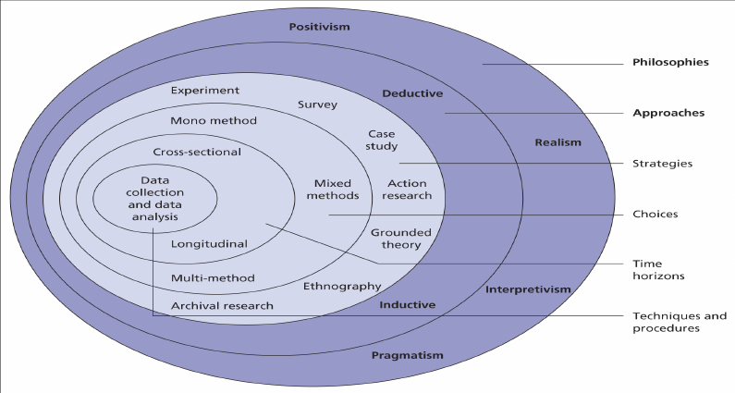
Figure1: Research Onion by Saunders (2009, p.108)

The research onion, proposed by Saunders (2009, p.108), assists in clarifying research strategies. Each layer demonstrates in what direction the research should be developed. The research onion provides a choice of philosophies, approaches, strategies, choices, horizons, techniques and procedures that should be undertaken to meet ultimate aims and objectives of the study.

2.2 Research Philosophies

Positivist and interpretive philosophies will be applied to this study.

Saunders (2009, p.103) states that only “factual” knowledge acquired through observations, including measurement, can be scientifically reliable. From a positivistic view, one of the main limitations for the researcher is the collection of data and its further interpretation through objective analysis. Positivism depends on quantifiable observations that lead themselves to statistical analysis. It has been noted that “as a philosophy, positivism is in accordance with the empiricist view that knowledge stems from human experience”. Utilisation of positivism necessitates gathering of quantitative data, which in this case, will be done via surveys.
Fisher (2013, p. 214) points out that interpretivism, which is perfectly suitable for qualitative data analysis, is concerned about construing the elements of study and taking into consideration human interests into research. Interpretivists are convinced that solely via “subjective interpretation and intervention in the reality” will enable us to understand the reality. This type of philosophy subjectifies world where individuals experience physical and social reality differently. For dissertation, couple of interviews will be conducted, and philosophy of interpretivism will be a solid philosophical base for this strategy.

2.3 Research Approaches

As philosophies of interpretivist and positivism are applied to these studies, both deductive and inductive approaches will be utilised.
Saunders (2009, p.127) assumes that an inductive approach involves identifying a pattern from observations, developing logical explanations for them and thereafter postulating theories. Theory is developed only after the data has been collected. It is also considered that if a topic of the research is relatively recent, but have already raised debates, and on which there is a lack of academic literature, it is appropriately to select an inductive approach. As this approach deals with qualitative data interpretation, the conduct of interview will be relevant to these studies.
In terms of deductive approach, Saunders (2009, pp. 129) holds the view that this method refers to “the development of theory that is subjected to the development of theory that is subjected to the rigorous test”. This approach supposes the analysis of quantitative data which in this case will be gained through questionnaires.

Methodological Choice
2.4 Research Strategy:
Research strategy is vital as it aims to maximise the benefits of the studies by advancing fundamental knowledge (Dinnen, 2014).
Survey, which is associated with a deduction approach, will be a part of the research strategy for this dissertation.
Saunders (2009, p.144) assumes that “surveys allow to obtain more control over the research process and when sampling is used, it is possible to generate findings that are representative of the whole population”. However, one of the main disadvantages of data collection via surveys is that its further analysis with a help of software prone to be very time consuming.
In addition, to increase reliability of the studies, a case study will also be regarded as a research strategy. Number of interviews will be taken. Robson (2002, p. 178) defines case study as ‘a strategy for doing research which involves an empirical investigation of a particular contemporary phenomenon within its real-life context using multiple sources of evidence’.

2.5 Research Choices:
These studies will be based on mixed methods, as both quantitative and qualitative data via surveys and interviews will be gathered.
According to Cameron (2014) mixed research methods include collection, analysis and interpretation of numerical and qualitative information in one entire study or series of studies, which explore one particular phenomenon. This method offers a more investigational scrutiny, as a combination of quantitative and qualitative approaches provides a clearer comprehension of the research problems. The final purpose of this research choice is not to replace qualitative or quantitative data, but to submerge their advantages and overcome weaknesses in both approaches within a single study.
In addition, to provide a solid base for the validity of the research, data triangulation method will be used as a technique for a research choice.
Bryman (2007, pp.130-133) identifies data triangulation as a “use of two or more independent sources of data or data collection methods to corroborate research findings within a study”. It refers to the application and combination of several research methods in the study of the same phenomenon.
In the frame of this study, triangulation will facilitate validation of data collected via surveys and interviews.

2.6 Time Horizon:
The following study will be concerned with a cross sectional time horizon approach, as it compares a different population at a single point in time. Unlike longitudinal studies, cross sectional study allows to draw a comparison between variables quicker and it does not demand months/years of observations.
However, Olsen and George (2004, pp.7-11) indicate that one of the disadvantages of cross sectional time horizon is, because of its narrow time frames, it has a more superficial approach to a study and it will not allow to deeply analyse the cause and effect of the phenomenon.

2.7 Sample:
Convenient sampling will be employed as a sampling method for this study, which is also widely known as an opportunity sample. It can be identified as a non-probability sampling method where subjects/participants are involved in the research process because of their easy accessibility and proximity to the researcher (Sekaran, 1992, p. 272)
Convenient sampling will be applied to both surveys and interviews. The approximate number of manufacturing SMEs in South Wales is 90 000 (StatsWales, 2015), but the only 30 -50 surveys will be sent out. Because of time limitations, 2-3 interviews will be taken from accounting professionals.
In the following studies, industry professionals within manufacturing SMEs of South Wales will be targeted. They will be accountants, managers and owners of the businesses.
2.8 Data Collection Methods:
Saunders et al (2009, p.137) admits that data collection methods suppose the utilization of the method, through which the research will find the answers to its fundamental questions and will meet its goals and objectives. Surveys and interviews will be conducted to meet the goals and objectives of the dissertation and to justify the rationale of the dissertation.
Survey will be conducted among managers of the manufacturing SMEs in South Wales. The questions in the survey will measure the impact of Making Tax Digital on the businesses around South Wales region. Likert scale will be used to identify the attitudes and the opinions of the participants. The sample size of the survey for the research will not exceed 50-100 people over the age of the 18. The advantage of the surveys is that “they allow the collection of a large amount of data from sizeable population in a highly economical way (Saunders, 2009).
In addition, this study will contain interviews with accountants, who will express their overviews on Making Tax Digital and will identify the difficulties and opportunities manufacturing SMEs may envisage with a new upcoming tax regulations in South Wales. The advantage of the interviews is that participants can share plenty of details to provide a decent answer. Interviews also achieve a high response rate.
2.9 Limitations of the research
2.9.1 Time Management and sample
Due to the nature of dissertation there will be couple of factors to adhere to. One of them is time. This factor may set rigid limitations to the scope of analysis and research execution, which, as a consequence, will set a boundary to the depth of the following studies. For instance, time devoted to the research will imply limit to the total population of all manufacturing companies from which the number of the interviews and surveys will be taken.
Opportunity sample which has been selected for its simplicity and short period of time, during which the data can be collected.
The sample may not reflect various perspectives, and there are chances that biased information may occasionally be provided.
The main limitation of the research is that the chosen topic area is quite recent. Government made its first announcement of making tax digital in 2016. A few books have been written on the proposed subject for the dissertation. Articles from journals and websites will utilised for the secondary research.
It is worthwhile to mention that some of the articles from respectable online sources (websites) do not tend to have the author and/or date for them. This can be considered as limitation because it may have an effect on thoroughness of referencing.
2.9.2 Ethical Considerations
Surveys will be sent to financial directors of manufacturing SMEs, seeking their professional views on MTD.
There are not too many issues of this study that can be related to ethical considerations.

3. Reliability and validity
According to Hernon and Schwartz (2009, pp. 73-74), reliability can be identified as concept which evaluates the “extent to which the data can be consistent”. Whilst, validity is defined as a concept that refers to the “extent to which study results are generalizable to the population”.
Saunders (2007, pp.156) defines the reliability as something that “refers to the extent to which the data collection techniques or analysis procedures will yield consistent findings”.
The reliability of this studies can be assessed by posing three following questions:
- Will the measures match the same results on the occasions?
- Will the similar conclusions be reached by the researchers at the end of the observations?
- Is there a transparency in how sense was made from the row data?

It is crucial that the findings gathered represent high validity and high reliability. This can be achieved if the execution of the research is in consistent pattern to limit the impact of variables. The research must be conducted in a fairly and unbiasedly ways, which is consistent to all participants.
Robson & McCartan (2015, pp.169-170) states that validity estimates how credible and believable the research is.
Quinton et al (2005, pp. 299-311) claims that using multiple methods can provide better opportunities to answer a research question and to evaluate the extent to which findings may be trusted and inferences made. For that reason, in this research surveys and interviews will be conducted.
Quinton et al (2005, pp. 299-311) further determines that it is crucial that the findings represent high validity and high reliability. This can be achieved if the execution of the research is in consistent pattern to limit the impact of variables. With mixed methodologies, it is aimed that this research will be conducted in a fairly and unbiased ways, which is consistent to all participants.
In order to increase reliability and validity of the following research quantitative and qualitative research methods will be utilised.

4.Resources and planning
4.1. Resources
Reports, books, journals, magazines and professional accounting websites will be a solid base for the research of this study. The above-mentioned resources will be accessed through online research databases provided by University, libraries and various search engines.
4.2 Gantt Chart
In order to map out tasks that are needed to be accomplished, the utilization of Gantt chart can be considered (Kumar, 2015, p.15). It assists the researcher to plan tasks efficiently and ensures that the researcher is on the right track to accomplish the aims and objectives by preparing a timeline checklist. Attached below in Figure 2. is the Gantt chart indicating the plan for the following dissertation, including deadlines for the specific tasks.



5. References
Anamwong, S. (2016). Finally, more information about Making Tax Digital! Retrieved from The Freelancer & Contractor Services Association (FCSA): http://www.fcsa.org.uk/resources/technical-briefings/finally-more-information-about-making-tax-digital/
Bougie, R., & Sekaran, U. (2009). Research Methods for Business: A Skill Building Approach. Chichester: John Wiley & Sons Ltd.
Brown, R. B. (2006). Doing Your Dissertation in Business and Management.
Bryman, A. (2007). The research question in social research: what is its role?
Cameron, R. (2015, July 2). Mixed Methods Research. Retrieved from https://www.deakin.edu.au/__data/assets/pdf_file/0020/681023/Dr-r-cameron_mixed-methodology.pdf
Dinnen, J. (2014, March). Clearly Define Your Research Strategy. Retrieved from MacKenzie Corp.: https://www.mackenziecorp.com/phase-2-clearly-define-research-strategy/
Ebdon-Poole, T. (2016, March 24). HMRC Making Tax Digital – What You Need To Know. Retrieved from TaxCalc: https://www.taxcalc.com/blog/hmrc-making-tax-digital-what-you-need-to-know
Fisher, C. (2010). Researching and Writing a Dissertation: An essential guide for business students. London: Pearson Education Limited.
Global, A. (2016, August 31). MAKING TAX DIGITAL: SEPTEMBER 2016 UPDATE. Retrieved from ACCA Global: http://www.accaglobal.com/uk/en/technical-activities/technical-resources-search/2016/august/making-tax-digital-sept-16.html
Hattersley, R. (2016, September 15). AccounitngWEB. Retrieved from MTD: Will accountants be nudged aside?: https://www.accountingweb.co.uk/tax/hmrc-policy/mtd-will-accountants-be-nudged-aside
Hernon, P., & Schwartz, C. (2009). Reliability and validity. Library & Information Science.
Jones, E.-L. (2017, August 3). MTD delay – “welcome news” for accountants. Retrieved from Accountex: http://www.accountex.co.uk/mtd-delay-welcome-news-accountants/
Knill, J. (2016). The implications for taxpayers of the ‘Making Tax Digital’ regime. Retrieved from Knill James Chartered Accountants: https://www.knilljames.co.uk/news/knill-james-news/archive/news-article/2017/March/the-implications-for-taxpayers-of-the-making-tax-digital-regime
Laing, S. (2016). Core Tax Annual 2016/17. Croydon: Bloomsbury. Retrieved from https://books.google.co.uk/books?id=JtR6DQAAQBAJ&pg=PA52&dq=sarah+laing+making+tax+digital&hl=en&sa=X&ved=0ahUKEwifrMvtxp3XAhWMvBoKHfOTAXQQ6AEIKDAA#v=onepage&q=sarah%20laing%20making%20tax%20digital&f=false
Making Tax Digital - what does it mean for you? (2016, August). Retrieved from Free Agent: https://focusaccountancy.co.uk/wp-content/uploads/2016/08/making-tax-digital-for-micro-businesses.pdf
McLeod, S. (2014). Sampling Methods. Retrieved from SimplyPsychology: https://www.simplypsychology.org/sampling.html
Olsen, C., & George, D. M. (2004). Cross-Sectional Study Design and Data Analysis.
Partnership, T. T. (2012). The Bloomsbury Professional Tax Guide 2017/18. Croydon: Bloomsbury. Retrieved from https://books.google.co.uk/books?id=dpaWDQAAQBAJ&pg=PA10&dq=making+tax+digital&hl=en&sa=X&ved=0ahUKEwj-9a-Ol4DXAhUGSRoKHSDZBSwQ6AEIQzAG#v=onepage&q=making%20tax%20digital&f=false
Purdue, M. (2017, July 4). Delayed Making Tax Digital Announced. Retrieved from Digita Professional suite: https://www.digita.com/pro/blog/making-tax-digital-timetable/
Quinton, S., & Smallbone, T. (2007). The Troublesome triplets: issues in teaching reliability, validity and generalisation to business students.
Robson, C., & McCartan, K. (2015). Real World Research. London: John Wiley & Sons Ltd.
Sachdeva, J. K. (2009). Business Research Methodology.
Saunders, M., Lewis, P., & Thornhill, A. (2009). Research Methods for business students. Financial Times.
Smith, E. (2017, April 12). Making Tax Digital: Is HMRC’s recent system fault a cause for concern? Retrieved from AccountancyAge: https://www.accountancyage.com/2017/04/12/making-tax-digital-is-hmrcs-recent-system-fault-a-cause-for-concern/
Smith, E. (2017, April 25). Making Tax Digital: Revolution or revolt? Retrieved from AccountancyAge: https://www.accountancyage.com/2017/04/25/making-tax-digital-revolution-or-revolt/
Taxes are going digital - Here's what you should know about it. (2015). Retrieved from CitizenSafe: https://www.citizensafe.co.uk/tips-and-guides/taxes-are-going-digital
What is Making Tax Digital & when does it start? (2016). Retrieved from Broomsfield Alexander professional advisors: https://www.broomfield.co.uk/services/tax/making-tax-digital/



Contents

5. References 12
2.1 Introduction to Literature Review 16
2.2 Origins for introducing MTD 16
2.3 History Prior to MTD 17
2.4 Rationale for MTD 17
2.5 Purpose of quarterly reporting 18
2.6 Criticism and challenges of MTD 19
2.7 Tax digitization in other countries 20
2.8 Agents 20
2.9 Accounting Software for MTD 21
Appendix 22
References 23

2.1 Introduction to Literature Review
The purpose of this chapter is to provide a critical review through a systematic research of the introduction of a new tax regime, making tax digital.
This study is of an exploratory nature and it is not the intention of the author to identify a definitive answer. Information for this chapter was collected solely via online resources.
There is a substantial amount of literature, which enables the researcher to provide answers for the main research questions. This chapter will evaluate the opportunities and challenges that taxpayers and accounting agents will face with implementation of MTD. Also, an attempt will be made to unravel the reason for introducing MTD.

2.2 Origins for introducing MTD
When first announced, MTD was explained as a new regime from which businesses will benefit by lowering their compliance costs. However, according to different tax experts, the first and foremost reason for introducing MTD was to assist in closing the tax gap, which is the difference between the tax HMRC expects to be paid and the tax which is actually paid. Because of errors made and carelessness in small business the net tax gap is evaluated to be £8.2 bn. (Hubbard, 2017).

Cave (2017) who was analysing the speech of HMRC representative Jim Harra, found out that tax authorities firmly believe that timely and digital recording of transactions will reduce errors made by omissions of income and expenses. Also, the digital transmission of that data will not allow copying and the transfer of errors. By eliminating those mistakes, the MTD programme will increase the tax paid by small businesses to £870m per annum.

2.3 History Prior to MTD

Before MTD, taxpayers had to file Self-Assessment tax return within 10 months of the tax year. The vast majority of small business owners used to keep digital records in excel spreadsheet. Businesses did not have to utilise certain accounting HMRC linked software to meet the filing requirements (McNeill, 2017).

2.4 Rationale for MTD

Kitcat (2017), who is a head of policy at Crunch Accounting, states that there has been a protest regarding the implementation of MTD, but mostly complaints have not been justified. He has a positive outlook in MTD and he thinks that the new regulation is quite necessary for everyone in the UK as it will make taxation simpler, more precise and quicker.

Government has also bowed to pressure in allowing spreadsheets to be counted as ‘digital record keeping’. Kitcat (2017) has some concerns about this, as spreadsheets can be to contain inadvertent error and confusion, while purpose-built software can be more robust. However, it will simplify the transition for those individuals, who are not able work online all the time or for whom it is more convenient to work with spreadsheets.

Kitcat (2017) identifies the clear benefit of MTD. By combining the updates along with other data from banks and pension providers, for instance, HMRC will have a considerably accurate snapshot of the individual’s tax position. This will reduce or even eliminate the over and underpayments that can make cash-flow an issue for the self-employed.

Warwick-Ching (2017) discovers that under the current system a tax return has to be submitted yearly, but HMRC believes that filing on a frequency of at least once every three months will definitely have a positive effect on accuracy. Having digital records will also boost the tax-collector’s ability to identify trends and changes, enhancing their ability to tackle underpayment and evasion more effectively. During the interview with Warwick-Ching (2017) Gordon Andrews, tax and planning expert at Old Mutual Wealth, says that MTD will also simplify for tax-collectors when seeking evidence from businesses and individuals where documentation is required to validate or analyse figures mentioned in a submission.

Warwick-Ching (2017) has also highlighted that HMRC has already started using real-time PAYE data to reduce end-of-year overpayments and underpayments, by making changes in tax codes in-year. Individuals have probably received the PAYE coding notice of the pension which uses information already available to HMRC recently. In future, taxpayers will be able to see what reliefs and personal allowances are set against which sources of income, and to decide how those are allocated. It is clear that the “making tax digital” project will revolutionise the way HMRC deals with people’s tax affairs. This year, the Treasury select committee recommended that HMRC ought to slow the pace of implementation and conduct more trials, before it is rolled out nationally. However, there is a lack of clarity whether HMRC’s plans will be changed, and whether implementation will be delayed.

Despite the lack of clarity in terms of how MTD will be implemented Thomas (2017), KPMG Director of global mobility service, in her article highlights the opportunities and the significance of upcoming tax regulations. She lists the main advantages of MTD implementation:

She is convinced that MTD will allow the reduction:
- the administrative time of Global Mobility teams in tracking payments and refunds, potentially freeing up their time to track assignment costs and return on investment by the business
- the burden and time delays associated with paper form completion and postal exchange
- the phone interactions with HMRC

- She firmly believes that the new system will encourage software developments that gather and submit information to the digital account in a real-time environment.

2.5 Purpose of quarterly reporting

Theresa Middleton, HMRC representative, confirmed that the data transmitted in the quarterly updates to HMRC would only be summaries of income and expenses, and not accounts. This data would not be checked for accuracy by HMRC. The only sanctions applicable to quarterly updates would be penalties for late or non-submission. However, the first year of MTD would be a soft landing when no penalties would be applied. (Cave, 2017)

Middleton (2016) further admits that HMRC would only get digital data transmitted in the quarterly updates. It would reflect income and expenses, and not accounts. HMRC would test the accuracy of the data. Late or non-submissions of quarter reports would be penalised. She also added that the first year was supposed to be a soft landing of MTD, so no sanctions and penalties would be applied.

When clarity about the reason for quarterly tax submissions was requested, Jim Harra, HMRC representative, responded that it was only the combination of keeping digital accounting records and making regular returns to HMRC which would close the tax gap. He said this reduction of the tax gap had been proven with the introduction of RTI, which required more frequent returns from employers. (Lovell, 2016)

Middleton (2016) added that the quarterly updates would assist businesses with predicting and planning cash flow, as the response from HMRC would provide the business with rough estimate of the amount of tax owed. However, she claimed that this would not always reflect a reasonable figure of tax due on the income, especially when there were seasonal changes in profit.

2.6 Criticism and challenges of MTD
Williams (2017) is cautious about MTD being a heavy burden for small businesses. A number of tax experts state that new tax regulation may demand extra admin and IT costs. Government’s aim to fully digitize taxation in the UK by 2020 worries even small business experts. Williams is concerned that small business will struggle with increased administration work because of quarterly submissions, investment of money in accounting software and time for staff training.
Williams (2017) believes that large corporations have more sophisticated accounting software and accountants, so the switch to for them a new system will be easy.
Howard & Featherstone (2017) are convinced that with implementation of MTD, small businesses will experience many changes, and because of the scarce resources they will not be able to keep up with large companies. In addition to the MTD plan, small businesses are already challenged by doubling insurance premium tax, automatic pension enrolment, the extra cost of the living wage, the infrastructure levy and revaluation of business rates.
Morris (2017) suspects that the primary target of MTD is the contractors, who are paid by large businesses not as employees, but as self-employed individuals. The key benefit for large companies is that it avoids employment legislation, but also avoids paying employer national insurance, which constitutes 13.8%. The self-employed, also called contractor, only has to pay the employee contribution, which is equal to 9%. The increase in the employee Class 4 contribution to 11% aimed to put an end to this practice.
Morris (2017) further predicts that an increase in Class 4 rates and MTD in general may cause damage to the enterprising nation, and small businesses, of which 76% are self-employed sole traders. Morris also adds that Philip Hammond, Chancellor of the Exchequer, will need to close the £2bn tax gap by recalibrating the attention from small businesses to large corporations with their complex tax avoidance schemes.
The vast majority of taxpayers directly affected by MTD cannot take any further action towards the new system due to the lack of details. Unfortunately, it is uncertain with the recent announcement whether enough information has been provided for taxpayers to start planning now, particularly there are some uncertainties over the threshold. However, there is a complete clarity in terms of scale of the task that remains. At the heart of MTD is the software- taxpayers and agents will need to find out what software should be used, merits and demerits of each, its price, payment for installing it and training. Murphy (2017), KPMG tax advisor, is convinced that even large businesses will have to make changes in administration process.

Even tech-savvy companies accuse HMRC and the government of having unrealistic expectations for small business. Ray Backler, the CEO of Kapsa Accounting, commented that he and his clients have been utilising cloud software for more than a decade, so he is familiar with the types of mobile apps that will digitally capture main data from bills, invoices and receipts. The process is not always as straightforward as it might be,’ he reports (ACCA, 2017).

According to Ray Backler, expenses are not always identified correctly. The mobile app sometimes captures the wrong date, amount and supplier all in one photo. The users of the tax mobile app need to make sure that a single receipt for solely petrol is not taken for chocolate bar or newspaper, and the receipt should be identified only as a motor expense (ACCA, 2017).

2.7 Tax digitization in other countries
In order to predict what may be expected from MTD, Izza (2017) compares how other European countries have dealt with the digital advancement of their tax systems.

The Czech Republic digital tax regulation was implemented in just one year for all taxes. Filing methods were not intercompatible and requested excessive and irrelevant information. As a result, for most of the taxpayers in the Czech Republic tax reform remains unclear and the tax efficiency is vastly undermined.
Nonetheless, in the 1990s Estonia developed one single database, which gathers all tax records and connects to banks and government. The platform can be accessed from various government departments and organisations. It allowed Estonia to embrace tax digitization successfully (Kitcat, 2017).
Kitcat (2017) praises the Swedish tax system for its simplicity, reliability and successful organisation. The Swedish tax authorities took it upon themselves to do as much work in preparing taxpayers’ returns as they possibly could by using the data they had access to. Swedish taxpayers with regular monthly incomes would receive a text message or email asking them to confirm that the tax calculations for the year were accurate. If everything looked correct, the taxpayer just replied ‘OK’, and they were done.
Singapore has made a step forward towards digital tax advancements as well. In Singapore paper filing is no longer accepted for some returns and the transition to mandatory electronic filing (e-filing) for tax returns is under way. ‘E-filing of tax returns is currently voluntary, but will be made mandatory for all companies in respect of their YA 2020 tax returns,’ says Ong Siok Peng, tax partner, Deloitte Singapore. This mandatory e-filing is being phased in, with the largest companies (by turnover) being required to e-file earlier (ACCA, 2017).

2.8 Agents
MTD will challenge not only ordinary taxpayers, but accountants as well (Anamwong, 2017).
For many agents, the first step will be to segment their clients into groups depending on the client’s willingness and ability to use software to maintain digital accounting records. The approach will need to be tailored to the different groups of clients and agents may wish to consider the range of services they will offer. There are decisions to be made about software including the choice of software by clients and the extent to which the agent will wish to influence that choice and offer training and support. (ICAEW, 2017)
HMRC’s strategy is for tax agents to access HMRC systems through the use of commercial software. Agents who do not currently use commercial software will need to consider doing so, as the current web-based HMRC systems are likely to be gradually phased out. HMRC is committed to providing agents with access to client information in HMRC systems and has stated that the necessary services to comply with MTD obligations on behalf of clients will be available from the start of MTD (Stokdyk, 2017).
Agents will see some of their non-business/landlord clients being moved out of self-assessment (in tranches depending on the types of income they receive). The replacement will be the Personal Tax Account with data being updated directly, via software or, increasingly, pre-populated. These changes are being introduced using a phased approach (Riches, 2016) .
Tax agents from ClearBooks (2017) accounting company, concluded that because of MTD, demand for qualified accountants may rise as their guidance for the new tax regime will be extremely useful. Due to a potential lack of knowledge or lack of skills, one in five entrepreneurs may find it hard to cope with MTD software. Since MTD allows some people to be excluded, there must be someone else nominated to file quarterly tax submissions on their behalf. It is highly likely that accountants will take over the role of a liaison with HMRC.

By focusing on MTD, a number of companies will increase the number of clients and profit margin. Agents from ClearBooks (2017) explain that new tax regulation may appear to be a brilliant opportunity for accounting company to stand out among competitors by providing additional value to the services. People will need assistance to ensure compliance and accountants will assist them in meeting deadlines, avoiding penalties and submitting accurate tax returns.

In one of the surveys conducted by Ipsos Mori Institute, it was found out that 7 out of 10 people answered they are unaware of impending MTD and its requirements (Fino, 2017).
The result of the questionnaire has showed that 72% would need advice from their accountant, 20% will find out how to deal with MTD from the HMRC’s website, 13% will use the HMRC’s helpline, and 5% will ask for assistance from relatives and friends (Fino, 2017).
Tina Riches, tax partner at Smith and Williamson, urges tax advisers and chartered accountants to adapt their knowledge and skills. She predicts that the nature of the demand for their services will shift more from the book keeping to the tax compliance (Bartram, 2017).
Accountants are likely to find those businesses already using digital records easier to guide through the MTD process than those that are not. McCooney, a partner at chartered accountants Duncan & Toplis, identifies that the main challenge for an accountant is being prepared to MTD long time before its full implementation. He also states that if the company has started to make digital records, it will be less difficult for tax agents to provide guidance through new tax system. The willingness of the accountants and the entire company to adapt will decide their success and profitability (Bartram, 2017).

2.9 Accounting Software for MTD
With the implementation of MTD, accountants and taxpayers will have to keep their financial records online in a particular accounting software.
According to the Chartered Institute of Taxation (2017), a business will be obliged to produce only digital records only. ’Functional Compatible software’ must be utilized to comply with new regulations. Digital records have to be reflected in software, which is connected to HMRC’s platform through Application Programming Interface (API).
It is expected that the software will have a functionality to store business records in a digital form
and keep those digital records for 6 years. It will also produce a VAT return from the digital records, providing HMRC with any additional data voluntarily and acquire feedback from HMRC about the compliance of business records.

In addition, with the implementation of the new tax regime, there was uncertainty over the role of HMRC agents. According to McNeill (2017), HMRC’s current agents, who provide online services, will be substituted by MTD software (API). The new tax system will be based on one platform and data pool across all taxes. HMRC’s software will go through a five-year digital transformation and will allow third parties software to access HMRC systems.

McNeill (2017) has found out that there will be no free software for agents. However, it was guaranteed by HMRC that free software will be offered to small business, whose turnover is below the VAT 85 000 pounds threshold, with no employee s and utilizing cash-basis accounting.
McNeill (2017) pointed that the performance of the accounting company after implementation of MTD will be heavily dependent on the software used. Agents ought to get in touch with the software providers to find out the range of functions of the software and the timeframe of the tax submissions. All agents need to ensure that the software meets the requirements of their clients. For instance, MTD accounting software for individuals cannot be used by businesses as it is connected to a Personal Tax Account, while currently MTD Business accounting software aims to record mainly VAT returns (ICAEW, 2018).

Appendix
Here is a summary of the key milestones of MTD to come:
January – June 2017
New online billing system comes into effect.
Taxpayers able to report additional sources of income through their PTA.
Testing for digital reporting of income from letting property.
July – December 2017
Digital tax accounts to show taxpayers an overview of their liabilities in one place.
Automatic tax code adjustments to prevent PAYE under and overpayments.
January – June 2018
Interest paid by banks and building societies starts to be shown in digital tax accounts.
July – December 2018
Most businesses, self-employed and landlords start updating HMRC quarterly for income tax and National Insurance obligations through their accounting software.
Taxpayers who currently report their Child Benefit to HMRC no longer need to do so.
2019
Most businesses, self-employed and landlords start updating HMRC quarterly for VAT obligations through their accounting software.
Capital Gains Tax on the disposal of residential properties needs to be paid within 30 days.
2020
Most companies to start updating HMRC quarterly for Corporation Tax obligations through their accounting software.
The full range of HMRC services are available through digital tax accounts.

References
AccountingWEB. (2017). The MTD software race is on. Retrieved from AccountingWEB: https://www.accountingweb.co.uk/tax/hmrc-policy/the-mtd-software-race-is-on
Alexander, B. (2017). What is Making Tax Digital & when does it start? Retrieved from MHA Broomfield Alexander: https://www.broomfield.co.uk/services/tax/making-tax-digital/
Anamwong, S. (2017). Finally, more information about Making Tax Digital! Retrieved from FCSA: http://www.fcsa.org.uk/resources/technical-briefings/finally-more-information-about-making-tax-digital/
Bartram, P. (2018). How accountants and clients can benefit from Making Tax Digital | ICAEW Economia. [online] Economia.icaew.com. Available at: http://economia.icaew.com/en/technical-update/may-2017/how-accountants-and-clients-can-benefit-from-making-tax-digital [Accessed 19 Jan. 2018].
Cave, R. (2017). MTD: Rationale is to raise more tax. Retrieved from AccountingWEB: https://www.accountingweb.co.uk/tax/business-tax/mtd-rationale-is-to-raise-more-tax
CitizenSafe. (2017). Taxes are going digital - Here's what you should know about it. Retrieved from https://www.citizensafe.co.uk/tips-and-guides/taxes-are-going-digital:
ClearBooks. (2018). A brief guide to Making Tax Digital - Accountancy Age. [online] Available at: https://www.accountancyage.com/2017/09/15/a-brief-guide-to-making-tax-digital/ [Accessed 19 Jan. 2018].
ClearBooks. (2018). Is MTD a threat to your accounting firm?. [online] Available at: https://www.accountingweb.co.uk/community/industry-insights/is-mtd-a-threat-to-your-accounting-firm [Accessed 19 Jan. 2018].
Chartered Institute of Taxation. (2018). Making Tax Digital for VAT - Main issues for consideration | Chartered Institute of Taxation. [online] Available at: https://www.tax.org.uk/policy-technical/technical-news/making-tax-digital-vat-main-issues-consideration [Accessed 19 Jan. 2018].
Drew, K. (2017). Making Tax Digital (MTD) to replace Self-Assessment returns. Retrieved from Ascentat : http://ascentant.co.uk/making-tax-digital-mtd-replace-self-assessment-returns/
Dyson, R. (2017). New tax system for self-employed will 'seriously harm economy'. Retrieved from Telegraph: http://www.telegraph.co.uk/tax/self-employed/new-tax-system-self-employed-will-seriously-harm-economy/
Fino, J. (2018). Businesses rely on accountants for MTD advice | ICAEW Economia. [online] Economia.icaew.com. Available at: http://economia.icaew.com/en/news/december-2017/businesses-rely-on-accountants-for-mtd-advice [Accessed 19 Jan. 2018].
Gillet, G. (2017). What does digital exclusion mean for MTD? Retrieved from Walter Kluwers: https://www.wolterskluwer.co.uk/blog/topic/mtd?hsCtaTracking=3393dcdb-2c69-448b-837d-6aa3416e0603%7Ca08242dd-5aae-4bd3-b6e9-aa36a892e643
Gowers, L. (2017). Introducing Making Tax Digital or MTD. Retrieved from BOOX: https://www.boox.co.uk/introducing-making-tax-digital-or-mtd/
Hall, J. (2017). Self Assessment overhaul: what 'Making Tax Digital' means for the self-employed. Retrieved from Simply Business: https://www.simplybusiness.co.uk/knowledge/articles/2016/09/self-assessment-overhaul-what-making-tax-digital-means-for-self-employed/
Howard, E., & Featherstone, E. (2017). Business groups attack HMRC plans for quarterly tax returns. Retrieved from Guardian: https://www.theguardian.com/small-business-network/2016/apr/07/business-groups-attack-hmrc-plans-for-quarterly-tax-returns
ICAEW. (2017). MTD for agents. Retrieved from ICAEW: https://www.icaew.com/technical/tax/making-tax-digital/mtd-for-agents
Jones, R. (2017). Tax raid postponed as ministers rush through finance bill. Retrieved from Guardian : https://www.theguardian.com/money/2017/apr/25/tax-raid-postponed-ministers-rush-through-finance-bill-snap-general-election
Kennedy, W. (2017). Introduction to Making Tax Digital . London: Wilkins Kennedy. Retrieved from http://www.wilkinskennedy.com/static/media/uploads/GUIDES%202017/guide_-_2017-05_-_introduction_to_making_tax_digital.pdf
Kitcat, J. (2017). Making Tax Digital: What's It All About? Retrieved from Minute Hack : https://minutehack.com/opinions/making-tax-digital-whats-it-all-about
McNeill, P. (2017). Five things you need to know about practice software under MTD. Retrieved from ICAS: https://www.icas.com/technical-resources/five-things-you-need-to-know-about-practice-software-under-mtd
Meadows, S. (2017). Further questions over 'Making Tax Digital' as HMRC demands 7p from 83 year-old. Retrieved from Telegraph: http://www.telegraph.co.uk/tax/income-tax/questions-making-tax-digital-hmrc-demands-83-year-old-7p/
Meall, L. (2017). Digital tax administration is here. Retrieved from ACCA Global: http://www.accaglobal.com/uk/en/member/member/accounting-business/2017/04/practice/digital-tax.html
Middleton, T. (2017). Making tax digital: the view from HMRC. Retrieved from Tax Adviser: https://www.taxadvisermagazine.com/article/making-tax-digital-view-hmrc
Morris, A. M. (2017). Raising tax on small business – what does Philip Hammond think he is doing? Retrieved from Telegraph: http://www.telegraph.co.uk/news/2017/03/09/raising-tax-small-business-does-philip-hammond-think/
Murphy, S. (2017). Government has no plans to defer its Making Tax Digital reforms. Retrieved from KPMG: https://home.kpmg.com/uk/en/home/insights/2017/02/tmd-government-has-no-plans-to-defer-its-making-tax-digital-reforms.html
Riches, T. (2016). Making tax digital: examining the consultation. Retrieved from TAXJOURNAL: https://www.taxjournal.com/articles/making-tax-digital-examining-consultations-20092016
Rossmartin. (2017). Making Tax Digital: survival guide (for the self employed). Retrieved from Rossmartin: http://www.rossmartin.co.uk/self-employed/making-tax-digital/2536-what-making-tax-digital-means-for-you
Smith, E. (2017). Making Tax Digital: Is HMRC’s recent system fault a cause for concern? Retrieved from Accountancy Age: https://www.accountancyage.com/2017/04/12/making-tax-digital-is-hmrcs-recent-system-fault-a-cause-for-concern/
Stokdyk, J. (2016, October). Agent authorisation will transfer to MTD. Retrieved from Accounting Web : https://www.accountingweb.co.uk/tax/hmrc-policy/agent-authorisation-will-transfer-to-mtd
Thomas, B. (2017). Making Tax Digital; Reshaping Tax Climate. KPMG. Retrieved from https://home.kpmg.com/content/dam/kpmg/uk/pdf/2017/09/making-tax-digital-and-the-impact-on-mobility-functions.pdf
Warwick-Ching, L. (2017). Will new HMRC reporting rules mean I have to pay my accountant more? Retrieved from Financial Times: https://www.ft.com/content/1cac7c94-f435-11e6-95ee-f14e55513608
Williams, M. (2017). Small businesses may end up paying the price for digital tax system. Retrieved from Guardian : https://www.theguardian.com/small-business-network/2016/nov/10/small-businesses-digital-tax-system-hmrc-entrepreneurs
Xero. (2018). Getting ready for making tax digital | Xero. [online] Available at: https://www.xero.com/uk/resources/accountant-bookkeeper-guides/cloud-accounting/making-tax-digital/ [Accessed 19 Jan. 2018].

Chapter 3: Research methods

The aim of this chapter is to consider the importance of the research process. The chapter analyse data collection methods, research designs and will justify certain approaches applied to the research to meet the research aim

The aim of the study to evaluate the effects of Making Tax Digital on small and medium manufacturing enterprises in the South Wales Area.

and objectives:

1) To analyse the reasons behind the introduction of making tax digital

2) To identify the challenges, opportunities and implications, which a new tax system would bring for small manufacturing businesses in South Wales.

3) To make recommendations to manufacturing SMEs in South Wales to ensure the efficient adoption of MTD.

3.1 Influences on methodology

Creswell efficiently splits the research into several consecutive stages: "Research is a process of steps used to collect and analyze information to increase our understanding of a topic or issue". It consists of three steps: Pose a question, collect data to answer the question, and present an answer to the question” (Creswell, J. W. (2008).

Another definition of the research is provided by Collis and Hussey. Collis and Hussey (2003) define research as “a process of enquiry and investigation that is systematic and methodical and increases knowledge”. Research methodology according to Hussey (1997) refers “to the overall approach to the research, from the theoretical under pinning to the collection and analysis of the data.”

It is vital to select the most efficient ways to analyse, collect and present the data.
By ensuring that the right method is selected, the best possible results from the research can be concluded. The research design, data collection tools, the research process and the data analysis techniques selected to achieve the research objectives must be justified. Within the research process there are six fundamental stages of the research which are common to all scientifically based investigations. After each stage of the process it is important that the researcher reflects and refers back to the research topic and objectives (Hussey, 1997).

3.2 Research onion
To gather and analyse the research material needed to complete the study an appropriate framework must be adopted. Saunders et al (2003) describe the research process as an ‘onion’ that depicts the issues underlying the choice of data collection methods.

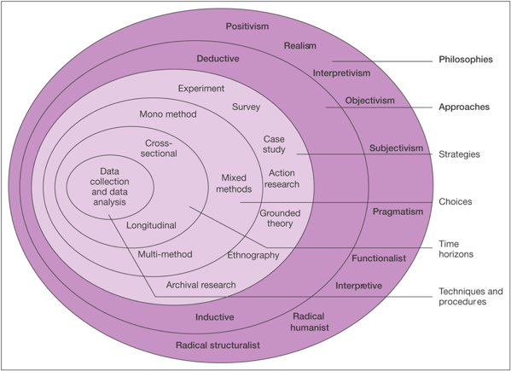
Before deciding on which method to adopt each layer of the ‘onion’ has to be peeled away and discussed. The first layer of the onion relates to the philosophy chosen that underpins the research. The second layer identifies the research approach that follows on from the philosophy. The third layer defines the research strategy, what strategy is used to conduct the research. The fourth layer determines the research choices of the research, what method is used. The fifth layer identifies the time horizons of the study. Finally the centre of the onion will show a culmination of all of the layers and show the data collection methods and data analysis techniques.

3.3 Research paradigm

The research paradigm is: ‘A perspective about research held by a community of researchers that is based on a set of shared assumptions, concepts, values and practices' (Johnson & Christensen, 2012, p. 31). This definition suggests that the research paradigm can be used when planning and conducting research. Saunders, et al. (2009) suggests that, when embarking on research, an individual aim to develop their knowledge in a particular area.
According to Saunders, et al. (2009), the strategy and methods chosen during the research depend on what the researcher wants to find out. The primary research for this dissertation involved accountants, business owners, managers, tax consultants to complete questionnaire. Therefore, it is highly likely that the results of the research are based on the perceptions of each individual, within the parameters of the questionnaire. Considering the above, is appears that the research will follow the interpretivism approach.
Collis & Hussey (2014, p. 45) state that: ‘Interpretivism focuses on exploring the complexity of social phenomena with a view to gaining interpretive understanding.' The interpretivism approach tends to use small samples, produce subjective and quantitative data, provide results with low reliability but high validity and allow the results to be generalised for a number of different settings (Collis & Hussey, 2014).
Also, for the purpose of this study a positivist philosophy has been applied to the data collection methods. In positivist studies, the researcher is independent from the investigation and there are no provisions for human interests within the study (Saunders, et al., 2015). Within a positivist study framework, data collected is subjected to the quantitative analysis and hypothesis testing.
3.4 Research Approach
Inductive approach will be applied to the following studies as the researcher aims to construct a theory based on the results of the interviews or tests.
3.5 Research methods/strategy

According to Lancaster (2007), there are a number of methods which can be used to collect data during research. Examples include case studies, observation, experimentation, interviews, surveys and other secondary data collection methods.
For the purposes of this research, a questionnaire was designed, allowing the research to be conducted among those who will be primarily affected by MTD. When planning the questionnaire, considerations were made with regards to the benefits and limitations of conducting a survey.

An online survey was designed using a questionnaire design website, known as Google Forms. A link to the survey was posted on via LinkedIn profile to the accountants, managers and business owners.
One advantage of using an online survey is that the survey will be available for completion 24 hours a day, meaning participants can complete the survey in their own time (Conway, 2004). Another advantage is the cost of conducting the research. Bryman & Bell (2015) argue that, by conducting an online survey, the researcher will save on costs such as paper and ink needed for paper-based questionnaires. Another advantage is that participants will be more likely to share their honest views, which they may not feel comfortable doing if it was a face-to-face paper-based survey (Brace, 2008). Finally, response time is reduced as participants only have to click on their answers. Also, using a website such as Google Forms cuts down the time taken to analyse the data as the software automatically produces graphs and charts relating to the responses given (Conway, 2004). The main disadvantage of using an online survey during the research is that internet access and some computer expertise in required to complete the survey (Conway, 2004).

In order to get a higher number of responses and to increase the validity of the research, 20 paper surveys were printed out and taken to accounting companies to be completed by accountants and tax advisors.

When planning the questionnaire, considerations were made with regards to the benefits and limitations of conducting a paper- based survey.

According to Brace (2008), one advantage of a paper-based survey is that participants may take more time to consider their responses to the questions. However, printing a hundred copies of the survey would be costly. In addition, not every participant may be willing to spare the time to complete the survey. Also, Wright (2005) argues that it would take a long time to complete the research as well as the time taken to organise and analyse the data if using paper-based surveys.

Once the researcher had completed the first design of the questionnaire, a pilot study was carried out. This study involved the researcher distributing the questionnaire to a number of friends and family members and asking them to read through and complete the survey, highlighting any issues they were faced with when answering each question. Doing this enabled the researcher to identify any flaws within the questionnaire and eliminate them before the full-scale research was conducted.
3.6 Questionnaire and interview design
The questionnaire for this research consisted of 20 questions, ranging from questions on professional background to questions specific to MTD topic area. The researcher wrote the questions in a way which was clear and concise so that respondents were able to fully understand and answer all of the questions. Researcher ensured that respondents to the survey remained anonymous.
The questionnaire was designed to include both open-ended and closed questions, with the intention of gathering quantitative and qualitative data from respondents. According to Thomas, et al. (2015), open-ended questions allow respondents the opportunity to express their views while closed questions will have a specific response such as yes or no.
In addition to open-ended and closed questions, some questions within the survey will be based on the Likert scale. Babbie (2010) suggests that Likert scale questions offer improved levels of measurement by using a number of categories for responses. These response categories consist of statements such as 'strongly agree, agree, disagree and strongly disagree’ where respondents choose the statement which best describes their views to the question being asked (Babbie, 2010).

3.7 Time horizon

The aim of the following research is to critically analyse MTD legislation. For this research, cross-sectional approach has been selected. A cross sectional time horizon allows the researcher to create the area of interest at a given moment of time (Creswell, 2008).

The collection of the primary data- surveys and interviews will take from two to three weeks in March 2018. The analysis and the interpretation of the data collected will demand from two weeks to three weeks. It will be finished by the middle of April 2018.

3.8 Sampling

A sample is: ‘a subset of a population’ with the population being: ‘a precisely defined body of people under consideration for statistical purposes' (Collis & Hussey, 2014, p 51). For the purposes of this research, the population consisted of accountants, tax consultants, managers and business owners.
A report by the National Audit Office suggests that: A sample size of between 50 and 100 should ensure that the results are sufficiently reliable for the majority of purposes, although there will be occasions when a sample as small as 30 may be sufficient.' (National Audit Office, 2001). Considering this, the intended sample size for this dissertation was 50-100 responses. However, because of the very low response rate and recent introduction of MTD, the number of responses collected was between 30-40.
More than 25 surveys were sent to the researcher’s connections to the professionals with a relevant professional background via LinkedIn. 34 surveys were printed out and taken to accounting companies in central Swansea area.
Convenience/opportunity sampling has been chosen as a technique. The following method has been chosen as it is not time consuming and less sophisticated. However, with a convenience sampling, there is a risk of the results being biased.

3.9 Reliability and Validity

Bryman (2012) argues that the reliability and validity of research are important factors in establishing the quality of the research that has been carried out. In support of this, Wood & Kerr (2011) suggest that anyone conducting research should carefully consider the way in which data is collected to ensure it is valid, or that the data is relevant and useable, and reliable, or that the data is consistent (Wood & Kerr, 2011).
According to Terrell (2016), the reliability of a study relates to whether or not the results from the research can be generalised and applied to different situations and locations. In addition, it has been suggested that the validity of research is underpinned by whether or not the results from the sample that the research was conducted on accurately reflect the population as a whole (Terrell, 2016).
Considering the above, the reliability of the research conducted for this dissertation could have been tested by conducting the same study repeatedly. If the results of the repeated questionnaire correlated with the results from the first study, the research would be reliable. However, as the researcher had a limited amount of time, and was unable to conduct a second study, the reliability of this research was measured based on the results of the pilot survey and those of the actual research to see if there was a correlation.
With regards to the validity of this research, the researcher took care to ensure that the survey did not include any questions which would lead respondents to an answer. In addition, the researcher remained impartial and unbiased whilst conducting the study. The researcher also took care to ensure that respondents fully understood each question within the study and that they could reach a firm answer. Finally, an ethical approval form was submitted to the university to ensure that the questions of the study were moral and ethical; with the form stating that respondent's participation in the study would remain anonymous.
3.10 Limitations of the Research

One of the main limitations of the research was time. The researcher was on a tight schedule and had just one week to conduct the primary research.
Another limitation would relate to the fact that the Making Tax Digital reform has been recently introduced by the government and will be implemented on the fullest scale in the following years. It may mean that some of the business owners, managers or even accountants may not be very well informed about it.
In addition, one of the factors, which limits the scope of the research is participants’ lack of interest. From more than 30 surveys sent via LinkedIn, it was expected to get back not more than 10 responses. And from 25 surveys given out to the accounting companies, not more than 15 were completed.

3.11 Data Analysis

During the primary research stage, a questionnaire was designed, allowing the research to be conducted in order to reach the intended sample size, an online survey was designed using Google Forms and a link to the survey was published.
Any questionnaires which were completed offline were analysed and inputted into a computer program. The results from the responses to the questionnaire on Google Forms. The information gathered from the primary research was compiled into qualitative and quantitative data, allowing graphs and charts to be created to illustrate the results.

Qualitative data will also be utilised to analyse interview responses.

References:

Hussey, J & Hussey, R. Business Research. London : Macmillan, 1997.

Collis J, Hussey R. Business Research, a practical guide for undergraduate and postgraduate students. 2nd Edition. Basingstoke : Palgrave Macmillan, 2003.

Saunders M, Lewis P & Thornhill A. Research Methods for Business Students. 3rd Edition. Edinburgh : Prentice Hall, 2003.

Johnson & Christensen, 2012, Educational research: quantitative, qualitative and mixed approaches

Lancaster, G. 2007 Research methods in Management oxford routledge
Terrell, S.R., 2016: Writing a proposal for your dissertation, New York Guilford press

Bryman A. 2012 Social research methods 4th.ed Oxford, oxford university press

Wood & Kerr 2011 Basic steps in planning research: from question to proposal. Sudbury:jones and barlet publishers
Babie 2010 basic of social research, belmont cengage learning
Creswell, J. W. (2008). Educational Research: Planning, conducting, and evaluating quantitative and qualitative research (3rd ed.). Upper Saddle River: Pearson.

Chapter 4

Research Findings and Data Analysis

The aim of this chapter is to analyze the results gathered with help of primary research, which included taking two interviews from accounting professionals and collecting surveys from accountants, business owners, managers, etc. The results of the primary data will be compared to the secondary research data.

4.1 Findings

As it has been mentioned in the previous chapter, online surveys were sent out from LinkedIn to financial managers/directors, accountants, tax consultants in Wales working for manufacturing SMEs.
Paper surveys have been given out to the local accountants and small business owners.
Generally, the questionnaire attempted to explore the views of professionals on their own understanding and evaluation of MTD. The data from questionnaires was transferred to SPSS database, whom where table and graphs have been produced.

Two interviews were taken from a managing director of accounting company and from MTD expert with past accounting experience.

Professional background
 |  | Frequency | Percent | Valid Percent | Cumulative Percent
Valid | self-employed | 1 | 2.9 | 2.9 | 2.9
Valid | manager | 2 | 5.7 | 5.9 | 8.8
Valid | business owner | 6 | 17.1 | 17.6 | 26.5
Valid | accountant | 25 | 71.4 | 73.5 | 100.0
Valid | Total | 34 | 97.1 | 100.0
Missing | System | 1 | 2.9
Total |  | 35 | 100.0
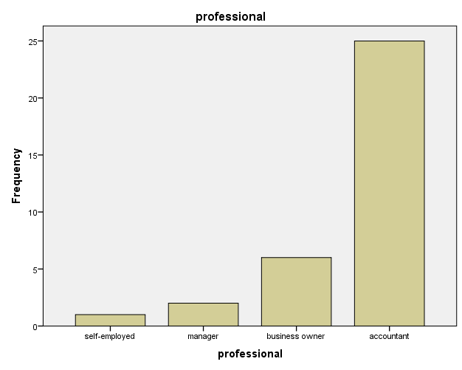

Graph and table above clearly demonstrate that the population of the dissertation comprised of the business owners, managers, self-employed people, but vastly out of accountants and tax consultants, which is more than 70%.
It may be the reason for overall results of the questionnaires being supportive towards MTD.

.

Turnover
 |  | Frequency | Percent | Valid Percent | Cumulative Percent
Valid | under 2 million | 27 | 77.1 | 79.4 | 79.4
Valid | under 10 million | 6 | 17.1 | 17.6 | 97.1
Valid | under 50 million | 1 | 2.9 | 2.9 | 100.0
Valid | Total | 34 | 97.1 | 100.0
Missing | System | 1 | 2.9
Total |  | 35 | 100.0

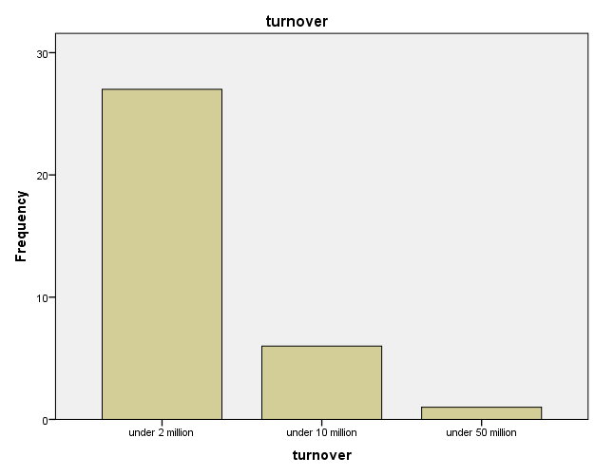

The professionals, who participated in the interviews and online/paper surveys, were mainly working in the companies, which turnover do not exceed £2 million.

Number of employees
 |  | Frequency | Percent | Valid Percent | Cumulative Percent
Valid | fewer than 10 employees | 13 | 37.1 | 38.2 | 38.2
Valid | from 10 to 49 employees | 18 | 51.4 | 52.9 | 91.2
Valid | from 50 to 249 employees | 2 | 5.7 | 5.9 | 97.1
Valid | more than 250 employees | 1 | 2.9 | 2.9 | 100.0
Valid | Total | 34 | 97.1 | 100.0
Missing | System | 1 | 2.9
Total |  | 35 | 100.0

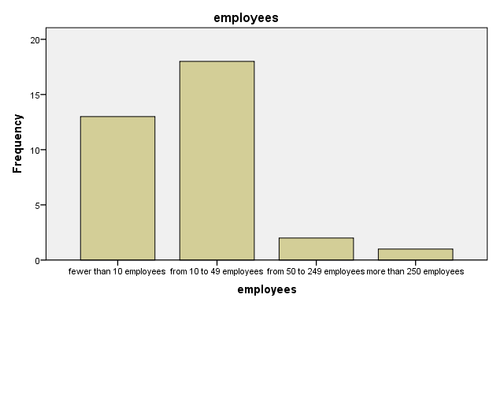

The vast majority of businesses (52%), where participants and interviewees were working, can be categorized as small businesses, which employed from 10 to 49 people.

Do you agree that the primary reason for introducing MTD was to close the tax gap, which is the difference between the tax HMRC expects to be paid and the tax which is actually paid?
 |  | Frequency | Percent | Valid Percent | Cumulative Percent
Valid | strongly agree | 10 | 28.6 | 29.4 | 29.4
Valid | agree | 19 | 54.3 | 55.9 | 85.3
Valid | undecided | 5 | 14.3 | 14.7 | 100.0
Valid | Total | 34 | 97.1 | 100.0
Missing | System | 1 | 2.9
Total |  | 35 | 100.0

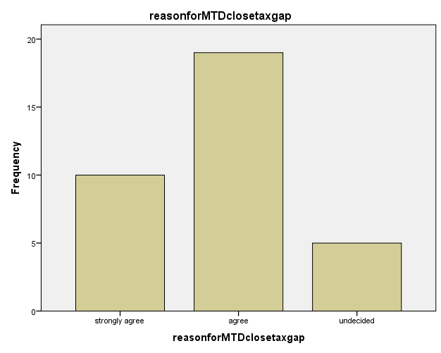
According to the table and graphs above, the majority of respondents, who constitute for more than 55%, have agreed that there is a potential for MTD to close the gap between HMRC’s tax forecasts and the amount of tax that is paid in reality.

In addition, both interviewees have agreed that the first and foremost goal of MTD is to narrow the tax amount underpaid to HMRC.

The results of the questionnaire in terms of whether MTD has a potential to close the tax gap fully support the assumption mentioned in the literature review.

Do you believe that timely and digital recording of transactions will reduce errors made by omissions of income and expense?

 |  | Frequency | Percent | Valid Percent | Cumulative Percent
Valid | strongly agree | 8 | 22.9 | 23.5 | 23.5
Valid | agree | 16 | 45.7 | 47.1 | 70.6
Valid | undecided | 7 | 20.0 | 20.6 | 91.2
Valid | disagree | 3 | 8.6 | 8.8 | 100.0
Valid | Total | 34 | 97.1 | 100.0
Missing | System | 1 | 2.9
Total |  | 35 | 100.0

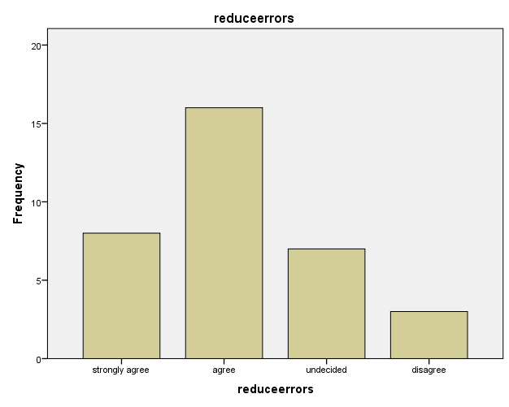

Statistics

Do you believe that timely and digital recording of transactions will reduce errors made by omissions of income and expense?
N | Valid | 34
N | Missing | 1
Mean |  | 2.1471
Median |  | 2.0000
Mode |  | 2.00
Sum |  | 73.00

The vast majority of the participants, which is 47%, and both interviewees have agreed that timely and digital recording will result in the decline of the errors made by omissions of income and expense. It is also worthwhile to mention that 20% of those who has responded to the questionnaire, feel undecided whether MTD’s periodical digitization of transactions will have a positive effect on accuracy of overall income and expenses.
Mean, median, mode results, which in this case is “2”, indicate that the most frequent answer for the question discussed above was “agree”.
In this case, primary data supports the secondary evidence from literature review and they do not contradict each other.

Do you agree that quarterly tax submissions will assist in closing the tax gap?
 |  | Frequency | Percent | Valid Percent | Cumulative Percent
Valid | strongly agree | 6 | 17.1 | 17.6 | 17.6
Valid | agree | 21 | 60.0 | 61.8 | 79.4
Valid | undecided | 7 | 20.0 | 20.6 | 100.0
Valid | Total | 34 | 97.1 | 100.0
Missing | System | 1 | 2.9
Total |  | 35 | 100.0

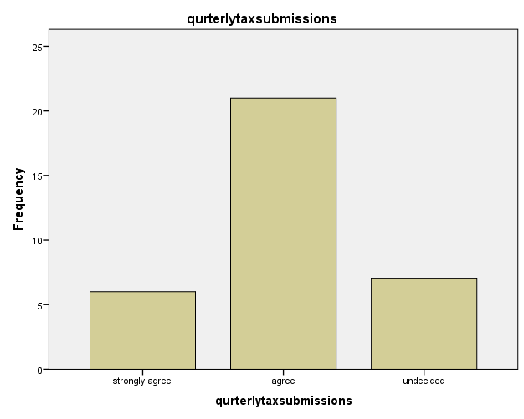

21 from 34 respondents and one of the interviewees have agreed on that tax submissions made on quarterly basis will narrow down the tax gap.

7 participants have expressed uncertainty over the topic.

One of the interviewees has disagreed that quarterly tax filings will help with closing the tax gap.
He has admitted that even today when MTD is not fully implemented, people can submit their tax returns much earlier before deadlines. In his opinion, graduate digitization of the tax system, part of which is MTD, will allow HMRC to increase their efficiency when collecting tax.

The result of this question from the survey fully support the assumption made in the literature review.

Will it be helpful if HMRC provides the business with a rough estimate of the tax amount owed?
 |  | Frequency | Percent | Valid Percent | Cumulative Percent
Valid | strongly agree | 5 | 14.3 | 14.7 | 14.7
Valid | agree | 13 | 37.1 | 38.2 | 52.9
Valid | undecided | 8 | 22.9 | 23.5 | 76.5
Valid | disagree | 7 | 20.0 | 20.6 | 97.1
Valid | strongly disagree | 1 | 2.9 | 2.9 | 100.0
Valid | Total | 34 | 97.1 | 100.0
Missing | System | 1 | 2.9
Total |  | 35 | 100.0

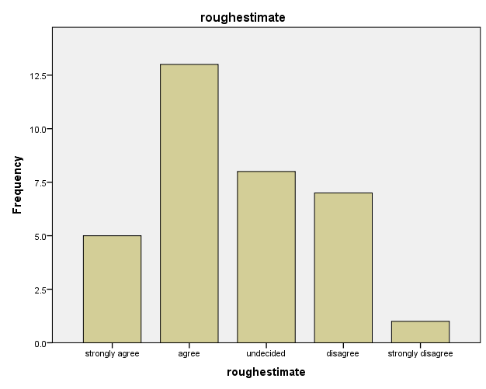

The results for the following question both from questionnaires and interviews support the assumption mentioned in the literature review.

The responses from the questionnaires and interviews indicate that approximately 40% of participants have agreed that it will be helpful if HMRC will inform businesses about their approximate tax liabilities.

Nearly 25% of those who have responded to the questionnaires cast a doubt on whether HMRC tax predictions for the businesses will make a profound difference on the overall performance of the companies.

Do you agree that quarterly tax updates will encourage businesses to predict and to plan their cash flow?
 |  | Frequency | Percent | Valid Percent | Cumulative Percent
Valid | strongly agree | 9 | 25.7 | 26.5 | 26.5
Valid | agree | 14 | 40.0 | 41.2 | 67.6
Valid | undecided | 10 | 28.6 | 29.4 | 97.1
Valid | disagree | 1 | 2.9 | 2.9 | 100.0
Valid | Total | 34 | 97.1 | 100.0
Missing | System | 1 | 2.9
Total |  | 35 | 100.0

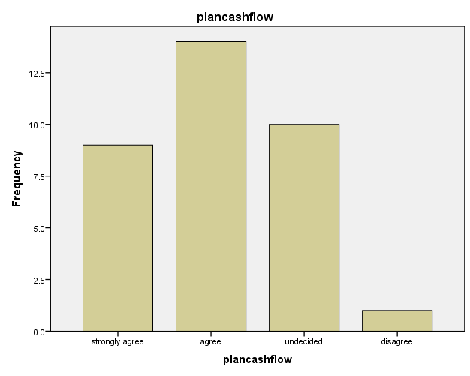

One of the interviewees and more than 40% of those who have filled in the questionnaires have agreed that regular tax updates will encourage businesses to make a forecast for future tax liabilities and plan their cash flow. However, one of the interviews and one the questionnaire respondents disagreed that submission of tax returns every three months will have any effect on businesses forecasting their cash flows.
The result of the questionnaires and interviews partially support the opinion of the accounting professionals from the literature review.

Do you support the introduction of MTD?
 |  | Frequency | Percent | Valid Percent | Cumulative Percent
Valid | strongly agree | 10 | 28.6 | 29.4 | 29.4
Valid | agree | 9 | 25.7 | 26.5 | 55.9
Valid | undecided | 14 | 40.0 | 41.2 | 97.1
Valid | disagree | 1 | 2.9 | 2.9 | 100.0
Valid | Total | 34 | 97.1 | 100.0
Missing | System | 1 | 2.9
Total |  | 35 | 100.0

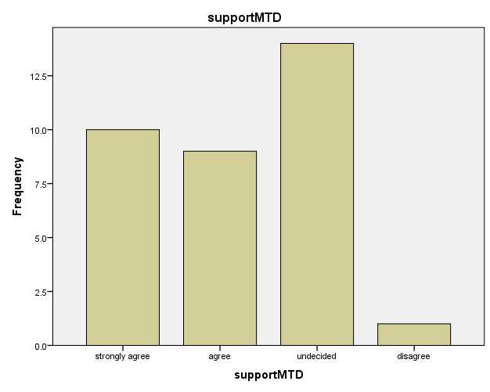

41% of questionnaire respondents feel undecided about the introduction of MTD.
However, both interviewees do support the implementation of MTD. One of the interviewees highlighted that MTD is the way for HMRC to increase efficiency of their services. Second interviewee does support MTD, but he noted that there are still so many uncertainties around it.
In the literature review chapter, it was highlighted that for some individuals MTD is associated with something vague and unclear, so the researcher anticipated that for some of the questions in survey many participants will express their uncertainty about impending tax regulations.

In your opinion, will the new regulation make the taxation system simpler?
 |  | Frequency | Percent | Valid Percent | Cumulative Percent
Valid | strongly agree | 3 | 8.6 | 8.8 | 8.8
Valid | agree | 11 | 31.4 | 32.4 | 41.2
Valid | undecided | 9 | 25.7 | 26.5 | 67.6
Valid | disagree | 11 | 31.4 | 32.4 | 100.0
Valid | Total | 34 | 97.1 | 100.0
Missing | System | 1 | 2.9
Total |  | 35 | 100.0
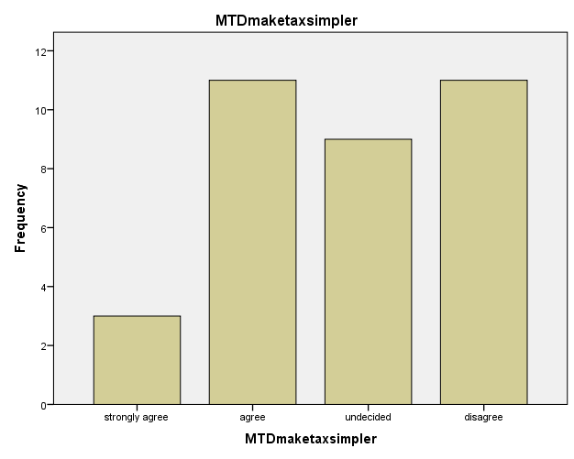

In the literature review it was discussed opposing opinions of the professionals, those who think that MTD has a potential to make tax simpler and those who believe that MTD may increase the level of bureaucracy in companies.

During the interviews, two accounting professionals and 32% survey respondents disagreed that MTD will make tax simpler.

However, other 32% of participants do believe that MTD has a potential of making tax less sophisticated. There is also a significant percent (27%) of those, who are undecided what MTD will bring to the taxpayers and accountants.

If HMRC has an accurate snapshot of the individual's tax position, over/underpayments of the self-employed (and taxpayers in general) will be eliminated?
 |  | Frequency | Percent | Valid Percent | Cumulative Percent
Valid | strongly agree | 2 | 5.7 | 5.9 | 5.9
Valid | agree | 20 | 57.1 | 58.8 | 64.7
Valid | undecided | 6 | 17.1 | 17.6 | 82.4
Valid | disagree | 5 | 14.3 | 14.7 | 97.1
Valid | strongly disagree | 1 | 2.9 | 2.9 | 100.0
Valid | Total | 34 | 97.1 | 100.0
Missing | System | 1 | 2.9
Total |  | 35 | 100.0

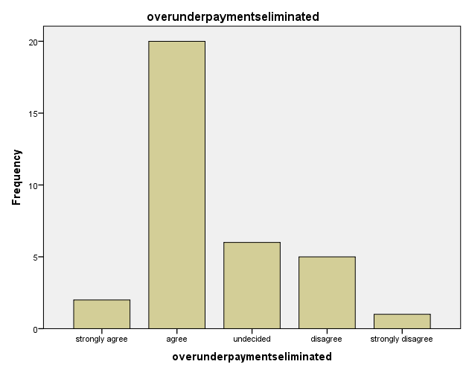

58% of participants do agree that MTD will contribute to elimination of under/over payments. Both interviewees have admitted that over/underpayments could not be fully eliminated, but significantly reduced. These results provide a basis for the opinion of the accounting professional stated in the literature review.

In addition, more than 30% of survey respondents feel undecided or disagree with the topic mentioned above.

Do you believe that tax filing frequency of at least once in three months will have a positive effect on accuracy?
 |  | Frequency | Percent | Valid Percent | Cumulative Percent
Valid | strongly agree | 3 | 8.6 | 8.8 | 8.8
Valid | agree | 17 | 48.6 | 50.0 | 58.8
Valid | undecided | 9 | 25.7 | 26.5 | 85.3
Valid | disagree | 4 | 11.4 | 11.8 | 97.1
Valid | strongly agree | 1 | 2.9 | 2.9 | 100.0
Valid | Total | 34 | 97.1 | 100.0
Missing | System | 1 | 2.9
Total |  | 35 | 100.0

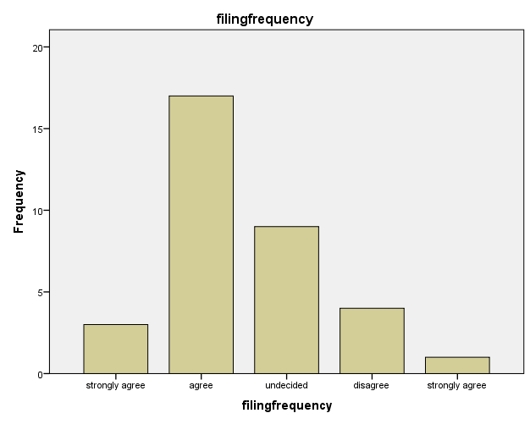
Both interviewees and 50% of questionnaire respondents have agreed that quarter filing frequency will affect positively on the accuracy of the tax submissions. Nevertheless, more than 25% of the participants struggle to define effect of the quarter filings.
The results of the primary data and the secondary data support each other in this case.

Do you believe that having access to digital records will boost the tax collectors' ability to tackle underpayment and to identify tax evasion?
 |  | Frequency | Percent | Valid Percent | Cumulative Percent
Valid | strongly agree | 10 | 28.6 | 29.4 | 29.4
Valid | agree | 14 | 40.0 | 41.2 | 70.6
Valid | undecided | 7 | 20.0 | 20.6 | 91.2
Valid | disagree | 3 | 8.6 | 8.8 | 100.0
Valid | Total | 34 | 97.1 | 100.0
Missing | System | 1 | 2.9
Total |  | 35 | 100.0

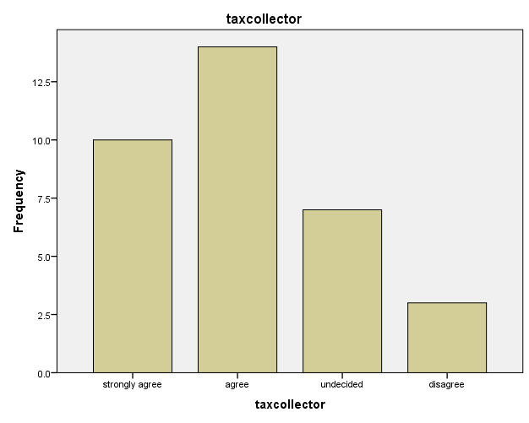

More than 60% of participants and both interviewees either agree or strongly agree that MTD will ease the task of the tax collector, when identifying tax evasion. The results of the primary and secondary data do not contradict each other.

Do you agree that MTD will make it easier for tax collectors to seek evidence from the taxpayers when documentation is required to validate figures?
 |  | Frequency | Percent | Valid Percent | Cumulative Percent
Valid | strongly agree | 17 | 48.6 | 50.0 | 50.0
Valid | agree | 11 | 31.4 | 32.4 | 82.4
Valid | undecided | 6 | 17.1 | 17.6 | 100.0
Valid | Total | 34 | 97.1 | 100.0
Missing | System | 1 | 2.9
Total |  | 35 | 100.0

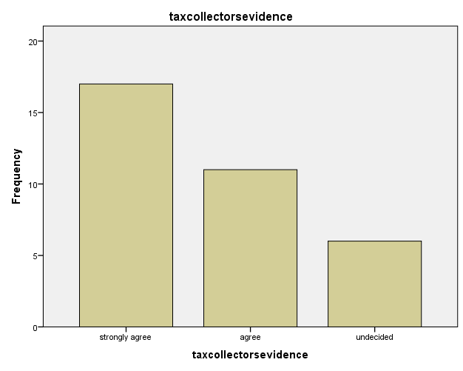

More than 80% of survey respondents and both interviewees are either strongly agree or agree that MTD will make it simpler for tax collectors to find approval for figures mentioned in the reports submitted by taxpayers.

The primary data from interview and surveys in this case goes hand in hand with a theory postulated in a literature review.

Do you believe after implementation of MTD the demand for accountants will eventually rise?
 |  | Frequency | Percent | Valid Percent | Cumulative Percent
Valid | strongly agree | 8 | 22.9 | 23.5 | 23.5
Valid | agree | 8 | 22.9 | 23.5 | 47.1
Valid | undecided | 9 | 25.7 | 26.5 | 73.5
Valid | disagree | 9 | 25.7 | 26.5 | 100.0
Valid | Total | 34 | 97.1 | 100.0
Missing | System | 1 | 2.9
Total |  | 35 | 100.0

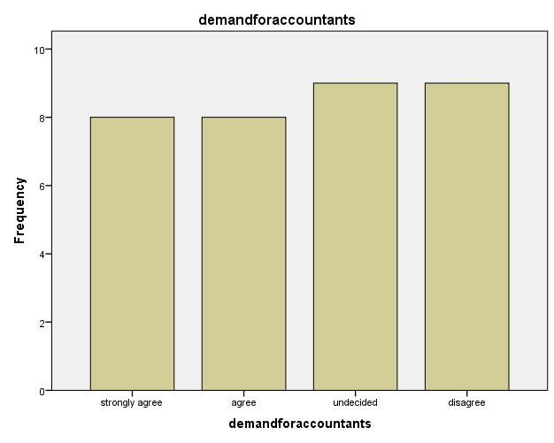

The primary data from interviews and questionnaires does not support secondary data from Chapter 2.

26% of respondents remained undecided on whether MTD will increase a demand for accountants, while another 26% disagreed with it.

One of the interviewees presumed that there may be slight increase in the demand for the accountants after MTD implementation, while the other admits that MTD poses a risk for accounting industry as digitization of tax may make taxpayers more independent and decrease the need for having an accountant.

Do you believe that currently there is not much clarity on MTD software?
 |  | Frequency | Percent | Valid Percent | Cumulative Percent
Valid | strongly agree | 6 | 17.1 | 17.6 | 17.6
Valid | agree | 12 | 34.3 | 35.3 | 52.9
Valid | undecided | 10 | 28.6 | 29.4 | 82.4
Valid | disagree | 6 | 17.1 | 17.6 | 100.0
Valid | Total | 34 | 97.1 | 100.0
Missing | System | 1 | 2.9
Total |  | 35 | 100.0

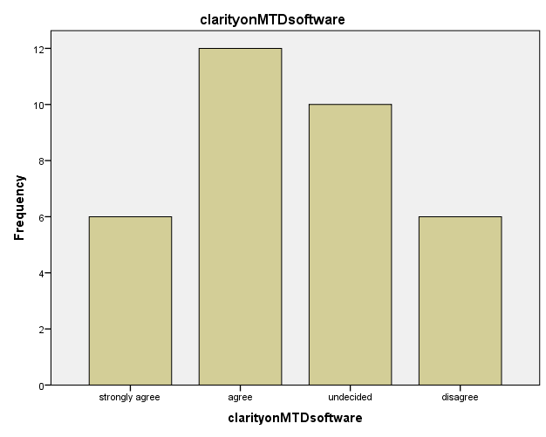
The primary data results agree with the secondary data.
The vast majority of the respondents, which constitute to 35%, and both interviewees believe that MTD’s software is a topic for which they are anticipating clarity from HMRC.

Will the introduction of MTD require further training of staff?
 |  | Frequency | Percent | Valid Percent | Cumulative Percent
Valid | strongly agree | 18 | 51.4 | 52.9 | 52.9
Valid | agree | 16 | 45.7 | 47.1 | 100.0
Valid | Total | 34 | 97.1 | 100.0
Missing | System | 1 | 2.9
Total |  | 35 | 100.0

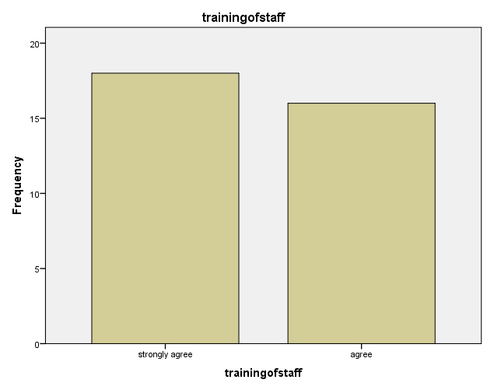

Both interviewees and all respondents either agree or strongly agree that the training of staff with the implementation of MTD will be crucial as the lack of knowledge on how MTD shall be executed may result in loss of the clients. This point was discussed in the literature review and results of the questionnaire and interviews have provided an approval for it.

Do you believe that the performance of the accounting company will be heavily depending on the software it will be using?
 |  | Frequency | Percent | Valid Percent | Cumulative Percent
Valid | strongly agree | 7 | 20.0 | 20.6 | 20.6
Valid | agree | 17 | 48.6 | 50.0 | 70.6
Valid | undecided | 7 | 20.0 | 20.6 | 91.2
Valid | disagree | 3 | 8.6 | 8.8 | 100.0
Valid | Total | 34 | 97.1 | 100.0
Missing | System | 1 | 2.9
Total |  | 35 | 100.0
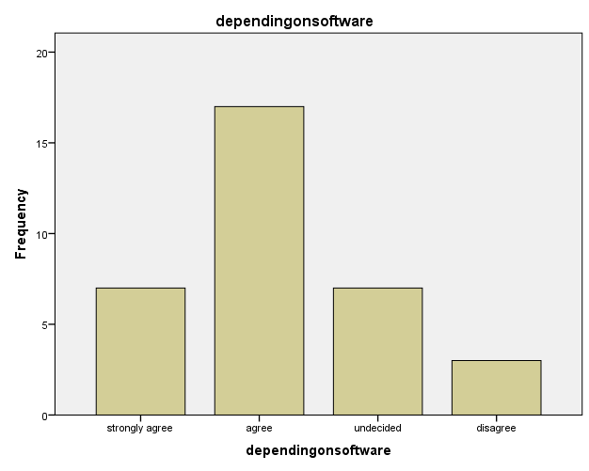

Statistics
dependingonsoftware
N | Valid | 34
N | Missing | 1
Mean |  | 2.1765
Median |  | 2.0000
Mode |  | 2.00
Sum |  | 74.00

The substantial majority of the participants, which constitute for more than 70%, either strongly agree or agree that level of the performance of accounting companies will be affected by the software they will be utilising. It was admitted in the literature review that the accountants would need to ensure that the software meets the expectations of the client.

Both interviewees agreed that MTD software will be a key driver of success for the accounting companies. One of the interviewees stated that accounting companies would have to adopt several accounting solutions, while businesses in general will be using only one. It can be inferred that the higher number of software accounting company will be able to run, the more likely that the firm will appeal to its new customers/businesses.

Does your company pay for services of the subcontractors?
 |  | Frequency | Percent | Valid Percent | Cumulative Percent
Valid | yes | 10 | 28.6 | 29.4 | 29.4
Valid | no | 24 | 68.6 | 70.6 | 100.0
Valid | Total | 34 | 97.1 | 100.0
Missing | System | 1 | 2.9
Total |  | 35 | 100.0

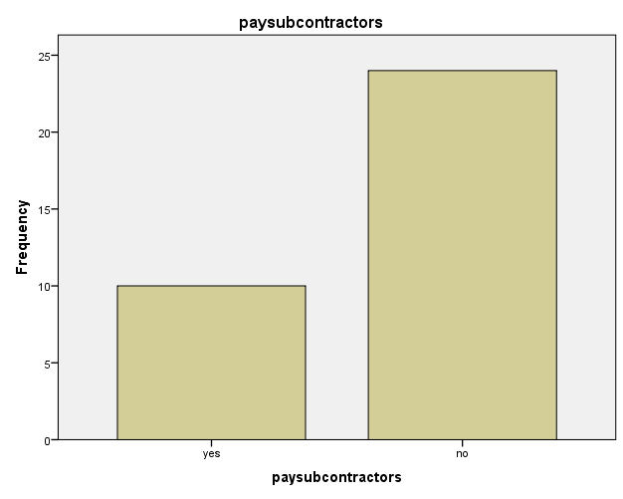
70% of participants, the majority of which work for accounting companies, and one of the interviewees stated that they do not pay for the services of the subcontractors.

Another interviewee mentioned that when he was a practicing accountant he used to pay for the services of the subcontractors.

Do you think it will be more beneficial if the tax from subcontractor's wages is deducted at the source?
 |  | Frequency | Percent | Valid Percent | Cumulative Percent
Valid | strongly agree | 6 | 17.1 | 17.6 | 17.6
Valid | agree | 17 | 48.6 | 50.0 | 67.6
Valid | undecided | 6 | 17.1 | 17.6 | 85.3
Valid | disagree | 5 | 14.3 | 14.7 | 100.0
Valid | Total | 34 | 97.1 | 100.0
Missing | System | 1 | 2.9
Total |  | 35 | 100.0

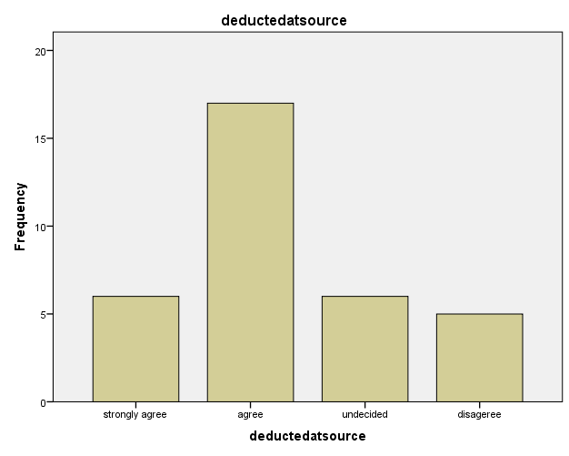

Both interviewees and 50% of the participants consider that subcontractor’s wages ought to be deducted at the source.

Do you believe that MTD may increase the number of clients and profit margins of the accounting companies?
 |  | Frequency | Percent | Valid Percent | Cumulative Percent
Valid | strongly agree | 7 | 20.0 | 20.6 | 20.6
Valid | agree | 10 | 28.6 | 29.4 | 50.0
Valid | undecided | 9 | 25.7 | 26.5 | 76.5
Valid | disagree | 8 | 22.9 | 23.5 | 100.0
Valid | Total | 34 | 97.1 | 100.0
Missing | System | 1 | 2.9
Total |  | 35 | 100.0

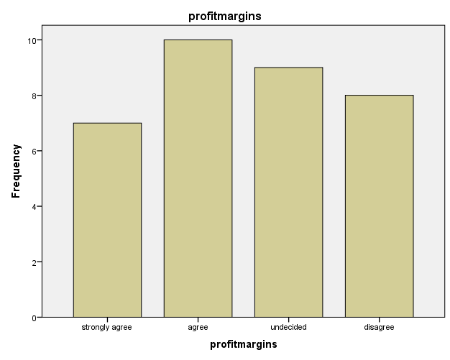

More than 40% expressed agreement with assumption that MTD may assist accounting companies in getting more clients and yielding higher profit.

First interviewee presumed that the profit margin of the company may be increased by providing value added services for a fair price, while the second interviewee admitted that for the profit margin to grow, accountants need to increase the efficiency of their own business operations. Both primary and secondary data in this case support each other, but it can be deduced (especially from the interviews) that MTD itself will not become the accelerator of the profit. If only enhancing productivity, MTD may turn out to be an opportunity for accounting companies to thrive in accounting industry.
The information gathered via interviews and surveys fully supports the presumption made in the literature review.

Mean, Mode, Sum
Statistics
 |  | overunderpaymentseliminated | filingfrequency | taxcollector
N | Valid | 34 | 34 | 34
N | Missing | 1 | 1 | 1
Mean |  | 2.5000 | 2.5000 | 2.0882
Median |  | 2.0000 | 2.0000 | 2.0000
Mode |  | 2.00 | 2.00 | 2.00
Sum |  | 85.00 | 85.00 | 71.00

Statistics
 |  | qurterlytaxsubmissions | roughestimate | plancashflow
N | Valid | 34 | 34 | 34
N | Missing | 1 | 1 | 1
Mean |  | 2.0294 | 2.5882 | 2.0882
Median |  | 2.0000 | 2.0000 | 2.0000
Mode |  | 2.00 | 2.00 | 2.00
Sum |  | 69.00 | 88.00 | 71.00

Cross Tabulation

overunderpaymentseliminated * filingfrequency Crosstabulation
Count
 |  | Do you believe that tax filing frequency of at least once in three months will have a positive effect on accuracy? |  |  |  |  | Total
 |  | strongly agree | agree | undecided | disagree | strongly agree | Total
If HMRC has an accurate snapshot of the individual's tax position, over/underpayments of the self-employed will be eliminated? | strongly agree | 0 | 2 | 0 | 0 | 0 | 2
 | agree | 2 | 12 | 4 | 2 | 0 | 20
 | undecided | 0 | 3 | 2 | 1 | 0 | 6
 | disagree | 1 | 0 | 3 | 1 | 0 | 5
 | strongly disagree | 0 | 0 | 0 | 0 | 1 | 1
Total |  | 3 | 17 | 9 | 4 | 1 | 34

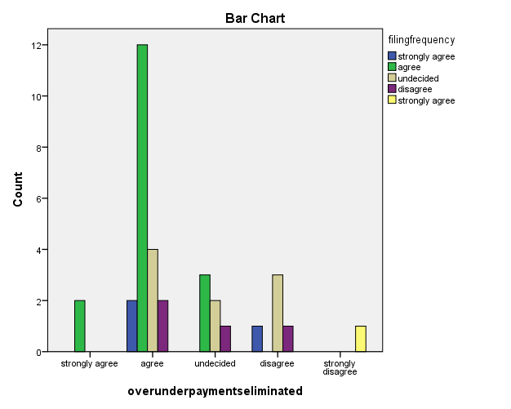

The cross-tabulation data demonstrates that the majority of the respondents who believe that once HMRC may help over/underpayments of the self-employed to be eliminated, also believe that quarterly filing frequency will have positive affect on accuracy of the submissions. It also is suggesting that more returns will lead to the more efficient collection of taxation.
paysubcontractors * deductedatsource Crosstabulation
Count
 |  | Do you think it will be more beneficial if the tax from subcontractor's wages is deducted at the source? |  |  |  | Total
 |  | strongly agree | agree | undecided | disagree | Total
Does your company pay for services of the subcontractors? | yes | 4 | 4 | 2 | 0 | 10
Does your company pay for services of the subcontractors? | no | 2 | 13 | 4 | 5 | 24
Total |  | 6 | 17 | 6 | 5 | 34

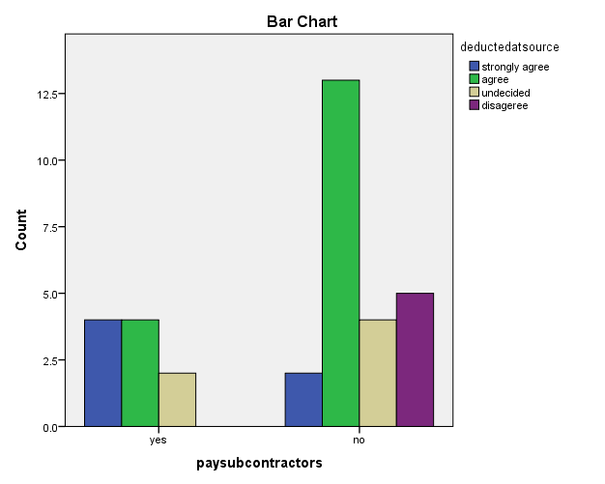

The current cross-tabulation data displays that the vast majority of those respondents who do not pay for the services of the subcontractors still believe that tax from subcontractors’ income shall be deducted at the source.

demandforaccountants * profitmargins Crosstabulation
Count
 |  | Do you believe that MTD may increase the number of clients and profit margins of the accounting companies? |  |  |  | Total
 |  | strongly agree | agree | undecided | disagree | Total
Do you believe after implementation of MTD the demand for accountants will eventually rise? | strongly agree | 1 | 6 | 1 | 0 | 8
 | agree | 5 | 1 | 1 | 1 | 8
 | undecided | 1 | 0 | 4 | 4 | 9
 | disagree | 0 | 3 | 3 | 3 | 9
Total |  | 7 | 10 | 9 | 8 | 34

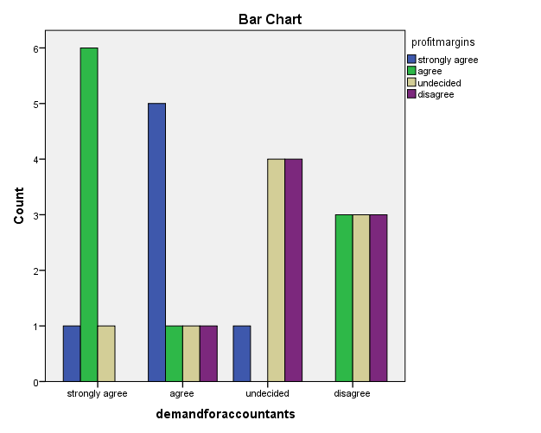

This spread suggests that the respondents are undecided whether there will be an increase in demand for accountants which will eventually lead to more clients and greater profit margins.

Chapter 5:

