Case Study Report –
GSK Carbon Neutral Laboratory For Sustainable chemistry
ACBA 5000
Ayesha Williams

Table Of Contents

Introduction………………………………………………………………………..3
Main Body Of Report Analysing & Discussing;……………………………...3-6
- Foundation requirements of building giving its location
- Choice of Materials for super structure
  - Design
  - Structural strength and Stability
  - Fire Safety
  - Aesthetics
  - Environmental impact & Sustainability
References………………………………………………………………………..7

Introduction
In this report, the foundation requirements of the GSK Carbon Neutral Laboratory for sustainable chemistry will be analysed and discussed in detail, along with an analysis of the materials chosen for the building in relation to its design, structural strength, fire safety, aesthetics, and sustainability and environmental impact. The report will include vital graphics and information to back up the discussion topics.
Foundation Requirements
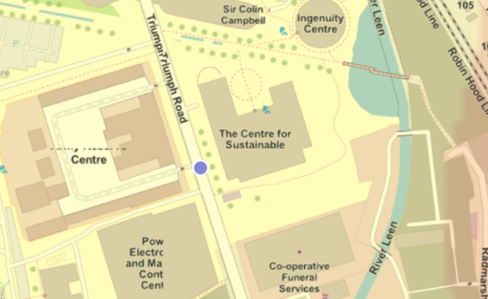
The new innovation park in Nottingham, specifically, is where the GSK Carbon Neutral Lab is located (UKGBC, N.D). According to (School of Chemistry, N.D.), the project has been designed developed with low carbon emissions in mind, but it also "utilizes water reduction and heat-capturing technology to give an array of additional environmental benefits." as stated by (School of Chemistry, N.D). The BGS Geology Viewer makes it evident that the carbon neutral lab was originally built on top of the Lenton Sandstone, which is a bedrock formation, along with alluvium, or surface deposits of clay, silt, sand, and gravel (BGS, N.D). In addition, given the understanding of the bedrock beneath this building, the foundation requirements used for this building, had been that with the good ground strata, it would be preferable to install a piled foundation with the already known requirement of the building and given the amount of weight and use this building would experience over the course of its lifetime. When designing a foundation, it is important to consider how much weight will be placed on the ground. This is especially true when designing a foundation for a laboratory that will house heavy equipment, a lot of foot traffic, and continuous loads day and night. Throughout this project it has always been clear that the building built with sustainability in mind, this was evidently clear from the beginning of the project when the contractors used “Vibro stone columns” for the piles and “granulated blast furnace slag” (Cleanroom Technology, 2016)was used to construct the floor slab. These materials are sustainable due to the reuse of materials such as the Virbo stone columns which are made from the reusing crushed stone columns and vibrating the Virbo stone to make new compacted piles (CNC Foundations , N.D). The blast furnace slag is the bi product of producing iron, the slag is then ground into fine powder ready to be reused. (CaginUlubeyli, 2015).
Figure 1 - This figure is the geology review of the area in which the building is situated in - https://geologyviewer.bgs.ac.uk/?_ga=2.61586027.695140748.1668781614-678357134.1668781614

Secondly this report will include an analysis of each consideration of choice of materials using the following:
Design
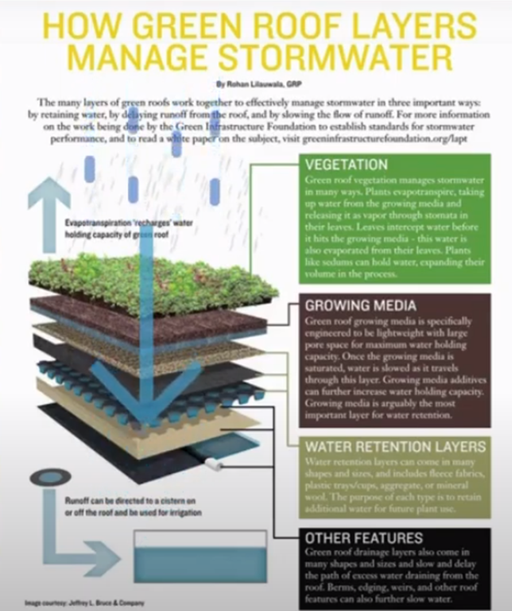
The architectural concept for this project has not been neglected in any way, especially the design, which includes the building's overall shape, consideration of the building's orientation, and application of certain materials such cross-laminated timbers and its glulam structural braced wood framed beams (BMtrada, N.D). A "horseshoe design" was created for the building's architecture, allowing for separate spaces for "write-up areas and separate sections for hazardous work which include the use of mechanically ventilated equipment" (Cleanroom Technology, 2016). The curtain wall, particularly this double-glazed curtain wall, has really highlighted the utilisation of natural illumination (Cleanroom Technology, 2016) The curtain wall enhances the use of natural daylight contrasting against the light cross laminated beams overall producing a light and airy spaces for its laboratories and its users. When the design for the building made, the architect embraced the environment in relation its roof design. The roof was designed with a "Green Roof" extension to provide the building more space for an enclosed courtyard. This has a naturally insulated roof which faces north. Small solar panels on the south side of the building store sunlight to power this area as sustainably as possible (CIBSE Journal, 2017). Using the lake next to the building as a heat sink, the building utilizes its geothermal technology by using the lake to divert part of the sun's rays away from the building (Devilina, 2022). It must be noted that using natural ventilation counts for cooling the labs keep the chemicals at a constant temperature in the storage rooms. Natural ventilation has been incorporated into this project's design by using the shape of the building to allow for the ventilation to flow and exert any used ventilation through the chimneys taking with it any fumes that have been exhausted by the labs (CIBSE Journal , 2017). Finally, the design of the building has been centred on its entire purpose use, which is as a number of laboratories. The use of these laboratories would include constant vibrations and heavy-duty equipment, which justifies the use of the floor structures being made from cross laminated timbers, which are known for these strength, ductile, and workable traits. (BMtrada, N.D)
Figure 2 - This Diagram displays the function of a green roof - (Devilina, 2022).
Stability and Structural Strength
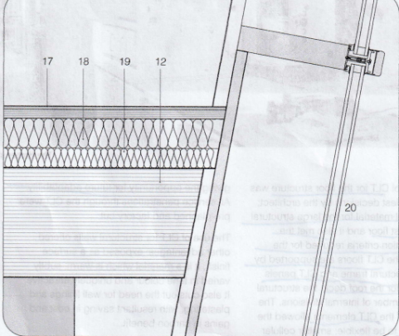
The main focus on stability within this project is down to the use of glulam timbers. Glulam timbers are known for the stability they can provide for large scale projects similar to this building, Glulam timbers are known for their high strength and dimensional stability as stated by (Eco House Smart , N.D). This author of (Eco House Smart , N.D) also claims that the use of glulam in relation to “strength to weight ration to steel is approx. 1.5-2 times” stronger than steel. The influential shape of this building has been complimented and enhanced its environment by using these glulam timbers and cross laminated timber, known for their strength and durability. The build also incorporates steel footings which are located at the end of each structural timber, connecting to the foundations.
Figure 3 - This shows the junction at curtain wall and first floor - bmtrada case study

Fire Safety
The concept of fire safety was very much high on the agenda for this project, in terms of the vast number of materials at high risk. The project experienced a blaze that destroyed the building while it was in the process of being built in when it was first designed. (Urquhart, 2014), the building was said to have been “designed to meet stringent fire regulation requirements” as also stated by (Urquhart, 2014) in the article. This really made the project team rethink its design to relation to fire safety. The building now contains fire stoppers in relation of steel dowels capped with wooden oak plugs which are there for the aesthetics however deeper into the design these steel dowels can isolate the risk of fire from each timber beam (PEFC, N.D). The glulam present in the project plays another crucial part in fire resistance, glulam has high resistance to fire due to the speed at which its able to char, meaning the risk to fire catching is timely (Eco House Smart , N.D). The building continuously monitors all of its areas throughout all hours of the days and nights therefore any risk of fire should be picked up soon enough to eradicate the fire before it is able to spend causing significant damage. The build incorporates a very well-established natural ventilation system (BMtrada, N.D), this helps ventilate the rooms or areas in which needs constant ventilation which for example is the labs, whereas other areas such as the social areas and corridors, do not require additional ventilation therefore any fumes congregating in areas of high danger to fire can be helped with the ventilation built in to the building.

Aesthetics
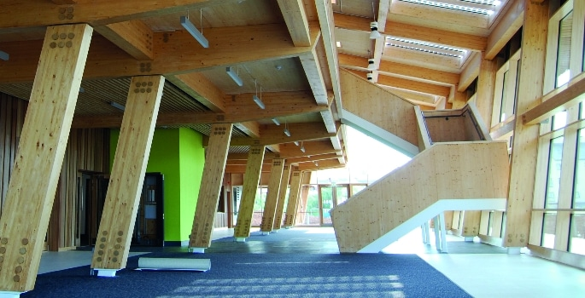
From the entire floor plan of this build to the curtain walls which were designed to enhance its surroundings, to the colour of the timbers, every inch of this design has been built with its main focus on the environment and its innovated design. The floor plan has been carefully designed to occupy 4500 square meters over two floors and in addition, laboratory space for 100 researchers as stated by (Cleanroom Technology, 2016). The layout consists of open plan laboratories which are naturally ventilated due to their locations and design of using the prevailing wind to assist in ventilating fume hoods (Cleanroom Technology, 2016) including both safe laboratories write up areas and areas with a completely isolated ‘hazardous laboratory’ only for use of hazardous chemicals and experiments. (Cleanroom Technology, 2016). The cleverly placed curtain wall enhances the amount of daylight the building receives, the curtain wall is located on the south side which was designed with two purposes, these include views onto its gardens and grounds and to detracts the solar gains from being too powerful helping to always maintain a comfortable temperature within the building. As part of the design, the designers and contractors were to use sustainable materials as well as environmentally enhancing materials therefore the choice to use oak coloured timber closely matched the natural environment on the doorstep of this project, as do the oak-coloured plugs used to mask the steel dowels connecting the structural timbers for the building support. The use of the glulam timber was not only used for their stability and strength, but they were used for the durability and their ability to be formed into complex shapes enhances all aspects of the design, from the internal element of making the building look very modern to enable the green roof to blend in with the environment especially by shaping the glulam timbers into the wave like design completing and assisting in follow the shape in the topology. The green roof has been fitted with a breathable membrane felt topped with a winter garden, again this helps with blending the project into its natural environment. (Cleanroom Technology, 2016)
Figure 4- shows the steel dowels covered by oak plugs. https://universitybusiness.co.uk/news/gsk-carbon-neutral-lab-for-sustainable-chemistry-case-study/
Environmental impact and Sustainability
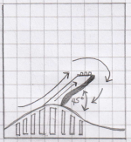
The build of this carbon neutral lab has always captured the main aspect of sustainability and ensuring very little environmental impact hence name of being a “carbon natural laboratory”. The Laboratory from each aspect has met the requirement of little to no impact on the environment and from the sustainability approach. Firstly, the laboratory wall has been cladded with a “Rainscreen of western red cedar boards and single fire terracotta panels” as discussed by (BMtrada, N.D), these materials were decided on because of their “low-embodied energy” as also stated by (BMtrada, N.D). As previous stated in the above subtopic of the aesthetics, natural ventilation is key in this project especially in relation to using unnecessarily mechanically ventilation, they skilfully used the direction of wind to circulate the air intake and air discharge around the labs by placing roof mounted wind catchers (BREEAM, N.D). Another practical use for the naturally ventilated labs is the lack of need to constantly mechanically cool labs, using the natural ventilation helps do this also especially when a lot of the equipment and chemicals housed in the building need to be kept at a certain temperature for safety. (School of Chemistry, N.D). Water saving strategies have been actively incorporated into this building in the form of using the green roof which recycles the rainwater to keep the roof itself and its vegetation hydrated and they have used metered systems throughout the whole of the building which is all electronically metered to ensure that all water used is used for a correct purpose and that water leaks are immediately highlighted ensuring that any water is not unintentionally used as waste water (Bregroup , N.D). A large amount of consideration had been given to the site itself in relation to the overall build. The key method of construction used had been offsite construction and very limited onsite construction to avoid any damage to the near environment and local residents and that all transport that was used for either delivery purposes or any other purpose was not unintentionally used if it did not need to be. (Cleanroom Technology, 2016). The overall heating and power system of the building. The system used to heat the building is called a ‘biomass boiler’ which uses an alternative fuel source other than petroleum, which is said to been less harmful to the environment and only using what is necessary. The building also incorporates dimmable LED lighting throughout the whole site fitted with sensors allowing for little to no waste in term of power. (School of Chemistry, N.D) The south side of the entire of roof has been fitted with ‘photovoltaic panels’ which act as solar panels, used to build and store the energy to power the building and all of its equipment (BMtrada, N.D). One of the overall main attractions to this build in the form of sustainability is the project has been built with a “Hybrid Design” which permits the overall building with allowances when the project may change in the future, whether this is for developing building regulations or general extensions to the original project as stated by (BMtrada, N.D).
Figure 5 - This shows the construction of the ventilation towers at a 45-degree angle with the direction of wind recycling process - hand drawn by author.

References
BGS, N.D. Geology Viewer. [Online]
Available at: https://geologyviewer.bgs.ac.uk/?_ga=2.61586027.695140748.1668781614-678357134.1668781614
[Accessed 2022 November 18].
BMtrada, N.D. GSK Carbon Neutral Laboratory for Sustainable Chemistry , Unknown: s.n.
BREEAM, N.D. GlaxoSmithKline’s Carbon Neutral Laboratory for Sustainable Chemistry achieves BREEAM Outstanding. [Online]
Available at: https://bregroup.com/case-studies/breeam-new-construction/glaxosmithklines-carbon-neutral-laboratory-for-sustainable-chemistry-achieves-breeam-outstanding/#:~:text=In%20particular%20the%20carbon%20neutral,visual%20features%20for%20the%20project.
[Accessed 2022 December 09].
Bregroup , N.D. GlaxoSmithKline’s Carbon Neutral Laboratory for Sustainable Chemistry achieves BREEAM Outstanding. [Online]
Available at: https://bregroup.com/case-studies/breeam-new-construction/glaxosmithklines-carbon-neutral-laboratory-for-sustainable-chemistry-achieves-breeam-outstanding/
[Accessed 2022 November 25].
CaginUlubeyli, G., 2015. Sustainability for Blast Furnace Slag: Use of Some Construction Wastes. [Online]
Available at: https://www.sciencedirect.com/science/article/pii/S1877042815037763
[Accessed 2022 November 18].
CIBSE Journal , 2017. Chemical equilibrium – carbon neutral laboratory. [Online]
Available at: https://www.cibsejournal.com/case-studies/chemical-equilibrium-carbon-neutral-laboratory/
[Accessed 2022 November 21].
Cleanroom Technology, 2016. Nottingham University leads the way in sustainable labs. [Online]
Available at: https://www.cleanroomtechnology.com/news/article_page/Nottingham_University_leads_the_way_in_sustainable_labs/122880
[Accessed 2022 November 18].
CNC Foundations , N.D. Vibro Stone Columns for Ground Improvement. [Online]
Available at: https://cncfoundations.com/what-we-do/ground-improvement-services/vibro-stone-columns/
[Accessed 2022 November 18].
Devilina, A., 2022. HVAC System | The GSK Carbon Neutral Laboratory for Sustainable Chemistry Short Film. s.l.:s.n.
Eco House Smart , N.D. GLUE-LAMINATED TIMBER (GLT) BEAMS ARE STRONGER THAN STEEL. [Online]
Available at: https://ecohousemart.com/glulam-beams-are-stronger-than-steel/
[Accessed 2022 November 22].
PEFC, N.D. GlaxoSmithKline Carbon Neutral Laboratory. [Online]
Available at: https://www.pefc.co.uk/case-studies/glaxosmithkline-carbon-neutral-laboratory/
[Accessed 2022 November 22].
School of Chemistry, N.D. The Carbon Neutral Laboratory. [Online]
Available at: https://www.nottingham.ac.uk/chemistry/research/centre-for-sustainable-chemistry/the-carbon-neutral-laboratory.aspx
[Accessed 2022 November 18].
UKGBC, N.D. CASE STUDY: GSK CENTRE FOR SUSTAINABLE CHEMISTRY. [Online]
Available at: https://www.ukgbc.org/solutions/case-study-gsk-centre-for-sustainable-chemistry/
[Accessed 2022 November 18].
Urquhart, J., 2014. Blaze destroys Nottingham sustainable chemistry lab. [Online]
Available at: https://www.chemistryworld.com/news/blaze-destroys-nottingham-sustainable-chemistry-lab-/7751.article
[Accessed 2022 November 22].

