An Empirical Analysis of Factors Influencing Delivery Efficiency and Logistics Performance in Amazon’s International Logistics Network
Name: Sabbir Ahmed

1. Introduction, Background and Research Problem
The rapid growth of e-commerce has fundamentally transformed logistics and supply chain operations, elevating their strategic importance within international business. As one of the world’s foremost e-commerce organisations, Amazon operates an extensive global logistics network to fulfil customer orders across diverse countries and regions. The effectiveness of such operations is contingent upon delivery efficiency, operational capability, and the capacity to identify and manage the multifaceted factors that shape logistics performance.
Within an increasingly competitive commercial landscape, consumer expectations for fast, reliable, and cost-effective delivery have intensified considerably. As a result, logistics operators face mounting pressure to streamline processes and enhance delivery performance. A range of operational factors—including delivery distance, traffic conditions, weather conditions, vehicle characteristics, and order-related variables—may exert a significant influence on the efficiency of last-mile and broader logistics operations.
Despite a considerable body of scholarship on supply chain management and logistics performance, a gap persists in empirical research examining how specific operational factors determine delivery efficiency within large-scale e-commerce logistics networks. A deeper understanding of these relationships would enable organisations to enhance operational performance and customer satisfaction whilst mitigating delivery delays and systemic inefficiencies.
This study seeks to address this gap by analysing the factors influencing delivery efficiency and logistics performance within Amazon’s international logistics network, drawing upon a large-scale secondary dataset. Quantitative analytical techniques will be employed to identify the principal determinants of delivery performance and to derive evidence-based recommendations for improving logistics operations.

2. Research Aim
To empirically investigate the operational factors influencing delivery efficiency and logistics performance within Amazon’s international logistics network, with a view to informing evidence-based improvements in logistics management.

3. Research Objectives
- To identify and examine the key operational factors affecting delivery efficiency within Amazon’s logistics network.
- To examine the relationship between delivery distance and delivery performance outcomes.
- To evaluate the individual and combined impact of traffic conditions and weather conditions on delivery efficiency.
- To assess the influence of vehicle characteristics and order-related factors on overall logistics performance.
- To formulate evidence-based recommendations for enhancing delivery efficiency and operational effectiveness within international logistics networks.

4. Research Questions
- Which operational factors most significantly influence delivery efficiency within Amazon’s logistics network?
- To what extent does delivery distance affect delivery performance outcomes?
- In what ways do traffic conditions affect delivery efficiency, and how does this impact vary across different contexts?
- How do adverse weather conditions influence logistics performance and delivery timeliness?
- Which operational factors are the strongest predictors of delivery delays and systemic inefficiencies?

5. Preliminary Literature Search
The literature review will draw upon scholarship across the following thematic areas, each of which informs the theoretical and empirical foundations of this study:

Logistics and Supply Chain Management
Christopher (2022) contends that logistics efficiency is a critical determinant of competitive advantage and customer satisfaction within global supply chains. Effective logistics management not only supports day-to-day operational performance but also underpins long-term organisational competitiveness in dynamic international markets.

E-Commerce Logistics
Chopra and Meindl (2019) observe that the exponential growth of e-commerce has substantially increased the operational complexity of logistics systems, placing heightened emphasis on delivery speed, supply chain responsiveness, and the integration of fulfilment processes across multiple channels and geographies.

Operational Efficiency
Ivanov and Dolgui (2021) draw attention to the critical importance of operational resilience and performance optimisation within contemporary logistics networks. Their work underscores the centrality of data-driven decision-making in identifying vulnerabilities and systematically improving logistics outcomes under conditions of uncertainty.

Technology and Logistics Performance
Gunasekaran et al. (2017) identify information technology and analytics as critical enablers of logistics efficiency and operational performance. Advanced technologies support route planning, inventory management, and delivery optimisation.

International Business Perspective
Efficient logistics networks constitute a foundational element of international business operations. By facilitating seamless cross-border trade, reducing lead times, and supporting international market entry and expansion, high-performing logistics systems play an instrumental role in enhancing customer satisfaction and sustaining competitive positioning in global markets.

6. Research Methodology

Research Philosophy
This study adopts a positivist research philosophy, grounded in the principle that social and organisational phenomena can be measured objectively and analysed through systematic empirical observation. A positivist stance is particularly suited to this investigation given its focus on quantifiable logistics performance variables and the statistical testing of theoretically derived hypotheses (Saunders et al., 2019).

Research Approach
A deductive research approach will be employed, moving from established theoretical frameworks to empirical testing. Existing theories relating to logistics management, operational efficiency, and supply chain performance will provide the conceptual basis for the formulation of hypotheses and the subsequent analysis and interpretation of findings (Bryman and Bell, 2019).

Research Strategy
The study employs a quantitative research strategy, utilising secondary data analysis as the principal means of investigating the research questions. This approach is consistent with the positivist philosophy and deductive orientation of the study, and is well suited to the analysis of large-scale structured datasets (Saunders et al., 2019).

Data Collection
The research will draw upon a publicly available Amazon Delivery Dataset sourced from Kaggle. This secondary dataset was selected on account of its scale, relevance to the research objectives, and its coverage of a broad range of operational logistics variables.
Comprising in excess of 40,000 individual delivery records, the dataset affords a statistically robust basis for multivariate analysis of logistics performance. The key variables incorporated in the study are as follows:

Dependent Variable
- Delivery Time (measure of delivery efficiency and logistics performance)

Independent Variables
- Delivery Distance
- Traffic Conditions
- Weather Conditions
- Vehicle Type
- Vehicle Condition
- Delivery Agent Rating
- Order Characteristics

Data Analysis
All quantitative analyses will be conducted using Python, leveraging a suite of well-established scientific computing and statistical libraries:
- Pandas
- NumPy
- Matplotlib
- Seaborn
- Scikit-learn
- Statsmodels
The analytical procedure will comprise the following sequential stages:

Data Cleaning and Preparation
- Missing value treatment
- Data validation
- Data transformation

Descriptive Statistics
- Mean
- Standard deviation
- Frequency analysis

Exploratory Data Analysis
- Distribution analysis
- Trend analysis
- Visualisation

Correlation Analysis
Pearson and Spearman correlation analyses will be conducted to examine the direction and strength of bivariate relationships between operational factors and delivery performance, thereby informing variable selection for subsequent regression modelling.

Multiple Regression Analysis
Ordinary least squares (OLS) multiple regression analysis will be employed to determine the relative predictive power of each operational variable with respect to delivery efficiency. This technique permits simultaneous estimation of multiple predictor effects whilst controlling for confounding variables.
The proposed regression model takes the following form:
Delivery Time = β₀ + β₁(Distance) + β₂(Traffic) + β₃(Weather) + β₄(Vehicle Type) + β₅(Vehicle Condition) + ε

7. Risks and Limitations
The study is subject to a number of methodological limitations that should be acknowledged when interpreting its findings:
- The study is contingent upon the quality and completeness of the secondary dataset, over which the researcher exercises no direct control
- As the data were collected and structured by a third party, the researcher is unable to verify the original data collection procedures or assess potential systematic biases
- The dataset may contain missing, erroneous, or incomplete records that could affect the reliability of the analysis
- The findings derived from Amazon’s logistics network may have limited generalisability to other logistics organisations operating under different structural or contextual conditions
Notwithstanding these limitations, the substantial volume of observations contained within the dataset provides a sufficiently robust empirical foundation for meaningful statistical analysis and the generation of theoretically grounded insights.

8. Proposed Timeline (Gantt Chart)

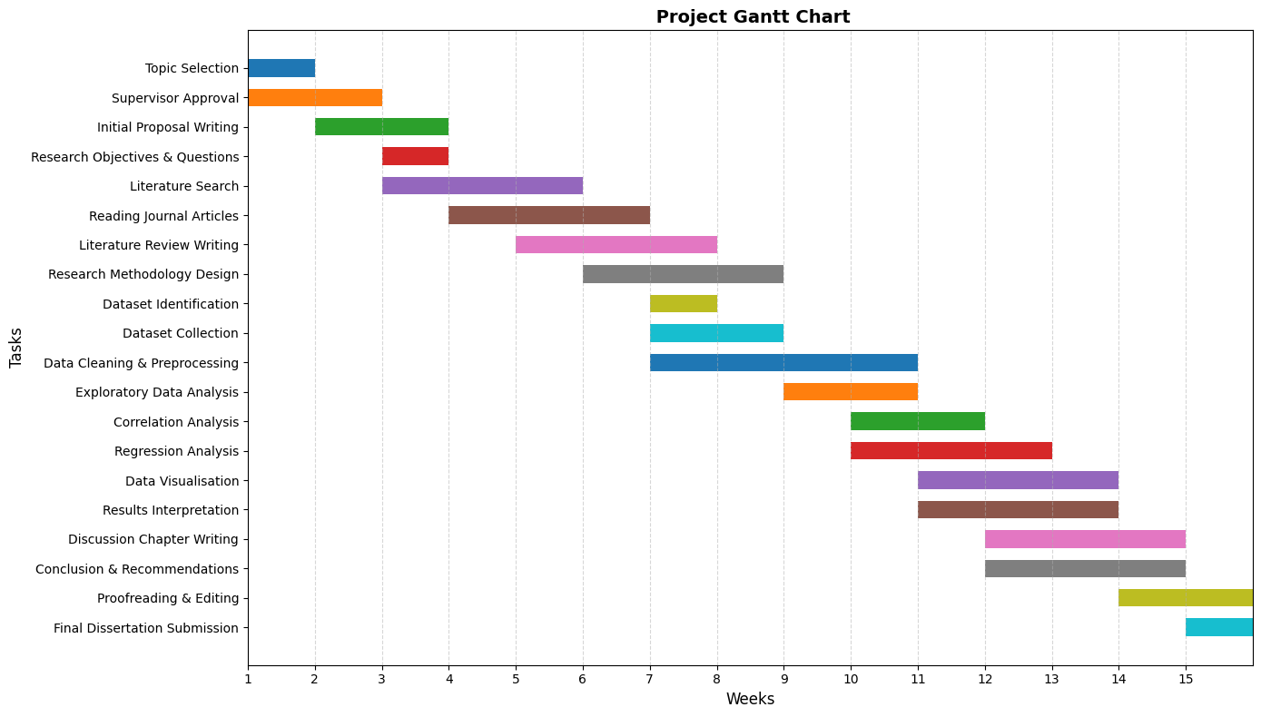

References
Bryman, A. and Bell, E. (2019) Business Research Methods. 5th ed. Oxford: Oxford University Press.
Christopher, M. (2022) Logistics and Supply Chain Management. 6th ed. Harlow: Pearson.
Chopra, S. and Meindl, P. (2019) Supply Chain Management: Strategy, Planning and Operation. 7th ed. Harlow: Pearson.
Gunasekaran, A., Subramanian, N. and Papadopoulos, T. (2017) Information Technology for Competitive Advantage within Logistics and Supply Chains. Transportation Research Part E, 99, pp.14–33.
Ivanov, D. and Dolgui, A. (2021) A Digital Supply Chain Twin for Managing Disruption Risks and Resilience in Supply Chain Systems. International Journal of Production Research, 59(9), pp.2768–2784.
Saunders, M., Lewis, P. and Thornhill, A. (2019) Research Methods for Business Students. 8th ed. Harlow: Pearson.

