Professional Career
Development

Report

Student Name: Shazul Miah
Student ID: 1712428
Submission Date: 22nd June2018
University of Wales Trinity Saint David

Executive Summary

Professional Career development is an ongoing process all about Skills, Challenges, Experience and goals aimed towards a fulfilled work life. The philosophy of the report is to analyse the importance of a career development which involves Employability skills, strategies, Study skills, Yourself awareness skills, and communication skills which can help you archive your goals and have a successful career. The report outlines the desire of learning in many different ways for both employers and employees, The purpose of this report is to understand the barriers of learning , How you can overcome your objectives by studying and getting you ready for employment.

Page 1

Table of Contents

Executive Summary………………………………………………………………….…………….…1
Introduction…………………………………………………………………… ………………………..2
My learnings ……………………………………………………………………………………………..3-5
Main Findings………………………………………………….…………………………………………6-8
Learning Log……………………………………………………………………………..…..…….......9-10
Conclusion…………………………………………………………………………………..…………..11-12
Barriers………………………………………………………………….………………………..…… ..13-14
Appendices………………………………………..…………………………………………………….15-19
References……………………………………………………………………………………………….20-21

Introduction

Professional career development is very important for both employees and employers, Career development is based on various different types of skills and experience that will help individuals towards achieving the goals . To have a successful career you have to have the desire, understanding and belief in yourself for your success. yourself awareness is very important as its for you to understand what your strengths and weakness are and how you are going prepare yourself to be employable.

Career development plan is an ongoing process, it’s about setting objectives and how are you going to overcome your barriers to be successful. We are going look at various different types of skills such as Interpersonal communication skills, Employability skills, Study skills and Yourself awareness skills. The aim of this report is to analyse how we can develop our skills to be employment ready.

Yourself awareness interplays a very important role for the workplace, which includes your strengths, weakness, threats and opportunity in short SWOT. By understanding the Swat analysis it enables you to find out what skills and experience you can bring to the employer, so you have to question yourself do you have the employability skills what the employer will require from you.

Page 2

My learnings

My strengths that I believe are employability skills

. Teamwork
. Communication skills
. Working on my own initiative
. Punctual
. Reliable
. Listening
. Well organised
. Friendly
. Positive attitude
. Flexibility able to adapt ext.

I believe for me it was about identifying and understanding what my strengths and weakness are which will help me to build my confidence, It is vital for me to understand that skills is the key to success and you have to know yourself. Cottrell (2015).

Page 3

Examples of my conversion strategies that I have used to help me overcome my weakness into strengths and my threats into opportunities .

(1)

: Strengths : Weakness
Communication Presentations

: Opportunity : Threats
Confidence
Learn and practice presenting
with other fellow
Students

Example ( 2)
PDP Strategies

: Strength
Teamwork

: Opportunity
. Working with others from various background
. Positive mental attitude and time management.

: Strategy required
. By being a team player
. always being friendly
. Prioritise my own work
. Leadership skills

By identifying these skills it has made me gain more confidence and have the desire to how to learn. Gilbert and Chackrovaity (2001)
Page 4

My Understandings of being employable is that you should always have objectives of what is to be achieved, How are you going to achieve it and what would the end result will look like. One of the most important employability skill which I believe is teamwork, most employers will recruit you if they can see that you have team work skills and that you are capable of bringing that togetherness to the business.
To be a team player requires you to do lots of different kind of things such as, being friendly, clear purpose, building effective relationships by understanding others. Parker (2009)

Communication is also another employability skills that inter plays a big factor in any business, communication can be done in various different ways such as.
. face to face
. letters
. Emails
. phone

The best way of communication is by being clear and friendly you have to understand that people like who are like themselves. Rapport stands right in the centre of any communication, Rapport is a feeling of commonality.
Robbins (2017)

Page 5

Main findings

Smart objectives is another set of skills for the workplace, It’s about achieving your goals, Meeting targets, Being prepared and how are you going to prioritise your daily task or requirements.

You have to question yourself what is your goal?
How are you going to manage and plan your objectives. Doran (1981)

S = Is your goal specific what exactly you want to archived.

M= Is your goal measurable how will you know you have archived it.

A= Is your goal attainable, do you have the desire to do it and is it something you have researched about.

R= Why is this important for you.

T= Time management very important you meet targets and deadlines and how you will prioritize your daily task.

Page 6
Use of smart learning objectives is a continuing professional development for any employee, It’s about how you set your goals and take control by planning it out.
Raia (2008)

: Here is a few examples of my smart objectives and

Goals and actions
: Getting a pass rate in my university course

S = Try and archive maximum marks in my assignments.

M = listening skills, attending lectures, research, complete and get involved in exercises during lectures, positive mental attitude, being confident and take in feedback from any in class assignments.

A = Being prepared, organised, time management, prioritize lecture notes, try learn from other fellow students and by believing in myself.

R = Meeting targets, aiming, practice, confident, making notes of deadline dates, try and attend all lecture classes and doing research about my goal as much as I can.

T = Time management, well organised, get involved in class tasks, desire to learn, understanding and take in any feedback, critical thinking and that should help you archive your goals and be successful.

Page 7

Goals and actions
: Presentations

Actions
. Confidence
. Learn from others
. Practice
. Prepare and read presentations
. Doing research
. Practice
. Believe in yourself
. Be organised
Success

I believe career development is all about building your experience and employability skills. Fallows and Steven (2000)

Time Management
Time management is very vital and important for any workplace, business, university ext. Employees who are organised and manage the time are more productive, more efficient and they are likely to the targets and goals.
When looking at time management you have to question yourself that where do you spend the most important time of your day and you have to prioritize your day.
Matrix (1989)

Page 8

Learning log:

I have learned that to always stay positive and think you are in a win win situation and by understanding and persons emotion. (mirror the interviewer) Covey (1989)

Learning log
In my learning journey I found that it is very important to keep a learning log, A learning log helps you to record your work, Your learning experience so you can track it down and refer back to it whenever you want. By doing this in my course It help me to stay positive put things into practice and it also can be very time efficient.

(Here is an example of my learning log)

: What have I learned about myself?
. Presenting front of others
. confidence in myself
. My strengths and weakness

: How does what I have been doing lead to me becoming better at my skill?
. Believing in myself
. by putting things in practice makes me confident and positive
. Meeting targets
: How can I use this plan for the future?
. well organised
. Doing presentations
. It can help me in my career development
. Leadership skills

Page 9

By completing this learning log here is an example how I put my study skills into action.

Summary of my current skills
. Team work
. Setting prioritises
. Organising work to meet deadlines

Summary of what I need to do, How can I improve
. To find information from different resources
. To be confident while preparing for presentations
. To get help to build up my IT skills

MY priorities
. Research
. Priorities daily task before meeting any deadlines
. Learn from others
. To get confidence by listening to our lectures

How will I know I have improved?
. Feedback on assignments results
. quality of my work
. By having confidence in myself

Page 10

Conclusion

At the end of my learning log its helps me to get to my conclusions and my lesson learned, The report analysis the importance of development through various different ways of studying and by putting all your skills together to be employment ready.

What did I learn?
. SWOT
. Smart objectives
. Johari window
. Learning log

What have I archived?
. Understanding of SWOT
. Smart thinking
. Understanding myself awareness
. Confidence in myself

How have I put any theory into practice?
. Swot strategy
. Conversion Strategy
Research
Doing research is another skill it’s about getting knowledge that you may not have, it a very important tool of learning.
Doing research is very vital that you understand that you are learning and getting knowledge from someone else is work not yours. It is very important that you avoid any plagiarism,
The are various different types of research methods. Zina (2017) talks about qualitative and quantitative data.
You can do research and referencing in various different methods.,
. Books
. Online journals
. websites. ext
Page 11

Plagiarism is also very important in any sector where is for a business or while studying , from my lectures at my university I have learned about the consequences of plagiarism. The was also news on plagiarism on the BBC about the Youtube stars being paid to sell cheating they used plagiarism to complete other people ‘s work for money.

My question is still about being employable, you have to question yourself why would any company recruit you for, what employability skills do you have and can bring into their business.
There are various types of employability skills such as
Team work
Punctual
Organised
Communication
Friendly ext

Having all these various different types of skills it have help you in develop your career and management.
Bridgestock (2001)

By joining this course I believe it will help me in my career development plans, Its very simple I have learned it’s all about understanding yourself and others. having the desire to learn with the appropriate training the main factor is all about yourself awareness. So basically the are two factors in the workplace is what you know about yourself, Second factor is what other people know about you.
Luft and Ingam (1955)

Johari window

Open Blind
Known to yourself Not known to self

Hidden Unknown
Not known to others Not Known to self

Page 12

Go Mad : Learning

Barriers
Success
Degree
1
Reason why
3
Plan priorities
2
Define goal

Assignments
Lectures
Time management
Research
Meeting targets
Organised
Listening to lectures
Revision
Meeting deadlines
Complete course
Achieve my degree

5
Involve others
6
Personal responsibilities
4
Self belief

Positive mental attitude
Be confident
Research
Learn from other students and lectures
Prioritise assignment
Attend all lectures
Make notes

7
Take action
Measure results to

Assignments
Lectures
Time management
Research
Meeting targets

Page 13

My personal development for essay writing:

Skill/behaviour: | Action needed: | Resources needed: | Date(s) for action: | Date for review: | Aspiration goal: | Met?
Critical thinking | Reading various resources | Textbooks  Friends  Lecturer | Research and take notes every Monday | Review essay before uploading it | Organised and having the desire to learn | Yes
Practice writing skills | Practice essay writing and receive feedback on work from others | Lecturers  Friends | Practice writing every Wednesday | Putting everything together and in practice | Prioritise all actions  Into practice | Yes
Reading texts | Finding appropriate resources and making notes | Textbooks  Online websites | Read texts every Monday whilst critically assessing the resources | Prioritise  Tasks needed | Confidence  Meeting targets | Yes
IT skills | Learn from others  Attend appropriate classes | Computers  IT classes  Friends | Practice every Thursday | Feedback  From others before uploading it | Be able to confidently use my IT skills when completing my work | Yes
Proof reading | Read over work before handing it in | Friends  Lecturers | Proof read after every essay written | Complete essay and hand in before deadline | Time management  Organised | Yes

Page 14

Self-evaluation of academic skills

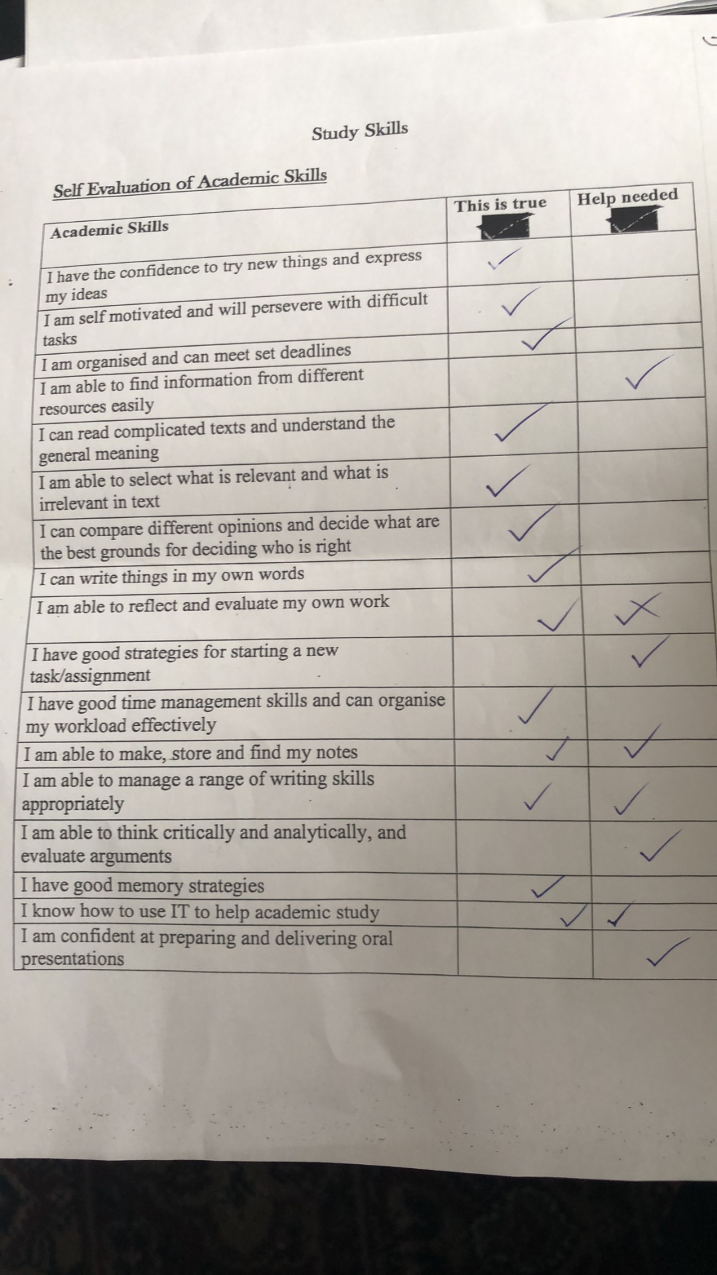

By complete the above learning style it shows what is true about me so indication of my strengths, And help needed were I can improve on my weaknesses.
Page 15

Learning style questionnaires:
Example 1:

The Vark questionnaire aims to find out something about how you learn best,

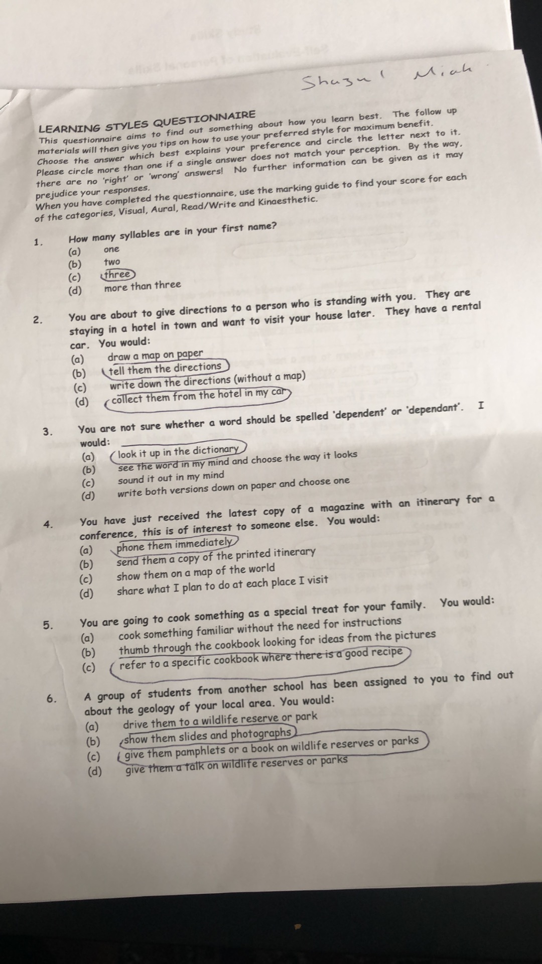

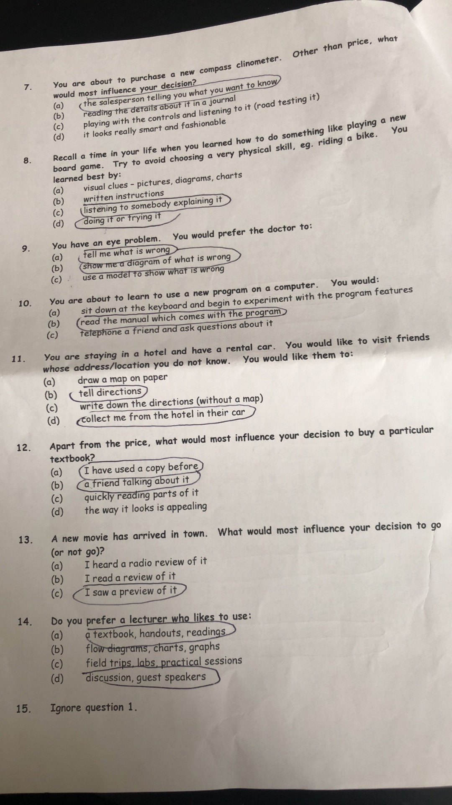

Page 16

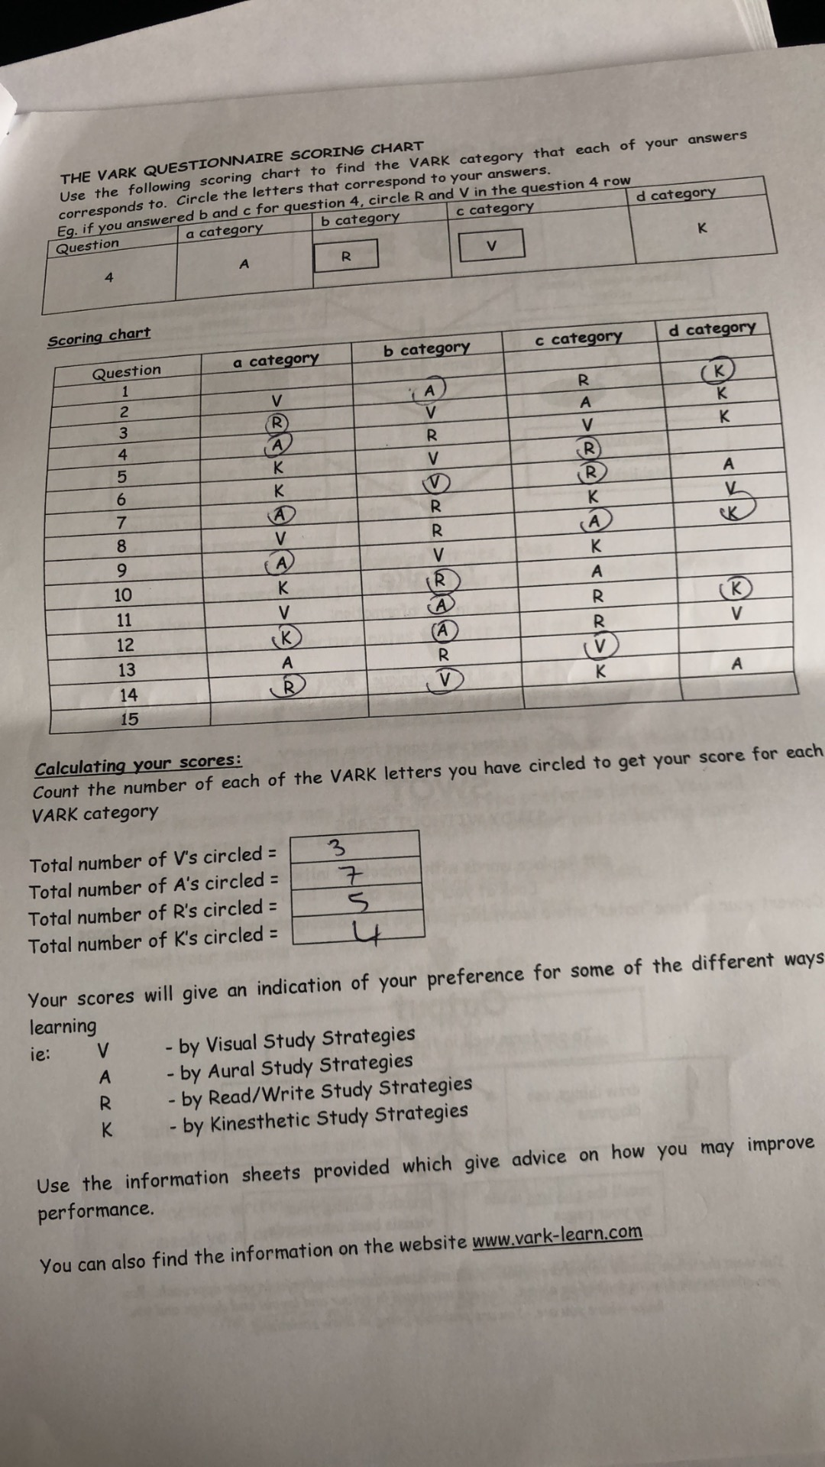
The results of this Vark sheet has given me a guidance of learning in many different ways such as Visual study strategies, Aural Stratiegies, Read and write strategies and Kinesthetic strategies which will help me improve my learning journey.

Page 17

Example 2:

Myers Briggs – Personality profiling
By completing this questionnaire its given me confidence , learns me how to archive my goals and to develop career. The questionnaire is based only on you, To understand and learn how you can improve your future learnings you have to answer it very honestly.

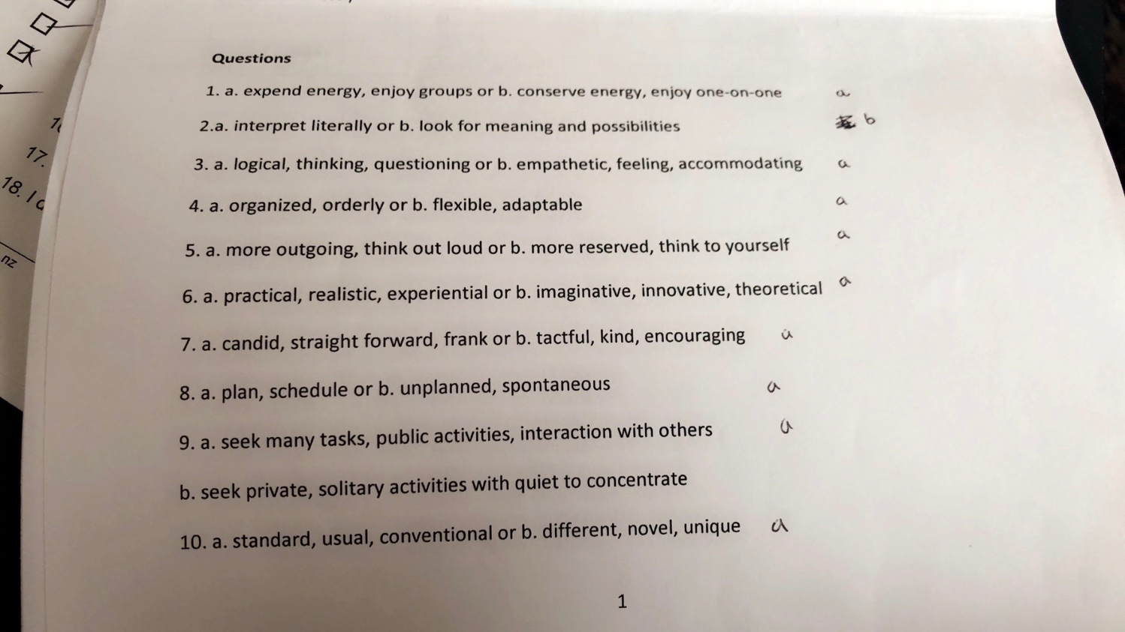

Page 18
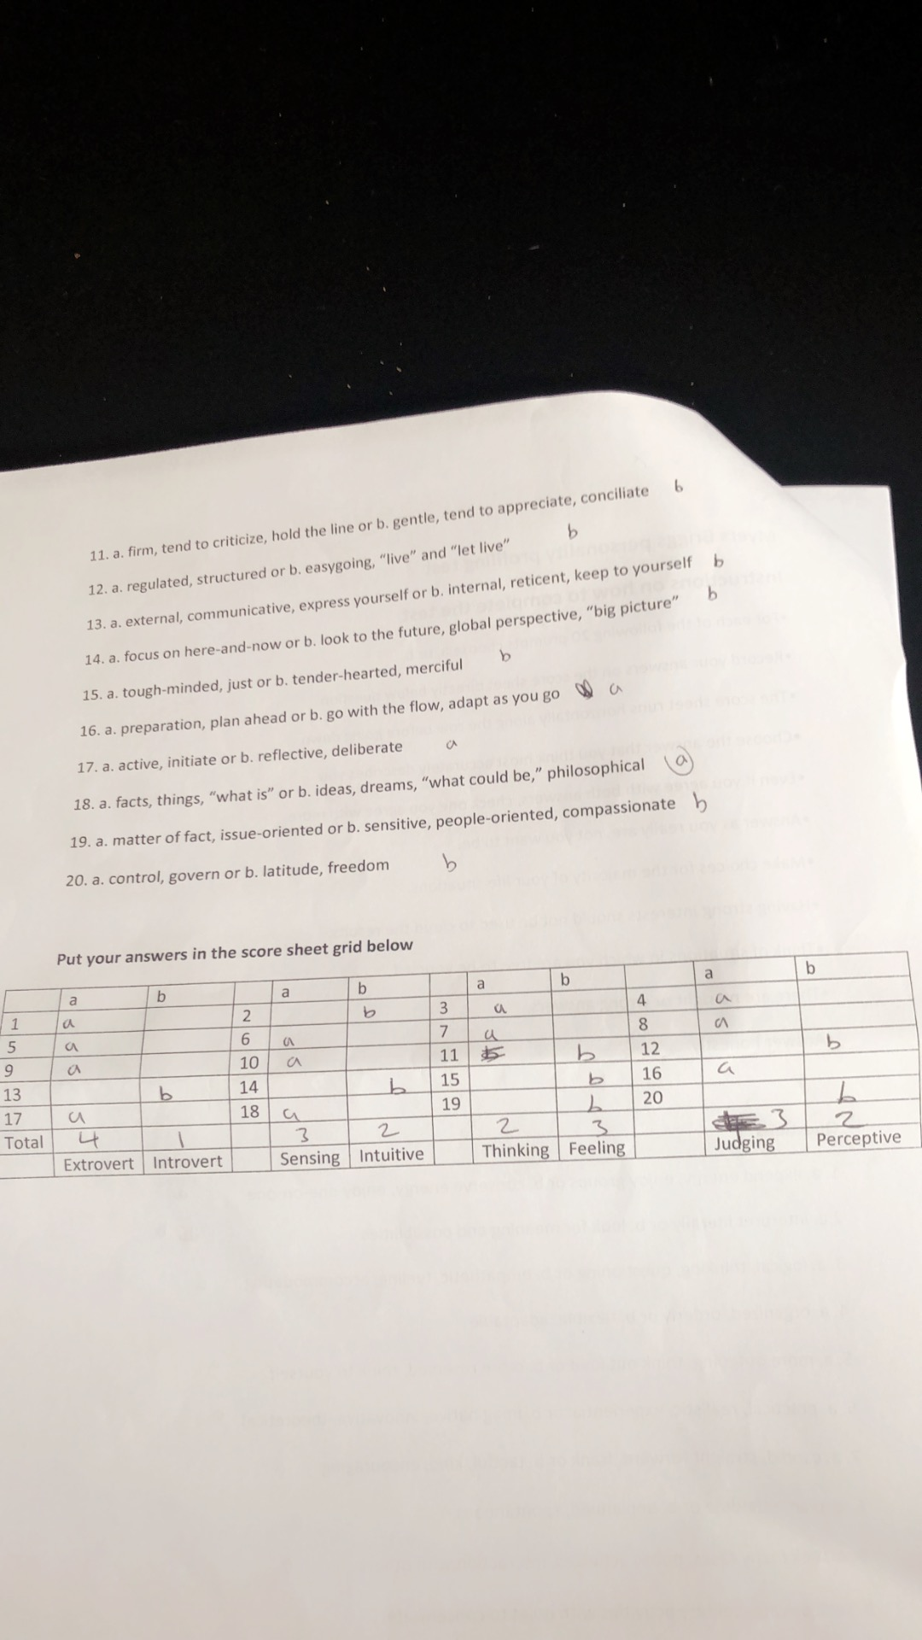
19

Robbins, T. (2017) ‘The art of effective communication; : www.youtube.com/videos-https://yout.be/KqKAG-hRlyE, (accessed, 14/07/18

Doran, G.T. (1981) ’ There is a smart way to write management goal; Management review, PP 35-36

Gilbert, A. and Chackrovaity, I. (2001) Go Mad: about coaching. Bath. Bath press.

Fallows, D and Steven, C. (2000) ‘Building employability skills; In to higher education curriclam, 42(2), PP 75-83

Jeffrey, B. and Main, E. (2018) ‘The youtube stars being paid to sell cheating; :bbc.co.uk/News/Education-43965600013, (accessed, 14/07/18

Covey, S. R. (1989) ‘ The 7 habits of highly effective people; United States, Free press.

Luft, J. and Ingham, H. (1955) ‘The Johari window; Proceedings of the western training laboratory in group development: University of California, Los Angeles

Luft, J. and Ingham, H. (1961) ‘The Johari window; Human relations trading news, 5(1), PP 6-7

O’ Leary, z. (2017) ‘Doing your research project; London, Sage.

Page 20
Bridge, R. (2009) ‘ Enhancing graduate employability through career management skills; Higher education research and development, 28(1), PP 31-44

Briggs, L.M. (1962)’The Myer – Briggs tyre indicator; California, Palo, Alto

Stella, C. (2015) ‘Skills for success; Personal development and employability, London, Macmillan International higher education.

Parker, M. (2009) ‘Team work; 20 steps to success, Human resource development. Volume 1.

Raia, A.P. (2008) ‘Goal setting and self control; Journal of management studies, 2(1), PP 34-53

Page 21

