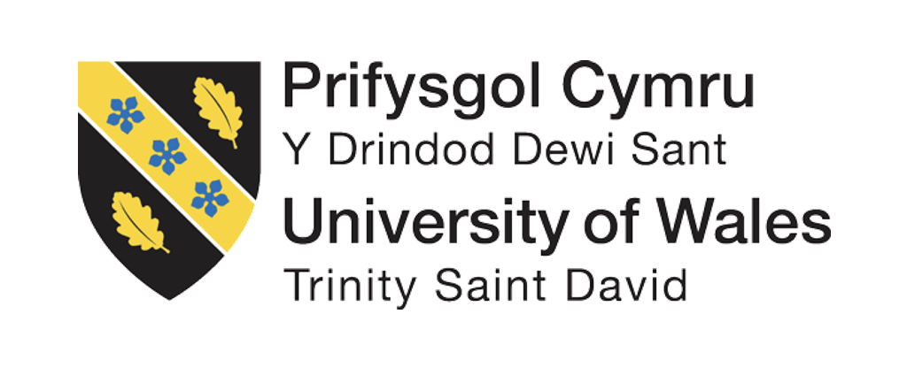

BA (Hons) Leadership and Management Skills for the Workplace
Module: Understanding and Engaging Stakeholders
Module code: LCLM5001

Student Name: Ana Maria Solcan
Student Id: 2427756
Lecturer: Christopher Osborne

Executive Summary
The stakeholder engagement strategies discussed in this report relate to the introduction of the StaySmart+ premium service in the global hospitality organisation InterContinental Hotels Group (IHG). This report examines organisational environments in SWOT and PESTLE models and sets SMART goals to achieve successful implementation of the service. The identification of the key internal and external stakeholders involved in the project, their role, duties, advantages and challenges are critically analysed. Several stakeholder engagement models are used, such as the stakeholder matrix, RACI model, engagement plan, and communications strategy to enable successful collaboration. The management of the stakeholders is also assessed in the report based on the 4Cs model, that is, communication, consultation, collaboration, and commitment. In general, the discussion features that the optimal stakeholder engagement leads to service innovation, efficiency of operations and sustainable organisational performance.

Table of Contents
1. Introduction 4
2. Company Appraisal 5
2.1 SWOT Analysis 5
2.2 PESTLE Analysis 7
3. Key Internal and External Stakeholders 9
3.1 Identification of the Stakeholders 9
3.2 Benefits and Challenges 11
3.3 Stakeholder Analysis Tools 12
4. Roles, Responsibilities, Benefits, and Challenges of Stakeholders 15
4.1 Communication Plan 15
4.2 Level of Engagement 16
4.3 RACI Matrix 18
5. Stakeholder Engagement Process Using the 4C’s Model 20
6. Effect of stakeholder involvement on the performance of a business and Recommendations 23
7. Conclusion 27
References 29

1. Introduction
Technological innovation, shifting consumer demands and increased need for personalised travelling experiences have been crucial in transforming the global hospitality industry (Ashcroft, 2017). The use of digital technologies, artificial intelligence, and sustainability initiatives is increasingly influencing the process of designing and providing services to hospitality organisations. The InterContinental Hotels Group (IHG) is among the most successful companies in keeping up with these developments, as it is a multinational enterprise that deals with the hospitality industry and has its headquarters in London, the United Kingdom. It operates more than 6,900 hotels, and it has outlets in more than 100 countries, and it operates internationally recognised brands such as Holiday Inn, Crowne Plaza, and InterContinental Hotels and Resorts (IHG, 2025).
IHG has been under constant innovation and customer experience to keep up with the competition of the industry in the international hotel industry. The organisation is strategizing a new high-end service, which will be called 'StaySmart+', which will increase the level of guest satisfaction and efficiency in operations. StaySmart+ is a combination of artificial intelligence-based guest engagement systems, customised travel planning offerings, and eco-friendly facilities. The hotel will offer tailored travel tips to customers, mobile digital companionship services, and eco-friendly hotel amenities like power-efficient rooms and waste minimisation programmes to its customers.
The implementation of StaySmart+ will take place in the six months in the international hotels that will be selected. This innovative service involves the coordination of a large number of stakeholders in different departments, geographical areas, and external entities to implement it. Proper stakeholder management is thus essential in ensuring that the service is developed, adopted, and rolled out across the globe successfully (Kudyba and D Cruz, 2023).
This report is a critical evaluation of the stakeholder engagement as applied in the IHG StaySmart+ project. The report will initially assess the organisational environment using SWOT and PESTLE analysis and develop SMART objectives of the project. It then establishes the most important internal and external stakeholders in the service launch, discussing their roles and responsibilities, benefits and possible challenges. Other stakeholder engagement models, such as the stakeholder matrix, the RACI model, and communication plans, are also implemented in the report. Lastly, it assesses the effects of the stakeholder involvement on the organisational performance and gives suggestions on how stakeholder partnership may be enhanced in the future in the production of hospitality innovations.

2. Company Appraisal
The organisational and environmental setting under which IHG operates needs to be analysed prior to the introduction of the StaySmart+ service.

2.1 SWOT Analysis
Strengths
IHG is a company that has over 6,000 hotels worldwide that operate in various markets (IHG, 2025). The broad range of hospitality brands that the organisation has enables it to cater to a variety of customer groups such as luxury travellers and low-end customers (Zeng, 2025). The IHG has also built a robust customer loyalty base on its digital loyalty programme, IHG One Rewards, that allows them to retrieve valuable customer data that could be used to offer personalised services like the StaySmart+.
Weaknesses
The firm has a good brand portfolio but has a complex operation based on the franchise nature of the business model. The alignment between corporate headquarters and the franchise hotel operators can pose a problem in the execution of standardisation of digital services in the international locations.
Opportunities
There is a significant opportunity in the growing demand for personalised and technology-orientated hospitality services. According to the World Tourism Organization, the international tourist arrivals have been noted to reach approximately 1.3 billion in 2023, and it demonstrates the further growth of international tourist travel (UN Tourism, 2026). Customers can have a better experience and improve competitiveness through the implementation of AI-powered services and sustainability campaigns.
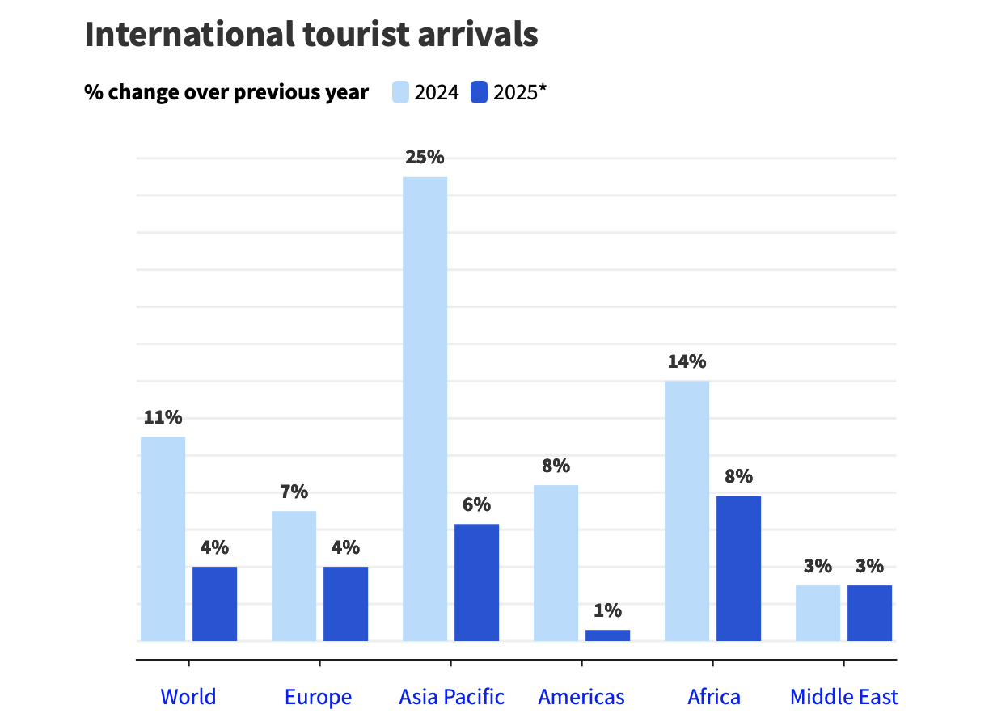
Figure: UN Tourism provisional data
(Sources: UN Tourism, 2026)
Threats
The hospitality industry is extremely competitive, and such giants as Marriott International and Hilton Worldwide Holdings invest in digital guest services. Economic uncertainty, geopolitical risks, and travel behaviour changes also have the ability to impact the demand of the hotel.

2.2 PESTLE Analysis
Political | The implementation of new services could be influenced by the government regulations of tourism and environmental standards as well as international business operations in the global markets.
Economic | Hospitality revenue and customer patterns of spending can be affected by such economic factors like inflation and changes in international travelling demands (Chu, 2025).
Social | In contemporary travellers, personalisation and sustainability have become more important. The World Travel and Tourism Council showed that over 80% of travellers will use sustainable travel choices when choosing accommodation.
Technological | The fast development of artificial intelligence, mobile technologies, and digital platforms allows hotels to offer automated services to their guests and provide real-time travel guidance.
Legal | The privacy laws like the General Data Protection Regulation demand organisations take care of guest information by ensuring it is safely handled during AI system deployment.
Environmental | The sustainability expectations are demanding that hospitality companies should embrace energy-efficient operations, waste management and environmentally responsive services (Handayani, 2025).

2.3 SMART Objectives of StaySmart+
Objective | Specific | Measurable | Achievable | Relevant | Time-bound
Improve Guest Experience | Implement StaySmart+ AI guest interaction and personalised travel planning in selected hotels. | Guest satisfaction scores and service ratings will be monitored through customer feedback surveys. | Use existing digital infrastructure and trained staff to support implementation. | Enhances the customer experience strategy of InterContinental Hotels Group. | Launch across selected hotels within 6 months.
Enhance Operational Efficiency | Introduce AI automation for guest requests and concierge services. | Measure reduction in response time and service efficiency levels. | Supported by the IT department and technology partners. | Improves operational productivity and service quality. | Achieve improvements within the first year of implementation.
Promote Sustainability | Integrate energy-efficient amenities and eco-friendly services through StaySmart+. | Track reduction in energy consumption and waste levels. | Utilise existing sustainability programs in hotels. | Aligns with global sustainable tourism goals. | Achieve measurable results within 12 months.

3. Key Internal and External Stakeholders

3.1 Identification of the Stakeholders
Stakeholder Type | Stakeholder Group | Roles and Responsibilities
Internal | Employees | Deliver day-to-day hotel services, operate digital tools related to StaySmart+, ensure quality guest experience, and implement sustainability practices.
 | Management | Develop strategic plans for the StaySmart+ project, oversee operational implementation across hotels, and monitor project performance.
 | Board of Directors | Provide governance and strategic oversight, approve major investments related to technology and sustainability initiatives (Sathana,  2025).
 | Shareholders | Provide financial investment, influence corporate strategy through voting rights, and expect improved financial performance from innovation initiatives.
External | Customers | Use the StaySmart+ service, provide feedback on personalised travel planning and AI concierge services, and influence brand reputation.
 | Technology Partners | Develop AI-driven systems, digital guest interaction tools, and support the technical infrastructure required for the service.
 | Franchise Hotel Owners | Implement the StaySmart+ service within their hotels, ensuring operational alignment with corporate standards (Bhandari and Sin, 2023).
 | Regulatory Bodies | Monitor compliance with data protection laws, environmental regulations, and hospitality industry standards.
 | Communities | Benefit from employment opportunities and local economic development generated by hotel operations.

3.2 Benefits and Challenges
Stakeholder Group | Benefits | Challenges
Employees | Improved skills through training in digital hospitality technologies and sustainability practices (Van Der Vlist, Helmond and Ferrari, 2024). | Resistance to adopting new technologies and adapting to digital service models.
Management | Improved operational efficiency and competitive advantage through innovation and digital transformation. | Managing organisational change and aligning multiple departments across international markets.
Board of Directors | Strengthened corporate governance and long-term strategic growth through innovation initiatives. | Balancing financial risks with long-term investment in new technologies.
Shareholders | Higher profitability and stronger market positioning through service innovation and enhanced customer experience. | Short-term profit expectations may conflict with long-term innovation investments.
Customers | Personalised travel planning, improved service convenience, and enhanced guest experience through AI technologies. | Concerns about data privacy and reliability of automated service systems.
Technology Partners | Opportunities for collaboration in hospitality innovation and expansion of digital hospitality solutions. | Integration challenges between new technology and existing hotel systems.
Franchise Owners | Increased customer satisfaction and occupancy rates due to improved service quality. | Investment costs required for implementing new digital infrastructure.
Regulatory Bodies | Improved compliance with sustainability and data protection standards. | Ensuring consistent regulatory compliance across multiple countries.
Communities | Job creation and economic development through hospitality industry growth (Christopher, Payne and Ballantyne, 2013). | Environmental concerns related to tourism activities.

3.3 Stakeholder Analysis Tools
3.3.1 Stakeholder Map

Power / Interest Level | High Interest | Low Interest
High Power | Board of Directors, Management | Regulatory Bodies
 | Franchise Owners | Technology Partners
Low Power | Employees, Customers | Communities

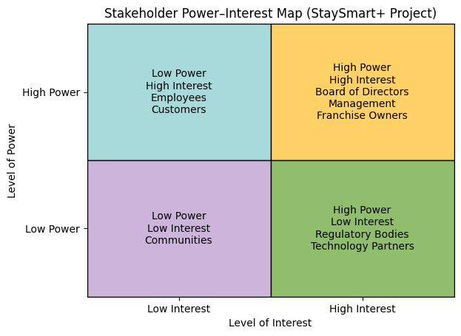
Figure: Stakeholder Map
(Source: Self-created)
The stakeholder map differentiates the stakeholders based on their interest and the extent of involvement in the StaySmart+ project. The stakeholders that are of high power and high interest and, therefore, have to be carefully monitored are the management and the Board of Directors, which have a direct influence on the strategic decisions and allocation of resources (Prince Antony and Ragul Kannan, 2024). The stakeholders who are highly powerful but have lower interest, like regulatory bodies and technology partners, should be maintained as satisfied so that they are compliant and supportive of the technology. Customers and employees are low-power and high-interest stakeholders due to the fact that they are directly influenced by introducing the service. The power of communities and their interest are usually low, yet they are significant because of their involvement in corporate social responsibility programmes and economic development of their localities.
3.3.2 Stakeholder Assessment
Stakeholder Group | Level of Interest (H/M/L) | Level of Involvement (H/M/L) | Level of Influence (H/M/L) | Level Impacted by Project (H/M/L)
Employees | High | High | Medium | High
Management | High | High | High | High
Board of Directors | High | Medium | High | High
Shareholders | Medium | Low | High | Medium
Customers | High | Medium | Medium | High
Technology Partners | Medium | Medium | Medium | Medium
Franchise Owners | High | High | High | High
Regulatory Bodies | Medium | Low | High | Medium
Communities | Medium | Medium | Low | Medium

Stakeholder assessment analyses stakeholders in terms of their interest as well as their involvement, influence and the degree to which the stakeholders are impacted by the StaySmart+ project. This is the case with internal stakeholders like the management and employees since the stakeholders have high interest and involvement levels due to their direct effects on project implementation and operational performance (Labadie and Legner, 2023). The project also affects the external stakeholders like customers and franchise hotel owners, who are the ones who interrelate with the new service and make it adopted. The regulatory bodies are powerful because they contribute to the fulfilment of the hospitality and data protection regulations. This analysis allows project managers to focus on stakeholder engagement processes and invest the resources in an effective manner to undertake successful project execution.

4. Roles, Responsibilities, Benefits, and Challenges of Stakeholders
The project manager plays a very important role in ensuring that the stakeholders are aligned and that the communication, collaboration, and decision-making processes are efficient throughout the project lifecycle (Walsh and Dodds, 2022). To implement the StaySmart+ service successfully, the manager should put in place organised systems like the planning of communication, level of engagement evaluation, and role allocation. These are tools that can be used to make sure that all the stakeholders are always informed, engaged and orientated to the goals of the project.

4.1 Communication Plan
Stakeholder | Meeting | Reports
 | Weekly Meeting | Monthly Meeting
Internal to Project
Product Development Team | X F2F | X VC
IT Department | X VC | X F2F
Marketing Department | X VC | X F2F
Operations Managers | X F2F | X VC
Senior Management | X VC | X F2F
External to Organisation
Customers
Technology Partners | X VC | X F2F
Franchise Owners | X VC | X F2F
Regulatory Authorities
Sustainability Organisations
Key:
F2F – Face to Face
VC – Video Conference
TC – Teleconference
PIP – Project Intranet Page
E – Email
This communication plan will make sure that the information about all the stakeholders in the project StaySmart+ is communicated timely and in the relevant manner to the stakeholders. The weekly meetings and online collaboration platforms that are used to coordinate the technical development and the operational implementation engage internal teams like the product development teams, the IT teams, and the operations teams (Panori et al., 2021). Top management is provided with strategic updates on monthly meetings and highlight reports, which provides them with a chance to track the project progress and discuss the arising issues.
The involvement of external stakeholders, including technology partners and franchise owners, is done via video conference and progress reports to ensure that project objectives and technical specifications are aligned (Silvius and Schipper, 2019). The newsletters and online means of communication are the main channels of informing customers about the advantages of the StaySmart+ service. Exception reports on compliance matters are submitted to regulatory authorities and make sure there is transparency and legal standards are followed.

4.2 Level of Engagement
Stakeholder | Unaware | Resistant | Neutral | Supportive | Leading
Product Development Team |  |  | C |  | D
IT Department |  |  | C |  | D
Marketing Department |  |  |  | C | D
Operations Managers |  |  | C |  | D
Senior Management |  |  |  | C | D
Customers |  |  | C |  | D
Technology Partners |  | C |  |  | D
Franchise Owners |  | C |  |  | D
Regulatory Authorities |  |  | C |  | D
Sustainability Organisations |  |  | C |  | D

Key:
C = Current Level
D = Desired Level
The level of engagement matrix determines the actual and the intended stakeholder participation in the StaySmart+ project. Internal stakeholders like product development teams and IT departments are neutral at this stage but will play a dominant role during the implementation phase since they are responsible for technical issues (Brodny, Tutak and Grebski, 2025). Marketing divisions and top management are already accommodative and will be expected to spearhead communication and strategic orientation.
The external stakeholders like the technology partners and franchise owners can be initially resistant because of the interest in the costs of investments and the changes in their operations. But the objective is to transfer them to leadership positions where they will be involved advocates of the project implementation (Sarangee et al., 2022). The targeted customers, regulatory bodies, and the sustainability organisations will be the main advocates to enjoy the advantages of customised, eco-friendly hospitality services.

4.3 RACI Matrix
Task / Activity | Product Development | IT Department | Marketing | Operations | Senior Management | Customers | Tech Partners | Regulators | Sustainability Groups
Develop StaySmart+ Service | R | A | C | C | I | I | C | I | C
Implement AI Guest Interaction Tools | C | R | I | C | A | I | R | I | I
Strategic Decision Making | I | I | I | I | R/A | I | I | I | I
Sustainability Initiative Implementation | C | C | I | R | A | I | C | I | R
Marketing and Promotion | I | I | R/A | C | C | C | I | I | I
Customer Feedback Collection | C | C | R | C | A | R | I | I | I
Regulatory Compliance Reporting | I | C | I | R | A | I | I | R | C
Stakeholder Engagement Activities | R | C | C | C | A | C | C | I | C

Key:
R – Responsible
A – Accountable
C – Consulted
I – Informed
The responsibilities and roles of the stakeholders involved in the StaySmart+ project are well-identified in the RACI matrix. There is a task done by responsible stakeholders and accountable stakeholders; there is input and expertise by consulted stakeholders and updates given to informed stakeholders on the project progress. With the help of the RACI framework, the project manager can be sure of accountability and minimise confusion in the decision-making process as well as encourage efficient cooperation between the stakeholders of the service launch.

5. Stakeholder Engagement Process Using the 4C’s Model
The stakeholders in this context play a crucial role in making the implementation of the StaySmart+ service successful in the international hotel properties (Geremew and Kleynhans, 2025). Being the project manager, I must make sure that I possess a process of stakeholder engagement that is systematic in nature and which promotes transparency, collaboration and alignment to organisational goals. The 4c model that incorporates communication, consultation, collaboration and commitment is a comprehensive description of how the relationship between the stakeholders should be managed throughout the project life cycle.
Communication
Effective stakeholder engagement is based on communication. Effective and consistent communication will enable all stakeholders to get the objectives, benefits and operational implications of the StaySmart+ service. I, as the project manager, would come up with an elaborate communication strategy that will help in disseminating information to both internal and external stakeholders.
To the internal stakeholders like the product development team, IT department, and marketing teams, communication would be done through normal project meeting sessions, digital collaboration tools, and performance reports (Dugbartey and Kehinde, 2025). Such communication channels enable the project members to exchange updates, risk identification, and organisation of project activities, among others.
The external stakeholders, owners of franchise hotels and technology partners need to be clearly informed about the timeframe, expenses and operational aspects of the implementation of the StaySmart+ system. Communication assists in developing trust and keeps the stakeholders updated on the project.
Moreover, the customers should be communicated with in order to create awareness and acceptance of the new service. The guests may be informed about the value of the AI-based guest services and greener efforts through marketing campaigns, updates of the mobile application, and personalized notifications.
Consultation
The consultation is the procedure of accepting the feedback of the stakeholders by actively requesting them to provide input in making the decision (Albareda, 2024). This will ensure that the stakeholders feel valued and they will be open to making contributions towards the project.
As an illustration, the hotel managers and low-level staff have useful operational intelligence that can enhance the design of the StaySmart+ service. The project team can also learn how to address the possible operational challenges and modify the service design by holding consultation workshops and feedback sessions.
In the same vein, customer consultation may be used to gain useful information on user expectations and preferences. Customer surveys, focus groups and online feedback systems can enable the company to optimise personalised travel planning functions and online concierge services obtainable with StaySmart+.
It is also important to consult technology partners. The expertise of external vendors can help to create scalable and reliable technological solutions since the AI infrastructure is needed and digital systems are needed to create the service.
Collaboration
Collaboration entails mutual activities of the stakeholders in order to accomplish common project goals (Ali and Haapasalo, 2023). Collaboration is especially essential in the context of StaySmart+ since the service is a combination of various organisational processes such as technology, operations, marketing and sustainability programmes.
The internal collaboration is possible by use of cross-functional project teams comprising representatives of various departments. These teams may collaborate to develop the service, tackle the operational issues and organise the implementation strategies at the international sites.
Cooperation with franchise hotel owners is also necessary. Due to the numerous hotels that the organisation has on franchise contract, it provides the necessary support to allow successful adoption of the services. The franchise owners are willing to take part in the rollout, and regular workshops and training programmes can help them realise the advantages of StaySmart+.
Collaborative relationships are also necessary with the partnerships with sustainability organisations and technology providers (Bowser et al., 2024). These partners bring in specialised knowledge that adds the environmental and the technological features of the service.
Commitment
The last element of the 4Cs model is commitment. Stakeholder commitment is the desire of the stakeholders to assist the project and provide resources needed to achieve the success of the project.
To develop internal stakeholder commitment, senior management needs to express the strategic significance of StaySmart+ in an explicit way and allocate sufficient financial and technological support. Employees can also be encouraged to embrace the new service model by the use of performance incentives and training programmes (Tan, Van Dun and Wilderom, 2024).
To the external stakeholders like the owners of the franchise hotels, commitment would be enhanced by showing them the possible financial and competitive advantages of the service. To illustrate, the satisfaction of the guests and the ease of its operation can be enhanced, which will lead to a higher hotel occupancy level and income.
The loyalty programmes and individualised service experiences can be used to make customers committed. Combining StaySmart+ functionality and IHG One Rewards, customers will be able to get personalised suggestions and discounts, enhancing long-term relations with the brand.
When taken as a whole, the implementation of the 4 Cs model will allow the project manager to establish a good relationship with stakeholders, reduce conflicts, and successfully introduce the StaySmart+ service in the international markets.

6. Effect of stakeholder involvement on the performance of a business and Recommendations
The involvement of stakeholders is very important in the issue of new product or service development success in the hospitality industry. Good engagement strategies enable organisations to match the interests of stakeholders and enhance service delivery and organisational performance (Hristov and Appolloni, 2022).
Implication on Business Performance
Enhanced service quality and customer satisfaction are also some of the greatest effects of stakeholder engagement. Involving customers, hotel staff and operational managers in the development process would enable organisations to create services that are more acceptable to the guests. In the example of StaySmart+, the feedback of customers is beneficial to make sure that the AI-driven travel planning tools and sustainability initiatives can offer any value to guests.
The increased customer satisfaction makes a direct contribution to brand loyalty and repeat business. To stay competitive in the market, hospitality companies depend on good experiences of the guests and online reviews. The involved stakeholders can contribute to the consistency in the delivery of services in the various hotel locations.
The other notable effect is enhanced operational efficiency. Employees and operational managers are included in the planning and implementation phases of a project; thus, they are in a better position to understand new systems and processes (Monod et al., 2024). This minimises the resistance to change and the possibility of successful technology adoption. Consequently, the automated capabilities of StaySmart+ with AI drive can be used to automate hotel management and lessen the administrative duties.
Innovation and knowledge sharing are also through stakeholder engagement. Cooperation with the external partners and the internal teams promotes the sharing of ideas and experience. As an example, the technology partners can add new digital tools that will improve the functions of the StaySmart+ platform. Equally, we can have sustainability organisations giving information on how to run a hotel in an environmentally friendly manner.
Effective stakeholder engagement should also lead to financial performance. The World Travel and Tourism Council claims that hospitality firms investing in customer experience and sustainable tourism initiatives tend to have better revenue growth and brand equity.
Nevertheless, engagement of stakeholders can also be a problem. It is not necessarily simple to control the various interests of stakeholders, especially when dealing with multinational organisations that have varying cultural and regulatory backgrounds. The stakeholders may have conflicts over the project costs, changes in operations or changes in technology (Sanyaolu et al., 2023).
As an illustration, the financial resources needed to install new digital infrastructure might be of concern to the franchise hotel owners. Equally, the employees might be confused about the impact of new technologies on their roles and duties. These issues underscore the need to have a powerful leadership and communication channel in managing stakeholders.
Recommendations
Category | Recommendation | Description
Internal Development | Strengthen Employee Training for Digital Services | The organisation should provide specialised training programmes for hotel staff to effectively operate AI-driven tools and personalised guest services associated with the StaySmart+ platform (Kujala et al., 2022). Continuous training will improve service quality, employee confidence, and operational efficiency during the implementation process.
Communication Strategy | Improve Internal and External Communication Channels | A structured communication system should be established to ensure that all stakeholders, including employees, franchise owners, and technology partners, remain informed about project progress. Regular updates, meetings, and digital platforms can increase transparency and strengthen stakeholder trust.
Technology Utilisation | Invest in Advanced AI and Data Security Systems | The organisation should invest in secure artificial intelligence technologies and data management systems to support personalised guest experiences while protecting customer information (Attah et al., 2024). Strong cybersecurity measures will ensure compliance with data protection regulations and increase customer confidence in digital services.
Customer Engagement | Enhance Personalised Customer Experience | The company should use guest data and feedback systems to continuously improve the StaySmart+ service. Personalised travel recommendations, digital concierge services, and loyalty programme integration can strengthen customer satisfaction and brand loyalty.
Strategic Partnerships | Collaborate with Sustainability and Technology Partners | Developing partnerships with technology firms and sustainability organisations can help the company improve innovation and environmental practices. These collaborations can support sustainable hotel operations and strengthen the organisation’s reputation in the global hospitality industry.

7. Conclusion
To achieve successful implementation and long-term organisational benefits, the introduction of new services in the hospitality business should be properly engaged with the stakeholders. This report reviewed the stakeholder engagement plans of introducing the StaySmart+ service in InterContinental Hotels Group.
The analysis started with an assessment of the organisational environment based on SWOT and PESTLE frameworks, which have presented major opportunities and challenges in the hospitality environment throughout the world. The results also showed that technological innovation, sustainability expectations, and evolving customer preferences are major issues in the development of new hospitality services.
The report followed with the identification of the major internal and external stakeholders in the Stay Smart+ project, which included product development teams, IT departments, marketing teams, franchise hotel owners, technology partners, and customers. All the stakeholder groups have a different role in designing, realising, and delivering the service. They bring their experience, resources and assistance in such a way that the service is delivered in line with organisational and customer expectations.
The stakeholder engagement frameworks, like the stakeholder matrix, RACI model, and communication plans, were used to explain stakeholder roles, responsibilities, and engagement plans. In addition, the 4Cs model – communication, consultation, collaboration and commitment, was employed to demonstrate how the project manager can efficiently cope with the relationship between the stakeholders and ensure that conflicts do not arise.
The analysis also revealed a positive stakeholder involvement in higher service quality, efficiency of the operations, innovation, and financial outcomes. Nevertheless, issues like interest clashes between stakeholders, technological integration issues, and data privacy issues should be well addressed.
All in all, a key success factor of the StaySmart+ initiative is its proper stakeholder engagement. With the help of organised engagement models, open communication channels, and friendly relations, the organisation will have the opportunity to launch the new service in foreign markets and improve customer experience and reinstate its competitive advantage in the global hospitality sector.

References
Albareda, A. (2024) Stakeholder consultation throughout the policy process. In Handbook on lobbying and public policy (pp. 117-129). Edward Elgar Publishing.
Ali, F. and Haapasalo, H. (2023) Development levels of stakeholder relationships in collaborative projects: challenges and preconditions. International Journal of Managing Projects in Business, 16(8), pp.58-76.
Ashcroft, J. (2017) The relational lens: understanding, measuring, and managing stakeholder relationships. Cambridge: Cambridge University Press. Available at: https://www-cambridge- org.ezproxy.uwtsd.ac.uk/core/books/relational-lens/value-and-importance-of-relationships/718C31032061BDFA3F480BA2A53F45D4#CN-bp-1.
Attah, R.U., Garba, B.M.P., Gil-Ozoudeh, I. and Iwuanyanwu, O. (2024) Evaluating strategic technology partnerships: Providing conceptual insights into their role in corporate strategy and technological innovation. Int J Front Sci Technol Res, 7(2), pp.77-89.
Bhandari, R. and Sin, M.V.A. (2023) Optimizing digital marketing in hospitality industries. Startupreneur Bisnis Digital (SABDA Journal), 2(1).
Bowser, G., Ho, S.S., Ziebell, A. and Lazendic-Galloway, J. (2024) Networking and collaborating: the role of partnerships across sectors to achieve educational goals in sustainability. Sustainable Earth Reviews, 7(1), p.17.
Brodny, J., Tutak, M. and Grebski, W.W. (2025) Open Innovation in Energy: A Conceptual Model of Stakeholder Collaboration for Green Transition and Energy Security. Energies, 18(21), p.5654.
Christopher, M., Payne, A., and Ballantyne, D. (2013). Relationship Marketing: Creating Stakeholder Value. Saint Louis: Taylor and Francis.
Chu, H.C. (2025) Empirical analysis of long-and short-run relationships between travel demand, economic factors, and hotel performance. Tourism Recreation Research, pp.1-17.
Dugbartey, A.N. and Kehinde, O. (2025) Optimizing project delivery through agile methodologies: Balancing speed, collaboration and stakeholder engagement. World Journal of Advanced Research and Reviews, 25(1), pp.1237-1257.
Geremew, Y.M. and Kleynhans, C. (2025) Staycation as a means of synergising resilience and stakeholder collaboration for sustainable tourism development: A roadmap for crisis management. Sustainability, 17(16), p.7308.
Handayani, T. (2025) Sustainable Operations Management in Hospitality: An Empirical Study of Energy Efficiency and Waste Reduction Strategies. Hospitality Management and Operations Journal, 2(2), pp.93-114.
Hristov, I. and Appolloni, A. (2022) Stakeholders' engagement in the business strategy as a key driver to increase companies' performance: Evidence from managerial and stakeholders' practices. Business Strategy and the Environment, 31(4), pp.1488-1503.
IHG, (2025). Brands with purpose [Online] Available at: https://development.ihg.com/hotel-brands [Accessed on: 13 March, 2026].
Kudyba, S. and D Cruz, A. (2023) Understanding project success involving analytic-based decision support in the digital era: a focus on IC and agile project management. Journal of Intellectual Capital, 24(6), pp.1429-1446.
Kujala, J., Sachs, S., Leinonen, H., Heikkinen, A. and Laude, D. (2022) Stakeholder engagement: Past, present, and future. Business & Society, 61(5), pp.1136-1196.
Labadie, C. and Legner, C. (2023) Building data management capabilities to address data protection regulations: Learnings from EU-GDPR. Journal of Information Technology, 38(1), pp.16-44.
Monod, E., Mayer, A.S., Straub, D., Joyce, E. and Qi, J. (2024) From worker empowerment to managerial control: The devolution of AI tools' intended positive implementation to their negative consequences. Information and Organization, 34(1), p.100498.
Panori, A., Kakderi, C., Komninos, N., Fellnhofer, K., Reid, A. and Mora, L. (2021) Smart systems of innovation for smart places: Challenges in deploying digital platforms for co-creation and data-intelligence. Land use policy, 111, p.104631.
Prince Antony, J. and Ragul Kannan, M.D. (2024) Revolutionizing the Tourism Industry through Artificial Intelligence: A Comprehensive Review of AI Integration, Impact on Customer Experience, Operational Efficiency, and Future Trends.
Sanyaolu, T.O., Adeleke, A.G., Efunniyi, C.P., Akwawa, L.A. and Azubuko, C.F. (2023) Stakeholder management in IT development projects: Balancing expectations and deliverables. International Journal of Management & Entrepreneurship Research P-ISSN, pp.2664-3588.
Sarangee, K., Schmidt, J.B., Srinath, P.B. and Wallace, A. (2022) Agile transformation in dynamic, high-technology markets: Drivers, inhibitors, and execution. Industrial marketing management, 102, pp.24-34.
Sathana, V. (2025) Application of artificial intelligence in travel, hospitality, and tourism: a systematic literature review.
Silvius, G. and Schipper, R. (2019) Planning project stakeholder engagement from a sustainable development perspective. Administrative sciences, 9(2), p.46.
Tan, A.B., Van Dun, D.H. and Wilderom, C.P. (2024) Lean innovation training and transformational leadership for employee creative role identity and innovative work behavior in a public service organization. International Journal of Lean Six Sigma, 15(8), pp.1-31.
UN Tourism, (2026) International Tourism to Reach Pre-Pandemic Levels in 2024 [Online] Available at: https://www.untourism.int/news/international-tourism-to-reach-pre-pandemic-levels-in-2024 [Accessed on: 13 March, 2026].
Van Der Vlist, F., Helmond, A. and Ferrari, F. (2024) Big AI: Cloud infrastructure dependence and the industrialisation of artificial intelligence. Big Data & Society, 11(1), p.20539517241232630.
Walsh, P.R. and Dodds, R. (2022) The impact of intermediaries and social marketing on promoting sustainable behaviour in leisure travellers. Journal of Cleaner Production, 338, p.130537.
Zeng, Y. (2025) Essays on Sharing Economy and Platforms. University of California, Los Angeles.

