Jacob C (2420842)
2420842@student.uwtsd.ac.uk
A report of the subjects and topics covered in the “Study Skills” Module
Study skills report
L4 - Study Skills for Electronics, Module Code: ACDA4021

Contents
Introduction 3
1 - Presentation Skills 3
2 - Personal Research on Essential Skills 5
2.1 - Essential Skills: 5
2.2 - Generic/Transferrable Skills: 6
3 - Self Evaluation and Action Planning 6
3.1 - Personality: 6
3.2 - Strengths and weaknesses: 7
3.3 - Personality Type: 8
3.4 - Future Goals: 8
3.5 - Long Term Goals: 8
3.6 - Short Term Goals: 8
3.7 - Action Planning: 8
4 - Application 8
4.1 - Data Storage and management 8
4.2 - Time Management and Self Organisation 8
5 - Conclusion and Evaluation 8
References 8
Appendix 8

Introduction
For this report we were tasked with evaluating and reflecting on the work performed by ourselves and our peers in the study skills module. This report will cover what was learned, how it has been adapted for use in other subjects, and what other essential skills could be applied to future works based on what was learned over the course of this module.

1 - Presentation Skills
Within the module, each student was tasked with creating a presentation about themselves, detailing who they are, and how did they get to where they are today, these presentations were to be no more than five minutes in length.
The students were then required to present their presentations to the class as a form of introduction, feedback was then given on potential improvements as well as what went well.
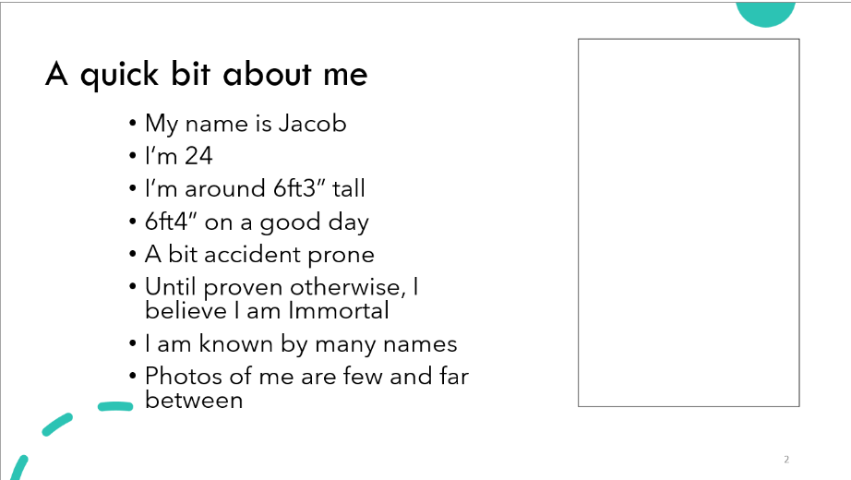
The first main slide from myself detailed a series of brief, and short points, allowing them to be presented and expanded upon without boring or overwhelming the audience with a large amount of information all at once. On the right was also a picture of myself, all media throughout the presentation was formatted to have the text on the left side and any media on the right, which allowed for a clear divide between information and media for the audience. A small amount of humour was also included within the slides, this was done in an attempt to break up the presentation, creating a sense of ease in order to try and relax both the audience and the speaker, allowing the presentation to flow clearer, this trend is present throughout the presentation.
This choice of formatting was intended to follow a “Tell don’t Show” model, this utilises a trick in human psychology [1], in which information on the slides would be kept brief and succinct, in order to keep attention on the presenter, as the reader would gather a brief overview of the information from the slide by a more in depth overview from the presenter, keeping them engaged and listening instead of having the audience tune out and focus on reading, or having them stop paying attention entirely as they have finished reading and have gotten all of the required information from the slide.
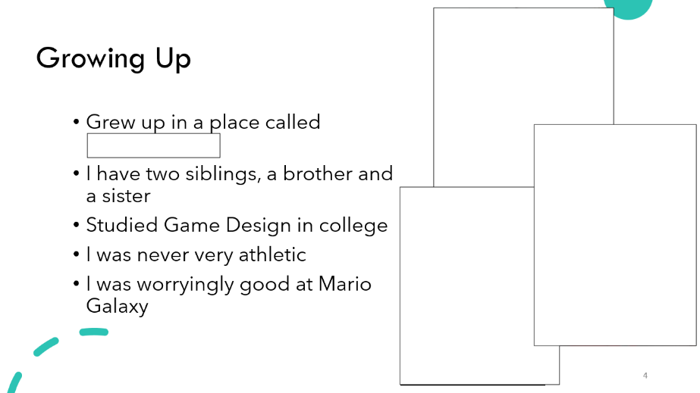
Following from the first slide, I went on to talk about my childhood, detailing where I grew up, what I studied in school, as well as including details about my hobbies growing up too, in this case video games. Including photos on the right to provide additional information to back up what was said and to provide the audience with additional context for any discussion and information from the presenter.
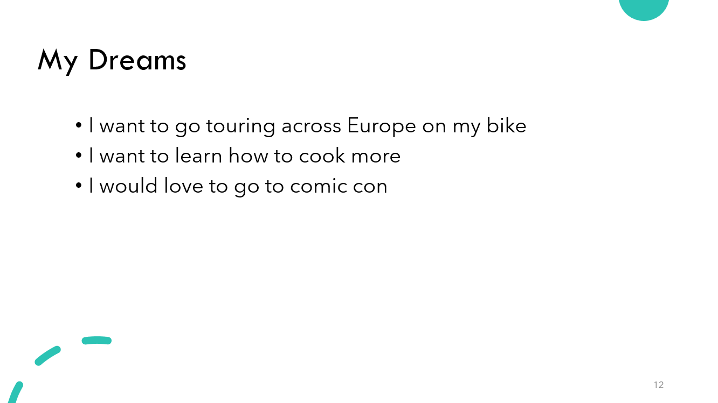
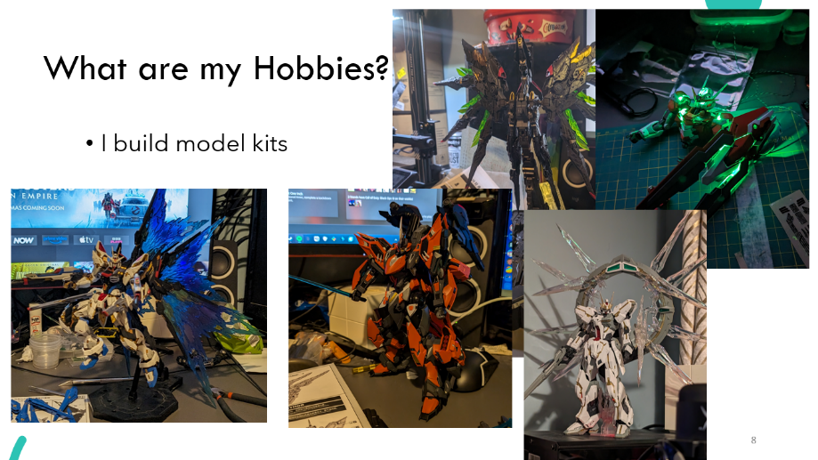
Next followed the slides detailing any hobbies and interests, these slides were formatted in a different way to the slides that came before. As they were detailing creative hobbies these slides were predominantly image based, allowing for the audience to gather a clear understanding as to what the hobbies were whilst the presenter was giving a further breakdown what each image detailed, and what exactly the hobby is.
Finally, was a slide detailing my dreams, as I did not have any long-term goals or aspirations at the time of presenting, only shorter-term goals were detailed. This side followed a simpler design than the previous, only containing a few brief bullet points as it was intended to help wrap up the presentation, and as such was kept simple and clean.
From this presentation and the feedback received from my peers I feel that future presentations would benefit from speaking with a slightly stronger cadence, as well as speaking at a slightly slower pace. This would allow for a presentation with a much better flow, without sounding rushed, and instilling confidence in the audience to make them believe that the speaker is knowledgeable in the field being presented.

2 - Personal Research on Essential Skills
This section details the skills and knowledge that are essential to higher learning environments, and professional environments, as well as how they can be applied to different fields regardless of the nature of said field, both in study and the workplace.

2.1 - Essential Skills:
There is a number of skills that are essential to higher education, these allow for a foundation for knowledge to be learned and to be then later cultivated and expanded upon, leading to later success.
Upon studying a number of sources [2] [3], there are a multitude of skills that are essential for success in higher education, particularly within a student’s first year of study.
According to an article by Paul Walker and Nicholas Finney [3] a developed capacity for critical thinking is an essential skill for the learning environments involved in higher education, as this skill enables the student to make purposeful, reasonable and effective decisions in order to reach a goal. This allows the student to take a step back evaluate the situation and then put together a plan of action. This kind of thinking is involved in solving problems, calculating risk, inferring information, and making decisions, making it a key skill necessary in both higher education and throughout the student’s career after the end of their education. The traits displayed within critical thinking are also found in a number of other essential skills, such as problem solving, time management, and the ability to work with others.
Problem solving, as described in the article by Peter Washer [2], details the ability to appreciate the complexity of a task, being able to identify any potential issues, and then discover a solution to lead you to the desired outcome. This skill ties into critical thinking, and as such enables a student to further develop their understanding of the task as hand and the subject as a whole, as they are able to evaluate the task and identify solutions that may not be evident at first and then apply the knowledge learned from the problem to other potential issues, further increasing their understanding of the subject matter at hand.
Time management is another key skill described in the article by Peter Washer, as this allows the student to properly manage time, enabling them to achieve deadlines within a timely manner without rushing at the last minute to achieve them. This is also an essential skill in the wider industry beyond their education as the student will be required to achieve difficult deadlines in their future careers.

2.2 - Generic/Transferrable Skills:
Beyond a person’s experiences in higher education lies the wider world, where both the skills learned throughout university as well as new skills which will be learned throughout a person’s career will be essential all throughout their lives. Included are skills such as teamwork, organisational skills, data management, use of IT.
Teamwork is an important skill in the wider world beyond one’s study. In an article by Kathryn Hoff [4], teamwork is described as something that enables teams to evolve as it is a typically a group full of people with a multitude of different backgrounds and experiences, however typically with the specific expertise needed to complete the task at hand. Teamwork is especially important as within a good team, all participants are enabled to grow and learn from each other and potentially further their careers.
Self-management, reflection and development, as mentioned in a journal article by Chris Morgan [5], are important lifelong skills and are highly desirable to employers as they enable individuals to be able to reflect upon any areas of improvement and act independently to improve and develop their skillset, enabling them for further development in the future.
A study performed by John Aliu and Clinton Aigbavboa [6] talks about a number of generic key skills desirable in people in the professional industry, specifically grouping a large number into a cluster of four groups, being “critical and analytical skills”, “entrepreneurship skills”, “problem solving skills”, and “leadership skills”. All of the skills that fall into these four categories are essential for the success of any working professional, as they allow for the growth and evolution an individual’s skillset. Some skills that fall into these four categories include: adaptability skills, interpersonal skills, management skills, analytical skills, networking skills, ICT skills.

3 - Self Evaluation and Action Planning
This section will cover an evaluation of myself, covering the various strengths and weaknesses discovered throughout the participation in external research surveys, as well as different personality traits discovered and the accuracy of the various surveys with how they apply to myself.

3.1 - Personality:
Prior to participating in the research surveys, I believe myself to be an introvert, with a creative mindset, and an analytical nature. These traits are most evident in my hobbies, and general nature, with my hobbies being more focused on being indoors (model making, tinkering etc), requiring slow and methodical work whilst isolated from wider social groups, whilst also listening to music to help to focus, a study from the video by the BBC has shown that introverts tend to focus better whilst listening to music [7].

3.2 - Strengths and weaknesses:
Following a personality survey, where a series of 50 questions are asked to a user to evaluate their approaches to different circumstances and problems, a score on five different fields was shown to display where the user sits on different scales.
For “Extroversion” a score of 33 was shown, indicating that that the user is more introverted than not, but is not so introverted to completely avoid social situations, as it is close to a “middle of the road” score. This indicates that the user displays signs of both introversion and extroversion, but more so to the introverted side of the scale.
The second score was “Emotional Stability” with a score of “22”. The Emotional stability score is also referred to as neuroticism, meaning that the user shows signs of anxiety, fear, worry, anger and loneliness. Users with a higher score however are shown to be more emotionally resilient and are better at coping with stress and adversary. With a score of 22, this shows that the user in this case is more prone to show signs of stress and anxiety in situations where they are prone to more pressure.
The Third score was “Agreeableness”, which showed a score of 40. Users who score higher on this scale are characterised as being warmer and more considerate, with a stronger sense of empathy and concern for others. Users who score lower on this scale however are shown to be more competitive and sceptical, and may be more likely to express their opinions, even at risk at causing conflict with others.
The fourth category was “Conscientiousness”, with a score of “22”. A lower score on this category typically details that a person can be impulsive or disorganised, where they can have difficulty setting and achieving goals. Whereas users with a higher score are typically more responsible organised and motivated, however an extremely high score could indicate negative behaviours such as perfectionism or being rigid in their behaviours, as such it is good to maintain a balance between the two scores.
The final category is “Intellect/Imagination” with a score of 80. This category is also known as the openness to experience. Users with a higher score in this category are typically known to be imaginative, curious, and open to new ideas and experiences, they also show a preference towards the aesthetic details of projects and general creativity. In contrast to this, users with a lower score are typically more traditional with their approaches, where they prefer a more familiar approach to a situation.

3.3 - Personality Type:
A survey on the “16 Personalities” website has shown that the user possesses the INFP-T personality type. This translates out to “Introverted, Intuitive, Feeling, Prospecting, Turbulent”.
The results of this test show that the user is someone who prefers quieter more intimate encounters as opposed to busier venues, where they can explore their own thoughts, and values, this is shown through the first three values, Introverted Intuitive and Feeling. The prospecting value shows the user is very adaptable, and flexible allowing them to adapt to any situations that may arise, where they prefer spontaneity and impulse over a set plan and schedule.
The turbulent aspect of the result shows that the user is likely self-conscious and is prone to stress, with a perfectionistic viewpoint, whilst also being eager to improve.

3.4 - Future Goals:
This subsection covers the long- and short-term goals, the users intends to pursue in the future.

3.4.1 - Long Term Goals:
- Complete my degree
- Get out of debt
- Move into my own place

3.4.2 - Short Term Goals:
- Start to learn a new language
- Improve overall academic performance
- Establish a morning routine
- Improve note-taking ability
- Meet new people

3.5 - Action Planning:
To Achieve the goals outlined above, it is essential to establish a plan of action in order to find the best approach to tackle these tasks. One way to establish a plan of action is to use SMART, which stands for; “Specific”, what am I going to do? “Measurable”, how will I measure my success? “Attainable”, What will I do to achieve my goal? Relevant”, is this goal worthwhile? “Time-bound”, when will I accomplish my goal?
For the above goals it is also necessary to establish a SMART plan, this will be shown below.

Example 1: Long term goal – Get Out of Debt
Specific – “What am I going to do? And why is this important to me?”
The author wishes to get out of debt so they can reclaim their financial independence
Measurable – “How will I measure my success? How will I know when I have achieved my goal?”
Success will be shown in when each aspect of the debt has been erased, closing cards or freezing cards when they have been cleared and putting them away.
Attainable – “What will I do to achieve this goal?
Put aside 20% of salary every month after bills and expenses to pay into the debt, putting any remaining funds into a savings account.
Relevant – Is this goal worthwhile? How will achieving it help me?
This goal will help the author to reclaim control over their finances, allowing them to save for building a future.
Time-Bound – When will I accomplish my goal? How long will I give myself?
2 years’ time will be given to accomplish this goal, in the meantime money will be spent frugally, and only on necessities.
Example 2: Long term goal – Move into my own place
Specific – “What am I going to do? And why is this important to me?”
The author wishes to move out of their parents’ house and into their own flat/house, allowing them to finally have their own space
Measurable – “How will I measure my success? How will I know when I have achieved my goal?”
Success will be measured once a new home is obtained
Attainable – “What will I do to achieve this goal?
Money will be put aside after all bills and expenses every month until enough is saved for a deposit.
Relevant – Is this goal worthwhile? How will achieving it help me?
This goal will help the author to reclaim their personal freedom and allow them to build a personal life for themselves.
Time-Bound – When will I accomplish my goal? How long will I give myself?
The goal will be reached once a deposit has been saved; 12 months is the timeframe.
Example 3: Short term Goal – Start to learn a new language
Specific – “What am I going to do? And why is this important to me?”
The author wishes to start to learn a new language, to allow for new opportunities in the future
Measurable – “How will I measure my success? How will I know when I have achieved my goal?”
Success will be measured by taking log of every day where a lesson has been taken until a full month has been reached, and a habit has been formed
Attainable – “What will I do to achieve this goal?
Sign up for a language program and take regular lessons
Relevant – Is this goal worthwhile? How will achieving it help me?
This goal will help open new career opportunities for the author.
Time-Bound – When will I accomplish my goal? How long will I give myself?
The goal will be reached after a month of continuous learning.

Example 4: Short Term Goal – Improve Academic Performance
Specific – “What am I going to do? And why is this important to me?”
The author wishes to improve their overall performance in their studies
Measurable – “How will I measure my success? How will I know when I have achieved my goal?”
Success will be measured once their confidence in their stuffies improves
Attainable – “What will I do to achieve this goal?
The author will research new studying techniques, where they will try and practice until they find a method that feels comfortable.
Relevant – Is this goal worthwhile? How will achieving it help me?
This goal will help the author improve their overall grades for their course.
Time-Bound – When will I accomplish my goal? How long will I give myself?
The user has given themselves until the end of the current academic year to find a better technique; 6 months.

4 – Application
This section will cover the application of different techniques to ensure for better organisational standards and data retention.

4.1 - Data Storage and management
The author has demonstrated a data storage method to allow for data to be stored in 3 different places at one time. This method allows for the data to be protected and easily recoverable in the event of data loss, i.e.: a ransomware attack, data corruption.
This was achieved by storing a copy within the user’s “one drive”, to allow for a cloud-based backup that would update whenever the locally saved copy is saved and sent, and then finally keeping a hard backup of the system stored on an external HDD, which would be backed up every other day.
Not only is this good practice for study, but this is also good practice for general use, as it also protects the user against different types of cyber-attack, one of the most common being a ransomware attack, which encrypts the user’s data, and holds it at ransom. Good data protection practice methods such as a simple backup is an excellent method of protecting yourself and mitigating your losses as a simple data restore from a backup will restore the system to before it was compromised [8].

4.2 - Time Management and Self Organisation
Time management and self-organisation are essential skills to maintain and practice, regardless of the field as proper time management and self-organisation will allow for someone to be able to properly evaluate their time and schedule in a neat and proper manner, allowing for proper preparation and punctuality in all most cases.
One method used to ensure a proper and organized schedule is known as “blocking” [9]where a schedule is meticulously planned down to allow for little to surprises within a day. This method is ideal for the right type of person, as it allows for someone to plot their entire day/week, however this method of organisation can be stressful for others as a slight delay could mean the derailment of their entire day.
In the case of the author, they intend to begin to use their calendar to schedule in events, however not to the scale of a block calendar, instead intending to simply keep track of any tasks/events that they may have coming up in the near future, as they benefit best from a mostly loose schedule.

5 - Conclusion and Evaluation
Throughout this report, the author has undergone an amount of self-reflection and learning, picking up on areas they were lacking in their presentation skills, establishing what skills are essential for higher education and what skills to consider learning for the more generic field, as well as undertaking a large amount of self-evaluation and where how they can improve their personality for the benefit of themselves and for the betterment of others.
The key topics of development for the author were to establish a better understanding of critical thinking and to better understand what interpersonal skills to develop in order to establish a better basis for networking and establishing connections in their future careers.

References

[1] | Ryan, “Presentation Geeks,” 24 05 2022. [Online]. Available: https://presentationgeeks.com/blog/presentation-psychology-7-top-tips/. [Accessed 2024 12 30].
[2] | P. Washer, “Quality in Higher Education,” Taylor & Francis Online, vol. 13, no. 1, pp. 57-67, 2007.
[3] | P. W. &. N. Finney, “Teaching in Higher Education,” Taylor & Francis Online, vol. 4, no. 4, pp. 531-547, 1999.
[4] | K. S. Hoff, “Leaders and managers: Essential skills required within higher education,” Higher Education, vol. 38, pp. 311-331, 1999.
[5] | C. Morgan, “Developing and assessing generic skills at a distance,” 2003.
[6] | J. A. a. C. Aigbavboa, “Key generic skills for employability of built environment graduates,” INTERNATIONAL JOURNAL OF CONSTRUCTION MANAGEMENT, vol. 23, no. 3, pp. 542-552, 2023.
[7] | C. Luthuli, Director, Why can some people study as they listen to music, while others can't?. [Film]. United Kingdom: BBC, 2016.
[8] | J. C, “Ransomware,” 2025.
[9] | J. Martins, “Are you time blocking your calendar? Here’s why you should start now.,” Asana, 25 02 2024. [Online]. Available: https://asana.com/resources/what-is-time-blocking. [Accessed 12 01 2025].

Appendix
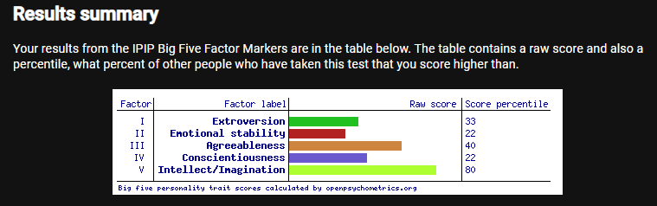
Results following a “big five” personality test
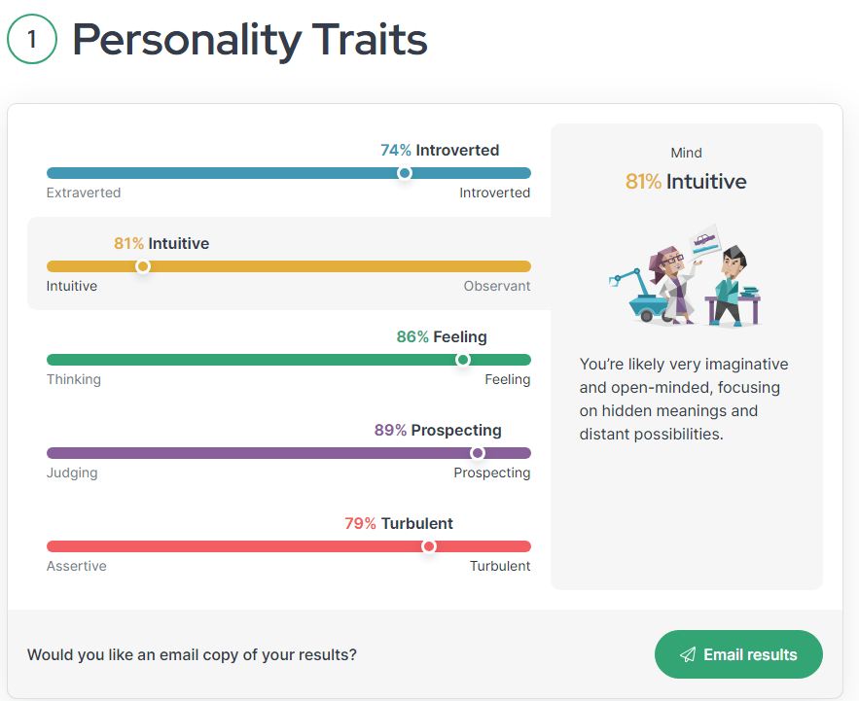
Results following the “16 personalities” personality test
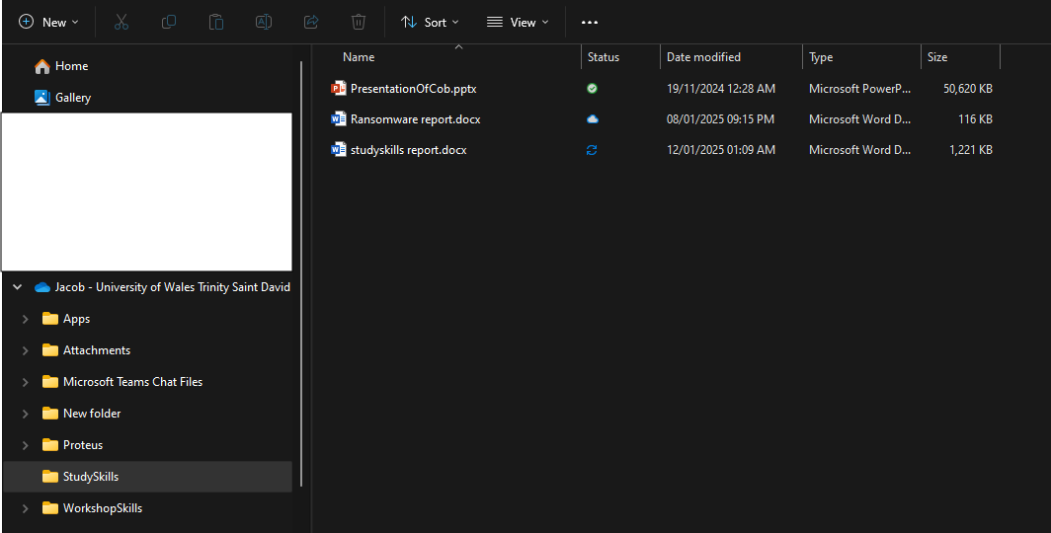
A demonstration of the users cloud based data backup structure using one drive.

