

Name: Kinjalkumari Nareshbhai Ahir
Lecturer name: Zeno Leung
Student Id: 2522437

The Impact of Social Media Use on the Mental Health of University Students in the United Kingdom: A Quantitative Cross-sectional Survey

Table of Contents
1. Introduction 3
1.1 Background to the Study 3
1.2 Prevalence of the Problem 3
2. Rationale of the Research 4
3. Research Aim, Objectives and Research Question/Hypothesis 4
4. Literature Review 5
4.1 Patterns and Frequency of Social Media Use Among University Students in the United Kingdom 5
4.2 Impact of Excessive Social Media Use on Anxiety, Depression and Stress Among University Students 6
4.3 Strategies for Promoting Healthy Social Media Use and Improving Mental Well-being Among University Students 6
4.4 Theoretical frameworks 6
4.5 Research gap 7
5. Research Methodology 7
5.1 Research Philosophy 7
5.2 Research Approach 7
5.3 Research Design 7
5.4 Recruitment, Sampling and Study Participants 8
5.5 Data Collection Methods 8
5.6 Data Analysis Technique 8
6. Ethical Considerations 9
7. Implications of the research 9
8. Research timeline or Gantt chart 10
Reference list 11

1. Introduction

1.1 Background to the Study
Social media has become one of the crucial parts of university students’ everyday lives, influencing their communication, learning process, and mental health (Rehman et al., 2023). Though social media makes it easy to communicate and get information, excessive amounts of time spent on its use were found to increase anxiety, depression, and stress and decrease satisfaction with life (Brailovskaia et al., 2022).
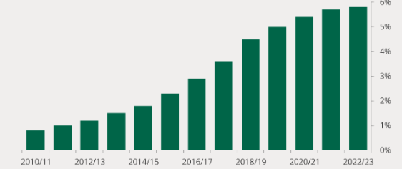
Figure 1: Mental health conditions of the students
(Source: Commons Library, 2025)
In the UK, 5.8% of the students in higher education institutions reported having a mental health problem during the academic year 2022/23, which is significantly higher than it was a decade earlier (Commonslibrary.parliament.uk, 2025). Besides, in 2024, 69% of adults in the UK were actively using health and wellness websites or applications, showing the growing concern about mental health among citizens of the country (Ofcom, 2025). The investigation of the impact of social media on students' welfare is highly important for developing evidence-based public health measures.

1.2 Prevalence of the Problem
There is an increasing dependence on social media that has caused a serious public health concern among the United Kingdom University students, where the students have experienced great feelings over the mental health. This dependence among the students has put them at risk in the sense that it is being revealed that university students are affected by academic stress, social comparison, and digital Hypertension as they are constantly connected. A large survey conducted showed that about 1,408 university students indicated being depressed, with about 47% suffering from this condition, while about 44% of them indicated that they had anxiety (Akram et al., 2023).
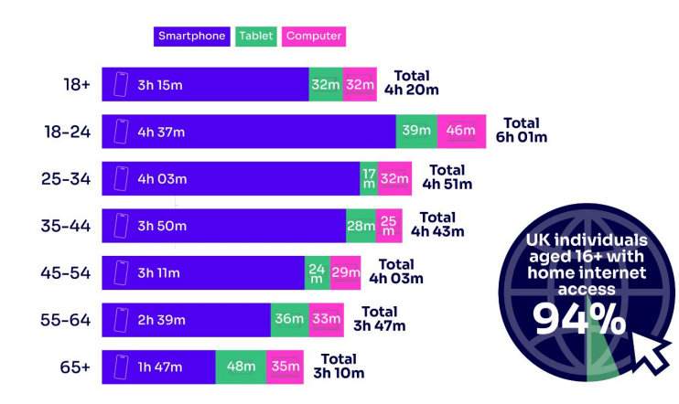
Figure 2: Daily time spent by the adult students online
(Source: Ofcom, 2025)
Out of all the individuals interviewed, it was reported that about 94% of adults in the United Kingdom had access to social media sites and realised that there is a possibility of suffering from these effects of social media (Ofcom, 2025).

2. Rationale of the Research
With the growing prevalence of social media in the lives of students, its overuse has become an increasing cause of poor mental health due to social comparison, cyberbullying and poor sleep, which underlines the need for further research in UK universities (Lam et al., 2022). It has been identified that aged between 16 and 24, 16.4% of people experienced moderate-to-severe symptoms of depression (Children’s Commissioner, 2025). The UK Children’s Commissioner reported that 82% of children aged 13 to 15 were using social media every day, reflecting the continuation of digital interaction with this form of communication beyond their school years (Children’s Commissioner, 2025). This research will provide evidence-based approaches to the use of social media in respect to digital well-being.

3. Research Aim, Objectives and Research Question/Hypothesis
Aim
To undertake a critical assessment of how the use of social media by university students is related to their overall mental well-being and health in the context of the United Kingdom; to provide an overview of how social media usage by university students in the United Kingdom might impact their overall mental well-being and to provide implications for public health practice.
Research Objective
- To examine how often and how much students at universities located in the United Kingdom utilise various social networking sites.
- To analyse what kinds of impacts may occur as a result of the excessive use of social media, such as increased levels of anxiety, depression and overall stress, among university students due to excessive use of social networking.
- To create guidelines for healthy use of social media while also working towards improving the mental health of university students.
Research Question
What impact can social media have on the mental health of university students in the UK?
Research Hypothesis
H1: There is a significant association between the extent of social media use and the mental health of university students in the UK.
H0: There is no significant link between how often people use social media and the mental health of students in higher education institutions in the United Kingdom.
H2: Different patterns or purposes of social media use are significantly associated with mental health outcomes among university students in the UK.
H0: There is no significant association between different patterns or purposes of social media use and mental health outcomes among university students in the United Kingdom.

4. Literature Review

4.1 Patterns and Frequency of Social Media Use Among University Students in the United Kingdom
The knowledge of social media usage patterns helps to understand the impact of social media on mental well-being of students. According to Anto et al. (2023), students in the UK use social media extensively in terms of communication, entertainment, and academic purposes, which leads to overuse of social media that makes them emotionally dependent and vulnerable. Conversely, Hickie et al. (2024) point out that high social media usage cannot simply explain the problem of mental health issues since it is also necessary to take into account digital technology and vulnerabilities in term of mental health. The agreement exists between the two studies with regard to the fact that social media is often used by young people; however, they differ in which high levels of social media usage have a negative effect. The argument of Hickie et al. (2024) seems to be more appropriate in this case since it takes into account various factors. In addition, the differing outcomes may be due to differences in methodologies rather than real inconsistencies. While Anto et al. (2023) undertook a qualitative approach, Hickie et al. (2024) took a more general approach that does not help either study establish a cause for the associations made.

4.2 Impact of Excessive Social Media Use on Anxiety, Depression and Stress Among University Students
Researchers have identified that excessive use of social media can have negative mental consequences. For instance, per Steinsbekk et al. (2023), some social media usage causes an increase in anxiety and depressive symptoms due to passive browsing and negative communication on social media. On the contrary, Iqbal et al. (2022) indicated that social media causes depression by increasing social anxiety and loneliness. The major point of difference in both studies is that while authors affirmed that harmful psychological effects of excessive use of social networks exist, they explained how these effects work through different mechanisms. The findings of Iqbal et al. (2022) seem more convincing since researchers identified several psychological mediators that determine how social media leads to anxiety and depression in people. The reason for a more robust association could also lie in the difference between research methodologies in the selected studies. For example, Steinsbekk et al. (2023) used the longitudinal cohort approach, while Iqbal et al. (2022) used a cross-sectional approach which limits any possibility of causation being understood.

4.3 Strategies for Promoting Healthy Social Media Use and Improving Mental Well-being Among University Students
It is becoming more and more important to formulate effective ways of reducing the dangers to mental health in terms of the role university students play in social media. In their work, Shahria et al. (2026) use machine learning to make it possible to find unknown relationships between the use of social media and people’s mental health status, thus creating possibilities for personalised assistance in the form of programs introduced for these vulnerable individuals. Meanwhile, Matos Fialho et al. (2025) advocate the application of public health interventions in the area of mental health to improve the overall state of students. In this way, while both studies provide ideas for preventive measures, the authors differ in their focus, with one being more oriented on the use of technology and the other, on the health promotion strategy. The viewpoint of Matos Fialho et al. (2025) is more plausible because it suggests effective evidence-based means to help students use social media services. Despite the uncertainty of the effectiveness of such interventions, it does have a basis of its own that is laid in the approaches suggested by the studies. Shahria et al. (2026) introduced predictive methodologies, while Matos Fialho et al. (2025) reviewed previous evidence which makes it impossible to identify the effectiveness of intervention via these studies.

4.4 Theoretical frameworks
Social Comparison Theory
The theory of social comparison is good in that it reveals how comparing to others may affect one’s psychological well-being (Wah, 2025). Students in universities regularly compare their achievements, styles and looks through social networking and thus contribute to their anxiety, depression and stress. The use of this theory supports the psychological analysis of mental health.
Uses and Gratifications Theory
This theory is significant due to the fact that it shows the motives behind subject choices of media platforms and the way subjects interact with it (Habes et al., 2022). Students in universities during the typical day use social networking for communication, entertainment, acquisition of information and socialising. Hence, being aware of the reason behind the usage of social networking may help identify the frequency of its usage and help to analyse the behavioural patterns.

4.5 Research gap
Research until now has focused on social media usage patterns, psychological consequences and intervention methods separately. There is not much information available that integrates all the variables within one study focusing on UK students. Also, there is not enough evidence dealing with all variables at once: frequency of usage, mental health results and intervention strategies (Anto et al., 2023; Matos Fialho et al., 2025).

5. Research Methodology

5.1 Research Philosophy
Positivism is suitable for this study as it provides an objective framework for measuring the effects of social media use on students’ mental health through empirical evidence instead of subjective perception (Wells and Giacco, 2025). This philosophy advocates testing theories through the use of measurable variables, hence increasing the reliability and generalisability of findings. The research employs positivism as it looks into the usage of social media among university students in the UK and its relationship with anxiety, depression and stress levels experienced by these learners. Positivism guarantees statistically valid results that match the research objectives by providing research findings based on empirical evidence.

5.2 Research Approach
Using the deductive approach is a good choice since it starts with already known theories that explain the relationship between social media use and mental well-being, and then tests the hypotheses using empirical data through data collection activities (Wu et al., 2024). This logical reasoning increases objectivity through the process of finding out whether or not theoretical propositions have been confirmed. It is suitable for the objectives of the research since it observes quantifiable trends in social media usage, looks at their correlation to anxiety, depression and stress levels, and provides factual information for making practical suggestions on how to develop healthier social media habits among students.

5.3 Research Design
A descriptive research design is appropriate due to the fact that it provides a way to provide a detailed description of the patterns of social media use and its effects on students’ emotions without interfering with any variable (Eburu et al., 2023). Descriptive research allows gaining valuable insight into different students’ experiences and behaviours, thus providing a good representation of the current situation in universities in the UK. With the help of this design, it is possible to determine the frequency of usage as well as indicators for mental health problems faced by students.

5.4 Recruitment, Sampling and Study Participants
The objective of this research is to use a purposive sampling method to sample 80-100 students registered in universities across the UK who are either in undergraduate or postgraduate classes and who are active on social media. The current project studied a sample range of 80 to 100 university students because past research done with surveys demonstrated good results with relatively small samples ranging from around 90 to 100 respondents (Vornholt & De Choudhury, 2021). Though Kim and Hong (2021) covered 226 respondents in their research, because they used data from multiple universities they needed to apply a bigger sample size. The current research is conducted as a sole cross-sectional Master's dissertation. Purposive sampling is perfect in that it allows for targeting people with relevant experience who are likely to fulfil the research goals and objectives (Ahmad and Wilkins, 2025). Recruitment of the participants will be through email communication via university mailing lists, student organisations, and social media networks where online invites containing study information and links to the survey will be sent.

5.5 Data Collection Methods
The choice of primary quantitative research method is justified by the possibility to collect measurable information systematically from a large number of respondents and thus to allow reliable statistical analysis (Ghanad, 2023). It will be conducted to collect primary information via the online questionnaire prepared in Google Forms for the purpose of discovering the relationship between the use of social media and mental health and well-being of university students in the UK. The questionnaire will have 15 closed questions and will be sent to participants by email, university clubs or social networks (Refer to Appendix 1). The questionnaire includes questions about the demographic data of the respondents, their use of social media and conditions of their mental state. The survey will be conducted only among recruited students who are going to fill in the questionnaire using a secure link. This questionnaire will be pre-tested in a sample of 10-15 students of the University of Wales Trinity Saint David (UWTSD), Birmingham Campus.

5.6 Data Analysis Technique
The quantitative data collected from this study will be analysed with the help of SPSS software version 32. To find out the results, descriptive statistics, graphs, charts, Pearson correlation and linear regression analysis will be used for analysis. The use of descriptive statistics is significant as it makes the data easier to comprehend through the analysis of frequencies, percentages, means and standard deviation (Kotronoulas et al., 2023). In this way, it will be possible to understand the patterns of social media usage and the state of mental health of people under study. Graphs and charts are valuable for the visual understanding of data, which helps to analyse the findings more effectively. Apart from this, Cronbach's alpha reliability testing, assumption testing, independent-samples t-tests, one-way ANOVA, correlation and linear regression analyses will be performed to summarise data, assess reliability, verify statistical assumptions, compare groups, examine relationships, and test the proposed hypotheses while producing valid research findings objectively. Pearson correlation analysis will allow us to understand how strong and in what direction the correlation between social media use is with the mental health of the respondents (Twenge and Hamilton, 2022). On the other hand, correlation analysis allows understanding what kind of impact social media use has on mental health in general. Together, these techniques will allow for the addressing of the research questions and finding out the trends of social media usage among the participants, their psychological influence, and provide recommendations on social media usage among the students.

6. Ethical Considerations
Ethical principles will be observed in every aspect of the research. Before taking part in the study, participants will be given a consent form in which, among other details, the aim of the study, the voluntary nature of participation, and the confidentiality of all submitted answers will be explained. Participants are allowed to leave the study whenever they like without consequence before they return the questionnaire. Because mental health is the subject of the research, contact information about university counselling and wellness services will be provided in case participants suffer from any distress or discomfort from their participation.
Research limitations
The proposed cross-sectional method does not allow for establishing a causative relationship between social media utilization and mental health. One possible disadvantage is the self-administered questionnaires that could result in experiencing memory and “social desirability” biases. Also, convenience sampling may reduce generalisability and therefore the purposive sampling will be used but purposive sampling and small sample size may diminish the generalizability of the results over all UK universities. Another limitation is students from one university may not represent all UK students.

7. Implications of the research
The study will contribute to knowledge development among university students, as they will learn about the impact of the use of social media sites on their mental health and overall mental states and thus will adopt better online behaviour. The results of the research will also help university administrations create evidence-based digital well-being programmes and awareness campaigns as well as student support services, which will help in reducing anxiety, depression, and stress. The data obtained will also be useful for public health and social care experts, as they will be able to develop prevention and intervention programmes that will combat mental health problems in young people. In addition, the information obtained can be used by health professionals to improve mental health evaluation processes.

8. Research timeline or Gantt chart
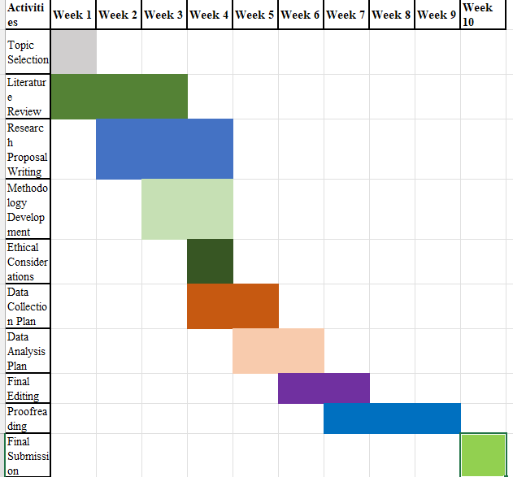
Figure 4: Gantt chart
(Source: Self-developed)

Reference list
Ahmad, M. and Wilkins, S., 2025. Purposive sampling in qualitative research: A framework for the entire journey. Quality & Quantity, 59(2), pp.1461-1479.
Akram, U., Irvine, K., Gardani, M., Allen, S., Akram, A. and Stevenson, J.C., 2023. Prevalence of anxiety, depression, mania, insomnia, stress, suicidal ideation, psychotic experiences, & loneliness in UK university students. Scientific Data, 10(1), p.621.
Anto, A., Asif, R.O., Basu, A., Kanapathipillai, D., Salam, H., Selim, R., Zaman, J. and Eisingerich, A.B., 2023. Exploring the impact of social media on anxiety among university students in the United Kingdom: qualitative study. JMIR formative research, 7(1), p.e43037.
Brailovskaia, J., Frahsek, M. and Margraf, J., 2022. Work overload and addictive social media use: a relationship with depression symptoms and life satisfaction. Journal of Technology in Behavioral Science, 7(3), pp.358-367.
Children’s Commissioner, 2025. Digital childhoods: a survey of children and parents. Available at: https://www.childrenscommissioner.gov.uk/resource/digital-childhoods-a-survey-of-children-and-parents/ [Accessed on: 08.07.2026]
Commons Library, 2025. Student mental health in England: Statistics, policy, and guidance. Available at: https://commonslibrary.parliament.uk/research-briefings/cbp-8593/ [Accessed on: 08.07.2026]
Eburu, O.S., Ironbar, V.E., Edu, G.O., Atah, A.V., Emmanuel, U.D., Ogbeche, O.R., Odok, E.A., Ahueansebhor, E., Ukah, U.J., Ushie, A.S. and Ingiona, A.P., 2023. A descriptive analysis of social media usage as predictors of study habits among students with intellectual disabilities in Calabar Metropolis: Implications for inclusive education. Journal of Intellectual Disability-Diagnosis and Treatment, 11(4), pp.176-190.
Ghanad, A., 2023. An overview of quantitative research methods. International journal of multidisciplinary research and analysis, 6(08), pp.3794-3803.
Habes, M., Salous, M.H. and Al Jwaniat, M.I., 2022, April. Applying the uses and gratifications theory to college major choice using social networks online video. In International Conference on Advanced Machine Learning Technologies and Applications (pp. 388-400). Cham: Springer International Publishing.
Hickie, I.B., Lambkin, F.K., La Sala, L., Robinson, J. and Iorfino, F., 2024. Are new digital technologies and social media causing the spike in anxiety and depression in young people?. Research Directions: Depression, 1, p.e14.
Iqbal, J., Asghar, M.Z., Ashraf, M.A. and Rafiq, M., 2022. Social media networking sites usage and depression among university students during the COVID-19 pandemic: The mediating roles of social anxiety and loneliness. Social Media+ Society, 8(3), p.20563051221107633.
Kim, T. and Hong, H., 2021. Understanding university students’ experiences, perceptions, and attitudes toward peers displaying mental health–related problems on social networking sites: Online survey and interview study. JMIR mental health, 8(10), p.e23465.
Kotronoulas, G., Miguel, S., Dowling, M., Fernández-Ortega, P., Colomer-Lahiguera, S., Bağçivan, G., Pape, E., Drury, A., Semple, C., Dieperink, K.B. and Papadopoulou, C., 2023, April. An overview of the fundamentals of data management, analysis, and interpretation in quantitative research. In Seminars in oncology nursing (Vol. 39, No. 2, p. 151398). WB Saunders.
Lam, T.N., Jensen, D.B., Hovey, J.D. and Roley-Roberts, M.E., 2022. College students and cyberbullying: how social media use affects social anxiety and social comparison. Heliyon, 8(12).
Matos Fialho, P.M., Wenig, V., Heumann, E., Müller, M., Stock, C. and Pischke, C.R., 2025. Digital public health interventions for the promotion of mental well-being and health behaviors among university students: a rapid review. BMC Public Health, 25(1), p.2500.
Ofcom, 2025. Online Nation 2024 Report. Available at: https://www.ofcom.org.uk/siteassets/resources/documents/research-and-data/online-research/online-nation/2024/online-nation-2024-report.pdf?es_id=911d15d746&v=386238 [Accessed on: 08.07.2026]
Rehman, F., Sajjad, S., Saleem, S. and Omair, M., 2023. How technology transforms students: unpacking its influence on daily life, academic learning, social bonds, and mental wellness. Journal of Social Sciences and Media Studies, 7(2), pp.77-89.
Shahria, M.A., Mithila, S.D., Alam, T., Mahmood, M.S. and Khatun, M., 2026. Uncovering Latent Patterns in Social Media Usage and Mental Health: A Clustering-Based Approach Using Unsupervised Machine Learning. arXiv preprint arXiv:2604.24611.
Steinsbekk, S., Nesi, J. and Wichstrøm, L., 2023. Social media behaviors and symptoms of anxiety and depression. A four-wave cohort study from age 10–16 years. Computers in Human Behavior, 147, p.107859.
Twenge, J.M. and Hamilton, J.L., 2022. Linear correlation is insufficient as the sole measure of associations: The case of technology use and mental health. Acta Psychologica, 229, p.103696.
Vornholt, P. and De Choudhury, M., 2021. Understanding the role of social media–based mental health support among college students: Survey and semistructured interviews. JMIR Mental Health, 8(7), p.e24512.
Wah, J.N., 2025. Unlocking Psychological Wellness: How Social Comparison Influences Well-Being and the Crucial Role of Perceived Social Support in Navigating the Digital Landscape of Mental Health. Chinese Science Bulletin, 70(2), pp.23-074.
Wells, I. and Giacco, D., 2025. Theoretical frameworks used to inform qualitative mental health research: a focus on positivism, interpretivism and critical realism. BJPsych Advances, 31(5), pp.299-307.
Wu, Q., Gu, L., Zhang, M. and Liu, H., 2024. Understanding dual effects of social network services on digital well-being and sustainability: a case study of Xiaohongshu (RED). Sustainability, 16(15), p.6709.

Appendix 1: Survey questionnaire
Section A: Demographic Information
Q1. What is your age?
- 18–20
- 21–23
- 24–26
- 27 years or above
Q2. What is your gender?
- Male
- Female
- Non-binary
- Prefer not to say
Q3. What is your current level of study?
- Undergraduate
- Postgraduate (Master's)
- Doctoral (PhD)
- Other
Section B: Social Media Use and Mental Well-being
Please indicate your level of agreement with each statement.
Scale
1 | 2 | 3 | 4 | 5
Strongly Disagree | Disagree | Neutral | Agree | Strongly Agree

Independent Variable 1 (IV1): Frequency and Intensity of Social Media Use
Q4. I spend several hours each day using social media.
Q5. I check my social media accounts frequently throughout the day.
Q6. Social media is an important part of my daily routine.
Independent Variable 2 (IV2): Social Comparison and Online Behaviour
Q7. I often compare my life with others on social media.
Q8. Seeing other people's posts makes me feel dissatisfied with my own life.
Q9. I feel pressure to present a positive image of myself on social media.
Independent Variable 3 (IV3): Problematic/Excessive Social Media Use
Q10. I find it difficult to reduce the amount of time I spend on social media.
Q11. My social media use sometimes interferes with my academic activities.
Q12. I continue using social media even when I know it negatively affects me.
Dependent Variable (DV): Mental Health Status
Q13. I found it difficult to relax.
Q14. I felt downhearted and depressed.
Q15. I felt scared or anxious without a clear reason.

