27/03/2026
Samuel Kargbo (2423977)
[company name]
Assignment 1

module name: Network operating systems and services
module code: acca5023
student name: samuel momoh kargbo
student id:2423977
lecturer: Dr. SADEQUE SHAIKH
university of wales Trinity saints david (london campus)

Contents
Task 1 1
Research on Hypervisor 1
Research on IP Addressing 4
Based on the above Group Activity, reflect your understanding on IP Addressing with appropriate and adequate in-text citations 4
Research on Routing 10
Research on Network Services 11
Task 2 11
Task 3 12
Reflection 12
References 13

Task 1

Research on Hypervisor
A Hypervisor (Virtual Machine Monitors or VMM) Is a software which lets multiple operating systems (OS) works on one physical machine (VMs) it does this by creating and managing virtual machines, each behaving like an independent computer with its own OS and applications.
Hypervisor plays a crucial role in in virtualization technology, enabling efficient use of hardware resources, isolation of environments, flexible deployments of various OS types on one physical machine. There are two main types: Type 1 (Bare-Mental) and Type 2 (Hosted) Hypervisor [1]

Type 1Hypervisor
Type 1 are commonly used or runs directly on the physical hardware of a computer, without the need of a host operating system. That mean its act as a software layer controlling the hardware, it also manages the creations and operations of Virtual Machines (VMs) on the systems. Businesses and data center’s usually used Type 1 hypervisor when they needed high performance and reliability, such as VMware ESXI, Microsoft Hyper-V and Kernel -based Virtual Machine (KVMs). [2]

Architecture Of Type 1 Hypervisor
Hardware – Type 1 Hypervisor – Virtual Machine (Guest Operating System)

Note: The hypervisor interacts with the physical hardware component such as the Memory, Network Interface, CPU, and Storage Device
Each VM runs its own guest operating system independently, isolated from other VM.

Benefits:
Reliability: Designed for continuous operation with minimal downtime
Scalability: suitable for running many VMs in data center’s environment and enterprises.
High Performance: Direct accessibility to hardware resource which means less overheads and better performance for VMs.

Example
Prominent example of Type 1 Hypervisor includes VMware ESXi, Kernal-Based Virtual Machine (KVM), all widely adopted in cloud computing and virtualization infrastructure.

TYPE 2 HYPERVISOR
A Type 2 Hypervisor operates as a software application that runs on top of an existing host operating system, Hypervisor depends on operating system (OS) to facilitate hardware resource access, this additional abstraction layer introduces overhead, which can result in reduced performance relative to Type 1 hypervisor that run directly on hardware. Despite this performance trade-off, Type 2 hypervisor offer simple installation processes and are commonly employed in environments focused on development, educational purposes, and testing due to their ease of use and flexibility. Prominent instance of Type 2 hypervisors includes Oracle VM VirtualBox and VMware Workstation

ARCHITECTURE OF TYPE 2 HYPERVISOR
PHYSICAL HARDWARE – HOSTING OPERATING SYSTEM -HYPERVISOR -VIRTUAL MACHINECS

Note: The Hypervisor leverages the host OS to mediate hardware access, managing virtual machines by allocating resources through the host.

Example Of Type 2 Hypervisors
Common example of Type 2 Hypervisors includes Oracle VM VirtualBox and VMware Workstation. Both products are widely used in the industry of desktop virtualization, which supports a broad range of guest operating systems and offering robust features such as snapshot management, shared folder, and seamless integration with host systems [3].

Reflect On Hypervisor
For the given topology, static routing is the most suitable approach considering the roles of the Debian Sever and the Windows Sever. The Debian Sever function as a DHCP Relay, Debian Sever and the Windows Sever must be reliable and clearly define.
Static routing is appropriate because the network topology is relatively small and stable, with a limited number of routers and predictable communication paths. By manually configuring routes between the subnets, administrators can ensure that DHCP broadcast requests forwarded by the Debian Server reach the Windows Sever without ant routing issues. This approach simplifies network management and reduces complexity.

Justification
To effectively design a network for the domain Association of Chartered Certified Accountants (BIRMINGHAM.ACCA), the topology must be structured to ensure robust domain management, seamless interoperability between Windows and Debain clients, optimal utilization of hardware resources, and stringent adherence to security protocols. The network should employ a centralized domain controller using Microsoft Active Directory to facilitate domain management, user authentication, and policy enforcement primarily for Windows clients. To support the Debain clients, integration through compatible service such as LDAP or Samba should be implemented. The topology should incorporate a hierarchical and segmented design, with core switches and routers ensuring efficient traffic flow and isolation of sensitive segment to reduce attack surface.

Research on IP Addressing
During our group activity, we discussed how data travels across the Internet and the critical role of IP addressing in this process. When a user sends data, such as opening a website, the data is divided into smaller units called packets. Each packet contains both source and destination IP addresses, which function like digital “home addresses.” These IP addresses ensure that data knows where it originates and where it needs to be delivered. The packets traverse multiple networks and are reassembled at the destination device, enabling accurate and seamless communication.
IP addresses are essential because they uniquely identify devices on a network. Without them, routing data correctly would be impossible. Protocols like TCP/IP guarantee reliable delivery by detecting errors and retransmitting any lost packets.
We also explored the roles of routers and switches in data transmission. Routers connect different networks and use routing tables and algorithms to determine the most efficient path for data packets. They examine the destination IP address and forward packets accordingly. In contrast, switches operate within local area networks (LANs), using MAC addresses to send data directly to the intended device, which reduces unnecessary network traffic.
In conclusion, IP addressing, along with routers and switches, forms the backbone of Internet communication. Together, they ensure that data is transmitted accurately, efficiently, and reliably across interconnected networks worldwide [4]

Data transfer across the internet through fundamental techniques know as Packet Switching. When a computer transfer information, such as sending a message or accessing a website the data is segmented into smaller units called Packets. Each packet encapsulates a fragment of the original data [5]

Switch
Switch primarily operates within a local area network (LAN) environment, serving as a central device that connects multiple networked devices such as Printers, Computers, and servers. When a device transmits data, the switch examines the Media Access Control (MAC) address, which is a unique hardware identifier assigned to each network interface card (NIC).

Router
Router function as a device that interconnects different networks, enabling data transmission between a local home network and the broader internet. Routers manage communication across multiple distinct networks. While switches forward data frames based on MAC addresses within a LAN, routers route packets between networks at the IP layers. switches and routers play complementary roles in network infrastructure ensuring data is accurately directed

Based on the above Group Activity, reflect your understanding on IP Addressing with appropriate and adequate in-text citations

Introduction
IP Addressing is a fundamental concept in computer networking that enables devices to communicate across each network. Each device connect to a network must possess a unique internet protocol (IP) address to ensure that data packets are accurately routed to their destination. Comprehensive knowledge of IP addressing includes IPv4, IPv6, subnetting, and address allocation is critical for designing networks that are both efficient and scalable.

Roles of IP Addressing in Network Functionality
IP Addressing Plays a critical role in the operation and efficiency of networks. Each device connected to a network must have a unique IP Address to enable switch and router to correctly identify and to route data packets. Without the IP Addressing device would not be able to send or receive information over internet or local networks.

Key contributions of IP Addressing include:
Routing and Packet Delivery: Each device is uniquely identified with a network
Scalability: Hierarchical addressing facilities efficient management of large-scale network.
Network Organization: IP Addressing enables network to be segmented into logical subdivisions.

These capabilities collectively ensure reliable communication across complex global networks.

Structure, Format and Representation of IPV4
IPV4 Address Structure
IPV4 (Internet Protocol Version 4) is a 32-bit address used to uniquely identify devices on a network.
Format:
The 32-bit are divided into four sections called octets. Each octets contain 8 bits.
Representation:
Each octet is converted into decimal number ranging from 0-225. These decimal numbers are written in dotted-decimal notation, separated by periods (.).
Example:
198.51.100.5: Frequently seen in example for statics IP Configuration

Diagram of IPV4 Address
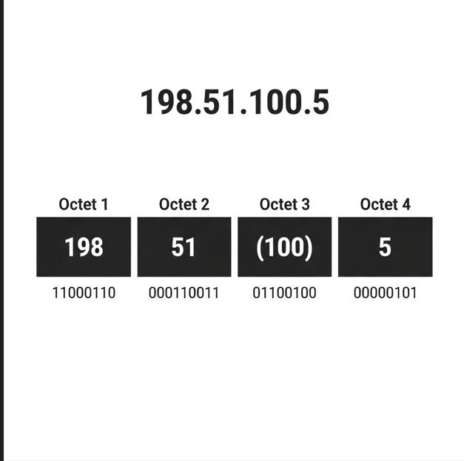
Here is a diagram example for IPV4 Address 198.51.100.5 showing each octet in decimal and it is corresponding binary representation.

Example Practical Explanation
In typical home network, a router assign unique IPV4 addresses to a device within the same local network.
Device | IPv4 Address
Router | 192.168.1.1
Laptop | 192.168.1.10
Phone | 192.168.1.15
Printer | 192.168.1.20
All these devices belong to the same local network (Subnet)
Each device has unique host address to identify it on the network

Structure, Format and Representation of IPV6
IPV6 Address Structure
An IPV6 address is 128 bit long, and it divided into eight groups. Each group contain 16 bits (or 4 hexadecimals digits), These groups are separated by colons [6]
Format of IPV6 Address:
Written as eight groups of four hexadecimal digits.

Representation
IPV6 addresses are represented as eight digits groups of four hexadecimal digits, each group separated by colons. Example of IPV6 address look like this: 2345:0425:2CA1:0000:0000: 0567:5673:23b5. Leading zeros in each group can be omitted, and consecutive group of zeros can be compressed using double colon (: :) once in an address to simplify notation.
Example of IPV6 Address:
2345:0425:2CA1:0000:0000: 0567:5673:23b5
Each group represents 16 bits, and the full address contains 128 bits

Diagram of IPV6 Address:
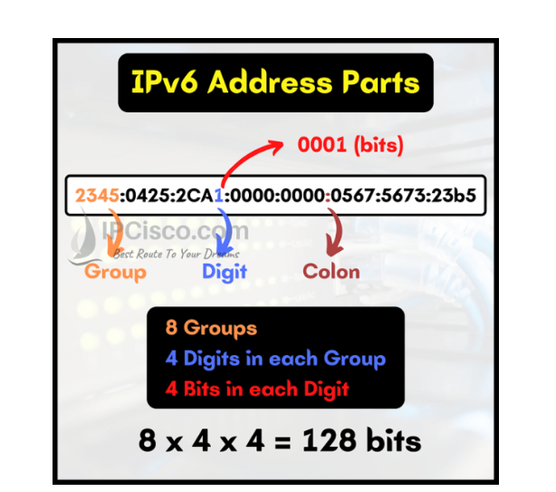
Note: As you can see IPV6 has 8 groups and each group is separated by colons. In each group, there are 4 digits. Each of these digits can be created with 4 bits. Total there are 128 bits addresses.

Example of IPV6 Address Practical:
Device | IPv6 Address
Router | 2001:db8:1::1
Laptop | 2001:db8:1::10
Server | 2001:db8:1::20
Network prefix:
2001:db8:1: :/64

Concept of Subnetting
Subnetting is the process of dividing a large network into smaller, networks called subnets. This technique allows network administrators to organize and optimize network resources effectively.

Purpose of Subnetting
Subnetting helps to:
- Efficiently allocate IP Address to avoid wastage and accommodate growth
- Reduce network congestion through better traffic manage

Subnetting Example
Original network:
Network: 192.168.1.0/24
Total Hosts:254
After subnetting, the network is divided into four smaller subnets.

Subnet | Network Address | Prefix Length | Number of Hosts (approx.)
Subnet 1 | 192.168.1.0/26 | 26 | 62
Subnet 2 | 192.168.1.64/26 | 26 | 62
Subnet 3 | 192.168.1.128/26 | 26 | 62
Subnet 4 | 192.168.1.192/26 | 26 | 62

Each subnet supports up to 62 hosts, allowing the original network to be segmented into smaller, more manageable parts, improving performance and security.

Efficient Utilization of IP Addresses
Efficient use of IP Addresses is essential for managing the limited IPV4 address space and ensuring optimal network operation.
Techniques Uesd
CIDR (Classes inter-Domain Routing)
CIDR allows for flexible and efficient allocation of IP Address by using variable-length subnet masking (VLSM). This approach replaces the traditional class-based addressing system, enabling more precise control over address block sizes and reducing the exhaustion of IPV4 addresses.

Example:
192.168.1.0/24 (a standard Class c block)
192.168.1.0/26 (a smaller subnet within the original /24 block)

Research on Routing
Routing protocols operate by exchanging routing information among routers. They analyze factors such as hop count, bandwidth, delay, and network topology to calculate the best route for packet transmission. Common dynamic routing protocols include Routing Information Protocol (RIP), Open Shortest Path First (OSPF), and Enhanced Interior Gateway Routing Protocol (EIGRP). These protocols automatically update routing tables in response to network changes, ensuring continuous connectivity and improved network performance

There are two primary routing approaches: static routing and dynamic routing. Static routing involves manually configuring routes on a router or server. It is simple, secure, and suitable for small or stable networks because routes remain fixed unless manually updated. However, static routing lacks flexibility and cannot automatically adapt to network changes. In contrast, dynamic routing uses routing protocols to learn and update routes automatically. This approach is more scalable and efficient for large or complex networks but requires additional resources and configuration
In the context of a network topology where a Debian Server functions as a DHCP Relay and a Windows Server provides connectivity services, static routing may be more appropriate for a small, stable network environment. Since the DHCP relay forwards DHCP requests between subnets and the network structure is relatively fixed, static routing offers sufficient reliability while keeping configuration simple and manageable

Research on Network Services
Network services are essential functions provided by servers and network infrastructure to support communication, resource sharing, and data management across computer networks. These services enable users and devices to access applications, data, and resources efficiently over local area networks (LANs) and the Internet.
One of the most common network services is the Domain Name System (DNS), which translates human-readable domain names into IP addresses, allowing users to access websites easily. Another key service is Dynamic Host Configuration Protocol (DHCP), which automatically assigns IP addresses to devices on a network, simplifying network management. File Transfer Protocol (FTP) is used for transferring files between computers, while Hypertext Transfer Protocol (HTTP/HTTPS) enables web browsing and secure communication over the Internet.
Email services, such as SMTP, POP3, and IMAP, facilitate the sending and receiving of electronic messages. Additionally, network services include file and print sharing, authentication services, and cloud-based services that allow remote storage and access to data.
Network services improve efficiency, security, and scalability by centralizing resources and management. They also support modern technologies such as cloud computing, virtualization, and remote access. However, proper configuration and security measures are necessary to protect against threats like unauthorized access and data breaches.
In conclusion, network services are a vital component of modern networking, enabling seamless communication, efficient resource utilization, and secure access to information in both organizational and global network environments [7]

Virtual Private Network (VPN)
A VPN enables users to securely connect to a private network over the internet by creating an encrypted tunnel between the user’s device and the network protecting data from unauthorized access. Key features include encryption, authentication, and secure remote access.

Certificate Authority
A CA issued certificate that verifies identities and enable secure communication via encryption. Certificates are widely used in HTTPS, VPNs, and secure email system. Best practices for CA management include safeguarding private keys, implementing certificate lifecycle management, and utilizing trusted certificate authorities to maintain network security.

Task 2

Task 3

Reflection
Technical Reflection on Network Development and Testing
During the network deployments and testing phase, several technical challenges arose related to service configuration and device connectivity. One primary issue was IP Address conflicts caused by incorrect DHCP configuration, where multiple devices attempted to use the same IP address. To diagnose this, network configuration of affected devices was examined using commands such as ipconfig and ping. After identifying duplicate addresses, the DHCP scope was reviewed and adjusted to ensure unique IP allocation for all clients.
Firewall configuration also posed difficulties during testing. Certain services, including domain authentication and server communication, were blocked by firewall rule. This was diagnosed by reviewing firewall logs and temporarily disabling the firewall to confirm it rules in the issue.

Personal Reflection
This project provided valuable hands-on experience in deploying and managing network service. Through configuring servers and resolving connectivity issues, I gained a deeper understanding of the interaction between various network components in an enterprise environment.
A key lesson learned was the critical importance of careful planning and verification throughout network configuration. Minor errors in DNS setting, IP addressing, or firewall rules can caused significant connectivity disruption. Diagnosing these problems step by step helped me develop stronger problem-solving and analytical skills.
In summary, this project improved both my technical knowledge and practical skills in network administration. It also emphasized the value of patience, systematic troubleshooting, and attention to details in managing complex network environments.

References

[1] | N. Grover, Virtualization Essentials, USA: Wiley, 2018.
[2] | Oracle, “Oracle,” VM Virtual Box, jun 2024. [Online]. Available: https://www.vmware.com/products/esxi.html. [Accessed Jun 2024].
[3] | G.J. Popek and R.P. Goldberg, “Survey of Virtual Machine Research,” Computing Magazine, vol. 7, no. 6, pp. 34-45, 1974.
[4] | C. Perkins, “Routing Protocols,” in Computer Networking Principles Protocols and Pratices 1st ed, San Francisco , S Keshav, 2014, p. 6.
[5] | C. Perkins, Networking Fundamentals 1st ed, New York NY, 2014.
[6] | T. Dunn, “The IPV4 Transition,” Internet IEEE Computing , vol. 6, no. 3, pp. 11-13, 2002.
[7] | A. S. Tanenbaum and D.J. Wetherall, Computer Networks 5th ed, Boston: MA: Pearson , 2011.

