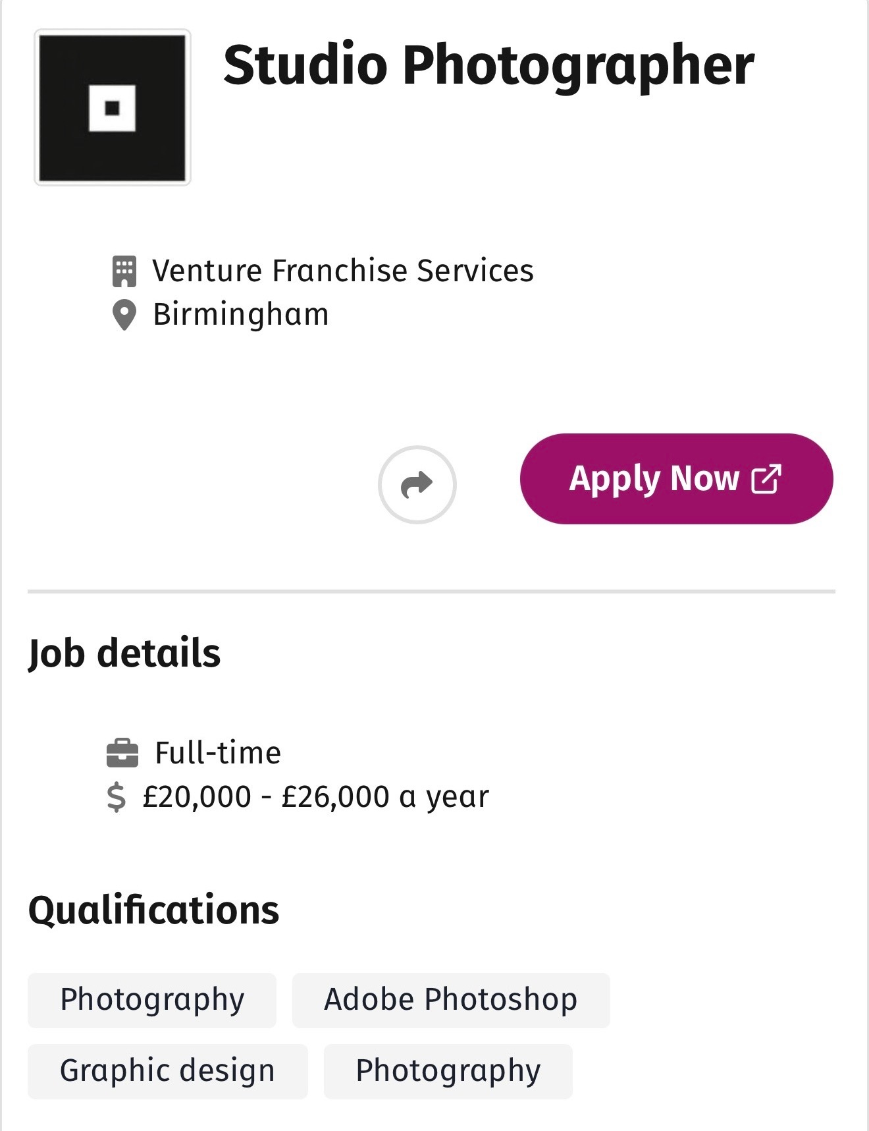
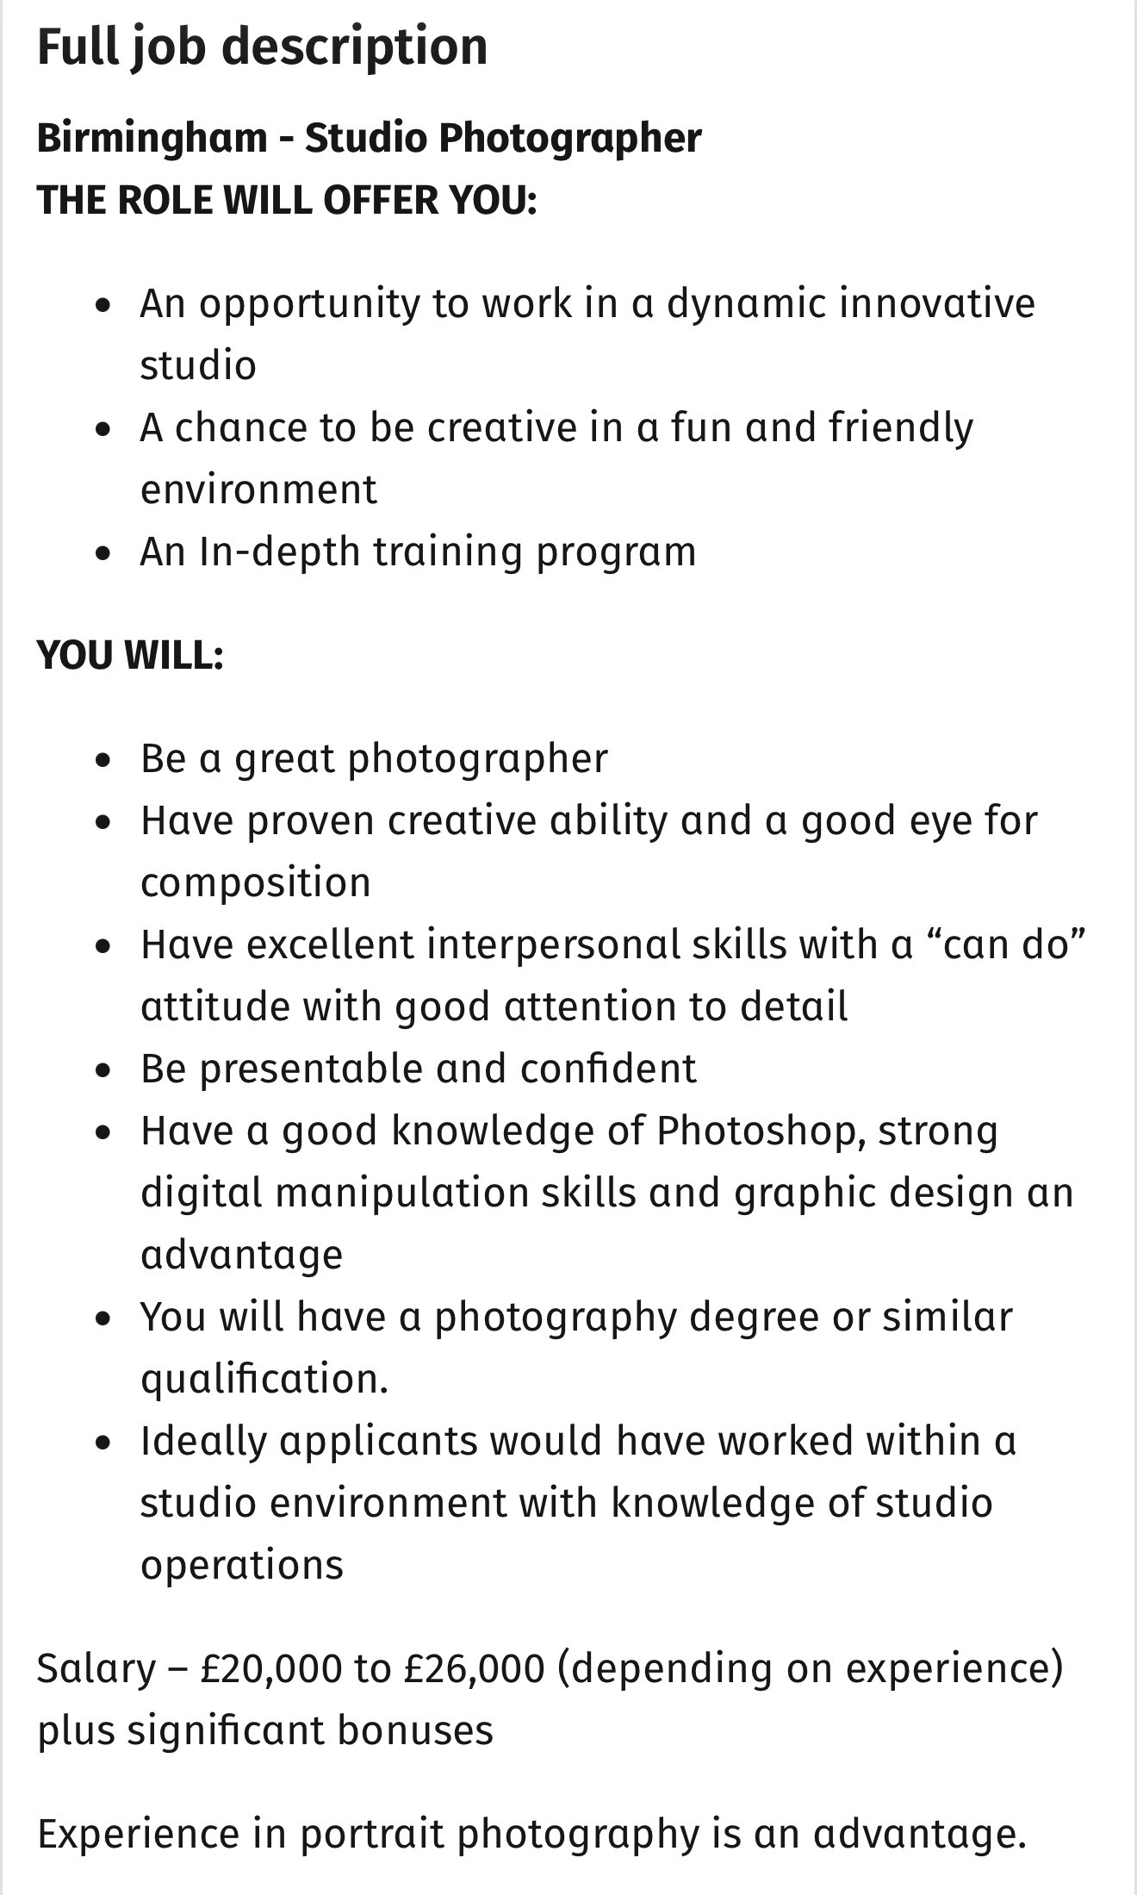
COVER LETTER

Brooklyn Brooks
Birmingham
07599944198
Brooklyn_brooks@outlook.com

Dear Hiring Manager,

I am writing to apply for the Studio Photographer position at Venture Franchise Services in Birmingham.

I have a genuine passion for photography and enjoy being creative while producing high quality work. I have a good eye for detail and capturing outstanding images that people connect with. I am also confident using Photoshop and enjoy learning new skills that help me improve my work.

What attracted me most to this role is the opportunity to work in a creative studio environment where I can develop my skills and be part of a team. I am enthusiastic, reliable and hardworking with a positive attitude. I enjoy working with others and helping people feel comfortable and confident in front of the camera.

I am excited by the opportunity to join your team. Thank you for taking the time to consider my application and I look forward to hearing from you.

Yours faithfully,

Brooklyn Brooks

CV

Brooklyn Brooks

07599944198
Brooklyn_brooks@outlook.com
Birmingham

Enthusiastic and creative photographer with a passion for capturing high quality and images and creating positive experiences for clients. Confident working both independently and as part of a team with strong attention to detail and a keen eye for composition. Friendly, reliable and eager to develop my skills within a professional studio environment. Experienced with Photoshop and committed to producing work to a high standard.

Key Skills

• Photography and image composition
• Photoshop
• Portrait photography
• Attention to detail
• Customer service and communication
• Creative problem solving
• Organisation and time management
• Working to deadlines
• Teamwork and collaboration
• Positive professional attitude

Experience

Photographer / Freelance Photographer
Hammersmith Apollo 2019

• Planned and carried out photography sessions.
• Edited and enhanced images using Photoshop.
• Worked closely with clients to achieve their desired results.
• Maintained high standards of image quality and presentation.
• Managed multiple projects while meeting deadlines.

Guest photographer / Collaborator
Brixton Academy 2026

• Delivered excellent customer service.
• Built positive relationships with customers and colleagues.
• Worked efficiently in a fast paced environment.
• Demonstrated reliability, professionalism and attention to detail.
Education

Art GCSE
Plantsbrook School
2012

Business and Law A-Levels
Bournville College
2020

Software Skills

• Photoshop
• Microsoft Office
• Social Media Platforms
• Basic Graphic Design

Additional Information

• Available for full time work
• Strong interest in photography, visual arts and creative design

References

Available upon request.

