Trinity Saint David University.
Financial Management and Planning



ACPA7002

Carl Jones Student 2134125.
Cohort 07/22
Lecturer Howard Davies

Assignment 1 – Capital Project Appraisal Report

Introduction of Industry 4.0 manufacturing techniques to enable competitive business case for recapturing lost product market share.

Contents
Introduction. 3
Process analysis. 4
Automation solution. 6
Project timeline. 6
Financial analysis. 7
Payback Period. 7
Net Present Value. 7
Profitability Index. 8
Benefit-Cost Ratio. 8
Accounting Rate of Return. 8
Weighted Average Cost of Capital. 8
Funding options. 10
Project considerations. 11
Redundancies 11
Disruption. 11
Downtime. 11
Technological. 11
Conclusions. 12
Bibliography 12

Table 1 Tubex Product Post Operations 4
Table 2 Punch Cycle Breakdown. 5
Table 3 PP Calculation. 7
Table 4 NPV Calculation 7
Table 5 ARR Table 8

Figure 1 Project Timeline 6
Figure 2 Financial Modelling of Micro-Hole Project 9
(Forbes, 2023) Figure 3 Berry Global Stock Price past 5 years. 10

Introduction.
The Tubex brand of tree shelters initial concept was developed in the mid 1980’s and has since developed continuously, fulfilling customer demand as different applications were identified and designs changed to meet use in different horticultural sectors, species specific requirements, and environments. The Tubes protect the sapling from grazing animals, pesticides, extreme weather by creating a micro-climate inside the Tube and reduced water loss, increasing tree growth, and reducing loss of young saplings (Arnold & Alston, 2012). In 1993 the first production of tree shelters as we know them now was produced in Aberdare, south Wales. Further product lines and enhancements have been developed including perforations along the Tube to allow the Tube to split if the tree growth exceeded the Tube inner diameter and holes to allow air flow around some species of tree that promote increased root growth due to bough movement (CMP Information Ltd., 2004). At end of life the Tubes can be 100% recycled back into Tube production to create a circular product life cycle.
One of the Tubes developed was the Micro-Hole Tube, a low-cost variant of the Tubex Combi-Tube that has small round air flow perforations at the top of Tube. Tubex competitors have taken market share of this product type and it was decided to focus on reducing product costs to recover market share.

Process analysis.

Product | Laser Line | Laser hole | Print Info. | Cut | Flared Rim | Punched. | Ties. | Drilled | Number of People | Profit Margin.
Standard | X | X | X | X | X |  | XX |  | 1
Combi | X | X | X | X | X | X | XX |  | 3
Micro-Hole |  |  | X | X | X | X |  |  | 3
Nature | X | X | X | X | X |  | XX |  | 1
Vine |  |  |  | X
Ventex | X | X | X | X | X |  | XX | X | 4
Shrub | X | X | X | X | X |  | XX |  | 1
Wraps |  |  |  | X |  |  |  |  | 2
Vole guards |  |  |  | X |  |  |  |  | 2
Table 1 Tubex Product Post Operations
All Tubex tree shelters are extruded on near identical lines, using predominantly Polypropylene (PP) a widely used thermoplastic polymer. The individual design differences are achieved using post-extrusion operations. Mobile modular processes are then positioned in-line to achieve desired product features such as laser holes, length cutting, printing of product information, flared top rims and ventilation holes.
Tubex Standard Tubes are the company’s biggest seller and is the market leading tree shelter.
Micro-Hole product is supposed to be a low-cost solution aimed at increasing plant survival and growth against low level browsers such as rabbits and hares.
Given that all Tubex Tubes share identical twin wall design and grams per square meter (GSM) weight, the only cost differences are attributable to post-extrusion operations. Material fillers such as Calcium have been trialled, but light transmissivity is a key characteristic of tree shelters and the fillers have reduced this important feature.
Laser Line, Leaser Hole(s) and Cut are produced in-line with the extrusion output and require no human intervention other than initial setup. All Tubes are cut dependant on customer requirements, Laser Lines and Holes are features dependant on product line and customer requirements.
Information is printed onto the outside diameter and includes Tubex text and logo, along with the recycle icon. No human intervention is required after initial setup.
Flared Rims are a Tree abrasion reduction feature at the top of the tube that stops the Tube from wearing the sapling when wind causes the tree to sway. The Flared Rim is created after the cut using a heating station to soften the top of the Tube, a forming head matched to the Tube inner diameter then advances forming the thermoplastic into the correct 10mm radiused form. No human intervention is required after initial setup.
The Punch operation is very labour intensive. The flared Tube is removed by an operator and manipulated into the Punch feed station. The Punch station then automatically feeds the Tube through the station automatically punching a series of holes through both sides of the Tube. Once the hole punching has finished the completed Tube is fed out of the machine. The tube is then removed alternately by two operators who manipulate the flattened Tube back to a round condition and then nest the completed Tubes. The number of punch series depends on Tube length and the cycle time varies accordingly. Punch cycle times vary between 6 and 8 seconds.
Product | Load time | Punch and feed (2 secs / series) | Unload and Un-flatten | Apply ties (3 secs / tie) | Nest completed Tubes
0.40 MH | 4 | 3 (6) | 4 | 0 | 3
0.50 MH | 4 | 4 (8) | 4 | 0 | 3
0.60 MH | 4 | 4 (8) | 4 | 0 | 3.5
0.75 CT | 4 | 5 (10) | 4 | 2 (6) | 3.5
0.80 CT | 4 | 5 (10) | 4 | 2 (6) | 4
1.20 CT | 4 | 6 (12) | 5 | 2 (6) | 4
1.50 CT | 4 | 7 (14) | 5 | 2 (6) | 5
1.80 CT | 4 | 8 (16) | 5 | 2 (6) | 5
Table 2 Punch Cycle Breakdown.
Using current manning it would require a cycle time of 4 seconds to match the competitors pricing of the Micro-Hole product. Current process bottleneck is the Punch (6 – 9 seconds) where the sequence is punch, feed of the tube to the next punch position then repeat.
Any process improvements to the Micro-Hole product would also benefit the Combi-Tube product as this uses the same process routing.
To reduce the Punch and feed cycle time it has been proposed to double up the punch tooling so two series of punched holes would be achieved in the same time as a single punch operation. Further cost reduction proposal is to remove manning from the Load and Unload and Unflatten operations saving two operators wages off each shift (six in total across three shifts). This will improve efficiencies and further decrease the cost to customer. Some product design changes will have to happen so the number of series is divisible by two.

Automation solution.
Company policy requires three quotations for investments of more than £50,000, so three automation integrators were approached to provide solutions for the Load and Unload and Unflatten operations. After careful consideration a solution using Kuka industrial robots was chosen to fulfil:
- Safe with all human interaction.
- Four second cycle time using Micro-Hole product @ 98% efficiency.
- Robust process design, with quick change tooling.
- Be modular and mobile so quickly removed when not required.
- Simple human interaction.
- Provide accurate runtime and downtime data.
- Minimum process uptime of 98%.
Cost of the robots, fixtures, tooling, and spares £165,000.
Cost of additional punch tooling and £18,000 (for both Micro-Hole and Combi-Tube)
Combi-Tube punch bottleneck would be reduced but would still require 2 operators to complete due to length and tie insertion so the automation solution would be solely used for Micro-Hole.
The successful integrator was chosen due to its long running operation, its reputation and the in-house skills it possesses ensure that any problems would be delt with by the same core team without the need to engage with sub-contactors (Worster, et al., 2013).

Project timeline.
The chosen integrator has indicted the following timeline:
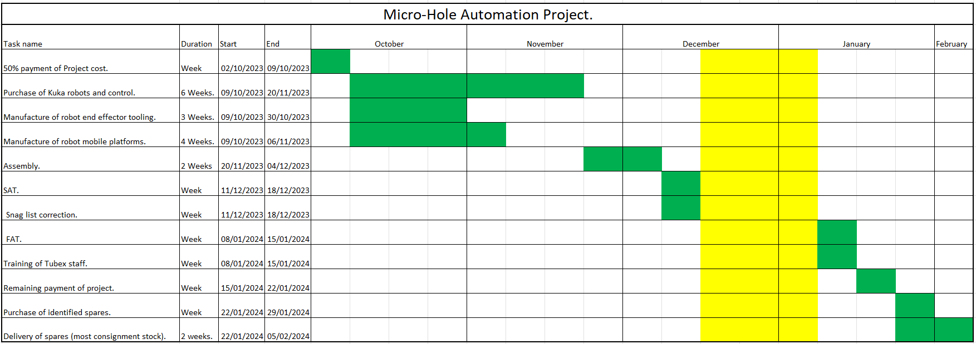
Figure 1 Project Timeline
During contract negotiations the integrator indicated the need to have 50% payment up-front to cover costs of equipment purchase. Supplier Acceptance Tests (SAT) to be carried out with Tubex oversight. Assuming acceptable Factory Acceptance Test (FAT) would be performed at Tubex, Aberdare. All of the Timeline tasks and Timeframe were agreed and set out in the contract negotiations.

Financial analysis.

Payback Period.
Payback Period (PP) is defined by Atrill & McLaney as “the time taken for an initial investment to be repaid out of the net cash inflows from a project” (Atrill & McLaney, 2017). Berry Global maximum PP for investment is 2.5 years.
Micro-Hole project PP:
Time |  | Net cash flow (£) | Cumulative cash flow (£)
Immediate | Cost of project | (174,000) | (174,000)
1 years’ time |  | 95,520 | (78,480) | (-17400+95520)
2 years’ time |  | 116,850 | 38,370 | (-78480+116850)
3 years’ time |  | 99,000 | 137,370 | (38370+99000)
4 years’ time |  | 81,175 | 218,545 | (137370+81175)
5 years’ time |  | 72,800 | 291,345 | (218545+72800)
 |  |  |  | 291,345
Table 3 PP Calculation.
PP = 1 + (⁷⁸⁴⁸⁰ / ₁₁₆₈₅₀) 0.67 = 1.67 years or 1 year 8 months.
Major issues with using PP as a viable project indicator is that it does not factor the effect of time on returns, or cash flow after the Payback Period has finished. Time is an important factor in considering the value of cash flow, £100 now is worth more than £100 in a years’ time (Atrill & McLaney, 2017), so recouping investment returns early in a project (year 1) is more valuable than recouping the same amount in year 2. Project dependant, the returns after the PP could be much greater than during the PP, potentially making a profitable project deemed to be not viable.
PP of 1.67 is lower than the maximum Berry Global PP of 2.5, so would be considered viable.

Net Present Value.
Net Present Value (NPV) is better approach than PP as it considers the costs and benefits of an investment, along with the effect of time (Atrill & McLaney, 2017). NPV uses Present Value Tables acting as a discount factor to show the effect of time on project annual cash flow.
Micro-Hole project NPV:
Time | Cash flow (£) | Discount factor (10%) or WACC. | Present value (£)
Immediate | (174,000) | 1 | (174,000)
1 Years time | 95,520 | 0.909 | 86,828
2 Years time | 116,850 | 0.826 | 96,518
3 Years time | 99,000 | 0.751 | 74,349
4 Years time | 81,175 | 0.683 | 55,443
5 Years time | 72,800 | 0.621 | 45,209
 |  | NPV | 184,346
Table 4 NPV Calculation
“A net present value that is a positive amount means that the actual return on investment exceeds the target rate” (Fields, 2016) of the Berry Global 10% discount factor. The positive NPV value indicates a viable investment opportunity.

Profitability Index.
Fields defines the Profitability Index (PI) as the comparison of actual Return On Investment (ROI) to the target ROI (Fields, 2016). It compares the Gross Present Value (GPV) and investment capital ratio:
GPV is the cumulative total of each years’ forecasted cash flow (86,828 + 96,518 + 74,349 + 55,443 + 45,209) = 358,347
PI = ^{GPV} / _{Investment Capital} = ^{358,347} / _{174,000} = 2.06.

Benefit-Cost Ratio.
The Benefit-Cost Ratio (BCR) is like PI except it uses the NPV in its calculation.
BCR = ^{NPV} / _{Investment Capital} = ^{184,346} / _{174,000} = 1.06.
The BCR of more than 1 indicates the profitability exceeds the discount factor (10%) used in the NPV calculation and is an additional indicator of a viable investment project (Hayes, 2022).

Accounting Rate of Return.
The Accounting Rate of Return (ARR) uses the annual average operating profit and the average investment to produce a percentage return that would need to achieve a Company Target ARR to be deemed a viable investment.
Term | Value (£) | Description
Total profit | 463,345 | Net cash flow
Depreciation | 139,200 | Initial investment – value of equipment after project has finished.
Average profit | 65,229 | Total profit – Depreciation / by project length
Investment | 174,000
Residual | 34,800 | Equipment worth after project has finished.
Average investment | 104,400 | Investment + Residual / 2
ARR | 62.48% | Average profit / Average investment x 100%
Table 5 ARR Table
The ARR of 62.5% is above Berry Global target ARR of minimum 40% so would be deemed a viable investment.
An issue with ARR is that it does not distinguish between when the cash flow occurs in the project and could give projects that return capital later in the project equal or better ARR than faster returns with lower project ARR (Atrill & McLaney, 2017).

Weighted Average Cost of Capital.
The Weighted Average Cost of Capital (WACC) is the percentage that companies use to gauge if investment will prove to be profitable, by forecasting the future value of cash. Different organisations use different WACCs dependant on current financial factors.
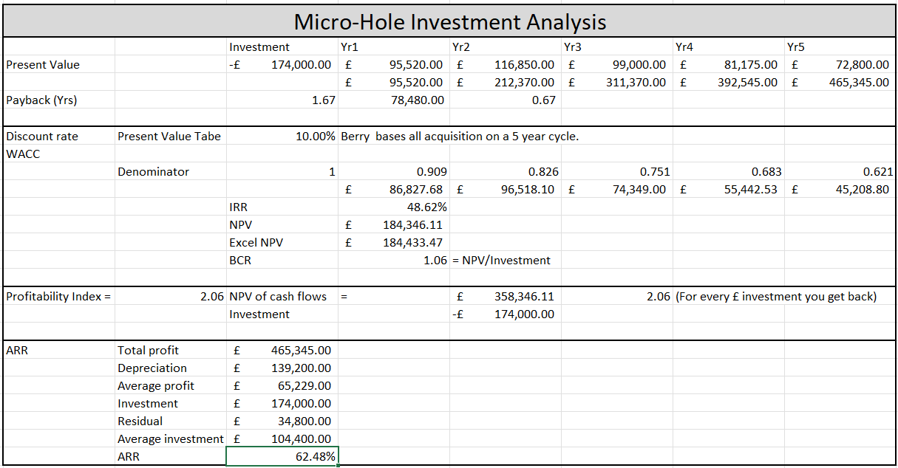
Figure 2 Financial Modelling of Micro-Hole Project

Funding options.
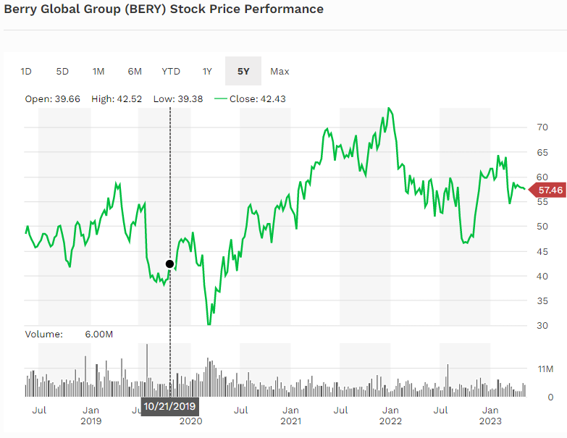
Berry Global revenue in 2022 was $14.3 billion, assets worth £17.3 billion, with profits of $724 million.
(Forbes, 2023) Figure 3 Berry Global Stock Price past 5 years.
Currently, Berry Global are in a cash rich position after an extremely profitable covid period. Lots of investment has occurred in all geographical areas, to grow existing markets and increase technological advantages over competitors.
The £174,000 requires European senior management sign-off and does not have to be presented to the USA board. All of the Berry Global metrics of PP, NPV and BCR have been successfully achieved. Decision was made to fun this internally through the European arm of Berry Global.
Leasing of the equipment was also considered but resulted in no residual equity after the project 5-year period, and no increase in project cash flow.

Project considerations.

Redundancies
There is a reduction of required staff hours due to the adoption of the robots replacing the Load, Unload and Un-flatten but this loss does not result in the reduction of full-time production staff. Unfortunately, this could mean the loss of an agency worker.
First year - 750,000 units @ 98% efficiencies = 35.4 days production. 35.4 / 242 (production days per year) = 0.146. Cost of people saving = £120,000 / year (6 x £20,000) x 0.146 = £17,520 fixed cost savings or 0.88 of a staff member.
Cost of running 2 x Kuka robots @ 4kWh / robot = 8kWh, 192kWh / day. 192 x 34.5 (days / working year) = 6,624Wh. 6,624 x £0.37 (kW price) giving an electrical cost of £2,451 / annum.
Cost saving in wages = £17,520 - £2,451 = £15,069. This saving has been included in the project.

Disruption.
The only foreseeable disruption would be during the FAT test and training week, but this has been scheduled into future production planning. Several weeks after the FAT test there might be some decreased efficiencies due to staff unfamiliarity, but this is difficult to accurately forecast.

Downtime.
The process has been designed to maintain 98% efficiency, and other similar systems have been installed in other industrial applications and proved highly reliable. Maintenance training is a part of the FAT period and essential spares have been identified and purchased as supplier consignment stock.

Technological.
This is the first introduction of Robotics into Tubex and will prove to be a challenge for the users and support staff. Training has been built into the project and a lot of focus has been placed into getting extensive documentation and simplifying the machine to human interface, with alarms and errors being displayed along with possible solutions.

Conclusions.
All the financial modelling has indicated that the project should prove to be financially viable, increasing the wealth of the shareholders, and helping to increase the long-term future of the Tubex plant in Aberdare.
Confidence in the process design is high and similar applications in other industries have proved to robust and reliable.

Bibliography
Arnold, J. C. & Alston, S. M., 2012. Life cycle assessment of the production and use of polypropylene tree shelters. Journal of Environmental Management, 94(1), pp. 1 - 12.
Atrill, P. & McLaney, E., 2017. Accounting and Finance for Non-Specialists. 10 ed. Harlow: Pearson Education Limited.
CMP Information Ltd., 2004. TREESHELTERS: Tubex roundabout - or a 20-year. Forestry and British Timber; Tonbridge, Volume ISSN 03087638, pp. 1 - 45.
Fields, E., 2016. The Essential of Finance and Accounting for Nonfinancial Managers. 3rd ed. New York: Amacom.
Forbes, 2023. Forbes. [Online]
Available at: https://www.forbes.com/companies/berry-global-group/
[Accessed 14 May 2023].
Hayes, A., 2022. Investopia. [Online]
Available at: https://www.investopedia.com/terms/b/bcr.asp#:~:text=The%20benefit%2Dcost%20ratio%20(BCR,in%20monetary%20or%20qualitative%20terms.
[Accessed 12th May 2023].
Worster, A., Weirich, T. R. & Andera, F., 2013. Overcoming the Challenge of System Integrators.. The Journal of Corporate Accounting & Finance, July - August(1), pp. 15 - 23.

