A Handbook for Early Years Professionals:
A guide to Transitions


(Source: TopsDayNurseries.co.uk, 2019)
The needs of the child Page 7-10
Content Page
Proposed Outcomes Page 14
Interventions Page 12-13
Partnership Working Page 11
Role of the Adult Page 5-7
Environment Page 4
Introduction Page 3
Introduction
Aims:
The aim of this handbook is to assist early year educators with the transitions which children experience through their childhood. This handbook will include the true meaning of transition, the role of the adult, the needs of the child, the learning environment, the importance of working in partnership and some of the useful strategies which practitioners like us can use to help children accomplishes their goals and move smoothly. Also, the handbook will look at theories which link to transitions in the early years setting.
What is a Transition?
Transition – The process or a period of changing from one state or condition to another “student in transition from one programme to another.” (Oxford dictionary, 2018)
According to early years matters (2023) transition’s mark significant moments in a child’s life and have a real impact on their growth. An important, adaptable development or event in a child’s life. There are different types of transition these being Horizontal, Vertical and Educational associated transitions says Vogler et al. (2008). This handbook’s purpose is to serve as a reference for professionals who help children make the transitions from home to the nursery. Transition is a process, not an isolated incident, and all parties to be involved including the individual (child), parents and all professionals. Most children will feel comfortable and secure and exhibit competence and confidence in familiar environment’s like at home.
Children go through a lot of change in their early years from birth to age five, followed by changes again as their become older and become adults. Transition is usually about change, especially adjusting to it, even something as basic as switching rooms can be considered as a transition r more complicated, like a two-year-old switching from home to pre-school, involving a change in their regular routine.
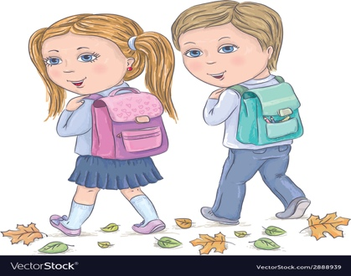
The Welsh Government (2017) say that it is imperative that carers and professionals comprehend and profound effects that change inn childcare have on a child’s growth and wellbeing.
Developmental milestones (HSE, 2018)
- Physical - crawling, walking
- Communication – talking, listening.
- Fine and gross motor skills
(Source: VectorStock, no date)
Environment

The learning environment plays a big role in transition for a child, as it is a vital part in supporting the child’s needs. Environments created with the goal of assisting children and families through transitional periods can facilitate communication, promote mental health, and boost the overall involvement, making transitions exciting and challenging rather than challenging and stressful.
Vygotsky’s theory of social development contends that language and community are essential to learning, while Piaget concluded which children’s cognitive development occurs in stages. Vygotsky disagreed, believing that social interactions cause children to develop cognately regardless of stages. Vygotsky believes that if we focus more on how children interact with peers and adult’s inn their immediate social and cultural surroundings enable the child to be active in their own development. Keenan, Evans, and Crawley (2016) say that children can only develop their skills through social interaction with other intelligent and skilful people.
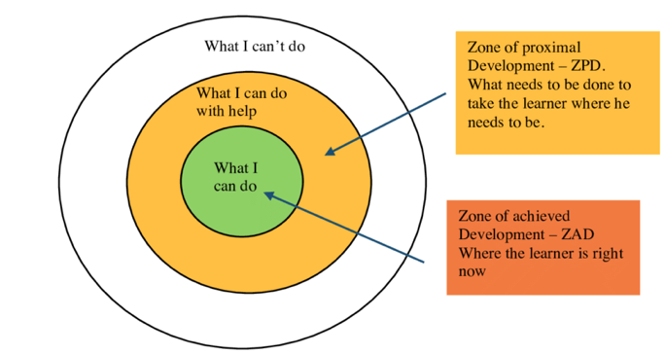
Vygotsky was accountable for the creation of the Zone of Proximal development (ZPD). The proposed theory emphasised the relationship between more capable or experienced individuals as well as less capable individuals. This theory is referred as scaffolding in early years.

(Source: educationaltechnology, 2020)
Vygotsky and Piaget believe that children learn best when they are actively investigating their surroundings and perceive the impact of their actions on them. According to Keenan, Evans, and Crowley (2016) one of the most important theories in human development is Piaget’s theory of cognitive development.
The Welsh Government (2015) suggests that a thoughtfully developed curriculum allows children to be actively involved in their own education, building on their prior knowledge, skills and interests and comprehension. Children’s development is enhancing and extended through active learning.
Role of the Adult

During a child’s early years life, their dependents are crucial in helping the children and the primary carers. By helping with childcare, providing practical support like housing or transportation, and lending a sympathetic ear, secondary carers can offer both physical and emotional support.
The child will have to make new friends with strangers when they start nursery school. The idea that young infants require access to a familiar adult during transitions has gained widespread acceptance in recent times, according to Dowling (2014). The key worker is not the only person we discuss while discussing the role of the adult.
Parents:
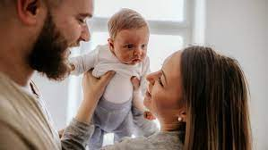
Parents have the main role in partnership in with the key worker and the setting, to maintain brilliant communications. If the parent is open and honest with the key worker setting from the beginning it will ensure the setting will know everything for the individual child, the outcome will be more positive transition which will be tailored to the individual’s needs. Social competencies and acquired through regular social interactions. According to Henry (1996) the parents of the individual are people who know their children the best, and therefore they may be an invaluable resource for professionals/ educators.

(Source: CNBC, 2022)

Key worker:
Daly, Byers, Taylor (2009) suggests a practitioner whose primary duty is to help a child and family inside the setting by acting as a lead, establishing contact, and communicating with them to foster strong bonds between staff and the individual children.
As childcare practitioners or children’s educations it is our responsibility to make the transition into the setting as calm and free as possible. Article 12 of the United Nations Convention on the rights of the child asserts that children should always be listened to and included in their decision-making processes Welsh Government (2015). For stability and support, children and teens often looking to their educators or professionals. According to Bowlby’s theory (1969) explains the bond which the individuals develop is with the key worker. The foundation of Bowlby’s theory is the idea that attachment formation is a survival strategy which is embedded in new-born’s biology. There is a pattern of behaviour that seems to work together. For instance, when a child cries, they are picked up, or when they grin adults react by raising their voices. Blowlby thought that a child can use communicative systems such as crying, smiling, or cooing to imitate proximity to their carer giver.
An experienced individual with a range of skills, the key worker will facilitate a seamless transition into the setting. The key worker will observe the individual child for a while to learn more about their preferences and dislikes. The key worker will conduct a home visit to build a rapport and trust with the parents. A child needs to feel valued and safe to learn and develop and this can only happen if there is constant communication.
Bowlby’s theory is the reason why the key worker system is now more frequently utilised in early years childhood education.
The manager and key worker must schedule a home visit so that a meeting can take place in the family's living space to obtain information on the child's and family's needs before the transition process can start. During this visit, necessary paperwork and a "all about me" document will be finished. Welsh Government (2000) says that before the child starts, visits to the setting are suggested to enable the child and parent/caregiver get acquainted with the personnel, the daily schedule, and the operation of the setting. It is important to communicate this clear settling-in approach to parents and carers.
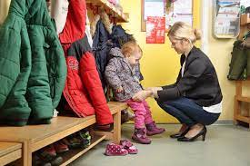

(Source: Starschildcaregroup, 2023)

Key workers must keep the following in mind as part of their responsibility as the child begins the gradual settling in process:
- To provide a positive example by consistently protecting and encouraging children and families.
- Caring assistance and comfort to the youngster as well as the parent or caregiver.
- Superior care for the child in a kind and inviting setting.
- Maintain observations, assessments, and planning.
- Meeting physical, social, and emotional needs.
- Value and respect the child and their families.
- Good communication by providing parents with constant updates.
- Play and activities that are child-initiated and that mirror the child's upbringing and culture.
These guiding concepts, effective teaching methods, and best practises will assist children and families adapt smoothly and successfully while also improving outcomes over time for the children. (Daly, Byers, Taylor, (2009)
Setting Leader
The setting leader bears the obligation of instituting best practises together with well-defined policies and procedures. They promise to provide an inclusive and diversified service, ensuring that no child faces disadvantages. To guarantee that the child has the best possible transitional experience, the manager will supervise the key worker's connection with the parents. The manager bears the additional duty of ensuring that the child has access to an enjoyable, secure, engaging, and enriching learning environment.

Welsh Government (2017) proposes that the child's and family's needs be taken into consideration during the transition process, acknowledging any additional needs that may arise. Working closely with families and other agencies that may be important will enable the practitioner to accomplish this. Pay close attention to any children or families who might require more assistance and be ready to modify your plans to meet their needs.
(Source: Prepacademyschols, 2017)

The needs of the child

Recognising that every child is unique and that their requirements reflect this is essential to satisfying their needs. The focus must be on getting to know the child their likes and dislikes, thought process, and interests for us as practitioners to be able to care for them Dowling (2014).

Lindon, (2010) says good practise is to regard children and their development holistically; for practitioners to be effective, they must consider the child as a whole.
Maslow’s Hierarchy of needs (1943) is a theory of motivation that maintains that five categories of human needs influence an individual's actions. Physiology, safety, love and belonging, esteem, and self-actualisation are a few of these. Prior to achieving the goals further up the triangle, the needs at the bottom must be met. This is crucial throughout transitions because a child who doesn't feel safe and secure may deny even the most necessities, like food and drink, which makes it difficult for them to make friends, establish self-worth, or become independent learners.

Maslow’s Hierarchy Theory
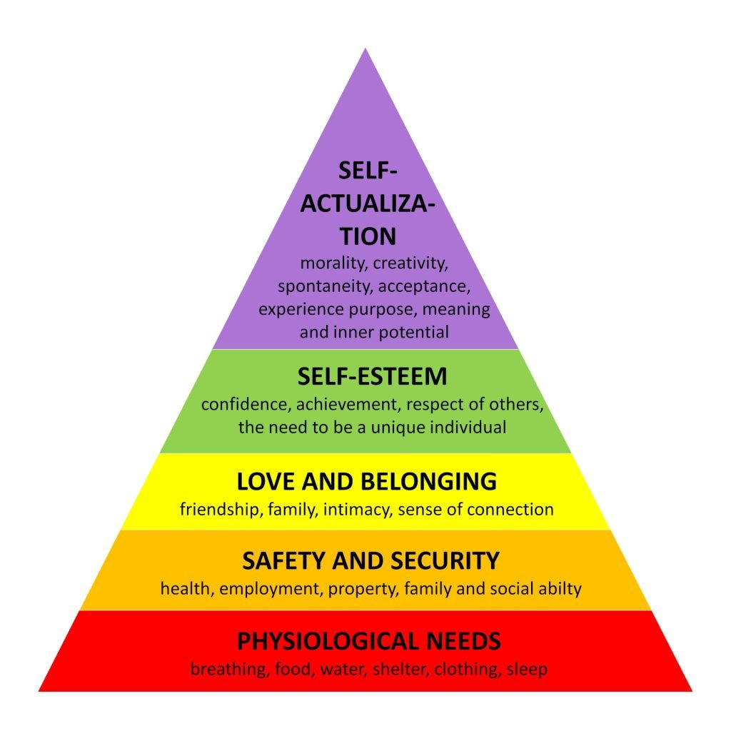

(Source: SimplyPsychology, 2023)

Building a strong relationship with anyone requires communication but working with children can make this more difficult. There are multiple reasons that communication can be challenging. When children feel terrified, agitated, or overwhelmed, it is difficult for them to express themselves. Some children may not communicate verbally, and their discomfort may be difficult to interpret from their body language. All practitioners are trained to identify the signs and strategies that indicate a child is nervous or apprehensive, and they will have a wealth of expertise in doing so.
TES (2019) says that Maslow’s Hierarchy of needs has an impact on classrooms and school/setting policy practice and can often been seen, for example:
- Guaranteeing that every child has unrestricted access to water and encouraging them to bring a nutritious active snack during break time.
- Being able to play in a stimulating and safe environment.
- The overall school/setting culture, relationship with the community and parents.
- Wellbeing or circle time in schools/settings to increase the child’s self-esteem.

According to Maslow, this results in self-actualisation and the readiness to learn and accomplish says TES (2019). However, as TES (2019) suggests that there may be more complex conditions to take into account, it is essential for practitioners to keep in mind that this model can be seen as limited and perhaps biased. Consequently, it is important to consider the child as mentioned by Lindon (2010).

Regular observations will be made to help the key worker make the best plans possible for the child's requirements. These observations could be official or informal, but they will demonstrate the kinds of resources the person will get access to. Once more, this procedure of continuous evaluation and monitoring guarantees that the children are benefiting from the offered activities.

“Even the growth of the brain itself… may not progress adequately if the baby does not have the right conditions to develop” (Gerhart,2015)
Vygotsky’s Sociocultural Theory of Cognitive Development.
According to Psychology notes HQ (2020) The foundation of Vygotsky's theory of cognitive development is the adult-child exchange of direct information and communication. Long-term shared thinking is required to help children advance to new levels of competence beyond what they can now accomplish on their own. Listen closely to what the youngster says and does and determine when and if they are prepared to proceed to the next level.
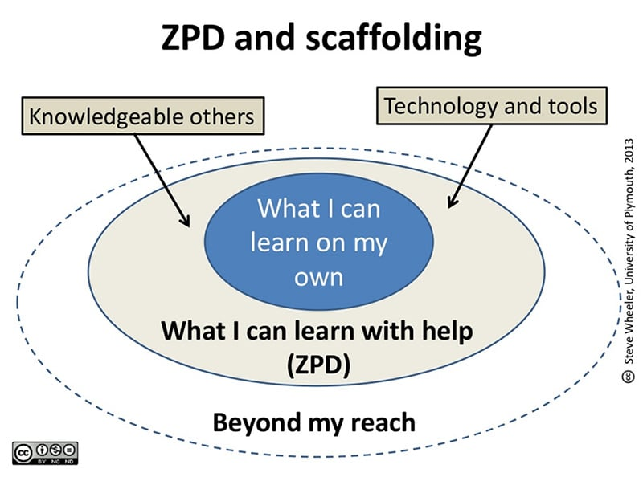

(Source: SimplyPsychology, 2023)
Froebel's theories and principles still hold true in modern practise. He felt that kids should be able to express themselves freely, feel a part of their community and surroundings, and have the chance to play, be creative, and interact with the natural world says Tovey (2017). The UNCRC acknowledges these concepts. Article 31 stipulates that child must have time and opportunities for leisure, play, and culture, whereas Article 13 emphasises the right to freedom of expression.
As the New Curriculum for Wales is put into practise, Welsh Government (2020) notes in the Four Purposes that the school's goal is to assist students in becoming competent and self-assured learners. Welsh Government (2020) goes on to state that practitioners should determine each child's unique needs and address them on a regular basis.
When a child with hearing loss moves from Nursery to the other children in the group, their needs could change. In what ways could the reception class practitioners facilitate this child's transition?
- Ascertain the child's abilities.
- Make sure the child participates and modify the activities as needed.
- Motivate the child to engage in activities at their comfort level.
- Pay attention to the youngster so you may learn about their desires, emotions, and hobbies.
Partnership Working

One of the most important aspects of supporting a child's growth is forming partnerships. To make sure that a clear strategy is in place for the child's transition, cooperation in the child's best interests is essential. Meaningful interventions that help improve a child's transition can be made possible by collaborating with parents and a range of other agencies.
Establishing solid relationships among everyone involved is crucial to facilitate constructive shifts.
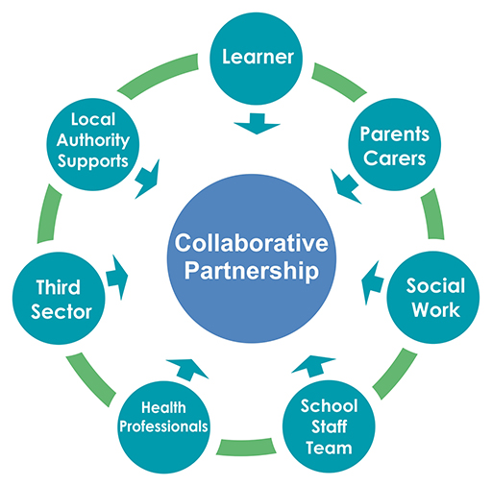
Tovey (2020) says that while addressing Froebel's Principles, families, parents, and the community should be closely connected to the child's school. Effective communication can foster an environment where parents and carers are completely engaged in their child's education and are encouraged to participate in it (Welsh Gov, 2016).

(Source: Open.edu, 2023)
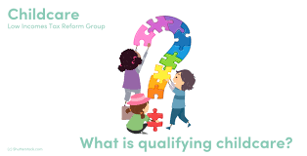
The previous picture highlights how crucial it is to place the child at the centre of every communication. It also demonstrates how crucial the key person's role is in coordinating and communicating with all parties engaged in a child's care.
(Source: litrg.org.uk, 2023)
Interventions

According to the Early intervention foundations (2023) the procedure of identifying children and adolescents who are at risk of adverse outcomes and providing them with adequate early care is known as early intervention. Aiming to prevent problems before they arise or deal with them head-on when they occur, effective early intervention.
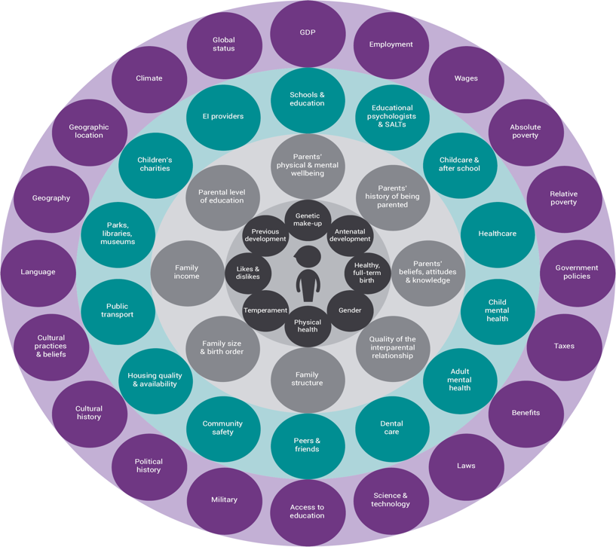

(Source: Early interventions foundation, 2023)

At the individual’s level, these risk indicators are neither deterministic nor predictive; that is, they are unable to pinpoint the precise child or young person who will require assistance. However, they can assist us in identifying kids who are at risk and could require more assistance. Research indicates that early intervention is most effective when it is provided to kids based on previously identified concerns.
Some things to take into consideration:

Home visits:

A nursery instructor and the child's key worker will visit the child at home prior to the kid starting in the nursery. According to Bronfenbrenner, the importance of spending brief amounts of time studying children's behaviour in unfamiliar settings has been overemphasised. Home visits provide the child the opportunity to see that their parents or other carers trust us enough to let us inside their house, which marks the start of a close relationship with the family. This is a chance to observe the youngster in a setting where they feel content, at ease, secure, and safe a "true picture" of the child's character. Additionally, it's a chance to have conversations with families to learn about the child's hobbies, preferences, dislikes, worries, etc.

Welcome booklet:
During the house visit, a welcome pack will be handed to each family. This includes all the forms that need to be filled out, including one for the "child record." This is the family's chance to give us a written record of all pertinent facts about the child. To help the child feel like they belong before they even start, there is also a t-shirt, a notepad with the setting emblem on it, a pen, and a key ring with a teddy bear wearing the same t-shirt.
(Source: The empowered educator, 2023)

Stay and play sessions:
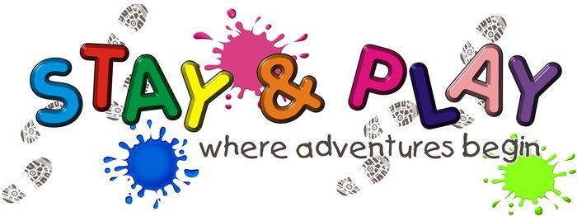
(Source: Ghyll royd school and pre-school, 2020)

Before starting to settle he child the parents can be invited into the settings, so the child ca starts to form a bond before leaving the child. Then throughout the time at the setting there will be opportunities for parents, carers, and guardians to visit the nursery for unstructured stay and play sessions during the year, once all the children have settled in.
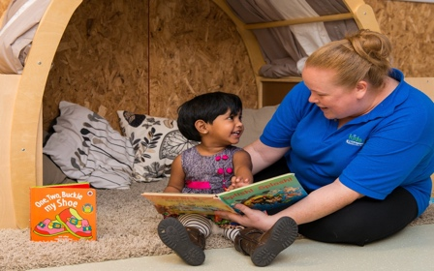
Settling sessions:
(Source: Kids play day nurseries and pre-school, no date)
A child will be invited to a series of settling-in workshops prior to starting in the childcare. First, to reassure their child, parents and carers are advised to stay with them. The child will then spend an hour alone without a parent. From child to child, the number of settling in sessions will differ. Information about the child and the most significant individuals in their life are shared during settling in sessions (Collins, 2010, p. 233).

Handovers when the child gets picked up:
(Source: Gelaw, 2028)

The child's key worker will conduct an informal handover with the parents at the conclusion of each session, providing an opportunity to talk about any problems or worries. Practitioners can better organise activities to support children by using information acquired at these handovers (Collins, 2010, p. 234).

Proposed Outcomes

When a child shows signs of stability, their transition has been effective. This will become apparent when the child starts to play on their own and is less reliant on their important person for comfort. They'll start forming bonds with their peers and maybe with other practitioners working in the same environment. As soon as the youngster feels more at ease in their surroundings, they will start to demonstrate an understanding of it. They will begin to show signs of self-awareness and an awareness of their place in the world. A well-adjusted youngster exhibits traits such as consistency, emotional maturity, responsiveness, sensitivity, security, happiness, and independence in exploring their environment.
Laevers (1994) asserts that there are two methods for assessing children's learning and development. The first is emotional well-being, which can be identified by a child's level of openness, receptivity, assertiveness, flexibility, ease of mind, and confidence. The second is participation, which is observing how a youngster focuses, is active, persistent, expresses themselves, and is satisfied.


(Source: Vector stock, 2023)

Reference list:
CNBC (2020) Available at: https://www.cnbc.com/2022/03/28/budgeting-for-baby-what-financial-advisors-recommend-for-new-parents.html (Accessed: 29th November 2023)
Collins, S (2010) Thinking through the uses of observation and documentation’ in Moyles, J. (ed) Thinking about play. Berkshire: Open University Press.
Daly, M. And Byers, E. and Taylor, W. (2009) Early years management in practice. 2nd Ed. Essex: Heinemann, Pearson Education limited.
Dowling, M. (2014) Young children’s personal, social, and emotional development. 4th Ed. London: Sage
Early intervention foundation (2023) What is early intervention? Available at: https://www.eif.org.uk/why-it-matters/what-is-early-intervention#:~:text=Early%20intervention%20means%20identifying%20and,do%2C%20before%20problems%20get%20worse. (Accessed: 3rd December
2023)
Early Years Matters (2023) Transitions. Available at: https://www.earlyyearsmatters.co.uk/eyfs/positive-relationships/transitions/ (Accessed: 20th November 2023)
Ghyll Royd School and Pre-School (2020) Available at: https://www.ghyllroydschool.co.uk/events/stay-and-play-friday-toddler-group-51/ (Accessed: 3rd December 2023)

Gregorian Emerson family law solicitors (2018) Available at: https://www.gelaw.co.uk/blog/children-blog/children-child-custody/managing-contact-handovers.html (Accessed: 3rd December 2023)

Henry, M. (1996) Young children, parents, and professionals. London: Routledge
HSE (2028) Your child’s developmental milestones. Available at: https://www2.hse.ie/babies-children/checks-milestones/developmental-milestones/ (Accessed: 20th November 2023)
Keenan, T. Evans, S. Crowley, K. (2016) An introduction to child development. 3rd Ed. London: Sage
Koblin, J (2020) Vygotsky’s theory of cognitive development in social relationships. Available at: https://sproutsschools.com/vygotskys-theory-of-cognitive-development-in-social-relationships/#:~:text=Vygotsky%20claimed%20that%20we%20are,finally%20gain%20%27higher%20mental%20functions. (Accessed: 26th November 2023)
Kennan, T. Evans, S. and Crowley, K. (2016) An introduction to child’s development. 3rd Ed. London: Sage.
Kids play day nurseries and pre-school (no date) Available at: https://www.kidsplaychildcare.co.uk/nurseries/2021/11/17/settling-into-nursery/ (Accessed: 3rd December 2023)
Lindon, J. (2010) Understanding child Development. 2nd Ed. London: Hodder Education.
Laevers, F. (1994) Defining and assessing quality in early childhood education. Leuven: Leuven University Press.
Low-income tax reform group (2023) What is qualifying childcare? Available at: https://www.litrg.org.uk/tax-guides/childcare/tax-credits-childcare-support/what-qualifying-childcare (Accessed: 3rd December 2023)
Main, P (2023) Bowlby’s attachment theory. Available at: https://www.structural-learning.com/post/bowlbys-attachment-theory#:~:text=This%20theory%20proposes%20that%20the,serves%20as%20a%20survival%20strategy. (Accessed (29th November 2023)
Prep Academy Schools (2017) Available at: https://prepacademyschools.org/7-tips-raising-happier-children/ (Accessed: 3rd December 2023)
Stars childcare group (2023) Available at: https://www.starschildcaregroup.co.uk/blog/the-importance-of-your-childs-key-person (Accessed: 3rd December 2023)
TES (2019) Pedagogy focus: Maslow’s Hierarchy of needs. Available at: https://www.tes.com/magazine/maslow-hierarchy-of-needs (Accessed: 3rd December 2023)
The empowered educator (2023) Available at: https://www.theempowerededucatoronline.com/2018/01/educator-orientation-packs.html/ (Accessed: 3rd December 2023)
The Psychology notes HQ (2020) Vygotsky’s theory of cognitive development. Available at: https://www.psychologynoteshq.com/vygotsky-theory/ (Accessed: 3rd December 2023)
Tops Day Nurseries (2019) Available at: https://www.topsdaynurseries.co.uk/parent-guide-early-years-foundation-stage/ (Accessed: 20th November 2023)
Tovey, H. (2020) Froebel’s principals and practice today. London: Froebel Trust.
Oxford dictionary (2023) Definition of Transition. Available at: https://www.oxfordlearnersdictionaries.com/definition/american_english/transition (Accessed: 20th November 2023)
Open education (2023) Collaborative partnership working. Available at: https://www.open.edu/openlearncreate/mod/oucontent/view.php?id=146352&printable=1 (Accessed: 3rd December 2023)
Vector stock (no date) Available at: https://www.vectorstock.com/royalty-free-vector/children-go-to-school-vector-2888939 (Accessed: 20th November 2023)
Vogler et al. (2008) Early childhood transitions research: A review of concepts, theory, and practice. Available at: early childhood transitions research: A review of concepts, theory, and practice (Accessed: 20th November 2023)
Vector stock (2023) Available at: https://www.vectorstock.com/royalty-free-vector/happy-children-jumping-vector-2089437 (Accessed: 3rd December 2023)
Welsh Government (2015) Curriculum for Wales: The Foundation Phases Framework. Cardiff: Welsh Government.
Welsh Government (2017) Transition Guidance, flying start- annex. Pp 1-106. Available at: https://www.gov.wales/sites/default/files/publications/2019-07/flying-start-transition-guidance-for-professionals.pdf (Accessed: 20th November 2023)
Welsh Government (2017) Flying start – Annex Transitions guidance. Available at: https://moodle.uwtsd.ac.uk/pluginfile.php/214826/mod_resources/content/1/141124-transition-guidence-en-v1.pdf (Accessed: 20th November 2023)

