
Swansea Business School

Applied Qualitative Business Research (BMDB7002)

Assignment Title: Written Assignment

Submitted
By
Nabil Hossain Tonmoy
Student ID: 1813032

Table of Contents

1.0 Introduction 1
1.1 Approaches to Qualitative Research 1
1.1.1 Narrative Research 1
1.1.2 Phenomenological Research 3
1.1.3 Grounded Theory Research 4
1.1.4 Ethnographic Research 5
1.1.5 Case Study Research 7
2.0 Comparison of the 5 approaches 8
2.0.1 Similarities 8
2.0.2 Differences 9
3.0 Qualitative Research Methods and Research Ethics: Relationship 12
4.0 Evaluation of Qualitative Research approaches 14
5.0 Conclusion 15
References 16

Introduction

Qualitative research can be defined as research which uses exploratory and theoretical frameworks to inform the research problems. Qualitative research begins with assumptions. The data collection of qualitative research is sensitive to people and places. Both inductive and deductive data analysis is visible in qualitative research which establishes a pattern of themes. Qualitative research includes the voice of participants, the reflexibility of researchers and the interpretation of the problem (Creswell and Poth, 2018). To define qualitative research, the author has emphasized the process of research from philosophical assumptions to the interpretive lens to the procedures to study social and human problems.
Denzin and Lincoln (2011), also defined qualitative research by stating that qualitative research discovers the observer in the world which consists of interpretive and material practices. They have also stated that these practices make the world visible. Qualitative research also consists of a series of representation such as interviews, conversations, field notes, recordings etc. according to the authors' qualitative research involves an interpretive, naturalistic approach to the world.
When to use or conduct qualitative research? The qualitative research is used or conducted when the problem or the issue needs to be explored when the problem needs a detailed understanding of the issue when the researcher wants the participant’s story to be shared, their voices to be heard. Researchers conduct qualitative research to understand the context in which participants address the problem or the issue (Creswell and Poth, 2018).

1.1 Approaches to Qualitative Research

There are 5 popular qualitative approaches to the inquiry which are, narrative, case-study, grounded theory, ethnography, and phenomenology. In this section, we will introduce the 5 approaches to inquiry.

1.1.1 Narrative Research

The origin of narrative research came from literature, anthropology, history, sociology. But different fields of study have adopted their approach to narrative research (Chase, 2005). In this approach, individuals express their lived experiences and stories. According to Czarniawska (2004), the narrative approach is a spoken or written text of an event or series of events which is chronologically connected. The narrative study can also be differentiated in various types such as a biographical study, Autoethnography, life history and oral history. Narrative research is fairly used in clinical healthcare. For example, narrative research gathers stories of patients about how the disease affects them (Greenhalgh, 2016). Myers (2020) also pointed out that narrative research is also used in many disciplines of business management such as accounting, marketing, information system etc. For example, in marketing, researchers have studied about how the consumers look at themselves and the world.

Narrative research and challenges for a novice researcher:
Even though Creswell (2007) mentioned that a narrative inquiry approach is not very structured, but there are some analysis phases such as transcription, coding and interpretation which might be daunting for a novice researcher. He also pointed out that, the narrative approach has more freedom to custom make a procedure which is appropriate for the study and becomes less prescriptive. But this freedom and lack of prescriptive procedures might seem daunting for a novice researcher. Also, in the coding stage, experienced researchers prioritise sequencing and linguistics to break apart the participant’s story, whereas a novice researcher might find it difficult to apply in practice (Floersch et al. 2010).

- Procedures of Narrative research

There are certain procedures to conduct narrative research. The general procedures of narrative research are mentioned below.

- First and foremost, the researcher must determine whether the research problem best fits the narrative research as narrative research is best fitted to capture detailed stories and life experiences of individuals (Creswell and Poth, 2018).

- The researcher can observe the individuals and record field notes, or the participant can also record their stories (Clandinin and Connelly, 2000)

- The researcher should consider how the collected data and their recording can take different shapes.

- The researcher should gather information about the context of the stories.

- The researcher can restore the stories into a framework as often the participants or individuals do not present their stories in a chronological sequence which consists of a beginning, a middle and an end (Creswell and Poth, 2018). Cortazzi (1993), supports this argument by stating that the chronology sets narrative research apart from other genres of research.

1.1.2 Phenomenological Research

In phenomenological research, the researcher tries to find a common meaning among several individuals’ lived experience. Phenomenological research looks for the concept of a phenomenon. The purpose of this type of research is to reduce individual experiences to a phenomenon (van Manen, 1990). According to van Manen, “Doing phenomenology means developing a pathos for great texts” (van Manen, 2014) and “Phenomenological writing is not just a process of writing up or writing down the results of a research project. To write is to reflect; to write is to research. And in writing, we may deepen and change ourselves in ways we cannot predict.” (van Manen, 2014). Once the researcher collects data from the individuals who have experienced a phenomenon, develops a composite description of the essence of the experience for all the individuals (Moustakas, 1994). There are two types of phenomenology, hermeneutic phenomenology (van Manen, 1990) and transcendental phenomenology (Moustakas, 1994) which is also known by empirical or psychological phenomenology.
Phenomenological research is also used in the field of supply chain management. For example, to assess financial problems in the cash-to-cash cycle of SCM that links the operation supply and financial supply chains, the researcher has surveyed 16 supply chain professionals to gather their perceptions on the problem. Phenomenology research enabled the researcher to observe the supply chain professionals or we could also say the participants in a natural setting within the organizations. On the other hand, quantitative research in this context would have been challenging and time-consuming to gather and analyse numeric data in the corporate environment (Smit, 2012).

Procedures of Phenomenological Research

- Similarly, to the narrative research, in phenomenological research, the researcher must determine whether the problem or the issue is best suited to the phenomenological research. understanding the common experiences of the individuals is important to develop a deeper understanding of the phenomenon (Moustakas, 1994).

- The researchers must bracket out their own experience as much as possible to completely describe how participants view the phenomenon (Moustakas, 1994).

- According to Polkinghorne (1989), researchers should interview from 5 to 25 individuals who have all experienced the phenomenon.

- Another procedure is called the Horizonalization, where the researcher analyses the data and build significant statements of the participants’ experiences (Moustakas, 1994).

- The next procedure is called a textural description where the significant statements of the participants' experiences are being written descriptively (Moustakas, 1994).

1.1.3 Grounded Theory Research

Unlike narrative research and phenomenological research, the grounded theory provides a general explanation of action and discovers a new theory. The idea is to develop or generate a theory rather than coming off the shelf (Corbin & Strauss, 2007), (Strauss & Corbin, 1998). There are two very popular approaches to the grounded theory which are, the systematic procedures and the constructivist approach (Creswell and Poth, 2018). According to the Straussian grounded theory research, it follows a three-stage process which is, Open coding, axial coding, and selective coding.
Misconceptions regarding Grounded Theory Research
There are some common misconceptions regarding the grounded theory research. As a new or novice researcher, we should be mindful about these misconceptions. The researcher as a blank slate- this is probably the most harmful misconception where the researcher is regarded as a blank slate who rushes into the data collection prior looking at the literature (McCallin, 2003; Andrew, 2006). Whereas, to produce well-grounded theory research, understanding of the literature is an essential aspect. Grounded theory research is inflexible- this another misconception about the grounded theory that it is inflexible and difficult to apply. There was a split between Glaser vs Strauss and Corbin back in 1990, where Glaser opposed to Straus and Corbin’s coding paradigm. Glaser pointed out that due to the forcing effect of the coding paradigm presented by Strauss and Corbin, it was no longer a grounded theory (Urquhart and Fernández, 2016). Glaser also stated that forcing by preconception derails the research from relevance (Glaser, 1992).

Procedures of Grounded Theory Research

- Like the other approaches, the researcher must determine whether this approach is best suited to the research problem.

- After the initial exploration of the issue, the researcher should ask the participants a detailed questionnaire which will then help to shape up the axial coding phase. The idea is to develop a model with adequate information (Creswell and Poth, 2018).

- To identify a phenomenon, the researcher should develop a structured coding diagram (Creswell and Poth, 2018).

- The researcher then writes a substantive level theory close to a specific problem with the help of open, axial, and selective coding. At this point the research could stop or could be tested for an empirical verification with quantitative data which can determine if it generalises to a sample or population Creswell & Plano Clark, 2011).

1.1.4 Ethnographic Research

According to Harris (1968), ethnography is a design which interprets the shared values, beliefs and behaviours of a culture sharing group. The unit of analysis in ethnography research is much larger than the grounded theory research as ethnography research focuses on an entire cultural group. Ethnography research comprises of an extended observation by the researcher (Creswell and Poth, 2018).

Ethnographic research is used in many sectors of business. For example, it is widely used in the fashion industry where the researcher observes many backstage events, trade fairs etc. to explore new trends (Rinallo and Golfetto, 2006). Ethnographic research is also being used during purchasing (Andersson et al., 2008) or negotiation meetings (Azimont and Araujo, 2007). However, there might be entry barriers for an ethnographic researcher while trying to get into corporate fieldwork. For example, while trying to perform ethnographic research in a restricted mining site in Canada, the researchers had to establish great connection with the top management to get access to the restricted area (Kalyta and Malsch, 2018).

Procedures of Ethnography Research

- As usual, the first procedure is to determine whether this approach suits the research problem.

- Then the researcher needs to find a culture sharing group where the members of the group have been together for a long time. The researcher needs to find individuals who will allow the researcher into the group. They are often called the gatekeeper or key informants (Creswell and Poth, 2018).

- The researcher needs to decide on themes to study about the group. This themes usually provides a framework for the study (Atkinson 1995, Wolcott 1987, 1994b, 2008a, and Fetterman 2010).

- Then the researcher needs to determine the type of ethnography which will be best to use.

- According to Wolcott (2008a), the researcher needs to gather information regarding the setting which is called fieldwork.

- Then the researcher needs to analyse the themes that come out of the group (Wolcott, 1994b). according to Fetterman, (2010), this analysis ends with an overall picture.

- Finally, the researcher needs to establish a set of rules as the final product of the analysis. The views of the participants (emic) and the views of the researcher (etic) also comes as a complete picture of the group (Creswell and Poth, 2018).

1.1.5 Case Study Research

A case study research is when a researcher explores a case or multiple cases thoroughly with detailed and in-depth data collection. According to Yin (2009), this research requires a real-life contemporary setting. But on the other hand, Stake (2005) argues that a case study is a choice of what is to be studied rather than a methodology. But according to Denzin & Lincoln (2005), Merriam (1988) and Yin (2009), a case study is a strategy or inquiry or a comprehensive strategy. Mentioned by Stake (1995), there are three types of case study research which are intrinsic case study, instrumental case study and multiple case study.
Case study research is widely used in the area of supply chain management. For example, to understand sustainability from a supply network perspective, a case study method was adopted. In this case, the researcher used four case studies (multiple case study) to conduct the research (Meqdadi, Johnsen and Johnsen, 2018).

Procedures of Case Study Research

The procedures below to conduct a case study research is adopted from Stake’s (1995) and Yin’s (2009) approaches to conducting a case study

- Like all other approaches, the researcher needs to determine whether the case study approach is appropriate for the specific research problem.

- Then the researcher needs to identify the cases.

- Then the researcher needs to collect data.

- Then the researcher needs to analyse the collected data.

Comparison of the 5 approaches

2.0.1 Similarities

Similarities among the various qualitative research approaches remain notable. The first aspect of similarity that cuts across the designs involves similar data gathering or collection processes, which include the use of audio-visual materials, structured interviews, documents, as well as participant observation (Creswell, 2018; Levitt et al., 2017). Most of the mentioned data collection methods are applicable in business and management, mainly because managers can use them to determine consumer behaviour as well as ask for customer opinions. In particular, narrative research prioritizes the use of documents and different forms of interviews, semi-structured, informal, and fully structured. A case study, on the other hand, uses a wide range of sources, including artefacts or arts, interviews, documents, and observation. The main advantage of using a case study approach in business and management scenarios is that it allows business managers to collect data related to their business environment and determine why, when, and how of certain scenarios (Sutton & Austin, 2015). Phenomenology places a great deal of emphasis on utilizing interviews with study participants. Equally important, some phenomenologists incorporate art, documents, and observations into their data collection process (Bryman, 2012; Maxwell, 2016). Grounded theory tends to adopt the specific approach as in the case of phenomenology, collecting data by primarily interviewing between 20 and 60 research participants. For instance, a company may decide to interview 20 consumers to determine the public’s perception of its products or service, showing how qualitative research methods are useful in business and management scenarios (Sutton & Austin, 2015). Ethnography utilizes interviews and participant observations, but ethnographers leave room for the use of other data collection methods.
The second similarity revolves around the fact that each of the five qualitative research methods follows a six-step process to conducting research. All five approaches begin with the identification and a brief or detailed description of research problems. Then, they proceed to list research questions and related hypotheses, in addition to explaining how each question would be addressed in the study (Bryman, 2012). For each qualitative research approach, researchers use the introduction to provide a comprehensive description of the research focus. The introduction plays a central role in familiarizing the readers with the problem to be addressed (Viswambharan, 2016).
The third, fourth, and fifth steps that all the five designs follow include data collection, data analysis, and data interpretation. In most cases, however, all the approaches combine the data analysis section with data interpretation because these two steps tend to focus on similar procedures and tools (Maestrini et al., 2016). The final step is the research report stage in which the inquirer presents the analysed data to the target audience. Investigators often simplify information through the use of graphs, tables, pictures, pie charts, and other presentation methods (Pistol & Bucea-Manea-Tonis, 2017).
Another key similarity of the different qualitative research methods in business and management is that they effectively answer the how and why questions, especially when it comes to seeking specific answers to a research question. When it comes to business and management operations, the use of qualitative research methods involves a systematic investigation as a way of establishing facts and reaching new conclusions (Damgaard et al., 2001). One example of using qualitative research methods in business and management is salesforce polling or survey. This approach combines statistical methods with a qualitative approach of selecting a given number of people to provide valuable insights into the impacts of a particular decision. In management circles, this practice is important in that it allows business managers to ask more in-depth questions regarding the state of a targeted market segment and, in the process, get data and information to create short term and long term forecasts (Sutton & Austin, 2015). Consumer surveys also represent another form of qualitative research approach used by business managers to obtain answers from consumers regarding their feelings about a product or service as well as determining their level of satisfaction (Damgaard et al., 2001). The responses provided by consumers provide invaluable information to the managers who may want to test the customer reactions to come up with or change the existing managerial decisions.

2.0.2 Differences

The first dimension for distinguishing any of the five approaches from another is the research focus. In other words, the five can be distinguished based on what they designed to achieve, commonly known as the research approach’s primary objectives or goals of the study (Creswell, 2018). Even though the different qualitative research methods are used in business environments to focus on getting data and information that can be used to make business decisions, the research focus adopted in each case differs from one research to another (Cassell et al., 2018). The same distinction applies to research methods tasked with the responsibility of investigating and describing the unique behaviours of a given consumer segment (Damgaard et al., 2001). In this respect, the main objective of narrative research is the collection of data about an individual and using this information to retell the story in chronological order. An oral story, a type of narrative, allows the researcher to gather personal reflection of a particular event, including their causes and potential impact from either an individual or many people (Berg, 2012; Gill et al., 2008). For instance, narrative research can also be used to gather the personal reflection of consumers regarding the launching of a particular product or service or a group of experts regarding the operations of a business (Cassell et al., 2018). A typical example of narrative research involves interviewing teachers and students with the sole purpose of understanding their first-hand experiences with the current curriculum.
In contrast, the main aim of phenomenology is to provide an accurate description of the complex lived encounters of a people (Paul, 2017). In essence, phenomenological research does not focus on the generation of any models. This explains why, in a phenomenological study, the investigator seeks to validate emerging themes with the participant as doing so goes a long way in ensuring their lived experiences are meaningful (Hammarberg, Kirkman, & de Lacey, 2016). For example, phenomenology can be used by the inquirer to address the problem of what constitutes the lived experiences of seasoned employees who are planning to engage in a post-retirement job. From this question, the researcher would focus on establishing how the employees’ career and early life and educational background have influenced their perceptions about work.
The focus of ethnography grounded theory and case study research involves learning about a given culture from individuals with first-hand experience with the said culture, discovering social-psychological processes, and illustration of an issue in its context, respectively. In an ethnographic study, a culture may refer to a business organization, an ethnic population, a social world, a particular society, or even a spatial location (Denscombe, 2010). Therefore, ethnography describes practices, values, as well as belief systems of a given cultural group. Case study research requires the investigator to collect and compile data about the case’s settings. In comparison, it is evident that, when studying a single individual, researchers should use the case study and narrative approaches because the former is provides a broader and more generalizable picture of cultures, with the latter being clear and concise (Creswell, 2018).
Although the five approaches seem to follow one data collection process, there are significant differences when it comes to concepts of emphasis and extent. According to Creswell (2018), ethnographic researchers put more emphasis on observations, while ground theorists focus on undertaking in-depth interviews. Regarding the degree of data collection, interviews remain the primary method of gathering information from informants. At the same time, case study research uses several or multiple forms with the sole purpose of providing in-depth case pictures.
Besides differences resulting from the extent and emphasis of a given qualitative approach, another difference manifests in a unit of analysis adopted by each design. While narrative research studies an individual or more, phenomenology studies not only several individuals but also ensure they are people with shared experiences (Kuckartz, 2014). On many occasions, students have difficulty distinguishing ethnographic research from the phenomenological study. Another area that often confuses researchers involves understanding units of analysis in the case study and grounded theory methods. Notably, grounded theory researcher studies an interaction, a process, or a given action that involves many individuals. In contrast, a case study involves the study of an activity, an event, a particular program, or two or more individuals (Kuckartz, 2014). Very simply, grounded theory phenomena that surround individuals, while case study research studies both people and given activities. However, both research approaches can be applied to business and management environments, especially when it comes to getting information from consumers, or a business entity (Bluhm et al., 2010).
Apart from the unit of analysis, the type of research that suits an approach brings another dimension of differences witnessed among the five research designs. Narrative research is driven by the desire or need to tell understand and retell stories based on an individual’s personal experiences. For instance, business managers can use the narrative approach to interview or survey the consumer’s personal experiences when using a certain product or service and then use the information obtained to make changes (Bluhm et al., 2010). Phenomenology, on the other hand, is founded on the need to present a vivid description of what constitutes the essence of a particular aspect of lived experiences. The kind of research best suited for grounded theory is establishing a theoretical framework based on the participants’ viewpoints (Flick, 2013).
The type of research that best suits ethnography is the systematic description and interpretation of shared cultural patterns of a given group of individuals. When compared to ethnographic studies that thrive in the examining cultural aspects of a people, case study research seeks to provide the much-needed in-depth understanding of or insight into programs, events, individuals, or activities (Flick, 2013). The differences suggest that ethnography is suitable for anthropologists and sociologists because it presents the investigator with the opportunity to collect reliable data on cultures, patterns, systems, as well as subcultures. According to Bryman (2012), ethnography is used in the examination of worldviews, self-defined social institution, belief systems, self-contained social institutions, religions, ethnic enclaves, and cults or sects. To demonstrate how ethnographic methods work, Mertin (2015) conducted a study to investigate the factors why individual Japanese students take relatively longer to learn English as a second language than learners from other linguistic, as well as cultural backgrounds. From this study, the researcher hypothesized that social norms and associated cultural elements unique to Japanese students and how they influence learning a new language.
Additional differences among the approaches are evident in reporting, organization, and reporting, and concluding methods. The product of a given research method is informed by the various processes that precede it, including problem statement, statement of specific objectives and hypotheses, and data analysis (Creswell, 2018). This suggests that stories written about individuals become their narratives, with descriptions regarding the essence of their lived experiences translate to phenomenology. Although the provision of detailed explanations remains a common feature across the five methods as stated earlier, their organization tends to vary, with narrative research assuming a chronological arrangement of events or stories. Likewise, a phenomenological study reports a given phenomenon through the use of key statements made by the informant (Haradhan, 2018). Concerning the approaches’ concluding strategies, case study research tends to close by a vignette. At the same time, ethnographic investigators often use cultural portraits as a way of highlighting questions resulting from the study and lessons learned.

3.0 Qualitative Research Methods and Research Ethics: Relationship

The complexity that characterizes any kind of research presents investigators with a wide range of ethical, as well as legal challenges. In this respect, the five approaches are expected to follow the basic ethical principles that govern research involving human beings. According to the Belmont Report, the generally accepted cultural tradition of research comprises three major principles of justice, respect for persons, as well as beneficence (HHS, 1979). This means that the inquirer should observe all the professional, legal, and ethical standards that govern research just like a registered nurse is required to exercise a great deal of vigilance when it comes to the prescription of drugs for patients based on a given treatment plan.
Investigators using the various qualitative research methods should take some specific precautions to demonstrate that their respect for persons, in this case, participants. The first precaution involves respecting the informant’s rights to autonomy, anonymity, and privacy (Mertin, 2014). Given qualitative methods are mainly used in social science studies, a sensitive knowledge domain, researchers should familiarize themselves with the concepts of keeping social boundaries or distance, the scope of questions to ask, and sharing personal information. Depending on the researcher-informant relationships, the inquirer can disclose the informant’s real name in the final report of narrative research. In many cases, this is subject to whether or not the investigator has a duly signed informed consent to use such sensitive information. If the informants have not consented to the request, the researcher must either use anonymous names or avoid including any name altogether, and simply use the term “participants” (HHS, 1979). Doing so goes a long way in protecting the informant’s privacy and avoiding the potential impact of being stigmatized by the reader and society.
Another connection between the five approaches and research ethics involves the need for qualitative researchers to ensure the study participant’s right to information and confidentiality. In other words, there are ethical and a professional standard that governs nursing practice, which means failure to adhere to a given standard is most likely to attract a penalty or lawsuit against the nurse (Fowler & American Nurses Association, 2015). Similarly, a researcher is expected to disclose crucial information to the selected participants as a way of allowing the informant to decide whether or not to take part in the research.
Qualitative researchers are responsible for the promotion of the principle of beneficence. Interviewing an informant to gather data for phenomenology or ethnographic research, the inquirer should be in a position to meet the informant’s needs (Sanjari et al., 2014). While the researcher’s focus is to gain a deeper understanding of their participants, which becomes useful in presenting verifiable data, he or she should demonstrate to the informants that their interests are key to the research outcome. With this assurance, the researcher would be able to build and maintain a strong inquirer-informant relationship throughout the research (Mohajan, 2018). Relationships are built through proper coordination, which in turn creates room for immediate correction of errors, while at the same time, ensuring consistency of the data collection process. The investigator can achieve this by remaining a sympathetic and empathetic listener, allowing the informant to respond conclusively to the research questions without interruption.
Researchers are tasked with the responsibility of protecting their research and results’ validity and reliability. For instance, getting information and data from consumers requires the researcher to guarantee that personal details will be protected as well as enhancing confidentiality (Bandyopadhyay, 2015). According to Haradhan (2018) and Zohrabi (2013), one of the major shortcomings of most qualitative research involves the investigators’ failure to incorporate rigorous analytical frameworks and tools into the data collection process, which results in the inaccurate and ineffective presentation of findings. This risk is common in ethnographic and narrative research methods (Mohajan, 2018). Another potential pitfall experienced by qualitative researchers in the formulation of biased research questions and making preconceived conclusions. In response to these ethical challenges, ethnographic investigators conducting a case study, phenomenology, or narrative should be able to understand their participants’ cultures, worldviews, and an overview of experiences (Mertin, 2014). The researcher should never reach predetermined conclusions.

4.0 Evaluation of Qualitative Research approaches

Credibility is considered as internal validity that referred to portrayed trustworthiness of the related findings. The aspects of credibility dependent upon data enrichment to the quantity of data. The participants of the research decide if the result could be reflected towards phenomena that are being studied and thus, it made them effective to present credible and accurate findings. Strategies that required for credibility demand sustainability and continuous observations with the method of triangulation (Bell, 2018). Credibility helps to establish research’s study findings to portray accurate responses of participants.
Transferability referred to external validation for qualitative analysis, which accumulates the findings of the research, which can be transferred to other researchers (Carey, 2017). Through which it can be assumed that the results are generalised and can be applied to pursue similar settings, situations, and populations. In the setup of transferability, the content of qualitative research can be transferred to other researchers with several other respondents. Creswell (2017) emphasise that transferability purposed to present potential judgements through research methodologies which are required for deep descriptions to portrayed purposeful samplings.

Dependability referred to the persistency with which the results can be repeated and thus possess similar findings. Further, the nature of research can be changing to perceived in research settings. As a case study approach, it is required for the researchers to conclude all the findings to describe the changes in research methods to proceeds further research methods (Duff, 2018). The aspect of dependability involved participant’s evaluation of findings, the interpretations, and recommendations of the study to support the relevant data, which is received from the study (Edmonds, and Kennedy, 2016). The qualitative research methods managed for the enquiry of data to examine the process which provides data analysis.

Conformability is the degree, which referred to the neutrality in research’s study findings methodology. Moreover, it highlighted the findings of the research that are based upon the participant’s responses and potential bias to perceived motivations of the researcher (Langley, 2018). To establish conformability, qualitative researchers are asked to provide an audit trail through the accumulation of data analysis which has been made for rational decision making. According to Nicholas, (2016), it has been found that audit trails offered visible trails that produce accumulation of data collection. Additionally, conformability can be offered to establish by using a reflexive journal. However, those documents can be considered as reflexive that are kept by researchers to reflect upon and planned data collection methodology (Gibbons, 2015).

5.0 Conclusion

From the above discussion throughout this report, we can know a brief description of qualitative research, some general explanation about the approaches to qualitative research with some examples of business and management. Then it talks about the similarities and differences of these different approaches. In this report, the importance of ethical issues with these approaches is also explained. Why the researcher should be careful about the ethical implications. The evaluation of these approaches is also talked in this report.
This report is to some extent aimed at new or novice researchers. It can be presumed that this report might be helpful for a novice researcher.

References

Appendix 1

Andersson, P., Aspenberg, K., & Kjellberg, H. (2008). The configuration of actors in market practice. Marketing Theory, 8(1), 67–90.

Andrew, T. (2006). The Literature Review in Grounded Theory: A response to McCallin (2003), The Grounded Theory Review: An International Journal 5(2/3): 29–41.

Azimont, F., & Araujo, L. (2007). Category reviews as market-shaping events. Industrial management.

Bell, E., Bryman, A. and Harley, B., (2018). Business research methods. Oxford university press.

Berg, B. L. (2012). Qualitative research methods for the social science (8th Ed.). Long Beach: Allyn and Bacon

Bloomberg, L.D. and Volpe, M., (2018). Completing your qualitative dissertation: A road map from beginning to end. Sage Publications.

Bryman, A. (2012). Social research methods. Oxford: Oxford University Press.

Carey, M., (2017). Qualitative research skills for social work: Theory and practice. Routledge.

Cassell, C., Cunliffe, A. L., & Grandy, G. (2018). Introduction: Qualitative research in Business and management. The SAGE Handbook of Qualitative Business and Management Research Methods: Methods and Challenges, 1-13.

Chase, S. (2005). Narrative inquiry: Multiple lenses, approaches, voices. In N. K.

Clandinin, D. J., & Connelly, F. M. (2000). Narrative inquiry: Experience and story in qualitative research. San Francisco: Jossey­Bass.

Corbin, J., & Strauss, A. (2007). Basics of qualitative research: Techniques and procedures for developing grounded theory (3rd ed.). Thousand Oaks, CA: Sage.

Cortazzi, M. (1993). Narrative analysis. London: Falmer Press.

Creswell JW (2007) Qualitative inquiry & research design: choosing among five approaches. (2nd edition). Sage Publications, Thousand Oaks.

Creswell, J. (2018). Five qualitative approaches to inquiry. In: Qualitative inquiry and research design: Choosing among five approaches (pp. 103-106). SAGE Publications.

Creswell, J. W., & Plano Clark, V. L. (2011). Designing and conducting mixed methods research (2nd ed.). Thousand Oaks, CA: Sage.

Creswell, J.W. and Poth, C.N. (2018). Qualitative inquiry & research design : choosing among five approaches. Los Angeles: Sage.

Creswell, J.W. and Poth, C.N., (2017). Qualitative inquiry and research design: Choosing among five approaches. Sage publications.

Czarniawska, B. (2004). Narratives in social science research. Thousand Oaks, CA: Sage.

Damgaard, T., Freytag, P. V., & Darmer, P. (2001). Qualitative methods in business studies. Getting Better at Sensemaking, 143-186

Denscombe, M. (2010). The good research Guide: For small-scale social research. McGraw Hill.

Denzin, N. K., & Lincoln, Y. S. (2011). Introduction: The discipline and practice of qualitative research. The Sage handbook of qualitative research (4th ed., pp. 1–19). Thousand Oaks, CA: Sage.

Duff, P., (2018). Case study research in applied linguistics. Routledge.

Edmonds, W.A. and Kennedy, T.D., (2016). An applied guide to research designs: Quantitative, qualitative, and mixed methods. Sage Publications.

Fetterman, D. M. (2010). Ethnography: Step by step (3rd ed.). Thousand Oaks, CA: Sage

Flick, U. (2013). The SAGE handbook of qualitative data analysis. Newcastle Upon Tyne, USA: SAGE.

Flick, U., (2018). An introduction to qualitative research. Sage Publications Limited.

Floersch J, Longhofer JL, Kranke D and Townsend L (2010) Integrating Thematic, Grounded Theory and Narrative Analysis: A Case Study of Adolescent Psychotropic Treatment. Qualitative Social Work. 9, 3, 407-425.

Fowler, M. D. M., & American Nurses Association. (2015). Guide to the code of ethics for nurses with interpretive statements: Development, interpretation, and application (2nd ed.). Silver Spring, Maryland: American Nurses Association.

Gill, P., et al., (2008), “Methods of data collection in qualitative research: Interviews and focus groups,” British Dental Journal, vol. 204, pp. 291-295.

Glaser, B.G. (1992). Emergence vs. Forcing: Basics of grounded theory analysis, Mill Valley, CA: Sociology Press.

Hammarberg, K., Kirkman, M, & de Lacey, S., (2016), “Qualitative research methods: When to use them and how to judge them,” Human Reproduction, vol. 31, no. 3, pp. 498–501.

Haradhan, M., (2018), “Qualitative research methodology in social sciences and related subjects,” Journal of Economic Development, Environment and People, vol. 7, no. 1, pp. 23-48.

Harris, M. (1968). The rise of anthropological theory: A history of theories of culture. New York: T. Y. Crowell.

Kalyta, P. and Malsch, B., (2018). Ethnographic Accounting Research: Field Notes from the Frontier. Accounting Perspectives, 17(2), pp.241-252.

Kuckartz, U. (2014). Qualitative text analysis: A guide to methods, practice and using software. Newcastle Upon Tyne, USA: SAGE.

La Rocca, A., Hoholm, T. and Mørk, B., (2017). Practice theory and the study of interaction in business relationships. Industrial Marketing Management, 60, pp.187-195.

Levitt, H. M., et al., (2017) “Recommendations for designing and reviewing qualitative research in psychology: Promoting methodological integrity,” Qualitative Psychology, vol. 4, no. 1, pp. 2–22.

Maestrini, V., et al., (2016), “The action research cycle reloaded: Conducting action research across buyer-supplier relationships,” Journal of Purchasing & Supply Management, vol. 22, pp. 289–298.

Maxwell, J. A., (2016), “Expanding the history and range of mixed methods research,” Journal of Mixed Methods Research, vol. 10, no. 1, pp. 12–27.

McCallin, A.M. (2003). Grappling with the Literature in a Grounded Theory Study, Contemporary Nurse 15(1–2): 62–69.
Meqdadi, O.A., Johnsen, T.E. and Johnsen, R.E., (2019). Power and Diffusion of Sustainability in Supply Networks: Findings from Four In-Depth Case Studies. Journal of Business Ethics, 159(4), pp.1089-1110.

Merriam, S. (1988). Case study research in education: A qualitative approach. San Francisco: Jossey­Bass.

Merriam, S.B. and Grenier, R.S. eds., (2019). Qualitative research in practice: Examples for discussion and analysis. John Wiley & Sons.

Mertin, P., (2014), “The role of the culture of Japanese students in acquisition of academic English: An ethnographic study,” Journal of Research in International Education, vol. 13, no. 3, pp. 190-202.

Mohajan, H., (2018), “Qualitative research methodology in social sciences and related subjects,” Journal of Economic Development, Environment and People, vol. 7, no. 1, pp. 23-48.

Moustakas, C. (1994). Phenomenological research methods. Thousand Oaks, CA: Sage.

Myers, M., (2020). Qualitative Research In Business & Management. 3rd ed. London: Sage Publication Ltd.

Ospina, S.M., Esteve, M. and Lee, S., (2018). Assessing qualitative studies in public administration research. Public Administration Review, 78(4), pp.593-605.

Paul, K. B., (2017), “Introducing interpretive approach of phenomenological research methodology in environmental philosophy: A mode of engaged philosophy in the anthropocene,” International Journal of Qualitative Methods, vol. 16, pp. 1–10.

Pierre, E., (2012), “A brief and personal history of qualitative research,” Journal of Curriculum Theorizing, vol. 3o, no 2, pp. 1–19.

Pistol, L., & Bucea-Manea-Tonis, R., (2017), “Model of simulation for optimizing marketing mix through conjoint analysis case study: Launching a product on a new market, Economics World, vol. 5, no. 4, pp. 311–315.

Polkinghorne, D. E. (1989). Phenomenological research methods. In R. S. Valle & S. Halling (Eds.), Existential­phenomenological perspectives in psychology (pp. 41–60). New York: Plenum Press.

Punch, K. F. (2013). Introduction to social research: Quantitative and qualitative approaches. SAGE Publications.

Rinallo, D., & Golfetto, F. (2006). Representing markets: The shaping of fashion trends by French and Italian fabric companies. Industrial Marketing Management, 35(7), 856–869.

Sanjari, M., et al., (2014), “Ethical challenges of researchers in qualitative studies: The necessity to develop a specific guideline,” Journal of Medical Ethics and History of Medicine, vol. 7, p. 14.

Seidel, S. and Recker, J.C., (2009). Using grounded theory for studying business process management phenomena. Association for Information Systems.

Smit, P., (2012). A Phenomenological Examination of Supply Chain Professionals' Experiences to Improve Cash-to-Cash Positioning (Doctoral dissertation, Walden University).

Stake, R. E. (2005). Qualitative case studies. In N. K. Denzin & Y. S. Lincoln (Eds.), The Sage handbook of qualitative research (3rd ed., pp. 443–466). Thousand Oaks, CA: Sage.

Strauss, A., & Corbin, J. (1998). Basics of qualitative research: Techniques and procedures for developing grounded theory (2nd ed.). Thousand Oaks, CA: Sage.

Sutton, J., & Austin, Z. (2015). Qualitative research: Data collection, analysis, and management. The Canadian Journal of Hospital Pharmacy, 68(3)

Tong, A., et al., (2012), “Enhancing transparency in reporting the synthesis of qualitative research: ENTREQ,” BMC Medical Research Methodology, vol. 12, p. 181.

Urquhart, C. and Fernández, W., (2016). Using grounded theory method in information systems: The researcher as blank slate and other myths. In Enacting Research Methods in Information Systems: Volume 1 (pp. 129-156). Palgrave Macmillan, Cham.

van Manen, M. (1990). Researching lived experience. New York: State University of New York Press.
van Manen, M. (2014) Phenomenology of Practice. Walnut Creek CA: Left Coast Press Inc.

Viswambharan, A. & Priya, K., (2016), “Documentary analysis as a qualitative methodology to explore disaster mental health: Insights from analysing a documentary on communal riots. Qualitative Research, vol. 16, no. 1, pp. 43–59.

Yin, R. K. (2009). Case study research: Design and method (4th ed.). Thousand Oaks, CA: Sage.

Zohrabi, M., (2013), “Mixed method research: Instruments, validity, reliability and reporting findings,” Theory and Practice in Language Studies, vol. 3, no. 2, pp. 254–262.

Appendix 2

HHS.gov. 1979. Read The Belmont Report. [online] Available at: <https://www.hhs.gov/ohrp/regulations-and-policy/belmont-report/read-the-belmont-report/index.html> [Accessed 12 May 2020].

Greenhalgh, T., 2016. Cultural Contexts Of Health: The Use Of Narrative Research In The Health Sector. [online] Ncbi.nlm.nih.gov. Available at: https://www.ncbi.nlm.nih.gov/books/NBK391066/ [Accessed 13 June 2020].

Narrative Research Design. n.d. Steps In Conducting Narrative Research. [online] Available at: http://edrm600narrativedesign.weebly.com/steps.html [Accessed 16 June 2020].

Mcleod, S., 2019. Qualitative Vs Quantitative Research | Simply Psychology. [online] Simplypsychology.org. Available at: <https://www.simplypsychology.org/qualitative-quantitative.html> [Accessed 8 June 2020].

Appendix 3
- Exemplary Open codes
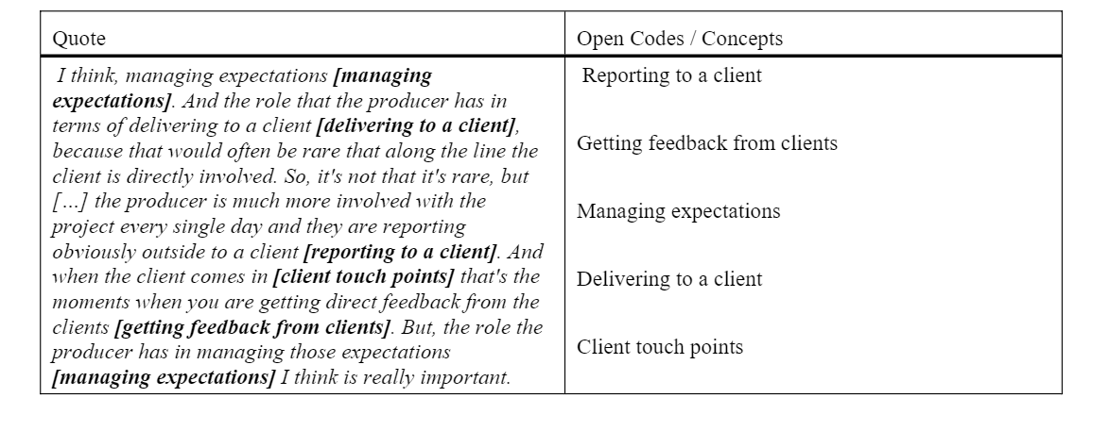
Source: Seidel, S. and Recker, J.C., (2009).

- Developing categories
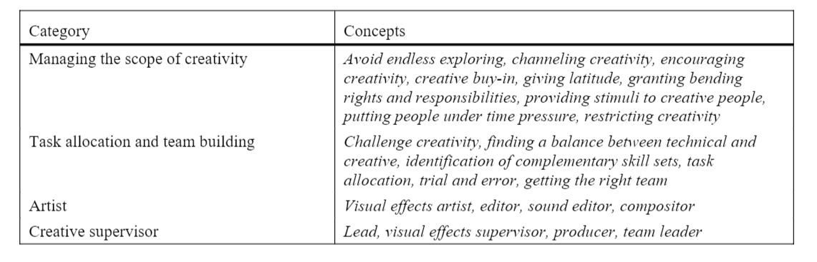
Source: Seidel, S. and Recker, J.C., (2009).

- Steps of conducting Narrative research
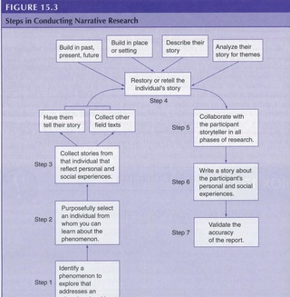
Source: http://edrm600narrativedesign.weebly.com/steps.html

- Conceptual framework for researching the impact of power on sustainability diffusion in supply networks
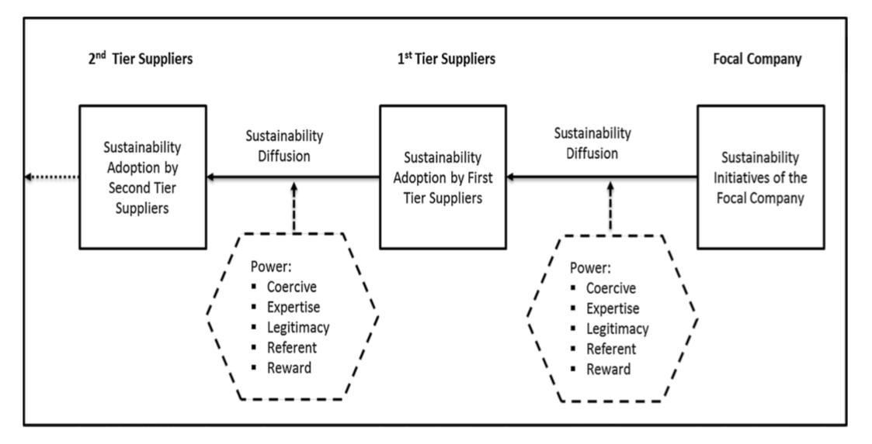
Source: (Meqdadi, Johnsen and Johnsen, 2018)
5.
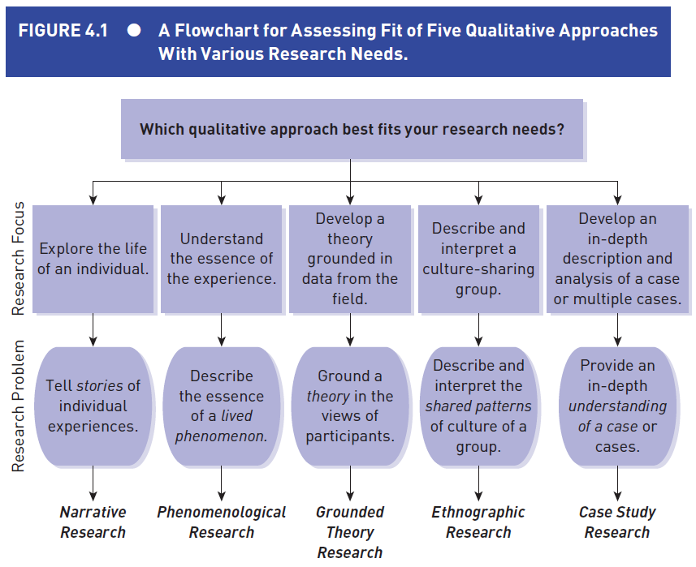
Source: Creswell (2018).

6. Narrative research procedures
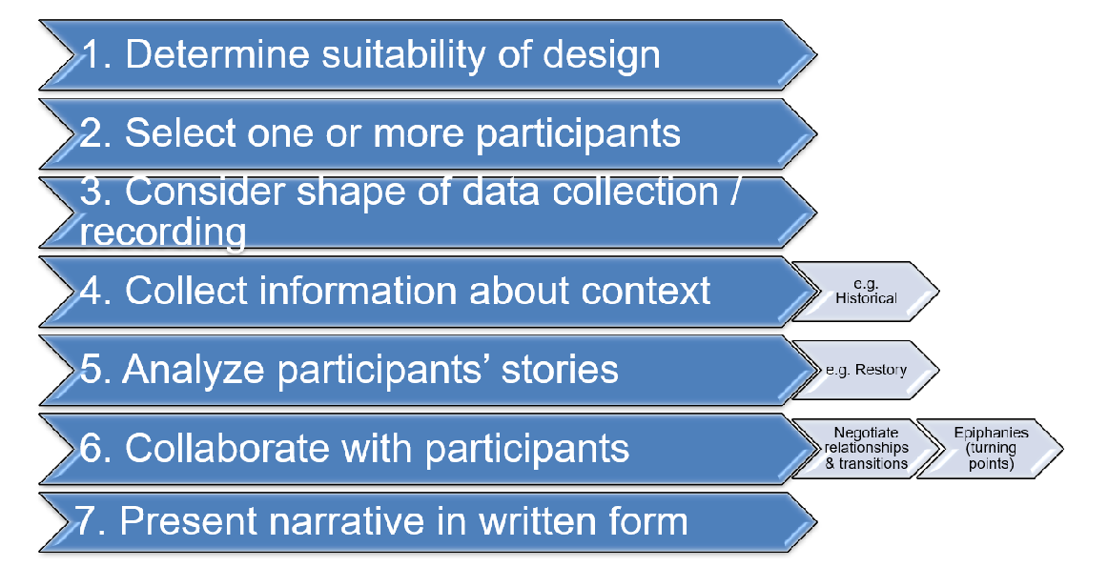
Source: Creswell (2018).

Appendix 4

During the class, we were put into groups and had to do some class activities. Those activities included presentation as well. Those activities improved my presentation skills. Also, during class, we were provided with some materials as well which we had to read and talk about. So, that improved my reading skills. One of the assessments in this module was to create video blogs. Most of us were not very familiar with video blogging but this module taught us how to do video blogging. This will help me in the long run. Apart from the class activities, I have investigated a lot of journals which improved my knowledge about the subject. I tried to relate my research area with qualitative approaches and now I have a better idea about which approach to use during my research and how to use it. This module helped me to grow as a better novice researcher.

