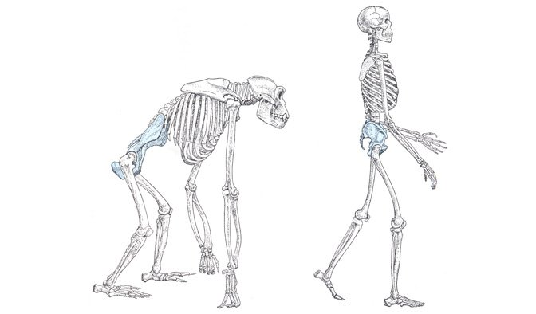
Image 1: Bipedalism (Kissel, 2020).

HPAN6006 - Human Evolution: The Origins of Modern Human Behavior.
Design and Influences during the Evolution of the Feet
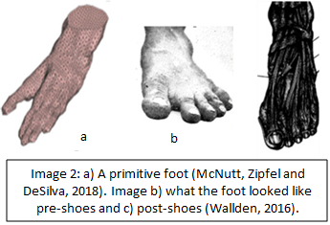
c
January 17, 2024
Julia Jones – 2007994
UWTSD

Images:
Image 1: Bipedalism (Kissel, 2020).
Image 2a: A primitive foot (McNutt, Zipfel, and DeSilva, 2018). Image 2b: what the foot looked like pre-shoes (Wallden, 2016). Image 2c: post-shoes (Wallden, 2016).
Image 3: Chimpanzee (Pan troglodytes) and Human (Homo sapien) differences in the foot (Holowka and Lieberman, 2018).
Images 4a, b and c: Changes in the foot (Holowka and Lieberman, 2018, Fig. 8).
Image 5: “Phylogenetic relationships and temporal distributions of plesiadapiforms” and Euprimates (Gunnell and Silcox, 2010, p. 276).
Image 6: Comparison of primate feet (Jones, 1920).
Image 7: Climate, Species, and milestones in human evolution timeline (The Smithsonian National Museum of National History, 2024c).
Image 8: Fossilised footprint from Engare sero, Tanzania (Pobiner, 2020).
Image 9: “Prehistoric human footprints” (Pobiner, 2020).
Image 10: Fossil footprints: the fascinating story behind the longest known prehistoric journey (Bennett and Reynolds, 2020a).
Image 11: Depth of fossilised footprints and colour chart, with blue for the deepest parts (Bennett and Reynolds, 2020b).

Design and Influences during the evolution of the Feet: Quadrupedal to Bipedal
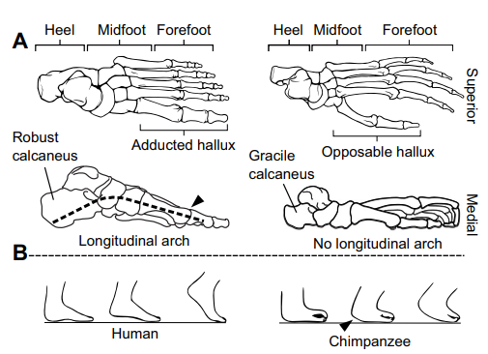
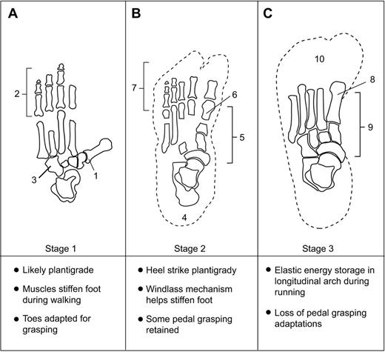
Locomotion and bipedalism have changed the way our feet have developed over the last several million years (Images 1 - 4, 6, 8, 10 and 11), alongside many ecological, genetic, and behavioural influences. Professor Hylton Menz, a podiatry specialist, states that ‘the function of the foot depends on the person attached to it, the pressure distribution under the foot is reliant on the gait pattern due to a connecting blood supply, the amount of pain experienced is dependent on the individual's pain threshold’ and that much confusion has been caused when recording data of feet as a separate or single unit, leading to duplications of statistics and differences in the left and right foot not being interpreted correctly or at all (Harcourt-Smith and Aiello, 2004; La Trobe University, 2024; Menz, 2004).
Image 3: Chimpanzee (Pan troglodytes) and Human (Homo sapien) differences in the foot (Holowka and Lieberman, 2018).
Image 4: Changes in the foot (Holowka and Lieberman, 2018, Fig. 8).
A
B

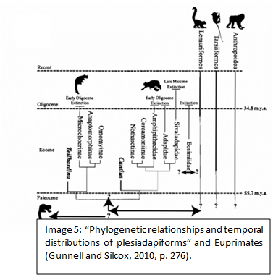
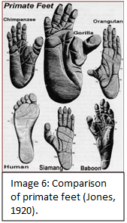
The majority of modern homo sapiens (humans) (Image 7:2u) have “ten toes, fifty-two bones, and sixty-six muscles in their feet,” making up a quarter of the bones in the body (Rinzler, 2013). Research shows that the muscles in the feet help push against the ground whilst walking or running, producing forward propulsion from one step to the next (Anderson, 2019). Early twentieth-century scientists such as William Gregory, Sir Arthur Keith, Dudley Morton, and Adolph Schultz theorised we started as quadrupedal ape-like primates that lived in the trees, evolving over approximately six million years. (Gregory, 1928; Keith, 1928; Morton, 1924; Rinzler, 2013; Schultz, 1930; The Smithsonian Institution,2024b). Although different to other mammals, primates all belong to the same family. Gibbons, sometimes known as lesser apes, are nearer to man than the lowest of the primates and chimpanzees are even closer relatives (Pontzer and Wrangham, 2004; Shook, et. al., 2019). Physical changes in appearance between some species became apparent as monkeys retained their tails and apes lost theirs, however, both species have arboreal feet and limb bones, meaning they are better suited to trees. Transforming from “a small group of primitive haplorrhine primates, into animals that resembled modern anthropoids,” a group of mammals from the “Cenozoic” period (Image 5) (Beard, 2013). Primitive anthropoids such as the fossil primate taxa Eosimiidae from Asia, were small and ate fruit and insects, whereas the larger and slower Amphipithecidae may have eaten nuts and seeds. Both were arboreal quadrupeds from the Eocene part of the Cenozoic period (Gunnell and Silcox, 2010, p. 284; Hladik, and Charles-Dominique, 1974.; Suwa, et. al., 2007; Wild Chimpanzee Foundation, 2024). Chimpanzees and gorilla feet have a hand-like appearance and are fundamentally different to those of humans (Image 6). The hind foot of the oldest known primates had an enlarged big toe set off from the other four toes, and in humans, the big toe is in line with the other toes (Images 3a, 3b, 4a – 4c). The big toe increased in size whilst the other four toes decreased in size. The muscles are the same but have been modified in size, strength, and arrangement, re-purposing the sole to allow for forward thrusting whilst walking or running (Gregory, 1928, p. 361, 364). Millions of years of bipedal hominid function, alongside natural selection and an adapting foot structure (Image 2a -2c), has resulted in a foot that has a robust calcaneus, proximodistal elongated midtarsal region and short phalanges (Image 3: b). The feet of chimpanzees or apes have a divergent hallux, foreshortened midtarsal, long metatarsals, and phalanges (Image 3: a). The human forefoot is in an everted position, whereas the ape lateral forefoot is inverted, putting the lateral digits in opposition to the hallux, which is larger in African apes than in Orangutans (Pongo). ‘Orangutans and humans share a common ancestor that does not include the extant African apes’ (Grehan and Schwartz, 2009) have long arms and short legs, live mostly in trees and are intelligent enough to be able to use a variation of tools, unlike the bonobos (pan paniscus) who show little interest in tool use (Furuichi, et. al., 2015; Fox, Sitompul and Schaik, 1999). Orangutans are a surviving species of the subfamily Ponginae, which have also been known as Asian hominids, diverged from other hominoids such as gorillas, pan troglodytes, pan paniscus, hylobatids (gibbons) and Homo sapiens approximately twelve million years ago (Image 5) (DeSilva, et. al., 2019; Grehan and Schwartz, 2009). Extended lives led to co-evolving in the hominid line due to a dietary shift to larger and better-quality food, the division of labour in food production, and childcare within the group led to the improvement of cognitive and social abilities that impacted the design and function of the feet (Mithen, 2007, p. 276). Bipedalism is an indication of being human, and the foot is a pivotal development of bipedalism (D’Costa, 2018). Adapted over a prolonged evolution from mobile and grasping into propulsive feet designed for bipedal locomotion (DeSilva, et. al., 2019). Biologist Thomas Henry Huxley demonstrated the resemblance between the foot of a gorilla and that of a human (Huxley, 1877) and understanding the differences between the ancestral and contemporary apes can give clues to the changes that were needed for bipedalism, as the diversity in locomotion supports a “mosaic evolution” (D’Costa, 2018; DeSilva, et. al., 2019).
Gorillas, the largest of the living primates, “share 98.3 % DNA (deoxyribonucleic acid) with humans.” They are under serious threat from poachers, disease, and the loss of their habitat alongside our closest primate cousins, pan paniscus (bonobos) and Pan troglodytes (Furuichi, et, al., 2015; Pontzer and Wrangham, 2004; World Wildlife Fund, 2024). In the late Miocene epoch, 10 - 4 million years ago, the fossil record, climate and tropical forests dried up (Blaxland, 2018), raising a lot of debate but less unbiased, evidence-based answers to our origins beginning in Africa as the preservation of footprints and bones may only be due to the conditions of their surrounding environment and many of our extinct hominid ancestors may have lived in warmer and wetter conditions, where fossils are less likely to have survived (Stewart, 1955, p. 1441). The first pre-humans were believed to have walked on two legs (bipedally) rather than on four (quadrupedally) approximately seven million years ago. One of our extinct ancestors Sahelanthropus tchadensis (Image 7:2a) walked upright and lived in forests and grasslands. They were believed to of had a body structure similar to modern chimpanzees (our closest living cousins), climbed trees and walked on the ground with four legs (Blaxland and Dorey, 2020; The Smithsonian Institution, 2024c).
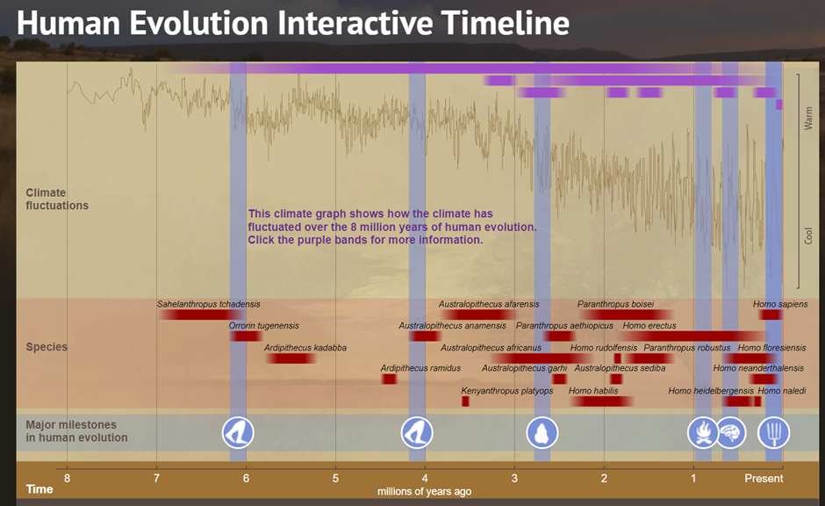
Approximately five million years ago, Australopithecines such as Ardipithecus kadabba (c. 5.8 - 5.2 Mya) (Image 7:2c) were small-brained apes that developed the ability to walk on two legs, however, their gait was quite different to modern Homo sapiens, and they retained the ability to climb trees. A hominin foot bone, (left fourth proximal foot phalanx) belonging to an Ardipithecus ramidus kadabba dated to approximately 5.2 million years old also exhibited a mosaic morphology between early primates and humans (Harcourt-Smith and Aiello, 2004). Discoveries of Australopithecus africanus (little foot) (c. 3.67 – 2.3 Mya) (Image 7:2h) from Sterkfontein in South Africa, were found to have a human-like talus (Image 3b) an opposable hallux better adapted for grasping and a mobile mid-tarsal joint (Image 3a) (Strait, 2010). Early Australopithecus afarensis (hominins such as ‘Lucy’ that lived approximately three and a half million years ago), were ‘recovered in 1974 from Hadar in Ethiopia’. With ape-like features, sturdier arches, a highly mobile big toe, and the ability to grip and adapt for bipedal walking, signifying that they were capable of shorter periods of bipedal locomotion, that needed greater physical energy to accomplish (Johanson and Edey, 1990, p. 24; Jungers, 1982). Homo habilis (c. 2.4 - 1.5 Mya) (Image 7:2k) had a similar body size but different feet, indicating the possibility of varied types of bipedalism arising from different lineages. Early Homo Habilis (Image 7:2k) and Homo ergaster had more aligned big toes, which were less mobile and a higher arch that helped with push-off during walking and running over distances, rather than for grasping tree branches (Cann, Stonekin and Wilson, 1987).
Image 7: Timeline: Climate, Species, and milestones in human evolution (The Smithsonian Institution, 2024c).

3a
3b
3c
3d
3e
3f
1
2
3
2a
2b
2c
2d
2e
2f

2g
2h
2i
2j
2k
2l
2m
2o

2p
2q
2r
2s
2t
2n
1a
1b

2u
Paranthropus robustus bones (c. 1.8 – 1.2 Mya) (Image 7:2p) discovered in Kromdraai, South Africa had an ape-like talus (Image 3a) (Harcourt-Smith and Aiello, 2004). Four million years ago early hominins (all great apes and their ancestors) lived near open areas and dense woods (Blaxland and Dorey 2020). Their bodies were thought to be mainly suited to upright walking and different habitats (The Smithsonian Institution, 2024c). Climate warming would have increased plant life, creating a larger food source for animals to survive and eventually thrive. In the beginning, smaller groups of animals of varied species may have lived side by side with enough food to stay healthy and fit enough to populate the species. Over time, vegetation decreased due to the climate and its events (Image 7:1) such as drought or flooding, alongside at times, the overpopulation of different species creating competition and rivalry between groups, requiring a need to protect themselves and their family, often by escaping, hiding, or fighting. Safety in the trees and coming down when it was safe to scavenge scraps of meat or forage was less possible during the extremely hotter and colder periods and a reduction in trees, food sources, water and other species caused the extinction of many early forms of hominins. Evolving over millions of years to being able to stay on the ground by adapting their diets according to what was available to them at the time and to be able to manipulate materials to make tools, which increased the productivity of the water sources, food, and amenities (Images 7:3d,7:3f) (Almécija, et. al., 2021; Ingold, 2004, p. 318; Potts, 2012; The Smithsonian Institution, 2024c). Just under two million years ago, our ancestor's legs got longer and straighter with a more efficient striding gait, making it easier to walk or run long distances. These changes coincided with changes to the shoulders, chest, and waist, allowing for balance during prolonged running. Whilst the pelvis changed from tall and narrow to short and wide, the lower limbs became more vertical with less distance between the knees and hips, bringing the knees and feet directly under the body’s centre of gravity, allowing the body to balance on one leg whilst taking a step with the other leg (Image 1) (Gruss and Schmitt, 2015). Modifications to the feet and toes developed a stable platform and energy-efficient spring to push off the ground with each step. 299,000 years ago, the ability to control fire enabled fundamental changes in the early human diet, safety, social habits, and sharing of food and information (Image 6:3c) resulting in a bigger brain that helped our ancestors adapt and survive (Image 7:3d) (Leigh, 2004, p. 140).

700, 000 – 200,000 years ago our common fully bipedal ancestor Homo heidelbergensis (Image 7:2r) diverged with a distinct Hominid genetic sequence of DNA, living in areas of China and Africa for over 400, 000 years before becoming extinct (Frazer, et. al, 2003; Harcourt-Smith and Aiello, 2004; The Smithsonian Institution, 2024c). 200,000 years ago, Homo sapiens anatomically evolved a rigid toe that was aligned with the others, a pronounced arch, shorter and wider heels, and mid-feet, improving stability and shock absorption during walking and running. The big toe reduced in size throughout human evolution enhancing bipedalism whilst replacing grasping ability. Human toe bones are short, straight, and non-opposable in comparison to apes who have curved toes and opposable big toes for grasping (Blaxland and Dorey, 2020). This change supports our hunter-gatherer ancestors having a more active, nomadic lifestyle (Jungers, 1982). Neanderthals (c.120,000-35,000 thousand years ago) (Image 7:2s) in comparison to apes were advanced with a bigger body mass and lost heat more slowly. The Male Neanderthals, Amud, and Schul discovered in the Levant had a hyoid bone and chin capable of language, and foot fossils of European Neanderthals had an ape-like foot and divergent hallux (DeSilva, et. al., 2019). Over time maturation in other species got longer, the Neanderthals carried for longer and had a bigger pelvis resulting in babies with larger brains. Neanderthals interbred with modern humans, dying out approximately 45,000 years ago and compared to humans were a lot less advanced (The Smithsonian Institution, 2024a). Evidence of Neanderthal “tracks and trackways” from “Huelva Coast of SW Spain” containing hominid footprints attributed to Neanderthals and “short-range raw materials” for “short-term activities” “such as food procurement and meat processing” (De Carvalho, et. al., 2023) and 12,000 years ago farming transformed the natural landscape (Image 7:3e) (The Smithsonian Institution, 2024c).

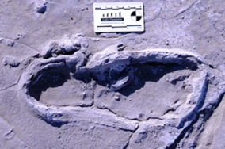
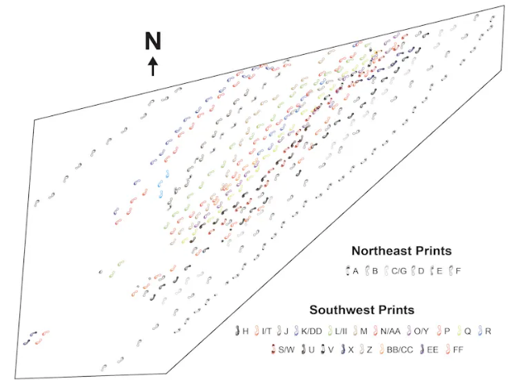
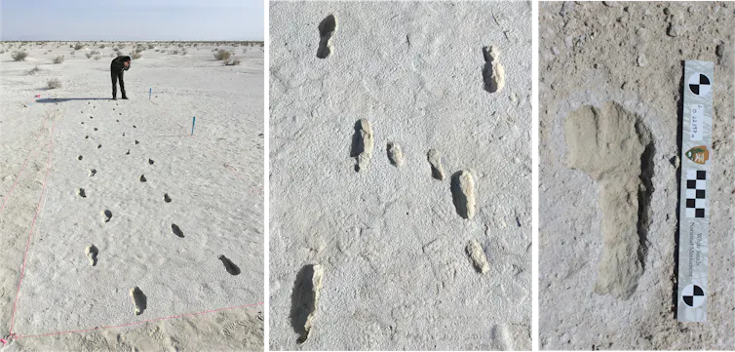
Image 8: Fossilised footprint in volcanic ash from Engare sero, Tanzania (Pobiner, 2020).
Image 9: ‘Prehistoric human trackways from Engare sero, Tanzania’ (Pobiner, 2020).
Image 10: Fossil footprint (Bennett and Reynolds, 2020a).

Hominid Fossil footprints, bones, and the sediments they are in can identify differences between modern humans and our predecessors. Footprint evidence of five separate consecutive bipedal footprints from Laetoli Tanzania dating back approximately 3.66 million years ago was discovered in 1976 by Peter Jones and Philip Leakey and in 1978, trackways were also discovered (Image 9). They compared the footprints against American black bears, chimpanzees, and humans. Due to having a narrow step width, they were interpreted as being from a small cross-stepping bipedal hominid (Masao, et. al., 2016). The taxonomic position and classification of fossil hominins have created much confusion in the order, class, family, and genus of a species. By examining the relevance of those differences in the feet of gorillas, Pan troglodytes, Pongo, and extant great apes, using X-rays or computerised tomography (CT) scans to reconstruct the morphology and movement of the bones and their correlation with the joint movements in primates, a simulation of how early hominins may have walked can be constructed. 3D photogrammetry has also revealed at least two hominid taxa, due to differences in their leg gaits, feet, and the depth of the fossilised impressions they left behind (McNutt et. al., 2021, p. 468). The growing fossil record shows anatomical differences between the extant ape, bear, and human foot bones, with distinct foot forms, and calcaneus differences as bipedal locomotion evolved, resulting in the re-categorisation of some specimens (Nozaki, Amano and Ogihara, 2021). Improved techniques exploring “gene expression differences” of the evolving molecules for genome rearrangements produce a vast variation between humans and other species aiding in the identification of biological, physical, and behavioural differences and making it easier to categorise species, though DNA used for genetic sequencing has only been retrieved from our recent ancestors such as the Neanderthals, and the oldest from an exceptionally well-preserved mammoth dating back approximately one million years old, so far (Frazer, et. al, 2003, p. 344).
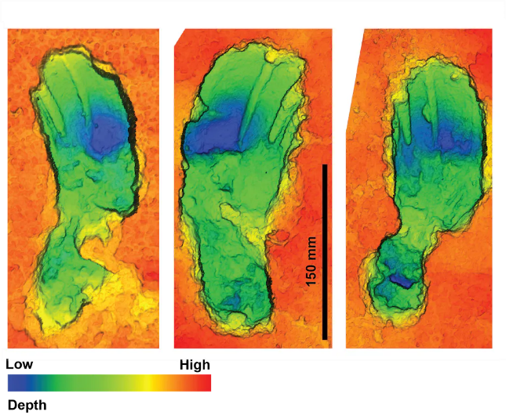
Forensic research has shown that approximately 40,000 years ago humans wrapped their feet in hide and fur. The Romans then wore sandals that were also strapped around the leg or sandal boots. During the Middle Ages (500-1500 years ago) new types of footwear emerged then Goodyear started to make shoes in the fifteenth century, in a range of styles and sizes by the sixteenth century. Nineteenth-century shoes were mass-produced, whereas twentieth-century shoes are now glued rather than stitched (Tripathi, 2021). Natural selection, an evolving foot structure, ill-fitting shoes and an out-of-line gait all affect the spine, leading to back pain. The effects of exercise, restrictions, relevance, and importance of the biological function of the toes that have been studied show that toes are needed for gait efficiency, in creating an adjustable grip, they help the foot stay rigid when taking a step, protect the frontal plane and provide information to the brain through the nervous system. The foot also acts as a shock absorber and functions related to the structure of an ill-fitting shoe, such as fallen arches could cause buckling and stresses that compromise the performance of the feet. Curved foot bones create arched feet with straighter foot bones causing flat feet (Wallden, 2016). Specifically designed sports shoes for athletes were also useful for stability, preventing backache and mutilation from a natural foot shape (Image 2: b) to a deformed or deconditioned, shoe-shaped foot (Image 2: c) and are now popular all over the world (Tripathi, 2021). Ideally, shoes should be non-restrictive whilst encouraging activation of the muscles. In the future, they may even have sensors on them that detect wear and tear, as well as functional imbalances. Barefoot conditioning increases the strength in the muscles lost from wearing shoes and reduces the risk of further injury, however, it comes with its own set of risks. Research would need to be split into two categories of pre-shoes and post-shoes to demonstrate the influence of how shoes have changed how we walk (Wallden, 2016). Research was conducted on the relationship between the foot, and leg characteristics by measuring their dimensions and angles to analyse the comfort experiences of different shoes whilst standing, walking and running, the shoe hardness flexibility and stiffness were taken into consideration resulting in the discovery that the fit of the shoe is not sufficient on its own for comfort and that skeletal alignment, shoe stiffness, and cushioning are all variables important for comfort (Miller et. al., 2000).
Image 11: Depth of fossilised footprints and colour chart, with blue for the deepest parts (Bennett, and Reynolds, 2020b).

Human behaviour is influenced by need, supply, and demand. Our ancestors developed the ability to adapt to most environments and habitats through bipedal migration and dispersal, sexual diversion of labour, new food groups, and food specialisation that increased brain size, all played a part in the evolution of the feet. As new fossil species, footprints and genetic evidence are discovered and the research analysed, improved knowledge and technology are helping to identify the different types of characteristics and traits used to re-evaluate taxa classifications to gain a better understanding of the rise, fall, and paths taken in between, how they were taken and why, to gain a complete or at least a more precise evolutionary species timeline than the variable one we have at present, as well as aiding with corrections to the foot caused by environmental, behavioural and physical damage.

Reference List:
Almécija, S., Hammond, A.S., Thompson, N.E., Pugh, K.D., Moyà-Solà, S. and Alba, D.M., 2021. Fossil apes and human evolution. Science, 372 (6542) 4363.
Anderson, K., (Editor), 2019. “New understanding in the evolution of human feet.” News Medical.net. [Online] Available At: https://www.newsmedical.net/news/20190114/Newunderstanding-in-the-evolution-of-human-feet.aspx (23).
Beard, C.K., 2013. Anthropoid origins. A companion to palaeoanthropology, 358-375.
Bennett, M.R., and Reynolds, S.C., 2020. “Fossil footprints: the fascinating story behind the longest known prehistoric journey.” The Conversation, 2024. [Online] Available At: https://theconversation.com/fossil-footprints-the-fascinating-story-behind-the-longest-known prehistoric-journey-147520 (Accessed 10-01-2023).
Blaxland, B., 2018. Hominid and hominin – what’s the difference? Australian Museum, 2023. [Online] Available At: file:///C:/Users/Student/Desktop/HPAN6008%20Human%20Evolution/Hominid%20and%20hominin%20%E2%80%93%20what%E2%80%99s%20the%20difference_%20%20The%20Australian%20Museum.html (Accessed 13-12-2023).
Blaxland, B., and Dorey, F., 2020. “Walking on two legs – bipedalism” The Australian Museum. [Online] Available At: https://australian.museum/learn/science/human-evolution/walking-on-two-legs-bipedalism/ (Accessed 16-12-2023).
Cann, R.L., Stoneking, M., and Wilson, A.C., 1987. Mitochondrial DNA and human evolution. Nature, 325 (6099) 31-36.
D’Costa, K., 2018. What Makes the Human Foot Unique? - Scientific American Blog Network. Photo Min An. Pexels. [Online] Available At: https://blogs.scientificamerican.com/anthropology-inpractice/what-makes-the-human-foot-unique/ (Accessed 01-12-2023).
De Carvalho, C.N., Muñiz, F., Cáceres, L.M., Rodríguez-Vidal, J., Medialdea, A., del Val, M., Cunha, P.P., García, J.M., Giles-Guzmán, F., Carrión, J.S. and Belaústegui, Z., 2023. Neanderthal footprints in the “Matalascañas trampled surface” (SW Spain): new OSL dating and Mousterian lithic industry. Quaternary Science Reviews, 313 108200.
DeSilva, J., McNutt, E., Benoit, J. and Zipfel, B., 2019. One small step: A review of Plio‐Pleistocene hominin foot evolution. American Journal of Physical Anthropology,168 63-140.
Fox, E.A., Sitompul, A.F. and Van Schaik, C.P., 1999. Intelligent tool use in wild Sumatran orangutans. The mentality of gorillas and orangutans, 480 99-116.
Frazer, K.A., Chen, X., Hinds, D.A., Pant, P.K., Patil, N., and Cox, D.R., 2003. Genomic DNA insertions and deletions occur frequently between humans and nonhuman primates. Genome Research, 13 (3) 341-346.
Furuichi, T., Sanz, C., Koops, K., Sakamaki, T., Ryu, H., Tokuyama, N. and Morgan, D., 2015. Why do wild bonobos not use tools like chimpanzees do? In Bonobo cognition and behaviour. Leiden: Brill. 179-214.
Gregory W.K., 1928. The upright posture of man: Review of its origin and evolution. Proc. Am. Philosophy Society 67 339–376.
Grehan, J.R., and Schwartz, J.H., 2009. Evolution of the second orangutan: phylogeny and biogeography of hominid origins. Journal of Biogeography, 36 (10) 1823-1844.
Gruss, L.T., and Schmitt D., 2015. “The evolution of the human pelvis: changing adaptations to bipedalism, obstetrics, and thermoregulation.” Philosophical Transactions of the Royal Society of Biological Sciences. Royal Society Publishing.org. [Online] Available At: https://royalsocietypublishing.org/doi/10.1098/rstb.2014.0063 (Accessed 04-11-2023).
Gunnell, G.F. and Silcox, M.T., 2010. Primate origins: the early Cenozoic fossil record. A companion to biological anthropology, 275-294.
Hladik, C.M. and Charles-Dominique, P., 1974. “The behaviour and ecology of the sportive lemur (Lepilemur mustelinus) in relation to its dietary peculiarities.”
Ingold, T., 2004. Culture on the ground: The world perceived through the feet. Journal of Material Culture, 9 (3) 315-340.
Pobiner, B., 2020. “Prehistoric human footprints reveal a rare snapshot of ancient human group behaviour: William E. Harcourt-Smith.” The Conversation, 2024. [Online] Available At: https://theconversation.com/prehistoric-human-footprints-reveal-a-rare-snapshot-of-ancient-human-group-behavior-138502 (Accessed 23-11-2023).
Potts, R., 2012. Environmental and behavioural evidence pertaining to the evolution of early Homo. Current Anthropology, 53 (S6) S299-S317.
Harcourt‐Smith, W.E., and Aiello, L. C., 2004. Fossils, feet, and the evolution of human bipedal locomotion. Journal of Anatomy, 204 (5) 403-416.
Holowka B. and D.E., Lieberman, 2018. “Rethinking the evolution of the human foot: insights from experimental research.” [Online] Available At: https://journals.biologists.com/jeb/article/221/17/jeb174425/19587/Rethinking-the-evolution-of-the-human-foot (Accessed 28-11-2023).
Huxley, T.H., 1877. Evidence as to Man's Place in Nature. D. Appleton and Company.
Jones, F.W., 1920. The principles of anatomy as seen in the hand. London: Churchill. In Testbook. [Online] Available at: https://testbook.com/biology/how-are-primates-differ-from-other-mammals (Accessed: 15-01-24).
Johanson, D. and Edey, M., 1990. Lucy: The beginnings of humankind. Simon and Schuster.
Jungers, W., 1982. “Lucy's limbs: skeletal allometry and locomotion in Australopithecus afarensis.” Nature 297, 676–678. [Online] Available At: https://doi.org/10.1038/297676a0 (Accessed 11-12-2023).
Keith, A., 1928. The history of the human foot and its bearing on orthopaedic practice. J. Bone Joint Surg. 11 10–32.
Kissel, M., 2020. “Human Evolution: Bipedalism.” Human blogspot.com. [Online] Available At: https://humanevoblog.blogspot.com/2020/06/bipedalism.html (Accessed 30-11-2023).
La Trobe University, 2024. “Hylton Menz Profile.” [Online] Available At: https://scholars.latrobe.edu.au/hmenz (Accessed 06-12-2023).
Leigh, S.R., 2004. Brain growth, life history, and cognition in primate and human evolution. American Journal of Primatology: Official Journal of the American Society of Primatologists, 62 (3) 139-164.
Masao, F.T., Ichumbaki, E.B., Cherin, M., Barili, A., Boschian, G., Iurino, D.A., Menconero, S., Moggi-Cecchi, J. and Manzi, G., 2016. New footprints from Laetoli (Tanzania) provide evidence for marked body size variation in early hominins. Elife, 5, e19568.
McNutt, E.J., Hatala, K.G., Miller, C., Adams, J., Casana, J., Deane, A.S., Dominy, N.J., Fabian, K., Fannin, L.D., Gaughan, S. and Gill, S.V., 2021. Footprint evidence of early hominin locomotor diversity at Laetoli, Tanzania. Nature, 600 (7889) 468-471.
McNutt, E.J., Zipfel, B., and DeSilva, J.M., 2018. The evolution of the human foot. Evolutionary Anthropology: Issues, News, and Reviews, 27 (5) 197-217.
Menz, H.B., 2004. “Two feet, or one person?” Problems associated with statistical analysis of paired data in foot and ankle medicine, 14 (1) 2-5.
Miller, J.E., Nigg, B.M., Liu, W., Stefanyshyn, D.J. and Nurse, M.A., 2000. Influence of foot, leg, and shoe characteristics on subjective comfort. Foot & Ankle International, 21 (9) 759-767.
Mithen, S.J., 2007. Key changes in the evolution of human psychology. The evolution of mind: Fundamental questions and controversies, 256-268.
Morton D.J., 1924. Evolution of the human foot II. American Journal of Physical Anthropology, 7, 1–52.
Nozaki, S., Amano, H., Oishi, M. and Ogihara, N., 2021. Morphological differences in the calcaneus among extant great apes investigated by three-dimensional geometric morphometrics. Scientific Reports, 11 (1) 20889.
Pontzer, H., and Wrangham, R.W., 2004. Climbing and the daily energy cost of locomotion in wild chimpanzees: implications for hominoid locomotor evolution. Journal of Human Evolution, 46 (3) 315-333.
Rinzler, C.A., 2013. Leonardo's Foot: How 10 Toes, 52 Bones, and 66 Muscles Shaped the Human World. New York: Bellevue Literary Press.
Robbins, S.E. and Hanna, A.M., 1987. Running-related injury prevention through barefoot adaptations. Med Sci Sports Exercise, 19 (2) 48-156.
Schultz A.H., 1930. The skeleton of the trunk and limbs of higher primates. Human Biology. 2303 - 438.
Shook, B., Nelson, K., Aguilera, K. and Braff, L., 2019. Meet the Living Primates. Explorations.
Stewart, T.D., 1955. Review of The Fossil Evidence for Human Evolution: An Introduction to the Study of Palaeoanthropology, by W. E. Le Gros Clark. American Anthropologist, 57 (6) 1341–1342.
Strait, D.S., 2010. The evolutionary history of the Australopiths. Evolution: Education and Outreach, 3 (3) 341-352.
Suwa, G., Kono, R.T., Katoh, S., Asfaw, B. and Beyene, Y., 2007. A new species of great ape from the late Miocene epoch in Ethiopia. Nature, 448 (7156) 921-924.
The Smithsonian Institution, 2024a. “Ancient DNA and Neanderthals”, Human Origins Program. [Online] Available At: https://humanorigins.si.edu/evidence/genetics/ancient-dna-and-neanderthals (Accessed 06-01-2023).
The Smithsonian Institution, 2024b. “Introduction to Human Evolution”, Human Origins Program. [Online] Available At: https://humanorigins.si.edu/education/introduction-human-evolution (Accessed 04-01-2024).
The Smithsonian Institution, 2024c. “Human Evolution interactive timeline”, The Human Origins Program. [Online] Available At: https://humanorigins.si.edu/evidence/human-evolution-interactive-timeline (Accessed 04-01-2023).
Tam, N., Wilson, J.L.A., Noakes, T.D. and Tucker, R., 2013. Barefoot running: an evaluation of current hypothesis, future research, and clinical applications. British journal of sports medicine.
Tripathi, R., 2021. “How Shoes Have Evolved Over Time.” The Shoe Museum. [Online] Available At: https://www.the-shoe-museum.org/how-shoes-have-evolved-over-time (Accessed 06-01-2024).
Wallden, M., 2016. Toe-tal recall–What on Earth are our toes actually for? Journal of Bodywork and Movement Therapies, 20 (2) 418-431.
Wild Chimpanzee Foundation, 2024. “What do Chimpanzees eat?” [Online] Available At: https://www.wildchimps.org/about-chimpanzees/what-they-eat.html (Accessed 03-01-2024).
World Wildlife Fund, 2024. “Bonobo. Facts. Why they matter.” [Online] Available At: https://www.worldwildlife.org/species/bonobo (Accessed 03-01-2024).
Zihlman, A.L., Mootnick, A.R. and Underwood, C.E., 2011. Anatomical contributions to hylobatid taxonomy and adaptation. International journal of primatology, 32 865-877.

