INDIVIDUAL REPORT
Investigating the Role of Communication in the Business Environment
Module | LCBB4009
Assessment | Component 2: Individual Report
Student name | Humaira Mahboob
Student number | 2406922
Selected company | Microsoft Corporation
Word Count | 1583

Contents
1. Introduction 3
2. Communication and Methods 3
2.1. Digital Collaboration Methods 4
2.2. Formal, Leadership and Upward Communication 4
2.3. External Communication and Overall Effectiveness 5
3. Common Issues 6
3.1. Communication Overload and Hybrid Fragmentation 6
3.2. Voice, Escalation and Organisational Legitimacy 7
4. Recommendations 8
5. Conclusion 8
References 10

Introduction
The process of communication is not merely transfer of information within organisations. In business contexts, it aids in the coordination of work, the use of power, the creation of culture, encouragement of learning and retention of legitimacy among internal and external stakeholders (Izak, Case and Ybema, 2024). The case of Microsoft fits well since it is a large, globally spread technology business, in which the performance relies on the coordination of technical, managerial and commercial functions. As of 2025, Microsoft had 228,000 full-time workers and was divided into three key sections, including Productivity and Business Processes, Intelligent Cloud, and More Personal Computing (Microsoft, 2025a). In the report, the definition of business communication is presented, the key communication tools at Microsoft assessed, the potential problems and recommendations offered. This renders the quality of communication a strategic problem as opposed to an administrative narrow issue in a fast-moving high-risk business environment.

Communication and Methods
Business communication encompasses formal and informal contact that assists organisations in the coordination of activities, problem solving and relationship preservation of the stakeholders (Hartley, Marriott and Knapton, 2023). According to the latest studies, communication is not only supportive but is constitutive of organising, as the roles, priorities and routines are reproduced through interaction, documentation and interpretation (Izak, Case and Ybema, 2024).
This is apparent in Microsoft. According to its 2025 Annual Report, the strategic objectives of the three segments of the company are consistent in terms of development, sales, marketing, and service operations (Microsoft, 2025a). Communication thus flows downwards through leaders, upwards through employees, cross-functional and outwards to other stakeholders. Since Microsoft sells and uses such tools like Teams, Exchange and SharePoint, communication becomes not only an internal provision but also a probation of corporate image.
Table 1: Microsoft’s principal communication methods and their strategic significance
Method | Microsoft example | Strategic value | Critical risk
Leadership communication | Annual report, executive blogs, town halls and cascades | Aligns priorities and interprets change | Can become symbolic
Digital collaboration | Teams chat, meetings and shared files | Supports cross-functional coordination | Creates overload
Formal written communication | Policies, logs, repositories and customer documentation | Builds accountability and continuity | Can become bureaucratic
Upward voice and listening | Surveys, ERGs and feedback systems | Surfaces risk, inclusion issues and ideas | Loses credibility if ignored
External transparency | Security blogs and responsible AI reporting | Strengthens legitimacy | Invites scrutiny if weak

Digital Collaboration Methods
To minimize the geographic barriers and facilitate cross-functional coordination, Microsoft uses extensively digital collaboration tools, including Teams meetings, chat, shared documents and asynchronous workspaces. Though, studies indicate that digital channels can succeed only in case they are backed by policy, leadership, culture, collaboration and trust (Wuersch, Neher and Peter, 2023). This implies that the Microsoft systems are not just valuable because of speed, but because of the disciplined application as well. Workers should understand how often they should see each other, when making decisions should be recorded, who should be and how to escalate disagreements (Wuersch et al., 2024).

Formal, Leadership and Upward Communication
Written formal communication is still necessary since email, policy books, knowledge repositories and decision records offer continuity, responsibility and auditory history, particularly in legal, security and customer-facing situations. Priority in an organisation is also determined by leadership communication. The interpretation of change is facilitated by annual reports, executive blogs, town halls and manager cascades to understand change by employees and external stakeholders. According to the 2025 Annual Report, security, quality, and AI innovation are the primary priorities outlined by Microsoft, and communication is another strategy that enables strategic alignment (Microsoft, 2025a). Top-down communication is also important. According to the listening systems of Microsoft, the employee resource groups and the D&I reporting, the employee voice is managed as a strategic resource (Microsoft, 2024).

External Communication and Overall Effectiveness
Outside, Microsoft relies on communication to clarify governance, commitment and risk management to customers by public reporting, such as responsible AI disclosures (CIPD, 2024a). Inclusion and transparency can enhance trust and legitimacy, but it would only depend on listening and transparency to result in visible organisation activity and not symbolic communication (Place, 2023). In general, the communication methods employed by Microsoft are numerous, although they need to be combined disciplinarily. The ambiguity of the rich media, accountability of documentation, and legitimacy of listening are required.
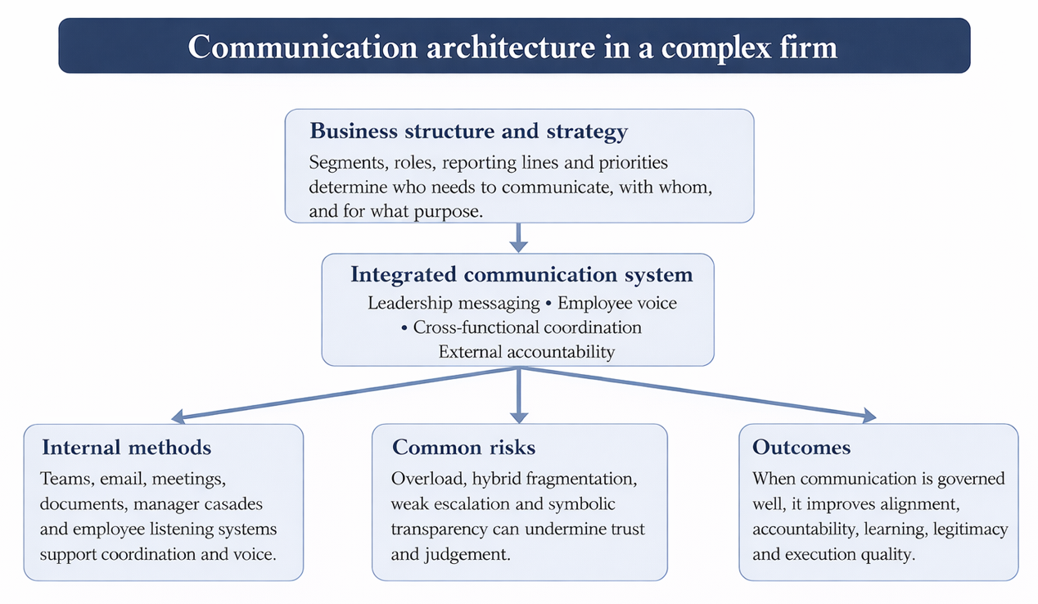
Figure 1: Communication architecture required in a complex firm such as Microsoft based on Microsoft (2025a, 2025b, 2025c, 2025d), CIPD (2024a, 2024b) and Wuersch et al. (2024)

Common Issues

Communication Overload and Hybrid Fragmentation
The communication issues that Microsoft faces are not due to the lack of channels as much as it is due to the fact that maintaining the level of judgement and trust at the scale is hard. The first issue is overload. According to 2025 WorkLab data provided by Microsoft, the average employee gets 117 emails, 153 Teams messages every workday, and 57 percent of the meetings are impromptu, approximately 30 percent are cross-time zone, and over 50 messages are sent outside regular business hours (Microsoft, 2025b). The threat is that the quality of communication may mix with the volume of communication. Studies associate digital overload, post-hours pressure, and work with technology-related supplements with stress and burnout, poor occupational dissociation, and turnover intentions (Belkin, Becker and Conroy, 2020). This becomes a puzzle to Microsoft, the same technologies that have enabled distributed collaboration can also normalise permanent availability and undermine thoughtful; this is its paradox (Marsh, Perez Vallejos and Spence, 2024).
The second problem is hybrid fragmentation. Hybrid work can enhance flexibility, as well as inclusion and attraction, but also renders coordination more complex in a situation where the communication practices vary between teams and places (CIPD, 2024b). According to Handke et al. (2024), hybrid teamwork may weaken shared mental models and enable trust and feedback to be more difficult to maintain. Equally, Wu et al. (2023) observed that the incompatibility of perception towards communications technologies may harm the relationship in seeking advice. The actual problem then lies not in channels accessibility, but in congruence of meaning geographies to geographies, functions and professional subcultures.

Voice, Escalation and Organisational Legitimacy
The third issue is that of employee voice and escalation. According to CIPD (2024a), voice facilitates trust, innovation and improvement, whereas Nyfoudi, Kwon and Wilkinson (2024) demonstrate that voice is particularly necessary at the time of crisis as employees should have a chance to identify weak signals at the early stages. Investment in listening systems and inclusion initiatives are present in the public materials published by Microsoft, but even the large organisation encounters the issue of listening asymmetry, where any uncomfortable message is watered down on its way to the top (Microsoft, 2024).
The most evident one is the 2023 Exchange Online intrusion. Cyber Safety Review Board results in the conclusion that the incident was associated with preventable failures and had to be reformed significantly (Cyber Safety Review Board, 2024). In the subsequent reaction by Microsoft, such as the Secure Future Initiative and a larger volume of public reporting, communication has been employed to address and handle repair and responsibility (Microsoft, 2025d). Nevertheless, the case also demonstrates the fact that robust post-crisis messaging is not enough to counterbalance weak pre-crisis escalation, inter-team transparency or cultural accountability (Microsoft, 2025a).

Recommendations
Microsoft ought to react through more definite communication structure as opposed to channel profusion. To start with, it must present a communication governance matrix that connects issue type, default channel, owner of the decision, response time and documentation requirement. This would decrease the ad hoc meeting creep and enhance better understanding of where decisions are in reality. Second, Microsoft needs to better the practice of organisational listening by quantifying closure, rather than participation: managers are expected to demonstrate what has changed following surveys, ERG feedback, security issues or responsible AI actions. Third, middle managers are to be trained and assessed as communication translators and hybrids as facilitators. Based on the digital capability research, this training is to include brief writing, asynchronous teamwork, cross-cultural interaction, meeting format and escalation discipline (Wuersch et al., 2024). Fourth, Microsoft ought to combine communication with observable measures, like after-hours messaging, decision turnaround time and age of unresolved escalation, to make the overload and silence risks just background noise instead of overload and silence. Lastly, Microsoft can address the issue of overload by directly investing into the concept of protected focus time, stronger after-hours guidelines, smaller default meetings and decision logs which decrease redundancy in clarification. Communication should not be the goal but rather more considered, accountable and trusted communication.

Conclusion
This report has revealed that communication in Microsoft is not a supportive activity but a kind of organizational infrastructure. It facilitates cross segment and functional coordination, inclusion and employee voice, and the development of customer, regulator and investor trust. The company is strong in Microsoft digital platforms, formalization, listening, and increasing transparency in solutions like security and responsible AI. Nevertheless, the risks equally persist and negate these strengths: overload, hybrid fragmentation, weak escalation of uncomfortable issues and the likelihood that transparency turns out to be symbolic and not substantive. The overall lesson is thus crucial. Adding channels does not yield the effective communication that is required in a complex business environment. It occurs when structure, accountability, listening and practice are in line with managerial practice. In the case of Microsoft, the quality of communication cannot be separated with the performance of operations, organizational learning and corporate legitimacy. That is what communication in modern business setting should be evaluated in accordance to in practice.

References
Belkin, L. Y., Becker, W. J., & Conroy, S. A. (2020). The invisible leash: The impact of organizational expectations for email monitoring after-hours on employee resources, well-being, and turnover intentions. Group & Organization Management, 45(5), 709-740.
Cyber Safety Review Board (2024) Review of the Summer 2023 Microsoft Exchange Online Intrusion. Washington, DC: CISA. Available at: https://www.cisa.gov/sites/default/files/2025-03/CSRBReviewOfTheSummer2023MEOIntrusion508.pdf
CIPD (2024a) Employee voice. Factsheet. Available at: https://www.cipd.org/en/knowledge/factsheets/voice-factsheet/
CIPD (2024b) Hybrid working: Guidance for people professionals. Available at: https://www.cipd.org/en/knowledge/guides/planning-hybrid-working/
Handke, L., Aldana, A., Costa, P. L., & O’Neill, T. A. (2024). Hybrid teamwork: What we know and where we can go from here. Small Group Research, 55(5), 805-835.
Hartley, P., Marriott, S., & Knapton, H. (2023). Professional and business communication: Personal strategies for the post-digital world. Routledge.
Izak, M., Case, P. and Ybema, S. (2024) ‘Communication in organizations: An overview and provocations’, International Journal of Management Reviews, 26(4), pp. 628–648. https://doi.org/10.1111/ijmr.12374
Kühner, C., Rudolph, C.W., Derks, D., Posch, M. and Zacher, H. (2023) ‘Technology-assisted supplemental work: A meta-analysis’, Journal of Vocational Behavior, 142, 103861. https://doi.org/10.1016/j.jvb.2023.103861
Maor, D. and Honigmann, D. (2024) Unlocking organizational communication: Five ways to ignite employee engagement. McKinsey & Company, 11 June. Available at: https://www.mckinsey.com/locations/mckinsey-client-capabilities-network/our-work/strategic-and-change-communications/the-communications-exchange/unlocking-organizational-communication-five-ways-to-ignite-employee-engagement
Marsh, E., Perez Vallejos, E. and Spence, A. (2024) ‘Overloaded by information or worried about missing out on it: A quantitative study of stress, burnout, and mental health implications in the digital workplace’, SAGE Open, 14(3). https://doi.org/10.1177/21582440241268830
Microsoft (2024) 2024 Global Diversity & Inclusion Report. Available at: https://www.microsoft.com/en-us/diversity/inside-microsoft/annual-report
Microsoft (2025a) Microsoft Annual Report 2025. Available at: https://www.microsoft.com/investor/reports/ar25/index.html
Microsoft (2025b) Breaking down the infinite workday. Microsoft WorkLab, 17 June. Available at: https://www.microsoft.com/en-us/worklab/work-trend-index/breaking-down-infinite-workday
Microsoft (2025c) Responsible AI Transparency Report 2025. Available at: https://www.microsoft.com/en-us/corporate-responsibility/responsible-ai-transparency-report/
Microsoft (2025d) Securing our future: April 2025 progress report on Microsoft’s Secure Future Initiative. Microsoft Security Blog, 21 April. Available at: https://www.microsoft.com/en-us/security/blog/2025/04/21/securing-our-future-april-2025-progress-report-on-microsofts-secure-future-initiative/
Nyfoudi, M., Kwon, B. and Wilkinson, A. (2024) ‘Employee voice in times of crisis: A conceptual framework exploring the role of human resource practices and human resource system strength’, Human Resource Management, 63(4), pp. 537–553. https://doi.org/10.1002/hrm.22214
Place, K. R. (Ed.). (2023). Organizational listening for strategic communication: Building theory and practice. Taylor & Francis.
Wu, Y.J., Antone, T., DeChurch, L.A. and Contractor, N.S. (2023) ‘Information sharing in a hybrid workplace: Understanding the role of ease-of-use perceptions of communication technologies in advice-seeking relationship maintenance’, Journal of Computer-Mediated Communication, 28(4), zmad025. https://doi.org/10.1093/jcmc/zmad025
Wuersch, L., Neher, A. and Peter, M.K. (2023) ‘Digital internal communication: An interplay of socio-technical elements’, International Journal of Management Reviews, 25(3), pp. 614–639. https://doi.org/10.1111/ijmr.12323
Wuersch, L., Neher, A., Maley, J.F. and Peter, M.K. (2024) ‘Using a digital internal communication strategy for digital capability development’, International Journal of Strategic Communication, 18(3), pp. 167–188. https://doi.org/10.1080/1553118X.2024.2330405

