Robie House by Frank Lloyd Wright
Abbie Messer
2011661
History and Theory 1
M4X01975

Robie House by Frank Lloyd Wright
The Modern Movement saw the emergence of iconic architectural figures resulting in world renowned pieces of architecture. One esteemed example is Robie House by Frank Lloyd Wright, an influential pioneer of 20th Century architecture.
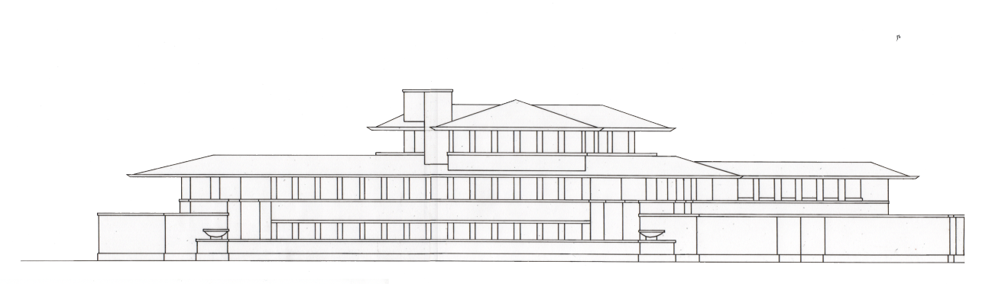
The background of Robie House
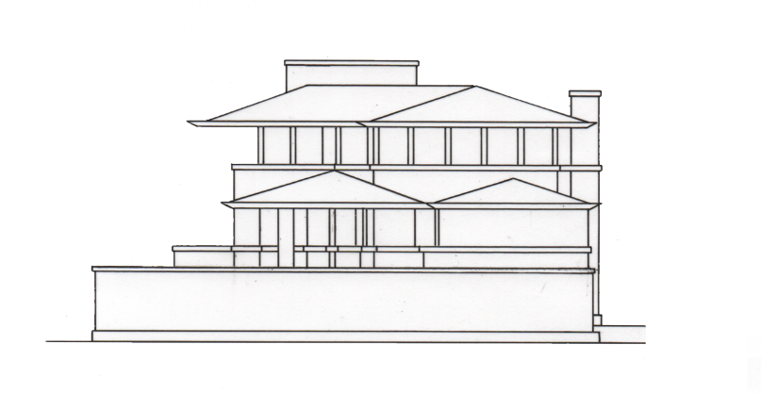
Figure. 1 Elevation of the front of Robie House. (Reference image to create drawing: Historic American Buildings Survey, nd a) (Drawing credit: Abbie Messer, 2021)

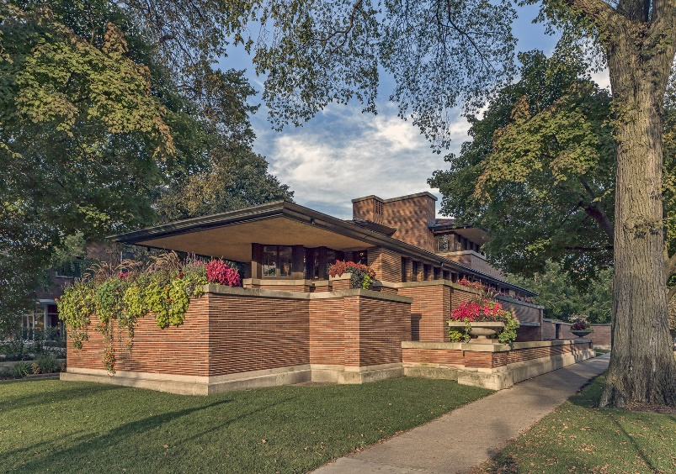
Figure. 2 Elevation of the side of Robie House. (Reference image to create drawing: Historic American Buildings Survey, nd b) (Drawing credit: Abbie Messer. 2021)
Figure. 3 Photograph of the exterior of Robie House (Photography by: James Caulfield, nd a, via Harboe Architects, nd a)
The unique horizontal, layered composition displayed by the 1910 Chicago built Robie House (Gibson, 2017) was highly innovative for the period in which it was built. Its smaller scale and natural aesthetic contrast the high-rise builds in Chicago at the time such as those designed by Wright’s mentor, Louis Sullivan (Stott, 2018). Initially intended for residential use for Frederick C Robie, the house served many purposes throughout its lifetime being a home to three separate residents as well as being a class and office (Gibson, 2017). At present, the building is utilised for tours arranged by the Frank Lloyd Wright Trust (Frank Lloyd Wright Trust, nd). The importance of the building can be seen through external funding such as by The Getty Foundation who granted fifty thousand dollars towards its preservation (The Getty Foundation, 2014, p.5). The building is recognised as a National Historic Landmark as of 1963 (National Park Service, 2018) and as of 2019 it was added to the UNESCO World Heritage List (McGrath, 2019). The house was at risk of demolition in 1957 which resulted in a combined effort from Wright himself and following his passing, the Frank Lloyd Wright Trust, external organisations and the public’s support (Frank Lloyd Wright Foundation, nd a). Therefore these later grants and recognitions received by the house, were highly significant to its maintenance and overall survival following such threat. Though the purpose of the house has changed, the design and original aesthetics have remained through meticulous planning and a great effort from those conserving Wright’s work. This was realised when the house underwent restoration in 2018 under the Trust, carried out by Harboe Architects (Harboe Architects, nd b) whose work aided the preservation of the buildings history.
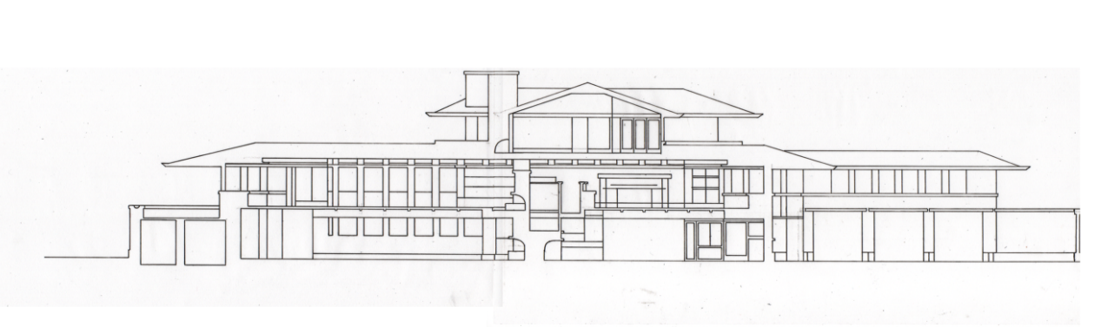
Architectural drawings and analysis
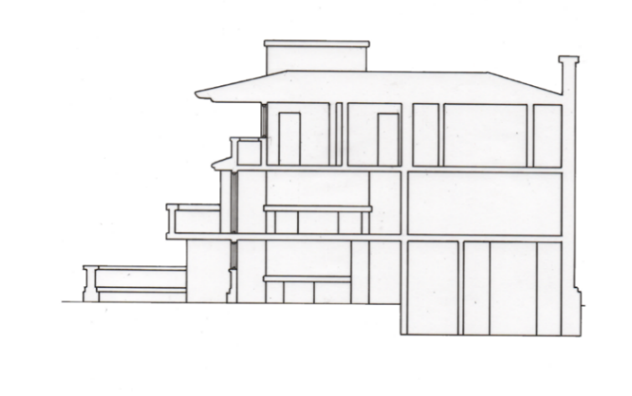
Figure. 4 Section of Robie House from the front. (Reference image to create drawing: Historic American Buildings Survey, nd a) (Drawing credit: Abbie Messer, 2021)
Figure. 5 Section of Robie House from the side. (Reference image to create drawing: Historic American Buildings Survey, nd c ) (Drawing credit: Abbie Messer, 2021)
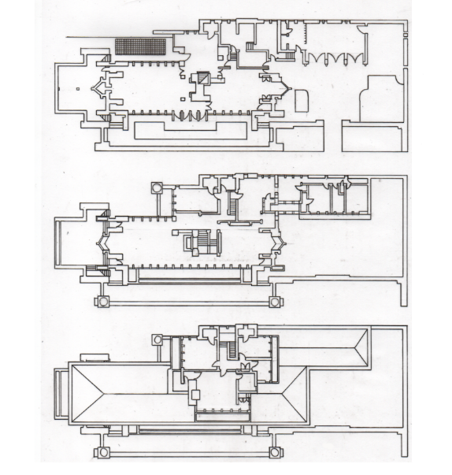
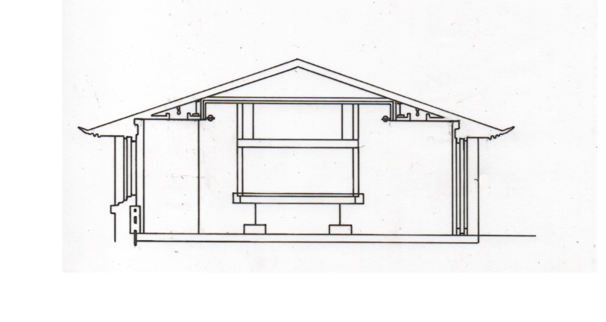
Figure. 6 Section of the living room in Robie House showing the central fireplace in relation to the surrounding space of the room and to the windows. (Reference image to create drawing: Historic American Buildings Survey, nd d) (Drawing credit: Abbie Messer, 2021)

Figure. 7 Robie House plans, top to bottom: Ground floor, first floor, second floor. (Reference images to create drawings top to bottom: GreatBuildings, nd a, GreatBuildings, nd b, GreatBuildings, nd c) (Drawing credit: Abbie Messer, 2021)
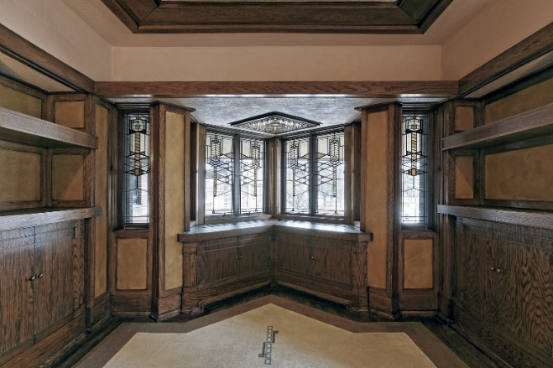
The asymmetry of the plan creates alternating planes contributing to the buildings horizontality. This irregular configuration generated space for a main open section on the ground and first floors with private areas towards the back of the building and on the second floor; it also allowed for multiple entrance points without appearing confusing and disrupting the composition of the external façade. Robie House is comprised of three storeys, the ground floor acts as a relaxation space including a playroom and garage; the garage and driveway are built onto the house, the shifted arrangement of the two main bodies of the building allows this space to be integrated into the design (GreatBuildings, nd a). The first floor houses the main areas of the home including a living area, dining area and kitchen; as well as this there are rooms designated for staff, this dates the house showing the period in which it was built (GreatBuildings, nd b). The second floor contains the main bedrooms (GreatBuildings, nd c). There is a consistency to the plans; the statement fireplace acts as a central point to the ground and first floor allowing for circulation. There are windows regularly distributed along the building’s façade as well as unique windowed triangular areas giving the building an elongated feel with the ends of the rooms coming to a point rather than being boxed off; this draws the eye across the space giving the illusion of distance. Clearly from the plans the use of windows and natural light is evident; suggesting the house to be built later than 1910. Similarly, the open plan of the main living area which allows for circulation as well as effective lighting of the space, is identifiable to modern day residential builds; this further indicates Wright’s pioneering position in architecture that continues to inspire and influence the architects and designers of the 21st century.
Figure. 8 Photograph of a window in Robie House arranged in a triangular formation. (Photography by James Caulfield, nd b, via Harboe Architects, nd c)
Materiality and lighting
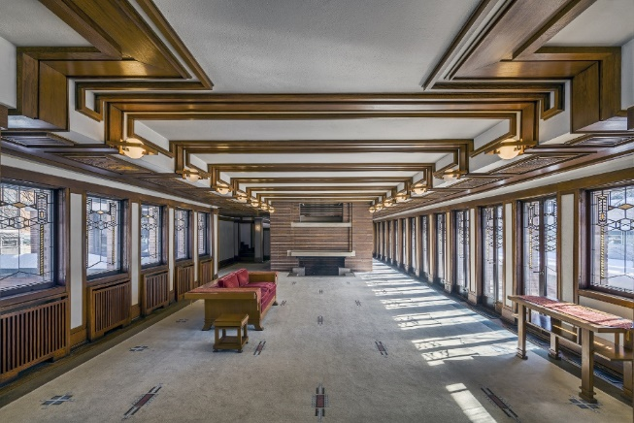
Throughout the interior the materials and finishes are very consistent, it is evident that Wright had a clear vision and was able to translate it into a refined, well thought out design. The materials and corresponding colour palette of earthy creams and browns give the impression of richness. The house is constructed with the use of steel frames, the roofs finished with tile and copper, the finish on the exterior façade is achieved through the use of Roman brick and limestone (Frank Lloyd Wright Trust, 2019, p.7). These bricks are unique as they appear thinner and longer than regular bricks adding to the horizontal aesthetic. The same bricks used for the exterior are taken inside to the fireplace showing a thoroughly cohesive design by Wright. Framing the ceilings of some of the rooms are circular lights arranged in a linear fashion incorporated into a horizonal panelling design seen spanning the area. They not only add light for visibility but also frame the ceiling, this illuminating effect adds dimension and height to the space. Throughout the building, wall sconces add soft light contributing to the warm toned atmosphere. The open circulation design allowed for the perimeter of the building to feature large quantities of windows, some of which open onto balconies, allowing solar gain as well as the infiltration of natural light to brighten the dark internal finishes. The windows too are of a unique design consistent with the aesthetic of the house. They are decorated with aspects of staining which allow for patterns of light to be created further adding to an interesting aesthetic and a welcoming atmosphere. Some windows sit above radiators which too are in the same dark brown finish as much of the interiors.
Figure. 9 Photograph of the interior of Robie House (the living area) showing lighting, windows, colours and furnishings. (Photography by James Caulfield, nd c, via Harboe Architects, nd d)
Behind the design
Wright’s design for Robie House encapsulated his new vision for architecture, a Prairie style, which was translated through the exterior façade as well as internally including furniture that he too designed (Frank Lloyd Wright Foundation, nd a). Yang (2016, p.81) explains how the Prairie style is influenced by the site in which the building is located – this is visible in Wright’s Robie House as it fits in with the green landscaping due to its natural colours and layering almost mimicking the earth’s structure. Large built in plant pots give the impression of the house being the ground with plants growing out of it further solidifying this interpretation. This aspect of blending into the landscape gives Robie house an understated, refined yet striking look upon arrival. Kamin (2017) further explains the significance of location to Wright’s Prairie houses stating this style and horizontality encapsulates the Midwest of America which was a clear inspiration. This idea of connection to the site is translated inside – the vast windows give the feeling of being outside when inside, the balconies shaded by cantilevered roofs further translate the internal environment to the external.
Arguably, the most prominent influence of the horizontal design were the cantilevered roofs. Instantly recognisable as one of Wright’s signature design features they could have shaped the whole design as well as his future designs, such as Falling Water. Of the period and location in which it was built, this style was extremely unique. Though it is relatively small to other early 20th century Chicago builds, the eaves appear to resist gravity making it technologically advanced in its own right. The form of construction used combines new technologies with an emphasis on materiality, this partly connects Robie House to aesthetics seen in Arts and Crafts buildings suggesting Wright adapted previous styles to suit the architectural conditions in Chicago (Frank Lloyd Wright Trust, 2019, p.16). Furthermore, Wright’s ideas were likely influenced through direct mentorship given to him by Louis Sullivan (Frank Lloyd Wright Foundation, nd b). Inevitably, the design resulted from a culmination of factors but most importantly, Wright’s innovative, pioneering ideas and unique outlook on what residential architecture could entail in the future. It was this thinking about the future which resulted in such a distinctive design which acted and still acts as inspiration to many, making these concepts still relevant more than one hundred years later.
Conclusion
To conclude, it is evident as to why Robie House is such an esteemed piece of architecture – Frank Lloyd Wright’s ability to create such an integrated design with specific detailing is to the credit of his education and innovative, original approach towards architecture at the beginning of the 20th Century. The fact that he was able to integrate his concept of horizontality and the use of different planes from the cantilevered roofs into the interior design and even down to materiality, highlights Wright’s ability to create a cohesive design. Therefore in terms of the concept, the final outcome proved successful, the detailing demonstrates the level of thought and preparation that went into the design as well as the level of care and precision that went into the actual construction. This level of quality was not compromised during its restoration. With the intended purpose of the building being used for residential purposes, the plan and layout suggests that it operated successfully, however since it is no longer used for this purpose it might be argued that over time, into the 21st century it might fall short in terms of modern day requirements. At this point it is unknown if it would operate efficiently as a 21st Century home and would most likely need a whole new form of renovation to meet current standards. However, the fact that the purpose has changed is not necessarily a negative; with it now being used for tours, Robie House can now be appreciated on a more intimate level by a wider audience and be used as a source of inspiration. These tours meant that money could be generated for it to be restored and inevitably prevent it from being demolished (Harboe Architects, nd b). Therefore, when reflecting on the achievements and influence of Robie House it is a success. It solidified Wright’s role in 20th century architecture and paved the way for the future architects of the Modern Movement and beyond.

References
Caulfield, J. (nd a) Robie House. [Photograph] Available at: https://www.harboearch.com/robie-house.html (Accessed: 9 April 2021)
Caulfield, J. (nd b) Robie House. [Photograph] Available at: https://www.harboearch.com/robie-house.html (Accessed: 12 April 2021)
Caulfield, J. (nd c) Robie House. [Photograph] Available at: https://www.harboearch.com/robie-house.html (Accessed: 12 April 2021)
Frank Lloyd Wright Foundation (nd a) Robie House. Available at: https://franklloydwright.org/site/robie-house/ (Accessed: 31 March 2021)
Frank Lloyd Wright Foundation (nd b) About Frank Lloyd Wright The Life of Frank Lloyd Wright. Available at: https://franklloydwright.org/frank-lloyd-wright/ (Accessed 31 March 2021)
Frank Lloyd Wright Trust (2019) FRANK LLOYD WRIGHT’S PRAIRIE VISION Frederick C. Robie House Conservation Management Plan. Available at: https://flwright.org/sites/default/files/RobieCMP_FLWT_web.pdf (Accessed: 31 March 2021)
Frank Lloyd Wright Trust (nd) Robie House. Available at: https://cal.flwright.org/tours/robie (Accessed: 31 March 2021)
Gibson, E. (2017) Frank Lloyd Wright's Robie House was his most "consummate expression" of Prairie style. Available at: https://www.dezeen.com/2017/06/05/robie-house-frank-lloyd-wright-150-anniversary-prairie-style-20th-century-architecture-usa/ (Accessed: 31 March 2021)
GreatBuildings (nd a) · Robie Residence · Chicago, Illinois Robie_Plan_2. [Drawing] Available at: http://www.greatbuildings.com/cgi-bin/gbc-drawing.cgi/Robie_Residence.html/Robie_Plan_2.html (Accessed: 7 April 2021)
GreatBuildings (nd b) · Robie Residence · Chicago, Illinois Robie_Plan_1. [Drawing] Available at: http://www.greatbuildings.com/cgi-bin/gbc-drawing.cgi/Robie_Residence.html/Robie_Plan_1.html (Accessed: 7 April 2021)
GreatBuildings (nd c) · Robie Residence · Chicago, Illinois Robie_Plan_3. [Drawing] Available at: http://www.greatbuildings.com/cgi-bin/gbc-drawing.cgi/Robie_Residence.html/Robie_Plan_3.html (Accessed: 7 April 2021)
Harboe Architects (nd a) Robie House. [Photograph] Available at: https://www.harboearch.com/robie-house.html (Accessed: 9 April 2021)
Harboe Architects (nd b) Robie House. Available at: https://www.harboearch.com/robie-house.html (Accessed: 31 March 2021)
Harboe Architects (nd c) Robie House. [Photograph] Available at: https://www.harboearch.com/robie-house.html (Accessed: 12 April 2021)
Harboe Architects (nd d) Robie House. [Photograph] Available at: https://www.harboearch.com/robie-house.html (Accessed: 12 April 2021)
Historic American Buildings Survey (nd a) HABS ILL,16-CHIG,33- (sheet 5 of 14) - Frederick C. Robie House, 5757 Woodlawn Avenue, Chicago, Cook County, IL Drawings from Survey HABS IL-1005. [Drawing] Available at: https://www.loc.gov/resource/hhh.il0039.sheet/?sp=5 (Accessed: 8 April 2021)
Historic American Buildings Survey (nd b) HABS ILL,16-CHIG,33- (sheet 6 of 14) - Frederick C. Robie House, 5757 Woodlawn Avenue, Chicago, Cook County, IL Drawings from Survey HABS IL-1005. [Drawing] Available at: https://www.loc.gov/resource/hhh.il0039.sheet/?sp=6 (Accessed: 9 April 2021)
Historic American Buildings Survey (nd c) HABS ILL,16-CHIG,33- (sheet 7 of 10) - Frederick C. Robie House, 5757 Woodlawn Avenue, Chicago, Cook County, IL Drawings from Survey HABS IL-1005. [Drawing] Available at: https://www.loc.gov/resource/hhh.il0039.sheet/?sp=22 (Accessed: 9 April 2021)
Historic American Buildings Survey (nd d) HABS ILL,16-CHIG,33- (sheet 10 of 14) - Frederick C. Robie House, 5757 Woodlawn Avenue, Chicago, Cook County, IL Drawings from Survey HABS IL-1005. [Drawing] Available at: https://www.loc.gov/resource/hhh.il0039.sheet/?sp=10 (Accessed: 9 April 2021)
Kamin, B. (2017) ‘Wright at 150’ at MOMA is a deep dive into the first ‘starchitect’. Available at: https://www.chicagotribune.com/entertainment/ct-frank-lloyd-wright-moma-150-20170613-column.html (Accessed: 2 April 2021)
McGrath, K. (2019) These Eight Frank Lloyd Wright Structures Have Just Been Designated UNESCO World Heritage Sites. Available at: https://www.architecturaldigest.com/story/frank-lloyd-wright-structures-designated-unesco-world-heritage-sites (Accessed: 12 April 2021)
National Park Service (2018) NHLs Associated with Frank Lloyd Wright. Available at: https://www.nps.gov/subjects/nationalhistoriclandmarks/nhls-associated-with-flw.htm (Accessed: 31 March 2021)
Stott, R. (2018) Spotlight: Louis Sullivan. Available at: https://www.archdaily.com/544355/spotlight-louis-sullivan (Accessed: 2 April 2021)
The Getty Foundation (2014) THE GETTY FOUNDATION ANNOUNCES MAJOR PHILANTHROPIC INITIATIVE FOCUSED ON CONSERVING 20TH CENTURY ARCHITECTURE. Available at: http://news.getty.edu/content/1208/images/gfkeepingitmodern20142.pdf (Accessed: 2 April 2021)
Yang, M. (2016) ‘The Prairie Style: Rethinking the American Identity’. South Atlantic Review. 81(1), pp. 81-93. Available at: https://www.jstor.org/stable/soutatlarevi.81.1.81?Search=yes&resultItemClick=true&searchText=mimi%20yang&searchUri=%2Faction%2FdoBasicSearch%3FQuery%3Dmimi%2Byang%26acc%3Doff%26wc%3Don%26fc%3Doff%26group%3Dnone%26refreqid%3Dsearch%253A9e31e86379046dd94ee243584951e333&ab_segments=0%2Fbasic_search_gsv2%2Fcontrol&refreqid=fastly-default%3A32b6dc036061e555d1e0877b0d6bab6f&seq=1 (Accessed: 31 March 2021)
Word count: 1566

