​​

Student Name: Samina Bibi

​​Student Number: 2412887

​​Module: Introduction to Independent Research Skills

​​Module Code: BMHP5019

​​Component 2: Research Report

Table of Contents
1. Introduction……………………………………………………………………………………. 3
1.1 Context and Key Concepts………………………………………………………………... 3
1.2 Research Problem and Rationale………………………………………………………... 3
1.3 Aim…………………………………………………………………………………………….. 4
1.4 Objectives……………………………………………………………………………………. 4
1.5 Review Question……………………………………………………………………………. 4
2. Background…………………………………………………………………………………… 5
2.1 Understanding Digital Exclusion and the Digital Divide…………………………… 5
2.2 Digital Transformation of Healthcare in England…………………………………… 5
2.3 Older Adults and Digital Exclusion……………………………………………………… 5
2.4 Digital Exclusion and Healthcare Access……………………………………………… 6
2.5 Policy and Practice Responses………………………………………………………… 6
2.6 Literature Gap……………………………………………………………………………….. 6
3. Methods………………………………………………………………………………………. 7
3.1 Scoping Review Design…………………………………………………………………… 7
3.2 Data Sources and Search Strategy……………………………………………………… 7
3.3 Eligibility Criteria……………………………………………………………………………. 7
3.4 Study Selection and Data Extraction……………………………………………………. 7
3.5 Thematic Analysis………………………………………………………………………….. 7
3.6 Ethical Considerations…………………………………………………………………… 8
3.7 Limitations…………………………………………………………………………………… 8
4. Results…………………………………………………………………………………………. 8
4.1 Introduction to the Results……………………………………………………………… 8
4.2 Theme 1: Digital Exclusion as a Healthcare Inequality……………………………… 8
4.3 Theme 2: Barriers to Digital Healthcare Access……………………………………… 8
4.4 Theme 3: Strategies that promote Digital Inclusion………………………………….. 9
4.5 Theme 4: Continuing Challenges………………………………………………………… 9
4.6 Summary of Findings………………………………………………………………………. 9
5. Discussion …………………………………………………………………………………….11
5.1 Overview of the Findings………………………………………………………………….. 11
5.2 Digital Exclusion a Healthcare Inequality………………………………………………. 11
5.3 Barriers to Access of Older Adults……………………………………………………… 12
5.4 Interventions and Responses…………………………………………………………….. 13
5.5 Policy and Practice implications…………………………………………………………. 14
5.6 Strengths, Limitations and Future Research. …………………………………………14
6. Conclusion and Recommendations………………………………………………………. 15
6.1 Conclusion…………………………………………………………………………………… 15
6.2 Recommendations…………………………………………………………………………. 16
Recommendation 1: Promote the digital literacy programmes………………………… 16
Recommendation 2: Keep Non-Digital Access Routes………………………………… 16
Recommendation 3: Improve access and user-centred design………………………… 16
Recommendation 4: Enhance Monitoring-Evaluation…………………………………… 16
Recommendation 5: Promote co-operative approaches………………………………… 16
References………………………………………………………………………………………...17
Appendices……………………………………………………………………………………… 20

DIGITAL EXCLUSION AND HEALTHCARE ACCESS AMONG OLDER ADULTS IN ENGLAND: A QUALITATIVE ANALYSIS OF NHS AND GOVERNMENT POLICY DOCUMENTS (2020–2025)
1. Introduction
1.1 Context and Key Concepts
The NHS App, electronic prescriptions, online appointment booking systems, and patient portals and remote consultations are all examples of how digital technologies are utilized in the healthcare sector of the English NHS (Allcock et al., 2024). They grew in use during COVID-19 and are also used as part of NHS modernisation (Green et al., 2022; KC et al., 2025). Although digital healthcare can enhance the convenience, communication and engagement of patients, these benefits are not felt equally (Farre et al., 2023).
Digital exclusion is the case of limited access, availability, skills, confidence, motivation, or ability to make use of digital technologies (Polizzi et al., 2025). For this review, older adults are those age 50 years and older. This population could have barriers such as lack of digital literacy, inappropriate devices, financial constraints, disability, cognitive issues, and privacy and security concerns (Ge et al., 2025; Harris, Blocker, and Rogers, 2022). Access to health information in digital form requires the skill to locate, comprehend and apply it, which is termed digital health literacy (Wamala Andersson and Gonzalez, 2025).
1.2 Research Problem and Rationale
Inequalities can be inadvertently increased with digital healthcare expansion, as services become less accessible or alternatives to digital are diminished or limited. This can potentially lead to older adults with socioeconomic disadvantage, disability, and limited digital experience to having limited access to appointments, prescriptions, information, and professional support (Zhang et al., 2023). A scoping review is required to chart peer-reviewed evidence, understand barriers and what approaches have been taken to promote equitable access.

1.3 Aim
To explore literature that has been peer-reviewed regarding digital exclusion and access to health care for older adults.
1.4 Objectives
The aims are to identify barriers, review approaches which can facilitate digital inclusion, review and compare selected studies and reflect on implications for UK healthcare policy and practice.
1.5 Review Question
What are the barriers that facilitators identified in peer-reviewed research that limit access to digital healthcare for older adults in the context of UK healthcare practice?
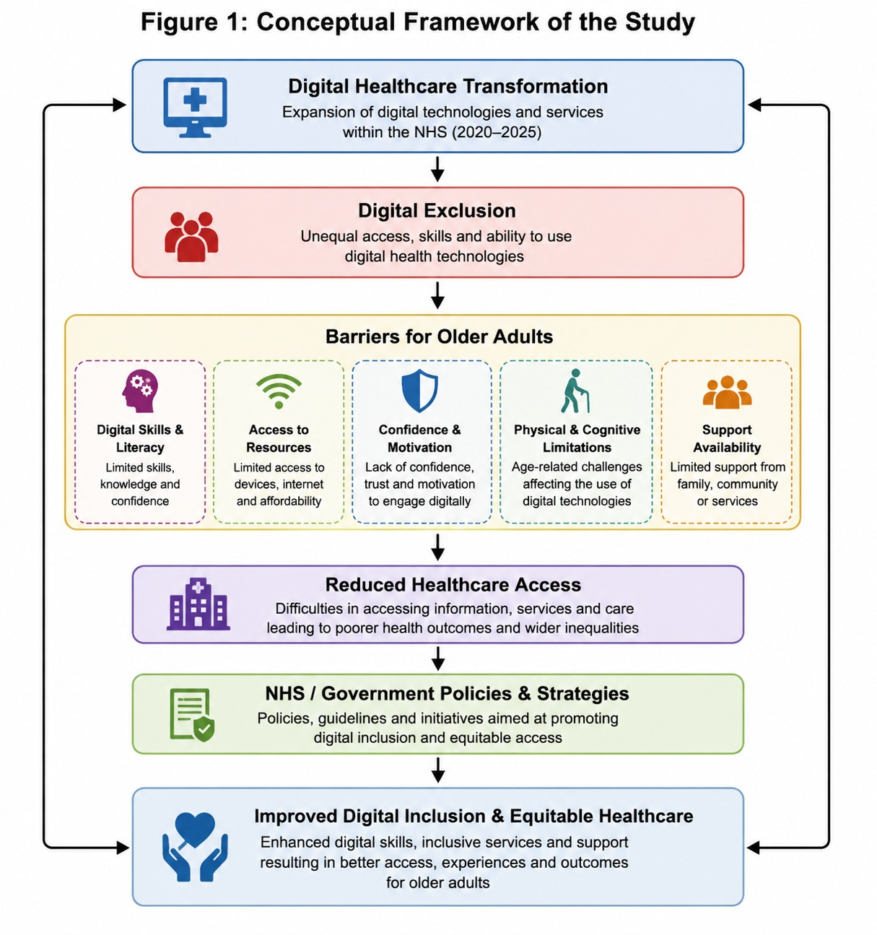
Figure 1: Conceptual Framework of the Study

2. Background
2.1 Understanding Digital Exclusion and the Digital Divide
Digital exclusion is the failure to access, use or reap the benefits of digital technologies and services. It covers barriers to internet access, affordability, digital skills, confidence, motivation, accessibility, and the effect that the use of technology has on outcomes (Rasi-Heikkinen and Doh, 2023). The digital divide has come to mean more than access to digital devices, however existing knowledge also considers the inequalities related to digital competence, meaningful participation, and benefits from the use of the Internet (Richardson et al., 2022). The disparities are significant in health care because they can hinder access to information, appointments, prescriptions, records, and communications with healthcare professionals. Improvements in access through digital innovation will not occur until equity and inclusion is integrated into implementation (Varadarajan, 2024).
2.2 Digital Transformation of Healthcare in England
Digital transformation is now an integral part of the policy and delivery of healthcare services in England. The success of digital systems introduction is influenced by governance, infrastructure investments, regulations, and organisational leadership (Fernandes et al., 2024). The NHS has improved electronic health records, online booking systems, e-prescriptions, patient portals, remote consultations, and the NHS App (Allcock et al., 2024). These services can be used to support convenience, patient involvement, and continuity of care when they are available and easily used (KC et al., 2025). The COVID-19 pandemic has been a catalyst for the growing adoption of remote consultations and the growing trend towards focusing on digital routes for accessing healthcare (Green et al., 2022). But it is not only technological change that is needed for successful transformation, but it also involves organizational change, supporting staff, and user-centered design (Yahia Marzouk, 2025).
2.3 Older Adults and Digital Exclusion
Older people are a group at particular risk of digital exclusion but should not be treated as a monolithic group. Some barriers can be limited such as digital literacy, low confidence, financial issues, lack of adequate devices, poor connectivity, physical and cognitive limitations (Ge et al., 2025). The probability of technology adoption increases if the systems are useful, easy to use and have adequate training (Harris, Blocker, and Rogers, 2022). Fears of leakages, complexity, error, and uncertainty regarding personal data can deter engagement. Personal, social, environmental, and technological factors also influence older adults' participation (Kebede et al., 2022). There was an increase in older adults using the internet since the pandemic and inequalities were experienced by those with various socio-economic, educational and health conditions (Kung and Steptoe, 2023).
2.4 Digital Exclusion and Healthcare Access
With the increasing adoption of digital routes, its impact on access to health care is noteworthy. Those with challenges with digital systems might find it hard to make appointments, fill prescriptions, find reliable information, access records, and/or communicate with providers. Digital services will have a positive impact on access for confident users and a negative impact for people who are not supported (Farre et al., 2023). The digital health divide is linked to age, income, education, disability, geographic location, and greater social disadvantage (Zhang et al., 2023). However, older, and vulnerable patients may not be as adept at using patient portals and digital platforms (Barker et al., 2026). Digital health literacy is therefore vital as patients need to be able to access, interpret, assess, and use health information safely (Wamala Andersson and Gonzalez, 2025).
2.5 Policy and Practice Responses
There is a growing emphasis in policy and practice on digital literacy programmes, accessible service design, assisted digital support and/or the involvement of community organisations. Significant contributions from users and co-production can make services more inclusive, which can help ensure they meet the needs of people who may not be involved otherwise (Wilson et al., 2024). Individualised training and ongoing guidance can enhance older people's self-confidence and engagement (Wale et al., 2025). However, there are still inequalities between vulnerable groups, and digital inclusion is relevant in the context of NHS transformation (Polizzi et al., 2025). Telephone, in-person and paper-based routes are also a critical requirement to avoid digital-first systems becoming an impediment to care.
2.6 Literature Gap
There has been existing literature on digital exclusion, healthcare digitalisation and barriers older people face. However, the evidence is scattered in study design, populations, and setting. Further research is needed to map and compare peer-reviewed studies on the effects of digital exclusion on older adults' access to healthcare and interventions that help to keep older people included. This scoping review aims to fill this gap by summarising current evidence and drawing out implications for future research, policy, and healthcare practice for England.
3. Methods
3.1 Scoping Review Design
To explore peer reviewed evidence about digital exclusion and access to health care for older adults, a scoping review design was used. This was suitable, because the research from various study designs could be identified, compared, and synthesized without collecting primary data (Fetzer, 2025).
3.2 Data Sources and Search Strategy
Academic databases via the UWTSD Library were used to identify relevant studies. Boolean operators AND OR were used to combine the following terms in the search: older adults, digital exclusion, digital health, healthcare access, digital literacy, and United Kingdom. No attempts were made to search for a more diverse set of studies; only English-language, peer-reviewed studies published between 2020 and 2025 were searched. The structured search strategy helped to increase transparency and limit selection bias (Costa et al., 2025; MacFarlane et al., 2022).
3.3 Eligibility Criteria
Studies were selected if they discussed digital exclusion or digital health and care access, primary or secondary research, and were relevant to UK health or social care practice and involved adults aged 50 years or older. Policy papers, opinion pieces, non-peer-reviewed sources, studies not related to healthcare access were not included.
3.4 Study Selection and Data Extraction
The titles and abstracts were first screened for eligibility, and then full texts were reviewed. The five studies were chosen for more detailed analysis. The information that was retrieved were author, year, setting, aim, design, sample, findings, limitations, and relevance to the review question.
3.5 Thematic Analysis
Findings were coded and analysed for similarities and differences across the studies included. Themes were developed through familiarisation, coding, reviewing, and defining patterns within the evidence (Ahmed et al., 2025; Hole, 2024).

3.6 Ethical Considerations
Human participants were not recruited as published research was analysed. Ethical practice involved accurate representation, transparent selection, avoidance of plagiarism and consistent Harvard referencing.
3.7 Limitations
The review was restricted due to the limited number of studies included the use of English only and the time range of the study, as well as potential differences between international evidence and current NHS practice.
4. Results
4.1 Introduction to the Results
Four themes were identified in peer-reviewed literature about digital exclusion and access to health care services among older adults. These related to digital exclusion as an inequality in healthcare, barriers to digital healthcare, strategies that enable digital inclusion and lack of evidence and implementation.
4.2 Theme 1: Digital Exclusion as a Healthcare Inequality
The research revealed that digital exclusion is not just about having access to devices or the Internet. Lack of digital skills, levels of confidence and skills in accessing health services may limit access to care and exacerbate inequalities (Richardson et al., 2022; Farre et al., 2023). Digital inequity is particularly a risk for older adults who are educationally and/or economically disadvantaged (Kung and Steptoe, 2023).
4.3 Theme 2: Barriers to Digital Healthcare Access
Factors inhibiting the use of ICTs were low confidence, low digital literacy, affordability, Internet access, and unsuitable devices. It was challenging to navigate digital healthcare platforms (Ge et al., 2025) due to physical, sensory, and cognitive issues. There was a lack of interest due to privacy concerns, the complexity of the technology, and the fear of errors (Harris, Blocker, and Rogers, 2022).

4.4 Theme 3: Strategies that promote Digital Inclusion.
Confidence and participation were enhanced with personalised training, assistance, and community support (Lee, Lim, and Nam, 2022; Wale et al., 2025). Inclusive services (Wilson et al., 2024) were important, and accessible, user-centred design was key.
4.5 Theme 4: Continuing Challenges
Inequalities persisted, and there was limited evidence of the outcomes of long-term interventions (Zhang et al., 2023).
4.6 Summary of Findings
Digital exclusion was multidimensional all told. Responsive responses need to have accessible designs, ongoing support, and ongoing alternative non-digital access.
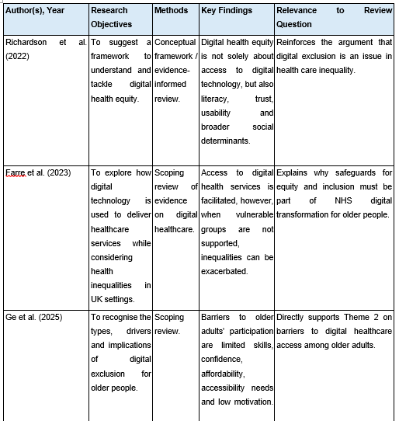

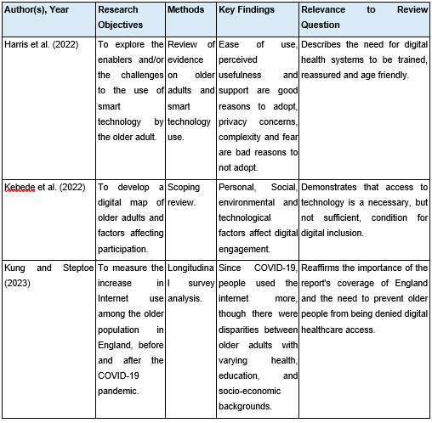
Figure 2 Table of Characteristics and Key Findings of Studies Included in the Scoping Review

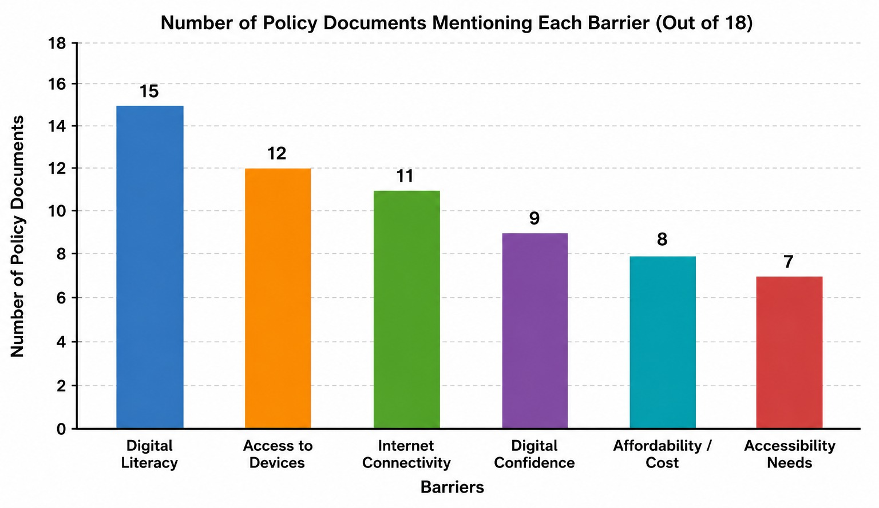Figure 3: Frequency of Barriers Mentioned in Policy Documents

5. Discussion
5.1 Overview of the Findings
This scoping review explored digital exclusion and access to healthcare for older adults. The results indicate that digital exclusion is not just about not having a computer, a smartphone, or the Internet. Digital skills, confidence, motivation, affordability and accessibility, health status, and the design of health systems (Ge et al., 2025; Rasi-Heikkinen and Doh, 2023) also play a role. Digital technologies have the potential to enhance convenience, communication, and patient engagement, but can also pose risks for older adults who lack the capability to use them independently (Farre et al., 2023; Richardson et al., 2022). The review found four issues related to the concept of digital exclusion: digital exclusion is a healthcare inequality, barriers for older people, interventions to increase digital inclusion, and implications for policy and practice. The overall findings indicate that inclusion should be addressed from the design to delivery and evaluation of digital healthcare (Wilson et al., 2024).
5.2 Digital Exclusion a Healthcare Inequality
A finding was that digital exclusion should not be seen as just a technological issue, but a health equality issue as well. Access to devices is not the only factor contributing to digital health equity, as literacy, trust, and usability, along with other social determinants, can affect the impact of online healthcare on individuals (Richardson et al., 2022). Even if an older person has a smartphone or a computer, they will not be able to book appointments, view their medical records, order prescriptions, and attend teleconsultations if the service is hard to understand, or if there is no support (Ge et al., 2025). Digital health can enhance access for confident users but also can pose new barriers for those who need support, potentially exacerbating current inequities in health participation (Farre et al., 2023).
This presents a challenge between efficiency goals of digital transformation and the obligation of healthcare organisations to ensure equitable access. Digital-first services could evolve into digital-only, if telephone, paper-based or in-person services are cut or hard to find (Wilson et al., 2024). Increase services on the internet without proper measures may thus contribute to existing inequalities rather than decrease them (Zhang et al., 2023).
Digital exclusion is not a phenomenon confined to the ages per se, as older adults experience, have abilities, resources and preferences that vary. Education, income, disability, health status, past technology use, and availability of social support all impact digital participation (Kebede et al., 2022). A one-size-fits-all approach should not be taken with older adults (Ge et al., 2025). Greater access to the Internet after COVID-19 does not equal less inequality. Those with different education, health and socioeconomic conditions still showed differences with regard to internet engagement among older adults (Kung and Steptoe, 2023). Therefore, the meaningful use and outcomes of the healthcare organisation must be measured, but not only the number of registrations, downloads, or logins (KC et al., 2025).
5.3 Barriers to Access of Older Adults
Few studies reviewed included digital skills and digital health literacy as significant barriers. Skills, confidence, affordability, accessibility, and motivation all play a role in digital exclusion, and these factors can compact each other (Ge et al., 2025). Limited experience could lead someone to believe that they will get it wrong, to not understand instructions, or to refrain from using online services altogether, particularly if the information is personal or timely (Harris, Blocker, and Rogers, 2022).
Digital health literacy is crucial because access to the internet is not enough for online health care. Users should be able to find, comprehend, evaluate, and utilize health information, manage passwords, fill in forms and be aware of how their personal information is stored and used (Wamala Andersson and Gonzalez, 2025). An older person can easily use an app for messaging but find it difficult to use an NHS app, patient portal, or online booking system. Digital training may therefore not be general enough, if it does not involve certain working tasks in healthcare (Wamala Andersson and Gonzalez, 2025).
Other factors that influence participation include confidence, motivation, and fear of technology. Factors such as perceived usefulness, ease of use, and support that are available can promote adoption, while complexity, privacy concerns, and fear of error can deter engagement (Harris, Blocker, and Rogers, 2022). A lack of willingness is not necessarily a sign of opposition to change as it could stem from poor experiences, fraud fears, or concerns about security.
Accessibility and cost of suitable devices are still significant challenges. Digital services involve equipment, internet access, and, in some cases, mobile data, which also have costs that can impact older adults with low or fixed incomes (Polizzi et al., 2025). Shared devices can also take away the privacy when people are accessing records or talking about sensitive information. Other factors such as physical, sensory, and cognitive might make things more challenging. Limited vision, hearing loss, lack of dexterity, memory deficits, or cognitive impairment can make it difficult to read small print, remember passwords, or follow complex procedures (Ge et al., 2025). Therefore, the interaction between personal, social, environmental, and technological factors influences digital engagement (Kebede et al., 2022).
5.4 Interventions and Responses
The results indicate that confidence and participation can be enhanced by digital-literacy training, personalised support, and community support. The use of structured programmes was found to have a positive effect on the confidence, social participation, and technology use of older people (Lee, Lim, and Nam, 2022). Personalised training, ongoing support, and community-based interventions were also found to be helpful in addressing digital exclusion (Wale et al., 2025). The results show that one-off training is not sufficient since people might require multiple sessions of training and support if systems, devices, or security procedures change.
Assisted support might be especially helpful in known environments like general practices, libraries, community centres, and voluntary organisations. However, it is not all the responsibility of community groups as healthcare providers are still responsible for making services accessible and equitable (Wilson et al., 2024).
User centred design is also key as you will not solve the problem if you teach people to use a badly designed service. Inclusive digital healthcare should be accessible, co-produced, use simple language and text, and be easy to navigate, with users involved in the design and testing process (Wilson et al., 2024). Services should be broadly introduced with older people with disabilities or limited experience being consulted. But there are limitations to the evidence base as some studies report on general technology use instead of direct technology in relation to healthcare access. Doing something more confident or on the internet does not necessarily mean it is better appointments, treatment, safety, or health outcomes. Going forward, it would be important to assess meaningful outcomes in healthcare.
5.5 Policy and Practice implications
The results align with the idea of digital transformation as a means of enhancing healthcare access, and that these skills, confidence, affordability, and accessibility limitations can impede older adults' ability to benefit. Responses at individual, organisational, and social level are needed. Training should be linked to available service design, staff knowledge, affordable connectivity options, and available non-digital options (Wilson et al., 2024).
Do not rely on application downloads and online registrations as measures of success. Availability of the NHS App does not equate to equal participation in or benefit from the app (KC et al., 2025). Monitoring should consider age, disability, ethnicity, deprivation and location, and respect privacy. Services should also look at failed login attempts, depending on relatives, and factors that led to telephone or face-to-face interaction.
Staff practice is also a factor in implementation. Receptionists, administrators, and clinicians could be the first to suspect a problem. Staff should be sensitised to the signs of digital exclusion, make a note of communication preferences and provide support or alternative. Do not view telephone, web, or paper as short-term or low-quality. Blended is fairer as it considers the differences in ability, preference, and situation.
5.6 Strengths, Limitations and Future Research.
One benefit of this review is that it pulls together evidence relating to skills, confidence, affordability, and access and service design. This offers a wider perspective than those which are device or connectivity centric. Yet the review is curtailed by the small number of studies, variability of methods, populations, and settings. Some evidence could be from elsewhere than England, making it less relevant to NHS services. Some populations might also be under-represented such as older adults with cognitive impairments, low English proficiency, lack of secure housing, or minimal family support.
It is possible that the review may be subject to publication bias due to the fact that successful interventions are more likely to be published in journals. Making comparisons is challenging due to differences in definitions of digital exclusion and of older adults. Further research could assess interventions in NHS contexts in terms of access, safety, and inequality outcomes. Long term studies are required to assess maintenance of improvements. Services for older people need to be designed and evaluated with their involvement, taking disability, income, education, ethnicity, and living arrangements into account.
Overall, digital healthcare can enhance accessibility and engagement, but digital inclusion should be built into the design, implementation, and evaluation of services, not tacked onto the end of digital systems.
6. Conclusion and Recommendations
6.1 Conclusion
In this study, documents of the NHS and Government on digital exclusion and access to health services for older people in England were analysed between 2020 and 2025. The results reveal that the NHS App, virtual consultations, electronic prescriptions, patient portals, and remote services are key to the modernisation of healthcare, as are digital transformation initiatives. These technologies have enhanced efficiency, access, and patient engagement.
But older people are still risked by digital exclusion. Digital literacy, low confidence, cost, accessibility issues and physical and/or cognitive ability are key barriers (Rasi-Heikkinen and Doh, 2023). Older people are engaging with technology, however, there are inequalities in digital participation in accessing healthcare and in the benefits gained from digital health services (Kung and Steptoe, 2023).
The results reveal that digital exclusion is acknowledged as a healthcare inequality. Digital inclusion policies have been brought in by the NHS and the Government, but there are problems with the uptake of technology, support for the young and the evaluation of policies. Thus, a targeted inclusion policy and alternative ways of access must go hand in hand with the expansion of digital healthcare to guarantee equity in care provision.

6.2 Recommendations
Recommendation 1: Promote the digital literacy programmes.
Digital literacy programmes should be scaled up to enhance the confidence, skills, and effectiveness of older citizens using digital health services.
Recommendation 2: Keep Non-Digital Access Routes.
Equitable access to face-to-face, telephone, and paper-based services should be maintained in addition to digital services.
Recommendation 3: Improve access and user-centred design.
The interfaces, accessibility and usability testing with older users should be designed in the future platforms.
Recommendation 4: Enhance Monitoring-Evaluation.
Policymakers need to set up tools to evaluate the impact of digital inclusion programmes on healthcare inequalities.
Recommendation 5: Promote co-operative approaches.
Older adults who are digitally excluded should be supported by working together between healthcare providers, local authorities, and community and voluntary organisations.
Such recommendations would lead to a more inclusive health care system and ensure digital transformation is inclusive for all, irrespective of digital ability or ages. ￼

REFERENCES
Ahmed, S.K., Mohammed, R.A., Nashwan, A.J., Ibrahim, R.H., Abdalla, A.Q., Ameen, B.M.M. and Khdhir, R.M., 2025. Using thematic analysis in qualitative research. Journal of Medicine, Surgery, and Public Health, 6, p.100198.
Allcock, J.A., Zhuang, M., Li, S. and Zhao, X., 2024. Landscape of digital technologies used in the national health service in England: content analysis. JMIR Formative Research, 8, p.e51859.
Barker, R.D., Gökmen, R., Naylor, D., and Teo, J.T., 2026. Unlocking digital health: inequalities in the adoption of a patient portal. BMJ health & care informatics, 33(1), p.e101587.
Calero-Plaza, J., González-García, R.J. and Fernández-Piqueras, R., 2025. Validation of a scale to measure digital competence in the elderly population. International Journal of Instruction, 18(1), pp.77-94.
Costa, I.C.P., Mendes, K.D.S. and Freitas, P.S., 2025. Literature search strategies: a guideline for identifying the best evidence in healthcare. Texto & Contexto-Enfermagem, 34, p.e20230405.
Farre, A., Fang, M., Hannah, B., Makita, M., McFadden, A., Menezes, D., Rodriguez, A., Sixsmith, J. and M Gray, N., 2023. Exploring the use of digital technology to deliver healthcare services with explicit consideration of health inequalities in UK settings: A scoping review. Digital Health, 9, p.20552076231185442.
Fernandes, F.A., Chaltikyan, G., Adib, K., Caton-Peters, H. and Novillo-Ortiz, D., 2024. The role of governance in the digital transformation of healthcare: Results of a survey in the WHO Europe Region. International Journal of Medical Informatics, 189, p.105510.
Fetzer, S.J., 2025. Considering a Scoping Review. Journal of PeriAnesthesia Nursing, 40(4), p.1075.
Ge, H., Li, J., Hu, H., Feng, T. and Wu, X., 2025. Digital exclusion in older adults: A scoping review. International Journal of Nursing Studies, 168, p.105082.
Green, M.A., McKee, M., and Katikireddi, S.V., 2022. Remote general practitioner consultations during COVID-19. The Lancet Digital Health, 4(1), p.e7.
Harris, M.T., Blocker, K.A. and Rogers, W.A., 2022. Older adults and smart technology: facilitators and barriers to use. Frontiers in Computer Science, 4, p.835927.
Hole, L., 2024. Handle with care; considerations of Braun and Clarke's approach to thematic analysis. Qualitative research journal, 24(4), pp.371-383.
KC, S., Papoutsi, C., Reidy, C., Gudgin, B., Powell, J., Majeed, A., Greaves, F., and Laverty, A.A., 2025. Ease of access to general practice, patient experience, and use of the NHS App: an ecological analysis of English data. JRSM Open, 16(12), p.20542704251398918.
Kebede, A.S., Ozolins, L.L., Holst, H. and Galvin, K., 2022. Digital engagement of older adults: scoping review. Journal of Medical Internet Research, 24(12), p.e40192.
Khalil, H., Campbell, F., Danial, K., Pollock, D., Munn, Z., Welsh, V., Saran, A., Hoppe, D., and Tricco, A.C., 2024. Advancing the methodology of mapping reviews: A scoping review. Research synthesis methods, 15(3), pp.384-397.
Kung, C.S. and Steptoe, A., 2023. Changes in Internet use patterns among older adults in England from before to after the outbreak of the COVID-19 pandemic. Scientific Reports, 13(1), p.3932.
Laverty, A.A., Reidy, C., KC, S., Papoutsi, C., Gudgin, B., Majeed, A. and Powell, J., 2026. The NHS App should focus on inequalities to improve population health. Journal of the Royal Society of Medicine, 119(2), pp.37-41.
Lee, H., Lim, J.A., and Nam, H.K., 2022. Effect of a digital literacy program on older adults’ digital social behaviour: A quasi-experimental study. International journal of environmental research and public health, 19(19), p.12404.
MacFarlane, A., Russell-Rose, T. and Shokraneh, F., 2022. Search strategy formulation for systematic reviews: Issues, challenges, and opportunities. Intelligent Systems with Applications, 15, p.200091.
Mullins, E., 2022. Building digital literacy among older adults: Best practices. Samuel Centre for Social Connectedness.
Narayan, S.M., Chung, M.K., Adedinsewo, D., Brant, L.C., Davis, L.L., Duncker, D., Hall, J.L., Han, J.K., Lam, C.S., Lewis, E. and Loscalzo, J., 2026. Access to digital health technologies: personalized framework and global perspectives. Nature Reviews Cardiology, 23(1), pp.9-22.
O’Malley, L. and Brown, D., 2025. Finding and reviewing literature. In Teaching Research Methods in Sociology (pp. 78-97). Edward Elgar Publishing.
Polizzi, G., D'Arcy, J., Harris, R. and Yates, S., 2025. Digital inclusion landscape in the UK: An overview for the Welsh Government.
Rasi-Heikkinen, P. and Doh, M., 2023. Older adults and digital inclusion. Educational Gerontology, 49(5), pp.345-347.
Richardson, S., Lawrence, K., Schoenthaler, A.M. and Mann, D., 2022. A framework for digital health equity. NPJ digital medicine, 5(1), p.119.
Rosairo, H.S.R., 2023. Thematic analysis in qualitative research. Journal of Agricultural Sciences–Sri Lanka, 18(3).
Soliman, M., Abdelziz, O., Radwan, A., Shehata, M.S., Ronquillo, C. and Shearer, K., 2026. Secondary use of health data: applications, models, algorithms, and ethical considerations. AI and Ethics, 6(2), p.165.
Su, Q., Cheng, G. and Huang, J., 2023. A review of research on eligibility criteria for clinical trials. Clinical and experimental medicine, 23(6), pp.1867-1879.
Varadarajan, R., 2024. Inclusive innovations in services: leveraging digital technologies for inclusive innovations in healthcare services. European Journal of Marketing, 58(13), pp.107-129.
Wale, A., Everitt, J., Ayres, T., Okolie, C., Morgan, H.E., Shaw, H., Cooper, A., Edwards, A. and Lewis, R., 2025. Effectiveness of interventions for addressing digital exclusion in older adults in the social care domain: rapid review. JMIR aging, 8, p.e70377.
Wamala Andersson, S. and Gonzalez, M.P., 2025. Digital health literacy—a key factor in realizing the value of digital transformation in healthcare. Frontiers in Digital Health, 7, p.1461342.
Wilson, S., Tolley, C., Mc Ardle, R., Lawson, L., Beswick, E., Hassan, N., Slight, R. and Slight, S., 2024. Recommendations to advance digital health equity: a systematic review of qualitative studies. NPJ Digital Medicine, 7(1), p.173.
Yahia Marzouk, Y., 2025. Digital transformation in the healthcare sector: a novel strategic perspective. Journal of Health Organization and Management, 39(8), pp.1718-1753.
Zhang, J., Gallifant, J., Pierce, R.L., Fordham, A., Teo, J., Celi, L. and Ashrafian, H., 2023. Quantifying digital health inequality across a national healthcare system. BMJ health & care informatics, 30(1), p.e100809.

Appendices
Figure 1 Policy Document Selection Process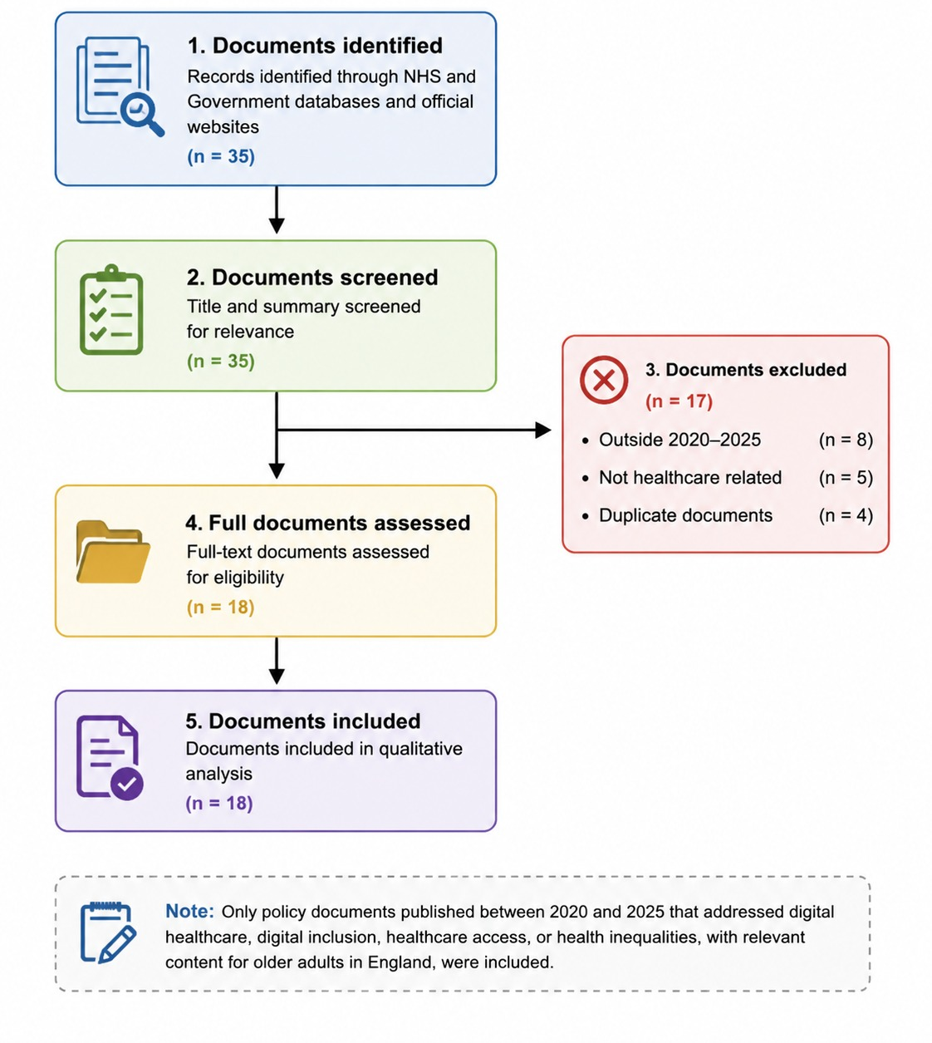

Figure 2: Braun and Clarke Six-Step Thematic Analysis
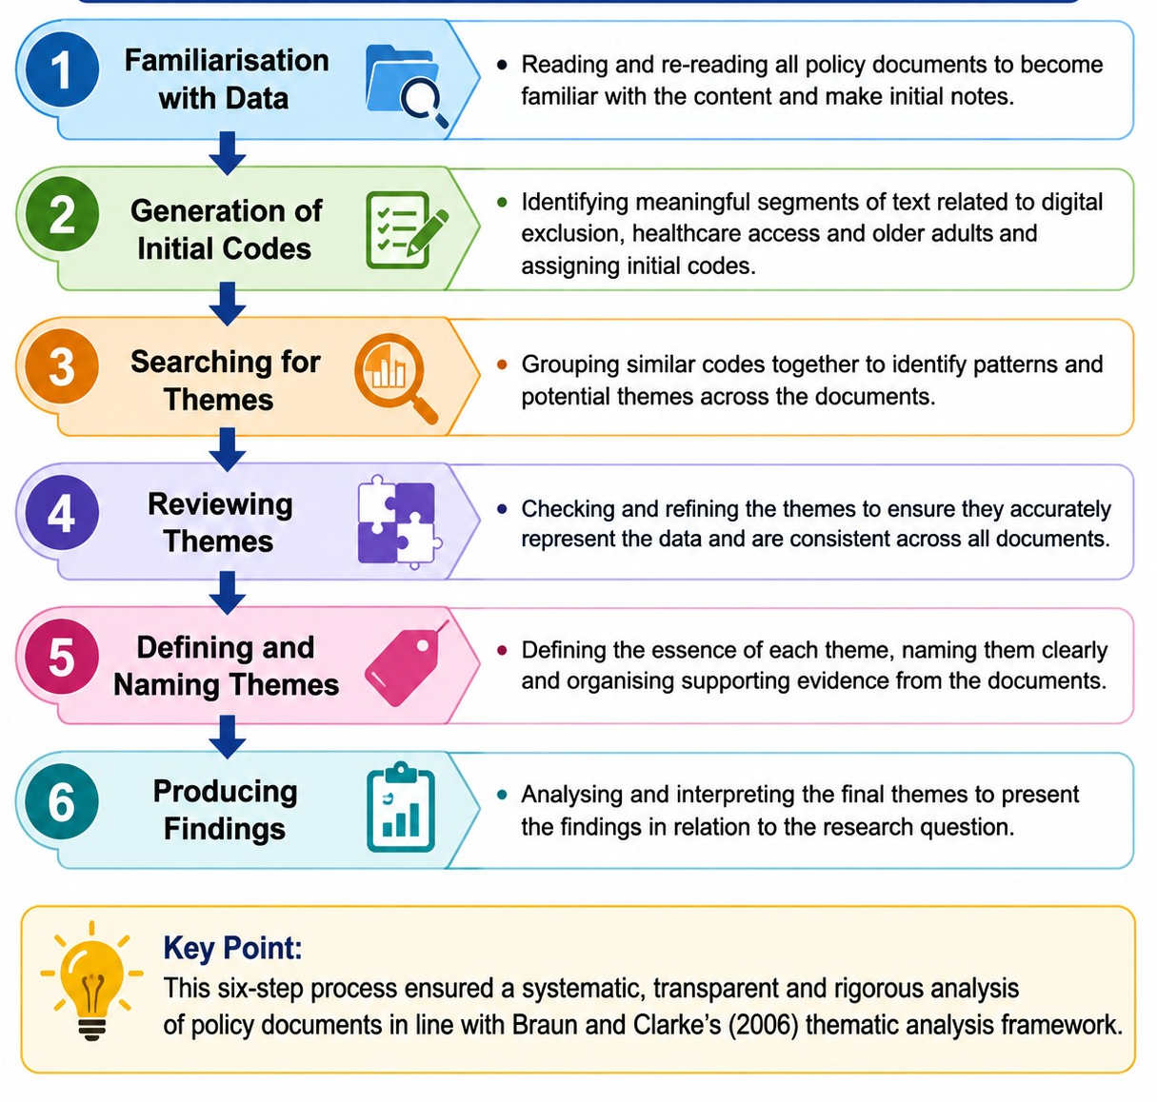

Figure 3: Coding Framework
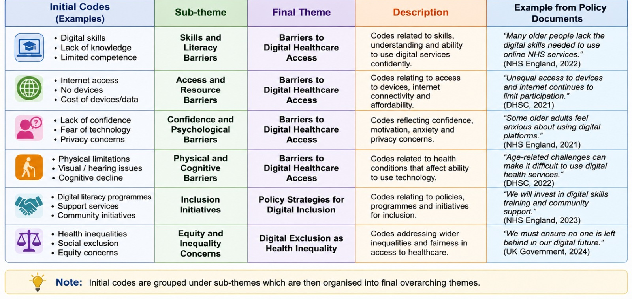
Figure 4: Policy Documents Analysed
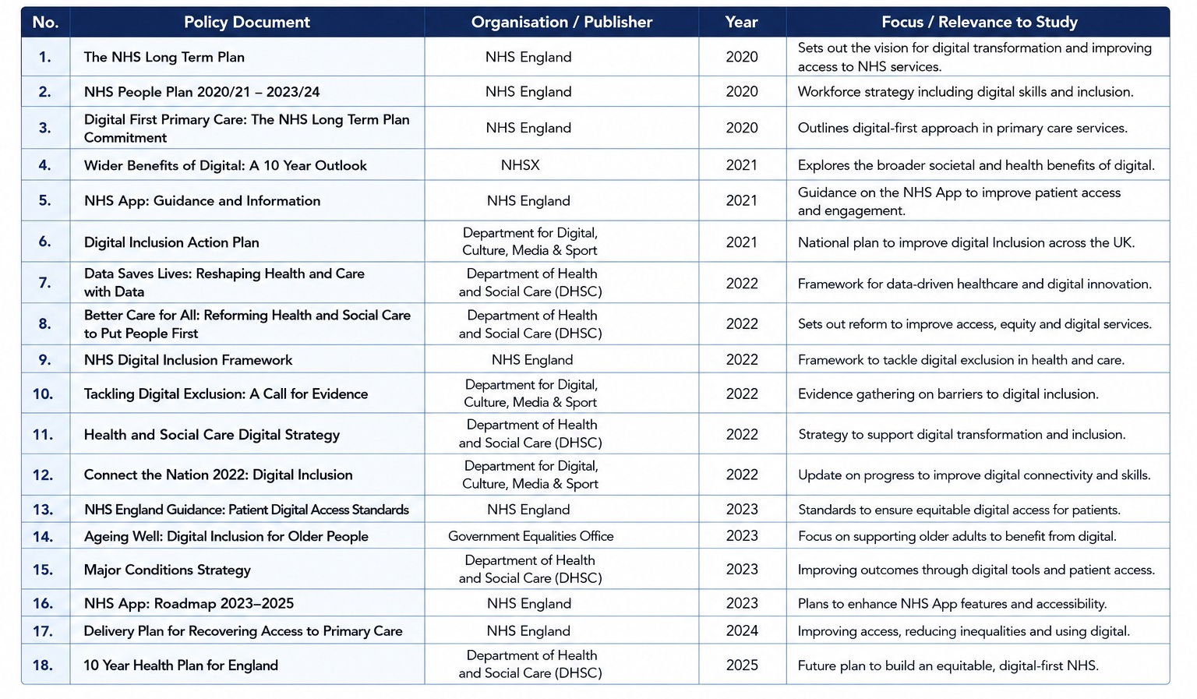

Figure 5: Themes Emerging from Policy Analysis


