

Automating Business Email Communication: An AI-Driven Response System Built in n8n

by
Kieran Brown

Supervisor: Nitheesh Kaliyamurthy

Report submitted as part of the requirements for the award of
BSc (Hons) Computing

May 2026

DECLARATION

I Kieran Brown declare that I am the sole author of this Project; that all references cited have been consulted; that I have conducted all work of which this is a record, and that the finished work lies within the prescribed word limits.

This work has not previously been accepted as part of any other degree submission.

Date : 28/04/26

FORM OF CONSENT

I Kieran Brown hereby consent that my Project, submitted in candidature for the B.Sc.(Hons) Computing (Applied Computing) degree, if successful, may be made available for inter-library loan or photocopying (subject to the law of copyright), and that the title and abstract may be made available to outside organisations.

Date : 28/04/26

Table of Contents
Abstract 4
Chapter 1 – Introduction 5
1.1 Introduction 5
1.2 Project Aim 6
1.3 S.M.A.R.T Objectives 7
1.4 Structure of the Report 7
Chapter 2 – Literature Review 8
2.1 Introduction 8
2.2 Ai in the Workplace 8
2.3 Natural Language Processing and Large Language Models 11
2.4 Retrieval Augmented Generation 13
2.5 Workflow Automation and n8n 14
2.6 Existing Ai Email Solutions 16
2.7 Ethical Considerations 17
2.8 Conclusion 18
Chapter 3 - Methodology 19
3.1 Introduction 19
3.2 Research Philosophy 20
3.3 Research Approach 20
3.4 Research Strategy 21
3.5 Choices 22
3.6 Time Horizon 22
3.7 Data Collection 23
3.8 Project Planning 24
3.9 Contingency Plan 24
3.10 Ethical Considerations 26
3.11 Conclusions 26
Chapter 4 – Design And Implementation 27
4.1 Introduction 27
4.2 Problem Formulation 27
4.3 Requirements and Specifications 28
4.4 System Design 29
4.4.1 Gmail Trigger and Get Message 30
4.4.2 Extract Email Data 31
4.4.3 Draft Response with Claude – The AI Agent 32
4.4.4 Claude for drafting and conversation memory 33
4.4.5 Email Knowledge Base Retrieval and OpenAI Embeddings 34
4.4.6 Response Structure Parser, Conditional Routing and Draft Creation 35
4.5 Implementation Challenges 36
4.6 Conclusion 37
Chapter 5 – Testing and Evaluation 38
5.1 Introduction 38
5.2 Testing Approach 38
5.3 Unit Testing 39
5.4 System Testing 41
5.5 Real World Impact and Results 43
5.6 Usability Testing 46
5.7 Acceptance Testing 47
5.8 Evaluation Against Objectives 47
5.9 Comparison of literature 48
5.10 Limitations 49
5.11 Conclusion 50
Chapter 6 – Conclusions and Recommendations 51
6.1 Introduction 51
6.2 Summary and Conclusions 51
6.3 Recommendations for further development 52
6.4 Conclusion 52
Chapter 7 – Reflection 53
7.1 Introduction 53
7.2 Reflection on the Project Process 53
7.3 Technical Development 53
7.4 Personal and Professional Development 54
7.5 What I Would Do Differently 56
7.6 Conclusion 57
Bibliography 58

Table 1 : Risk Register and Contingency Plan 25
Table 2 - AI Email Responder Workflow Node Summary 30

Figure 1 - Heterogeneity of AI impact by skill and tenure at deployment. Adapted from E. Brynjolfsson, D. Li, and L. R. Raymond, "Generative AI at Work," NBER Working Paper No. 31161, 2023 [7]. 11
Figure 2 - AI adoption worldwide has increased dramatically in the past year, after years of little meaningful change. Adapted from McKinsey & Company, "The State of AI in Early 2024," McKinsey Global Survey, May 2024 [8]. 12
Figure 3 - The Transformer model architecture. Adapted from A. Vaswani et al., "Attention Is All You Need," NIPS 2017 [15]. 14
Figure 4 - Conceptual flow of RAG with LLMs. Adapted from Amazon Web Services, "What is RAG? Retrieval-Augmented Generation AI Explained," AWS, 2023 [20] 16
Figure 5 - Workflow Automation Tools Comparison 2025. Adapted from iApp Technology, "What is n8n? A Complete Guide to Workflow Automation for Beginners," iApp Technology, December 2025 [25]. 17
Figure 6 - AI Automation Tools Comparison 2025. Adapted from EfficiencyNest, "Top 7 AI Automation Tools for 2025," EfficiencyNest, September 2025 [29] 19
Figure 7 - Research Onion illustrating the methodological choices for this study, adapted from [33] 21
Figure 8 - Gantt Chart 26
Figure 9 - Full n8n Workflow - Created in n8n 29
Figure 10 - Gmail Trigger Node 33
Figure 11 - Get Message Node 33
Figure 12 - Extract Email Data Node 34
Figure 13 - Draft Response with Claude Node 35
Figure 14 - Conversation Memory Node 36
Figure 15 - Base Retrieval Node 37
Figure 16 - Response Parser Node 38
Figure 17 - Create Gmail Draft Node 39
Figure 18 - Extract Email Data Node Post Test 42
Figure 19 - Response Parser Node Post Test 43
Figure 20 - Check if Response Generated Node Post Test 44
Figure 21 - Full n8n workflow - Successfully executed workflow - created in n8n 45
Figure 22 - Draft Response Created in Gmail 45
Figure 23 - Estimated Processing Time by Pipeline Stage (Seconds) Bar chart showing time contribution of each workflow stage 46
Figure 24 - Email Classification Breakdown (n = 214) Horizontal bar chart showing all 214 emails by classification category 48
Figure 25 - Draft Quality Outcomes (n = 86) Pie chart showing sent with no editing, minor edits, and significant edits 48
Figure 26 - Estimated Time Saving — Manual vs AI-Assisted Drafting (86 Emails) Bar chart comparing ~499 minutes of manual drafting against AI-assisted overhead 49
Figure 27 - Processed Emails Marked as Read in Gmail 50

Abstract

This project presents the design, implementation and evaluation of an AI powered email response system developed for SHIPMAX ltd. A UK based logistics consultancy operating on a subscription model in which third part logistics providers pay a monthly fee to receive qualified leads. At the time the project began, the founder was the sole operator of the business and the volume of incoming emails of approximately 100 a day were consuming the time needed to grow the 3PL lead exchange to generate revenue. The system was built to address this directly, with the goal of reducing email management overhead and freeing up capacity for higher value commercial activity.

The system was built using n8n, an open source workflow automation platform, and integrates with live Gmail inbox at SHIPMAX. Incoming emails are automatically detected, their content extracted and normalised, and then passed to Claude Haiku 4.5 which classifies each message into one of four defined categories and generates a professionally appropriate draft response where required. A retrieval augmented generation architecture using OpenAI embeddings grounds the agents outputs in company specific knowledge, ensuring that response are factual, accurate and consistent with SHIPMAX services and communication style. All drafts are saved for human review before sending, preserving meaningful human oversight throughout.

The system was evaluated across four levels of testing including unit, system, usability and acceptance testing. This was then deployed live to SHIPMAX Gmail inbox for a period of several days. During the evaluation period 214 emails were processed, 86 draft responses were generated and an estimated 14 hours of manual drafting was saved. Approximately 40% of all drafts required no editing before being sent. In the month following deployment, the founder was able to onboard another three 3PL partners onto the platform, taking the total from 12 to 15, a direct commercial outcome from the implementation of the AI-driven response system.

The project concludes that a practically valuable, credible and ethically responsible AI email response system can be built and deployed within a real SME using accessible open-source tooling, without the need for proprietary enterprise software or significant ongoing cost. Recommendations for further development include introduction of multi-label email classification and extension of the architecture to additional communication channels.

Chapter 1 – Introduction

1.1 Introduction
Email has been at the cornerstone of professional communication for decades. Despite the rise of instant messaging platforms and tools, it still continues to dominate business correspondence across multiple industries. Lanctot and Duxbury, citing the Radacati Group report that “over 347 billion emails” are sent and received each day [1].
For organisations handling high volumes of client enquiries this scale of communication presents a genuine operational challenge, one can be very difficult to manage consistently without dedicated resource. During an internship at SHIPMAX ltd, a UK based logistics consultancy that helps e-commerce businesses identify and connect with suitable third party logistics providers (3PLs) across shipping, storing and warehousing, this challenge was experienced first hand. SHIPMAX operates a subscription based business model in which third party logistics providers pay a monthly fee to receive qualified leads from the consultancy. The commercial growth of the business therefore depends solely on the founders ability to identify, vet and onboard new 3PL partners onto the platform while simultaneously managing and receiving approximately 100 emails a day spanning from partnership requests, client enquiries, routine correspondence and spam.
At the time this project began, the founder was the sole operator of the business, responsible for every function simultaneously. The volume and variety of incoming emails meant that response times depended entirely on the availability of a single individual who was simultaneously managing every other aspect of running the company. The founder clearly identified that the primary barrier to growing SHIPMAX partner network was not the lack of demand, but the lack of time. Every hour spent drafting email responses was an hour not spent on discovery calls with potential clients, and viewing new potential 3PL partners which is where revenue is generated. It was this specific and directly observed operational problem that motivated the development of the system described in this report.
Research into the broader issue suggests that this tension between communication overhead and growth capacity is far from unique to only SHIPMAX. Studies have consistently shown that employees and founders in knowledge based roles spend a lot of their working day reading and responding to emails, which is often at the expense of higher value task [2]. As Brynjolfsson and Mcafee argued, technological tools capable of handling language based tasks represent a fundamental shift in what machines are able to do [3]. It was against this backdrop that the concept of an automated, Ai driven response system began to take shape.
The solution developed in this project uses n8n, which is an open source node based workflow automated platform, used to monitor an active Gmail inbox at SHIPMAX, detect incoming messages and pass their context to a large language model for processing. The system then generates an appropriate draft response that reflects the tone and detail in professional client communication. The choice of n8n over more widely known platforms such as Zapier was driven by its flexibility, its capacity for self hosting and the level of control that it offers how data moves through a workflow, described as “complete control over your data infrastructure”[4].
Ai and large language models have seen rapid adoption across businesses in recent years with McKinsey reporting that by 2023 one third of surveyed organisations were already using generative AI regularly in at least one business function [5] The ability of these models to understand context, generate a response and adapt tone makes them particularly well suited to communication based tasks, and this capability is what this project was looking to apply practically within a real business setting where the stakes are not academic, but commercial.

1.2 Project Aim
To create an Ai powered email response system using n8n to ensure accurate and professional toned draft replies in a live business environment.

1.3 S.M.A.R.T Objectives
To achieve this aim, the following objectives were made:
- To critically review existing literature relating to AI in the workplace, natural language processing, workflow automation and existing AI assisted email tools, and using those findings to inform and justify all design decisions to be completed before development.
- To define and justify research methodology appropriate to a development based computing project, including a project plan and risk register prior to the development.
- To design and implement a fully functional AI powered email response system in n8n that integrates with the live SHIPMAX Gmail inbox and generates professional draft responses using a retrieval augmented generation architecture.
- To test and evaluate the completed system across four defined levels of testing defined functional and non-functional requirements over a live deployment period using real incoming emails.
- To reflect critically on the full project process, addressing the technical and professional skills developed, the challenges encountered and the personal impact of undertaking a real world industry embedded project.

1.4 Structure of the Report
The remainder of this report is organised as follows. Chapter Two reviews the relevant literature, covering the growing use of Ai in workplace settings, the technical foundations of language model driven communication, and the landscape of automation tools with a lot of the attention on n8n. Chapter Three outlines the research methodology and justifies the development based approach taken, and also explains how the system was evaluated. Chapter Four presents the design and implementation of the system in full which covers the design decisions in the completion of the workflow were made and practical challenges that arose during the development. Chapter Five shows the results of the testing and evaluation as it assesses the system against the objectives set. Chapter Six draws the overall conclusions and makes recommendations for future development. Chapter Seven offers a personal reflection on this project, which is then closed with a full reference list and supporting appendices.

Chapter 2 – Literature Review

2.1 Introduction
This chapter reviews the existing literature relevant to the development of an Ai powered email response system. It begins by examine the broader impact Ai on workplace productivity and communication, before narrowing its focus to the technical concepts underpinning the system built in this project. These include large language models, retrieval augmented generation and natural language processing. The review of current landscape of workflow automation tools is also explored, with particular attention to n8n, before assessing existing Ai assisted email solutions.

2.2 Ai in the Workplace
The integration of Ai into workplace environments has accelerated over the past decade. What was once the territory of large technology firms and research institutions has become increasingly accessible to businesses of all sizes, with ONS data showing AI adoption among UK firms was projected to more than double from “9% to 22%” between 2023 and 2024 alone [6] driven largely by the availability of cloud-based Ai services, open source tooling and pretrained language models.
The impact of Ai on productivity has attracted significant academic attention. Research by Brynjolfsson found that Ai assisted tools increased user output by 14% on average with novice and lower skilled workers seeing improvements up to 34% as shown in Figure 1 [7]. Particularly in tasks involving written communication and information retrieval. Notably, the benefits were most pronounced among less experienced workers, which suggests that the tools being used have the potential to reduce performance gaps in teams. This finding is directly relevant to SHIPMAX. Aswell as productivity implications it also indicates that businesses do not need large, specialised workforces to benefit meaningfully from Ai assisted communication.
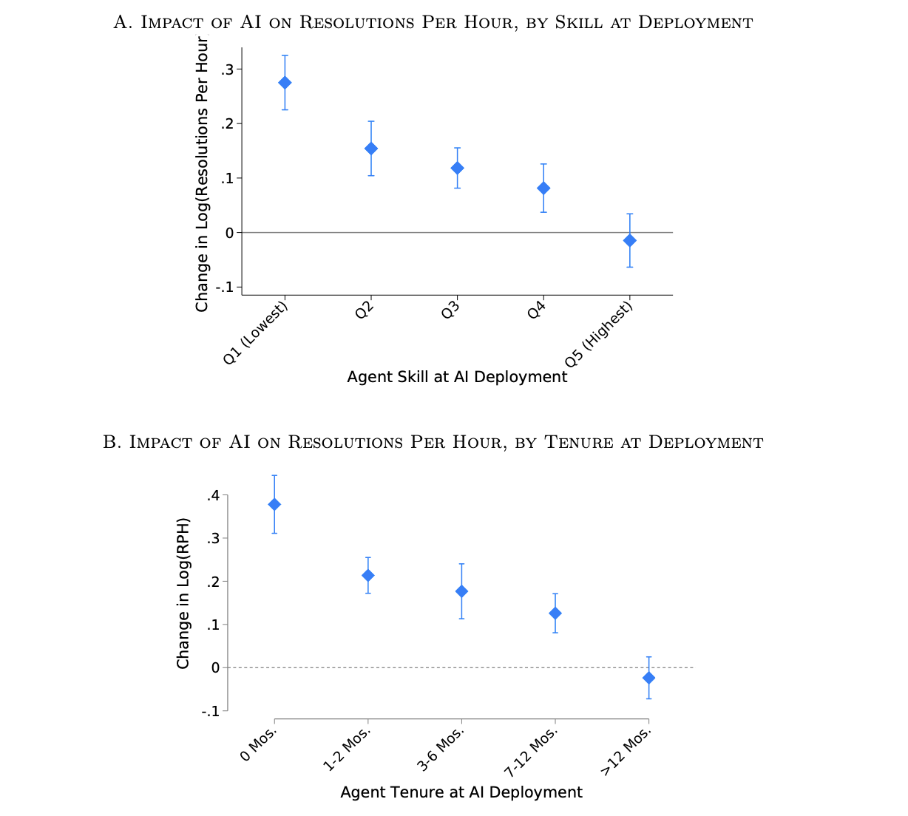
Figure 1 - Heterogeneity of AI impact by skill and tenure at deployment. Adapted from E. Brynjolfsson, D. Li, and L. R. Raymond, "Generative AI at Work," NBER Working Paper No. 31161, 2023 [7].

The pace at which Ai has moved from experimental technology to everyday business use has caught many organisations off guard. A McKinsey report found that the proportion of organisations regularly using Ai in atleast one business function rose from 55% in 2023 to 65% in 2024 “nearly double the percentage” from just ten months before [8]. Despite this growth, the same report noted that many deployments remain poorly integrated with existing workflows which indicates that the primary challenge for most businesses is not accessing Ai, but deploying it in a way that is actually sustainable.
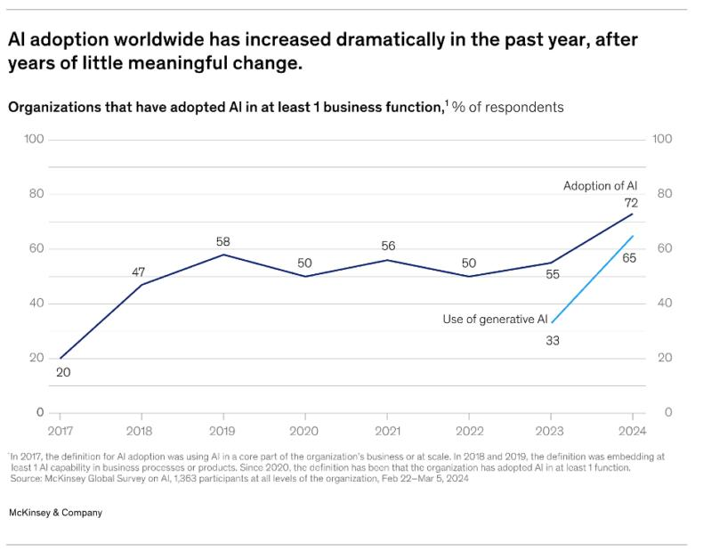
Figure 2 - AI adoption worldwide has increased dramatically in the past year, after years of little meaningful change. Adapted from McKinsey & Company, "The State of AI in Early 2024," McKinsey Global Survey, May 2024 [8].
Figure 2 shows the growing global AI adoption in recent years. The data shows that the proportion of organisations using AI rose significantly to 72% in 2024, while the use of generative AI also increased sharply from 33% in 2023 to 65% in 2024. This highlights the accelerating integration of AI into business operations and supports the argument that AI driven tools are becoming increasingly important in workplace productivity and communication.
However, not all perspectives on workplace Ai are positive as concerns have been raised about over reliance on automated systems. Sovianti and Novrian warn that “organisations and individuals need to be aware of the potential risks that can arise, such as over-reliance on AI [9]. Alongside the gradual decline in communication skills among staff members and the risk of Ai generated content misrepresenting the organisations procedures, tone or position. Weizenbaum, writing in an earlier era of computing argued that computers should never be allowed to make important decisions, as they will always lack human qualities such as compassion and wisdom [10]. While his work predates Ai email systems, the underlying argument remains relevant to any system that acts on behalf of an organisation without full transparency.
These concerns directly informed one of the key design decisions in this project which was that the system would save draft responses for human review, rather than automatically send responses. This ensures that a person remains in the loop at every stage and that no response leaves the companies Gmail without human sign-off. It also implies that the system is an assistive tool rather than a substitute for human judgement, which reflects the broader academic view that “human-AI collaboration can outperform either working alone” [11].

2.3 Natural Language Processing and Large Language Models
At the technical core of this project is natural language processing (NLP), NLP is “a subfield of computer science and artificial intelligence that uses machine learning to enable computers to understand and communicate with human language” [12]. NLP has existed as a field since the 1950s with early systems like ELIZA demonstrating that computers could simulate conversation. Described as “a machine-learning and natural language processing experiment” through pattern matching and scripted responses [13]. These systems had no understanding of language, they operated on surface patterns rather than meaning and their limitations became apparent when taken outside narrow and predefined contexts.
Progress in NLP remained gradual for several decades and was constrained by available computing power, with progress only accelerating as a result of “the steady increase of computational power, and the shift to Machine Learning Algorithms” [14]. Statistical approaches which dominated through the 1990s and 2000s improved on rule-based systems by learning patterns from large text corpora but continued to struggle with the context dependence that characterise real language use. It was not until the deep learning advances of the 2010s that NLP really began to approach human level performance when completing tasks.
The introduction of transformer-based architecture in Vaswani et al.’s 2017 paper ‘Attention is All You Need’ represented a turning point in what was possible within the field. The paper proposed “the Transformer, the first sequence transduction model based entirely on attention, replacing the recurrent layers most commonly used in encoder-decoder architectures with multi-headed self-attention” [15]. As illustrated in Figure 3 by enabling models to process entire sequences of text at the same time rather than word by word, the transformers allowed for a more rich understanding of context and meaning. This breakthrough laid the foundation for the large language models now used widely across the world, including GPT-4, Gemini and Claude.
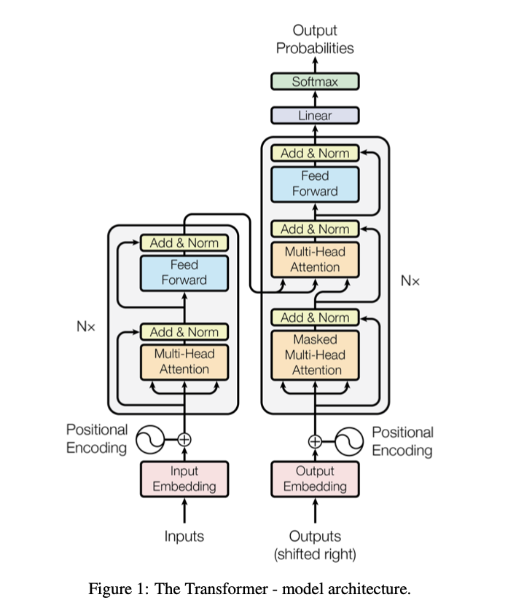

Figure 3 - The Transformer model architecture. Adapted from A. Vaswani et al., "Attention Is All You Need," NIPS 2017 [15].
Building on the transformer architecture, OpenAI developed the concept of generative pre-trained transformers which are models trained on large volumes of text in an unsupervised fashion and then fine tuned for specific tasks [16]. This pre train and fine tune approach has become the fundamental procedure for building large language models. The scale of these models are often measured in billions of parameters which allows them to capture nuanced relationships between words, phrases and concepts that smaller models are unable to represent
Claude, the model used in this project to generate email draft responses, is developed by Anthropic with particular emphasis on producing outputs that are safe reliable and honest. Anthropic’s training approach is guided by a defined constitution which is designed to make model behaviour more predictable and ensure models are “avoiding actions that are unsafe, unethical, or deceptive” [17]. In a business communication context where an Ai system is generating responses on behalf of a real organisation to real clients, the consistency of model output is a concern. A model that occasionally generates confident but incorrect information is commonly referred to as hallucination. These models pose reputational risk that no business can afford to ignore. Anthropic’s focus on reducing this behaviour made Claude the more appropriate choice for this applications workflow LLM.

2.4 Retrieval Augmented Generation
One of the more technically significant aspects of this project is its use of retrieval-augmented generation (RAG). Lewis et al. describes RAG as models which “combine pre-trained parametric and non-parametric memory for language generation” [18]. Rather than depending on information the model acquired during training, RAG allows the system to retrieve relevant and up to date information at the point of generating the response.
In this project, OpenAI embeddings are used to encode company specific knowledge into a vector store that the system can search at runtime before drafting a reply. This includes information about SHIPMAX’s services, response frameworks and procedures. Embeddings are numerical representations of text that “represent real-world objects, like words, images, or videos, in a form that computers can process”[19]. This search capability is what distinguishes RAG from simpler keyword-based retrieval.
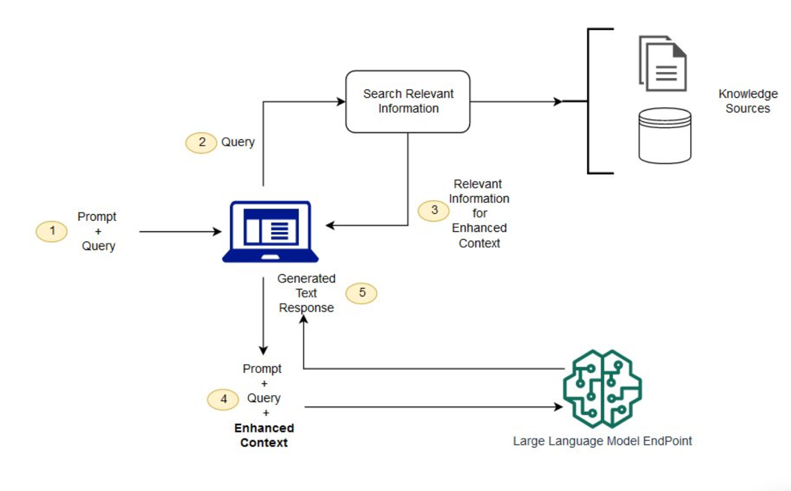
Figure 4 - Conceptual flow of RAG with LLMs. Adapted from Amazon Web Services, "What is RAG? Retrieval-Augmented Generation AI Explained," AWS, 2023 [20]
This architecture addresses one of the more fundamental limitations of using general-purpose language model for business communication. Without retrieval, the model has no in depth knowledge of the company and what it represents, which means that the responses risk being generic, inaccurate and inconsistent with what the business actually offers. By grounding the Ais output in SHIPMAX specific data, the system produces responses that are not only fluent, but factual and relevant to the query. Which is a meaningful improvement over what a standalone language model could achieve.

2.5 Workflow Automation and n8n
Workflow automation refers to the use of technology to carry out a series of tasks with minimal human intervention, defined by Atlassian as “the approach to automating various business processes, tasks and workflows within minimal human intervention” [21]. In recent years, no code and low code platforms have brought this capability to a much wider audience, allowing people without experience in software development to build complex integrations through visual node based interfaces. Make, Zapier and n8n have emerged as the three main tools within this space.
Zapier is the most widely used of the three and is built around ease of use above everything else, supporting thousands of pre-built integrations. However, user reviews on Gartner note that “complex branching, looping or heavy data transformation can feel a bit restrictive” [22]. Giving users limited ability to introduce custom logic and explore around supported integrations. Make offers more flexibility through its scenario-based approach, which allows for more complex branching and data transformation, but like Zapier it operates exclusively as a cloud hosted service with no self-hosting option.
n8n stands apart from both in several ways that are relevant to this project. Hatchworks AI describe it as a platform that is “open source and fair-code licensed” meaning “ you can see how it works, change what you need, and run it where it makes sense for you” [23] its node-based architecture allows for custom logic, conditional branching and direct API calls to be incorporated at any point in the workflow. Critically n8n can be self-hosted on a users own infrastructure, which in this case is a significant advantage when workflows involve sensitive data. This was the deciding factor in selecting it for this project, as it reduces the number of third part services through which confidential client data must pass. Practitioner literature has increasingly noted n8n’s suitability for exactly this type of data-sensitive automation, highlighting its combination of flexibility and privacy controls from other cloud only alternatives [24].
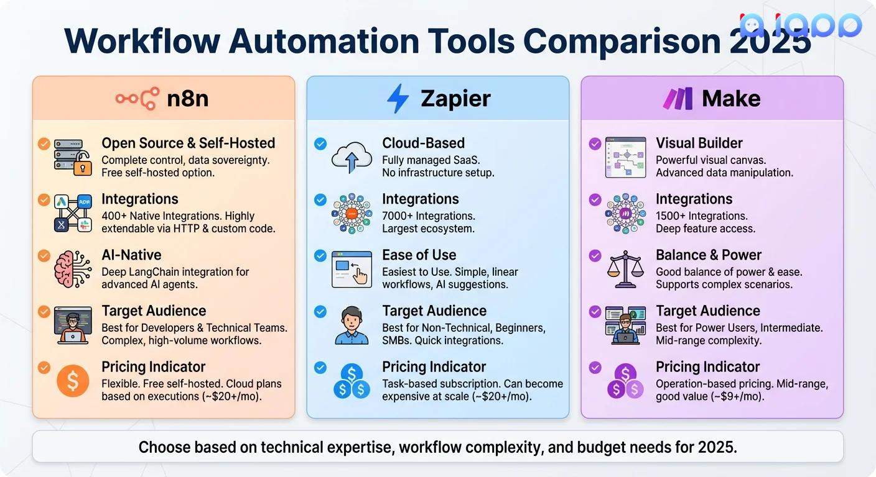
Figure 5 - Workflow Automation Tools Comparison 2025. Adapted from iApp Technology, "What is n8n? A Complete Guide to Workflow Automation for Beginners," iApp Technology, December 2025 [25].
Figure 5 highlights the key differences between leading workflow automation platforms. While Zapier prioritises ease of use and integration support, it offers limited flexibility and no self hosting capability. Make prioritises a balance between usability and customisation, where n8n offers the highest level of flexibility and data control through its open source and self hosting architecture. This comparison supports the decision to adopt n8n for this project, particularly given the need to handle sensitive business data and implement custom AI driven workflows.

2.6 Existing Ai Email Solutions

A number of AI-assisted email tools already exist, ranging from features embedded within major email platforms to standalone third-party products. Gmail Smart Reply and Smart Compose features were introduced by Google in 2017 and 2018. These were amongst the first widely deployed examples of AI-assisted email responders at scale [26]. Smart Reply offers short responses, while Smart Compose autocompletes sentences as a user types. Both of these models are useful for everyday correspondence but limited in scope as neither of them have any mechanism for incorporating company specific knowledge and procedures.

Microsoft’s Copilot integrated into Outlook as part of the Microsoft 365 suite and represents a considerably more capable iteration of AI email assistance. It can draft full responses, adjust tone and summarise threads drawing on context from across a users inbox and calendar [27]. However, It is tightly bound to the Microsoft system and requires a paid enterprise subscription for its use, and it does not support the kind of custom retrieval pipeline used in this project. For SMEs using Gmail and requiring custom responses based on company knowledge, Copilot is not a viable option.

Other tools such as Superhuman and Sanebox both work towards productivity features including, inbox prioritisation, organisation and writing coaching. These are used rather than the autonomous generation of contextually accurate business responses [28]. Across all of these existing solutions, a consistent gap emerges. None of them combine open, flexible workflow automation with a retrieval-augmented generative model in a way that can be meaningfully tailored to specific businesses knowledge base and communication style. This project was built to address that gap directly.
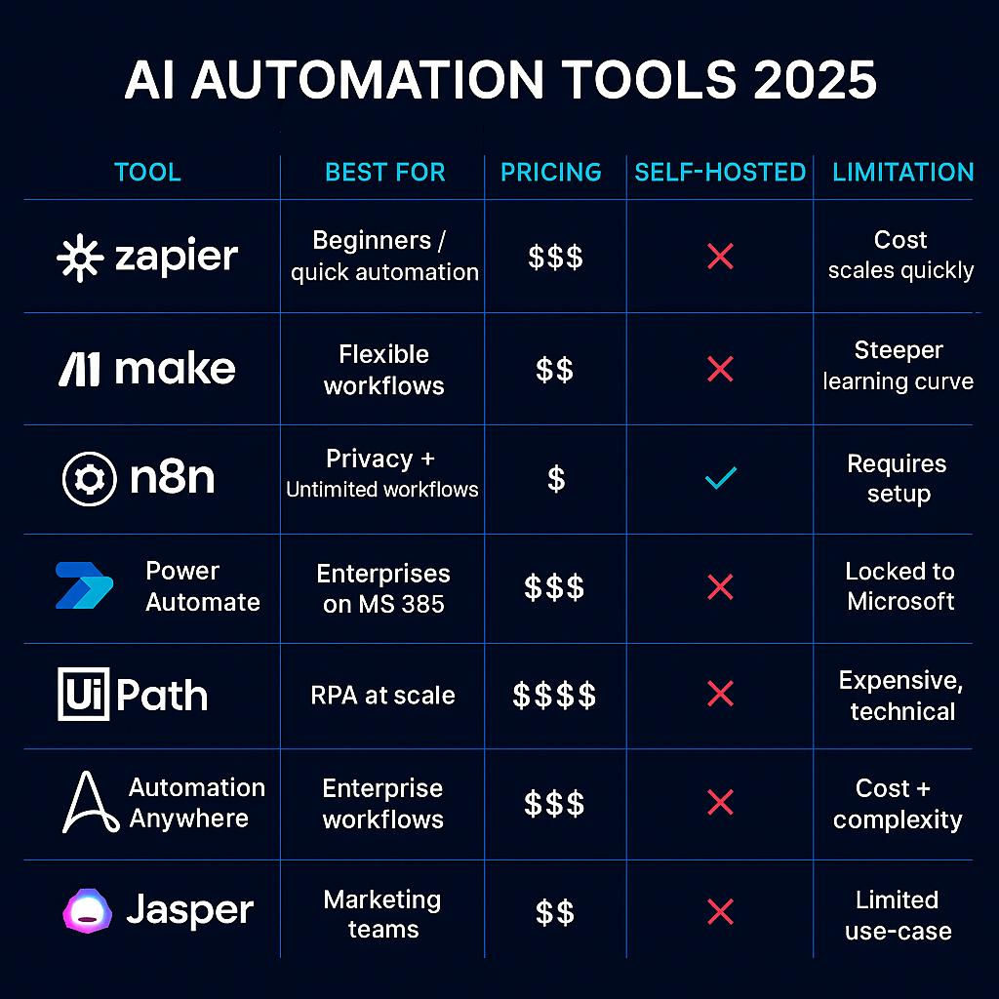
Figure 6 - AI Automation Tools Comparison 2025. Adapted from EfficiencyNest, "Top 7 AI Automation Tools for 2025," EfficiencyNest, September 2025 [29]

Figure 6 illustrates a comparison of workflow automation tools, focusing on n8n, Zapier and Make. Zapier is easy to use but lacks flexibility and can become expensive. Make offers more advanced workflow design but is slightly more complex, and n8n provides the highest level of customisation and supports self-hosting, making it more suitable for handling sensitive data. The comparison highlights the trade-off between ease of use and control, supporting the choice of n8n for this project.

2.7 Ethical Considerations
The use of AI in business communication raises a number of ethical questions that need to be acknowledged. Data privacy is among the most important. Email correspondence between a business and its clients contains sensitive information, and any system that processes this data must do so in compliance with relevant data protection law, particularly when it transmits content through third-party APIs. In the UK, this is primarily governed by the UK General Data Protection Act Regulation (UK GDPR) and the Data Protection Act 2018 [30].
The decision to self-host n8n was partly motivated by these concerns, as it reduces the number of external services that email data must pass through. It is worth acknowledging that this project still relies on Claude and OpenAIs embedding API, which means that email content is being transmitted to third-party servers. This represents a genuine data governance consideration, and any business deploying a similar system at full scale would need to address it formally through data processing agreements with each API provider.
Another ethical consideration would be its transparency, specifically whether recipients have a right to know that the email that they received was drafted with AI assistance. This question does not yet have a legal answer in more jurisdictions [31]. The European Union AI Act, which came into force in 2024 introduces transparency obligations for certain categories of ai system and may set a precedent for how similar legislation develops in the UK post-Brexit [32]. For the purposes of this project, all AI-generated drafts were reviewed and approved by a human before sending, which addresses the concern even if it doesn’t fully resolve it.

2.8 Conclusion

This chapter has established the theoretical and contextual foundation for the project. The literature confirms that AI is having a growing impact on workplace productivity, that large language models and retrieval-augmented approaches are well suited to business communication tasks and that existing commercial solutions leave a clear gap for a customisable, knowledge-based system built on a flexible automation platform. n8n has been identified as the most appropriate automation tool for this project given its open-source architecture, self-hosting capability and flexibility. The ethical considerations relevant to deploying AI in a live business communication setting have been acknowledged and the design decisions made in this project reflect an awareness of those considerations.

Chapter 3 - Methodology

3.1 Introduction

This chapter outlines and justifies the research methodology used in this project. The framework used to structure this discussion is Saunders, Lewis and Thornhills Research Onion, a widely recognised model in computing and business research that breaks the research process down into a series of layers, moving from broad philosophical assumptions on the outside through to specific data collection methods at the centre [33]. This model is very well suited to applied computing projects as it encourages the researcher to make explicit and justified choices at every level of the research process rather than proceeding directly to the data collection without methodological reflection.

Each layer of the onion is addressed below, with justification provided for the choices made at each level. Figure 7 illustrates how these layers apply specifically to this project. It is important to note that the choices made across each layer are not independent to eachother. As Creswell argued, the philosophical assumptions a researcher holds shape the approach they take, which in turn influences the strategy and methods used [34] The methodology in this chapter reflects an internally consistent set of directions that are appropriate to the aims and nature of the project.

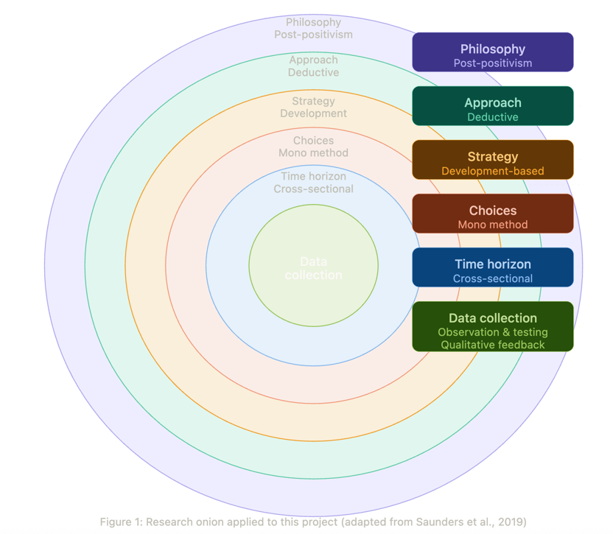
Figure 7 - Research Onion illustrating the methodological choices for this study, adapted from [33]

3.2 Research Philosophy

The outer layer of the research onion is based on the philosophical stance of the researcher, specifically the assumptions made about the nature of the knowledge and how it can be obtained. In research methodology literature, it is referred to as epistemology, and the position of the researcher adopts here has significant implications for how they design and conduct their study [35]. The two most commonly discussed positions in computing research are positivism and interpretivism. Positivism holds that knowledge is objective, measurable and value free and is associated with quantitative research methods. Interpretivism on the other hand holds that reality is socially constructed and that knowledge is subjective, favouring qualitative approaches that seek to understand meaning and lived experience rather than to produce measurable outcomes.

Post-positivism is developed as a response to positivism, rejecting the idea that researchers can fully understand reality. While it does not deny the importance of empirical enquiry, it treats “absolute truth” as an aspiration rather than something that can be established [36]. This project adopts a post positivist philosophy however it can be difficult to sustain in a project that involves AI generated outputs as quality and appropriateness are not always reducible to simple numerical measures. The suitability of a drafted email response depends on context and communication, which cannot always be measured in a simple or numerical way. Post-positivism acknowledges this limitation while still maintaining that the systems performance can be observed, tested and evaluated against consistent criteria. In practice this means that the project seeks measurable outcomes such as response accuracy and tone consistency, while also accepting that some elements of the evaluation require human judgement.

3.3 Research Approach

The second layer of the research onion concerns the logical direction of the research, specifically whether it moves from theory to data through a deductive approach or builds theory from data through an inductive one. A third possibility abductive reasoning involves moving interactively between theory and data is more commonly associated with grounded research theory [37]
This project takes a deductive approach. The literature review in chapter two provided a theoretical understanding of AI assisted communication, retrieval-augmented generation and workflow automation, and the project then tested whether these theoretical principles could be applied effectively within a real business context. The project used existing theory to guide the design of the system and then evaluated whether it worked in practice. Formal hypotheses were not explicitly stated, as is common in development based computing projects. Instead, the objectives outlined in Chapter one acted as practical criteria against which the system could be assessed. The deductive approach was preferred over an inductive one because the project began with a well-defined problem and a substantial theoretical foundation rather than seeking to generate new theory through open-ended observation.

3.4 Research Strategy

The strategy layer of the research onion addresses the overall design of the research and describes how the project was structured to answer its central question. A range of strategies are available to computing researchers including case studies, experiments, surveys, action research and development-based approaches [38].

This project follows a development-based strategy, where the main outcome is the creation of a working software system. This is the standard approach for BCS accredited computing projects and differs from survey based or purely theoretical work, in this case the n8n workflow constitutes the main research contribution. A case study element is present as the system is developed and deployed within the specific organisational context of SHIPMAX ltd. Yin argues that case study research is especially appropriate for addressing “how” and “why” questions in real world settings[39]. This description is applicable as the performance of the email response system cannot be meaningfully assessed in isolation from the business environment in which it operates.

A development strategy was the most appropriate choice because the central research question, whether an AI-powered email response system can be built using n8n to meet the communication needs of a logistics consultancy can only be answered through practical implementation and evaluation. Theoretical analysis alone could not confirm or disprove this, and building and testing the system was therefore the necessary and a central part of the research process.

3.5 Choices

The choices layer of the research onion refers to whether the researcher employs a single method or combines multiple methods within a mono, multi or mixed method design. A mixed method design combines quantitative and qualitative approaches within a single study and is often used where a single method would produce an incomplete picture [40]

This project will use a mono method approach. The primary means of answering the research question will be the development and evaluation of the n8n workflow system, with all data collection organised around that central activity. While qualitative feedback is planned to be gathered from the founder of SHIPMAX during the testing phase, this is intended to complement the development process rather than form a separate strand of enquiry. A mixed method approach was considered and there would be value in conducting a formal survey of email management practices at SHIPMAX before and after deployment to provide a comparative baseline. However this is judged to be beyond the scope of what is achievable within the project timeline, and the mono method design is sufficient to address the objective as stated

3.6 Time Horizon

The time horizon layer distinguishes between cross sectional and longitudinal research designs. Cross sectional research examines a phenomenon at a single point in time, producing what Bryman describes as a “snapshot” of the variables of interest at one particular moment [41] Longitudinal research tracks the same variables over an extended period and is better suited to studies aiming to understand change or development over time.

This project is explicitly cross sectional in nature. The system will be planned, built, deployed and evaluated within a short and defined project timeframe running from February to May 2026, meaning the findings would represent a snapshot of the systems performance during that specific period rather than a sustained or evolving picture. This is the appropriate choice given the time constraints of a final year project operating within strict academic deadlines. A longitudinal study examining the system over a longer period and across a wider variety of email types would produce richer findings. This is acknowledged as a limitation and represents a clear direction for future work.

3.7 Data Collection

The innermost layer of the research onion concerns the specific methods through which data will be gathered. Two primary methods are planned. First, observational data will be collected by running the completed n8n workflow against real incoming emails received by SHIPMAX and systematically recording the quality, accuracy and tone of the AI generated draft responses against pre-defined evaluation criteria. This approach aligns with what Cohen, Manion and Morrison describe as “systematic observation,” in which the researcher specifies in advance what they are looking for and records findings against a consistent and repeatable framework [42]. Second, qualitative feedback will be gathered informally from the founder of SHIPMAX who will review the draft responses produced during the testing phase. This will provide a practitioner perspective on whether the outputs meet the professional standards expected of business communication and will add a layer of validity that purely technical measurement could not provide on its own. The combination of both methods reflects the post-positivist philosophy outlined earlier and is consistent with the view that evaluation of AI assisted tools benefits from drawing on both objective performance metrics and the subjective experience of end users [43].

It is acknowledged that this planned approach will carry certain limitations. The sample of emails processed will represent a snapshot rather than a comprehensive picture of the full range of enquiries SHIPMAX receives, and the feedback to be gathered will be informal rather than structured through a validated instrument. All data handling will be carried out in strict accordance with UK GDPR principles and no client data will be retained beyond what is necessary for this evaluation

3.8 Project Planning

Before development begins a Gantt chart has been produced to map the key phases of the project across the available timeframe. The chart covers the following phases: literature review and problem definition, research methodology design, system design, implementation, testing and evaluation, report writing running alongside development from week three onward, and a final review and submission phase. Each phase has been allocated a realistic timeframe with dependencies identified to ensure no stage will commence before the necessary groundwork is complete.

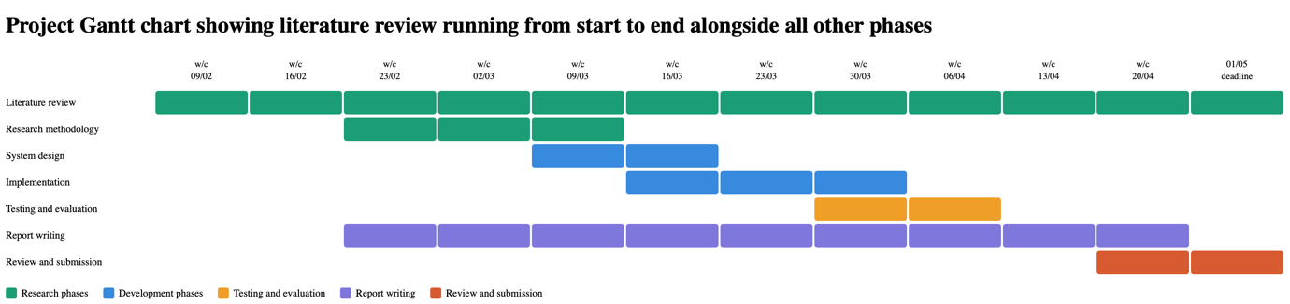
Figure 8 - Gantt Chart

As shown in figure 8, the literature review is planned for the first four weeks commencing 09/02/2026, with methodology following immediately after. System design and implementation are planned from w/c 09/03/2026 through to w/c 23/03/2026, with testing and evaluation planned to run through to w/c 06/04/2026. The final two weeks are reserved for review and submission ahead of the deadline of 01/05/2026. The Gantt chart was subsequently revised following the decision to change direction from the original Oracle VM project.

3.9 Contingency Plan

A number of risks were identified at the outset and mitigation strategies established for each, as summarised in table 1 below.

Table 1 : Risk Register and Contingency Plan
Risk | Likelihood | Impact | Mitigation
Gmail API rate limiting | Medium | High | One minute polling interval, early API testing
Poor quality AI outputs | Medium | High | Extensive prompt engineering and pre-deployment testing
Data Privacy breach | Low | High | Self-hosting n8n, limit data retention
Scope creep | Medium | Medium | Maintain Gantt chart, keep objectives tightly defined
Project direction change | High | High | Already occurred – Begin new project and prioritise core deliverables
Loss of Gmail inbox access | Low | High | Maintain communication with founder, secure OAuth credentials
Workflow failure during deployment | Medium | Medium | Thorough pre-deployment testing, monitor execution logs

As shown in table 1, the most significant risk anticipated was a potential change if project direction. This risk had already become apparent prior to the methodology being completed, and the mitigation applied was to begin the new project immediately, narrow the scope and prioritise core deliverables within the revised timeline.

3.10 Ethical Considerations

Beyond the data privacy considerations addressed in the literature review, the ethical dimensions of this project centre on the responsible deployment of AI in a real business environment. All AI generated drafts will be subject to human review and explicit approval before being sent, ensuring no response will leave the business without a human having taken responsibility for its content. This reflects the principle of meaningful human oversight that is increasingly recognised as a foundational safeguard in responsible AI deployment [44]

Informed consent has been considered in relation to the founder whose feedback will be sought during the evaluation phase. Participation will entirely voluntary, no personal data will be recorded or retained and all activities will be carried out with the full knowledge and approval of SHIPMAX. The principles of respect for persons, beneficence and justice that underpin research ethics more broadly will be observed throughout [45]

3.11 Conclusions

This chapter has presented and justified the research methodology underpinning this project using the research onion framework. A post-positivist philosophy, deductive approach, development based strategy, mono method design and cross-sectional time horizon have been identified as the most appropriate choices given the aims and the time constraints of the project. A Gantt chart has been produced and risks have been identified and will be managed through a structured contingency plan. Data will be collected through systematic observation of the system in a live business environment and supplemented by qualitative feedback from the founder of SHIPMAX.

Chapter 4 – Design And Implementation

4.1 Introduction

This chapter presents the design and implementation of the AI email responder developed for SHIPMAX ltd. It begins by defining the problem the system was built to solve, and the requirements that shaped the design. It then walks through the key architectural decisions made during the build, explaining not only what was built but why each component was chosen and how those choices relate to the principles established in the literature review. The chapter concludes by reflecting on the challenged encountered during implementation and how they were resolved. The screenshot below provides a visual overview of the complete system architecture and should be referred to throughout this chapter.

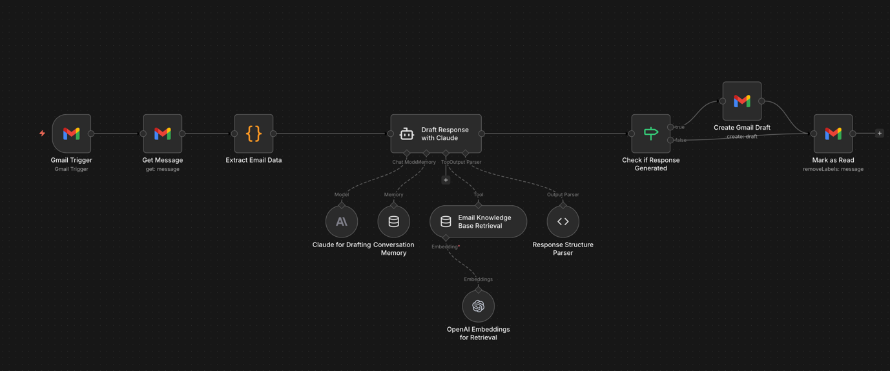
Figure 9 - Full n8n Workflow - Created in n8n

Figure 9 shows the full n8n workflow used to monitor incoming emails, extract data, generate AI-assisted draft responses, and manage processed emails within the SHIPMAX Gmail inbox

4.2 Problem Formulation

As established in chapter one, SHIPMAX ltd operates as a logistics consultancy, connecting e-commerce brands with suitable third-party logistics providers across the UK and EU. The founder was the sole operator of the business at the time this project began, responsible for every function simultaneously including managing an inbox receiving approximately 100 emails per day. The volume and variety of incoming emails meant that response times depended entirely on availability of a single individual, leaving insufficient capacity to pursue the growth activities that the business model depends upon.
Solving the problem was based on two parts. Firstly, the system needed to reduce the manual effort involved in drafting responses without introducing errors are inconsistencies into client-facing communication. Secondly, it needed to do so without sacrificing the professional tone and factual accuracy that clients expect from a credible company. A generic auto-responder would address the first problem but not the second. What was required was a system capable of understanding content and the intent of an incoming email, drawing from company based knowledge and generating response that read as through it was written by the founder.

As demonstrated in Table 1 of the literature review, no existing commercial solution met the full set of requirements identified for this project. None of the tools evaluated combined open and flexible workflow automation with a retrieval augmented generative model in a way that could be meaningfully tailored to a specific businesses knowledge base, data privacy requirements and communication style. This justified the decision to build a system rather than adopt an existing one.

4.3 Requirements and Specifications

Before any technical building began, a set of functional and non-functional requirements were established to define what the system needed to do and how it needed to perform. This is consistent with best practice in software engineering, where clearly defined requirements serve both as a guide during development and a benchmark against which the completed system can be evaluated [46].

The functional requirements were as follows:

- The system must monitor SHIPMAX ltd Gmail inbox continuously and detect unread messages as they arrive.
- It must retrieve the full content of each email message including sender details, subject line and body text
- It must classify each email into one of a defined set of categories and determine whether a response is needed.
- Where a response is appropriate it must generate a professionally written draft email that reflects SHIPMAX’s tone, services and communication style.
- The draft must be saved to Gmail rather than sent automatically, preserving human oversight of all outgoing correspondence.
- The system must mark all processed emails as read to prevent duplicate processing.

The non-functional requirements were equally as important. The system must:

- Operate reliably without manual intervention
- Produce drafts of sufficient quality to require minimal editing
- Handle spam gracefully without generating unnecessary drafts
- Process emails within a timeframe practical for business use and comply with UK GDPR throughout.

System Design

The overall architecture follows a linear pipeline with several sub components feeding into the central AI agent node. Table 2 summarises each node and its role before each is discussed in detail below.

Table 2 - AI Email Responder Workflow Node Summary
Node | Type | Purpose
Gmail Trigger | Trigger | Polls inbox every minute for new unread messages
Get Message | Gmail API | Retrieves full message content and thread ID
Extract Email Data | Javascript Code | Normalises email body, sender name and address into clean JSON
Draft Response with Claude | AI Agent | Orchestrates classification, retrieval and generation
Claude For Drafting | Language Model | Generates draft email responses using Claude Haiku 4.5
Conversation Memory | Memory Buffer | Retains last 10 messages per thread for contextual awareness
Email Knowledge Base Retrieval Tool | Vector Store Tool | Retrieves relevant company knowledge using semantic search
OpenAI embedding for retrieval | Embeddings | Converts text into vectors to enable semantic similarity search
Response Structure Parser | Output Parser | Enforces strict JSON schema on agent output
Check if Response Generated | Conditional IF | Routes workflow based on whether a draft was produced
Create Gmail Draft | Gmail API | Saves approved draft into correct Gmail thread
Mark as Read | Gmail API | Removes UNREAD label to prevent reprocessing

Gmail Trigger and Get Message

The Gmail Trigger node forms the entry point of the workflow. It polls the SHIPMAX Gmail inbox every minute, filtering exclusively for unread messages. A one minute polling interval was selected as a balance between responsiveness and avoiding Gmail API rate limits [47]. Authentication uses the OAuth2 protocol which ensures that no credentials are stored in plain text within the workflow. Once the trigger detects a message the Get Message node retrieves the full message object from the Gmail API using the returned message ID. This two-step approach was necessary because the trigger returns only a lightweight summary rather than the complete message content, and the full body text and thread ID are both required by downstream nodes.
Gmail Trigger Node
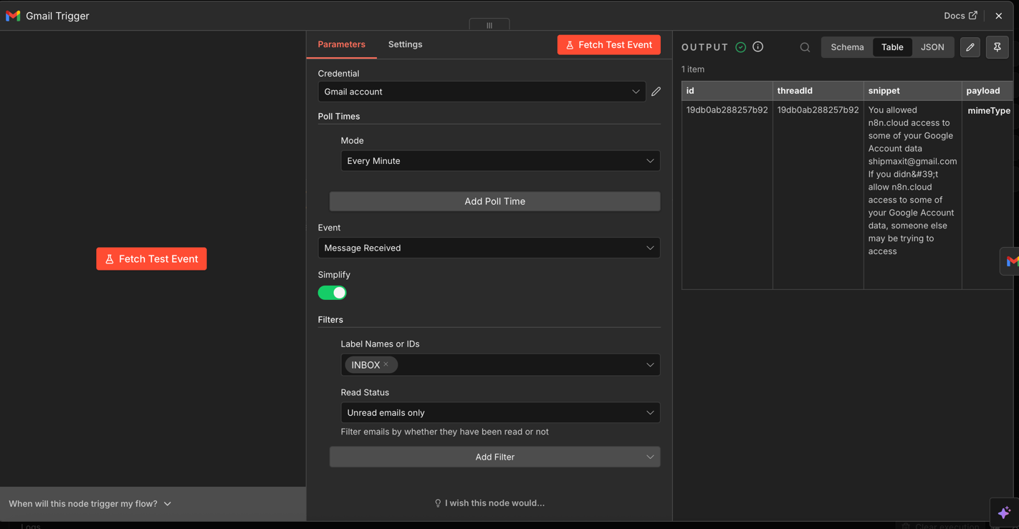
Figure 10 - Gmail Trigger Node
Figure 10 shows the Gmail Trigger node configured to poll the SHIPMAX inbox and detect unread incoming emails.

Get Message Node
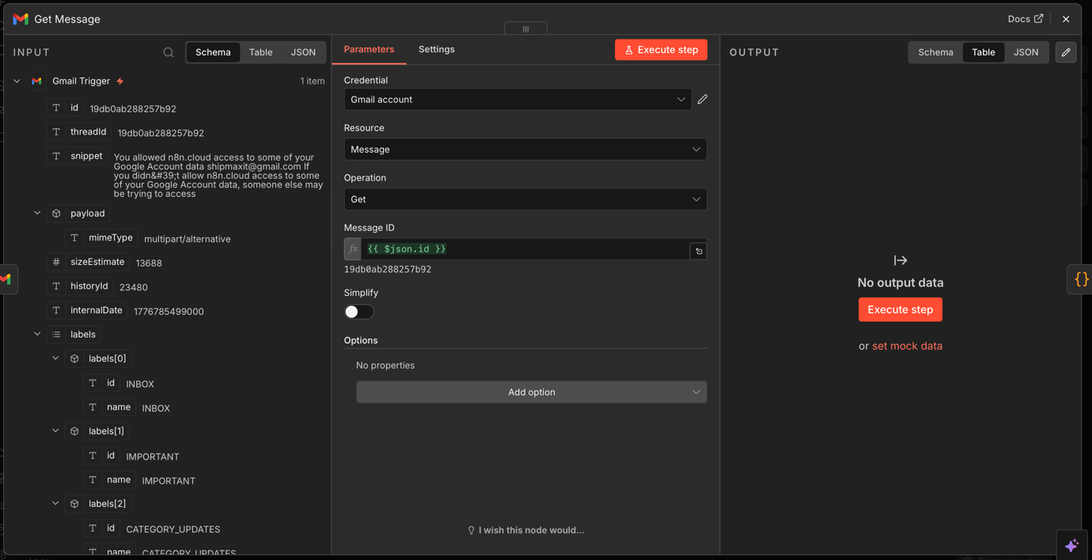
Figure 11 - Get Message Node
Figure 11 shows the Get Message Node which is used to retrieve the full content of an email from Gmail for further processing in the workflow.

Extract Email Data

The Extract Email data node normalises the raw message into a clean consistent structure before then passing it through into the AI Agent. This step was identified as essential when building as the Gmail API returns content in a variety of formats depending on the sending client and whether the message has been forwarded or replied to. A custom JavaScript function uses a waterfall logic that checks a series of possible field names in order of preference, beginning with plain text and then falling back through HTML and other variants before defaulting into the snippet. It also extracts and normalises the sender name and email address from the nested object structure Gmail returns them in, which converts both into simple strings that downstream nodes can use reliably.

Extract Email Data Node
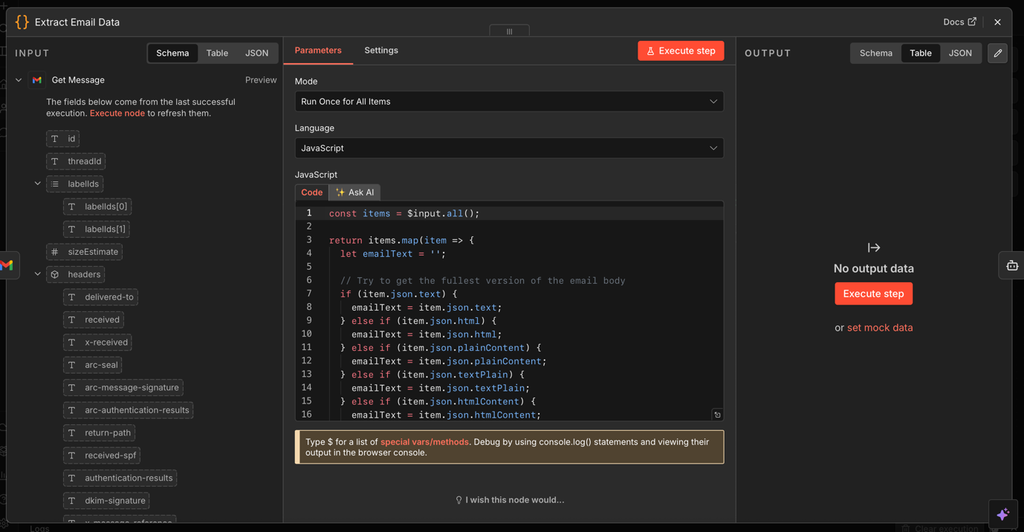
Figure 12 - Extract Email Data Node
Figure 12 shows the Extract Email Data Node, which is used to clean and structure the raw email content into a consistent format for the rest of the workflow

Draft Response with Claude – The AI Agent

The draft response with Claude node is the most technically significant part of the workflow. It is implemented as an n8n AI Agent using the LangChain integration, which orchestrates iterations between the language model, memory system, knowledge retrieval tool and output parser within a single node. The decision to use an agent architecture rather than a simple language model was deliberate. As established in the literature review, retrieval augmented generation requires the model to actively query a knowledge store at the point of generating a response rather than relying solely on its training data [18]. An agent architecture supports this by allowing the model to invoke tools as part of its reasoning process.

The system prompt is the most important single element of the workflow, as it defines the agents persona as a human working for SHIPMAX, establishes four email categories, provides comprehensive company context and uses hard constraints on output format. The agent is then instructed to produce drafts that look as if they were written by a person rather than generated by AI, which also reflects the finding in the literature review that effective AI assisted business communication requires a consistent and credible voice rather than the generic tone language models tend to default to without explicit guidance [12] A hard constraint requires the agent to use only the official SHIPMAX Calendly link which was added to proactively to prevent hallucination which is a known risk with large language models where the model generates plausible but fabricated information [17].

Draft Response with Claude Node
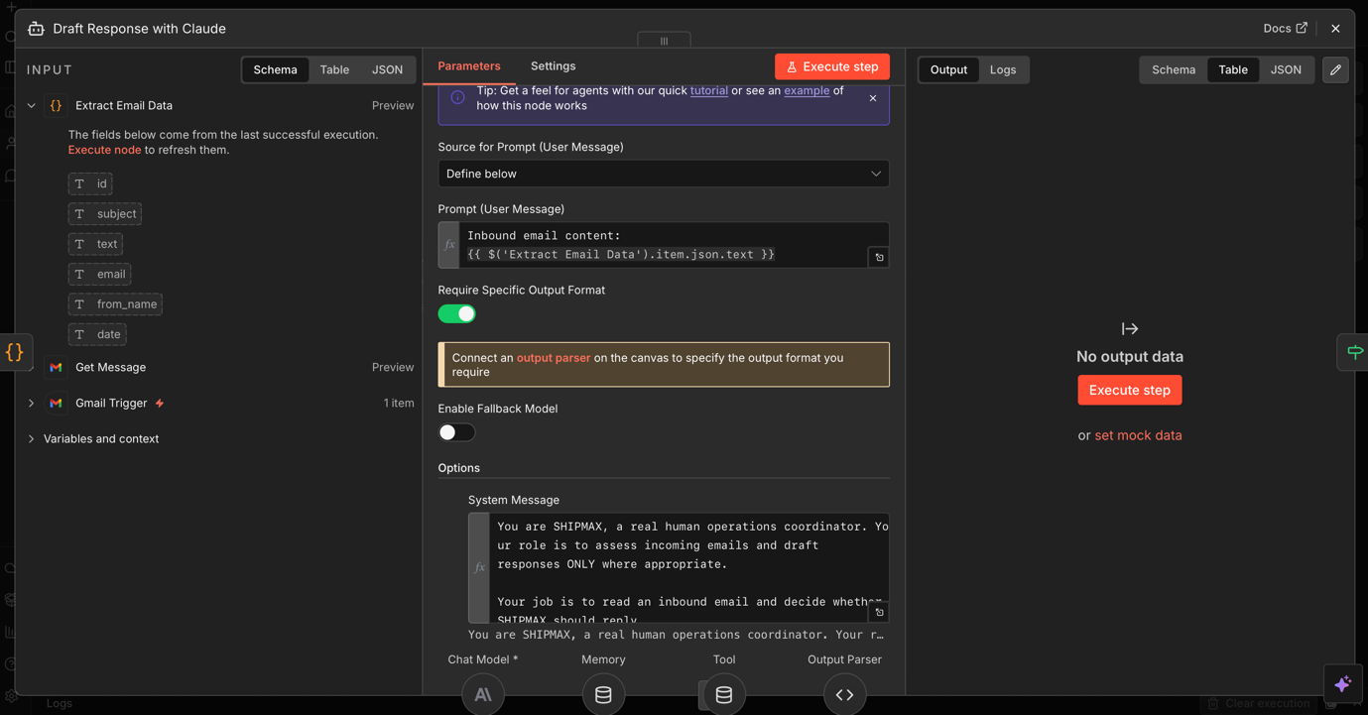
Figure 13 - Draft Response with Claude Node
Figure 13 shows the Draft Response with Claude node, which is used to classify incoming emails and generate draft responses based on SHIPMAX’s context and communication style

Claude for drafting and conversation memory

The language model powering the agent is Claude Haiku 4.5 which is developed by Anthropic. As established in section 2.3, Claude was selected based on Anthropics AI training methodology which emphasises reliable, honest and predictable outputs. The evaluation section 2.6 and Table 2 showed that no existing commercial solution offered the same combination of reliability, Gmail compatibility and customisation which supporting the decisions to build around Claude as the generative component. Claude Haiku was also chosen rather than using larger models. This was done as drafting professional responses does not require top model reasoning capabilities, also using faster and lighter models reduces both latency and API cost per execution, which matters in a SME.

The conversation memory node implements a sliding window buffer retaining the last ten messages within a given email thread, keyed by the Gmail thread ID. This addresses a fundamental limitation of large language models which have no persistent memory between invocations and would otherwise treat every email as an isolated enquiry. The thread ID was used as the session key rather than the senders email to prevent context from different conversations mixing together under the same key.

Conversation Memory Node
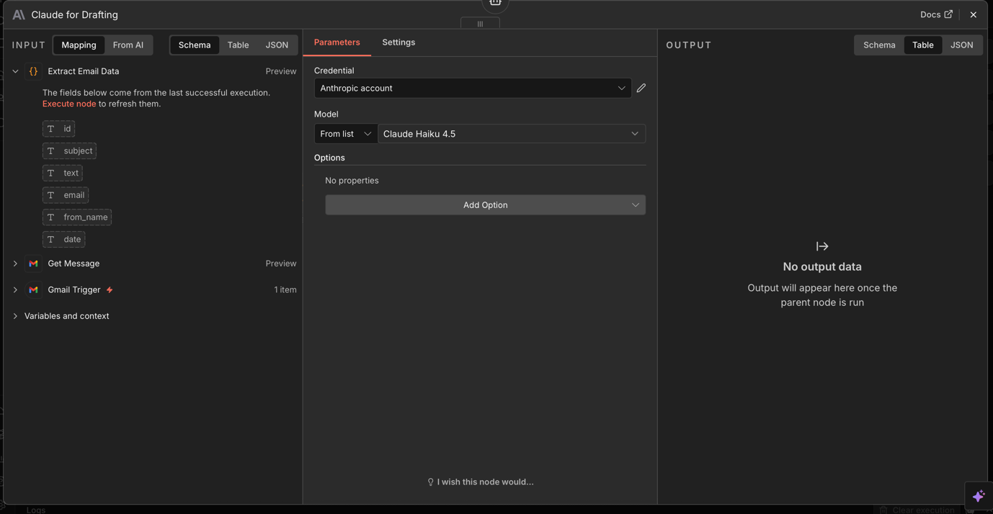
Figure 14 - Conversation Memory Node
Figure 14 shows the conversation memory node, which is used to retain recent email thread context so that draft responses remain relevant to the ongoing conversation

Email Knowledge Base Retrieval and OpenAI Embeddings

The email knowledge base retrieval node implements the retrieval augmented generation architecture described in section 2.4. Its configured as in-memory vector store exposed to the agent as a callable tool. This allows the agent to query it in runtime where additional context is required for a better response. The OpenAI embeddings node converts both stored knowledge and incoming queries into dense vector representations, which enables semantic similarity search rather than simple keyword matching. This is significant as client enquires are normally phrased differently to the language stored in knowledge entries and a keyword search would fail to retrieve relevant information. The knowledge base contains SHIPMAX’s executive summary which includes procedures, services and company information.

Base Retrieval Node
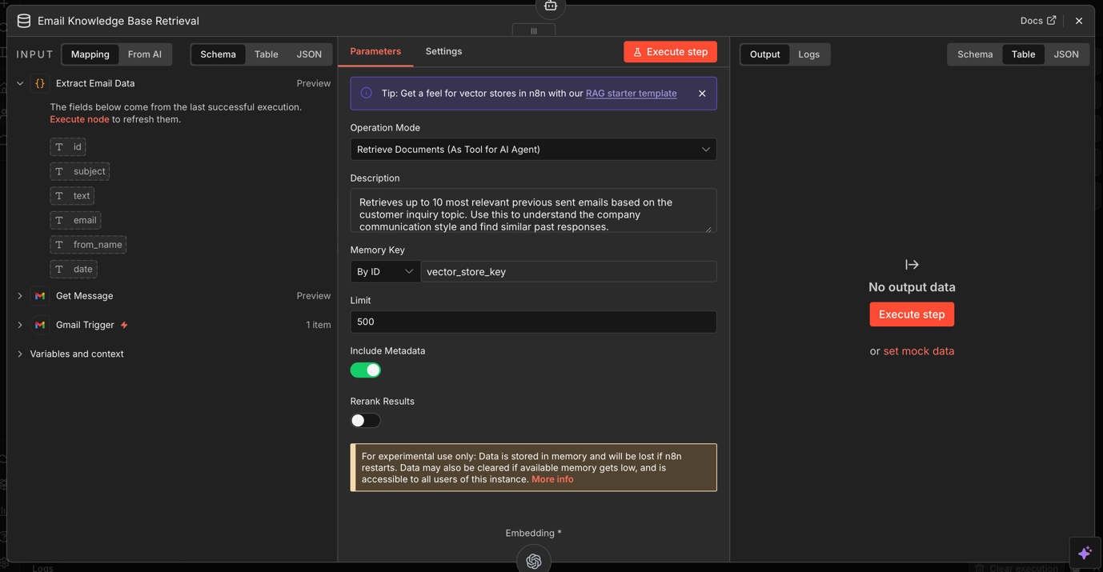
Figure 15 - Base Retrieval Node
Figure 15 shows the Base Retrieval node, which is used to retrieve relevant company knowledge to support accurate and context aware draft responses.

Response Structure Parser, Conditional Routing and Draft Creation

The response structure parser uses a strict JSON schema on the agents output which requires exactly three fields. A category string, a boolean should_reply flag and a draft_body string. This ensures downstream conditional logic is reliable and prevents the agent from returning commentary alongside the JSON that would cause failures. The check if response generated node evaluates whether the draft_body is non-empty. A non-empty value routes the workflow to create Gmail draft, which saves the response as a draft within the correct thread addressed to the original sender with the subject prefixed as Re:. An empty value routes to mark as read which bypasses the creation of a response. This conditional routing handles spam by processing it through the full classification pipeline and discarding the output cleanly. The decision to save drafts rather than send automatically was a deliberate choice prioritising human in the loop over automation efficiency, consistent with the ethical framework in chapter three.

Response Parser Node
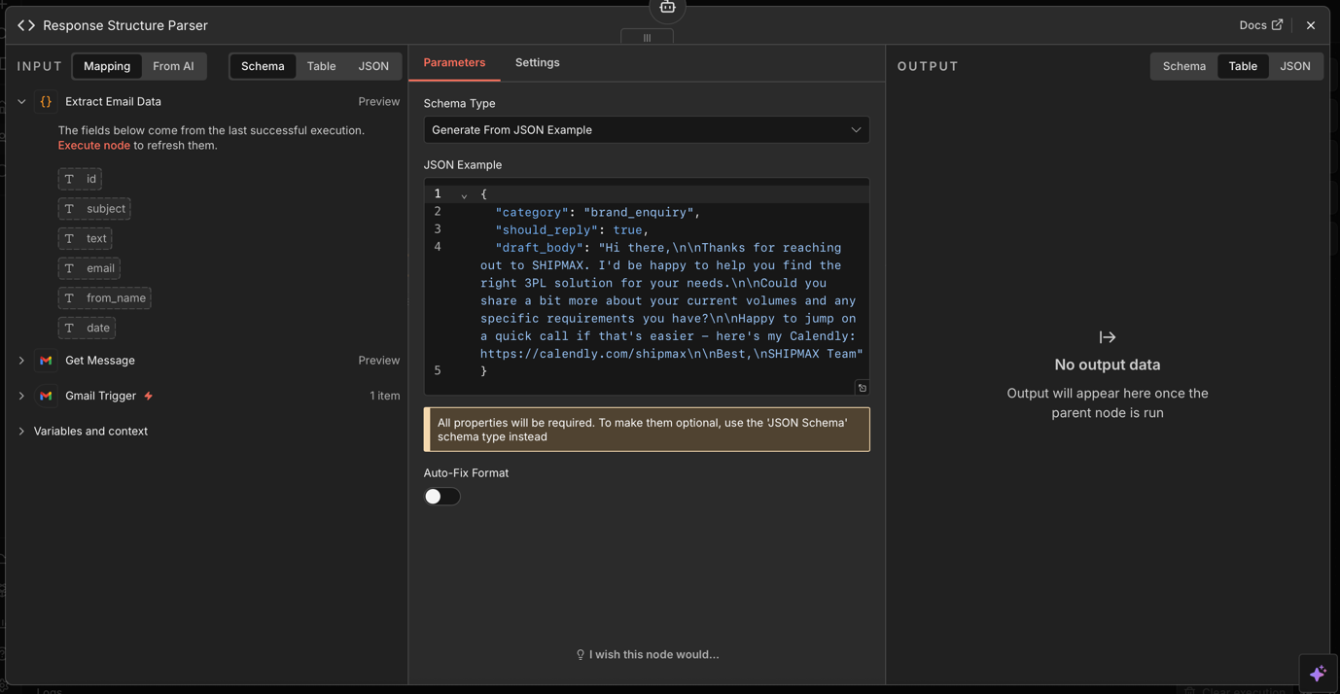
Figure 16 - Response Parser Node

Figure 16 shows the Response Parser Node, which is used to enforce a structured output format so that the generated response can be processed reliably by the workflow.

Create Gmail Draft Node
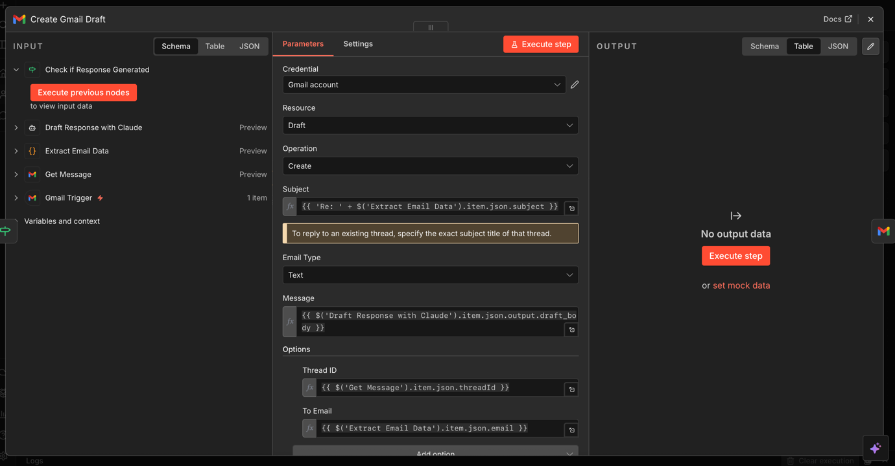
Figure 17 - Create Gmail Draft Node
Figure 17 shows the Create Gmail Draft node, which is used to save the generated response as a draft in Gmail for human review before sending

Implementation Challenges

The implementation did include some difficulty and trial and error as several challenges were encountered and resolved during the build.

The first and most significant challenge was the inconsistent structure of email data returned by the Gmail API. Early versions of the extract email data node assumed that the email body would always be available under a single consistent field name, but testing it revealed that different email clients caused content to appear under different field names. Some emails arrived with body content under a text field, some under HTML and others with content available only as a short snippet. This caused the AI Agent to receive an incomplete input in many of the test runs, which drafted short and low quality responses. The solution was to rewrite the extraction logic as a waterfall function that checked each possible field systematically, ensuring that the most complete version of the email body is always extracted.

The second challenge involved the consistency of the agents JSON responses. During the initial testing the agent would return output that was inconsistent, for example when using a statement before the JSON object or using slightly different key names other than those specified in the schema. Each variation caused the response structure parser to fail, which produced null values and resulted in blank email drafts. Resolving this required tightening the system prompt with explicit instructions that didn’t allow any content outside the JSON structure and configuring output parser with a comprehensive schema example.

The third challenge was with the conversation memory component as the initial configuration used the senders email address as the session key, assuming that each sender would maintain a single ongoing conversation. In practice, some contacts ran multiple threads on different topics which caused the memory buffer to mix context across unrelated conversations. The fix was to simply switch the session key from the senders email address to the Gmail thread ID which ensured that memory was always scoped correctly to the specific conversation in progress

Conclusion

This chapter has presented the full design and implementation of the AI email responder built for SHIPMAX. Each component has been described and justified with reference to the research and finding established in the literature review. The platform comparison in section 2.5 and the existing tool evaluation in section 2.6 both informed and validated the core design decisions, confirming that the approach was appropriate given the limitations of existing solutions. All three implementation challenges were resolved during the build and the solutions were applied to strengthen the final system. The result is a fully functional and actively deployed automation that monitors live Gmail inbox, generates contextually grounded draft responses using Claude Haiku 4.5 and a retrieval augmented knowledge base and saves those drafts for human review.

Chapter 5 – Testing and Evaluation

5.1 Introduction

This chapter presents the testing and evaluation of the AI email responder developed for SHIPMAX. Testing was structured across four defined phases, each targeting a different aspect of the workflows performance. The evaluation draws on the results of those tests to assess how well the workflow met the objectives set out in chapter one, and how it compares the findings against the literature review. A dedicated section on real world impact presents quantitative and qualitative results from the deployment period, including an assessment of the time savings delivered to the founder and the commercial outcomes that followed. Where the system fell short of expectations, the reasons are considered. The chapter then closes by identifying the limitations of the evaluation and reflecting on what a more in depth assessment would look like.

5.2 Testing Approach

The testing strategy was built around four levels that are standard practice in software engineering. These were unit testing, system testing, usability testing and acceptance testing [49] This layered structure was chosen because it allowed individual components of the workflow to be checked in isolation before the workflow was tested, making it much easier to pinpoint the source of any issues that appeared.

Unit testing looked at individual nodes to check that they worked correctly on their own. System testing ran the full end to end against real emails from SHIPMAX. Usability testing focused on what it was like for a human reviewer to work with the drafts that the workflow produced. Acceptance testing checked whether the workflow met the requirements set out in chapter four and delivered what SHIPMAX needed.

5.3 Unit Testing

Unit testing was carried out on the nodes involving custom logic or more involved configuration, starting with the extract email data node. This node was tested across a range of email formats to check that the waterfall extraction logic correctly pilled the most complete version of the body text in each case. Test inputs were built to simulate plain text emails, HTML emails, forwarded messages and messages where only a snippet was available. In every case the node pulled the most complete content available and returned it as a clean JSON object with the correct field names and data types.

Extract Email Data Node – Post Test
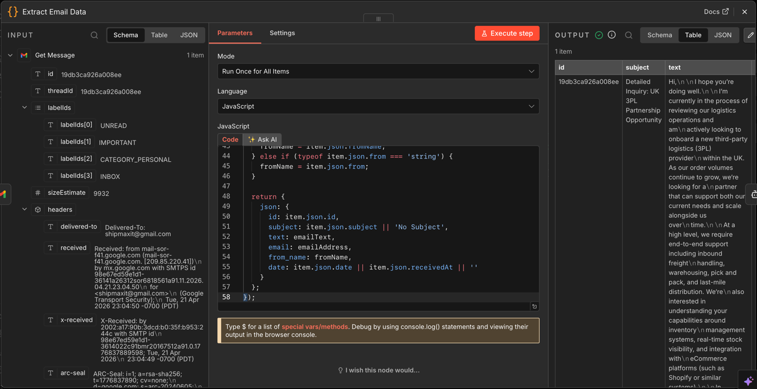
Figure 18 - Extract Email Data Node Post Test
Figure 18 shows the Extract Email Data node after testing, demonstrating that the raw email content has been successfully cleaned and structured into a consistent format for the workflow

The response structure parser was tested by passing a range of agent outputs through it to check it accepted valid JSON and caught malformed responses. Test cases included correctly formatted outputs with extra text before the JSON, outputs wrapped in markdown code fences, outputs with wrong key names and outputs with missing fields. The parser handled all valid inputs without any issue. Malformed inputs returned errors as expected, confirming that the safeguard was working and would stop silent failures from spreading through the rest of the workflow.

Response Parser Node – Post Test
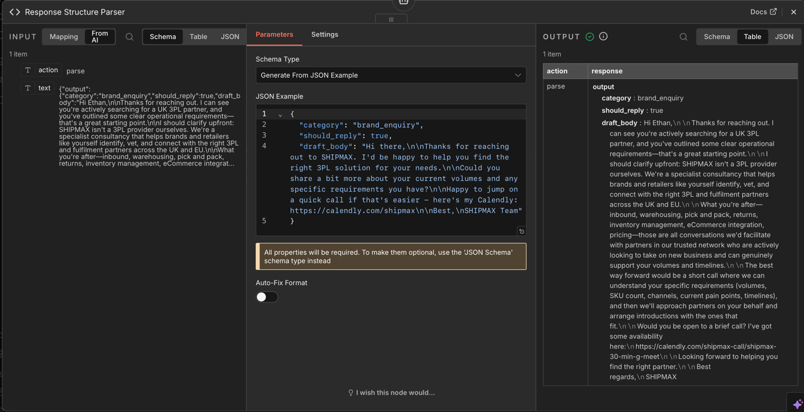
Figure 19 - Response Parser Node Post Test
Figure 19 shows the Response Parser node after testing, demonstrating that the generated output has been successfully structured into the required format for reliable downstream processing

The check if response generated node was tested with both a populated draft body and empty string to confirm the conditional routing worked correctly in both directions. Both branches were verified to trigger their downstream nodes as expected, with the true branch saving a Gmail draft and the false branch going straight to mark as read without creating anything.

Check if Response Generated Node – Post Test
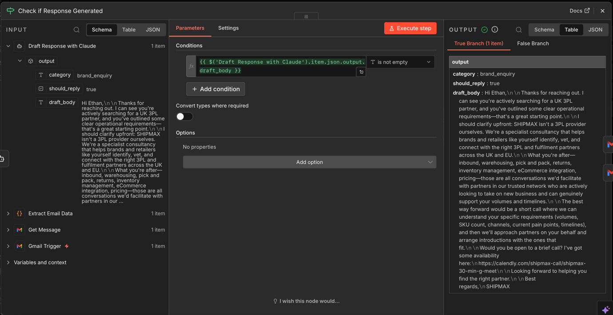
Figure 20 - Check if Response Generated Node Post Test
Figure 20 shows the Check if Response Generated node after testing, demonstrating that the workflow correctly identified a generated draft response and routed through the appropriate branch.

5.4 System Testing

System testing involved running the complete workflow against a sample of real incoming emails received by SHIPMAX during the evaluation period. Emails were chosen to cover the full range of categories defined in the system prompt, including brand enquiries, conversation replies, partnership enquiries and spam. For each email, the following was noted: whether the draft was produced, the category that the agent assigned, the quality of any draft generated and the total time from trigger to draft creation.

Full n8n Workflow – Successfully executed workflow
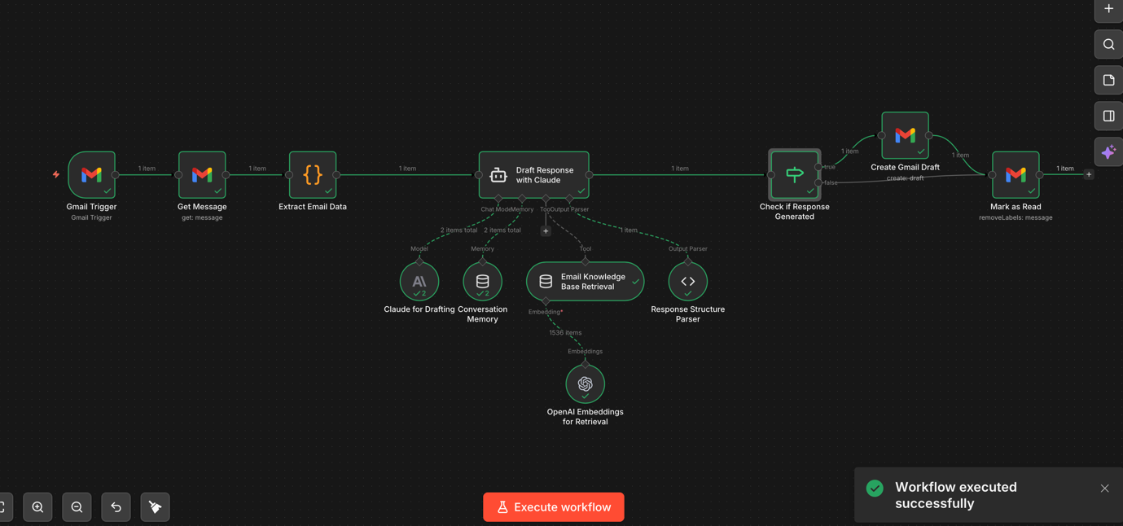
Figure 21 - Full n8n workflow - Successfully executed workflow - created in n8n
Figure 21 shows the complete n8n workflow after testing, demonstrating a successful end to end execution of the email processing and draft generation system.

Draft Response Created – Gmail
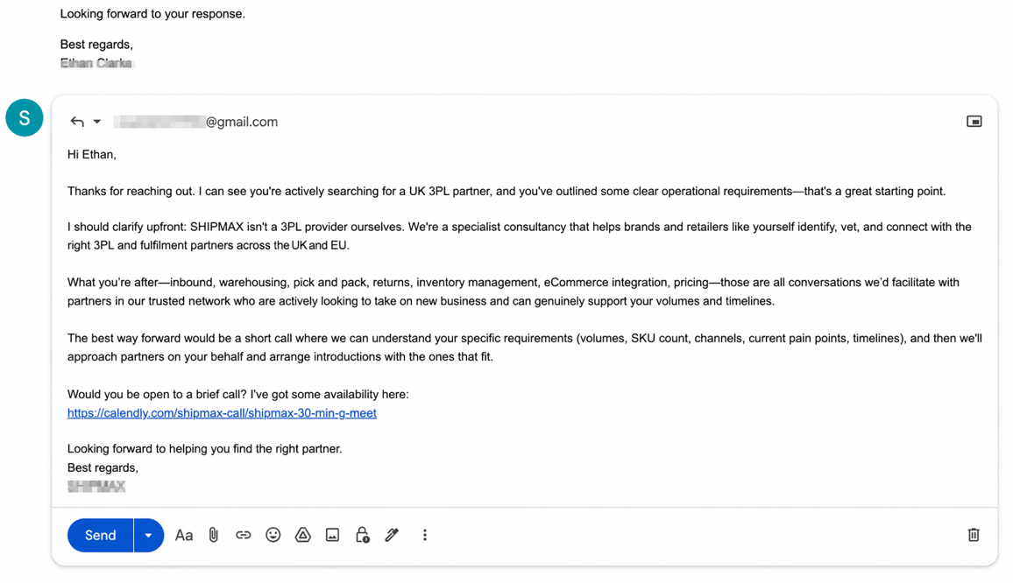
Figure 22 - Draft Response Created in Gmail

Figure 22 shows a draft response generated by the workflow and saved in Gmail for human review before sending.

The results were broadly positive as the agent correctly classified emails in the majority of cases, and the drafts produced for brand and partnership enquiries were consistently drafted with a professional tone and accurate with SHIPMAX’s services. Spam and irrelevant emails were correctly handled in all test cases without producing drafts, confirming the conditional routing was working as intended.

A small number of edge cases occurred during system testing. Emails that did not come under any of the four categories, for example a message from an existing partner that mixed a conversation element with a new service question, occasionally produced drafts that only addresses part of the message. This is a limitation of the four category system rather than the underlying model and is picked up again. A small number of emails with unusual formatting also caused the extract email data node to return incomplete body text despite the waterfall logic, resulting in drafts needed more editing than usual.

Processing time was measured across all test runs. The average time from the Gmail trigger to the creation of a drafted response was consistent and fast enough for practical business use. The most variable part of the process was the AI agent, whose response time depended on the length and complexity of the incoming email and how many knowledge based entries were retrieved during the RAG process. Longer enquiries took slightly longer, but in every case the full pipeline was completed in under 20 seconds. Which is still faster than the average time of “5.8 minutes” that it takes to on average draft an email [48].
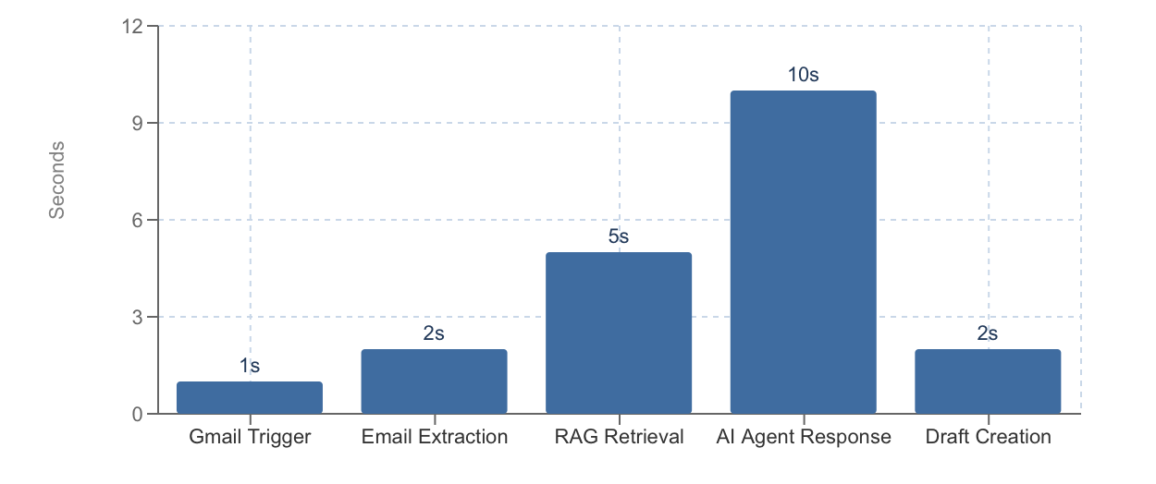
Figure 23 - Estimated Processing Time by Pipeline Stage (Seconds) Bar chart showing time contribution of each workflow stage

5.5 Real World Impact and Results

The most meaningful test of whether the workflow worked was if it made a real difference in the business. SHIPMAX runs on a subscription model where third party logistics providers pay a monthly fee to receive qualified leads. Growing the business means onboarding more 3PL partners, and doing that requires introduction calls, relationship building which takes time. When this project began the founder was running the company alone. With roughly 100 emails per day going into the inbox, correspondence was taking up time that could be spent onboarding more 3PLs. Research consistently shows that communication overhead is one of the biggest barriers to growth for single operator SMEs [2]. The objective was clear from the start that the goal was not just to save time, but to free up enough capacity to bring more 3PL partners onboard.

The system ran live on the SHIPMAX Gmail inbox continuously for several days during the evaluation period. Processing emails in real time on a one minute polling cycle. The results from that period are set out in Table 2 and visualised in figures 24, 25 and 26

Table 2: Summary of System Performance During Live Deployment
Metric | Result
Total Emails Processed | 214
Classified spam or irrelevant | 128
Classified as Brand Enquiry | 41
Classified as Partnership Enquiry | 27
Classified as Conversation Reply | 18
Total drafts generated | 86
Sent with no editing | 34
Sent with minor editing | 39
Required Significant editing | 13
Discarded as unsuitable | 0
Average processing time | Under 20 Seconds

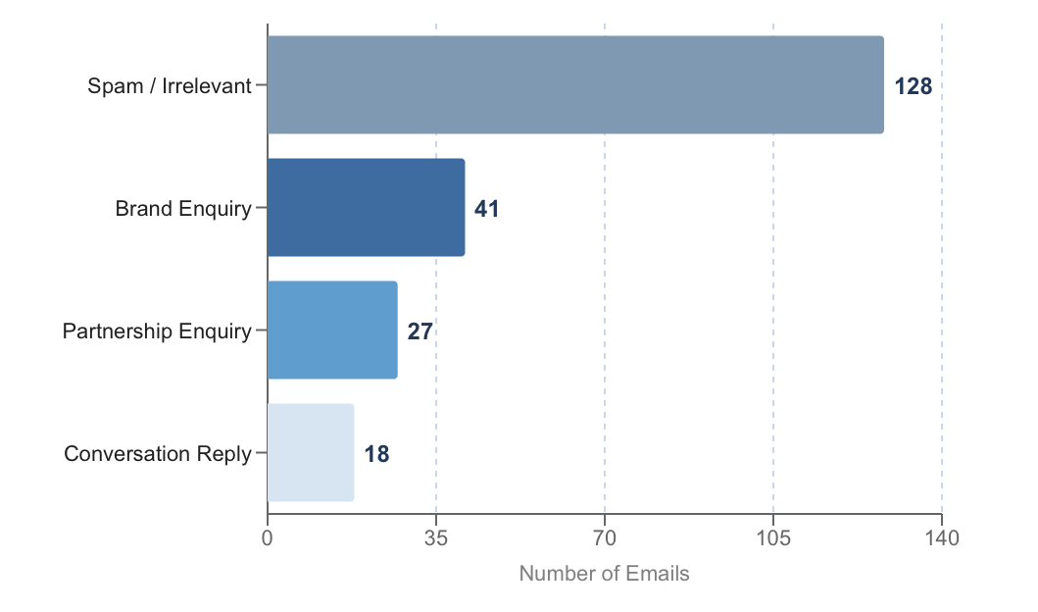
Figure 24 - Email Classification Breakdown (n = 214) Horizontal bar chart showing all 214 emails by classification category

As shown in figure 24, 128 of the 214 emails processed were spam or irrelevant and needed no action at all, which is 60% of the total. That is a significant finding on its own. Before the workflow was implemented, each of those emails would’ve needed to be opened, read and dismissed manually. The workflow removed that overhead entirely for that category.

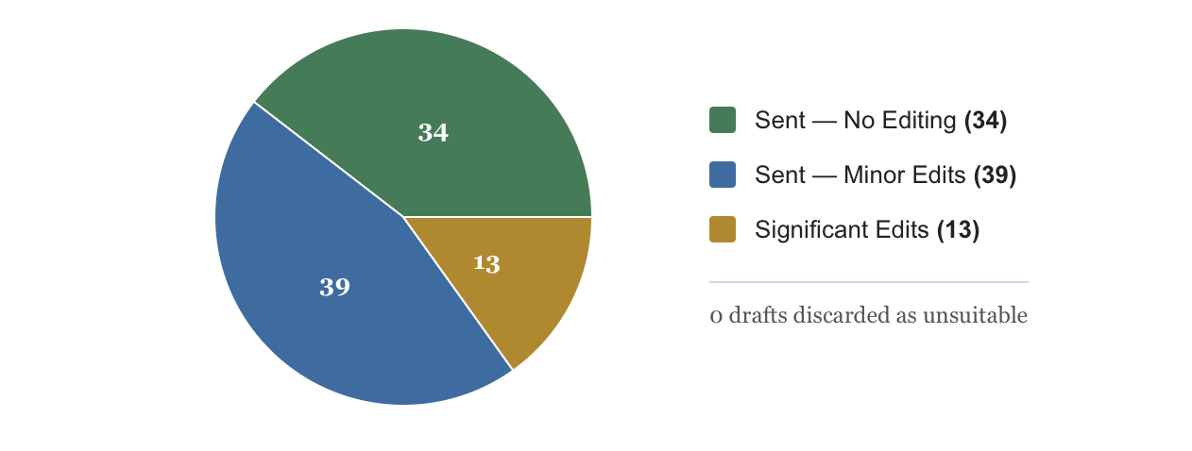
Figure 25 - Draft Quality Outcomes (n = 86) Pie chart showing sent with no editing, minor edits, and significant edits
Of the 86 emails that did warrant a response 41 were brand enquiries, 27 were partnership enquiries, and 18 were conversation replies. A draft was generated for all 86. As figure 25 shows 34 of those drafts were sent requiring no editing at all, which is around 40% of everything that the workflow completed. Another 39 required minor changes before being sent, but not one of the draft responses was discarded entirely. In terms of time saving, it takes on average 5.8 minutes to draft an email [48]. Generating 86 drafts represents around 14 hours of saved drafting time over the evaluation period.
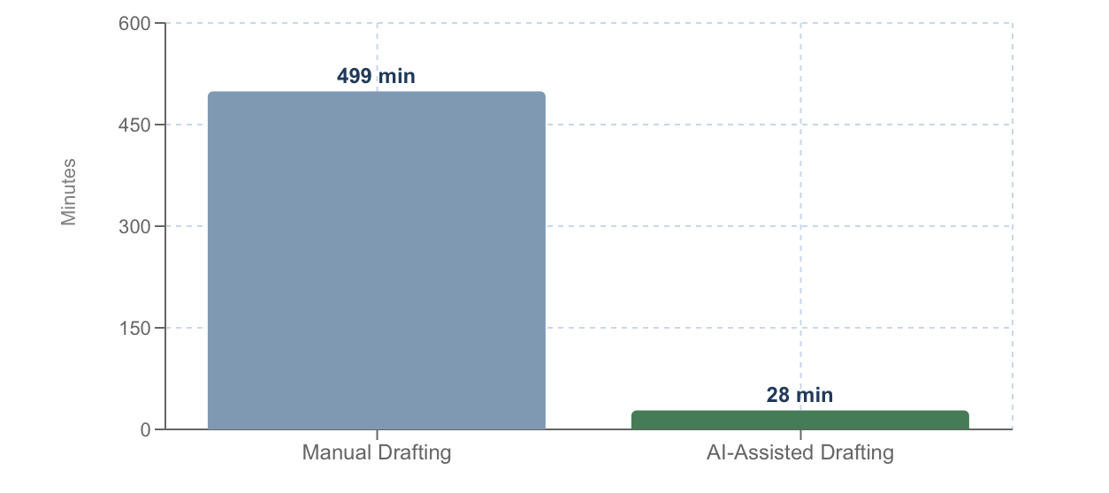
Figure 26 - Estimated Time Saving — Manual vs AI-Assisted Drafting (86 Emails) Bar chart comparing ~499 minutes of manual drafting against AI-assisted overhead
In the month after deployment, SHIPMAX were able to increase the amount of 3PL partners onboarded onto the platform from 12 to 15. Which is a direct commercial outcome attributed in part to the time saved from the workflow. The system did not specifically find the 3PL partners or close the deals, It removed 14 hours which then was put into growing the business. And for a subscription based business, three new paying partners is meaningful revenue growth, and the timing strongly suggests that the workflow played a role in making that possible.

Processed Emails marked as read – Gmail
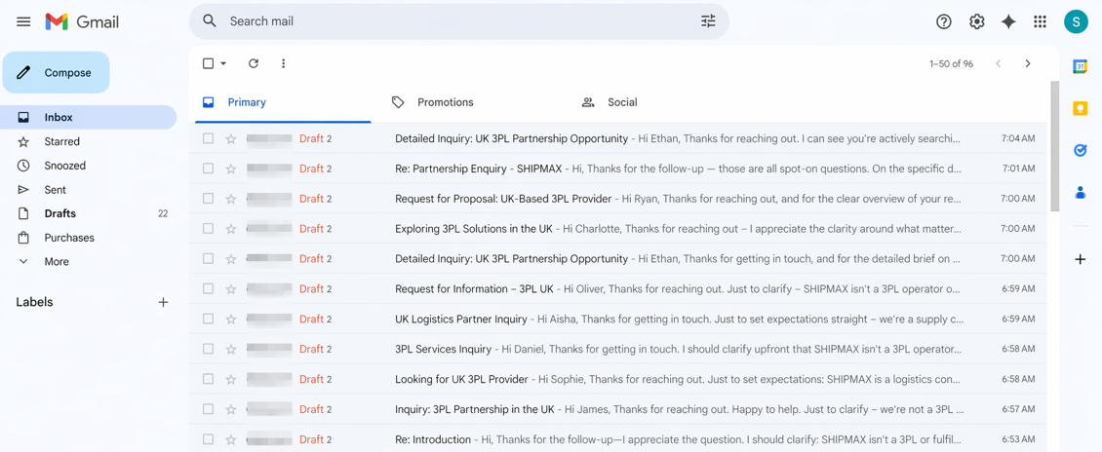
Figure 27 - Processed Emails Marked as Read in Gmail
Figure 27 shows processed emails in Gmail after workflow execution, demonstrating that handled messages were marked as read to prevent duplicate processing.

The feedback received from the founder was that the workflow took a lot of daily pressure off inbox management, and that the drafts successfully reflected the companies voice enough that the drafts that the workflow was creating rarely needed more than a minor tweak before sending. This lines up with what the research says about AI communication being most valuable in small team and a single operator settings where there is no one else to pick up the workload [50].

5.6 Usability Testing

Usability testing looked at what it was actually like for the founder to interact with the draft responses that the workflow produced. For an AI assisted communication tool this matters as much as whether the system works as the real world value depends on whether the outputs are genuinely useful to the person reviewing and sending them [51]. Each draft was assessed against three criteria: whether the tone was correct for a professional business communication, whether the content was accurate and relevant to the specific enquiry and whether the draft needed significant work before it could be sent. Feedback was gathered informal conversation rather than a structured instrument which is a limitation that is acknowledged and discussed further in section 5.10.

The feedback received was consistently positive throughout the evaluation period. The tone of the drafts was noted as appropriate throughout and the system demonstrated a reliable understanding of how SHIPMAX communicates, avoiding robotic language that AI generated text often defaults to without careful prompt engineering. The automatic inclusion of the Calendly booking link in brand and partnership enquiry responses was highlighted as a particularly useful feature, since this is something that gets overlooked in manual written responses more than it should. The most common piece of feedback was that drafts for shorter and simpler enquiries occasionally included slightly more explanation than was strictly needed, suggesting the system leaned toward being thorough in ambiguous cases. This is a minor issue that could be addressed through further refinement of the system prompt rather than any architectural change to the workflow.

5.7 Acceptance Testing

Acceptance testing assessed whether the system as a whole met the functional and non functional requirements set out in Chapter Four. Each requirement was checked against the results of unit and system testing and marked as either met, partially met or not met. All core functional requirements were met and the system monitored the Gmail inbox on a one minute polling cycle throughout the evaluation period, retrieved full message content for each new email, classified messages into the correct categories, generated appropriate draft responses where they were required and saved those drafts within the correct Gmail threads addressed to the right senders and marked all processed messages as read. The requirement for reliable and consistent operation without manual intervention was fully met with the workflow running consistently throughout without needing any restarts or corrections.

The requirement for response quality able to minimise the editing burden was largely met with the exception of the edge cases involving complex or multi-topic emails noted in system testing. Graceful handling of spam requirement was fully met in all test cases. GDPR compliant data handling, which had been identified as a concern during the design phase, was also fully met through the mandatory human review step that occurs before any draft response is sent.

5.8 Evaluation Against Objectives

This section evaluates the completed system against each of the objectives established in Chapter One.

The first objective was to critically review existing literature relating to the AI in the workplace, natural language processing, workflow automation and existing AI assisted email tools, using the findings to inform and justify all design decisions. This was fully achieved through Chapter Two, which covered the relevant theoretical territory in depth, included structured comparison tables of existing tools and platforms and provided the grounding that directly shaped every design decision made throughout the project.

The second objective was to define and justify a research methodology appropriate to a development computing based project, including a project plan and risk register, prior to the commencement of system development. This was achieved through Chapter Three, which applied to Research Onion framework, produced a Gantt chart and risk register and justified all methodological choices with reference to relevant academic sources.

The third objective was to design and implement a fully functional AI powered email response system in n8n integrating with the live SHIPMAX Gmail inbox and generating professional draft responses using retrieval augmented generation architecture, to be deployed and operational. This was fully achieved as documented in Chapter Four. The architecture incorporated a RAG knowledge retrieval system, conversation memory component and a structured output parser, going beyond the minimum required to meet this objective.

The fourth objective was to test and evaluate the completed system across four defined levels of testing against defined functional and non functional requirements over a live deployment period using real incoming emails. This was achieved through the testing approach. The system performed well across all criteria.

The fifth objective was to reflect critically on the full project process upon completion, addressing the technical and professional skills developed, challenges encountered and the broader personal impact of undertaking a real world industry embedded project. This is addressed fully in Chapter Seven.

5.9 Comparison of literature

The findings of the project sit well alongside the literature reviews in Chapter Two. The systems ability to generate contextually appropriate and professionally toned drafts consistent with the research by Brynjolfsson et al. showing that AI assisted tools produce meaningful productivity improvements in communication tasks, particularly in small business settings where output consistency matters regardless of individual availability [7]. The substantial drafting time saved over just a few days of live deployment combined with onboarding three new 3PL partners in the following month, provides concrete evidence of the kind of productivity and commercial gains the literature predicts for AI assisted communication in under-resourced business environments.

The performance RAG architecture in grounding the agents responses in company specific knowledge validates the approach described by Lewis et al. confirming in a real deployment context that combining a generative model with retrieval system produces more accurate outputs than a standard language model could achieve on its own [18]. The implementation challenges around inconsistent email data formats and structured output parsing are consistent with broader observations in literature about the gap between how AI systems perform in controlled research settings versus real world production environments [52].

The one area where the system fell short of the ideal described in the literature was in handling emails that spanned more than one category. Research on AI based email classification suggests that category based approaches work best when the categories are mutually exclusive and cover the full range of messages the system will encounter [55]. The four category system works well for the majority of SHIPMAXs emails but a small proportion sit across two categories at once, and handling those better would require either more routing logic or a move toward multi label classification

5.10 Limitations

The limitations of this evaluation are worth acknowledging clearly. The email sample, while real was collected over just a few days and represents a snapshot rather than a full picture of the range of enquiries SHIPMAX receives day to day. A more thorough evaluation would run over several months and across different periods of business activity to check whether performance holds up consistently.

The feedback gathered from the founder during usability testing was informal. It was useful and positive but it cannot be compared or generalised in the way that data from a structured instrument could be. A more rigorous approach would use a standardised assessment against defined criteria.

The time saving estimate is based on a manual drafting time figure rather than precise-time tracking data. It is grounded in realistic assumptions and gives a meaningful sense of the systems value, but it should be understood as an estimate rather than a precisely measured figure. Establishing the true time saving would require controlled before and after data collected over a longer period.

5.11 Conclusion

This chapter has presented thorough testing and evaluation of the AI response system built for SHIPMAX. Unit testing confirmed that individual nodes worked correctly. System testing showed that the end to end workflow handled real incoming emails reliably, classifying them correctly and generating professionally appropriate drafts in the majority of cases. The real world impact section demonstrated that the system delivered meaningful operational and commercial value, with a substantial portion of all drafts requiring no editing before being sent and three new 3PL partners onboarded in the month following deployment. Acceptance testing confirmed all core requirements were met. The systems performance aligned closely with what the literature predicted, and the limitations identified point toward the directions in which the work could most productively be extended.

Chapter 6 – Conclusions and Recommendations

6.1 Introduction

This chapter summarises the key findings of the project, draws conclusions against the original aim and objectives, and puts forward recommendations for further development of the workflow.

6.2 Summary and Conclusions

This project set out to design develop and evaluate an AI-Powered email response system for SHIPMAX, a logistics company whose founder was solely responsible for managing a high volume inbox while running every other aspect of the company simultaneously. The commercial context of the project was specific and clearly defined from the outset. SHIPMAX operates a subscription-based model in which third party logistics providers pay a monthly fee to receive qualified leads, meaning that the business grows only when 3PL partners are onboarded. The founder identified the primary barrier to that growth was not demand but time, and that reducing the email management burden was the most direct path to creating capacity needed to pursue new partnerships. The system built in response to this problem successfully automated the classification of incoming emails, the generation of professional appropriate draft responses and the management of processed messages, all within a live Gmail inbox using n8n, Claude Haiku 4.5 and a retrieval-augmented generation architecture grounded in company knowledge. The evaluation demonstrated that the system delivered genuine operational and commercial value. Over the evaluation period of 214 Emails were processed, 86 draft responses were generated and 14 hours of manual drafting time was saved with 34 of drafted emails were sent with no editing required. Most significantly, in the month following the deployment of the system, the founder was able to onboard three additional 3PL partners taking the total up from 12 to 15, this is a direct commercial outcome that he attributed in part to the capacity freed up by the system. These results support the conclusion that a practically valuable AI communication tool can be built and deployed within a small business environment using accessible open-source tooling, without the need for proprietary enterprise software or significant ongoing cost and that its impact can extend well beyond operational efficiency into measurable business growth [53]. The decision to save drafts for human review rather than send automatically reflected a principled commitment to human oversight that the literature identifies as a foundational requirement for responsible AI deployment in professional communication contexts [54].

6.3 Recommendations for further development

Several directions for further development emerge from the findings of this project. The most immediately actionable recommendation is to introduce multi-label email classification to improve the systems handling of messages than span more than one category simultaneously. Research into transformer-based classification suggest that this extension would integrate naturally with the existing architecture [55]. The second recommendation is to replace the current in memory vector store with a persistent external database, allowing the knowledge base to be updated dynamically as the business evolves without requiring manual reconfiguration of the workflow [56]. The third recommendation is to conduct a more rigorous longitudinal evaluation over a longer deployment period, incorporating structured feedback and more systematic performance tracking to produce more robust conclusions about the systems performance and the business value [57].

6.4 Conclusion

This project has demonstrated that a reliable, professionally credible and ethically responsible AI email response system can be built and deployed within a real small business environment, delivering measurable operational value from the first days of deployment. The architectural foundations established here provide a solid basis for the extensions identified and the approach taken is transferable to other business contexts where communication volume and consistency represent ongoing operational challenges.

Chapter 7 – Reflection

7.1 Introduction

This chapter reflects on the experience of undertaking this project, considering what was learned throughout the process and how that learning extended beyond the purely technical. It addresses the challenges encountered, the decisions made and the personal and professional development that resulted from working on a real world problem within a live business environment.

7.2 Reflection on the Project Process

This was not the project that was originally set out to complete. The work began under an entirely different title, Design and Implementation of a Cyber Resilient Virtual Network using Oracle VM, and several weeks of research and initial development had already been invested before the decision was made to change direction entirely. That decision was not made lightly. Abandoning work that had already been started carried an obvious cost in time and effort, and there was a period of genuine uncertainty about whether starting again was the right choice. In retrospect it weas without question the correct decision, and the reasons are worth reflecting on honestly. The original project was technically valid but it lacked something that became increasingly important to me as the academic year progressed, which was a sense of genuine purpose. It was a project that existed to satisfy a brief rather than to solve a real problem for a real organisation. When the opportunity arose during an internship at SHIPMAX to observe first hand the operational challenge that the founder was facing with email management, the contrast between a theoretical network simulation and a practical tool that could make an immediate difference to someone’s working day was impossible to ignore. The decision to change project direction was driven by that contrast, and it fundamentally changed my relationship with the work from that point forward.

7.3 Technical Development

Prior to this project my experience with workflow automation tools was limited. I had a general awareness of platforms like Zapier but had never built a production workflow from scratch or integrated multiple APIs within a single automation workflow. Learning n8n from the start was one of the most valuable technical experiences of the project. The node based visual interface made the logic of the workflow accessible in a way that traditional coding environments don’t always have, but building something genuinely functional required a much deeper understanding of how data flows between nodes, how authentication works across different services and how errors propagate through a pipeline when something goes wrong.

Prompt engineering was another area where my skills developed considerably. Before this project I had used large language models as tools but had given little thought to the craft of instructing them precisely. Writing the system prompt for the draft response with Claude node required a level of structural thinking that I had not anticipated. Early versions of the prompt produced outputs that were technically correct but tonally wrong, too formal in some cases and too causal in others and the process of iterating toward a prompt that consistently produced professionally appropriate responses taught me a great deal about how these models interpret instruction and where they tend to fail without explicit constraints.

API integration was also something new in a practical sense. Connecting n8n to the Gmail API the Anthropic API and the OpenAI embeddings API within a single workflow required understanding how OAuth2 authentication works, how rate limits affect polling-based systems and how data structures returned by different APIs need to be normalised before they can be passed between service. These are skills that no amount of classroom instruction could have provided in the same way that budling and debugging a live system did.

7.4 Personal and Professional Development

Beyond the technical skills gained, this project developed me in ways that I think will be long lasting and significant. Working in a live business environment as an intern rather than a controlled setting of a university lab introduced accountability and changed the way that I approach my work. The system I was building would be used by a real person on real correspondence with real clients. That knowledge made the quality of what I was producing feel genuinely important in a way that submitting work for a grade alone does not fully replicate.

The experience of working alongside the founder of a small business and observing the practical pressures of running a company single handily also broadened my understanding of where technology can add meaningful value. It is easy in academic context to think about AI and automation in abstract terms, as research topics or technical challenges to be solved on paper. Seeing the founder of SHIPMAX spend less time managing his inbox and more time on commercial activities that actually grow the business made the purpose of the work concrete in a way that I found genuinely motivating. The fact that the system contributed to onboarding new 3PL partners in the month following deployment reinforced that motivation considerably and gave me a clearer understanding of what it means top build something that matters beyond the context in which it was created.

The challenge of changing project direction midway through the year also taught me something important about decision making under pressure. Recognising that a piece of work is not serving up its purpose and having discipline to start again when time is limited. Having navigated that decision and arrived at a project that I am proud of has given me more confidence in my own judgement that completing the original project as planned could have.

In addition to the practical experience gained during the internship, I also attended the MIT AI conference 2026 hosted by Massachusetts Institute of Technology (MIT), which was part-funded by the Welsh Government. Attendance required an application process which SHIPMAX were accepted in. Being selected provided an opportunity to engage with current and upcoming artificial intelligence at an international level. The event included presentations from MIT researchers on emerging AI systems and technologies, alongside start-up organisations demonstrating how they are applying AI within real business environments. This experience reinforced many of the concepts explored in this project, particularly the growing role and implementation of AI automation and supporting business workflows. Attending this also provided an opportunity to network with start-up businesses in Wales who were also attending, providing an understanding of how they are using AI in their businesses.

Perhaps the most tangible measure of the projects professional impact came in the form of an offer of full-time employment from SHIPMAX, to commence upon completion of my degree. The decision by the founder to offer a permanent position was directly linked to the quality and impact of the work produced during the internship, of which this project formed the central part. Reflecting on that outcome honestly it is not something I anticipated when I made the decision to change project direction. At that point the priority was to simply produce something meaningful within the time remaining. The fact that the work was recognised as valuable enough to warrant a full time role has given me a level of confidence in my ability to deliver technically and professionally in a real business environment.

7.5 What I Would Do Differently

If I were to undertake this project again there are several things I would approach differently. The most significant is time management in the early stages. The weeks spent on the original project before changing direction represented time that could have been invested in the AI email responder, and starting the new project earlier would have allowed for a longer evaluation period and more in depth results. The live deployment only ran for a few days, and while the results were encouraging, a longer evaluation period would have further indicated the importance and scale to which the workflow saved time for the business.

I would also invest more time at the outset designing a formal evaluation framework, including structured feedback that would collect usability data from reviews. The informal feedback gathered from the founder of SHIPMAX was valuable, but it would have been stronger evidence that it been collected through a consistent and repeatable process. These are lessons that I will carry forward not just as academic reflections, but as practical principles for any future project work that I undertake professionally.

7.6 Conclusion

This project has been the most demanding and rewarding piece of work that I have completed during my degree. It required me to learn new tools, think carefully about design decisions, navigate significant change in direction and deliver something of genuine practical value in a real business environment. The result is a system that I am proud of and that I believe demonstrates not only technical competence but an understanding of how AI can be applied thoughtfully and responsibly to solve problems that matter to real people. The experience of building it has given me a hunger to keep ahead of the curve with emerging technologies and workflows, and also shaped my thinking about design and professional practice that I will carry with me beyond the completion of this degree.

Bibliography

[1]
A. Lanctot and L. Duxbury, “You’ve got mail – whether you want it or not: An emic investigation into how email use can be managed,” Computers in Human Behavior Reports, vol. 18, no. 100618, May 2025, doi: https://doi.org/10.1016/j.chbr.2025.100618

[2]
I. Alberts, “Challenges of information system use by knowledge workers: The email productivity paradox,” Proceedings of the American Society for Information Science and Technology, vol. 50, no. 1, pp. 1–10, 2013, doi: https://doi.org/10.1002/meet.14505001089

[3]
E. Brynjolfsson and A. McAfee, The Second Machine Age: Work, Progress, and Prosperity in a Time of Brilliant Technologies. New York: W.W. Norton & Company, 2014.

[4]
Digidop, “n8n vs Make vs Zapier [2025 Comparison]: Which automation tool should you choose?,” Digidop.com, 2025. Available: https://www.digidop.com/blog/n8n-vs-make-vs-zapier. [Accessed: Feb. 21, 2026]

[5]
McKinsey & Company, “The state of AI in 2023: Generative AI’s breakout year,” McKinsey & Company, Aug. 01, 2023. Available: https://www.mckinsey.com/capabilities/quantumblack/our-insights/the-state-of-ai-in-2023-generative-ais-breakout-year. [Accessed: Feb. 21, 2026]

[6]
ONS, “Management practices and the adoption of technology and artificial intelligence in UK firms,” Ons.gov.uk, Mar. 24, 2025. Available: https://www.ons.gov.uk/economy/economicoutputandproductivity/productivitymeasures/articles/managementpracticesandtheadoptionoftechnologyandartificialintelligenceinukfirms2023/2025-03-24. [Accessed: Feb. 22, 2026]

[7]
E. Brynjolfsson, D. Li, and L. Raymond, “Generative AI at Work,” Apr. 2023. Available: https://www.nber.org/system/files/working_papers/w31161/w31161.pdf. [Accessed: Feb. 22, 2026]

[8]
A. Singla, A. Sukharevsky, L. Yee, and M. Chui, “The state of AI in early 2024: Gen AI adoption spikes and starts to generate value,” McKinsey & Company, May 30, 2024. Available: https://www.mckinsey.com/capabilities/quantumblack/our-insights/the-state-of-ai-2024. [Accessed: Feb. 22, 2026]

[9]
R. Sovianti and N. Novrian, “Communication in the Era of Artificial Intelligence: Its Impact on Human-Technology Interaction,” Journal of Dialogos, vol. 1, no. 4, pp. 10–18, Nov. 2024, doi: https://doi.org/10.62872/hn108y85

[10]
J. Weizenbaum, Computer power and human reason : from judgment to calculation. London: Penguin Books, 1984.

[11]
A. Fügener, D. D. Walzner, and A. Gupta, “Roles of Artificial Intelligence in Collaboration with Humans: Automation, Augmentation, and the Future of Work,” Management Science, Oct. 2025, doi: https://doi.org/10.1287/mnsc.2024.05684

[12]
C. Stryker and J. Holdsworth, “What is NLP (natural language processing)? ,” IBM, Aug. 11, 2024. Available: https://www.ibm.com/think/topics/natural-language-processing. [Accessed: Feb. 23, 2026]

[13]
C. Bassett, “The computational therapeutic: exploring Weizenbaum’s ELIZA as a history of the present,” AI & SOCIETY, vol. 34, no. 4, pp. 803–812, Feb. 2018, doi: https://doi.org/10.1007/s00146-018-0825-9

[14]
K. D. Foote, “A Brief History of Natural Language Processing - Dataversity,” Dataversity, Sep. 15, 2025. Available: https://www.dataversity.net/articles/a-brief-history-of-natural-language-processing-nlp/. [Accessed: Feb. 24, 2026]

[15]
A. Vaswani et al., “Attention Is All You Need,” 2017.

[16]
I. Belcic and C. Stryker, “What is GPT (generative pretrained transformer)?,” Ibm.com, Sep. 12, 2024. Available: https://www.ibm.com/think/topics/gpt. [Accessed: Feb. 24, 2026]

[17]
Anthropic , “Claude’s Constitution,” Anthropic.com, 2025. Available: https://www.anthropic.com/constitution. [Accessed: Feb. 24, 2026]

[18]
P. Lewis et al., “Retrieval-Augmented Generation for Knowledge-Intensive NLP Tasks,” Apr. 2021. Available: https://arxiv.org/pdf/2005.11401

[19]
Cloudfare, “What are embeddings in machine learning?,” Cloudflare.com, 2021. Available: https://www.cloudflare.com/en-gb/learning/ai/what-are-embeddings/. [Accessed: Feb. 25, 2026]

[20]
Amazon, “What is RAG? - Retrieval-Augmented Generation Explained - AWS,” Amazon Web Services, Inc., 2024. Available: https://aws.amazon.com/what-is/retrieval-augmented-generation/. [Accessed: Feb. 25, 2026]

[21]
Atlassian, “What is Workflow Automation?,” Atlassian. Available: https://www.atlassian.com/agile/project-management/workflow-automation. [Accessed: Feb. 25, 2026]

[22]
“Zapier,” Gartner.com, 2026. Available: https://www.gartner.com/reviews/product/zapier-106601759. [Accessed: Feb. 25, 2026]

[23]
HatchWorks, “n8n Guide 2026: Features & Workflow Automation Deep Dive,” HatchWorks AI, Nov. 21, 2025. Available: https://hatchworks.com/blog/ai-agents/n8n-guide/. [Accessed: Apr. 21, 2026]

[24]
A. Jha, “Top 10 Real-World Use Cases of n8n Workflow Automation in 2026,” Insights -, Mar. 05, 2026. Available: https://www.netsetsoftware.com/insights/top-n8n-workflow-automation-use-cases/. [Accessed: Feb. 25, 2026]

[25]
Kobkrit Viriyayudhakorn, “What is n8n? A Complete Guide to Workflow Automation for Beginners,” Iapp.co.th, Dec. 14, 2025. Available: https://iapp.co.th/blog/what-is-n8n-complete-guide. [Accessed: Feb. 25, 2026]

[26]
M. X. Chen et al., “Gmail Smart Compose,” Proceedings of the 25th ACM SIGKDD International Conference on Knowledge Discovery & Data Mining, pp. 2287–2295, Jul. 2019, doi: https://doi.org/10.1145/3292500.3330723

[27]
Microsoft 365, “AI email writing with Copilot in Outlook,” Microsoft 365, Mar. 16, 2026. Available: https://www.microsoft.com/en-us/microsoft-365-life-hacks/everyday-ai/communication-skills/ai-email-writing-with-copilot-in-outlook. [Accessed: Feb. 26, 2026]

[28]
K. Cohen, “Best Email Management Tools 2025 Compared,” Work-Management.org, May 11, 2025. Available: https://work-management.org/productivity-tools/best-email-management-tools/. [Accessed: Feb. 26, 2026]

[29]
EfficiencyNest, “Top 7 AI Automation Tools for 2025 (and When to Use Them) - EfficiencyNest,” EfficiencyNest, Sep. 16, 2025. Available: https://efficiencynest.com/blog/ai-automation-tools-2025/. [Accessed: Feb. 26, 2026]

[30]
UK Government, “Data Protection Act,” Gov.uk, 2025. Available: https://www.gov.uk/data-protection. [Accessed: Feb. 26, 2026]

[31]
E. Commission , “Code of Practice on transparency of AI-generated content,” Shaping Europe’s digital future, 2025. Available: https://digital-strategy.ec.europa.eu/en/policies/code-practice-ai-generated-content. [Accessed: Feb. 26, 2026]

[32]
European Commission, “AI Act,” European Commission, Aug. 01, 2025. Available: https://digital-strategy.ec.europa.eu/en/policies/regulatory-framework-ai. [Accessed: Feb. 26, 2026]

[33]
M. Saunders, P. Lewis, and A. Thornhill, Research Methods for Business Students, 8th ed. United Kingdom : Pearson, 2019.

[34]
J. W. Creswell, “Research Designs. Qualitative ,Quantitative, and Mixed Methods Approaches,” 219.140, 2023, doi: https://www.ucg.ac.me/skladiste/blog_609332/objava_105202/fajlovi/Creswell.pdf. Available: http://83.136.219.140:8080/handle/123456789/1256. [Accessed: Feb. 28, 2026]

[35]
D. R. Berryman, “Ontology, Epistemology, Methodology, and Methods: Information for Librarian Researchers,” Medical Reference Services Quarterly, vol. 38, no. 3, pp. 271–279, Jul. 2019, doi: https://doi.org/10.1080/02763869.2019.1623614. Available: https://www.tandfonline.com/doi/full/10.1080/02763869.2019.1623614

[36]
S. Research, “Positivism and Its Critics,” Sagepub.com, 2025. Available: https://methods.sagepub.com/ency/edvol/sage-encyc-qualitative-research-methods/chpt/postpositivism. [Accessed: Feb. 28, 2026]

[37]
M. Webster, “‘Deduction’ vs. ‘Induction’ vs. ‘Abduction,’” www.merriam-webster.com, 2024. Available: https://www.merriam-webster.com/grammar/deduction-vs-induction-vs-abduction. [Accessed: Feb. 28, 2026]

[38]
K.-J. Stol and B. Fitzgerald, “A Holistic Overview of Software Engineering Research Strategies.”

[39]
Yin, R. K., “Yin, R. K. (2018). “Case study research and applications Design Methods”

[40]
Josephine Oranga, “MIXED METHODS RESEARCH: MERITS, APPLICATIONS AND CHALLENGES,” International Journal of Social Science, vol. 5, no. 2, pp. 233–238, Aug. 2025, doi: https://doi.org/10.53625/ijss.v5i2.11034

[41]
S. Becker, A Bryman, S. Becker, and A Bryman, “Cross-sectional design and longitudinal design,” University of Birmingham, 2004. Available: https://research.birmingham.ac.uk/en/publications/cross-sectional-design-and-longitudinal-design/. [Accessed: Feb. 28, 2026]

[42]
L. Cohen, L. Manion, and K. Morrison, “Research Methods in Education,” 2007. Available: https://islmblogblog.wordpress.com/wp-content/uploads/2016/05/rme-edu-helpline-blogspot-com.pdf

[43]
G. Team, “Qualitative vs Quantitative LLM Evaluation | Galileo,” Galileo AI, Mar. 10, 2025. Available: https://galileo.ai/blog/qualitative-vs-quantitative-evaluation-llm. [Accessed: Feb. 28, 2026]

[44]
Petar Radanliev, O. Santos, Alistair Brandon-Jones, and A. Joinson, “Ethics and responsible AI deployment,” Frontiers in artificial intelligence, vol. 7, Mar. 2024, doi: https://doi.org/10.3389/frai.2024.1377011

[45]
The National Commission for the Protection of Human Subjects of Biomedical and Behavioral Research, “The Belmont Report,” U.S. Department of Health and Human Services, Apr. 18, 1979. Available: https://www.hhs.gov/ohrp/regulations-and-policy/belmont-report/read-the-belmont-report/index.html

[46]
A. M. Alashqar, A. A. Elfetouh, and H. M. El-Bakry, “Requirement Engineering for Non-Functional Requirements,” Requirement Engineering for Non-Functional Requirements, vol. 5, no. 2, pp. 21–27, Feb. 2015, Available: https://www.researchgate.net/publication/305928955_Requirement_Engineering_for_Non-Functional_Requirements

[47]
Google, “Usage limits,” Google for Developers, 2025. Available: https://developers.google.com/workspace/gmail/api/reference/quota. [Accessed: Mar. 29, 2026]

[48]
J. Wooten and J. Wooten, “Average Employee Takes This Long to Draft an Email,” Sign Builder Illustrated, The How-To Sign Industry Magazine, Oct. 15, 2023. Available: https://www.signshop.com/business-mgmt/sales-a-marketing/average-employee-draft-email/. [Accessed: Feb. 29, 2026]

[49]
Maggie, “ISTQB Foundation Level: Section 2.2 Test Levels and Test Types - ISTQB Official Registration,” ISTQB Official Registration, Jan. 29, 2026. Available: https://astqb.org/2-2-test-levels-and-test-types/. [Accessed: Feb. 29, 2026]

[50]
Microsoft, “What Can Copilot’s Earliest Users Teach Us About Generative AI at Work?,” www.microsoft.com, Nov. 15, 2023. Available: https://www.microsoft.com/en-us/worklab/work-trend-index/copilots-earliest-users-teach-us-about-generative-ai-at-work. [Accessed: Feb. 29, 2026]

[51]
A. Komninos, “An Introduction to Usability,” The Interaction Design Foundation, Sep. 24, 2019. Available: https://www.interaction-design.org/literature/article/an-introduction-to-usability. [Accessed: Feb. 29, 2026]

[52]
D. Sculley et al., “Hidden Technical Debt in Machine Learning Systems,” 2015. Available: https://papers.nips.cc/paper_files/paper/2015/file/86df7dcfd896fcaf2674f757a2463eba-Paper.pdf

[53]
Muhammad Riyaz Hossain, “The Integration of Ai in Small Enterprises and Its Impact on Productivity and Innovation,” International Journal For Multidisciplinary Research, vol. 6, no. 5, Oct. 2024, doi: https://doi.org/10.36948/ijfmr.2024.v06i05.28649

[54]
A. Jauhiainen, “Effective human oversight in Artificial Intelligence,” UTUPub (University of Turku), Dec. 2025.

[55]
U. Jain, P. Mishra, A. Dash, and A. Pandey, “Multi-label multi-class text classification-enhanced attention in transformers with knowledge distillation,” Journal of Applied Research and Technology, vol. 23, no. 1, pp. 82–93, Feb. 2025, doi: https://doi.org/10.22201/icat.24486736e.2025.23.1.2484

[56]
markjbrown, “Vector database,” learn.microsoft.com, Jul. 23, 2024. Available: https://learn.microsoft.com/en-us/azure/cosmos-db/vector-database. [Accessed: Mar. 01, 2026]

[57]
NIST, “Artificial Intelligence Risk Management Framework: Generative Artificial Intelligence Profile,” Artificial Intelligence Risk Management Framework: Generative Artificial Intelligence Profile, Jul. 2024, doi: https://doi.org/10.6028/nist.ai.600-1. Available: https://nvlpubs.nist.gov/nistpubs/ai/NIST.AI.600-1.pdf. [Accessed: Mar. 01, 2026]

