University of Wales Trinity Saint David
School of Engineering

Passive RC Filter Networks
Electrical & Electronic Principles
ACDB4002

Robert Dale Gubbins
2316959
03/2024

Contents
1 Abstract 1
2 Introduction 2
2.1 Low pass filter 3
2.2 High pass filter 3
3 Circuit description 4
3.1 Low pass filter circuit experiment 4
3.2 High pass filter circuit experiment 5
4 Results 6
4.1 Low pass filter theoretical results 7
4.2 High pass filter theoretical results 9
4.3 Low pass filter experimental results 11
4.4 High pass filter experimental results 13
5 Discussion 15
5.1 Low pass filter discussion 15
5.2 High pass filter discussion 16
6 Conclusion 17
7 Appendices 18

Abstract
The purpose of this report is to perform both a low pass (LP) and high pass (HP) filter lab exercise, using the appropriate tools and recording the results. The experimental data captured will be analysed against theoretical analytical calculations.
To capture the analytical calculations (theoretical), formulas will be used to calculate the Capacitive Reactance (Xc), Voltage output (Vout) and Attenuation (dB) using a 5v constant Voltage input (Vin) and Resistor Value (R) for both high pass and low pass experiments. Different Capacitor values will be used for HP & LP filters. This will provide us a theoretical calculation of attenuation against frequency.
For the experiment, by setting a signal generator at a constant peak-to-peak Voltage (Vpk-pk) and measuring input and output voltages via an oscilloscope for a range of frequencies, we can determine true values for attenuation against frequency for both high pass and low pass filter exercises. The frequency ranges used within this experiment range from 100Hz through to 300KHz.
From the data gathered, the -3dB cut-off frequencies of both experiments can be determined and plotted graphically.

Introduction
Circuits known as high pass filters are used to remove or attenuate low frequency signals while allowing high frequency signals to pass. In contrast, low pass filters allow low frequency signals to pass while attenuating high frequencies.
There are many uses for high pass and low pass filters in various fields such as electronics, audio engineering and telecommunications among others. High pass filters are frequently used in audio engineering to eliminate undesired low-frequency noise from recordings, such as rumbling or deep humming. On the other hand, low pass filters are used to remove unwanted high-frequency noise, to add depth to audio or to remove hissing sounds.
By using the formula 1/2πRC we can calculate the cut-off frequencies for both high and low pass filters. The cut-off frequency is the point in which the circuit begins to attenuate, or block the input signal, therefore significantly reducing the power of the output signal.
Theoretically, by applying a constant peak-to-peak voltage to the low pass filter circuit and gradually increasing frequency upwards from 100Hz up to 300KHz, initially the output voltage will remain the same as the input voltage until the frequency is nearing the -3dB cut-off point (Half power point). When the frequency nears the cut-off point of -3dB attenuation, or 70.7% of the input voltage, the expected behaviour is for the output voltage to start decreasing rapidly and will continue decreasing as the input frequency is increased. Similarly, at the cut-off point, the higher the input frequency the more the signal will be attenuated.
The high pass filter circuit is much the opposite of the low pass filter circuit, in that the expected behaviour is, when frequency input has reached the -3dB cut-off point, the output voltage will increase to align with the input voltage as the input frequency is increased. The attenuation will gradually decrease as the frequency is increased up until a 0dB attenuation level is reached.
This report will include theoretical data for high pass and low pass filter circuits, which have been compiled into figure tables and calculated using the relevant formulas. A description of both circuits used in the LP and HP filter experiments will be provided. Theoretical and experimental data will be graphed, analysed and findings will be discussed.
For this experiment, a resistor (R) and capacitor (C) will be used in both the high pass and low pass filter circuit experiments.

Low pass filter
“A low pass filter can be realized using an RC circuit. If we connect the resistor followed by a capacitor in series and connect the source with the resistor then this circuit will act as a low pass filter and we will get the output across the capacitor. The cut-off frequency is given by 1/2πRC. The circuit diagram is given below:” (Electricalvoice, 2021)
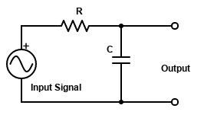

Figure 1 - Low Pass Filter Circuit (Electricalvoice,2021)

High pass filter
“A high pass filter can also be realized by an RC circuit. Here as well, we connect the resistor and capacitor in series but the difference is that here we connect the source with the capacitor and we get the output across the resistor. The cut-off frequency for high pass filter is also given by 1/2πRC. The circuit diagram for a high pass filter using an RC circuit is given below:” (Electricalvoice, 2021)
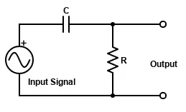

Figure 2 - High Pass Filter Circuit (Electricalvoice, 2021)

Circuit description
In this experiment, real world data will be gathered and used to evaluate the frequency cut-off point for both Low Pass (LP) and High Pass (HP) circuits at an attenuation of -3dB. For both experiments a signal generator will be set up with a peak-to-peak input voltage of 5V. The signal generator will be used to input a range of frequencies from 100Hz to 300KHz with more closely spaced measurements taken around the peak response with respect to the cut-off point.

Low pass filter circuit experiment
For the low pass filter experiment, the function generator was connected to the Vin points of figure 3. To monitor true input voltage (Vin) and output voltage (Vout), an oscilloscope was connected to the Vin and Vout as per diagram below. For this experiment a 10KΩ resistor and a 560pF capacitor was connected to a ‘breadboard’, the circuit diagram is shown in figure 3.
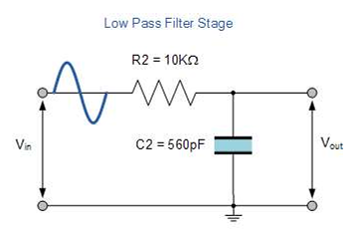

Figure 3 - Low Pass Filter Stage (UWTSD)

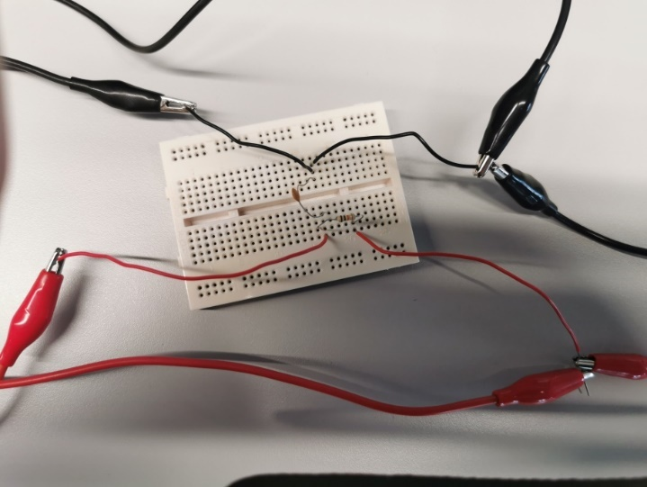
Figure 4 shows the physical connectivity of signal generator supplying input voltage and frequencies. The oscilloscope connectivity to monitor input and output voltages is also labelled.
Voltage output monitor
Signal generator connection

Voltage input monitor

Figure 4 - Low Pass Filter Experiment

High pass filter circuit experiment
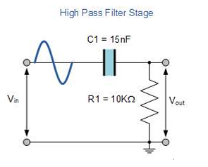
For the High pass filter experiment, the function generator was connected to the Vin points of figure 5. To monitor true input voltage (Vin) and output voltage (Vout), an oscilloscope was connected to the Vin and Vout as per diagram below. For this experiment a 10KΩ resistor and a 15nF capacitor was connected to a ‘breadboard’, the circuit diagram is shown in figure 5.

Figure 5 - High Pass Filter Stage (UWTSD)

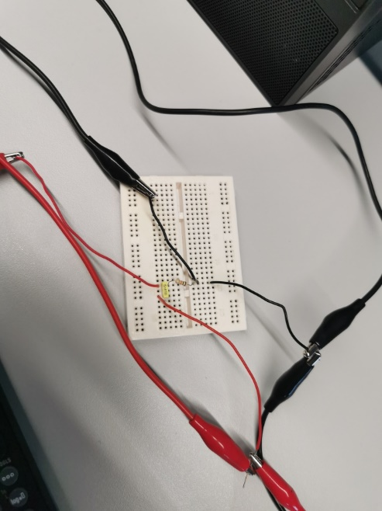
Figure 6 shows the physical connectivity of signal generator supplying input voltage and frequencies. The oscilloscope connectivity to monitor input and output voltages is also labelled.
Voltage output monitor
Signal generator connection
Voltage input monitor
Figure 6 - High Pass Filter Experiment

Results
The theoretical and experimental results for both high pass and low pass filters were calculated/collated and plotted on graphs to give a visual representation of the circuit behaviour. As explained previously, to find the expected -3dB cut-off point, the following calculation can be used:
Equation 1 - Frequency cut-off equation (learnabout-electronics.org, 2024)

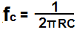

For the theoretical results, to find the expected Vout values for the LP filter circuit, the capacitive reactance (Xc) must first be calculated. This will be calculated using the input frequency (ƒ) and the circuit capacitor value (C). The formula to calculate Xc is:
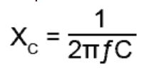
Equation 2 - Capacitive reactance equation (learnabout-electronics.org, 2024)

Once capacitive reactance values have been established, the Vout values can be calculated using the following formula:
Equation 3 - Voltage output equation (UWTSD)
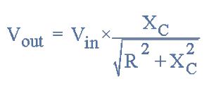

The Vout values will be used to calculate the attenuation in the circuit for both theoretical and experimental results. The formula to calculate attenuation is:
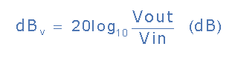
Equation 4 - Attenuation equation (electronics-tutorials.ws)

All data used for the below graphs can be found in the appendices section of this report.

Low pass filter theoretical results
Resistor Value = 10KΩ
Capacitor Value = 560pF
Using Equation 1 we can determine the expected cut-off frequency for the low pass filter circuit: 1 / 2π(10000 x 560 x 10⁻¹² ) = 28421Hz
Figure 7 shows the capacitive reactance as a function of frequency using Equation 2.
Figure 7 - Low Pass filter capacitive reactance (Theoretical)

Figure 8 shows the Voltage output (Vout) as a function of frequency using Equation 3.
Figure 8 - Low Pass filter voltage output (Theoretical)

Figure 9 shows the Attenuation (dB) as a function of frequency using Equation 4.
Figure 9 - Low Pass filter attenuation (Theoretical)

High pass filter theoretical results
Resistor Value = 10KΩ
Capacitor Value = 15nF
Using Equation 1 we can determine the expected cut-off frequency for the low pass filter circuit: 1 / 2π(10000 x 15 x 10⁻⁹ ) = 1061Hz
Figure 10 shows the capacitive reactance as a function of frequency using Equation 2.
Figure 10 – High pass filter capacitive reactance (theoretical)

Figure 11 shows the Voltage output (Vout) as a function of frequency using Equation 3.
Figure 11 - High Pass filter voltage output (Theoretical)
Figure 12 shows the Attenuation (dB) as a function of frequency using Equation 4.
Figure 12 – High pass filter attenuation (theoretical)

Low pass filter experimental results
Figure 13 shows the Voltage output readings as displayed on the oscilloscope at the set frequencies, note that measurements are more closely spaced around the cut-off point.
Figure 13 – Low pass filter voltage output (Experimental)

Figure 14 shows the attenuation readings at the set frequencies. To calculate attenuation, the results of the Vin and Vout values were input into Equation 4.
Figure 14 – Low pass filter attenuation (experimental)

High pass filter experimental results
Figure 15 shows the Voltage output readings as displayed on the oscilloscope at the set frequencies, note that measurements are more closely spaced around the cut-off point.
Figure 15 – High pass filter voltage output (experimental)

Figure 16 shows the attenuation readings at the set frequencies. To calculate attenuation, the results of the Vin and Vout values were input into Equation 4.
Figure 16 – High pass filter attenuation (experimental)

Discussion

5.1 Low pass filter discussion
By comparing the low pass filter theoretical and experimental graphs, the Voltage output (Vout) value began to drop off as the frequency was gradually increased. The start of this voltage drop off was around the frequency of 10KHz. This behaviour is expected, as the name “low pass” suggests, the output is not attenuated by the capacitor in the lower frequency ranges, thus allowing the voltage to pass through.
In this particular experiment, the calculated cut-off point for -3dB attenuation is 28421Hz. In figure 9 the -3dB attenuation is found between 25000Hz and 30000Hz with one reading of -3.25dB correlating to 30000Hz, similarly in figure 14 a value of -3.03dB has a frequency of 28000Hz. This shows the theoretically calculated values corresponds accurately to the experimental values, although not exactly.
Comparing figure 8 and figure 13 voltage output graphs, both the theoretical and experimental graphs show the voltage start to drop off around 5000Hz. As 5V was the input voltage, the cut-off point will be 70.7% of 5V, equalling 3.54V. The nearest corresponding frequency value in the theoretical graph was 3.44V at 30000Hz. The nearest corresponding frequency value in the experimental graph was 3.56V at 30000Hz. Again, these values are accurate but not exact to the calculated 3.54V at 28421Hz.
When comparing figure 8 to figure 13, the test measurement points plotted on figure 13 are more sporadic in nature. As figure 13 test results are experimental, the reason for this is that when using the function generator, the Vpk-pk would fluctuate around the 5V input voltage. The lowest Vin measurement being 4.84V up to a peak Vout of 5.28V. This can be seen in Appendix 3. Another potential reason for the sporadic nature of the measurements is tolerances of components. For example, in this experiment the 10KΩ resistor used had a gold tolerance band signifying a tolerance of 5%, meaning a potential resistance value of 9.5KΩ - 10.5KΩ.

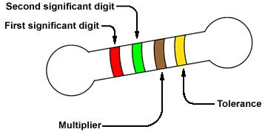
For carbon-composition and carbon film resistors, the common tolerances are 5%, 10%, and 20%, indicating that the actual value of the resistor can vary from the nominal value by ±5%, ±10% and ±20%. If the band is gold, it specifies a 5% tolerance; silver specifies a 10% tolerance; if no band is present, the tolerance is 20% (www2.engineering.com, 2006)

5.2 High pass filter discussion
By comparing the high pass filter theoretical and experimental graphs, contrary to the low pass filter, the voltage output (Vout) value began to increase as the frequency was increased. This voltage increases gradually until the frequency of 10KHz is reached and then levels off matching the input voltage of 5V. This behaviour is expected, as the name “high pass” suggests, the output is attenuated by the capacitor in the lower frequency ranges and attenuation drops as the frequency increases, thus allowing the voltage to pass through.
In this particular experiment, the calculated cut-off point for -3dB attenuation is 1061Hz. In figure 12 the -3dB attenuation is found close to 1061Hz with one reading of -3.28dB correlating to 1000Hz, similarly in figure 16 a value of -3.29dB has a frequency of 1000Hz. This shows the theoretically calculated values corresponds accurately to the experimental values, although not exactly.
Comparing figure 11 and figure 15 voltage output graphs, both the theoretical and experimental graphs show the voltage start to increase from 100Hz up until peak output at 10KHz. As 5V was the input voltage, the cut-off point will be 70.7% of 5V, equalling 3.54V. The nearest corresponding frequency value in the theoretical graph (figure 11) was 3.43V at 1000Hz. The nearest corresponding frequency value (figure 15) in the experimental graph was 3.48V at 1000Hz. Again, these values are accurate but not exact to the calculated 3.54V at 1061Hz.
As is for the low pass filter, when comparing figure 11 to figure 15, the test measurement points plotted on figure 15 are more sporadic in nature. As figure 15 test results are experimental, the reason for this is that when using the function generator, the Vpk-pk would fluctuate around the 5V input voltage. The lowest Vin measurement being 5.08V up to a peak Vout of 5.16V. This can be seen in Appendix 4. The same 10KΩ resistor, as used in the low pass filter experiment, was used for the high pass filter experiment meaning a 5% tolerance needed to be taken into account for discrepancies in measurements.

Conclusion
It has been found in this experiment that, while with minor deviations, the theoretical values calculated for the -3dB cut-off point match the data gathered from the lab experiment for both low pass and high pass filter circuits. In a real-world application of these filters, these potential deviations must be taken into account depending on the type of application, set parameters or costing.

References

Electricalvoice. (2021) Difference Between Low Pass Filter and High Pass Filter [Online]

Available at: Difference Between Low Pass Filter and High Pass Filter | Electricalvoice

Coates, E. (2020) Series resonance [Online]
Available at: Series Resonance (learnabout-electronics.org)

ElectronicsTutorials (2024) Decibel Attenuation [Online]
Available at: Passive Attenuators and Passive Attenuator Tutorial (electronics-tutorials.ws)

Engineering.com (2006) Color Code for Resistors [Online]
Available at: Color Code for Resistors | Engineering.com

Appendices
 | Low Pass Theoretical
 | Vin | 5 | V
 | R | 10000 | Ω
 | C | 5.6E-10 | F
Frequency (Hz) | X_{c} (Ω) LP | V_{out} (V) Low Pass | Atten.(dB) LP
100 | 2.84E+06 | 5.00E+00 | -5.38E-05
200 | 1.42E+06 | 5.00E+00 | -2.15E-04
400 | 7.11E+05 | 5.00E+00 | -8.60E-04
600 | 4.74E+05 | 5.00E+00 | -1.94E-03
1000 | 2.84E+05 | 5.00E+00 | -5.37E-03
1500 | 1.89E+05 | 4.99E+00 | -1.21E-02
2000 | 1.42E+05 | 4.99E+00 | -2.15E-02
2500 | 1.14E+05 | 4.98E+00 | -3.35E-02
3000 | 9.47E+04 | 4.97E+00 | -4.81E-02
3500 | 8.12E+04 | 4.96E+00 | -6.54E-02
4000 | 7.11E+04 | 4.95E+00 | -8.52E-02
4500 | 6.32E+04 | 4.94E+00 | -1.08E-01
5000 | 5.68E+04 | 4.92E+00 | -1.32E-01
5500 | 5.17E+04 | 4.91E+00 | -1.60E-01
6000 | 4.74E+04 | 4.89E+00 | -1.89E-01
6500 | 4.37E+04 | 4.87E+00 | -2.21E-01
7000 | 4.06E+04 | 4.85E+00 | -2.56E-01
7500 | 3.79E+04 | 4.83E+00 | -2.92E-01
8000 | 3.55E+04 | 4.81E+00 | -3.31E-01
8500 | 3.34E+04 | 4.79E+00 | -3.72E-01
9000 | 3.16E+04 | 4.77E+00 | -4.15E-01
9500 | 2.99E+04 | 4.74E+00 | -4.60E-01
10000 | 2.84E+04 | 4.72E+00 | -5.07E-01
15000 | 1.89E+04 | 4.42E+00 | -1.07E+00
20000 | 1.42E+04 | 4.09E+00 | -1.75E+00
25000 | 1.14E+04 | 3.75E+00 | -2.49E+00
30000 | 9.47E+03 | 3.44E+00 | -3.25E+00
35000 | 8.12E+03 | 3.15E+00 | -4.01E+00
40000 | 7.11E+03 | 2.90E+00 | -4.74E+00
45000 | 6.32E+03 | 2.67E+00 | -5.45E+00
50000 | 5.68E+03 | 2.47E+00 | -6.12E+00
55000 | 5.17E+03 | 2.30E+00 | -6.76E+00
60000 | 4.74E+03 | 2.14E+00 | -7.37E+00
65000 | 4.37E+03 | 2.00E+00 | -7.95E+00
70000 | 4.06E+03 | 1.88E+00 | -8.49E+00
75000 | 3.79E+03 | 1.77E+00 | -9.01E+00
80000 | 3.55E+03 | 1.67E+00 | -9.51E+00
85000 | 3.34E+03 | 1.59E+00 | -9.98E+00
90000 | 3.16E+03 | 1.51E+00 | -1.04E+01
95000 | 2.99E+03 | 1.43E+00 | -1.09E+01
100000 | 2.84E+03 | 1.37E+00 | -1.13E+01
150000 | 1.89E+03 | 9.31E-01 | -1.46E+01
200000 | 1.42E+03 | 7.03E-01 | -1.70E+01
250000 | 1.14E+03 | 5.65E-01 | -1.89E+01
300000 | 9.47E+02 | 4.72E-01 | -2.05E+01
Appendix 1 – Low pass calculations (theoretical)
 | High Pass Theoretical
 | Vin | 5 | V
 | R | 10000 | Ω
 | C | 1.50E-08 | F
Frequency (Hz) | X_{c} (Ω) HP | V_{out} (V) High Pass | Atten.(dB) HP
100 | 1.06E+05 | 4.69E-01 | -2.06E+01
200 | 5.31E+04 | 9.26E-01 | -1.46E+01
400 | 2.65E+04 | 1.76E+00 | -9.05E+00
600 | 1.77E+04 | 2.46E+00 | -6.16E+00
1000 | 1.06E+04 | 3.43E+00 | -3.28E+00
1500 | 7.07E+03 | 4.08E+00 | -1.76E+00
2000 | 5.31E+03 | 4.42E+00 | -1.08E+00
2500 | 4.24E+03 | 4.60E+00 | -7.19E-01
3000 | 3.54E+03 | 4.71E+00 | -5.12E-01
3500 | 3.03E+03 | 4.78E+00 | -3.82E-01
4000 | 2.65E+03 | 4.83E+00 | -2.95E-01
4500 | 2.36E+03 | 4.87E+00 | -2.35E-01
5000 | 2.12E+03 | 4.89E+00 | -1.91E-01
5500 | 1.93E+03 | 4.91E+00 | -1.59E-01
6000 | 1.77E+03 | 4.92E+00 | -1.34E-01
6500 | 1.63E+03 | 4.93E+00 | -1.14E-01
7000 | 1.52E+03 | 4.94E+00 | -9.87E-02
7500 | 1.41E+03 | 4.95E+00 | -8.61E-02
8000 | 1.33E+03 | 4.96E+00 | -7.57E-02
8500 | 1.25E+03 | 4.96E+00 | -6.71E-02
9000 | 1.18E+03 | 4.97E+00 | -5.99E-02
9500 | 1.12E+03 | 4.97E+00 | -5.38E-02
10000 | 1.06E+03 | 4.97E+00 | -4.86E-02
15000 | 7.07E+02 | 4.99E+00 | -2.17E-02
20000 | 5.31E+02 | 4.99E+00 | -1.22E-02
25000 | 4.24E+02 | 5.00E+00 | -7.82E-03
30000 | 3.54E+02 | 5.00E+00 | -5.43E-03
35000 | 3.03E+02 | 5.00E+00 | -3.99E-03
40000 | 2.65E+02 | 5.00E+00 | -3.05E-03
45000 | 2.36E+02 | 5.00E+00 | -2.41E-03
50000 | 2.12E+02 | 5.00E+00 | -1.96E-03
55000 | 1.93E+02 | 5.00E+00 | -1.62E-03
60000 | 1.77E+02 | 5.00E+00 | -1.36E-03
65000 | 1.63E+02 | 5.00E+00 | -1.16E-03
70000 | 1.52E+02 | 5.00E+00 | -9.98E-04
75000 | 1.41E+02 | 5.00E+00 | -8.69E-04
80000 | 1.33E+02 | 5.00E+00 | -7.64E-04
85000 | 1.25E+02 | 5.00E+00 | -6.77E-04
90000 | 1.18E+02 | 5.00E+00 | -6.04E-04
95000 | 1.12E+02 | 5.00E+00 | -5.42E-04
100000 | 1.06E+02 | 5.00E+00 | -4.89E-04
150000 | 7.07E+01 | 5.00E+00 | -2.17E-04
200000 | 5.31E+01 | 5.00E+00 | -1.22E-04
250000 | 4.24E+01 | 5.00E+00 | -7.82E-05
300000 | 3.54E+01 | 5.00E+00 | -5.43E-05
Appendix 2 – High pass calculations (theoretical)

Low Pass Filter Experimental
Freq (Hz) | Vin (V) | Vout (V) | Atten.(dB)
100 | 5.12 | 5.12 | 0.00E+00
500 | 5.12 | 5.12 | 0.00E+00
1000 | 5.12 | 5.08 | -6.81E-02
5000 | 5.16 | 5 | -2.74E-01
10000 | 5.16 | 4.72 | -7.74E-01
12000 | 5.12 | 4.68 | -7.80E-01
14000 | 5.08 | 4.56 | -9.38E-01
16000 | 5.12 | 4.44 | -1.24E+00
18000 | 5.08 | 4.28 | -1.49E+00
20000 | 5 | 4.16 | -1.60E+00
22000 | 5.12 | 4 | -2.14E+00
24000 | 5.12 | 3.92 | -2.32E+00
26000 | 5.08 | 3.8 | -2.52E+00
28000 | 5.16 | 3.64 | -3.03E+00
30000 | 5.12 | 3.56 | -3.16E+00
40000 | 4.92 | 2.96 | -4.41E+00
60000 | 4.84 | 2.24 | -6.69E+00
80000 | 4.92 | 1.84 | -8.54E+00
100,000 | 5.2 | 1.56 | -1.05E+01
120,000 | 5.32 | 1.32 | -1.21E+01
140,000 | 5.28 | 1.2 | -1.29E+01
160,000 | 5.2 | 1.12 | -1.33E+01
200,000 | 5.2 | 0.96 | -1.47E+01
250,000 | 5.16 | 0.76 | -1.66E+01
300,000 | 5.16 | 0.64 | -1.81E+01
Appendix 3 – Low pass results (experimental)

High Pass Filter Experimental
Freq (Hz) | Vin (V) | Vout (V) | Atten.(dB)
100 | 5.08 | 0.28 | -2.52E+01
200 | 5.08 | 0.8 | -1.61E+01
300 | 5.08 | 1.44 | -1.10E+01
400 | 5.08 | 1.88 | -8.63E+00
500 | 5.08 | 2.16 | -7.43E+00
600 | 5.08 | 2.56 | -5.95E+00
700 | 5.08 | 2.8 | -5.17E+00
800 | 5.08 | 3.12 | -4.23E+00
900 | 5.08 | 3.28 | -3.80E+00
1000 | 5.08 | 3.48 | -3.29E+00
1250 | 5.08 | 3.88 | -2.34E+00
1500 | 5.08 | 4.12 | -1.82E+00
1750 | 5.08 | 4.32 | -1.41E+00
2000 | 5.08 | 4.4 | -1.25E+00
2250 | 5.08 | 4.6 | -8.62E-01
2500 | 5.08 | 4.68 | -7.12E-01
2750 | 5.08 | 4.72 | -6.38E-01
3000 | 5.08 | 4.76 | -5.65E-01
3250 | 5.08 | 4.76 | -5.65E-01
3500 | 5.08 | 4.8 | -4.92E-01
3750 | 5.08 | 4.84 | -4.20E-01
4000 | 5.12 | 4.88 | -4.17E-01
4250 | 5.08 | 4.92 | -2.78E-01
4500 | 5.08 | 4.92 | -2.78E-01
4750 | 5.08 | 4.96 | -2.08E-01
5000 | 5.12 | 4.96 | -2.76E-01
10,000 | 5.12 | 5 | -2.06E-01
50,000 | 5.08 | 5.08 | 0.00E+00
100,000 | 5.16 | 5.12 | -6.76E-02
150,000 | 5.12 | 5.12 | 0.00E+00
200,000 | 5.16 | 5.12 | -6.76E-02
250,000 | 5.16 | 5.12 | -6.76E-02
300,000 | 5.12 | 5.12 | 0.00E+00
Appendix 4 – High pass results (experimental)

