06/06/2024
Effective Team-working and Communication BMSW4009

A report on teamworking and communication within the workplace.

Student: Leasha Sefton
Student Number: 2308720
Lecturer: Mel Squire
Submission Date: 06 June 2024
Table of Contents
Introduction 2
Theoretical Framework 3
Belbin’s Team Roles 4-5
Understanding Team Development 6-7
Managing conflict in the workplace 8-9
Conclusion 10-11
References 12-13

Introduction
Effective communication skills are the cornerstone of a thriving workplace environment. They enable individuals and teams to share information efficiently, resolve conflicts amicably, and collaborate towards common goals. This report explores the importance of communication skills, essential communication techniques, issues related to teamwork, and the application of these skills in resolving workplace conflicts, with references to Belbin’s Team Roles, and the Kilmann Conflict Resolution framework (Rahman, M.H.A., Jaafar, J. and Huda, M., 2023 ).
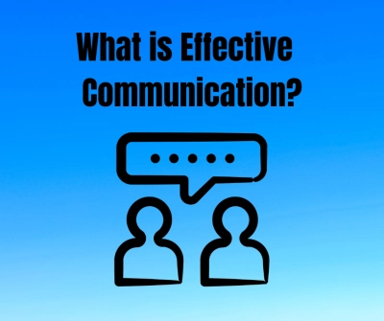
(lauriebrown.com.. (2024).
Theoretical Framework

Belbin's model identifies nine team roles essential for effective teamwork, emphasising balanced role distribution. Tuckman's model outlines four stages of team development: forming, storming, norming, and performing, guiding teams through growth and productivity phases. Kilmann's conflict model categorises five conflict-handling styles, competing, collaborating, compromising, avoiding, and accommodating, aiding in conflict resolution.

These models are crucial for understanding team dynamics, enhancing collaboration, and optimising organisational performance (Aritzeta, A., Swailes, S. and Senior, B., 2007).
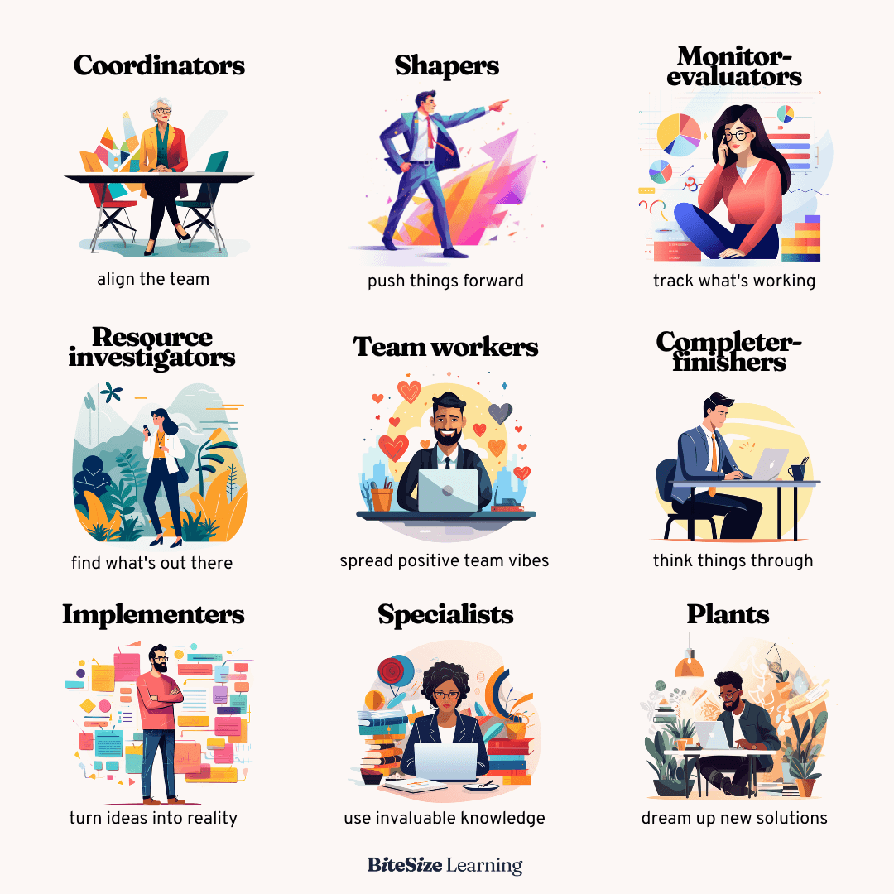
(bitesizelearning.co.uk.. (2024).
Belbin’s Team Roles
The Belbin Team Roles model, developed by Dr. Meredith Belbin, identifies nine roles that individuals can take on in a team. Its purpose is to help teams understand the dynamics among members and help the performance by balancing these roles (Fisher, S.G., Hunter, T.A. and Macrosson, W.D.K., 1998).

The nine team roles are
1. Plant: Creative, innovative, generates ideas.
2. Resource Investigator: Extroverted, explores opportunities, develops contacts.
3. Coordinator: Confident, clarifies goals, delegates tasks.
4. Shaper: Challenging, dynamic, drives progress.
5. Monitor Evaluator: Analytical, evaluates options, makes impartial judgments.
6. Team worker: Cooperative, listens, averts friction.
7. Implementer: Practical, organises work, turns ideas into action.
8. Completer Finisher: Detail-oriented, ensures quality, meets deadlines.
9. Specialist: Provides in-depth knowledge of a key area (Prichard, J.S. and Stanton, N.A., 1999).

Real-World Example:

Tesco

At Tesco, the Belbin model has been utilised to enhance team effectiveness. For instance, in their project management teams, Tesco assigns roles based on the Belbin framework to ensure a balanced mix of skills and personalities. A Coordinator might lead the team, ensuring everyone understands their objectives, while a Plant generates innovative ideas for new processes. Implementers and Completer Finishers are crucial in transforming these ideas into practical, quality-assured outcomes, ensuring projects meet deadlines and standards. By leveraging the Resource Investigator role, Tesco can identify new market opportunities and partnerships, while Team workers maintain harmony and morale within the team. Monitor Evaluators provide critical analysis and feedback, ensuring decisions are well-considered.

This strategic application of the Belbin model allows Tesco to form well-rounded teams that leverage each member's strengths, fostering a collaborative environment where tasks are effectively allocated, and goals are efficiently met (Chowdhury, M.S., 2022).

(thegrocer.co.uk.. (2023).

Understanding Team Development

Tuckman's Model

Tuckman's model of team development outlines five stages that teams typically progress through: forming, storming, norming, performing, and adjourning. Each stage presents unique challenges and opportunities (Miller, D.L., 2003).

1. Forming: This initial stage involves team members coming together and getting to know each other. The main challenge here is uncertainty and lack of clarity about roles and objectives. For Tesco, a new project team might hold introductory meetings to establish relationships and set initial goals. Opportunities include laying a strong foundation and setting clear expectations.

2. Storming: As team members start working together, conflicts and power struggles may arise. This stage is challenging due to potential clashes in personalities and working styles. Tesco can navigate this stage by encouraging open communication and addressing conflicts constructively. Team-building activities and clear conflict resolution strategies can help transform conflicts into opportunities for growth.

3. Norming: In this stage, the team starts to establish norms and mutual agreements. The challenge lies in solidifying these norms while ensuring everyone is on board. For Tesco, setting up regular check-ins and feedback sessions can reinforce positive behaviours and team cohesion. Opportunities here include enhanced cooperation and better alignment on objectives.

4. Performing: At this stage, the team functions at a high level of efficiency and effectiveness. The main challenge is maintaining this performance while adapting to any changes. Tesco can support its teams by providing ongoing resources and recognising their achievements. The opportunity is achieving peak performance and delivering high-quality results consistently.

5. Adjourning: When a project concludes, the team disbands. The challenge is managing the transition and ensuring members feel valued. Tesco can conduct post-project reviews to celebrate successes and learn from challenges, ensuring a smooth transition and providing closure.

By understanding and strategically managing each stage of Tuckman's model, Tesco can enhance team development and drive high performance (Widdowson, L. and Barbour, P.J., 2021).
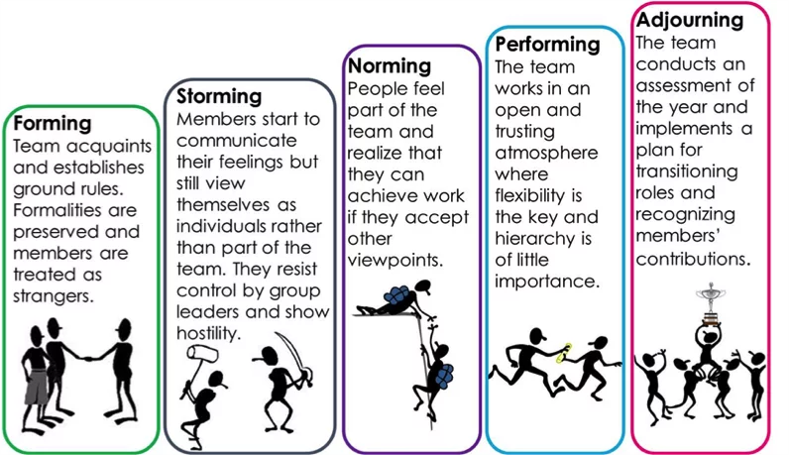
(youthemployment.org.uk.. (16th August 2022).

Managing conflict in the workplace

The Thomas-Kilmann mode is a widely used for understanding and managing conflict in the workplace. It categorises conflict-handling styles into five modes: Competing, Collaborating, Compromising, Avoiding, and Accommodating.

Each style has its appropriate use depending on the situation, and organisations often leverage this model to resolve conflicts and maintain positive relationships. Tesco, one of the largest retailers in the world, has effectively utilised the Thomas-Kilman model to manage conflicts within its teams (Qadir, A., 2020).

1. Collaborating: Tesco encourages a collaborative approach to conflict resolution, especially when dealing with complex issues that require input from various departments. For example, during strategic planning for new store locations, Tesco forms cross-functional teams where members are encouraged to share their expertise and perspectives openly. This collaborative effort ensures that all viewpoints are considered, leading to more innovative and comprehensive solutions.

2. Compromising: In situations where a quick resolution is necessary and both parties have equal power, Tesco employs the compromising style. For instance, during disputes over shift schedules between store managers and staff, a middle ground is often sought. Managers might agree to slightly adjust the schedules to accommodate staff needs while still meeting operational requirements, ensuring both parties are partially satisfied.

3. Avoiding: Tesco recognises that not all conflicts need immediate resolution. For minor disagreements or issues that might resolve themselves over time, the avoiding style is applied. For example, if two employees have a minor disagreement that does not impact their work, the management may choose to monitor the situation rather than intervening immediately, allowing the employees to resolve the issue on their own.

4. Accommodating: This style is used by Tesco in situations where maintaining harmony is more important than winning a dispute. For example, during peak holiday seasons, if an experienced employee requests a specific day off, managers might accommodate this request to ensure the employee remains motivated and satisfied, knowing that their expertise is crucial during busy times.

5. Competing: In situations where quick, decisive action is required, Tesco adopts the competing style. For instance, in cases of misconduct or violation of company policies, Tesco's management may take a firm stand to address the issue swiftly, ensuring that organisational standards are upheld.

By understanding and strategically applying these different conflict-handling styles, Tesco has been able to manage conflicts effectively, fostering a positive working environment and maintaining strong team relationships. This comprehensive approach ensures that conflicts are resolved in a manner that aligns with both organisational goals and employee well-being (Liddle, D., 2023).

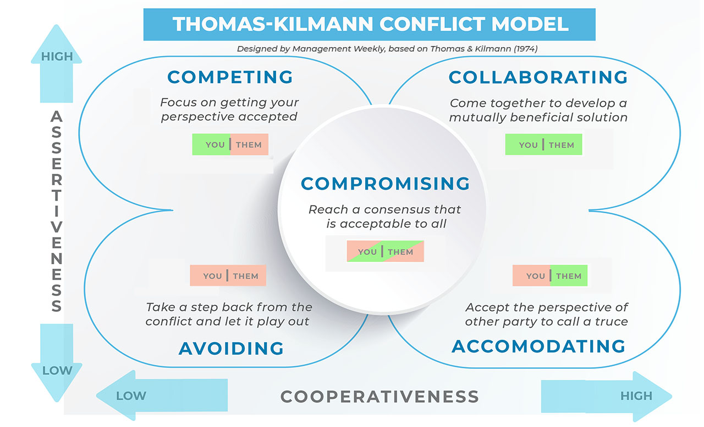
(Mishra,Arindra.. (May 12, 2021).

Conclusion

My report highlights several key findings and insights regarding the importance of effective teamwork in organisational success, using Tesco as an illustrative example as I worked previous for them. Tesco's success can be attributed to its strong emphasis on teamwork, which has fostered a culture of collaboration, innovation, and customer-service.

Firstly, effective teamwork at Tesco has led to improved problem-solving and decision-making capabilities, as diverse perspectives and skills are pooled together. This has enhanced the company’s ability to respond swiftly to market changes and customer needs. Additionally, teamwork has boosted employee morale and engagement, leading to higher productivity and lower turnover rates.
Secondly, Tesco’s approach to teamwork emphasises clear communication, mutual respect, and shared goals. These elements are crucial for aligning team members with the company’s objectives and ensuring that everyone is working towards common targets. Furthermore, Tesco invests in regular training and development programs to enhance team skills and cohesion, ensuring that teams remain effective and high performing.

Reflecting on these insights, it is evident that effective teamwork is essential for organisational success. It enables companies to leverage collective expertise, foster innovation, and maintain a competitive edge.

For organisations seeking to build and maintain high-performance teams, the following recommendations are offered:

1. Promote a collaborative culture: Encourage open communication, trust, and mutual respect among team members.
2. Define clear goals and roles: Ensure that each team member understands their responsibilities and how they contribute to the team’s objectives.
3. Invest in team development: Provide ongoing training and development opportunities to enhance team skills and dynamics.
4. Recognise and reward teamwork: Acknowledge and reward team achievements to motivate and reinforce the importance of collaboration.

By implementing these strategies, organisations can create and sustain high-performance teams that drive success and growth, just as Tesco has demonstrated (Brannen, M.Y., Moore, F. and Mughan, T., 2013).

References
Aritzeta, A., Swailes, S. and Senior, B., 2007. Belbin's team role model: Development, validity and applications for team building. Journal of Management Studies, 44(1), pp.96-118.
bitesizelearning.co.uk.. (2024). Belbin team roles, explained. [Online]. Bitesize learning. Available at https://www.bitesizelearning.co.uk/resources/belbin-team-roles-explained. [Accessed 13 June 2024].
Brannen, M.Y., Moore, F. and Mughan, T., 2013, September. Strategic ethnography and reinvigorating Tesco Plc: Leveraging inside/out bicultural bridging in multicultural teams. In Ethnographic Praxis in Industry Conference Proceedings (Vol. 2013, No. 1, pp. 282-299).
Chowdhury, M.S., 2022. INTER-CONNECTION OF EFFECTIVE WORKPLACE DIVERSITY WITH BETTER TEAM PERFORMANCE. Embracing Change in Business, Management & Social Sciences, p.23.
Fisher, S.G., Hunter, T.A. and Macrosson, W.D.K., 1998. The structure of Belbin's team roles. Journal of occupational and organizational psychology, 71(3), pp.283-288.
lauriebrown.com.. (2024). What Is Effective Communication?. [Online]. Laurie Brown. Available at https://lauriebrown.com/guides/communication-skills/what-is-effective-communication/. [Accessed 13 June 2024].
Liddle, D., 2023. Managing conflict: A practical guide to resolution in the workplace. Kogan Page Publishers.
Miller, D.L., 2003. The stages of group development: A retrospective study of dynamic team processes. Canadian Journal of Administrative Sciences/Revue Canadienne des Sciences de l'Administration, 20(2), pp.121-134.
Mishra,Arindra.. (May 12, 2021). Thomas Kilmann Conflict Model. [Online]. management weekly. Available at https://managementweekly.org/thomas-kilmann-conflict-resolution-model/. [Accessed 13 June 2024].
Prichard, J.S. and Stanton, N.A., 1999. Testing Belbin’s team role theory of effective groups. Journal of Management Development, 18(8), pp.652-665.
Qadir, A., 2020. Resolving conflicts at workplace–a discourse, using Thomas-Kilmann instrument mode framework. ZENITH Int. J. Multidisc. Res, 10(6), pp.28-46.
Rahman, M.H.A., Jaafar, J. and Huda, M., 2023. Information and communication skills for higher learners competence model. In Proceedings of the Computational Methods in Systems and Software (pp. 357-375). Cham: Springer International Publishing.
thegrocer.co.uk.. (2023). Tesco Droylsden: Grocer 33 store of the week. [Online]. Tesco Plc. Available at https://www.thegrocer.co.uk/the-grocer-33/tesco-droylsden-grocer-33-store-of-the-week/680720.article. [Accessed 13 June 2024].
Widdowson, L. and Barbour, P.J., 2021. Building Top-Performing Teams: A Practical Guide to Team Coaching to Improve Collaboration and Drive Organizational Success. Kogan Page Publishers.
youthemployment.org.uk.. (16th August 2022). The 4 Stages Of Teamwork. [Online]. Youth Employment UK. Available at https://www.youthemployment.org.uk/4-stages-teamwork/. [Accessed 13 June 2024].

