DS 1 Template

My Screenshots/Photos
- Please add 4–6 screenshots or photos of your digital life.
- You can use your phone or laptop.
- For each screenshot, write one or two sentences explaining what it shows.

Screenshot/Photo 1
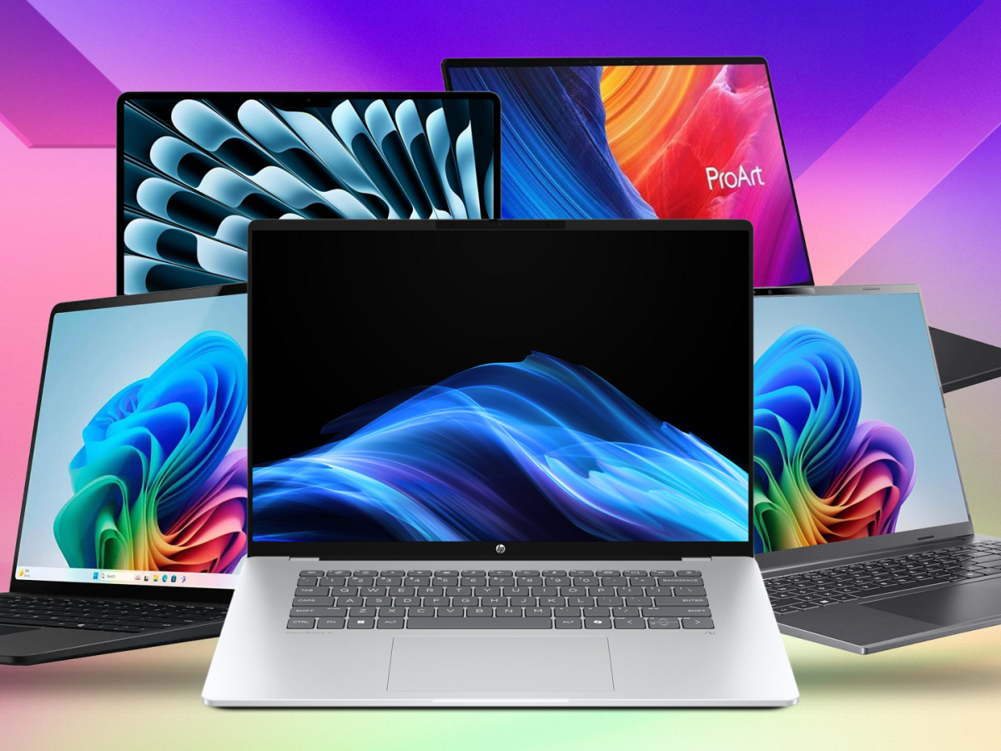
I use this digital laptop tool for many things. I use it to study, write documents, keep up to date with my calendar, check my work/ personal/ student email, search for information online. I also use it to watch videos, listen to authors, and keep in touch with friends and family. This laptop is very useful for me because I can carry it along and use it in different places.

Jo, M.J., 2026. The Brain That Goes Quiet: Serving a Large Model's Knowledge at 131 Tokens per Second on an 8 GB Laptop by Removing the Large Model from the Runtime Path. arXiv preprint arXiv:2606.12154.

Screenshot/Photo 2

This digital device we call a phone, is my constant and reliable companion. As a result of it always being on me hence making it a reliable digital tool to use at any possible given time without having to stress like prior when mobile phones didn’t exist. I use it daily to communicate with friends and family. It’s also great for taking photos, listening to audio and searching the web. Its compact size makes it easy to carry in your pocket or bag and use almost anywhere.
Lee, A.Y., Stevic, A., Walker-Keleher, G., Chen, C.Q.A., Charity, E., Dahlke, R. and Hancock, J., 2026, April. Going Light: The Effects of Minimal Mobile Phone Adoption on Young Adults’ Well-Being Depend on Motivation. In Proceedings of the 2026 CHI Conference on Human Factors in Computing Systems (pp. 1-18).

Screenshot/Photo 3
[Insert Photo/Screenshot below]
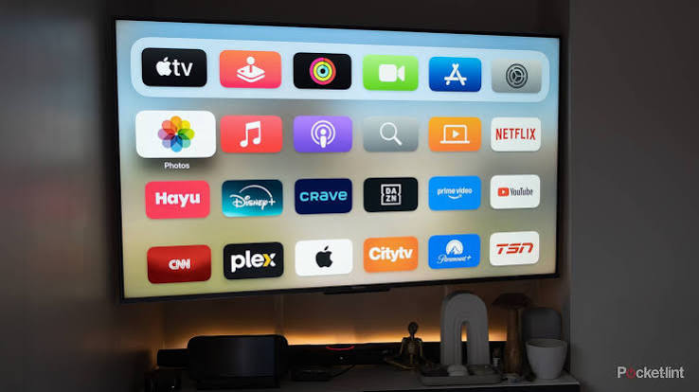
I use my TV to watch movies, catchup on the latest trending programmes and sometimes the news. Sometimes I play video games like Fifa or watch shows with the family. The big screen really enhances the viewing experience making it seem like a movie night or like going to the cinema.
Muguruza, B. and Bereziartua, G., 2026. Dragon Ball on the Basque public TV: influence on viewers’ language attitudes and practices. Journal of Multilingual and Multicultural Development, 47(2), pp.730-743.

Screenshot/Photo 4
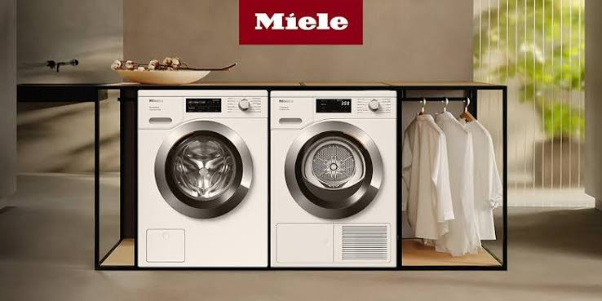
I use a washing machine to clean my clothes on a daily. I put the clothes inside, add liquid detergent, and choose a washing cycle with the right spin setting. It saves a huge amount of time and makes doing the laundry much easier. It’s one of the most effective digital hardware’s we have today. It saves us from running out of energy if we were to hand wash.
Wahab, A., Parizad, B., Bloomfield, S.M.E., Jamali, A., Moradi, P., Dehkordi, S.F., Mallipeddi, R., Milani, A.S. and Khayyam, H., 2026. Towards an AI-enhanced virtual lab for education and training in home energy efficiency and demand management. Results in Engineering, p.109490.

Screenshot/Photo 5
[Insert Photo/Screenshot below]

[Write what this shows of your digital life]

Screenshot/Photo 6
[Insert Photo/Screenshot below]
[Write what this shows of your digital life]

My Short Reflection
- Write 5–8 simple sentences about your digital life.
- You can use the sentence starters below if helpful.
My digital life is consumed with using a mobile phone every day to connect with people all over the world through social platforms like TikTok, Instagram, Snapchat, and many more. This digital software helps me stay connected with friends and family whenever I need them at any time without physically going/being in their presence. Having a mobile phone also helps with making shopping much easier from the comfort of my couch by allowing me to order my best Wardrope collections and not limiting my sugary appetite. It makes the job of restocking my kitchen a lot easier rather than having to physically go out and carry all of them heavy bags back home. It also helps with keeping track of my finances due to banks making their software available at any time.

Sentence starters
- I use digital tools to …
- I feel confident when I …
- I want to improve …
- I often use these tools: …
- I sometimes feel nervous about …
- I hope this module will help me …
- Digital skills are important for me because …
You can write more if you want.

Submission Checklist
Before you submit, please check:
​​​ ☐ I added 4–6 screenshots
☐ I wrote short sentences for each screenshot
☐ I wrote my short reflection
☐ My work is my own
☐ My file opens correctly
​​☐ My file opens correctly

