

LOCATION: SWANSEA | LLEOLIAD: abertawe
LEVEL 4 | LEFEL 4
EXAMINATION PERIOD | CYFNOD ARHOLIADAU
October 2024 | Hydref 2024

MODULE CODE: ACMA4018
INTRODUCTION TO PROCUREMENT
Graham Jones (2313935)
TIME: 2 Hours marks: 100

answer ALL QUESTIONS

This is an Open Book Exam

Question 1: Procurement Scope and Development (34 marks)

- Analyse how Kraljic's framework can be used to determine procurement positioning strategies for your organisation. (10 marks)

The Krajlic framework tool is used by procurement to categorise and prioritise purchases into 4 key categories based on the risk to the business and the chance of improving profits
- Bottleneck – High risk ; low profit (e.g. Steel supply for manufacturing)
- Critical – High risk ; High profit (E.g. Paint supply for manufacturing)
- Routine – Low risk ; Low profit (E.g. Outsourcing training programes)
- Leverage – Low risk ; High profit (E.g. Office supplies)

Once purchases have been categorised the procurement team can then target the activities that they wish to enhance working relationships with suppliers to either reduce the risk of sourcing or increase the profitability by negotiating better terms. Typically the procurement team will challenge purchases and suppliers in the bottleneck (to reduce risk) and Leverage (to improve profitability) categories.

- Develop your organisation’s purchasing profile using the ‘Purchasing Development Matrix’. (24 marks)

 | Infant | Awakening | Developing | Mature | Advanced
Activity Breakdown Analysis
Purchasing organisational structure
Purchasing services
Function position in business
Extent of training/ development of buyer
Relative remuneration levels
Measurement of purchasing performance
Standard of information systems
Computer technology
Standard of operating procedures
Interface development
Buying process involvement
Buyer characteristics / development
Degree of purchasing specialism
Supplier interface development
Policy on ethics
Hospitality
Quality of buyer-supplier relationship

Within Tata steel colors the majority of measurement areas are in an advanced stage due to two main factors;
- The experience within the department both from the fact that the business has been operating for over 100years and the personnel with in the department.
- Long term well established relationships with main suppliers to the business.

But also because of these two factors some of the other areas have slipped into developing or mature stage due to complacency of working with the same suppliers for many years.

New technology and a new way of interacting with suppliers being implemented has also dropped the supplier interface into a developing stage.

Hospitality has also dropped as we recover from the COVID outbreak and subsequent lockdown that eliminated hospitality completely.

Question 2: Cost, Pricing and Outsourcing in Procurement (33 marks)

- Discuss the concept of Total Acquisition Cost and Total Cost of Ownership by using the ‘Price-Cost Iceberg’ analogy. Justify your discussion with your workplace related examples. (20 marks)

Total acquisition cost and cost of ownership is concerned with the optimal price of a product or service could be if the buyer and supplier working relationship was improved to drive out unnecessary costs within the supply chain.

The price cost iceberg is a metaphor that illustrates that the total price for a product or service is not just the visible item itself or the service on offer but is made up of key components that lie beneath the surface that come together to create the whole.
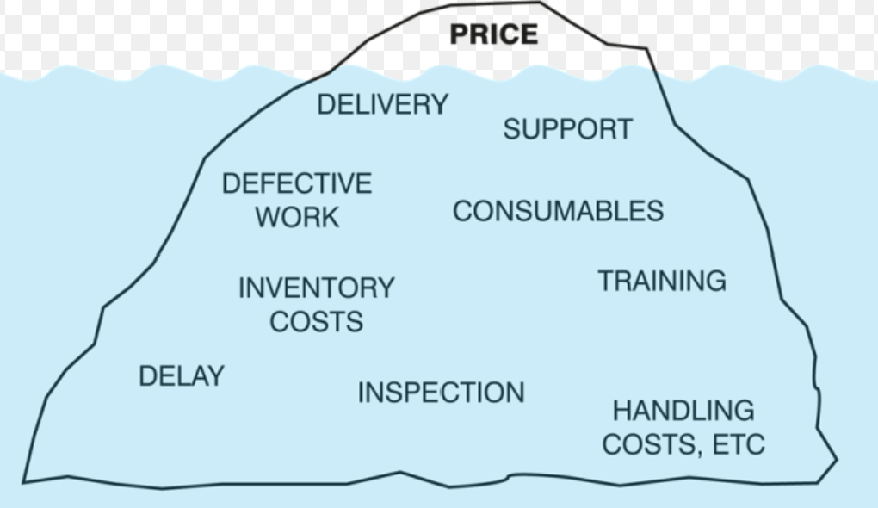

For example when Tata Steel colors sells finished material to the customer they only see the steel coil and the paint on the surface, but the cost of that product has been made up from various products, services and activities such as;
- Raw materials costs – Steel, Paint, Chemicals, etc
- Warehouse costs – Storage, transport, delivery, etc
- Employment costs – Operators labor, training, handling equipment, etc
- Business overheads – Energy cost, business rates, etc
- Maintenance costs – Contractors, parts, skills, etc
All of these hidden factors and costs will come together to form a final product price which will be competitive and provide the business with profit to expand, innovate and enhance the products.

- Why do organisations consider outsourcing and explain the key steps involved in the outsourcing process with your work-place related examples. (13 marks)

The main reason a company may outsource part of it’s business is for the expertise that outsourcing to a specialist supplier may bring in the quality of product or services or the cost of producing the same product or service. For example Tata Steel colors outsources many of it’s non-essential support functions to various companies, a few examples are;
- Logistics is outsourced to P&O logistics due to there expertise in handling vast amounts of cargo and their globally reach.
- On site security and cleaning services are contracted to acorn solutions who have expertise in both fields and provide manpower and training to employee’s.
- On site catering is also outsourced due to the cost involved in set-up, maintenance, training, employment and purchasing of products.

Question 3: Sourcing Strategies and Supplier Relationships (33 marks)

- Discuss different types of relationship with suppliers using your work-place related examples. (20 marks)

There are many different types of buyer supplier relationships depending on the level of interaction and purpose of transaction, each with their own advantages and dis-advantages;
- Arm length relationship – Transactional relationship solely for buying and selling items or services with immediate need. The benefit of this relationship is that procurement departments are able to switch suppliers if needed for better cost or lead-time. Downside very limited scope to enhance relationship with supplier and eliminate unnecessary costs. An example of this with my workplace is office supplies / stationary can be bought from various suppliers to minimise cost.
- Partnerships – High level of interaction between a single buyer and a single supplier that can benefit both parties needs. Within Tata steel colors we have a partnership with our steel supplier Tata steel strip products this benefits us with good communication and lead times at a good cost and provides Tata steel strip products a guaranteed outlet for it’s manufacturing products at agreed volumes every week.
- Buyer-supplier network – Within Tata steel colors we have a buyer-supplier network with all our paint suppliers where knowledge is shared on products to enhance quality and develop new innovations and also volume is distributed out amongst the suppliers to match each suppliers volume capacity and individual expertise to keep a stable and reliable supply-chain. The downside to this is that it is very difficult to bring in a new supplier to reduce costs if required.

- Read the following case and answer the questions listed below the case. (13 marks)

Case Study:
This case study, presented at eWorld, focused on Vendigital's collaboration with Vector Grey, a well-established company with a strong global brand presence in the upstream oil and gas development industry. Vector Grey generates annual revenues exceeding US $1.6 billion and employs over 11,000 individuals across 33 countries. The company underwent a merger with General Electric in March 2007.
The specific area of concern in this study was hydraulic manifolds, which are essential components used in drilling equipment on the seabed for oil and gas exploration. Vector Grey's customers operate in demanding conditions and rely on the company for innovative solutions. While Vector Grey possesses a capable in-house engineering team, a significant portion of the desired innovation from customers actually comes from Vector Grey's vendors.
Vector Grey identified several issues related to hydraulic manifolds:

- Customers require them on short notice due to the high cost of production interruptions.
- There are five main designs and 50 variants of hydraulic manifolds.
- The existing vendor struggled with quality and lead times.
- The process of finding a new vendor seemed overwhelming.
Vendigital then entered the picture, leveraging their expertise to thoroughly assess supply market options. This process included:
- Identifying and analysing 227 potential vendors.
- Engaging in discussions with 69 vendors that met size and experience criteria.
- Shortlisting 32 vendors for detailed tender stages.
- Conducting an auction involving five vendors to determine prices.
- Visiting final vendors and conducting quality audits before selecting Newburgh Engineering Ltd as the new vendor.
Newburgh Engineering was chosen for their manufacturing capabilities suitable for Vector Grey's requirements and their technical expertise leading to innovative solutions. The outcomes included reduced lead times, a 25% decrease in prices, and enhanced quality.
Interestingly, after conducting market testing in other spend areas, the original vendor garnered more business by focusing on products within their core competence.

Discuss the key takeaways from this case study by using all the relevant concepts and terminologies covered in the 'Introduction to Procurement' module.

Vector grey team had identified that they had an issue with the current vendor of hydraulic manifolds to the business and identified the key aspects that were required in selecting a suitable vendor to match the business needs.
- Shorter lead times
- Range of designs and variants
- Improved quality

Vector grey also identified that the process of finding a new vendor was intensive and outside of their capabilities so they decided to outsource the procurement of new vendor to Vendigital. Vendigital took Vector grey’s requirements on new vendor and identified and shortlisted various suppliers from it’s expertise within assessing suppliers. Vector grey could then evaluate and compare the short-listed vendors eventually selecting Newburgh Engineering as it’s new supplier.

Due to this partnership Vector grey were able to successfully integrate a new supplier which achieved all of their goals and Vendigital had secured future business by entering the partnerships. Also the original supplier were also able to benefit as they could focus the attention on business that better suited their capabilities.

Diwedd/End

