University of Wales Trinity Saint David
Wales Institute of Science and Art



Application of CAE Processes
Structural & Fluid Analysis ACHA6010

Dewi Miller
2112045
December 2024

Contents
1.0 Introduction 1
1.1 Background information 1
1.2 Fully Linked System 2
1.3 Baseline study 4
2.0 Validation Testing 8
2.1 Validation Calculation 8
2.3 Mesh Size Study 10
3.0 Analysis of Results of Baseline study 10
3.1 Total Stress of Baseline study 10
3.2 Total Deformation of Baseline study 10
4. Optimisation of Piston 11
4.1 Geometry Optimisation 11
4.2 Past Case Studies 11
4.3 Al 6061–1.5% B₄C-1.5% SiC 11
4.4 Al 2024 T3 11
5.0 Limitation 14
6.0 Context 15
7.0 References 15

Figure 1- Mechanical Properties 1
Figure 2- Properties 1
Figure 3- Engineering Data link to Rigid Dynamics 2
Figure 4- Engineering Data sheet 2
Figure 5- Engineering Data Component System 2
Figure 6 Piston Assembly (UWTSD) 2
Figure 7-Joint connections 3
Figure 8- Joint Probe 3
Figure 9- Transient Crankshaft 4000 RPM 3
Figure 10- Exporting Motion load for Gudgeon Pin to Piston 3
Figure 11- Linking Rigid Dynamics to a Steady State Thermal 3
Figure 12- Step Controls 3
Figure 13- Cos Graph 3
Figure 14- Supressing all other bodies apart from the piston head. 3
Figure 15- Imported motion load showing all loads 4
Figure 16- Motion load information 4
Figure 17: Thermal Study Boundary Conditions (UWTSD) 4
Figure 18- 6061 T6- Original Design Thermal Study 4
Figure 19- 1mm mesh sizing on the crown and oil control ring 6
Figure 20- Close up view of oil control ring 6
Figure 21- Equivalent stress baseline 6
Figure 22- Total deformation baseline 6
Figure 23- Oil control ring stress original design 6
Figure 24 - Oil control ring deformation, original design 6
Figure 25- fine 0.5mm mesh focusing on the oil control ring 7
Figure 26- Course mesh 7
Figure 27- Fixed supports 7
Figure 28- Cantilever Beam Simulation 8
Figure 29-Dubal 0042 Bending Cantilever with Axial Force 8
Figure 30- Static Structural Beam Results 9
Figure 31- Mesh Size Study 10
Figure 32- 6061 T6 optimisation geometry 12
Figure 33- Oil Control Ring Filet Edge 12
Figure 34- Increased thickness in the skirt size 12
Figure 35- Optimized Piston Crown 12
Figure 36- Al 6061–1.5% B4C-1.5% SiC 12
Figure 37- AI GHS 1300 Deformation 12
Figure 38- Ai GHS 1300 stress close-up of oil control ring 13
Figure 39- AI GHS 1300 stress 13
Figure 40- 2024 T3 total deformation 13
Figure 41- 2024 T3 Total stress zoom in on fillet 13
Figure 42- 2024 T3 Total stress 13

Introduction
The task involves simulating the testing of a real-world system modelled in a computational environment. This requires the creation of an assembly of a component, conducting a kinematic analysis under the realistic operating conditions, and performing a static structural assessment on one component within the assembly. The objective is to enhance the structural performance of the selected component by considering both structural loadings, total deformation, while also optimizing the design where feasible. This assignment serves to demonstrate the application of CAE tools in the engineering design process and to highlight their limitations.

1.1 Background information
Piston Material: Aluminium 6061- T6
Overview:
The material used in this study is a widely recognized aluminium alloy, 6061-T6, known for its high strength, corrosion resistance, and lightweight properties. 6061-T6 is a precipitation-hardened aluminium alloy, where the precipitation hardening process involves using high temperatures to enhance yield strength, reduce plasticity, and harden the material. This alloy has a density of 2.70 g/cm³ (0.0975 lb/in³) and is notably pure, consisting of 95.85%–98.56% aluminium. (Aerocom, 2024)
Technical Specification:
All material properties are sourced from Ansys Granta, a comprehensive materials database providing essential information for engineers. Its seamless integration with other Ansys software makes it an ideal resource for obtaining and transferring material data.
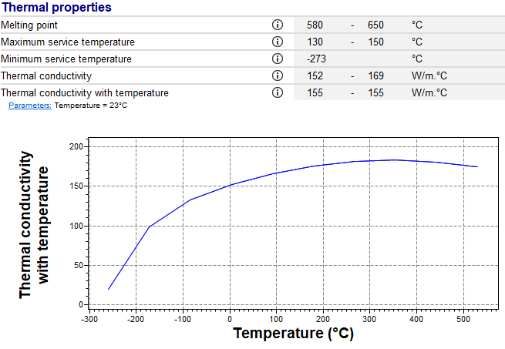  Figure 1- Thermal Properties | 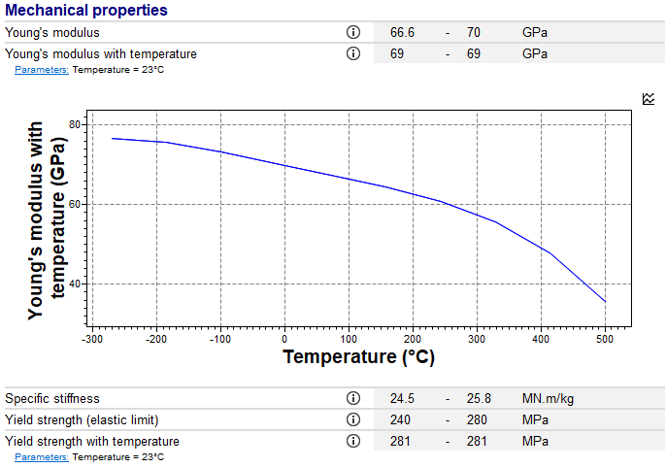  Figure 1- Mechanical Properties
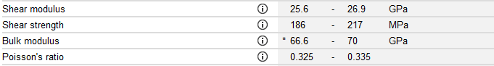
Figure 2- Properties
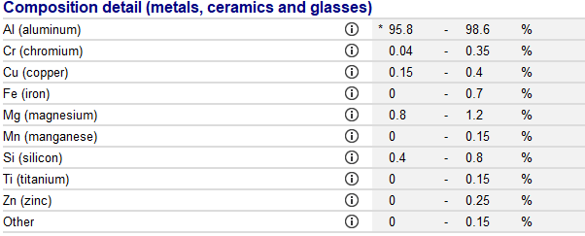
Figure 4- Composition detail

1.2 Fully Linked System
To conduct a structural analysis, a Rigid Dynamic (R.D.) analysis system must first be set up, followed by a component system labelled ‘engineering data’ (Figure 5). Material data should then be sourced, either from a provided material sheet, such as AMT - Advanced Materials Technology (2014) (Figure 6), or an engineering package like Granta Edu Pack, which offers a library of materials.
The materials used in this study include Aluminium 6061 T6, Aluminium 2024 T3 (sourced from Granta Edu Pack), Aluminium AI GHS 1300 (from AMT - Advanced Materials Technology, 2014), and AI 6061 T6 reinforced with 1.5% B4C and 1.5% SiC (Rashmita et al., 2024).
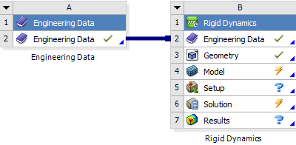  Figure 3- Engineering Data link to Rigid Dynamics | 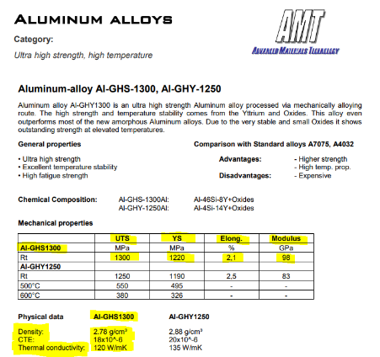  Figure 4- Engineering Data sheet
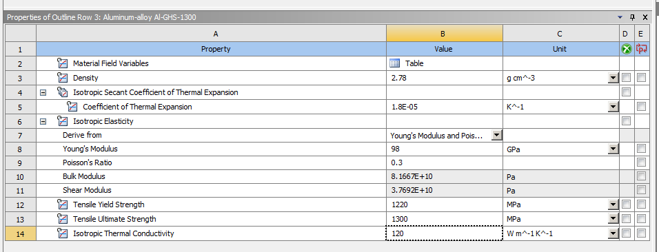  Figure 5- Engineering Data Component System | 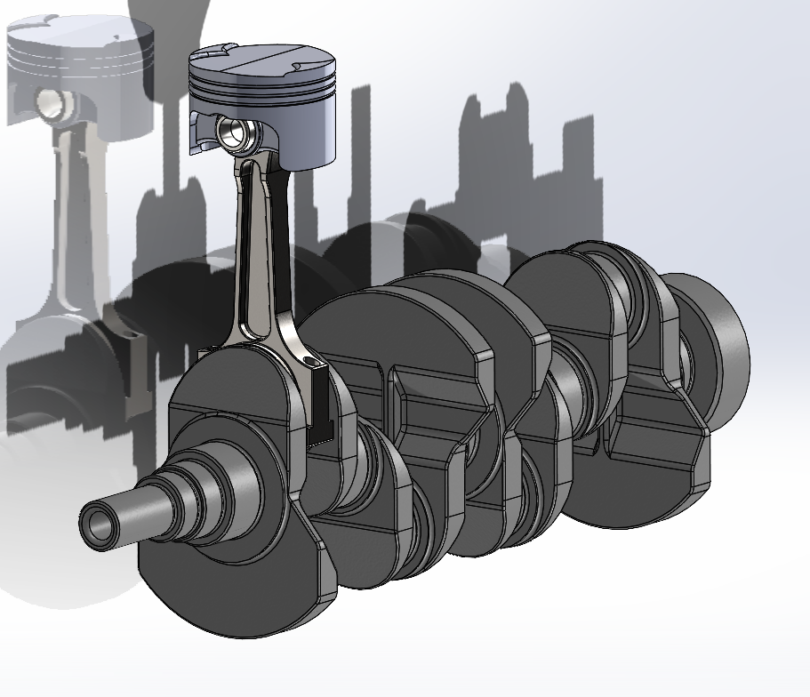  Figure 6 Piston Assembly (UWTSD)
The desired geometry should be imported into the R.D solver, ensuring that the assembly is in a STEP file format. In the model stage, it must be verified that the desired component is assigned the correct material. For the structural analysis, the piston serves as the component with changing material properties (Figure 11), while all other components, such as the crankshaft, gudgeon pin, and connecting rod, can remain defined as structural steel.
The solver settings (figure 10) are configured for a transient study with a 0.05-second time step and 4,000 RPM (Figure 11) to capture detailed iterations. A revolute joint between the crankshaft and ground is added as a joint load, while the piston-to-gudgeon pin joint is set as a joint probe to map forces during the solution process (Figure 10). Maximum load values, representing critical structural conditions, are exported as a motion load file (Figure 12) and applied in a static structural study to simulate peak loading scenarios.
In the static structural study, motion loads are imported, and the geometry, engineering data, and model setup are linked from the rigid dynamics study. All bodies except the piston are suppressed to focus the analysis (Figure 16). The piston body is set to flexible to allow deformation mapping. (Figure 16) The imported motion loads, including remote forces and moments, are applied to analyse the piston under specific loading conditions (Figure 17).

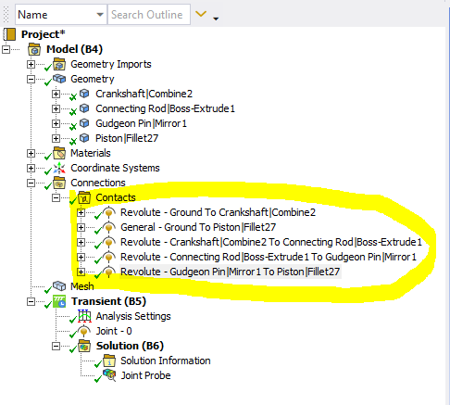  Figure 7-Joint connections | 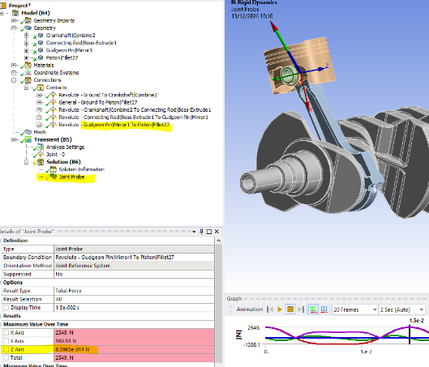  Figure 8- Joint Probe
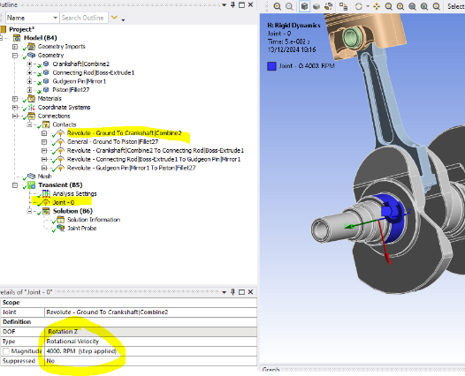  Figure 9- Transient Crankshaft 4000 RPM | 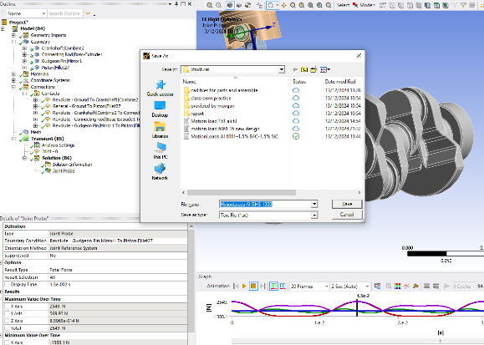  Figure 10- Exporting Motion load for Gudgeon Pin to Piston
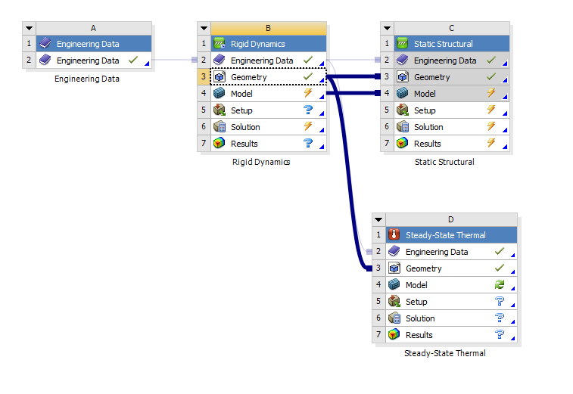  Figure 11- Linking Rigid Dynamics to a Steady State Thermal  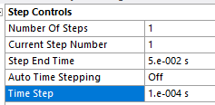  Figure 12- Step Controls  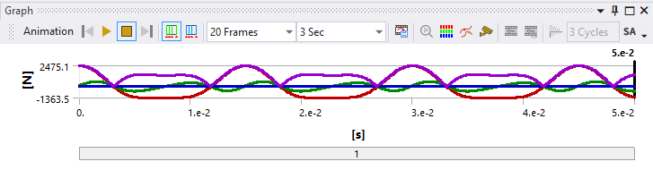  Figure 13- Cos Graph | 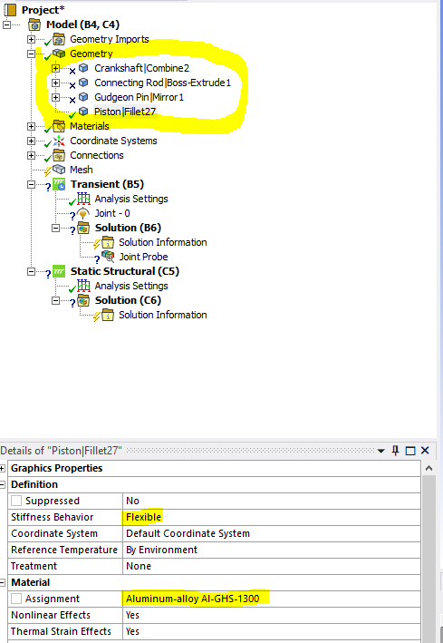  Figure 14- Supressing all other bodies apart from the piston head.
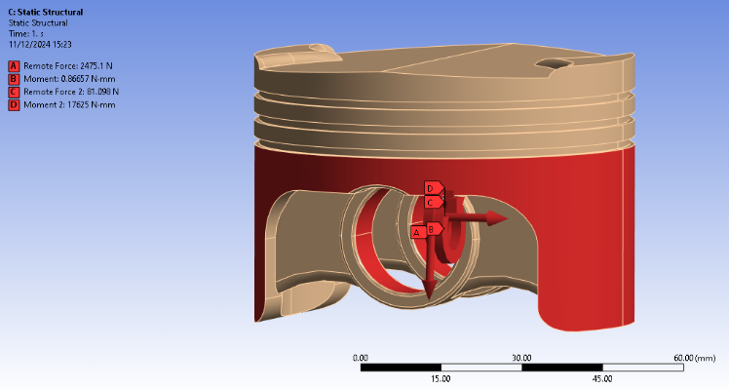  Figure 15- Imported motion load showing all loads |  | 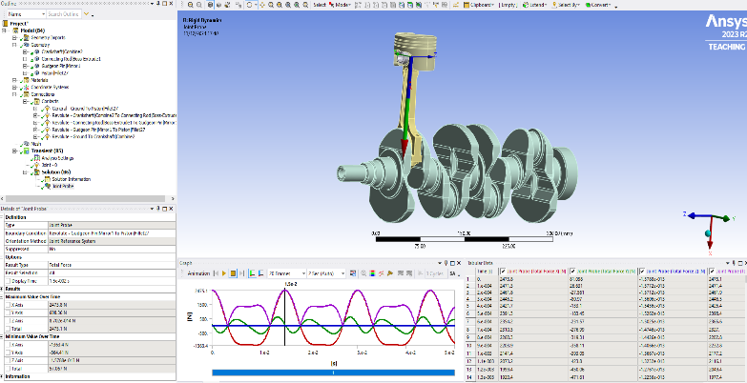  Figure 16- Motion load information
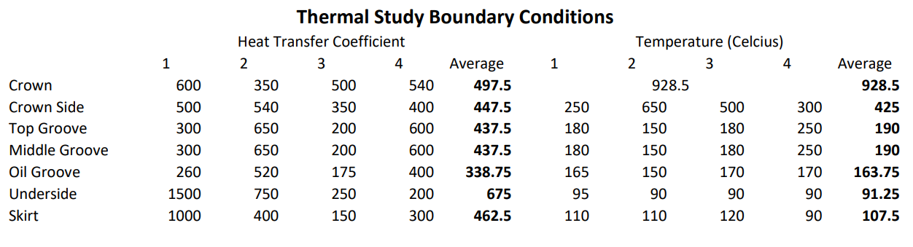
Figure 17: Thermal Study Boundary Conditions (UWTSD)

1.3 Baseline study
The steady-state thermal analysis involves linking the study to the rigid dynamics system, ensuring the engineering data and geometry remain consistent. It is essential to confirm that the piston is assigned the correct material and set as flexible, as these details may not fully transfer in Ansys. A fine mesh with a 0.5mm size (Figure 21 & 22) in the oil control ring is generated for accuracy. Thermal loads are applied using convection inputs, defined by boundary conditions such as heat transfer coefficients and ambient temperatures. Average values are assumed for these conditions. (Figure 19). The solution outputs displays a temperature profile, showing a maximum of 298.49˚C and a minimum of 163.9˚C (Figure20) aligning with expectations.
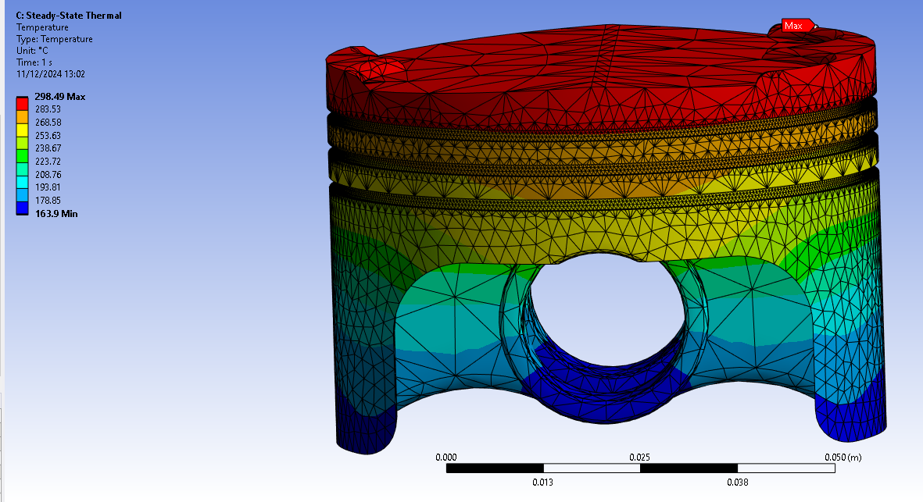
Figure 18- 6061 T6- Original Design Thermal Study
A baseline study is essential as it establishes a reference point for comparing simulation results and ensures that design changes for optimizations can be accurately assessed against initial conditions. Mesh sizing plays a critical role in achieving reliable results, as an overly coarse mesh can lead to inaccuracies (as shown in figure 25 & 26) it is unclear to where the hotspots of high stress accurately are in the oil control ring. While an overly fine mesh increases computational cost without significant gains in precision. Additionally, it is imperative that all units across the simulation- geometry, boundary conditions, material properties, and results- remain consistent to avoid errors or misleading comparisons.
The thermal study is completed, and its solution is linked to the static structural setup to incorporate the temperature profile as a boundary condition (Figure 18). After confirming the piston’s material and geometry, a fine 0.5mm mesh (Figure19 & 20) is generated to ensure precision in the oil control ring. Outputs, including equivalent stress and total deformation, are defined to evaluate the stresses and deformations experienced by the piston. Weak springs are initially enabled to flexibly support the geometry with minimal stiffness; however, an error necessitated replacing them with a fixed support (Figure 27) at the gudgeon pin, which slightly limits the accuracy of stress and deformation representation in that area.
A pressure of $105 ×{10}^{7}$ Pa is applied to the crown to simulate combustion chamber gas pressure. The static structural study is then solved to assess stresses and deformations under combined loading conditions, reflecting the fully linked system. This final analysis provides insights into the piston’s performance under realistic operational conditions, incorporating all applied loads and moments, as illustrated in Figure 21 & Figure 22.

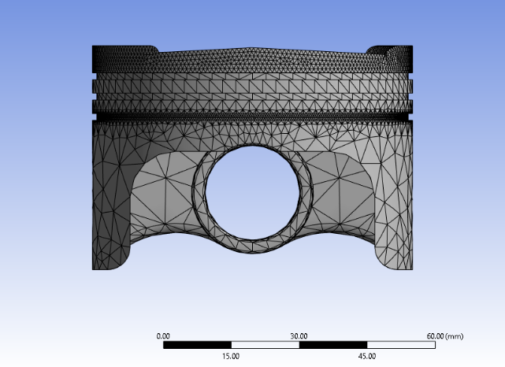  Figure 19- 1mm mesh sizing on the crown and oil control ring | 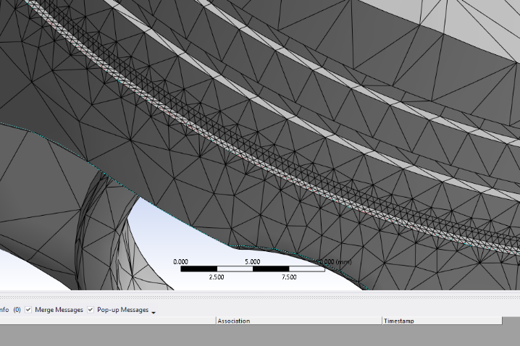  Figure 20- Close up view of oil control ring
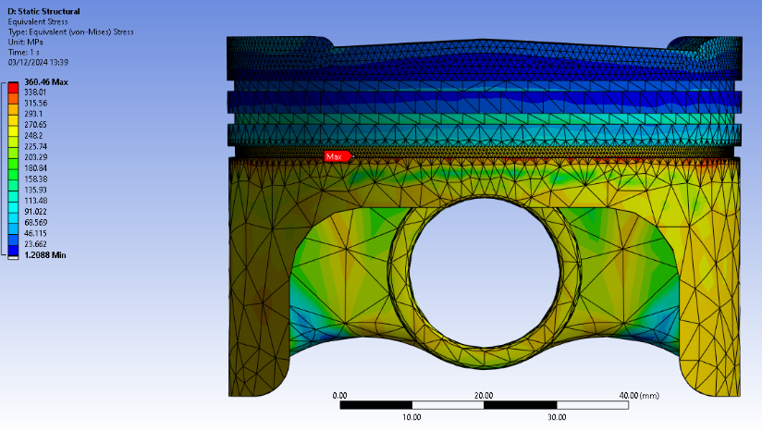  Figure 21- Equivalent stress baseline | 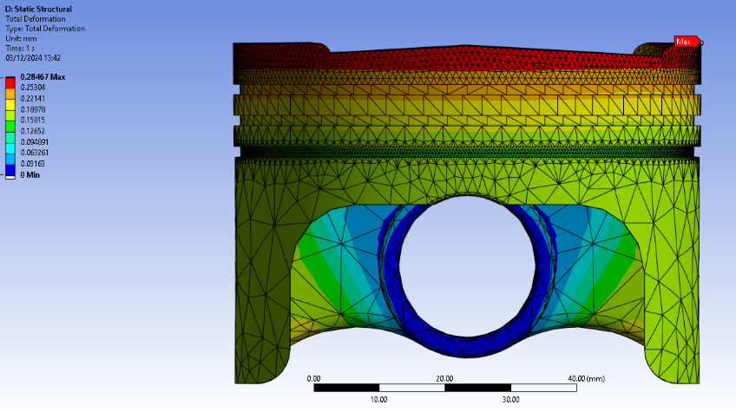  Figure 22- Total deformation baseline
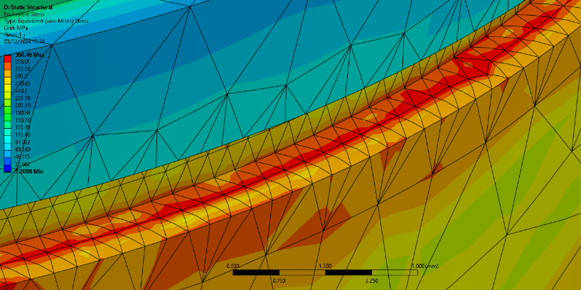  Figure 23- Oil control ring stress original design | 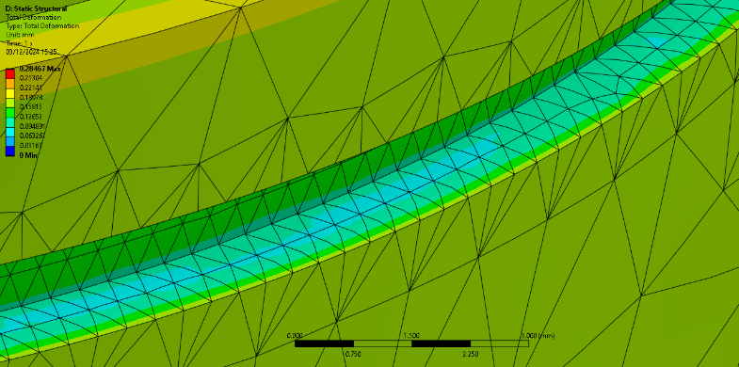  Figure 24 - Oil control ring deformation, original design

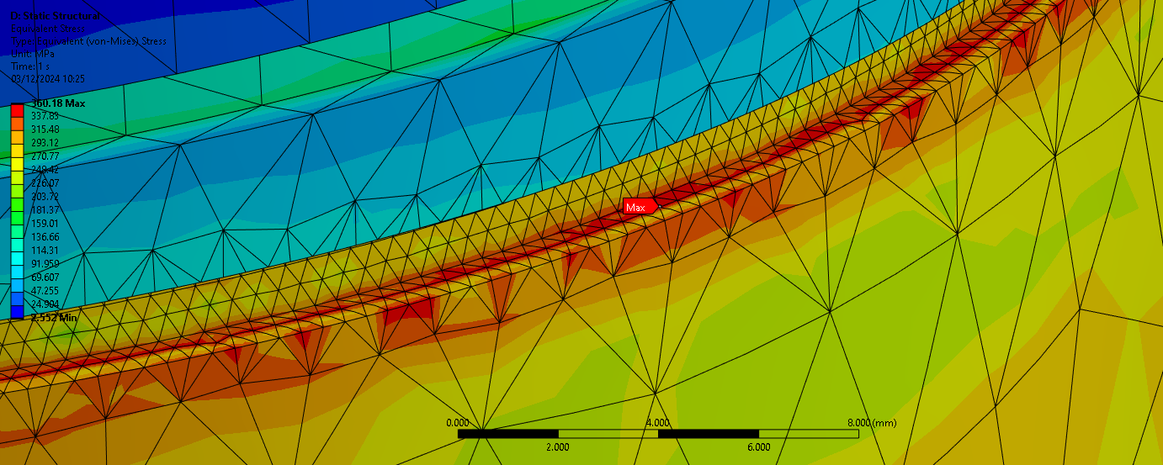
Figure 25- fine 0.5mm mesh focusing on the oil control ring
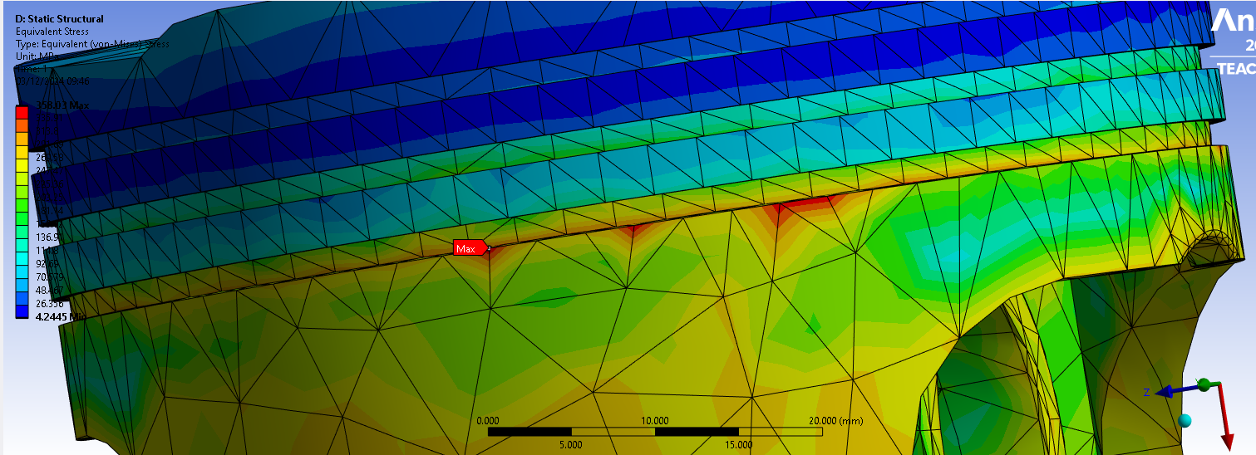
Figure 26- Course mesh
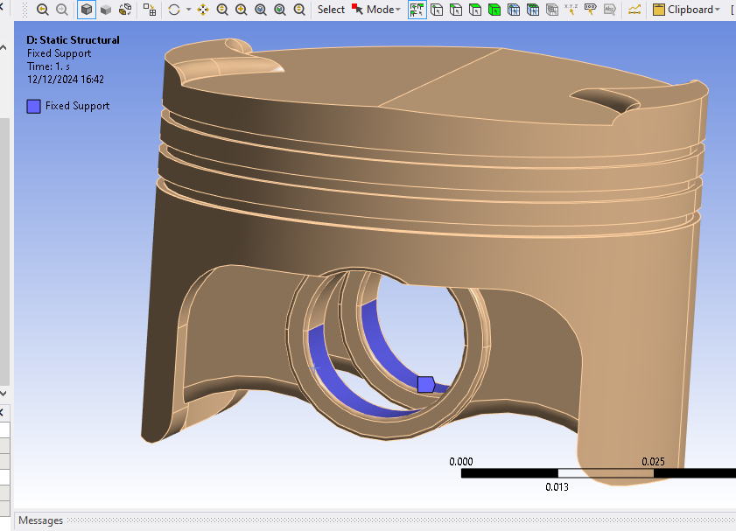
Figure 27- Fixed supports

2.0 Validation Testing
To validate Ansys, a simple case study of a cantilever beam under axial force is conducted. This validation ensures Ansys produces results comparable to theoretical calculations by evaluating the percentage difference between the two values. An acceptable range of 10% (Anne Helmenstine, 2024), the standardized range for experimental analysis, is used for comparison.
The process begins by creating the SolidWorks, matching the dimensions provided in the case study (Figure 28). A static structural analysis is then set up to observe results at a specific moment in time. Engineering data is modified to define a new material, inputting the isotropic elasticity properties. Ansys uses these properties to calculate other required material attributes for the simulation, which uses steel. The CAD geometry is imported to construct the model, and a mesh is generated with a size of 0.2 x 0.01m for optimal accuracy. While a larger mesh, such as the default, would not significantly skew results, a smaller mesh ensures the highest accuracy for validation purposes.
Constraints and forces are then applied to the model. A fixed support is added at one end of the beam, while a transverse force of 7.65 kN and an axial force of 1.6 kN are applied to the opposite end. This setup allows the software to simulate deformation and stresses, providing results for comparison with theoretical values.

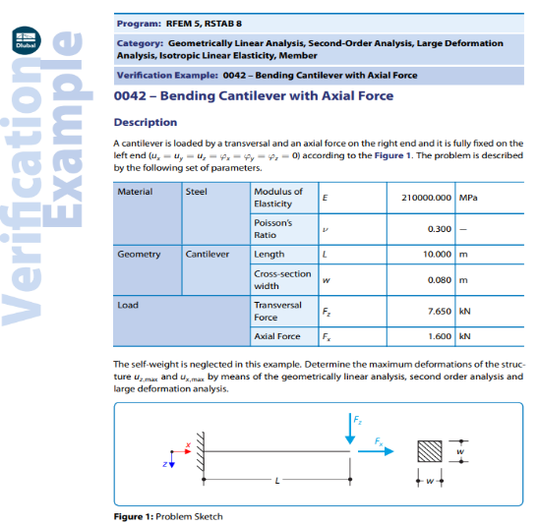  Figure 28- Cantilever Beam Simulation | 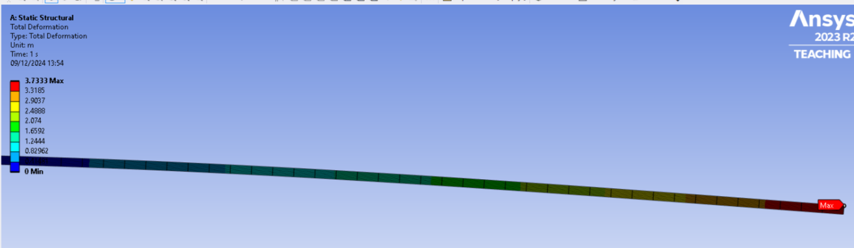  Figure 29-Dubal 0042 Bending Cantilever with Axial Force

2.1 Validation Calculation
To determine the suitability of Ansys, the percentage difference between the analytical value and the value obtained from Ansys is calculated using the following formula:
$$Percentage Difference= \frac{Ansys Value-Analytical Value}{\frac{Ansys Value+Analytical Value}{2}}X100=\frac{3.7333- 3.5575}{3.6454}X100=4.8\%$$
This calculation demonstrates that Ansys is a suitable software to use as it’s a valid result of 4.8%, which is less than the 10% required.

To calculate maximum deflection, the following equation is used:
$$U_{z,max}=\frac{6\left(α_{i}-α_{c}\right)\left(t_{i}+t_{c}\right)T_{c}L^{2}}{2\left(t_{s}^{2}K_{1}\right)}$$
All components above are given other than constant $K_{1}$ which can be calculated from the following equation:
$$K_{1}=4+6({\frac{t_{c}}{t_{i}})}^{2}+(\frac{E_{c}}{E_{1}})({\frac{t_{c}}{t_{i}})}^{3}+(\frac{E_{i}t_{i}}{E_{c}t_{c}})$$
Input Values are as follows
Invar Modulus of Elasticity $E=137000*{10}^{6}$ Copper Modulus of Elasticity $E=130000*{10}^{6}$
Invar Thermal expansion ($α_{i})=1.2*{10}^{-6}℃^{-1}$ Copper Thermal Expansion ($α_{c})=2*{10}^{-5}℃^{-1}$
Layer Thickness $t_{i}, t_{c},t=0.001m$ Thermal Loading= 100 $℃$
Length=0.1m
$$K_{1}=4+6*\left(\frac{0.001}{0.001}\right)+4*{\left(\frac{0.001}{0.001}\right)}^{2}+\left(\frac{130000*{10}^{6}}{137000*{10}^{6}}\right)*({0.001/0.001)}^{3}+\frac{\left(137000*{10}^{6}\right)*0.001}{\left(130000*{10}^{6}\right)*0.001}=16$$

$$U_{z,max}=\frac{(6*\left(1.2*{10}^{-6}\right)-(2*{10}^{-5}))*(0.001+0.001)*100*{0.1}^{2})}{2*\left({0.001}^{2}*16\right)}=7.05*{10}^{-3}m=7.05mm$$
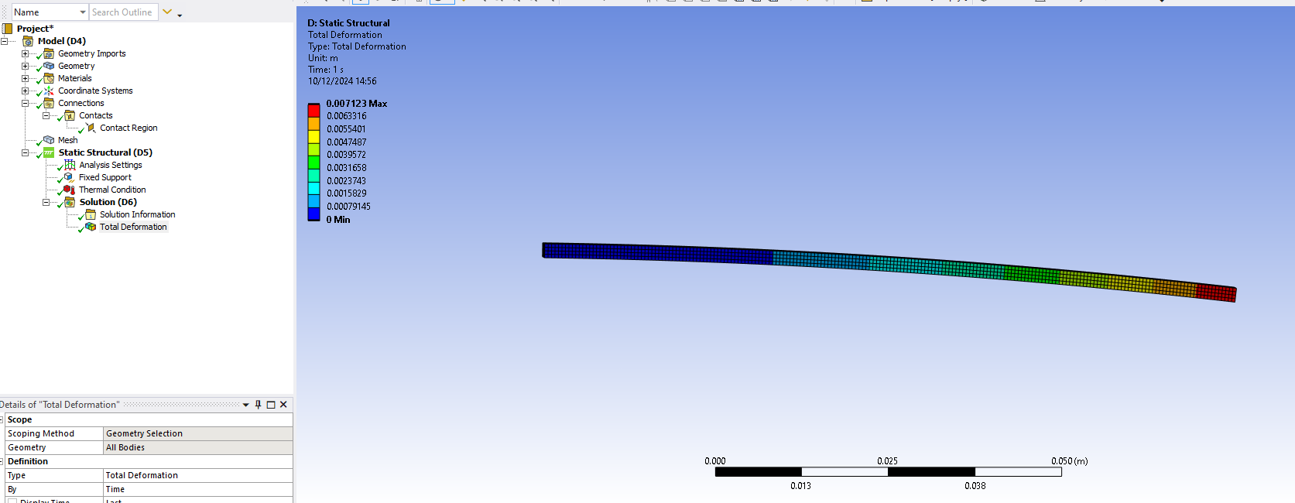
Figure 30- Static Structural Beam Results
Analytical Method deflection= 7.05mm | Static Structural= 7.12mm | Percentage difference= 0.99%
The difference in values between analytical methods and simulation result is under 1%, showing strong correlation. Therefore, validating the thermal conditions to give accurate values.

2.3 Mesh Size Study
Figure 31- Mesh Size Study | 1 | Analytical Method (M)
Figure 31- Mesh Size Study | 2 | 0.025
Figure 31- Mesh Size Study | 3 | 0.01
Figure 31- Mesh Size Study | 4 | 0.005
Figure 31- Mesh Size Study | 5 | 0.0025
Figure 31- Mesh Size Study | 6 | 0.001
Figure 31- Mesh Size Study | 7 | 0.005
Deflection is largely unaffected by mesh sizes smaller than 0.025m, as indicated by the flat line on the graph. However, stress analysis is most accurate with a 0.001m mesh, which will be used whenever possible to ensure precision. Smaller mesh sizes are impractical due to extended computation times, as observed during the bimetallic strip mesh study. Larger mesh sizes can also be used for this component if high precision is not required.

3.0 Analysis of Results of Baseline study

3.1 Total Stress of Baseline study
In the static structural study (Figure 21) the maximum stress, calculated as 360.46 MPa, occurs on the oil control ring, with elevated stressed observed around the skirt and near gudgeon pin due to shear and bending forces exerted by the connecting rod. The minimum stress is calculated as 1.2088 MPa and located crown side and top groove, where load interactions are minimal. Combustion pressures are applied to the crown, while mechanical loads from the connecting rod influence the lower region, resulting in the observed stress distribution. These identify critical areas requiring attention for stress management in the piston design. The target area for stress management will be the oil control ring to better target a lower stress concentration.

3.2 Total Deformation of Baseline study
The structural study indicates a maximum deformation of 0.28467mm at the crown ridges (Figure 22), where the piston is subjected to the highest thermal loads and combustion pressure. Sharp crown edges contributes to increased tensile and thermal stressed, further amplifying deformation. (Mohd Abdul Rahman et al., 2020) The minimum deformation is recorded as 0mm in regions experiencing lower temperatures and pressures. However, this value is influenced by the fixed support at the gudgeon pin, which restricts movement and reduces deformation in that area. While this limitation affects the accuracy of deformation results, it highlights critical areas requiring structural improvements in the piston design.

4. Optimisation of Piston

4.1 Geometry Optimisation
To optimise the piston design, a revised CAD geometry was developed to reduce the equivalent stressed and formation experienced by the piston. As illustrated in figure 25, the high stresses were concentrated in the oil groove. To address this, two fillets were added to the piston geometry (Figure 33), with radii of 0.05mm on the inner and outer edge of the groove. This modification reduced the stressed along the oil groove surface, as shown in Figure 32, which highlights the areas of highest stress. While the maximum stress was not significantly reduced, the overall stress distribution along this region improved, as indicated by the colour gradient. Additionally, the changes led to a reduction in stress within the underside of the piston, although this may result from additional load being distributed to the pin bosses. Overall, the geometric adjustments successfully reduced the stresses and deformation experienced by the piston.

4.2 Past Case Studies
Although Aluminium 6061 T6 is a suitable material for piston design due to its high strength and heat-resistant properties, material alteration were explored to further reduce the equivalent stresses and deformation experienced by piston. The material considered for optimization included Al GHS 1300(AMT- Advanced Materials Technology, 2014), AI 2024 T3 (Granta Edu Pack), and Al 6061–1.5% B₄C-1.5% SiC MMC (Rashmita et al., 2024). Research into case studies on material modifications for piston design revealed that incorporating elements such as carbon and silicon in composites enhances the mechanical and thermal properties requires for pistons.
(Design and Analysis of Piston by SiC Composite Material, 2015) demonstrated that Aluminium Silicon Carbide composites offer better temperature distribution, reduced deformation, and lower stress compared to pure aluminium, attributed to their superior thermal conductivity and higher Young's modulus. (Rashmita et al., 2024) identified Al $B_{4}C \& SiC$ are the optimal material, noting its significantly lower deformation, reduced stress, and exceptional ability to withstand temperature variations while maintaining mechanical integrity. (Figure 36)

4.3 Al 6061–1.5% B₄C-1.5% SiC
Comparing AI GHS 1300 with Al 6061-1.5% B4C-1.5% SiC. Total deformation for AI GHS 1300 mostly happens along the crown ridges. The results show an unusual concentration of deformation (Figure37), which suggests possible limitations in the material's reaction under combined loading circumstances, even if this is predicted in places subjected to high mechanical and thermal stresses. (Figure 39) Al 6061-1.5% B4C-1.5% SiC, on the other hand, exhibits less overall deformation, with peak values that are similarly centred close to the oil groove and crown regions. (Figure 32)
Because the reinforcement elements B4C and SiC give the composite structure of Al 6061-1.5% B4C-1.5% SiC more stiffness, it offers higher resistance to deformation. According to stress research, the AI GHS 1300 (AMT- Advanced Materials Technology, 2014) exhibits the highest equivalent stress (Figure 39) in the vicinity of the skirt edges and the oil control ring, where localized stress concentrations are caused by mechanical loadings from the connecting rod and shear forces. Al 6061-1.5% B4C-1.5% SiC, shows noticeably lower stress levels in contrast. By distributing stress more evenly throughout the piston, the composite material lowers peak stress levels and increases load-bearing capacity.
Overall, the results show that the better material for maximizing piston performance is Al 6061-1.5% B4C-1.5% SiC. Under realistic operating conditions, the piston's durability and structural efficiency are improved by its enhanced mechanical qualities, which lead to less deformation and stress.

4.4 Al 2024 T3
Because of its strengthened stiffness, Al 6061-1.5% B4C-1.5% SiC exhibits a lower maximum deformation of 0.01243 mm (Figure 36) for total deformation. Aluminium 2024 T3, on the other hand, shows a greater deformation of 0.32399 mm (Figure 40), mostly at the crown edges (Figure 41), suggesting a reduced ability to withstand mechanical and thermal loads.
Al 6061-1.5% B4C-1.5% SiC more efficiently distributes stress in stress analysis, lowering peak values. The lower structural performance of aluminium 2024 T3 is highlighted by its maximum stress of 447.85 MPa (Figure 42), which is focused at the oil groove and fillets. Al 6061-1.5% B4C-1.5% SiC exhibits better resistance to stress and deformation, making it more appropriate.
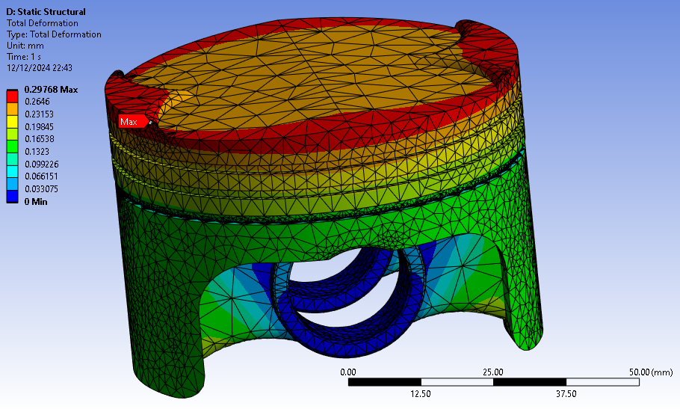  Figure 32- 6061 T6 optimisation geometry | 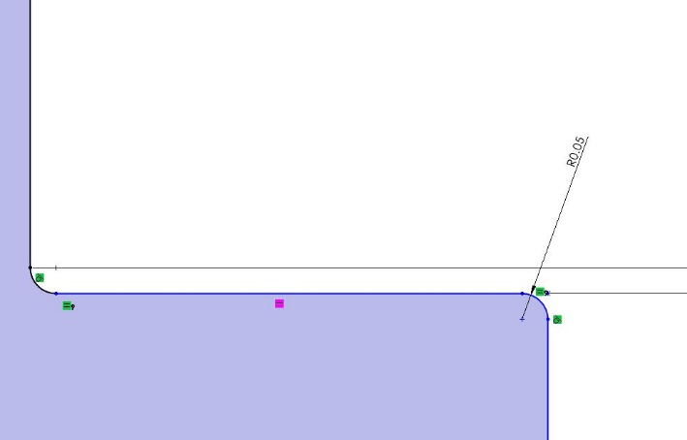  Figure 33- Oil Control Ring Filet Edge
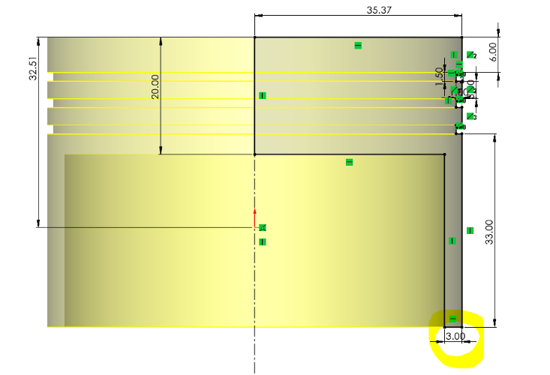  Figure 34- Increased thickness in the skirt size | 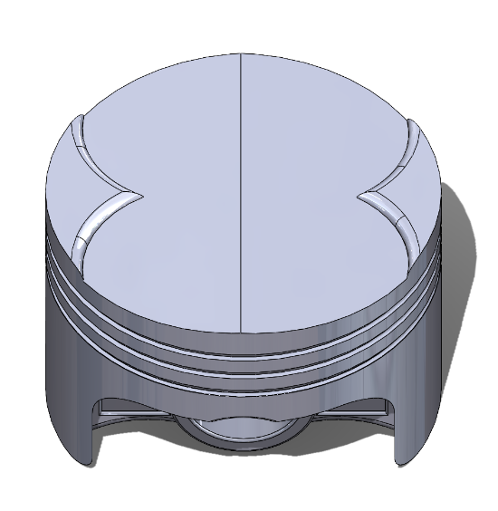  Figure 35- Optimized Piston Crown
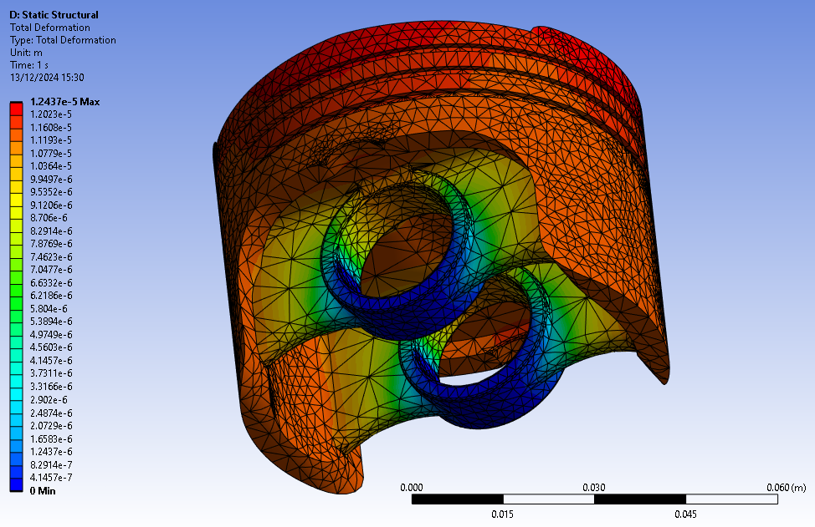  Figure 36- Al 6061–1.5% B4C-1.5% SiC | 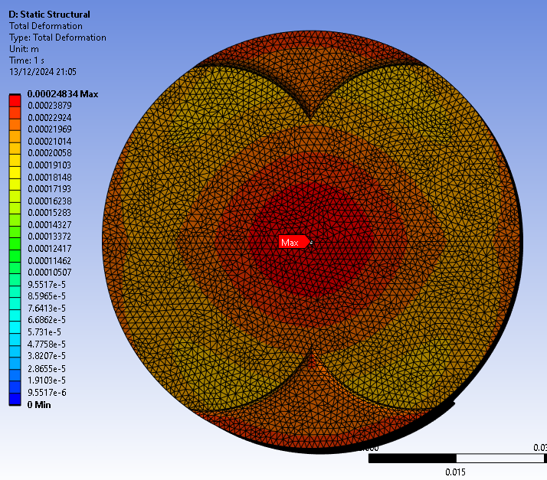  Figure 37- AI GHS 1300 Deformation

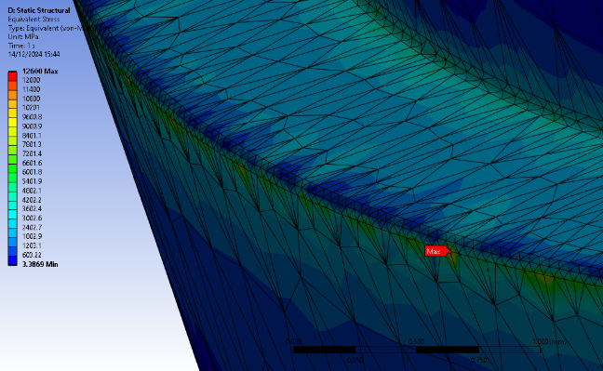  Figure 38- Ai GHS 1300 stress close-up of oil control ring | 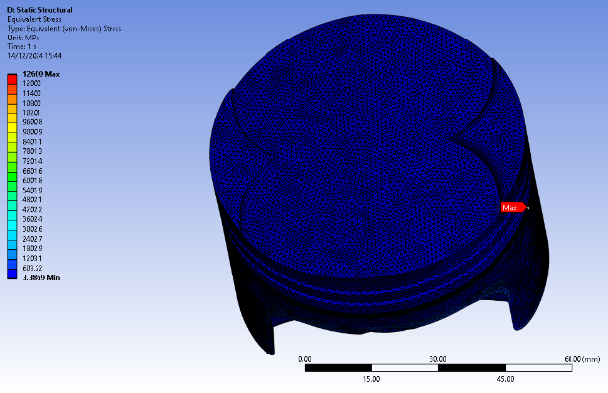  Figure 39- AI GHS 1300 stress
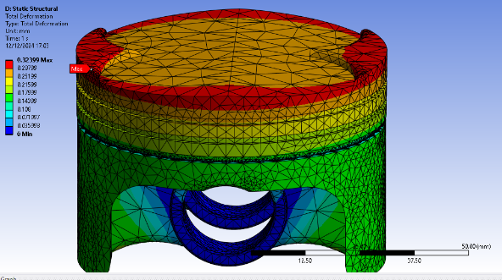  Figure 40- 2024 T3 total deformation | 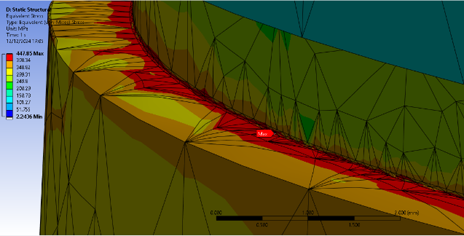  Figure 41- 2024 T3 Total stress zoom in on fillet
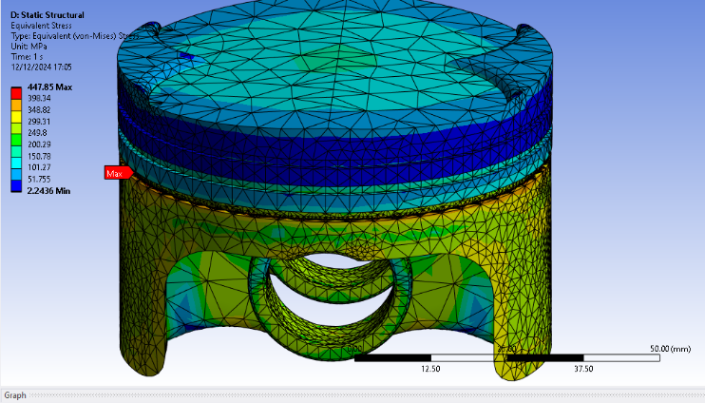
Figure 42- 2024 T3 Total stress

5.0 Limitation
A limitation of using Ansys is the potential inaccuracy in motion loads when materials are changed, as the rigid dynamics system was not rerun for each material. However, this inaccuracy is minimal, with only a 0.022 kg difference between the heaviest and lightest pistons, leading to an 8% change in inertia, which has negligible impact at low RPMs.

$$Percentage Difference=\frac{V1-V2}{(\frac{V1+V2}{2}}X100=\frac{0.27752-0.25513}{(\frac{0.27752+0.25513}{2})}X100=8.41\%≈8\%$$
Another limitation is the inability to solve with weak springs enabled, requiring a fixed support at the pin bosses. This reduced the accuracy of stress and deformation results, suppressing realistic movement in that region and causing the minimum deformation to be inaccurately displayed as zero.

6.0 Context
By integrating structural and thermal analysis with material and shape optimization, this report highlights the critical role of CAE in piston design. Ansys Workbench results were validated using a case study involving a cantilever beam.
Al 6061-1.5% B4C-1.5% SiC emerged as the most effective material for reducing stress and deformation while enhancing thermal efficiency. The optimization process demonstrated that material selection significantly impacts engine performance. However, limitations such as inaccuracies in motion load calculations and the constraints of fixed supports were noted. Despite these limitations, the study demonstrates the effectiveness of CAE in improving piston design for enhanced performance in practical applications.

7.0 References
Aerocom. (2024). Metallic Catalogue. Aerocom. https://aerocommetals.co.uk/products/aluminium/
AMT- Advanced Materials Technology. (2014). Aluminum Alloys.
Anne Helmenstine. (2024, April 30). Sources of Error in Science Experiments. Science Notes . https://sciencenotes.org/error-in-science/
Design and Analysis of Piston by SiC Composite Material (May 2015). https://www.ijirst.org/articles/IJIRSTV1I12006.pdf
Mohd Abdul Rahman, P. Ravi Chander, & M. Prasad. (2020). Modeling and Analysis of Piston using Various Piston Crown Geometries. International Journal of Innovative Technology and Exploring Engineering. https://api.semanticscholar.org/CorpusID:240667422
Rashmita, Singh, S., Kumari, A., & Aggarwal, S. (2024). Optimization of piston material with aluminium alloy based metal matrix composites. Materials Today: Proceedings, 103, 366–373. https://doi.org/https://doi.org/10.1016/j.matpr.2023.09.019

