Table of Contents
Introduction 1
1. Gibb’s reflective cycle 1
1.1 Description 2
1.2 Feelings 2
1.3 Evaluation 2
1.4 Analysis 2
1.5 Conclusion 3
1.6 Action Plan 3
2. Development of skills 3
2.1 Time management 3
2.2 Teamwork 4
2.3 Information finding 6
3. Personal development plan (PDP) 7
Conclusion 9
References 10

List of Figures
Figure 1: Gibb’s reflective cycle 2
Figure 2: 4Ds of time management 4
Figure 3: GRPI model 5
Figure 4: CRAAP model 7

List of tables
Table 1: Personal development plan 9

Introduction
A reflective report is a distinct form of writing that supports creating a reflection on learning that had been achieved from a process or activity (Megginson and Whitaker, 2017). For academic life, reflective learning helps deliver insights regarding the skills been developed throughout the academic activities that can help in career development. The reflective report can include what has been learned, how has been learned, the significance of the learnings, the skills developed and the application of the skills in future success or career (Black and Plowright, 2015). The reflective report is going to reflect on academic learnings and identify how the academic activities and learning models have helped me develop time management, teamwork and research skills along with delivering a personal development plan for further structured improvement.

1. Gibb’s reflective cycle
Gibb’s reflective cycle is a popular cyclical model of reflection that allows exploring an experience by going through six stages (Gibbs, 1988). The stages are:
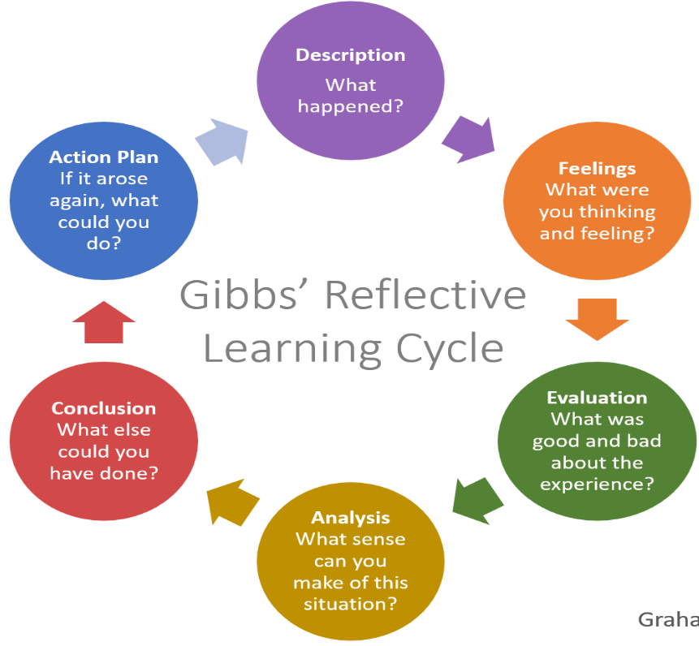

Figure 1: Gibb’s reflective cycle
Source (Gibbs, 1988)

1.1 Description
The 1st stage, description, ask to identify what happened during the learning, what the team members did, the expectations, the actual outcomes etc. regarding the learning activities (Hewitt et al., 2001). The instructor assigned a task to our team on time management that was a case-based task where the solution was supposed to be delivered via formal group presentation. We divided the task by assigning one question to one group member and each member was supposed to submit the task before two days of final submission so that we could seat, discuss, learn from each finding and combine the works into one for the final presentation. But we finished before the final day of submission and found that information was not mutually exclusive and lacked relevancy. So, we had to seat for hours to produce the final work into a single structural format by deleting information recurrency, irrelevancy and style differences.

1.2 Feelings
The second stage, feelings, ask to explore the thoughts during an experience and their influence on developing ab abilities that include questions like feelings before-during-after experience, team members’ feelings etc. (Fielding, 2019). During task dividing, each of the members was very confident regarding a perfect outcome but after submitting individual works, the expression changed to nervousness for information gaps and short time. But as we're optimistic and motivated each other to come up with solutions. Finally, we members sacrificed our plans and are satisfied with our on-time submission.

1.3 Evaluation
The third stage, evaluation, provide the opportunity to think about what has worked and what hasn’t to find out positive and negative aspects of an experience to learn from the negatives and preserve the positives (Rubin, Fry and Plovnick, 1974). The things that didn’t work were: not being on time, not understating the keywords to search for desired information, dissimilar members’ thought process, unstructured organisation of information. This that worked well is: planning to solve problems within a short time, critical thinking for the solution, proper notetaking for correcting mistakes and working under pressure.

Analysis
The fourth stage allows giving attention to details regarding why things happened (Siassakos et al., 2014). The main reason for the negative situation was not maintaining the team’s deadline for work submission that has affected our backup plan for problems to solve. Secondly, we didn’t understand what information to look for to answer the tasks that resulted in inaccurate research. Thirdly, the tasks were distributed according to the personal choices of members and thus, we were confident regarding our strengths on the topics and didn’t communicate with each other at all before our submission date. Then, we should have a group discussion before the task submission to check progress, relevancy and association of works. Finally, we lacked groupthink to not look disagreeable. If the members questioned the decisions, the problems could have been avoided.

1.5 Conclusion
The fifth stage, the conclusion, includes a summarization of findings to take corrective decisions to improve in future (Crenshaw, 2016). We realised that backup planning, brainstorming, noting and challenge taking mentality help to reach the goal. But we have also found some lacking that is important to reduce uncertainty and improve the work quality such as time management to have enough time on hand to solve problems. The team members should communicate during their tasks and question decisions for better ideas. Lastly, searching for information and presenting it in an organised and understandable manner is important for a better decision.

1.6 Action Plan
An action plan refers to planning for next to avoid similar mistakes and to act in a way that will assure the desired result (Rao, 2015). This stage also asks for planning to develop skills currently one lacks for personal, team and career development. A personal development plan has been created concerning the areas that need development given later.

2. Development of skills

2.1 Time management
Time management is the ability to plan and organize time for to-do activities. The skill can be developed using the 4D concept.

Figure 2: 4Ds of time management
Source (Hewitt et al., 2001)
To improve my time management ability, I apply 4Ds now. In 4Ds, do refer to completing the essential task, can be done by myself, will add value, will take short time but have huge significance etc. Megginson and Whitaker, 2017. Everyone should have a daily to-do list. I list daily Do tasks such as replying to emails and calls, noting and emailing my queries to the instructor, attending virtual group discussion, printing documents, updating or noting schedules, studying or completing a daily portion of academic tasks etc. In daily routine, these tasks should get the highest priority. Then defer is delaying task that doesn’t need immediate response and reschedule to attend while available (Green et al., 2016). I delay tasks that have a longer deadline to meet the earlier deadlines so that I can finish a task remaining focused and complete fast to start the next one. Sometimes a task can be better performed by another person considering ability, availability, urgency etc. (Williams, 2020). The task should be delegated to someone responsible that can be done by him. I delegate grocery shopping, posting, printing, emailing etc. tasks to someone who is already going to do it with proper instruction to save time during pressure. Finally, deleting unnecessary tasks that are insignificant, waste time or have no value should be deleted (Forsyth, 2017). I delete tasks like watching Netflix, or socializing or chatting if I have a busy schedule. The 4D model helps me prioritize tasks and meet my goals on expected time.

2.2 Teamwork
Teamwork is the ability to work with other people as a group to achieve a mutual goal with coordination, support, empathy, mutual understanding.
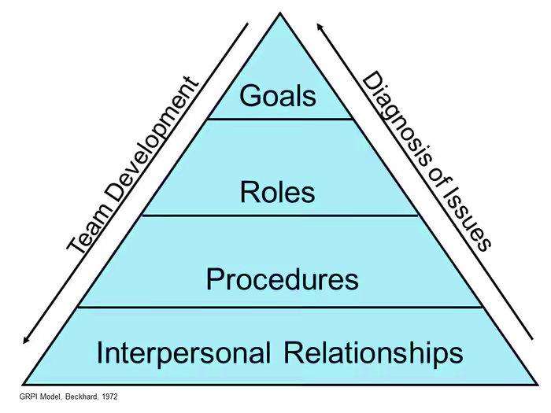
Figure 3: GRPI model
Source (Plovnick et al., 1974)
The goal is to set the objective of teamwork and communicate it with the members (Schon, 2017). Having goals direct members to set priorities and have a proper solution. I with other members set different goals such as main goals and supporting time goals, result goals, sub-goals, individual goals etc. that will end as achieving the final goal. This helps us to remain focused. Then, role refers to responsibilities, expectations, leadership authority (Roberts, 2013). Each team needs a leader who hears others’ constructive criticisms, guide members, monitor activities, coordinate and take decision with everyone’s consent. Depending on our strength in the course, we choose our team leader who takes extra responsibility like holding meetings, communicating with members, checking progress, taking delegation etc. Members are assigned roles like regular communication, problem sharing, reporting leader, meeting deadlines etc. Process refers to sequential tasks that are interconnected and one level is added to complete to move on to the next level of a process (Cox, 2014). We now apply the management process of planning, organizing, assigning, directing, and controlling in each assignment to avoid matching our performance to the desired outcome. An interpersonal relationship is communicating with team members, trusting them and offering flexibility (Cox, 2014). During group tasks, members have to attend a daily virtual meeting. Moreover, each one is expected to delegate tasks in an emergency to support during deadline meeting issues. This is how we are trying to build teamwork skills.

2.3 Information finding
Information finding skill is making preparations for your search, identifying useful keyword phrases, making choices on where you'll look for information and making the most of a variety of materials (Varela and Mead, 2018).

Figure 4: CRAAP model
Source (Liu, 2021)
Currency refers to the timeliness of information being used such as when has been published (Rao, 2015). During my homework, I search topics considering that some topics require current information such as statistics and some do well with older findings such as theories. I look to the published date and take information accordingly. Then relevance refers to the connection of the information with my work (Weinschenk, 2015). Such as in recent times, adding Covid-19 related information is relevant to add while discussing international tourism, but Malaria is less relevant but still, that depends on the topic. Authority refers to the source of information such as in online, BBC, The Telegraph, Forbes, CNN etc. are a credential source of news. I ignore Wikipedia for taking information and look for reputed sources mentioned. Similarly, I try to search best authors for a certain topic and look for their works for sourcing. Accuracy refers to the truthfulness of information (Liu, 2021). Sources can assure accuracy for statistics and news, and for theories, I now prefer papers backed by research on big sample sizes and published in reputed journals for correct interpretation of findings. Purpose refers to the reasons for the information being present in a source. Sometimes information is influenced by politics, society, fame, subscriptions, shares, transmission etc. Thus, I check small details like the country reputation, readers feedback, comments, identity of commenters etc. to assure that the information is impartial and legit.

3. Personal development plan (PDP)
A personal development plan is a self-improvement plan that takes into account one's career and educational development (Yang et al., 2017). A plan has been created considering the skill shortages mentioned above.
Skills need to be improved | Actions | Measure | Time
Time management  The skill is important because very meaningful work has a deadline to complete. During the academic life, assignments, exams, and classes have time to start and end. In work life, the evaluation will be negative and promotion will be delayed for poor timeliness. | - Always having a daily to-do list,  - Setting specific goals to accomplish within timeframes,  - Avoiding multitasking,  - Attending sessions on time management skills,  - Taking more assignments from instructor to develop deadline meeting ability, | Ticks on every daily task of the list can measure daily time management ability. Completing a semester syllabus within a set timeframe can also measure time-goal management. Submitting assignments on time and instructor given tasks can generate feedback on the improvement. | 5 to 6 months
Teamwork  Institutional life and career, both include working with people as a team to pursue mutual goals (Williams, 2020). During education, team performance is important for good scoring and developing the habit of working with people. In a career, it is important to meet the targets of the company. | - Asking instructor for more group works,  - Evaluating each other within the team after each task to learn how to improve as a team member or leader,  - Participating in team competitions with different teams to develop working ability with every type of person, | The score of the team tasks and feedbacks from members can evaluate the improvement.  The instructor’s observation during presentation or group discussions can also measure improvements.  The result of competitions can measure in-team working ability. | 6 months
Information finding/ research  This is the era of information and technology. Vast information is available on the internet and working with bid data requires searching, processing, interpreting the ability to use information meaningfully (Alldredge, 2017). For both academic tasks and job tasks, research is mandatory to come up with solutions. | - More critical tasks from instructors that need in-depth researching,  - Participating in case competitions,  - Attending sessions to improve in research,  - Assisting in research works,  - Enrolling in courses/coaching, | Instructor’s feedback on referencing and information used can evaluate development. The competitions’ results, research professor’s feedback, coaching’s feedback can also measure the improvement. | 3 to 6 months
Table 1: Personal development plan

Conclusion
The reflective cycle offers the opportunity to evaluate the experience to learn personal strengths, weaknesses, opportunities and threats that facilitate continuous development. Time management, teamwork and research skills are crucial to complete a task professionally. Models can guide us precisely on how to work on developing the skills. 4Ds, GRPI and CRAAP models can guide a student regarding the areas that need to be thought to design activities of improvement. Finally, a personal development plan considers the findings to form a detailed plan for future-oriented employability skills. So, everyone can work with a reflective model after small intervals and form PDP to remain in continuous development.

References
Alldredge, D., 2017. Institutional Investors and Information Processing Skill. SSRN Electronic Journal,.
Black, P. and Plowright, D., 2015. A multi‐dimensional model of reflective learning for professional development. Reflective Practice, 11(2), pp.245-258.
Canfield, J., Hansen, M. and Hewitt, L., 2001. The power of focus. London: Vermilion.
Cox, E., 2014. Adult learners learning from experience: using a reflective practice model to support work‐based learning. Reflective Practice, 6(4), pp.459-472.
Crenshaw, D., 2016. Time Management Fundamentals. [Carpinteria, Calif.]: Lynda.com.
Fielding, J., 2019. Rethinking CRAAP: Getting students thinking like fact-checkers in evaluating web sources. College & Research Libraries News, 80(11), p.620.
Forsyth, P., 2017. Successful Time Management. London, GBR: Kogan Page.
Gallie, D., Zhou, Y., Felstead, A. and Green, F., 2016. Teamwork, Skill Development and Employee Welfare. British Journal of Industrial Relations, 50(1), pp.23-46.
Gibbs, G., 1988. Learning by Doing: A Guide to a Teaching And Learning Methods. Oxford,Polytechnic: Further Educational Unit.
Huang, S., Xiong, Y. and Yang, L., 2017. Skill Acquisition and Information Sales. SSRN Electronic Journal,.
Liu, G., 2021. Moving up the ladder of source assessment: Expanding the CRAAP test with critical thinking and metacognition. College & Research Libraries News, 82(2), p.75.
Megginson, D. and Whitaker, V., 2017. Continuing professional development. London: Chartered Institute of Personnel and Development.
Rao, P., 2015. Time Management for New Employees. Packt Publishing.
Roberts, A., 2013. Encouraging reflective practice in periods of professional workplace experience: the development of a conceptual model. Reflective Practice, 10(5), pp.633-644.
Rubin, I., Fry, R. and Plovnick, M., 1974. Making health teams work. [Cambridge, Mass.]: [M.I.T.].
Schon, D., 2017. Donald Schon (Schön): learning, reflection and change. [online] infed.org. Available at: <http://infed.org/mobi/donald-schon-learning-reflection-change/>.
Siassakos, D., Draycott, T., Crofts, J., Hunt, L., Winter, C. and Fox, R., 2014. More to teamwork than knowledge, skill and attitude. BJOG: An International Journal of Obstetrics & Gynaecology, 117(10), pp.1262-1269.
Varela, O. and Mead, E., 2018. Teamwork skill assessment: Development of a measure for academia. Journal of Education for Business, 93(4), pp.172-182.
Weinschenk, P., 2015. Skill Formation Under Incomplete Information. SSRN Electronic Journal,.
Williams, J., 2020. Team Effectiveness in Academic Law Libraries: Using Targeted Team Interventions To Improve Dynamics and Performance. SSRN Electronic Journal,.

