

BMHP5014

Changemakers: Creativity and Value Creation

Component 1

Online portfolio of set exercises

Student name: Nicoleta-Gianina Abiaboeru
Student number: 2527024
Lecturer’s name: Soban Sadiq

Table of Contents
Task 1: Defining Key Concepts in Practice 3
1.1 Innovation 3
1.2 Creativity 3
1.3 Value Creation 3
1.4 Change 3
Task 2: Mind Map 4
Task 3: Self-Reflection of Group Activity 4
Task 4: Case Study Analysis of a UK Innovation – NHS Virtual Wards 5
Task 5: Research Task – Staff Stress in Health and Social Care 6
Task 6: Exploring Digital Innovation in Health and Social Care 7
6.1 Wearable Health Technologies 7
6.2 Electronic Health Records 7
6.3 Preventative Care and Health Promotion 8
Task 7: Understanding the NHS Leadership Framework 8
7.1 NHS Leadership Framework 8
7.2 Leadership Behaviour Application – Inspiring Shared Purpose 8
Task 8: Self-Reflection Journal 9
Reference 10

Task 1: Defining Key Concepts in Practice

1.1 Innovation
According to Cambridge dictionary (2023), innovation is the act of introducing new ideas, technologies, services or processes that lead to improvements on current practices and provide better results. In health and social care, innovation will not only help to improve the quality of services, but also make the processes more efficient and improve the quality of experience for the patient, using modern methods like telemedicine and electronic health records. The NHS has implemented the use of virtual wards to allow patients to be monitored remotely and to help to prevent unnecessary admissions to hospital. Rogers et al.'s Diffusion of Innovation Theory (2014) that a successful innovation is slowly adopted is because users are aware that the new product is useful, compatible, and beneficial to them.

1.2 Creativity
Creativity is the capacity of generating new and useful ideas to solve problems and/or enhance existing practices. Creativity can help the professionals in health and social care to come up with a unique, individual-centered solution to improve the quality of care and the patient's wellbeing (PMC, 2021). A personalised memory box could be used to encourage communication and minimise anxiety for a resident who is suffering with dementia, for example. The Componential Theory of Creativity proposed by Amabile states that creativity is the outcome of the alignment or combination of relevant knowledge, creative thinking skills and intrinsic motivation to effectively solve problems.

1.3 Value Creation
Value creation is about bettering outcomes for service users whilst making good use of resources (PMC, 2022). Value in health and social care is about providing quality services which are safe, effective and person centred and generate improved health and/or patient satisfaction. For instance, multidisciplinary care teams provide care coordination to minimize hospital rehospitalization and the continuity of care. The Porter's Value-Based Healthcare model (2008) suggests that value is created when the healthcare body can deliver improved outcome for their patients at a lower value of the care it provides.

1.4 Change
Change is an organization's intervention and application of improvements in services, practice or behaviour to gain better results. Within health and social care, change can contribute to the continuous improvement of the service, improve patient safety and can help to address future health and social care demand. For instance, EHRs mandates employee training and adjustment to new digitized systems. The Change Management Model developed by Kurt Lewin states that change is possible at the three stages of unfreezing, changing and refreezing existing behaviours (Memon, Shah and Khoso, 2021).

Task 2: Mind Map
Figure 1: Mind Map – Staff Burnout in Health and Social Care
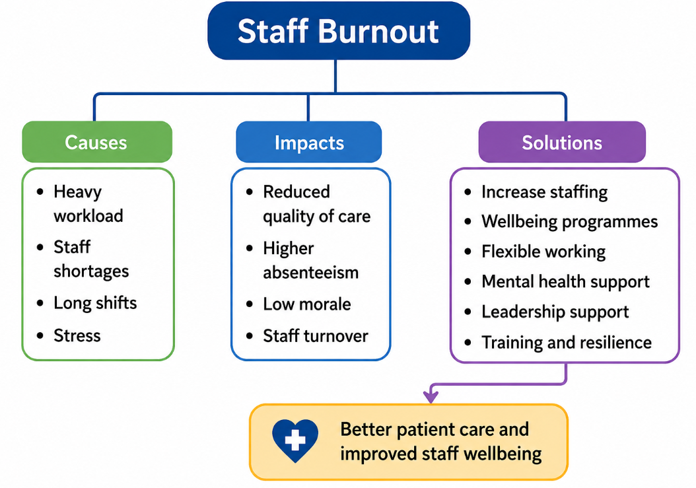
One major issue in health and social care is the issue of staff burnout, this occurs when staff are overworked, understaffed and understressed they are not providing the best care to patients and the care provided is not of a good quality, and this results in them becoming less well. Burn out can further exacerbate sickness absences, decrease staff morale, and lead to staff turn over, putting additional stress on the healthcare services. The mind map shows the key causes, consequences and solutions in practice including greater staffing, better wellbeing measures, leadership support, and flexible working. Staff Burnout is seen as a complex problem using a "Systems Thinking Approach" (Meadows 2008) influenced by inter-connected organisational issues and interventions are required to work together to create sustainable improvements.

Task 3: Self-Reflection of Group Activity
Description
In the group activity I was able to collaborate with fellow classmates to generate ideas and solutions to a health and social care problem by applying convergent and divergent thinking. Brainstormed options, considered the best solution, and chose the most feasible one.
Feelings
Throughout the process, I was not too sure about presenting my ideas, but I got more confident as I went. I've learned the value if listening to others' opinions and using them to better appreciate the importance of teamwork and to be more actively involved throughout.
Evaluation
The activity was productive because there were many creative ideas generated by divergent thinking and convergent thinking was utilized in narrowing down to the most appropriate solution. We expressed respect and we worked well together as a group to make decisions.
Analysis
Divergent thinking is a way to make people think creatively, it's about exploring lots of different options, convergent thinking is about choosing the best option. This Gibbs cycle of reflective learning (1988) was helpful for a systematic assessment of my contribution and learning.
Conclusion
The lessons I learned at the conclusion of the programme was that team work is essential when listening, speaking and making decisions of a balanced team. I developed confidence and was able to understand the need to think critically as well as be creative in tackling practical problems.
Action Plan
I will communicate more effectively in future group activities, calling on less vocal members to join in, and use a comprehensive evaluation process to make my decisions based on real data to enhance group activity and results.

Task 4: Case Study Analysis of a UK Innovation – NHS Virtual Wards
Background
The NHS England (2024) Virtual Wards programme was launched in response to the growing need for NHS service provision, lack of hospital beds and the need to meet the demand for safe care for patients at home. Healthcare professionals can monitor patients with acute or long-term conditions and avoid long hospital stays using remote monitoring technologies.
Creativity
The innovation is an integrator between the digital technology, remote monitoring tools and the multidisciplinary approach that allow hospital level care in the patient's home (Conley et al., 2022). The innovative solution allows on-site review of patient information, immediate care response to shifts in health conditions, and timely, individual patient care in a way that does not overload hospitals.
Value Created
The value of a virtual ward comes through providing better patient experience; preventing unnecessary hospital admissions; bringing down the cost of health services; and freeing up hospital beds for those patients that need intensive treatment. Patients are cared for in their own environment, healthcare teams are able to re-source better and provide continuity.
Outcomes
According to NHS England (2025) reports, virtual wards have resulted in a reduction in hospital admissions, decreased length of hospital stay, increased patient satisfaction and improvements to the system's efficiency in the following NHS trusts: Lancashire, Lincolnshire, Buckinghamshire, Staffordshire, and Nottinghamshire. The diffusion of virtual wards has been accelerated due to the well-recognised benefit of virtual wards, ease of implementation and a benefit for patient care, as referenced in the Rogers' Diffusion of Innovation Theory (2014). The benefits have helped to make this available across the wider health service (NHS) and continue to grow.

Task 5: Research Task – Staff Stress in Health and Social Care
Article 1
Søvold et al. (2021) studied mental health and wellbeing of healthcare workers finding that a heavy workload, emotional stressors as well as a lack of organizational support and the COVID-19 pandemic were all significant stressors for staff involved in the delivery of healthcare. The authors discovered that taking care of the mental health of health care workers is vital to ensuring they can provide safe, quality patient care. The study identifies several possible points of intervention that could help reduce physician burnout and improve employee retention such as bolstering support for employees, improving access to mental health care for employees, and creating resilient health care systems.
Article 2
Prasad et al. (2021) conducted a study on the stress and burnout amongst healthcare workers who were on duty during COVID-19. The findings revealed that there was a strong relationship between emotional exhaustion and psychological distress with long working hours, high patient workloads, lack of staffing and fear of infections. The research highlights that there needs to be more wellbeing programmes within healthcare companies, psychological help and improved workforce planning to aid staff wellbeing and patient safety.
Comparison of the Two Articles
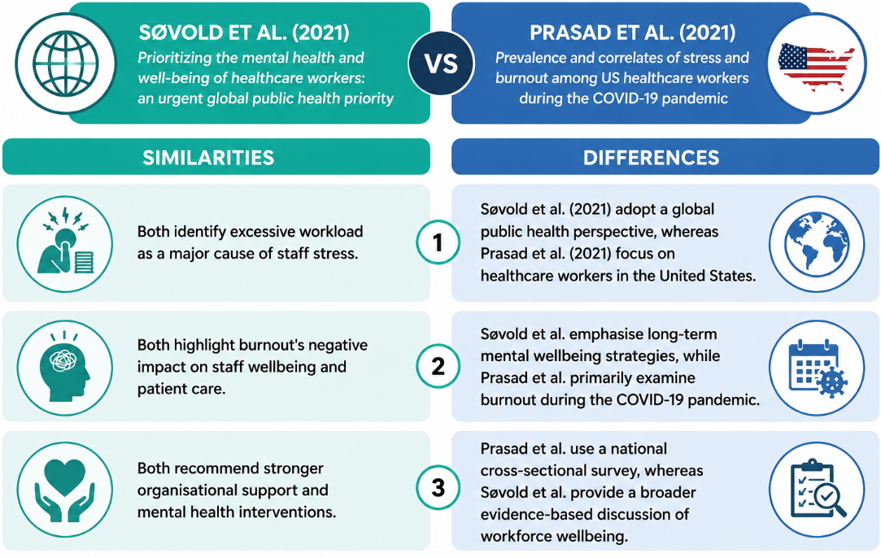

Task 6: Exploring Digital Innovation in Health and Social Care

6.1 Wearable Health Technologies
Chronic health conditions are managed with Wearable health technologies (like smartwatches, continuous glucose monitor, and a heart rate monitor) which monitor health data in real time. These devices can alert to abnormal readings early, facilitate self-management and facilitate clinical interventions. For instance, individuals with a medical issue of diabetes may have a continuous glucose screen that tracks glucose levels and informs medical care companies. The Technology Acceptance Model (TAM) (Davis, 1989) suggests that patients will use devices more frequently when they see these devices as useful, dependable and simple to use which in turn would impact their health.

6.2 Electronic Health Records
Electronic Health Records (EHRs) are digital data that keep patient records at NIH (2023), enabling healthcare providers to get access to precise medical details from any type of healthcare setting. This ensures better communication, avoids re-testing, aids with care co-ordination and reduces medication errors, thus providing good patient safety. For example, if the patient has been treated for an allergy in the hospital, the treating physician can access the patient's allergy history, instead of waiting for the history to be provided by other physicians. The Technology Acceptance Model (TAM) (Davis, 1989) suggests that the acceptance of EHR systems by healthcare practitioners is dependent on the positive impact that the systems have on their efficiency (increased coordination and patient safety), and the user-friendliness of the system.

6.3 Preventative Care and Health Promotion
Digital technology is helping to support preventative care: Health application, monitoring systems, reminders for vaccinations and promotion programmes for lifestyle. Mobile health apps can help promote regular physical activity, healthy eating habits, regular blood pressure checks, and screenings. Reminders to have vaccinations, routine health checks or other NHS related information can be sent via the health app and patients can monitor long-term health conditions from home. The Technology Acceptance Model (TAM) (Davis, 1989) argues that people use new technologies when they believe that the technology performs useful functions and is easy to use, which leads them to adopt the technology and encourage healthier behaviours and fewer preventable illnesses.

Task 7: Understanding the NHS Leadership Framework

7.1 NHS Leadership Framework
The behaviours of good leadership in health and social care organisations are identified in the NHS Leadership Framework, in seven areas of leadership (NHS England, 2024). These behaviours are: Inspiring Shared Purpose, Leading with Care, Evaluating Information, Connecting Our Service, Sharing the Vision, Engaging the Team and Holding to Account. Inspiring Shared Purpose: to motivate staff by communicating meaningful goals that inspire leaders. Leading with Care is about caring, respecting and looking after staff. Evaluating Information is about evidence-based decision making, Connecting Our Service is about working collaboratively across organisations (NHS Leadership Academy, 2026). The use of Sharing the Vision guides teams to work towards common goals, Engaging the Team helps to get everyone involved and thinking outside the box, and Holding to Account helps to hold team members accountable for high-quality care and continual improvement.

7.2 Leadership Behaviour Application – Inspiring Shared Purpose
Inspiring Shared Purpose encourages the leader to give the employees a vision of shared purpose, to inspire them to do shared purpose. Embedded decision-making engagement of health and social care leaders creates a workplace culture which embraces and values new ideas. For example, the active engagement of nurses and allied health staff in the creation of innovative approaches to accessing patient care can improve the quality of care provided, patient outcomes and motivation and engagement for staff. Drawing on Transformational Leadership Theory (Bass, 2015) this notion is that of a shared vision, encouragement and supporting followers to help them accept innovation, and improve collaboration and/or to deliver high standard, patient-centred care.

Task 8: Self-Reflection Journal
Concrete Experience
The module has encouraged me in hands-on practices to consider how I can find creativity, innovation and value creation. Creating the mind map and evaluating innovations within the NHS gave me a clear understanding of the benefits of creative solutions to enhance health and social care.
Reflective Observation
Such experiences shifted my thinking about innovation, and how that might be technology and also how it might be creative problem solving, working together, and leadership. I realised that the needs of service users need to be taken into account when planning improvement in service provision.
Abstract Conceptualisation
I learned that innovation, evidence-based practice, and effective leadership is a perfect combination of creating value. The Kolb Reflective Cycle was a powerful tool for me to bring together theory and practice, and deepen my understanding of professional learning.
Active Experimentation
In the future, within my health and social care role, I will think outside the box, embrace innovation and work cooperatively in team. I will continually review my practice in order to further enhance the subsequent outcomes for patients and service quality.

Reference
Bass, B., (2015). Transformational leadership theory. In Organizational Behavior 1 (pp. 361-385). Routledge.
Conley, J., Snyder, G.D., Whitehead, D. and Levine, D.M., (2022). Technology-enabled hospital at home: innovation for acute care at home. NEJM Catalyst Innovations in Care Delivery, 3(3), pp.CAT-21.
Davis, F.D., (1989). Technology acceptance model: TAM. Al-Suqri, MN, Al-Aufi, AS: Information seeking behavior and technology adoption, 205(219), p.5.
Memon, F.A., Shah, S. and Khoso, I.U., (2021). Improving Employee's Engagement in Change: Reassessing Kurt Lewin's Model. City University Research Journal (CURJ), 11(1).
NHS England (2024) “NHS leadership competency framework for board members” Available at: https://www.england.nhs.uk/long-read/nhs-leadership-competency-framework-for-board-members/ [Accessed on 30th June 2026]
NHS England (2024) “Virtual wards” Available at: https://www.england.nhs.uk/virtual-wards [Accessed on 30th June 2026]
NHS England (2025) “Virtual wards operational framework” Available at: https://www.england.nhs.uk/long-read/virtual-wards-operational-framework/ [Accessed on 30th June 2026]
NHS Leadership Academy (2026) “Explore the Healthcare Leadership Model” Available at: https://www.leadershipacademy.nhs.uk/healthcare-leadership-model/explore-the-healthcare-leadership-model/ [Accessed on 30th June 2026]
NIH (2023) “Electronic Health Records as Source of Research Data” Available at: https://www.ncbi.nlm.nih.gov/books/NBK597466/ [Accessed on 30th June 2026]
PMC (2021) “Creativity in problem solving to improve complex health outcomes: Insights from hospitals seeking to improve cardiovascular care” Available at: https://pmc.ncbi.nlm.nih.gov/articles/PMC9006532/ [Accessed on 30th June 2026]
PMC (2022) “Value Cocreation in Health Care: Systematic Review” Available at: https://pmc.ncbi.nlm.nih.gov/articles/PMC8994154/ [Accessed on 30th June 2026]
Porter, M.E., (2008). Value-based health care delivery. Annals of surgery, 248(4), pp.503-509.
Prasad, K., McLoughlin, C., Stillman, M., Poplau, S., Goelz, E., Taylor, S., Nankivil, N., Brown, R., Linzer, M., Cappelucci, K. and Barbouche, M., 2021. Prevalence and correlates of stress and burnout among US healthcare workers during the COVID-19 pandemic: a national cross-sectional survey study. EClinicalMedicine, 35.
Rogers, E.M., Singhal, A. and Quinlan, M.M., (2014). Diffusion of innovations. In An integrated approach to communication theory and research (pp. 432-448). Routledge.
Søvold, L.E., Naslund, J.A., Kousoulis, A.A., Saxena, S., Qoronfleh, M.W., Grobler, C. and Münter, L., 2021. Prioritizing the mental health and well-being of healthcare workers: an urgent global public health priority. Frontiers in public health, 9, p.679397.

