NAME: Harveen Kaur
STUDENT ID. NUMBER: 2230397
IMPORTANCE OF ETHICAL LEADERSHIP ON EMPOWERING EMPLOYEES AND RESOLVING INTERNAL CONFLICT WITHIN MNCS IN THE PHARMACEUTICAL SECTOR OF THE UK
NAME OF UNIVERSITY: University of Wales trinity saint David (business school Swansea)
YEAR OF SUBMISSION: 2024

Abstract
Research question
What is the role of ethical leadership on empowering employees and resolving internal conflict and enhancing employee empowerment within MNCs in the Pharmaceutical sector of the UK?
Significance
The study has the essential importance as it has focused on the implication of the ethical leadership management within the organisation for enhancement of employee engagement by empowering them for decision making and the conflict resolution within the organisation..
Methodology
The population of the employment is considered to detect the sample size based on the formulas of n=N x e^2/N+e^2-1. In this formula, n=sample size, N=Population, e=margin of error. In this case the population size has been considered 71,800, and a margin of error considered at 5% (0.05). Hence based on the formula the sample size can be calculated and a sample calculated 200 employees have been included in this study to collect data.
Findings
Based on the overall research outcome, it can be evaluated that there is the need for regulatory intervention to address organisational justice for mitigating deviant behaviour of leaders in the context of the UK pharmaceutical industry so that ethical leadership can be thoroughly practised as well as implemented. It is evaluated that presence of open communication and transparency in pharmaceutical MNCs is associated with the ethical leadership practices in the context of the UK pharmaceutical sector mainly.
Implication
UK pharmaceutical MNCs should assess and reassess and modify their current ethical leadership strategies to more effectively empower employees and address conflict resolution, this is to enhance employee empowerment so that companies should cultivate a culture of open communication and transparency.
Limitations
Respondents may be unwilling to provide honest opinion as the part of the survey response that may have reflected the power response of the research which can be noticed as one of the major drawbacks of this particular research study mainly. Apart from that survey gave the drawback of not being able to capture complex experiences also.

DECLARATION
This work has not previously been accepted in substance for any degree and is not being concurrently submitted in candidature for any degree.

Signed. Harveen kaur
Date. 25/7/2024

STATEMENT 1

This work is the result of my own investigations, except where otherwise stated.

Other sources are acknowledged by footnotes giving explicit references. A bibliography is appended.

Signed .....................................................................

Date ........................................................................

STATEMENT 2

I hereby give consent for my work, if accepted, to be available for photocopying and for inter-library loan, and for the title and summary to be made available to outside organisations.

Signed .....................................................................

Date ........................................................................

Table of Contents
Abstract 2
DECLARATION 3
STATEMENT 1 4
STATEMENT 2 4
Chapter 1: Introduction 11
1.1 Background 11
1.2 Problem Statement 13
1.3 Rational of study 15
1.4 Aims and Objectives 16
1.5 Research Question 17
1.6 Dissertation Structure 17
Chapter 2: Literature Review 18
2.1 Introduction 18
2.2 Ethical leadership 18
2.3 Ethical leadership and conflict management efficiency 20
2.4 Employee empowerment 21
2.5 Relations between ethical leadership and employee empowerment 22
2.6 Self-motivation as a mediating factor 24
2.7 Core function and strategies of ethical leaders 25
2.8 Challenges of managing ethical leadership 26
2.9 Employee well-being as a moderating factor 26
2.10 Literature Gap 27
2.11 Conceptual framework 27
2.12 Summary 28
Chapter 3: Methodology 29
3.1 Summary of research rationale and purpose 29
3.2 Use of research onion 29
3.2.1 Research philosophy: Positivism and quantitative 31
3.2.2 Research strategy: Survey 33
3.3 Data collection technique 33
3.3.1 Data collection 33
3.3.2 Sampling technique 34
3.3.3 Sample size 35
3.4 Research procedures 36
3.5 Validity, reliability and generalizability 37
3.6 Data analysis procedures 38
3.7 Ethical consideration 38
3.8 Chapter summary 39
Chapter 4: Findings and analysis 40
4.1 Chapter introduction 40
4.2 Research hypothesis 40
4.3 Overview of the data 40
4.3.1 Survey methodology 40
4.3.2 Sample characteristics 41
4.4 Descriptive statistics 44
4.4.1 Central tendency 44
4.4.2 Dispersion 44
4.4.3 Frequencies of percentages 45
4.5 Inferential statistics analysis 46
4.6 Hypothesis tests 47
4.7 Interpret the findings 48
4.8 Limitation to this study 51
4.9 Key findings 52
4.10 Chapter summary 52
Chapter 5: Discussion, Conclusions and Recommendations 53
5.1 Introduction 53
5.2 Interpretation the finding linked to research questions 53
5.3 Theoretical implications 55
5.4 Unique findings and insights 56
5.5 Strengths and limitations 56
5.6 Conclusions 56
5.7 Recommendations for managerial practice 57
5.8 Contributes to theory 58
5.9 Limitations of the study 58
5.10 Areas for further research 59
5.11 Final thoughts 59
Reference List 60
Appendices 75
Appendix 1: Raw survey data 75
Appendix 2: Central tendency analysis 75
Appendix 3: Dispersion analysis 75
Appendix 4: Frequencies of percentages analysis 76
Appendix 5: Correlation analysis 77
Appendix 6: Regression analysis 79
Appendix 7: Hypothesis tests with linear regression 80
Appendix 8: Summary of sample characteristics 80
Appendix 9: Survey questionnaire 82

List of Figures
Figure 1.1: Revenue of pharmaceutical production in UK 7
Figure 1.2: Employment in Pharmaceutical industry in UK 10
Figure 2.1: Social learning framework 20
Figure 2.2: Conceptual framework 25
Figure 4.1: Consent collected from 100% of the participants 38
Figure 4.2: Age dispersion among the respondents 39
Figure 4.3: Gender dispersion among the respondents 39
Figure 4.4: Educational background of the respondents 40
Figure 4.5: Professional experience dispersion among respondents 40

Acknowledgements
I would like to express my sincere gratitude to my supervisor for their invaluable guidance and support. Special thanks to the participants from the pharmaceutical organisation the UK, for their cooperation and to my family and friends for their unwavering encouragement throughout this research.

Chapter 1: Introduction

1.1 Background
Ethical leadership is considered as one of the most significant results and characteristics of Business Ethics associated with the workplace management practices since the 1970s. Since the 1980s the implication of Business Ethics was formulated and had been analysed by the Academics for its implication within the business environment and analysing the benefits and the fields of interest. Ullah et al. (2022) have analysed that ethical leadership is one of the greater and significant factors of the business ethics that helps in upholding the ideals of Human Rights management as well as it helps in improving the demonstrated motivation among the employees across the workplaces. As the business practices in the recent times have been focused on the benefits and the commercial interests of the organisation the loss of human rights and the lack of moral leadership are evident within the organisations due to which the effective ethical leadership has been important for increasing the motivation of the employees across the different industry as well as there are essential characteristics of ethical leadership that initiate the learning process in organisation and encourage the Holistic development in the institutions (Al Halbusi et al., 2021). In this respect the study mainly focused on analysing the impact of ethical leadership approaches on the empowerment of the employees in organisation as well as managing the conflict among the employees that can be helpful for Holistic development approaches among the workers and the different stakeholders within pharmaceutical organisations.
Adams–Harmon and Greer–Williams (2021) within their study have analysed that ethical leadership plays an essential role in empowering employees as it initiates the environment of learning and continuous development within the organisation culture. The ethical leaders generally set strong examples through their own behaviour that demonstrates integrity and the transparency and fairness in judgement. Therefore, the ethical decisions and the model principles are maintained for the case of organisation culture management and business operations. Ethical leadership in recent times are also offering the essential collaboration among the employees within the workplace and are creating the factors of integrity among the workers and equal contribution for the development of the organisation and operations (Dua et al., 2023). Moreover, the fairness in terms of the appreciation and reward management has also been another essential aspect for enhancing the motivation of the employee within the workplace in the pharmaceutical industry.
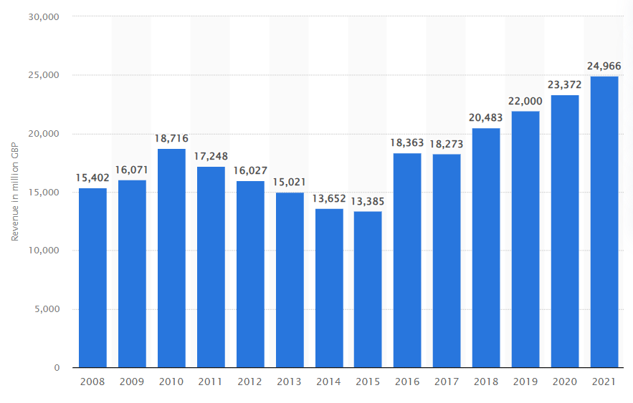

Figure 1.1: Revenue of pharmaceutical production in UK
(Source: Statista, 2024)
Ethical leadership has been important within the pharmaceutical industry of the UK due to the considerations of its contribution to the national economy of the UK. In 2021 the manufacturing systems of the pharmaceutical industry in the UK contributed more than 24 billion British pounds within the national economy (Statista, 2024). Therefore, the effective management of the production and the efficient operation systems within the organisations are essential for improving the production systems. In this respect the essential motivation of the workers and their essential contributions are important through the implication of the ethical leadership within the organisations. The recent employee turnover rate within the pharmaceutical industry of the UK will also be increasing by almost 10.3% in 2022 which will also be another essential cause for analysing the benefit of ethical leadership which can improve the organisation practices and the industrial contributions (Gitnux, 2024).
The studies of Aftab wet al. (2023) suggest that ethical leadership creates the culture of accountability and the responsibility within the employees that increase the clarity of actions among the employees within the organisation as well as set a clear standard of the behaviour within the organisation management process. The employees generally focus on taking the ownership of the responsibilities and maintaining the ethical standards of the behaviour within the pharmaceutical industry. Therefore, the effective feedback loop is created within organisations that reinforce and improve the operation management process in the pharmaceutical companies. Therefore, implication of the ethical leadership approaches are crucial for empowering the employees for their own decision making as well as he also benefits in emphasising the development and solving the conflicts among the culture and the ethics of the business standards (Aftab et al., 2022).
There are several international organisations and agencies such as WHO, EMA and FDA that focus on management of the standardised culture within the organisations and focus on maintaining the guidelines regarding legal management and ethical behaviour within the organisation while balancing the innovation practices (Limbu and Huhmann, 2022). The study mainly focus on implication and the role of ethical leadership within the pharmaceutical industry in terms of empowerment has the lack of empowerment and the centralised decision making create the issues regarding lack of transparency in terms of interaction among the health professionals as well as the lack of motivation which increase the development cycles and also increase the cost of operation (Xuecheng and Iqbal, 2022). The recent literature has also not focused regarding the impact of ethical leadership and ethical culture approach of employees on the transparent management of pharmaceutical industries rather than only focusing on the whistleblower protection systems for business ethics which would be crucial in the study.

1.2 Problem Statement
Studies such as Ali and Ullah (2023) while analysing the pharmaceutical industry of the UK have found that in terms of employee engagement management there are two factors that are essential for effective operation management. The benefit packages of the employees are important for the improved motivation of the employees while the second important factor is associated with goal setting and the empowerment of the employees. Moreover, due to the organisation standards regarding the testing of the products and product quality, centralised decision making has been important within international organisations in the pharmaceutical industry of the UK (Cavaliere et al., 2021).
However, it has the essential impact on reducing employee engagement and their motivation. The recent implications of the hourly job rate and the Zero-hour employment systems had been another essential cause of the lack of motivation for the workers within the pharmaceutical industry causing the high attrition rate on the other hand the lack of empowerment for decision making has been an essential cause for the lack of employee engagement within the workplace of pharmaceutical companies in UK (LaVan et al., 2021). Therefore, focusing on the aspects of the ethical decision making and ethical leadership is important for reducing the conflict of the biasness issues among the workers within the organisations and it is also important for empowering the employees and increasing their motivation for enhancing the engagement rate of employees in operation management systems (Anand et al., 2023).

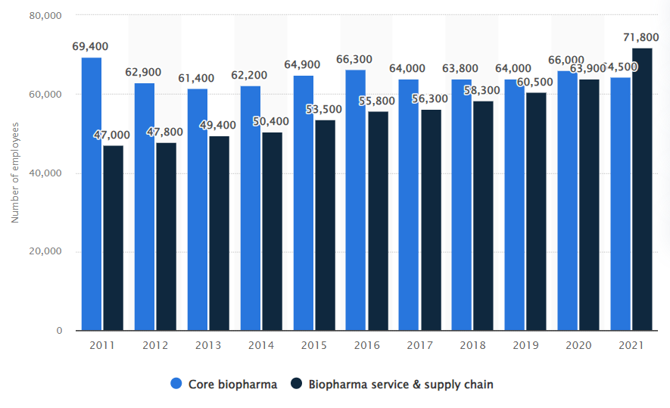

Figure 1.2: Employment in Pharmaceutical industry in UK
(Source: Statista, 2024)
The pharmaceutical industry within the UK has been a prolific resource of employment within the UK (Statista, 2024). While in 2017 the overall employment in the pharmaceutical industry had been more than 64000 in 2021 it reduced within 54000. The high level of employee attrition has been one of the major issues of effective productivity as well as the essential contribution for the nationality as it reduces the production systems in the organisation. In this respect, the improvement of the procedure of ethical leadership is essential for the improvement of empowerment of the employees in MNEs of the pharmaceutical industry of the UK. Furthermore, the study also emphasises on the recent issues and the gaps of the Literature such as the lack of metric in terms of understanding and analysing the satisfaction of the employees and the work life balance management. Moreover, the recent literature has also not focused on the factors of impact of ethical leadership for the conflict management across the employee due to the diversity of the culture in the different subsidiaries of the organisations of the pharmaceutical industry (Jia et al., 2022).

1.3 Rational of study
The research has essential importance in both the terms of organisation related contexts and also for the academic concept in terms of the ethical leadership management for the empowerment of employees and managing conflict within the work places. The different data within Statista (2024) and Medium (2024) have suggested that the employee engagement had been reducing within the pharmaceutical industry of the UK with the high rate of attrition among the employees. In 2021 the attrition rate in the pharmaceutical industry had been more than 57.3% in the worldwide basis while in 2022 the employee turnover rate in the UK had been more than 10% which is comparatively greater than the retail and the other industry of the UK. The high rate of attrition and employee turnover can cause the loss of skillful employees from the UK based pharmaceutical organisations and the lack of productivity within the organisation. The high rate of employee turnover also requires new employment that increases the cost of human resource management for the organisations. In this respect the lack of proper demonstration of the reward management and the ethical behaviour among the employees are creating the major issues in the organisation (Ullah et al., 2022). Moreover, the issues of the lack of effective culture for enabling the personal decision making in the daily operation and the lack of empowerment for the personal learning are also causing the lack of motivation of the workers within the pharmaceutical industry of the UK.
The different organisations including 3M, Sanofi and AstraZeneca had been facing serious issues within the organisation due to the loss of skillful human resources within the organisation. Sanofi, which is one of the most significant multinational organisations in the pharmaceutical industry of the UK, had been facing more than 11% of the employee turnover rate in the organisation while in the other companies the employee turnover rate had been more than 20% (Gitnux, 2024). The loss of human resources had been causing the serious issues of the productivity and the management of the subsidiaries within the different areas of business. In this consideration the empowerment of the employees for their own decision making in operation is important for enabling personal growth and the viability of employee motivation within the organisation (Suriyaprakash and Stephan, 2022). Apart from that the effective management of culture and the systems of effective reward management is also important for increasing the satisfaction of employees and their motivation for the greater engagement within the organisations of the pharmaceutical industry in the UK.
The study has the essential importance as it has focused on the implication of the ethical leadership management within the organisation for enhancement of employee engagement by empowering them for decision making and the conflict resolution within the organisation. Due to the cultural diversity in the different subsidiaries and due to the centralised decision-making systems in case of the product launching and daily operation management the issues regarding conflict of the interest of employees are also prominent within the pharmaceutical industry. In this respect ethical leadership and setting the ethical codes of conduct are important for the moral principles and for enhancing the rights of the employees within the workplace while improving their motivation in the operation management systems in the company (Mulinari et al., 2021). The study has also the essential importance as it will also focus on the academic aspect of the lack of research regarding the ethical leadership used in pharmaceutical industry for the proper reward management and conflict resolution due to the cultural diversity of the employees in organisations.

1.4 Aims and Objectives
Aim
The aim of the study is to analyse the implication of ethical leadership approaches in the pharmaceutical organisations of the UK for empowering the employees within the organisations as well as to manage the conflict within the companies across the employees.
Objectives
- To thoroughly understand the relationship between empowering the employees and ethical leadership in MNEs within the UK’s Pharmaceutical sector.
- To evaluate how ethical leadership is effective in empowering employees and managing the internal conflicts
- To analyse challenges that an organisation can face while empowering their employees or when an internal conflict arrives
- To recommend potential strategies that can help the companies to effectively utilise ethical leadership in empowering employees and solving conflicts

1.5 Research Question
- What is the role of ethical leadership on empowering employees and resolving internal conflict and enhancing employee empowerment within MNCs in the Pharmaceutical sector of the UK?

1.6 Dissertation Structure
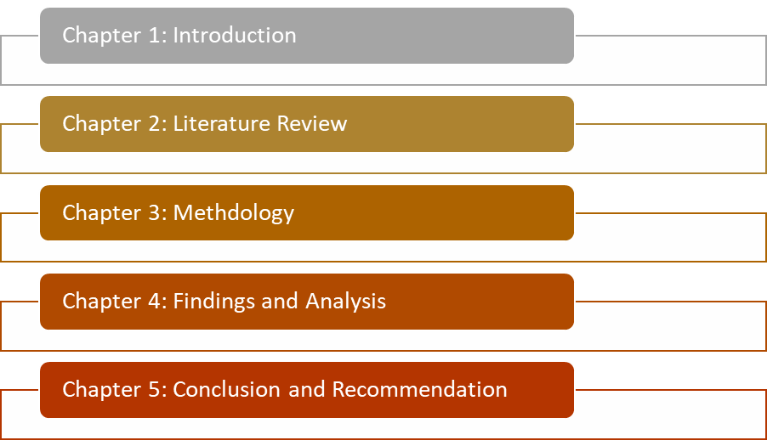

Chapter 2: Literature Review

2.1 Introduction
Chapter 2 of the study has crucial significance within the research as it mainly focuses on analysing and investigating the different concepts associated with the variables of the study and analysing the Relations between the independent and the dependent variables of the study on text. The chapter has also focused on analysing and finding the literature within the recent papers for creating the conceptual framework that can be helpful for gathering the data and reaching to the final conclusion at the end of the study.

2.2 Ethical leadership
The principles and the values of right and wrong generally characterise the organisation behaviour and formulate the essential pedestal upon which the leaders generally assert their influence over the employees for achieving the goals of the organisation and their personal aspects. The study of Hussein et al. (2022) has suggested that ethical leadership is one of the major processes of influence in the people and the employees within the organisation through the principals and values and the beliefs that are extensively focused on the organisation behaviour and accepted norms. The study of Opoku et al. (2023) also suggested that the collapse of the organisations. Such as Enron and Lehman Brothers show the essential importance of ethical behaviour within organisations that create the accepted norms within organisations and help to develop the exponential behaviour through the ethical concerns for the effective management in organisation (Lin et al. 2020; Banks et al. 2021). Following the ethical principles are important for motivating the employees as well as the community for the productivity and the performance and to create value through the responsibility and loyalty in actions (Ullah et al., 2022).
The contemporary studies Mulinari et al. (2021) have analysed that the business world has characterised the overall business practices and have created the challenges that lead to the Unethical practices of Business and lack of principal and value within business that can cause male practice. In that case the extensive attitude for creating value within the business is important for enhancing the ethical leadership approaches in business as well as the ethical leadership is also form by underline patterns where the leaders are obliged for incorporating the Exclusive exploitation of the value and the ethics within organisations for motivating the different numbers of the workers and others take holders (Zaim, Demir and Budur, 2021; Sarwar et al. 2020; Al Halbusi et al. 2021). The study of Hussein et al. (2022) has analysed that the factors of the ethical Foundation and distinctive pattern regarding ethical leadership is important for articulating the purpose of organisation value. The moral compiling attitude for the narrative of ethics is important for demonstrating the practical basis of value ethics within business as well as it is also important for demonstrating the selfless behaviour (Ren, Tang and Jackson, 2021; Islam et al. 2021; Kuenzi, Mayer and Greenbaum, 2020). It can be realised and resonated across the different numbers of the stakeholders for creating the values system in the organisation (Kim and Vandenberghe, 2021; Saleem et al. 2020).
Yazdan Henas and Mirzaei (2023) within their studies have analysed the overriding pattern of ethical leadership approaches that are inherent. It has the increased tendency for maintaining special attention for development of the resources of the organisation and improving the characteristics of the employees also (Qing et al. 2020; Mostafa and Abed El-Motalib, 2020). However, the study of Ejaz et al. (2022) has demonstrated that the ethical leadership is not concerned with the aspect of charities and the donation across the organisation. It rather identifies the loyalty of the employees and creates the channel of satisfaction for driving the success in Organisation in terms of operation and financial aspects (Men et al. 2020; Ahmad et al. 2023).
According to the study of Frazier and Janeczko (2021) Ethical leadership is mainly based on building the capacity within an organisation and also focuses on the fair and standardised ethical dimension in leadership Concept for managing people. The study has also analysed that the moral imperative development across the people is important for enhancing the value of an organisation as well as it is also important for improving the effectiveness of the engagement of employees (Nazir et al., 2021). The ethical leaders as per Magasi (2021) mainly focus on the belief of enhancing the wider expectation of the different members in the organisation and enhancing the value of the entity of business.
The study of Ghasempour Ganji et al. (2021) have evaluated the core functions of the ethical leadership which suggest that the main function of ethical leadership is associated with constructing the value paradigm within the organisation. The study of Liu et al. (2021) has outlined that the current practices within Global Business have been characterised with the ethical leadership approaches in recent times for reducing the confusion and improving the reliability for the organisation. The ethical leaders mainly focus on the consistent management and consistent conduct of the proper action that enable the employees of the organisation for effective management and creating value while serving the product and services to the consumer (Ashfaq et al., 2021).

2.3 Ethical leadership and conflict management efficiency
According to the study of Asif et al. (2022) the ethical leadership is mainly important for reducing the issues of conflict within the organisation among the employees as well as between the different levels of the stakeholders in the business operation. In that case the study has suggested that ethical leadership is important for improving the resolution efficiency of the leaders by enhancing the behaviour outcome and changing the prospective management situations within the organisation (Dua et al., 2023; Bhatti et al. 2021; Abdelhay et al. 2023). In that case the belief of efficiency is generally gained due to the domain specific behaviour which is associated with the task related leadership as well as the people Management related leadership approaches in Companies. However, studies such as Hoang et al. (2023) have clearly focused on the consistent distinction between the generalised self-efficacy and task specific efficacy of the leaders within an organisation. The study has also suggested that the employees as well as the leaders who generally follow the ethical leadership practices are equipped with the essential skills for handling the different situations within organisation (Markey et al. 2021; Sarwar et al. 2020; Banks et al. 2021). It is related to conflict and can consciously self-regulate their behaviour that cannot impact behaviour of any other person or co-worker within the organisation as well as it helps to improve the interaction among the workers within the company and the workplace (Wen et al., 2021).
The study such Oluwoleet al. (2022) have suggested that the leadership that follows ethical behaviour generally has the essential efficiency regarding solving the conflict and the issues associated with disagreement among the stakeholders and the personal incompatibility of the workers that can relate to the value and the Clash of personal belief and ideas. The research of Dey et al. (2022) shows that there are three aspects of the conflict within an organisation that can have a detrimental impact on the process of employee effectiveness and the organisation will rate effectiveness. In that case the relative conflict issue among the employees can create or hamper the interpersonal development and the interpersonal relationship among the workers which did use the overall satisfaction of the employees in the company and also reduce the ability for forcing on the tasks given in the workplace (Saleh et al., 2022; Al Halbusi et al. 2021; Novitasari et al. 2021).
The research of Le and Nguyen (2023) also has found that the personal conflict within the different departments of the organisation can also impact the performance of the employees as well as the satisfaction. In that case the study of Su et al. (2021) have suggested that the interpersonal conflict among the two or more workers within organisation can some time have the lower impact within organisation. It is related to the personal conflict and the personal issues or the Clash of the person has belief while the interdepartmental conflicts impact the overall performance of organisation (Ullah, Mirza and Jamil, 2021; Qing et al. 2020; Zheng et al. 2022). It is due to the lack of proper distribution of the workload and can have the negative impact on the satisfaction and efficiency of the workers which ultimately reduce the efficiency of the performance of the organisation (Tamer, 2021; Koay and Lim, 2022).

2.4 Employee empowerment
Arshad et al. (2021) within their studies have analysed the significant attributions regarding the employee empowerment within an organisation for its potential to enhance the satisfaction and its relation with the factors of performance and motivation of employees. The study explored the different aspects associated with the antecedents and the outcome as well as the factors of the implementation strategy regarding the employee empowerment practices in the organisation. The study of Asif et al. (2022) has analysed that employee empowerment is crucial for understanding the implication of the organisation related context and it also involves the factor of Decision-making power for the employees to take action as per their own autonomous thinking. It increases the clarity regarding the communication and also improves the factors of reliability and responsibility as well as the accountability for the actions of the individuals in the organisation (Qasim et al., 2022).
The study of Bhatti et al. (2022) has analysed that the antecedents associated with employee empowerment is extensively associated with the identified factors that contribute effectiveness of the workers in the company. Goswami et al. (2021) have suggested that the ethical leadership behaviour has the essential impact for empowering the employees and can also impact the organisation culture through promoting the empowerment by enhancing the value participation. The study of Novitasari et al. (2021) suggests that employee empowerment has been examined as per the different perspectives that include the team, individual and the organisational level. In this respect the individual level is associated with the empowerment for increasing the job satisfaction and the motivation as well as the commitment for the employees within the company. The empowered employees within the organisation feel the greater sense of the pollution and control through their autonomy over daily work practices that leads to the higher engagement and the effective performances of the organisation and the team (Marquardt et al., 2021). The study of Bahadori et al. (2021) has suggested the empowerment from the point of view of organisations which suggest that empowerment of the employees is associated with the organisation related performances that enhance the adaptability and the flexibility of the employees and also helps to develop the innovation among the workers. The organisations that allow the employees for their empowerment are better equipped through the essential degree of flexibility in terms of Sustainable growth of the organisation (Saeed et al., 2022).
The studies such as Markey et al. (2021) On the other hand have focused on the potential challenges associated with the employee empowerment where the resistance from the employees are also common and can affect the control and the authority of the executives within organisation. In some cases, overcoming the resistance of the employees also becomes a crucial situation for the effective management within Organisation (Zheng et al., 2022). In that case the participating leadership approach through the ethical standards and the collaboration across the workers and need it for ensuring the empowerment are aligned with the organisational goals and success. Dey et al. (2022) have also suggested that empowerment with a clear mechanism of goals and accountability is important for delivering the desired outcome within an organisation and avoiding the issues of conflict regarding the potential belief and individual aspects.

2.5 Relations between ethical leadership and employee empowerment
Relationship between the ethical leadership and the approaches of employee empowerment have been one of the major focal points for the organisation related researching the recent times as the researchers have focused on Analysing the different moderating and the mediating factors that have an essential impact on the employee enlargement and the employee empowerment result behaviour. in that case the study of Al Halbusi et al. (2021) have focused on the point that ethical leadership is characterised by the demonstration of the integrity and the fairness in the attitude of the employees and the leaders regarding the decision making and managing interaction. Therefore, the ethical leadership generally emphasises on the considerations of the action that can inspire that trust and the respect among the employees through the ethical behaviour factors. On the other hand, as per Ashfaq et al. (2021) employee empowerment is related to sharing the decision-making power and taking the initiative for contributing for the organisation related goals by the collaborative behaviour across the employees.
The theoretical framework associated with the study of social exchange theory suggests that there are essential relations of ethical leadership and employee empowerment which shows the prominent framework of social learning by learning ethical behaviour considerations and observing or imitating the attributions of employees and leaders (Ng et al., 2021; Limpo and Junaidi, 2023; Suifan et al. 2020; Ghasempour Ganji et al. 2021). The ethical leaders generally set the moral examples and shape the perception of the employees regarding their right to believe and the decisions within the organisation (Nazir et al. 2021; Liu et al. 2021). It creates the internal ethical norms and the values within the organisation that make the employees feel empowered and they can also act ethically with their independent decisions for contributing to the organisation's success.
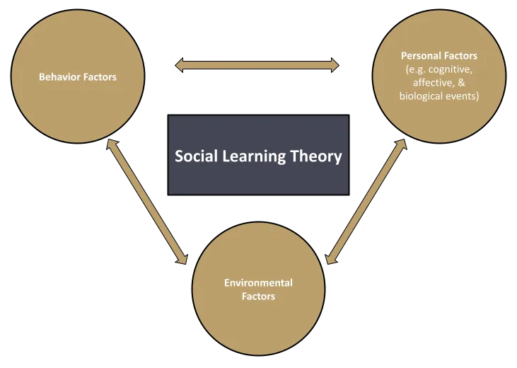

Figure 2.1: Social learning framework
(Source: Adapted from Nazir et al., 2021)
The empirical research of Nazir et al. (2021) has focused on the positive relation between ethical leadership and employee empowerment. The study has suggested that the ethical leaders are likely to improve the decision making within the organisation and encourage the employee voice and their opinion for sharing the belief for the delegation of authority. In that case the equal treatment of the employees through the fairness and respect impact the supportive work environment within the organisation where the employees feel trusted and valued in the organisation and also take their ownership for the work and making decisions for the benefit of the organisation. Within the study of Hussein et al. (2022) ethical leadership is also linked with employee engagement and job satisfaction commitment. When employees generally perceive their leaders to trust them and focus on the ethical behaviour they generally feel a sense of the psychological ownership regarding the identification within the organisation. This generally creates the environment where the employees are motivated and the equal contribution and ideas are shared for achieving the organisation goal in the company.
According to the study of Kim and Vandenberghe (2021) ethical leadership can also mitigate the negative impact within the organisation and can focus on improving employee empowerment. As an example of the hierarchical division within an organisation where the decision making is top down, ethical leaders generally focus on promoting the culture of empowerment by sharing and deleting the authority across the employees and encouraging the employee participation within the overall operation management process (Yazdanshenas and Mirzaei, 2023).

2.6 Self-motivation as a mediating factor
Self-motivation is also cultivated as an essential aspect that is improved through the ethical leadership practices within organisations. Studies such as Ejaz et al. (2022) indicate that there are essential relations between the self-motivation which is improved through ethical leadership practices and its impact on organisational performance. In that case drawing upon the empirical evidence and the theoretical frameworks are also important for analysing the psychological aspects associated with the organisational performance factors (Afzal and Crawford, 2022; Sulayman and Rahman, 2020; Mayasari, 2023). As per the study of Frazier and Janeczko (2021) self-motivation generally refers to the internal drive of the individuals for achieving the goals and overcoming the different challenges for maintaining excellence. Ethical leadership is generally characterised by the factors of integrity and the fairness and transparency in the business operation that improve the self-motivation among the employees. It creates a supportive environment within the workplace that helps to understand the employees that they are valued and respected and are empowered for excelling onto their roles (Adelia et al. 2024; Yang and Pu, 2022). Different theoretical frameworks are generally used for understanding the mechanism of the self-motivation however the use of Maslow’s hierarchy theory helps to understand the determination of the self-motivation associated with the psychological need for the effective autonomy (Nazir et al., 2021). The theoretical framework also suggests that the factors of competence and the relatedness which the factors of the recognition need and the psychological needs are also important for improving the opportunities of skill development and creating the meaningful relationships among the employees within the organisation satisfy the self-motivation and self-engagement (Wang, Lee and Hoque, 2020; Karna and Ko, 2022).
The empirical research findings of Magasi (2021) suggest that there are essential relations between self-motivation and ethical leadership which can impact the organisation's performance. The employee motivation is positively related to job satisfaction which is improved through the ethical leadership aspect that in turn predicts the higher level of organisational commitment for the employees to improve their performances. Ethical leadership has been associated with the high level of employee engagement by maintaining discretionary effort and leading to the improved outcome of the performance terms of productivity and profitability of the performance of the organisation. Moreover, the study of Ghasempour Ganji et al. (2021) has analysed that self-motivation is essential for improving the navigation of the organisational changes according to the situations and according to the uncertainty. Moreover, ethical leaders who generally communicate through the transparent way within the times of change and uncertainty can build the essential confidence and trust for adopting according to the situation quickly. Self-motivation of the employees helps in improving the opportunity of the growth and development as well as also helps to develop the stability and the security within the organisation.
The recent studies Liu et al. (2021) have supported that self-motivation which is generally nurtured through the effective ethical leadership aspect can create a profound impact on organisational performance. It can satisfy the employees for their psychological need to enhance the autonomy and the competence in the pharmaceutical industry regarding their own decision making.

2.7 Core function and strategies of ethical leaders
In this respect the study of Ashfaq et al. (2021) suggests that strategic leadership is generally an ongoing process through which the ethics and the culture at the workplace can create the effective development of the humanistic approach among the individuals within the organisation. The ethical leaders generally focus on guiding the employees for promoting the commitment and encouragement for the organisation and also Empire the employees at the different levels through initiating the process of learning in the organisation (Asif et al., 2021).
The work is established and the overall structure of the organisation is also established for attracting the investor as well as integrating the different numbers of the stakeholders in the organisation (Dua, 2023). The study of Hoang et al. (2023) has suggested that the ethical leaders generally focus on creating the delicate balance between the strength and system. As per the study of Wen et al. (2021) there are a specific actions taken by the ethical leaders for adopting the changes within the organisation through the strategic process and actions. This includes identification of the course of event and closely monitoring the implementation process of change in terms of the uncertain situation management (Oluwoleet al., 2022). Dey et al. (2022) also have supported through the research about the implication of flexibility by the ethical leadership aspect of the employees.

2.8 Challenges of managing ethical leadership
Researchers such as Saleh et al. (2022) have identified the several challenges associated with management of the ethical leadership in the organisation. in that case the study have focused on the point that the strategic value creation through the successful implementation of the ethical leadership are important for creating the socially responsible approach in organisation, yet the issues such as the characteristic environment within the organisation can create essential challenge of the management in creating the fairness and integrity for the terms of decision making. In majority of the cases the decisions of the executive Board of the companies are prevented by the approach of the financial profitability rather than from the force and the motivation of Profitability rather than the factors of integrity and providing for the community interest. The study of Su et al.(2021) has also suggested that the ethical leadership implementation can also create the essential tension within organised positions regarding the implementation of fairness in terms of the judgement and making decisions. There are also different factors of the egotistical aspects naturally from the executive levels of the employee regarding making decisions.

2.9 Employee well-being as a moderating factor
The studies such as Saleh et al., (2022) have analysed that ethical leadership has the essential influence on maintaining the employee welfare in the organisation. The literature has suggested that ethical leaders generally emphasise employee welfare for the interest of the management of employees and their motivation by demonstrating compassion and empathy through the interaction at the personal level.
Le and Nguyen (2023) have also analysed that ethical leaders generally focus on inspiring the confidence and the trust among the employees due to which the principles of the effective management and experience through the greater sense of the psychological safety. These are created in the organisation culture that helps in developing the security and the Welfare of employees by focusing on the psychological needs as per theoretical structure of Maslow. Su et al. (2021) suggests that the ethical leaders generally create the high ethical standards and the values within organisation. It has developed the consistent behaviour of the organisation in terms of maintaining accountability for the actions.

2.10 Literature Gap
There are essential literature gaps within the recent studies regarding analysis of the ethical leadership standards within organisations for developing the employee empowerment and resolution of the conflict among the employees. In that case the studies have only focused on the principles and the standards of the belief regarding the ethical leadership aspect however have not essentially focused on the effectiveness of the leadership to the ethical standards that can resolve the conflict among the employees especially in terms of the cultural diversity within the multinational organisation. Moreover, the recent studies have also not focused on the aspects of employee empowerment behaviour that can also create the challenge and can also relate to the conflict of interest between the executive and the employees in terms of their own decision making within the organisation.

2.11 Conceptual framework
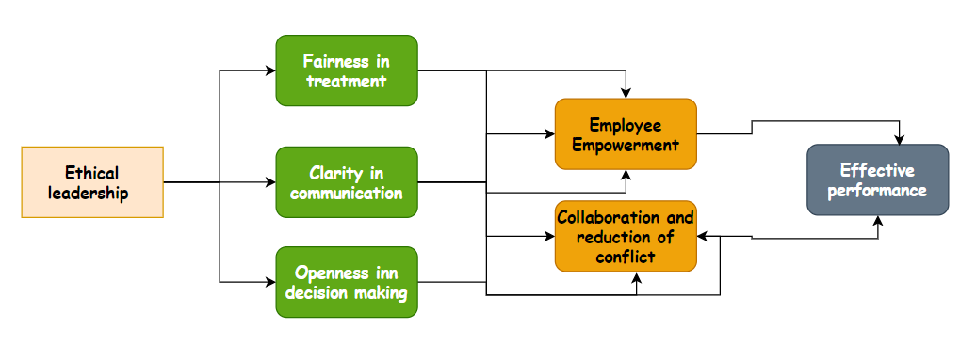

Figure 2.2: Conceptual framework
(Developed by the Author of dissertation)

2.12 Summary
The theoretical framework and the conceptual Framework created by analysing the relations and the interdependence between the variables of the study help in demonstrating the overall concept for reaching to the conclusion. It also helps in demonstrating the way of creating knowledge through the choice of effective methodology as well as it can also help in demonstrating the knowledge at last.

Chapter 3: Methodology

3.1 Summary of research rationale and purpose
The research aims at investigating the implication of ethical leadership approaches within the UK pharmaceutical industry. The study is prompted by the observed decline in employee engagement and the high rate of attrition within the industry, leading to loss of skilled employees and decreased productivity. Organisation such as 3M, Sanofi, Astrazeneca have been facing serious issues due to the loss of skilled human resources with turnover rates as high as 20%. The research identified several key issues contributing to the decline in employee engagement including the lack of effective culture for enabling personal decision making, insufficient empowerment for personal learning and a lack of proper reward management and ethical behaviour demonstration.
Objectives
- To thoroughly understand the relationship between empowering the employees and ethical leadership in MNEs within the UK’s Pharmaceutical sector.
- To evaluate how ethical leadership is effective in empowering employees and managing the internal conflicts
- To analyse challenges that an organisation can face while empowering their employees or when an internal conflict arrives
- To recommend potential strategies that can help the companies to effectively utilise ethical leadership in empowering employees and solving conflicts
What is the role of ethical leadership on empowering employees and resolving internal conflict and enhancing employee empowerment within MNCs in the Pharmaceutical sector of the UK?

3.2 Use of research onion
The research onion has been depicted in the figure 3.1, provides a framework for constructing research design guided through several stages of the research process. The onion model was introduced in early studies which have been widely used by different researchers to construct appropriate methodological considerations (Saunders, Lewis and Thornhill, 2009). The research onion is a metaphorical representation of the layers of research design. It starts from the outer layer and progresses towards the core with each layer representation of different aspect of the research process (Haydam and Steenkamp, 2020; Abdelhakim, 2021; Deshpande and Magerko, 2024).
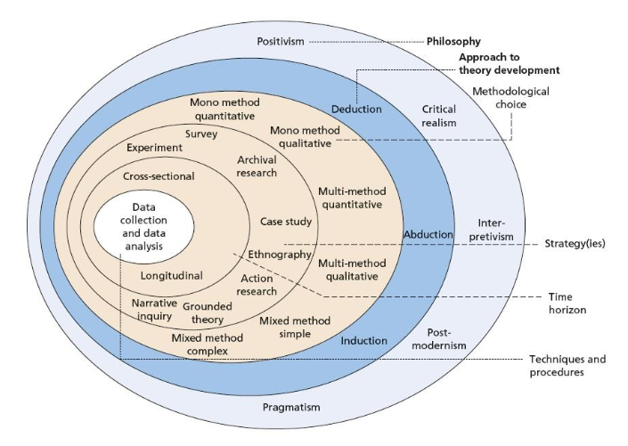
Figure 3.1: Research onion
(Source: Mardiana, 2020)
The research onion has its outer layer with the definition of the philosophical paradigm which includes epistemology, ontology; axiology in this layer sets the foundation for this research design. Second layer includes the philosophical paradigm and the appropriate research approach is selected. This paradigm is focused on approaching a deductive, inductive or abductive way to process with the philosophical stances within the researchers (Mardiana, 2020; Alturki, 2021).
In the 3rd layer, is possessed with a methodological practice required to include as the choice of methodology to guide the research strategy among quantitative qualitative and mixed methods (Bianchi, 2021). Fourth layer of the onion defined in how the data will be collected and this include different research designs to be effectively included, for example there are research designs as exploratory, descriptive, observational and causal research (Al-Ababneh, 2020). The fifth layer specifies on the duration of the research whether it is longitudinal or cross sectional. Lastly the sixth layer includes the central point and process as inner layer which points in the collection and lying data according to the chosen methodology (Mesek, 2023; Robertson, 2020).
Based on the research onion the methodological paradigm has been chosen in order to focus on the implication of the study which mainly concerns the focus on identification of the way that this research should be conducted. The way and process in which data are to be collected and analysed has been depicted in this chapter as per the involvement of the research onion.

3.2.1 Research philosophy: Positivism and quantitative
As per the research onion it has been evident that there are different types of philosophical stances available which can be beneficial for the study to be conducted. There is positivism philosophy which is defined to be considered in the social belied in the real world which follows with having a method similar to the use of natural sciences. Positivism philosophy is a philosophical choice which allows for the collection of quantitative data and can facilitate the identification of the causal relationship between variables such as the relationship between ethical leadership on employee empowerment of conflict resolution (Alharahsheh and Pius, 2020; Park, Konge and Artino Jr, 2020; Maksimovic and Evtimov, 2023).
On the other hand there is interpretivism philosophy which emphasises the understanding of the subjective meanings and interpretations of individuals within a particular context. It mainly focuses the depth of the meanings cultural differences and individuals perspectives. Unlike positivism, interpretivism philosophy mainly focuses on understanding the objective experiences and meanings attributed to the phenomena rather than on quantifiable data and statistical analysis (Junjie and Yingxin, 2022; Younus and Zaidan, 2022; Kirongo and Odoyo, 2020).
Critical realism is another philosophy which refers to combining certain aspects of positivism and interpretivism which acknowledges the existence of an objective reality while also recognising the role of subjective experiences and interpretations (Lawani, 2021; Zyphur and Pierides, 2020). This philosophy is likely to be positivism which acknowledges the existence of an objective reality that can be studied using empirical methods (Ugwu, Ekere and Onoh, 2021; Maretha, 2023; Moroi, 2021).
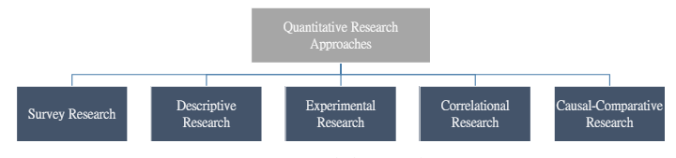
Figure 3.2: Types of quantitative research study
(Source: Taherdoost, 2022)
While based on the analysis, this study mainly uses positivism research philosophy over interpretivism and critical realism and any other philosophies as the positivist philosophy allows the research scope for the collection of measurable and objective data. This essentially allows study to consider phenomena and facilitates the identification of the causal relationship between variables as well (Turyahikayo, 2021; Park, Konge and Artino Jr, 2020; Saliya 2023). Positivism research philosophy is selected mainly for the reason that it tends to seek in the generalisable pattern and trends which become more important for drawing broader conclusions about the impact of ethical leadership in employee empowerment and conflict resolution in the pharmaceutical sector (Nyein et al. 2020; Ikram and Kenayathulla, 2022).
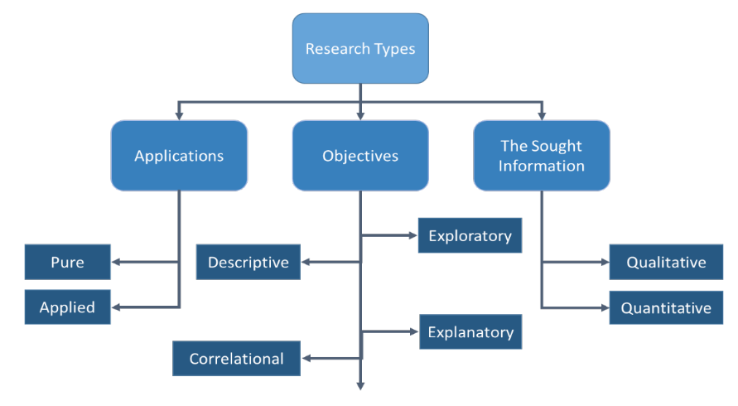
Figure 3.3: Types of research
(Source: Taherdoost, 2022)
Therefore as the positivist research philosophy has been selected, this study to conduct data collection and data analysis process follows with the justification of using a quantitative research method. Positivism research philosophy mainly emphasises on the importance of objective quantifiable data and this provides a structured and standardised approach to data collection with the help of quantitative data collection (Kandel, 2020; Gannon, Taheri and Azer, 2022). Quantitative data collection allows the collecting of numerical data which can be analysed using statistical methods and test the hypothesis, to explore the relationship between the variables. Overall, by using a quantitative research method aligned with the positivist philosophy, involvement allows in the collection of the objective quantifiable data and uses a statistical method (Strijker, Bosworth and Bouter, 2020). This approach ensures in the research which is a rigorous and structured way of producing reliable and generalizable findings in regards with the importance of ethical leadership in empowering employees and resolves internal conflicts within the pharmaceutical sector of the UK.

3.2.2 Research strategy: Survey
There are different types of research methodologies identified from the research onion, for example, case study grounded theory, ethnographic, action research and surveys. Case study based methodology involves an in-depth investigation of a single or small number of cases which provides rich and detailed insights into a specific phenomenon (Al-Ababneh, 2020; Aithal and Aithal, 2020). Grounded theory methodology aims at developing theory grounded in data which involves iterative data collection and analysis to identify patterns and develop theoretical insights. Ethnography involves immersing oneself in and unstructured culture of context being studied to gain a deep understanding of the social phenomenon (Menon and Muraleedharan, 2020). Action research involves collaboration between researchers and practitioners to solve real world problems and beans about practical changes (Al-Ababneh, 2020; Guad et al. 2021; Abdullah and Fakieh, 2020).
Whereas survey allows for a collection of objective quantifiable data from a large sample which makes it possible to generalise findings to a broader population (Varol et al. 2021; Ravikumar et al. 2022; Dziuba, Ingaldi and Zhuravskaya, 2020). Thus in comparison to the other researches, the survey methodology focuses on collecting quantitative data and provides a more effective snapshot of the data at a single point with the help of the cross sectional data collection technique (Mohajan, 2020; Malykhin et al. 2021; Ehler, Wolter and Junkermann, 2021). Therefore, in contrast to the longitude; and cohort studies, quantitative analysis with the help of the cross sectional approach for this study allows a more investigation of the correlations among the variables from a large sample (Mohajan, 2020; Han, Liu and Wang, 2023).

3.3 Data collection technique

3.3.1 Data collection
For this study in the importance of ethical leadership in empowering employees and resolving internal conflicts within the MNCs in the UK pharmaceutical sector the survey method is an appropriate qualitative research approach. A quantitative survey method allows for the collection of numerical data that can be statistically analysed to identify patterns and correlation trends. Survey methods are suitable for collecting data from a large sample size efficiently (Taherdoost, 2022; Kmetty and Stefkovics, 2022; Dykema et al. 2020). As the study targets 200 employees within the pharmaceutical companies in the UK, a survey method is well suited for gathering data from a large number of participants. Surveys provided a structured and standardised data collection, ensuring objectivity in responses, this is crucial for the study to analyse the impact of ethical leadership objectively (Lorè et al. 2023; Axenfeld, 2023; Aliero and Miswar, 2023).
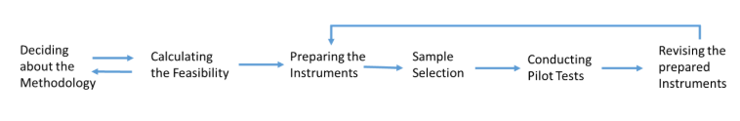
Figure 3.4: Questionnaire design types
(Source: Taherdoost, 2021)
The survey questionnaire has been designed to measure variables related to ethical leadership, employee empowerment and conflict realities within MNCs in the pharmaceutical sector in the UK. The questionnaire has been developed with the help of the Google forms and the distribution method chosen is LinkedIn ensuring access to employees within the target sector. The questionnaire followed with a segment of demographic characteristics of the respondents on the basis of the age, gender, educational qualification level and professional experiences. With the help of the questionnaire design types this is effective in employing a quantitative survey based approach which aims to provide empirical evidence regarding the importance of ethical leadership in MNCs within the pharmaceutical sector in the UK. A structured approach to data collection and analysis ensures the findings which are reliable and valid contributing to the existing body of knowledge in the topic (Taherdoost, 2021; Andrade et al. 2020; Mikkelsen and Parker, 2023; Krieglstein et al. 2022).

3.3.2 Sampling technique
There are different sampling techniques with probability and non-probability techniques. These include “simple random sampling, stratified random sampling, systematic random sampling, cluster sampling, multistage sampling, quota sampling, snowballs sampling, and convenience sampling, purposive sampling” (Obilor, 2023; Campbell et al. 2020). Given with the current context of the study is to conduct quantitative survey based analysis focuses on the importance of ethical leadership in empowering employees and resolving internal conflicts within MNCs in the pharmaceutical sector in the UK. There is a technique which allows for the selection of the participants based on their relevance to the research topic and objectives are most suitable (Hossan, Mansor and Jaharuddin, 2023; Mweshi and Sakyi, 2020; Basti and Madadizadeh, 2021). Purposive sampling is the most appropriate technique for this study. This sampling technique is having an advantage which allows for the selection based on relevance to the research topic. These sampling practices are effective to gain detailed knowledge about a specific phenomenon and save time by eliminating irrelevant elements of the population (Amir, Jabeen and Niaz, 2020; Mulisa, 2022; Jamalludin et al. 2022). Apart from this with the help of the sampling technique lowers the marginal sampling error by selecting participants closely related to the research context. However, the purposive sampling technique has certain disadvantages as well. These disadvantages include having a sampling bias by excusing certain subgroups, and not suitable for large populations and not suitable for making statistical inference about the populations (Pace, 2021; Angeloska Galevska, 2023; Dwivedi, 2024). Hence, this study is the most suitable sampling technique which allows the selection of the participant which has experience and knowledge relevant to research objectives (Andrade, 2021; Thomas, 2022; Ali and Al Hatef, 2024).

3.3.3 Sample size
The current employment in the pharmaceutical sector in the UK has been considered to detect the sample size to be included in this study. As per the graph in figure 3.5, the current employment on the UK from the year 2021, has been detected at having 71,800 employees (Statista.com, 2023).
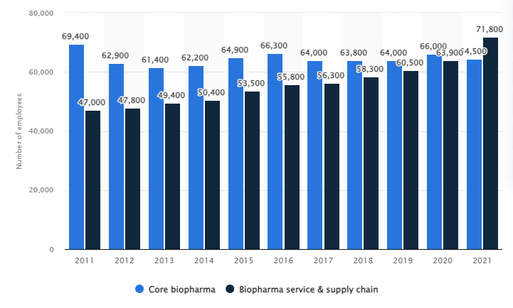
Figure 3.5: Current employment in the pharmaceutical sector in the UK
(Source: Statista.com, 2023)
Therefore, the population of the employment is considered to detect the sample size based on the formulas of n=N x e^2/N+e^2-1.
In this formula, n=sample size, N=Population, e=margin of error. In this case the population size has been considered 71,800, and a margin of error considered at 5% (0.05). Hence based on the formula the sample size can be calculated as follows:
n=N x e^2/N+e^2-1
= 71800 x 0.05^2/71800+0.05^2-1
= 179.50= approximately 180
Taking more 20 employees as a buffer to the sample calculated 200 employees has been included in this study to collect data.

3.4 Research procedures
Therefore from the discussion and analysis n the methodological constructs in this study follows with a step by step research approach which includes developing a questionnaire and administration, distribution among the employees to data collection and data analysis effectively with the help of the quantitative analysis technique and tool.
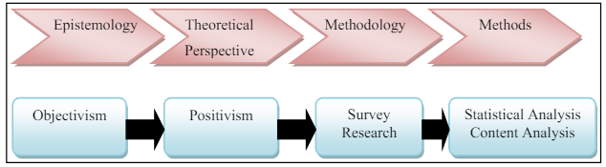
Figure 3.6: Elements of the research process
(Source: Al-Ababneh, 2020)
The questionnaire has been designed to measure variables related to ethical leadership, employee empowerment, conflict resolution within MNCs in the UK pharmaceutical sector. The survey questionnaire is distributed using Google forms with the distribution metro chosen as LinkedIn to ensure access to employees within the target sector. Data collection involves fathering responses from 200 employees within the pharmaceutical companies in the UK.
Data analysis is the last step to conduct this study which involves the statistical method to identify patterns and correlation trends focusing on the relationship between ethical leadership, employee empowerment within the current sector in the UK.

3.5 Validity, reliability and generalizability
The survey based quantitative research requires a valid and reliable research methodological approach. In this context the validity refers to an extent of the survey practices covers all the aspects and this is considered as content validity. This study approach mainly relies on the theory provide a description to the measurable constructs. The content validity ensures in the survey items are relevant and comprehensive, covering all the dimensions in the construct being measured (Mellinger and Hanson, 2020; Sürücü and Maslakçi, 2020). Apart from this the construct validity requires the correlations in relation to the latent variables with a nomological network. It becomes relevant to ensure that the survey measures understanding construct which intend to measure the practices.
Apart from this the reliability of the research with survey lies with the instrument offers and refers to a study which is effective in consideration to the ability to produce consistent and reproducible results. It ensures that the observed variation in numeric measures arises from the true differences attributable to the underlying construct and from measurement error (Mason et al. 2021; Aithal and Aithal, 2020). Based on the validity and reliability of the study approaches are measures its invariance which is considered as the generalizability of the study approach and the study findings. This is concerned with the consistency factor of structure, factor loading and means comparison with equality of variance and error access to different groups or samples.

3.6 Data analysis procedures
Thus the survey data has been analysed using statistical tools such as SPSS which allows for a detailed statistical test to be conducted identifying the relationships and patterns in data. Therefore, the SPSS based statistical analysis has been included as following a descriptive statistical analysis and inferential statistical analysis as well. The descriptive statistics include the analysis and calculation of the mean, medium, modem, standard deviation and frequency distribution. On the other hand, the inferential statistics are considered as Pearson's correlation coefficient analysis which is effective to understand the relationship between empowering employees and ethical leadership, and regression analysis to evaluate the ethical leadership is effective in empowering the employees and managing internal conflicts as well (Watkins, 2021).

3.7 Ethical consideration
Based on the current research methodology has been identified as to consider and prices with the ethical measurement consideration which effectively can be included in this study. Ethical issues such as informed consent, privacy and confidentiality, beneficence and non malfeasance, fair treatment and equity along with providing a respect to the participants are required to consider in conducting this study. These issues have been detected in order to provide the participants with the dignity, rights, autonomy and the feelings of breaching personal data and information as well (Tolmeijer et al. 2020).
This research proposes to adhere to the relevant research ethics codes, guidelines and policies such as UWTSD research ethics and integrity code of practice and research data management policy (UWTSD, 2020). Institutional review board and its approval provided the approach to consider the involvement of the ethics committee before conducting the research. Also, the consent form provides an understanding of the purpose of the study, their rights and how their data have been used. Hence, implementation of the measure to protect the privacy and confidentiality of participant data with anonymisation and secure data storage is needed (Tolmeijer et al. 2020). Thus, to ensure a participant and recruitment and selection processes are fair and equitable in avoiding any form of the discrimination of biases.

3.8 Chapter summary
The chapter mainly provides details of the research approach, design and data collection methods used in this study. It follows with a positivist philosophy and employs a survey based approach for data collection. A statistical analysis used SPSS is conducted to analyse the relationship between ethical leadership an employment engagement along with conflict resolution within the UK pharmaceutical sector.

Chapter 4: Findings and analysis

4.1 Chapter introduction
This chapter represents the results from the survey responses and formation of the research hypothesis which indicates the overview of the data. Survey methodology and sample characteristics have been refined in order to process descriptive and appropriate inferential statistics with the help of SPSS data analysis tools.

4.2 Research hypothesis
The hypothesis has been formed from literature gaps and research objectives identified from the previous chapters. A null hypothesis is a statement which usually represents a no change and no effect in the chosen research variables which represents a significant scenario (Sedgwick et al. 2022). The alternative hypothesis has been considered in this study as follows:
H1: Ethical leadership positively correlated with employee empowerment in multinational pharmaceutical companies in the UK.
H2: Ethical leadership has a significant effect on reducing internal conflicts in multinational pharmaceutical companies in the UK.
H3: Employee empowerment mediated by ethical leadership contributes to better conflict resolution in multinational pharmaceutical companies in the UK.
H4: The effectiveness of ethical leadership in promoting employee empowerment and managing internal conflicts is moderated by organisational culture in multinational pharmaceutical companies in the UK.
H5: Ethical leadership helps bridge the gap between executive and employee interests in decision making within multinational pharmaceutical companies in the UK.

4.3 Overview of the data

4.3.1 Survey methodology
The study mainly used quantitative survey methodology to explore the role of ethical leadership in employee empowerment and conflict resolution within UK pharmaceutical MNCs. A structured questionnaire was developed using Google Forms and distributed to 200 participants from LinkedIn.

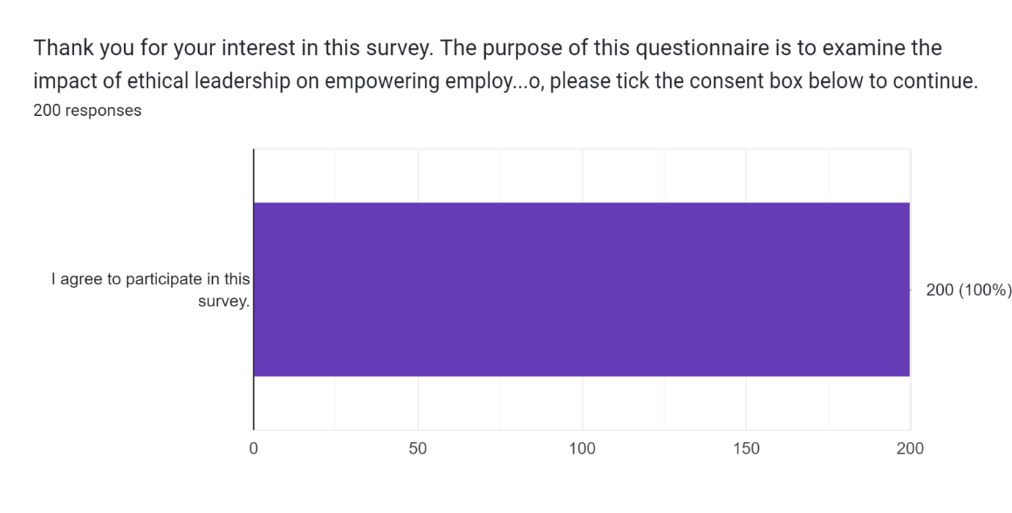Figure 4.1: Consent collected from 100% of the participants
From the survey and the demographic questions an overview of the sample characteristics can be estimated. The research employs the survey methodology which aimed at gathering empirical data assessment which impacts the ethical leadership on workplace dynamics. From the figure depicted in 4.1, it is evident that the survey has been conducted with full consent collected from every participant.

4.3.2 Sample characteristics
According to the current survey, it has been conducted within 200 samples of employees as respondents with varying demographics and experience in the pharmaceutical sector. The age distribution shows that the majority of the respondents are between the age group of 35 to 44 years at 37.5% with a significant portion from the age group of 25 to 34 years to 31.5%.
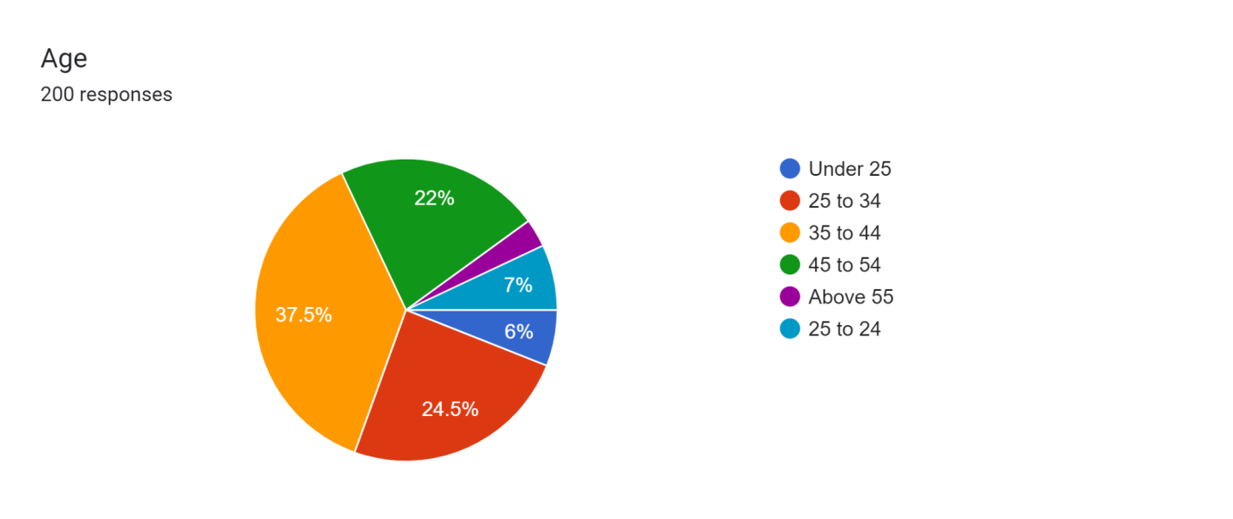

Figure 4.2: Age dispersion among the respondents
In terms of gender there are 60.5% from the female participants while only 34.5% are from male and 5% are from the other group of genders.
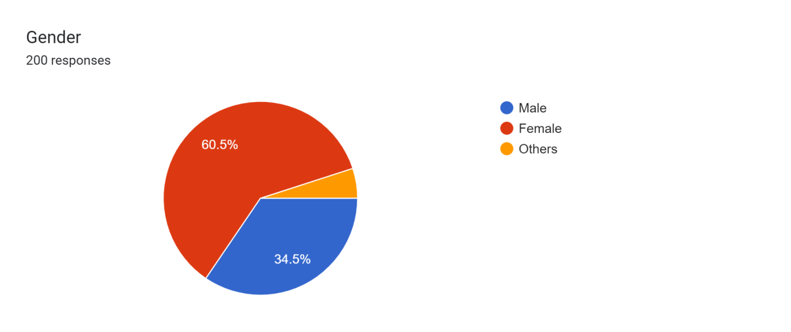

Figure 4.3: Gender dispersion among the respondents
Regarding the educational background the largest group holds a Bachelor’s degree at 53.5% followed by those with master’s degree at 29% of the participants. A smaller segment holds a high school diploma at 10% while only 7.5% hold a doctorate degree.
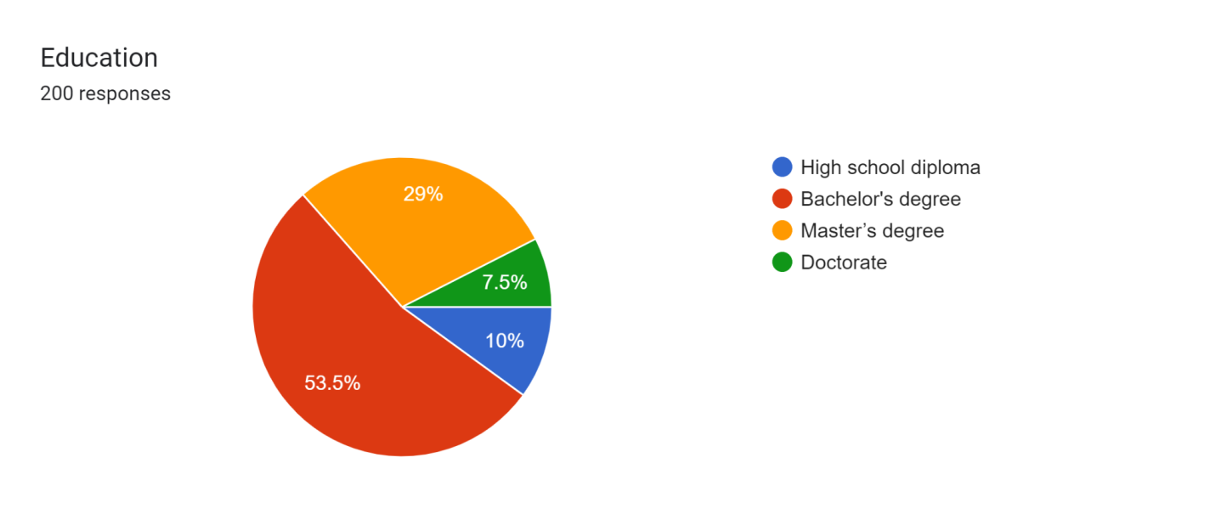

Figure 4.4: Educational background of the respondents
Professional experience of the employees in the pharmaceutical sector varies with most respondents having experience of 1 to 5 years at 47.5%.
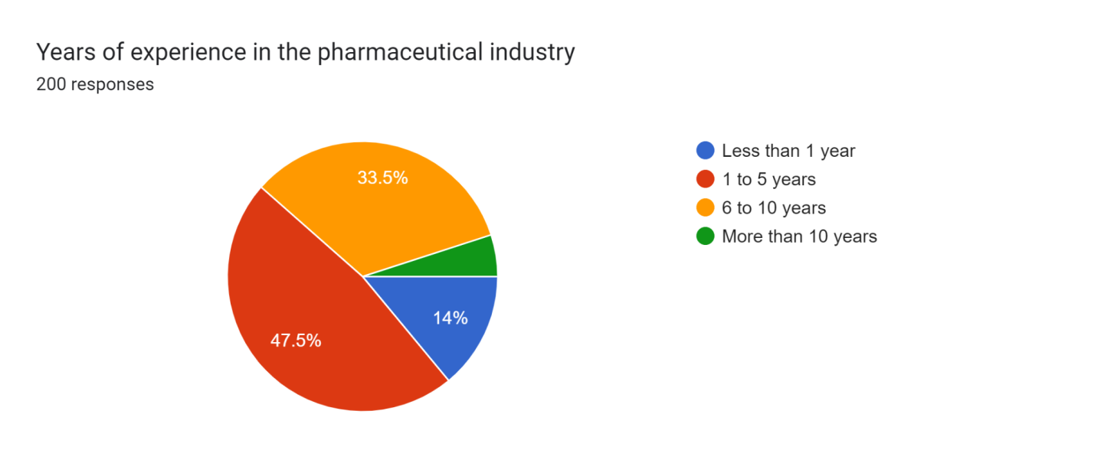

Figure 4.5: Professional experience dispersion among respondents
Apart from this 33.5% of the respondents have working experience from 65 to 10 years of age, while 14% have less than 1 years experience with only 5% having more than 10 years. [Refer to appendix 1] [Refer to appendix 8]

4.4 Descriptive statistics

4.4.1 Central tendency
The first test has been considered to collectively represent the descriptive data in the demographic and basic variables of this research. This includes mean, median and mode descriptive analysis (Hatem et al. 2022).
The age has a mean value of 2.85, median value at 3 and mode value at 3. The values have been tested and calculated as follows, indicating that the typical age range of the respondents collected falls around the 35 to 44 years age group. There is a possibility of skewness towards younger ages and evidence by the slightly lower mean compared to the median value. The majority of employers tend to fall within the 25-44 age ranges with a man of 2085 and a standard deviation of 0.936, indicating a relatively young workforce. Hence, it can implement targeted professional development programs to cater to this age group, focusing on career growth and skill enhancement. The mean years of experience is 2.30 with a standard deviation of 0.769 shows a workforce with varying levels of experience but leaning towards the lower end. It recommends development mentorship programs where more experienced employees guide newer employees. This can enhance knowledge transfer and reduce the learning curve.
As per the working experience of the professionals has a value of 2.30 mean value which suggests that the employee has a working experience between the 1 to 5 years of experience. The distribution has been identified as leaning towards the group having less experience. [Refer to appendix 2]
However, the employee satisfaction rate seems to hover around a neutral to satisfied level with a slight tendency towards a satisfaction which follows with having mean valued at 2.83. This analysis has evolved with the mean satisfaction rate which helps to conduct workshops on conflict resolution and decision making empowerment to boost satisfaction. Regular feedback sessions also help address concerns promptly.

4.4.2 Dispersion
The second test has been conducted with the help of the descriptive statistics in a more advanced stage which explores the standard deviation, variance and ranges to follow with the dispersion of the data (Shi et al. 2020).
This section offers a collective visualisation of the analysis using standard deviation variance and range. The table depicts the age which shows a standard deviation of 0.936 a variable of 0.875 and a range of 4. This indicates moderate dispersion of the ages among the data set. Thus this promotes gender diversity and inclusion initiatives. it ensures the policies and practices which are inclusive and supportive of all gender identified. Also, dispersion has been encouraged with continuous education and professional development. Offering incentives for advanced degrees and certification to further enhance the skills of employees.
The users of experience of the employees have a lower standard deviation at 0.769 and a variance value at 0.591 with a range of 3. This suggests a relatively narrow distribution of the experiences. Employee satisfaction rates display most of the variation with standard deviation at 1.114, and variance of 1.241 along with the range of 4. This calculates and the calculation indicates a more varied perspective in employee satisfaction. [Refer to appendix 3]

4.4.3 Frequencies of percentages
The third table has been formed with the help of the frequency analysis which includes the frequency counts and percentage values (Okagbue et al. 2021). This has been reflected and calculated based on the survey responses and this takes a count to the below table in order to measure the frequency rate of the responses collected.
In terms of gender ratio, the majority of the participants are female and most of the respondents hold a Bachelor’s degree in their educational practices. Regarding the existing ethical leadership practices within the sector as per the employee’s experiences, 51.5% have voted to have a good ethical leadership. Apart from this, 30.85% have identified to have fair ethical leadership practices within the pharmaceutical sector with 12.5% have been promoted to have an excellent ethical leadership and to have a poor ethical leadership at 5.5% of the total response rate. based on the interpretation it revolves around in the approach that it strengthens the ethical leadership which provides training in ethical decision making and transparency. This is effective to regular assessment and update of ethical guidelines and ensure leaders are exemplified with these practices.
Moreover, the employees have agreed on having open communication and transparency within their organisation at a rate of 26.5%. While 21% of the employees have strongly agreed on having open communication and transparency however, 22.5% remain neutral with the current situations. While, 16.5% have disagreed and 13.5% have strongly disagreed on the current situation which reflects in the frequency rate of having open communication and transparency within the pharmaceutical sector. Also, there is a dispersion and suggestion to foster a culture of open communication by holding regular town hall meetings and encouraging feedback. it ensures that the management communicates with clear and transparent decisions and policies.
Hence the frequency of the conflict resolution varies from the response rate by the employees, which indicates to have conflicts often supported by 34.5% of the employees 33% of the employees faced resolution to the conflicts within their organisation sometimes. Apart from them, there are 14% who have rarely faced the conflict resolution practices within their organisation and a smaller percentage of respondents of 12.5% experienced resolving conflicts always and 5.5% have not faced conflict resolution ever. [Refer to appendix 4]

4.5 Inferential statistics analysis
The Pearson correlation coefficient follows by measuring the linear relationship between continuous variables (Watkins, 2021).
The correlation analysis examines the strengths and direction of the relationships between the variables. As depicted in the above table 4.4, follows with having a Pearson correlation at 0.062. This indicates a weak positive correlation between the existing ethical leadership practices and empowerment through decision making. However, the significance of two tailed values has been estimated to be higher than the normal p-value at 0.05. Thus the relationship can be established but with no statistically significant approach.
Apart from this the suggestion for improved ethical leadership practices and challenges empowering employee and conflict resolution has a correlation blue at -0.122 and has a significant value at 0.086. This indicates to have a weak n negative correlation between these variables where it indicates to have a challenge increased and suggestion for improvement to ethical practices might decrease. [Refer to appendix 5]
The independent variable existing ethical leadership practices have been processed with the dependent variable reflected in the frequency of conflict resolution followed with regression coefficient analysis. Thus this shows the relationship between the independent and dependent variables, reported a value at 0.056. This suggests that for each one unit increase in the existing ethical leadership practices from poor to excellent with a tendency to increase the frequency of conflict resolution by 0.056 units. There is a small positive correlation identified between the age levels and with the existing ethical leadership practices and moderate positive correlation for open communication transparency. Whereas, gender and open communication and transparency along with frequency of conflict resolution has a negative correlation indicating that females perceived a lower level than the males. Hence, the analysis has suggested to improve conflict resolution mechanisms by establishing clear procedures and training managers in conflict resolution techniques. It encourages a proactive approach to address conflicts early. The analysis has a process with the practices and our creation with Age and leadership practices tailored with the leadership development programs. On the other hand gender has significant negative correlation with open communication and conflict resolution. this address in gender based communication gaps which promotes inclusive behaviour. Also, the study findings have suggested that empowering employees by inoving with the decision along with the processes helps in recognising their contributions. Thereby this enhances their sense of ownership and responsibility.
Given the variables are being ordinal, with a position of unstandardised coefficient value which indicates that as ethical leadership quality declines and the frequency of conflict resolution tend to decrease. This means to have poorer ethical leadership practices with a lower frequency of conflict resolution. The t-value calculated indicates how many standard deviations the efficient is from 0. The t-value estimated here is 1.243 which suggests that the coefficient is not very far from zero. However, the P-value calculated shows the probability that the observed relationship is due to chance. The p-value in this case is 0.215m which is a threshold for significance at 0.05. Therefore the p-value estimated is above the threshold, implies that the result is not statistically significant and implies in the observed relationship due to random variation. Mostly the variables, according to the age variables, have a positive linear regression level and most of it is not statistically significant. While, by the gender levels, there is a positive regression identified to the existing ethical leadership, open communication and transparency and empowerment through decisions making within the industry. On the other hand the frequency of conflict resolution had been negatively processed in relation to the gender variations.[Refer to appendix 6]

4.6 Hypothesis tests
The hypothesis testing with linear regression is to consider and understand in the evaluation the relationship between variables, which typically assess whether there is a significant effect in between two variables or not (McNulty, 2022).
The analysis provides the values which indicate the strength and direction of the relationship between the variables. A positive B value suggests a positive relationship, while p-value indicates the statistical significance of the relationship (Tyagi, Rane and Manry, 2022). The results are generally not considered to have statistical significance.
The B value estimated for the empowerment through decision making is -0.013 with a p-value at 0.811. This suggests a very weak and negative correlation between ethical leadership and empowerment through decision making. While, the p-value is greater than 0.05, indicates the result is not statistically significant. The B value for the frequency of conflict resolution is in 0.039 with a p-value of 0.7416. Thus, this indicates a slight positive relationship between ethical leadership and conflict resolution frequency. Hence the p-value is also greater than 0.05, which indicates that the result is not statistically significant.
Also the B value estimated for open communication and transparency is 0.046, with a p-value at 0.387 indicates to have a statistically non-significant and slight positive relationship between ethical leadership and to have open communication and transparency. Also, the B-values for employee satisfaction rate in empowerment and conflict resolution is estimated at 0.032 with a p-value at 0.606. This suggests a weak positive relationship between ethical leadership and employee satisfaction which indicates non significant statistical findings.
The hypothesis test has been considered with linear regression values, have calculated mainly, estimated and processed that the entire hypothesis is opposing with the alternative hypothesis formed. Therefore, the null hypothesis for each proposition has been considered and indicates to have no statistical significance which can support any of the proposed relationships. Therefore it become evident that the current ethical leadership practices implemented within the pharmaceutical industry in the UK, is not designed to promote effective employee empowerment, reduction in internal conflicts, effective conflict resolution, effective decision making by the employees and to promote organisational culture which can effectively empower employees and manage internal conflicts in the pharmaceutical sector in the UK. [Refer to appendix 7]

4.7 Interpret the findings
From the statistical tests it becomes evident that the role of ethical leadership in empowering employees and resolving internal conflict within UK pharmaceutical MNCs can be interpreted to consider the results.
Research objective 1
The result shows a weak statistically insignificant relationship between ethical leadership and employee empowerment through decision making. Therefore, this suggests that the current ethical leadership practices in the UK pharmaceutical MNCs do not significantly impact the current employee empowerment. Also, the analysis presents and indicates a variable in how the internal conflicts are resolved within these organisations. Therefore, the weak correlation identified between the variables follows by implying that ethical leadership practices which might not be consistent apply in resolving the internal conflicts within the pharmaceutical sector in the UK. On the other hand, Tufan et al. (2023), have focused on the relationship between ethical leadership and workplace deviant behaviour which suggests a significant and indirect effect of EL and WDB through organisational justice. The study has underscores on the importance of organisational justice in mitigating deviant behaviour and emphasis on the significant if ethical leadership in shaping perceptions of justice within the organisations (Tufan et al. 2023). However the study by Mulinari et al. (2021), follows the implication of the need for regulatory intervention to address the identified issues. The transparency study advocates for Europe wide “Sunshine Act'' to ensure the real transparency of drug company payments (Mulinari et al. 2021). Hence, these have complimented on the findings in ethical leadership which indirectly support the idea that self regulation not be effectively fostered with transparent and ethical practices within the pharmaceutical sector.
Research objective 2
Also with moderate proportion of employees have agreed on the presence of the open communication transparency but the overall frequency of the conflict resolution and satisfaction rates have suggested that there is a limited implementation of these practices. Hence, the test results have suggested that there is a lack of strong communication which hinders effective conflict resolution and employee empowerment. However there is a slight positive correlation between ethical leadership and employee satisfaction within this sector. Hence, this was processed with a lack of statistical significance which indicated that ethical leadership might not be a major driving force to the employee satisfaction within the pharmaceutical MNCs. According to a study by Jia et al. (2022), the assessment of the reliability and validity of the constructors uses several measures like its loading and other measures to ensure that the constructs are consistent and reliable. Also, this study examines multicollinearity using VIF values ensure in not having any issues with multicollinearity among the constructs. Thus the study findings have supported the current study findings which also, considered having no multicollinearity issues. As this current study findings have indicated a moderate level of agreement moving employees regarding the presence of open communication and transparency in pharmaceutical MNCs. Apart from this Brandish et al. (2021) have indicated that the fellowship led to up skilling of confident and motivated pharmacist leaders and supports the NHS’s goals of fostering diverse leadership.
Research objective 3
The study identified challenges such as limited implementation of open communication and transparency hinders effective conflict resolution and employee empowerment. Organisations need to address these challenges by fostering a culture of open communication, transparency and trust. Leaders should actively listen to employee concerns and create channels for constructive dialogue to address conflicts as they arise. Additionally Brandish et al. (2021) have focused on the notes that senior colleagues observed a progression in competencies and would recommend the fellowship to the pharmacist. Moreover, it mentioned positive outcomes such as increased job satisfaction, motivation, changes in job roles and promotions for some participants. Both of the studies can be merged in a certain way where the study finding focuses more broadly on organisational changes and the need for fostering a supportive culture which evaluates specific programs aimed to enhance leadership skills among pharmacists within the NHS (Brandish et al. 2021). Similarly Costello (2020) fosters the culture of open communication transparency and trust aligns with the notion of creating supportive environments for individuals to develop resilience. An effective conflict resolution and empowerment are essential components of organisational resilience as it contributes to a positive work environment where employees feel valued and supported (Costello, 2020).
Research objective 4
Hence, the findings have suggested that ethical leadership practices process with these MNCs is not successfully bridging the gap between executive decision and employee interests. Therefore this could effectively lead to lower employee morale and engagement. Also, the results have imposed on the organisational culture in the UK pharmaceutical MNCs which might not be considered to be conducive which can promote ethical leadership that can drive employee empowerment and internal conflicts resolution. Thus, this calls for encouraging a re-evaluation which can currently focus on the leadership practices which can ensure alignment with these goals. In consideration, the other studies follow with the emphasis on the importance of strict adherence to ethical standards in the field of pharmaceutical medicine specifically considering the complexities of innovative medicine development and the commercial pressures involved (Morris et al. 2020). This study process in contrast to the study findings that ethical leadership practices with MNCs may not have an effective bridge between executive decision and employee interest. This lack of alignment leads to lower morality and engagement among employees, to potentially impact organisational culture and hinders ethical leadership (Donkor, Papadopoulos and Spiegler, 2024). The study reveals that age positively correlates with perception of ethical leadership, open communication and empowerment. The whole gender shows minor negative correlates with open communications and conflict resolution with females perceiving less of both. Recommendations include tailored leadership training for different age groups enhancing open communications and transparency, empowering employees in decision making and gender disparities. Also there is a suggestion to promote a culture of ethical leadership to foster an inclusive and effective work environment in the UK pharmaceutical organisations.
Therefore with the given results and analysis have approached the correlation and tendency have been estimated to have a lack of statistically significant with many areas. Therefore, there is a clear need for the UK pharmaceutical sector which requires re-evaluation in their ethical leadership approaches which can be effective in promoting employee empowerment, reduced internal conflicts and fosters with a positive organisational culture. The analysis indicates that the ethical leadership practices and open communication have a positive but not significant impact on different age groups. While, open communication has a significant negative effect in gender shows that females perceive less transparency. Recommendations include tailored leadership training for different age groups, improved communication to address gender disparities, promotion of ethical leadership, enhanced decision making empowerment and better conflict resolution strategies have created a more inclusive and effective work environment in the UK pharmaceutical organisations.

4.8 Limitation to this study
There are certain limitations which should be considered for further research areas. Thus, the study was conducted with a sample size of 200 participants which might not fully represent the broader population of the employees in the UK pharmaceutical sector. Although the study focused on a limited set of variables related to ethical leadership and employee empowerment, where it did not consider the other factors and this could be possibly effective for further future research areas. The limitations have suggested focusing on the study’s current and future prone areas to provide an insight to the future possibility of the research aims to address the limitations in providing comprehensive understanding of the topic.

4.9 Key findings
The key findings from the study are as follows:
- There is a mixed perception among the employees regarding the implementation of ethical practices.
- There is a weak relationship with empowerment through decision making and the current ethical leadership practised.
- There is an inconsistency with the conflict resolution practices within the pharmaceutical sector in the UK.
- There is a limited open communication and transparency implementation within the pharmaceutical sector in the UK.
- There is a weak and positive relationship between the ethical leadership and employee satisfaction identified in the sector.
- Here the current ethical leadership practices have not effectively bridged the gap between executive and employee interest in decision making.
- Overall the interpretation indicates that the organisational culture in these MNCs is not fostered with ethical leadership which leads to employee empowerment and conflict resolution.
- There is a need for UK pharmaceutical MNCs to re-evaluate their ethical leadership practices.

4.10 Chapter summary
Hence, this chapter concludes and explores the results for the quantitative survey and aims at examining the role of ethical leadership in employee empowerment and conflict resolution within the UK pharmaceutical multinational corporations.

Chapter 5: Discussion, Conclusions and Recommendations

5.1 Introduction
This chapter addresses the research question and hypothesis by presenting the analysis, and the findings, the structure mainly includes the sections on the role of ethical leadership in empowering employees and resolving conflicts, the impact of organisational future and strategies for bridging the gap between executive and employee interests.

5.2 Interpretation the finding linked to research questions
The analysis provides insights into the role of ethical leadership in empowering employees, resolving internal conflicts and enhancing employee empowerment within MNCs in the UK pharmaceutical sector. The findings suggest that current ethical leadership practices within UK pharmaceutical MNCs may not significantly impact employee empowerment of conflict resolution. This implies a need for re-evaluation and potential adjustments of leadership approaches to better address these areas. This underscores the importance of fostering a culture of open communication, transparency and trust within an organisation to enhance employee empowerment.
Insights on ethical leadership and employee empowerment
The literature has emphasised the importance of ethical leadership in organisational behaviour and values (Hussein et al., 2022; Opoku et al., 2023). They have highlighted the role of the ethical leadership promoting employees' emotion, productivity and value creation (Ullah et al., 2022). The sources and studies have acknowledged the ethical leadership involvement demonstrated as the study’s findings have demonstrated integrity, fairness and transparency in decision making process (Frazier and Janeczko, 2021; Kim and Vandenberghe, 2021). While on the other hand there are certain focuses on the positive aspects of ethical leadership that the literature from previous studies have acknowledged with the challenges (Mulinari et al., 2021; Hussein et al., 2022). This involves a contradiction to the study’s findings as considering resistance from employees and tension between financial profitability and ethical considerations. The study found and emphasised the strategic static function of ethical leaders in creating supportive work environments as well. On the other hand, the literatures have a tendency to contradict the current conditions which emphasise on the discussion of the challenges associated with management of ethical leadership which included ego-driven decision making at the executive level (Ghasempour Ganji et al., 2021; Opoku et al., 2023). By the study’s discussion the findings and analysis have introduced the concept of self motivation as a mediating factor influenced by ethical leadership that contributes to organisational performance (Frazier and Janeczko, 2021; Ejaz et al., 2022). This also discusses the impact of ethical leadership in employee well being highlighting the role of leaders in promoting psychological safety and job satisfaction (Nazir et al., 2021; Su et al., 2021). This discusses and mentions the importance of ethical leadership in conflict resolution which expands by this study’s findings which discusses how ethical leadership influences conflict management efficiency through employee empowerment (Asif et al., 2022; Dua et al., 2023).
On the other hand the studies have agreed on the study’s current findings which signify employee empowerment in enhancing job satisfaction, motivation and organisational performances (Arshad et al., 2021; Asif et al., 2022). As the studies have acknowledged the role ethical leadership promoting employee empowerment have emphasised and support the study’s findings by encouraging autonomy and decision making power with collaboration (Goswami et al., 2021; Novitasari et al., 2021). On the other hand there are certain studies which contradict the study's findings which focus on potential challenges that are resisted by employees to consider positive aspects of employee empowerment facilitated by ethical leadership (Markey et al., 2021; Zheng et al., 2022). Hence, the study’s findings have discussed the impact of employee empowerment in organisational adaptability and innovation, where the existing literature does not reveal the deep insights in these aspects. The study provides a comprehensive discussion on the different levels and perspectives of employee empowerment which offers a holistic view of its implications (Bahadori et al., 2021; Bhatti et al., 2022). Thus, it introduces the concept of ethical leadership mitigating the negative impact of hierarchical divisions within organisations by promoting a culture of empowerment and participation with the current decision making practices (Yazdanshenasand Mirzaei, 2023; Kim and Vandenberghe, 2021).
Relations between the ethical leadership and employee empowerment
On the other hand, the study findings in relation to the previous literature have agreed on the positive relationship between ethical leadership and employee empowerment (Nazir et al., 2021; Ashfaq et al., 2021). As the study findings have emphasised on the role of ethical leadership in promoting trust, fairness and employee engagement which becomes evident that are essential for empowering employees. On the contrary there are studies who have claimed an opposite result to the study’s findings. Thus this discussion in the mechanisms through which the ethical leadership influences employee empowerment is considered to process through social learning and self motivation (Ng et al., 2021; Nazir et al., 2021). Hence the current settings have mentioned the positive relationship between ethical leadership and employee empowerment without exploring the underlying mechanisms and moderating factors in depth. Overall, the study emphasises and introduces the concept of self motivation as a mediating factor between the ethical leadership and organisational performances. Hence as per the study's finding and the critical analysis from the studies previous literatures provides a nuanced understanding over the relationship (Ejaz et al., 2022; Nazir et al., 2021). Therefore this also highlights the role of ethical leadership which helps in managing organisational changes and promotes employee well being. Therefore, this offers new insights into the broader impact of ethical leadership in organisational dynamics.

5.3 Theoretical implications
Based on the study’s findings and analysis, prompts in the theoretical implication based practices are followed with the implication of the social exchange theory and Maslow's hierarchy theory. The theory posits that employees reciprocate on the perceived benefits from leadership with an increased commitment and preferences, the results suggest that these challenges may not be occurring effectively (Ahmad et al. 2023; Xuecheng, Iqbal and Saina, 2022). Despite the perceived benefits of ethical leadership such as fairness and transparency, employees may not be considered to feel adequately empowered or supported which tend to focus on resolving conflicts (Wang et al. 2022). This discrepancy raises the questions about the nature of the exchange relationship between leaders and employees and underscores the need for a deeper understanding of the mechanism through which ethical leadership influences employee outcomes (Chen and Wei, 2020; Wang et al. 2020).
Maslow’s hierarchy needs theory has highlighted the importance of fulfilling higher level needs such as esteem and self actualisation for individual’s motivation and satisfaction (Zhang, 2020; Ștefan, Popa and Albu, 2020). As per the study's findings, there is doubt in whether ethical leadership within the pharmaceutical sector have promoted adequate approach in addressing the needs, whole ethical leadership practices promote fairness and respect where they may fall short in providing employees within the sense of empowerment and fulfilment necessary for achieving higher level needs (Durmuş, 2024; Mehta, 2021). Hence, this tends to suggest a potential gap between the principles of ethical leadership and their ability to consider satisfied holistic needs of employees challenging traditional assumptions about the role of leadership which fosters employee well being.

5.4 Unique findings and insights
This study identified a significant discrepancy between the perceived benefits of ethical leadership and its actual impact on employee empowerment and conflict resolution. The industry faces unique challenges and complexities including stringent regulation and high stakes decision making. The findings offer unique insights by contextualising the role of ethical leadership within the pharmaceutical industry. Therefore, existing literature suggests that ethical leadership positively influences employee outcomes. However this study highlights the stringent regulatory environments and higher decision making dilute these benefits. Each objective was addressed through comprehensive analysis of the leadership styles, organisational structures and stakeholder dynamics in relation to employee empowerment and conflict resolution.Hence, this calls for an exploration of how regulatory frameworks and industry norms with organisational cultures influence the perceived importance and impact in the ethical leadership in the pharmaceutical sectors.

5.5 Strengths and limitations
The study mainly comprises a comprehensive analysis of the literature which provides a contributory implication to the practical and theoretical involvement. On the other hand, the study is limited to sample size and cross sectional nature. Also, in order to employee the limitation follows with having a mixed methods approach n consider a contextual analysis will be beneficial for creating certain potential opportunity for the future research areas.

5.6 Conclusions
This study finding indicates that through a need for re-evaluation, modification of leadership approaches with open communication and transparency are moderately presences. There is a limited implementation of these practices that affects overall conflict resolution and employee satisfaction. Hence this has underscores the importance of fostering a culture of open communication transparency and trust to enhance employee empowerment. The study reveals that existing ethical leadership practices in the UK pharmaceutical MNCs do not significantly influence employee empowerment for conflict resolution. These study findings have indicated a need for re-evaluation and modification of leadership approaches to better address these areas. While, open communication and transparency are moderate present and the limited implementation of these practices affects overall conflict resolution and employee satisfaction hence this underscores the importance of fostering a culture of open communication, transparency and trust to enhance employee empowerment. Also, the study’s findings both align with contradictions to the previous literature in ethical leadership. While some of the studies emphasise the positive aspects in ethical leadership in promoting employee well-being and job satisfaction, others have highlighted the challenges such as resistance from employees and tension between financial profitability and ethical considerations. Also, the study hasemphasised on the strategic role of ethical leaders in creating a supportive work environments. Hence, the study introduces the concept of self-motivation as a mediating factor influenced by ethical leadership contributing to the organisation's performance. Ethical leadership is found to influence conflict management efficiency through which employee empowerment becomes crucial for enhancing job satisfaction, motivation and organisational performances. Also, the study provides a comprehensive insight into different levels and perspectives of employee empowerment. This has emphasised the impact on organisational adaptability and innovation. Therefore, the study challenges traditional assumptions from the theories with the context of ethical leadership in the pharmaceutical sector. The study findings suggest that ethical leadership fall short providing employees with a sense of empowerment and fulfilment necessary for achieving higher level needs. A need for deeper understanding has been identified which falls into the understanding of the mechanisms through which ethical leadership influences employee policies. Therefore, the study introduces and highlights the importance of further exploration into how ethical leadership can effectively promote employee empowerment and wellbeing and also has highlighted its role in managing organisational changes and promotes employee well-being as well. Therefore, the study tends to offer a holistic view towards employee empowerment and suggests that by promoting a culture of empowerment and participation. It can bring a mitigation strategy to the negative impact of the hierarchical divisions within the industry.

5.7 Recommendations for managerial practice
UK pharmaceutical MNCs should assess and reassess and modify their current ethical leadership strategies to more effectively empower employees and address conflict resolution, this is to enhance employee empowerment so that companies should cultivate a culture of open communication and transparency. Hence, this is to effectively build trust within the organisation which becomes crucial for employee engagement and empowerment. Thus, ethics leadership should demonstrate integrity and fairness which sets a starting example for others to follow. Investment in training and development can help in managing the procedure of managerial practices in the context of the company. This R&D investment can help the managers to feel invested and empowered for managing the practices of ethical practice in the context of the pharmaceutical organizations (Abaku and Odimarha, 2024). Apart from these, implementing targeted programs are focuses on empowering employees, and address the gap identified between ethical leadership practices leads to include leadership training and mentoring. Also, there is a possibility to develop and promote clear conflict resolution policies and practices where these tend to ensure employees feel supported and valued. Amongst these, by recognising a unique challenge within the industry and adapting leadership styles accordingly can be used. Thus leaders should be considered to follow a training which helps in navigating stringent regulation and high stakes decision making environments while maintaining ethical standards. By addressing a higher level needs for the employees identified by the Maslow’s hierarchy through career development opportunities and resignation programs promotes personal growth and job satisfaction. Also, with the help of promoting a supportive organisational culture foster is through ethical behaviour and employee well-being. Hence, the implication follows with having an involvement to create an environment where employees tend to feel respected values and motivated to contribute to the organisation’s success.
As per the gender diversity and inclusion initiatives, offering incentives for advanced degrees and certification can strategically enhance the skills of employees. This can be further improved by development mentorship programs where the existing skilled workforce can guide the new employees to stay innovative. This can be seen as one of the most effective approach of knowledge transfer and reducing the knowledge curve. Moreover, the prospects of ethical leadership can be improved by focusing on regular assessment and update of ethical guidelines so that the leaders can apply these tactics. This can be implemented by creating culture of open communication among the management and workforce.

5.8 Contributes to theory
This study has focused on the social exchange theory and Maslow theory where the focus has been given on the ethical behaviour factors among the workers of the pharmaceutical industry. This is the strategic management of focus, maintaining the factors of ethical leadership and employee empowerment so that the practice of social learning among the workers of the UK pharmaceutical industry can be maintained throughout the process (Bai et al., 2019). The way ethical leadership aspects can motivate the workforce of the UK pharmaceutical industry has been thoroughly addressed within the research primarily. This study has helped to explain the connection of employee, education theory and the ethical leadership practices as well.

5.9 Limitations of the study
Respondents may be unwilling to provide honest opinion as the part of the survey response that may have reflected the power response of the research which can be noticed as one of the major drawbacks of this particular research study mainly. Apart from that survey gave the drawback of not being able to capture complex experiences also. This social desirability bias and generalisation can also be seen as one of the major complications associated with the study (Miüller et al., 2020). The issue of survey bias and non-response bias can also be evident in the case of this research which can be noticed as one of the major drawbacks of this study primarily. As with the online survey, this research has the research drawbacks as the people with online accessibility can only be reached as a part of accomplishing this research.

5.10 Areas for further research
Mixed data gathering could have been given a more accurate research outcome for this study as the part of obtaining the data outcome for this study particularly (Almeida, 2018). Empirical studies are to evaluate how ethical leadership standards impact conflict resolution among employees, specifically in culturally diverse multinational organisations. This is how the study findings can provide practical insights in how the application and effectiveness of the ethical leadership principles can be considered. Hence, by examining a relationship between employee empowerment and conflict of interests particularly in decision making processes within the organisation will help for further research. Hence this effectively identified the area for further research to mitigate the identified literature gap by which understanding the dynamic situation can be helpful in developing strategies to balance empowerment and organisational harmony. Also, by implementing mixed data gathering techniques combined with qualitative interview with manager and qualitative surveys are in alignment with as identified to consider for further research areas. This approach is to consider and provide a holistic understanding of the issues, leading to more accurate and comprehensive research outcomes.

5.11 Final thoughts
Based on the overall research outcome, it is evaluated that limited implementation of open communication and transparency can lead to the issue of managing transparency and trust at the same time. However, the ethical leadership practices process is not adequate to address the gap existing between executive decision and employee interests. Thus, the UK pharmaceutical sector needs to re-evaluate the ethical leadership practices within the context of the organisations so that operational efficiency regarding employee empowerment and organisational culture can be strategically maintained throughout the organisational operation mainly.

Reference List
Abaku, E.A. and Odimarha, A.C., 2024. Sustainable supply chain management in the medical industry: a theoretical and practical examination. International Medical Science Research Journal, 4(3), pp.319-340.
Abdelhakim, A.S., 2021. Adopted Research Designs by Tourism and Hospitality Postgraduates in The Light‎ of Research Onion. International Journal of Tourism and Hospitality Management, 4(2), pp.98-124.
Abdelhay, S., Al Talay, M.S.R., Abdelhay, D.A. and El-Bannany, M., 2023. Relation between Employee Productivity, Job Satisfaction, and Ethical Leadership in the Context of Work-Life Conflicts. RES MILITARIS, 13(3), pp.2534-2546.
Abdullah, R. and Fakieh, B., 2020. Health care employees’ perceptions of the use of artificial intelligence applications: survey study. Journal of medical Internet research, 22(5), p.e17620.
Adams–Harmon, D. and Greer–Williams, N., 2021. Successful ascent of female leaders in the pharmaceutical industry: A qualitative, transcendental, and phenomenological study. Equality, Diversity and Inclusion: An International Journal, 40(7), pp.819-837.
Adelia, A., Hamid, R.S., Syamsuddin, S. and Ikbal, M., 2024. Innovation Orientation, Self-Motivation, and Marketing Communication: Their Role in Supporting the Marketing Performance of Women Entrepreneurs in Micro, Small, and Medium Enterprises. Proceedings Series on Social Sciences & Humanities, 15, pp.9-14.
Aftab, J., Sarwar, H., Kiran, A., Qureshi, M.I., Ishaq, M.I., Ambreen, S. and Kayani, A.J., 2023. Ethical leadership, workplace spirituality, and job satisfaction: moderating role of self-efficacy. International Journal of Emerging Markets, 18(12), pp.5880-5899.
Afzal, F. and Crawford, L., 2022. Student's perception of engagement in online project management education and its impact on performance: The mediating role of self-motivation. Project Leadership and Society, 3, p.100057.
Ahmad, R., Majeed, S., Ullah, S. and Zainab, R., 2023. Ethical Leadership and Ethical Decision Making: A Study at Secondary Schools in Lahore. Pakistan Journal of Social Sciences, 43(2), pp.323-333.
Ahmad, R., Nawaz, M.R., Ishaq, M.I., Khan, M.M. and Ashraf, H.A., 2023. Social exchange theory: Systematic review and future directions. Frontiers in Psychology, 13, p.1015921.
Aithal, A. and Aithal, P.S., 2020. Development and validation of survey questionnaire & experimental data–a systematical review-based statistical approach. International Journal of Management, Technology, and Social Sciences (IJMTS), 5(2), pp.233-251.
Al Halbusi, H., Williams, K.A., Ramayah, T., Aldieri, L. and Vinci, C.P., 2021. Linking ethical leadership and ethical climate to employees' ethical behavior: the moderating role of person–organization fit. Personnel Review, 50(1), pp.159-185.
Al-Ababneh, M., 2020. Linking ontology, epistemology and research methodology. Science & Philosophy, 8(1), pp.75-91.
Ali, M. and Ullah, M.S., 2023. Role of laissez-faire leadership in talent management: Evidence from the pharmaceutical industry of Bangladesh. Heliyon, 9(6).
Ali, M.D. and Al Hatef, E.A.J., 2024. Types of Sampling and Sample Size Determination in Health and Social Science Research. Journal of Young Pharmacists, 16(2), pp.204-215.
Aliero, H.S. and Miswar, B., 2023. Questionnaire Construction for Educational Research: Approaches and Challenges. African Journal of Humanities and Contemporary Education Research, 11(1), pp.57-65.
Almeida, F., 2018. Strategies to perform a mixed methods study. European Journal of Education Studies.
Alturki, R., 2021. Research Onion for Smart IoT‐Enabled Mobile Applications. Scientific programming, 2021(1), p.4270998.
Amir, N., Jabeen, F. and Niaz, S., 2020, November. A brief review of conditions, circumstances and applicability of sampling techniques in computer science domain. In 2020 IEEE 23rd International Multitopic Conference (INMIC) (pp. 1-6). IEEE.
Anand, A., Agarwal, U.A. and Offergelt, F., 2023. Why should I let them know? Effects of workplace incivility and cynicism on employee knowledge hiding behavior under the control of ethical leadership. International Journal of Manpower, 44(2), pp.247-266.
Andrade, C., Menon, V., Ameen, S. and Kumar Praharaj, S., 2020. Designing and conducting knowledge, attitude, and practice surveys in psychiatry: practical guidance. Indian Journal of Psychological Medicine, 42(5), pp.478-481.
Angeloska Galevska, N., 2023. Strategies аnd Methodological Considerations in Choosing a Research Sample. Annuaire de la Faculté de Philosophie.
Arshad, M., Abid, G. and Torres, F.V.C., 2021. Impact of prosocial motivation on organizational citizenship behavior: The mediating role of ethical leadership and leader–member exchange. Quality & Quantity, 55(1), pp.133-150.
Ashfaq, F., Abid, G. and Ilyas, S., 2021. Impact of ethical leadership on employee engagement: role of self-efficacy and organizational commitment. European Journal of Investigation in Health, Psychology and Education, 11(3), pp.962-974.
Asif, M., Miao, Q., Jameel, A., Manzoor, F. and Hussain, A., 2022. How ethical leadership influence employee creativity: A parallel multiple mediation model. Current Psychology, 41(5), pp.3021-3037.
Axenfeld, J.B., 2023. Imputation of missing data from split questionnaire designs in social surveys.
Bahadori, M., Ghasemi, M., Hasanpoor, E., Hosseini, S.M. and Alimohammadzadeh, K., 2021. The influence of ethical leadership on the organizational commitment in fire organizations. International Journal of Ethics and Systems, 37(1), pp.145-156.
Bai, Y., Lin, L. and Liu, J.T., 2019. Leveraging the employee voice: a multi-level social learning perspective of ethical leadership. The International Journal of Human Resource Management, 30(12), pp.1869-1901.
Banks, G.C., Fischer, T., Gooty, J. and Stock, G., 2021. Ethical leadership: Mapping the terrain for concept cleanup and a future research agenda. The Leadership Quarterly, 32(2), p.101471.
Basti, M. and Madadizadeh, F., 2021. A beginner's guide to sampling methods in medical research. Critical Comments in Biomedicine.
Bhatti, S.H., Kiyani, S.K., Dust, S.B. and Zakariya, R., 2021. The impact of ethical leadership on project success: the mediating role of trust and knowledge sharing. International Journal of Managing Projects in Business, 14(4), pp.982-998.
Bhatti, S.H., Kiyani, S.K., Dust, S.B. and Zakariya, R., 2021. The impact of ethical leadership on project success: the mediating role of trust and knowledge sharing. International Journal of Managing Projects in Business, 14(4), pp.982-998.
Bianchi, L., 2021. Exploring ways of defining the relationship between research philosophy and research practice. Journal of Emergent Science, 20, pp.32-37.
Brandish, C., Garraghan, F., Ng, B.Y., Russell-Hobbs, K., Olaoye, O. and Ashiru-Oredope, D., 2021, July. Assessing the impact of a global health fellowship on pharmacists’ leadership skills and consideration of benefits to the National Health Service (NHS) in the United Kingdom. In Healthcare (Vol. 9, No. 7, p. 890). MDPI.
Cavaliere, L.P.L., Lourens, M.E., Chowdhury, A.R., Balasudarsun, N.L., Soundararajan, L.R.A., Thankappan, S.M., Rajest, S.S. and Regin, R., 2021. Impact of leadership on organizational performance at pharmaceutical companies. Turkish Journal of Physiotherapy and Rehabilitation; Vol. 32, Issue 3.
Chen, X. and Wei, S., 2020. The impact of social media use for communication and social exchange relationship on employee performance. Journal of knowledge management, 24(6), pp.1289-1314.
Costello, F., 2020. Taught resilience programmes: a case study from the perspective of employees of a large pharmaceutical company based in the UK. Continuity & Resilience Review, 2(2), pp.111-129.
Deshpande, M. and Magerko, B., 2024. Holistic Approach to Design of Generative AI Evaluations: Insights from the Research Onion Model. In IUI Workshops.
Dey, M., Bhattacharjee, S., Mahmood, M., Uddin, M.A. and Biswas, S.R., 2022. Ethical leadership for better sustainable performance: Role of employee values, behavior and ethical climate. Journal of Cleaner Production, 337, p.130527.
Donkor, F., Papadopoulos, T. and Spiegler, V., 2024. Supply chain integration and supply chain sustainability relationship: A qualitative analysis of the UK and Ghana pharmaceutical industry. Production Planning & Control, 35(6), pp.535-558.
Dua, A.K., Farooq, A. and Rai, S., 2023. Ethical leadership and its influence on employee voice behavior: role of demographic variables. International Journal of Ethics and Systems, 39(2), pp.213-235.
Durmuş, İ., 2024. Organizational Overview of Maslow and Management Research. Turkish Psychological Counseling and Guidance Journal, 14(72), pp.137-152.
Dwivedi, S.N., 2024. What are the Major Sampling Methods to Obtain a Representative Sample for a Clinical Study?. Central India Journal of Medical Research, 3(01), pp.6-11.
Dykema, J., Schaeffer, N.C., Garbarski, D. and Hout, M., 2020. The role of question characteristics in designing and evaluating survey questions. Advances in questionnaire design, development, evaluation and testing, pp.117-152.
Dziuba, S.T., Ingaldi, M. and Zhuravskaya, M., 2020. Employees’ job satisfaction and their work performance as elements influencing work safety. System Safety: Human-Technical Facility-Environment, 2(1), pp.18-25.
Ehler, I., Wolter, F. and Junkermann, J., 2021. Sensitive questions in surveys: A comprehensive meta-analysis of experimental survey studies on the performance of the item count technique. Public Opinion Quarterly, 85(1), pp.6-27.
Ejaz, T., Anjum, Z.U.Z., Rasheed, M., Waqas, M. and Hameed, A.A., 2022. Impact of ethical leadership on employee well-being: the mediating role of job satisfaction and employee voice. Middle East Journal of Management, 9(3), pp.310-331.
Eluwole, K.K., Karatepe, O.M. and Avci, T., 2022. Ethical leadership, trust in organization and their impacts on critical hotel employee outcomes. International Journal of Hospitality Management, 102, p.103153.
Frazier, M.L. and Jacezko, M.C., 2021. Leader Machiavellianism as an antecedent to ethical leadership: The impact on follower psychological empowerment and work outcomes. Journal of Leadership & Organizational Studies, 28(2), pp.154-168.
Gannon, M.J., Taheri, B. and Azer, J., 2022. Contemporary research paradigms and philosophies. In Contemporary research methods in hospitality and tourism (pp. 5-19). Emerald Publishing Limited.
Ghasempour Ganji, S.F., Johnson, L.W., Babazadeh Sorkhan, V. and Banejad, B., 2021. The effect of employee empowerment, organizational support, and ethical climate on turnover intention: The mediating role of job satisfaction. Interdisciplinary Journal of Management Studies (Formerly known as Iranian Journal of Management Studies), 14(2), pp.311-329.
Ghasempour Ganji, S.F., Johnson, L.W., Babazadeh Sorkhan, V. and Banejad, B., 2021. The effect of employee empowerment, organizational support, and ethical climate on turnover intention: The mediating role of job satisfaction. Interdisciplinary Journal of Management Studies (Formerly known as Iranian Journal of Management Studies), 14(2), pp.311-329.
Gitnux, 2024. Employee Turnover Data, Available at: https://gitnux.org/employee-turnover-industry-statistics/#:~:text=Companies%20with%20high%20levels%20of,the%20pharmaceutical%20industry%20is%2010.3%25. [Accessed on 14.04. 2024]
Goswami, M., Agrawal, R.K. and Goswami, A.K., 2021. Ethical leadership in organizations: evidence from the field. International Journal of Ethics and Systems, 37(1), pp.122-144.
Guad, R.M., Mangantig, E., Low, W.Y., Taylor-Robinson, A.W., Azzani, M., Sekaran, S.D., Sim, M.S. and Azizan, N., 2021. Development and validation of a structured survey questionnaire on knowledge, attitude, preventive practice, and treatment-seeking behaviour regarding dengue among the resident population of Sabah, Malaysia: an exploratory factor analysis. BMC infectious diseases, 21(1), p.893.
Han, Y., Liu, C. and Wang, P., 2023. A comprehensive survey on vector database: Storage and retrieval technique, challenge. arXiv preprint arXiv:2310.11703.
Hatem, G., Zeidan, J., Goossens, M. and Moreira, C., 2022. Normality testing methods and the importance of skewness and kurtosis in statistical analysis. BAU Journal-Science and Technology, 3(2), p.7.
Hoang, G., Luu, T.T., Du, T. and Nguyen, T.T., 2023. Can both entrepreneurial and ethical leadership shape employees’ service innovative behavior?. Journal of Services Marketing, 37(4), pp.446-463.c
Hossan, D., Mansor, Z. and Jaharuddin, N., 2023. Research Population and Sampling in Quantitative Study. International Journal of Business and Technopreneurship (IJBT), 13, pp.209-222.
Hussein, B., Ibrahim, M.S. and Ismael, F., 2022. The influence of perceived leadership Styles on employee commitment: The mediating role of conflict management. International Journal of Humanities and Education Development (IJHED), 4(1), pp.43-60.
Ikram, M. and Kenayathulla, H.B., 2022. Out of touch: comparing and contrasting positivism and interpretivism in social science. Asian Journal of Research in Education and Social Sciences, 4(2), pp.39-49.
Islam, T., Khan, M.M., Ahmed, I. and Mahmood, K., 2021. Promoting in-role and extra-role green behavior through ethical leadership: mediating role of green HRM and moderating role of individual green values. International Journal of Manpower, 42(6), pp.1102-1123.
Jamalludin, N.N.M., Idrus, Z., Idrus, Z., Ahmarofi, A.A., Hamid, J.A. and Mahadzir, N.H., 2022. Data Clutter Reduction in Sampling Technique. International Journal of Advanced Computer Science and Applications, 13(12).
Jia, K., Zhu, T., Zhang, W., Rasool, S.F., Asghar, A. and Chin, T., 2022. The linkage between ethical leadership, well-being, work engagement, and innovative work behavior: the empirical evidence from the higher education sector of China. International journal of environmental research and public health, 19(9), p.5414.
Karna, D. and Ko, I., 2022. The role of we-intention and self-motivation in social collaboration: Knowledge sharing in the digital world. Sustainability, 14(4), p.2042.
Kim, D. and Vandenberghe, C., 2021. Ethical leadership and organizational commitment: the dual perspective of social exchange and empowerment. Leadership & Organization Development Journal, 42(6), pp.976-987.
Kirongo, A. and Odoyo, C., 2020. Research philosophy design and methodologies: A systematic review of research paradigms in information technology.
Kmetty, Z. and Stefkovics, Á., 2022. Assessing the effect of questionnaire design on unit and item-nonresponse: Evidence from an online experiment. International Journal of Social Research Methodology, 25(5), pp.659-672.
Koay, K.Y. and Lim, P.K., 2022. Ethical leadership and knowledge hiding: testing the mediating and moderating mechanisms. Journal of Knowledge Management, 26(3), pp.574-591.
Krieglstein, F., Beege, M., Rey, G.D., Ginns, P., Krell, M. and Schneider, S., 2022. A systematic meta-analysis of the reliability and validity of subjective cognitive load questionnaires in experimental multimedia learning research. Educational Psychology Review, 34(4), pp.2485-2541.
Kuenzi, M., Mayer, D.M. and Greenbaum, R.L., 2020. Creating an ethical organizational environment: The relationship between ethical leadership, ethical organizational climate, and unethical behavior. Personnel Psychology, 73(1), pp.43-71.
LaVan, H., Cook, L.S. and Zilic, I., 2021. An analysis of the ethical frameworks and financial outcomes of corporate social responsibility and business press reporting of US pharmaceutical companies. International Journal of Business Governance and Ethics, 15(3), pp.326-355.
Le, P.B. and Nguyen, D.T.N., 2023. Stimulating knowledge-sharing behaviours through ethical leadership and employee trust in leadership: the moderating role of distributive justice. Journal of Knowledge Management, 27(3), pp.820-841.
Limbu, Y.B. and Huhmann, B.A., 2022. Ethical issues in pharmaceutical marketing: A systematic review and future research agenda. Journal of Global Marketing, 35(1), pp.1-20.
Limpo, L. and Junaidi, J., 2023. Influence of empowering and ethical leadership on employees’ job satisfaction, performance, and organization commitment.
Lin, W.L., Yip, N., Ho, J.A. and Sambasivan, M., 2020. The adoption of technological innovations in a B2B context and its impact on firm performance: An ethical leadership perspective. Industrial Marketing Management, 89, pp.61-71.
Liu, X., Baranchenko, Y., An, F., Lin, Z. and Ma, J., 2021. The impact of ethical leadership on employee creative deviance: the mediating role of job autonomy. Leadership & Organization Development Journal, 42(2), pp.219-232.
Liu, X., Baranchenko, Y., An, F., Lin, Z. and Ma, J., 2021. The impact of ethical leadership on employee creative deviance: the mediating role of job autonomy. Leadership & Organization Development Journal, 42(2), pp.219-232.
Lorè, B., Barcherini, S., Bontempi, K., Fazzi, G., Liani, S., Pietropaoli, S. and Rosati, S., 2023. The respondent as the focus of the questionnaire design.
Magasi, C., 2021. The role of transformational leadership on employee performance: A perspective of employee empowerment. European Journal of Business and Management Research, 6(6), pp.21-28.
Maksimovic, J. and Evtimov, J., 2023. Positivism and post-positivism as the basis of quantitative research in pedagogy. Research in Pedagogy, 13(1), pp.208-218.
Malykhin, O., Aristova, N.O., Kalinina, L. and Opaliuk, T., 2021. Developing soft skills among potential employees: A theoretical review on best international Practices. Postmodern Openings, 12(2), pp.210-232.
Maretha, C., 2023. Positivism in Philosophical Studies. Journal of Innovation in Teaching and Instructional Media, 3(3), pp.124-138.
Markey, K., Ventura, C.A.A., Donnell, C.O. and Doody, O., 2021. Cultivating ethical leadership in the recovery of COVID‐19. Journal of nursing management, 29(2), pp.351-355.
Marquardt, D.J., Casper, W.J. and Kuenzi, M., 2021. Leader goal orientation and ethical leadership: A socio-cognitive approach of the impact of leader goal-oriented behavior on employee unethical behavior. Journal of Business Ethics, 172(3), pp.545-561.
Mayasari, V., 2023, July. The Effect of Self-Efficacy and Self-Leadership on Lecturer Motivation and Performance. In Proceeding of Midyear International Conference (Vol. 2).
McNulty, R., 2022. A logical analysis of null hypothesis significance testing using popular terminology. BMC Medical Research Methodology, 22(1), p.244.
Medium, 2024. HR analytics in Pharma Industry, Available at: https://medium.com/@dewiastuti.yt/hr-analytics-for-pharmaceutical-companys-employee-attrition-and-performance-ead3497c3787#:~:text=According%20to%20recent%20stats%2C%2057.3,of%20good%20employee%20engagement%20performance. [Accessed on 14.04. 2024]
Mehta, D., 2021. Motivation Maslow's Hierarchy of Needs. Issue 3 Int'l JL Mgmt. & Human., 4, p.913.
Men, C., Fong, P.S., Huo, W., Zhong, J., Jia, R. and Luo, J., 2020. Ethical leadership and knowledge hiding: a moderated mediation model of psychological safety and mastery climate. Journal of Business Ethics, 166, pp.461-472.
Menon, V. and Muraleedharan, A., 2020. Internet-based surveys: relevance, methodological considerations and troubleshooting strategies. General psychiatry, 33(5).
Mikkelsen, K.S. and Parker, C.M., 2023. Designing Survey Questionnaires: Should Surveys Ask about Public Servants’ Perceptions of Their Organization or Their Individual Experience?. In The Government Analytics Handbook: Leveraging Data to Strengthen Public Administration (pp. 497-523). World Bank Publications.
Miüller, J.C., Weibel, R., Lagrange, J.P. and Salgé, F., 2020. Generalization: state of the art and issues. GIS And Generalisation, pp.3-17.
Moroi, T., 2021. Quantitative and qualitative research and philosophical assumptions. Journal of Bunkyo Gakuin University, Department of Foreign Languages,(20), pp.127-132.
Morris, T., Brostoff, J.M., Stonier, P.D. and Boyd, A., 2020. Evolution of ethical principles in the practice of pharmaceutical medicine from a UK perspective. Frontiers in Pharmacology, 10, p.500005.
Mostafa, A.M.S. and Abed El-Motalib, E.A., 2020. Ethical leadership, work meaningfulness, and work engagement in the public sector. Review of Public Personnel Administration, 40(1), pp.112-131.
Mulinari, S., Martinon, L., Jachiet, P.A. and Ozieranski, P., 2021. Pharmaceutical industry self-regulation and non-transparency: country and company level analysis of payments to healthcare professionals in seven European countries. Health Policy, 125(7), pp.915-922.
Mulisa, F., 2022. Sampling techniques involving human subjects: Applications, pitfalls, and suggestions for further studies. International Journal of Academic Research in Education, 8(1), pp.74-83.
Mweshi, G.K. and Sakyi, K., 2020. Application of sampling methods for the research design. Archives of Business Review–Vol, 8(11), pp.180-193.
Nazir, S., Shafi, A., Asadullah, M.A., Qun, W. and Khadim, S., 2021. How does ethical leadership boost follower's creativity? Examining mediation and moderation mechanisms. European Journal of Innovation Management, 24(5), pp.1700-1729.
Nazir, S., Shafi, A., Asadullah, M.A., Qun, W. and Khadim, S., 2021. How does ethical leadership boost follower's creativity? Examining mediation and moderation mechanisms. European Journal of Innovation Management, 24(5), pp.1700-1729.
Ng, T.W., Wang, M., Hsu, D.Y. and Su, C., 2021. Changes in perceptions of ethical leadership: Effects on associative and dissociative outcomes. Journal of Applied Psychology, 106(1), p.92.
Novitasari, D., Riani, A.L., Suyono, J. and Harsono, M., 2021. The moderation role of ethical leadership on organisational justice, professional commitment, and organisational citizenship behaviour among academicians. International Journal of Work Organisation and Emotion, 12(4), pp.303-324.
Nyein, K.P., Caylor, J.R., Duong, N.S., Fry, T.N. and Wildman, J.L., 2020. Beyond positivism: Toward a pluralistic approach to studying “real” teams. Organizational Psychology Review, 10(2), pp.87-112.
Okagbue, H.I., Oguntunde, P.E., Obasi, E.C. and Akhmetshin, E.M., 2021. Trends and usage pattern of SPSS and Minitab Software in Scientific research. In Journal of Physics: Conference Series (Vol. 1734, No. 1, p. 012017). IOP Publishing.
Opoku, R.A., Adomako, S. and Tran, M.D., 2023. Improving brand performance through environmental reputation: The roles of ethical behaviorand brand satisfaction. Industrial Marketing Management, 108, pp.165-177.
Pace, D.S., 2021. Probability and non-probability sampling-an entry point for undergraduate researchers. International Journal of Quantitative and Qualitative Research Methods, 9(2), pp.1-15.
Park, Y.S., Konge, L. and Artino Jr, A.R., 2020. The positivism paradigm of research. Academic medicine, 95(5), pp.690-694.
Qasim, M., Irshad, M., Majeed, M. and Rizvi, S.T.H., 2022. Examining impact of islamic work ethic on task performance: mediating effect of psychological capital and a moderating role of ethical leadership. Journal of Business Ethics, 180(1), pp.283-295.
Qing, M., Asif, M., Hussain, A. and Jameel, A., 2020. Exploring the impact of ethical leadership on job satisfaction and organizational commitment in public sector organizations: The mediating role of psychological empowerment. Review of Managerial Science, 14(6), pp.1405-1432.
Ravikumar, R., Kitana, A., Taamneh, A., Aburayya, A., Shwedeh, F., Salloum, S. and Shaalan, K., 2022. Impact of knowledge sharing on knowledge Acquisition among Higher Education Employees. Comput. Integr. Manuf. Syst, 28(12), pp.827-845.
Ren, S., Tang, G. and Jackson, S.E., 2021. Effects of Green HRM and CEO ethical leadership on organizations' environmental performance. International Journal of Manpower, 42(6), pp.961-983.
Robertson, S., 2020. Module 4: Research Design: Collecting and Interpreting The Data of Everyday Social Reality. Foundations in Sociology I.
Roy, B., Kumar, A., Kumar, A. and Gowda, K.R., 2022. Ethical conflicts among the leading medical and healthcare leaders. Asia Pacific Journal of Health Management, 17(1), pp.165-172.
Saeed, I., Khan, J., Zada, M., Zada, S., Vega-Muñoz, A. and Contreras-Barraza, N., 2022. Linking ethical leadership to followers’ knowledge sharing: mediating role of psychological ownership and moderating role of professional commitment. Frontiers in Psychology, 13, p.841590.
Saleem, M., Qadeer, F., Mahmood, F., Ariza-Montes, A. and Han, H., 2020. Ethical leadership and employee green behavior: A multilevel moderated mediation analysis. Sustainability, 12(8), p.3314.
Saleh, T.A., Mehmood, W., Khan, J. and Jan, F.U., 2022. The impact of ethical leadership on employees turnover intention: An empirical study of the banking sector in Malaysia. The Journal of Asian Finance, Economics and Business, 9(2), pp.261-272.
Saliya, C.A., 2023. Research Philosophy: Paradigms, world views, perspectives, and theories. In Social Research Methodology and Publishing Results: A Guide to Non-Native English Speakers (pp. 35-51). IGI Global.
Sarwar, H., Ishaq, M.I., Amin, A. and Ahmed, R., 2020. Ethical leadership, work engagement, employees’ well-being, and performance: a cross-cultural comparison. Journal of Sustainable Tourism, 28(12), pp.2008-2026.
Saunders,M., Lewis, P. and Thornhill, M. (2009), Research Methods for Business Students, 5 th ed, Edinburgh: Pearson
Sedgwick, P.M., Hammer, A., Kesmodel, U.S. and Pedersen, L.H., 2022. Current controversies: Null hypothesis significance testing. Acta Obstetricia et Gynecologica Scandinavica, 101(6), pp.624-627.
Shi, J., Luo, D., Weng, H., Zeng, X.T., Lin, L., Chu, H. and Tong, T., 2020. Optimally estimating the sample standard deviation from the five‐number summary. Research synthesis methods, 11(5), pp.641-654.
Statista, 2024. Employment in the biopharmaceutical sector in the United Kingdom from 2011 to 2021, Available at: https://www.statista.com/statistics/1344913/biopharmaceutical-employment-in-the-uk/#:~:text=This%20statistic%20displays%20the%20number,another%20nearly%2072%20thousand%20employees. [Accessed on 14.04. 2024]
Statista, 2024. Revenue of pharmaceutical preparations and products manufacturing in the United Kingdom from 2008 to 2021, Available at: https://www.statista.com/statistics/328117/turnover-of-pharmaceutical-products-and-preparations-manufacture/[Accessed on 14.04. 2024]
Ștefan, S.C., Popa, Ș.C. and Albu, C.F., 2020. Implications of Maslow’s hierarchy of needs theory on healthcare employees’ performance. Transylvanian Review of Administrative Sciences, 16(59), pp.124-143.
Su, X., Lin, W., Wu, J., Zheng, Q., Chen, X. and Jiang, X., 2021. Ethical leadership and knowledge sharing: the effects of positive reciprocity and moral efficacy. Sage Open, 11(2), p.21582440211021823.
Suifan, T.S., Diab, H., Alhyari, S. and Sweis, R.J., 2020. Does ethical leadership reduce turnover intention? The mediating effects of psychological empowerment and organizational identification. Journal of Human Behavior in the Social Environment, 30(4), pp.410-428.
Sulayman, A.A.A. and Rahman, N.R.B.A., 2020. Self Motivation And Self Commitment Influecing On The Implementing Of The Strategic Quality Plan: Material And Non-Material Rewards As A Mediating Role. European Journal of Molecular & Clinical Medicine, 7(07), p.2020.
Suriyaprakash, C. and Stephan, C., 2022. A qualitative study on the factors contributing to organizational ethical behaviour of medical representatives. International journal of economic perspectives, 16(2), pp.83-98.
Tamer, G., 2021. The role of ethical leadership in increasing employees’ organizational commitment and performance: the case of healthcare professionals. Journal of Life Economics, 8(1), pp.133-146.
Thambisetty, S., 2021. Vaccines and patents: how self-interest and artificial scarcity weaken human solidarity. LSE COVID-19 Blog.
Tufan, C., Namal, M.K., Arpat, B., Yesil, Y. and Mert, I.S., 2023. The mediating effect of organizational justice perception on the relationship between ethical leadership and workplace deviant behaviors. Sustainability, 15(2), p.1342.
Tyagi, K., Rane, C. and Manry, M., 2022. Regression analysis. In Artificial intelligence and machine learning for EDGE computing (pp. 53-63). Academic Press.
Ullah, I., Hameed, R.M., Kayani, N.Z. and Fazal, Y., 2022. CEO ethical leadership and corporate social responsibility: Examining the mediating role of organizational ethical culture and intellectual capital. Journal of Management & Organization, 28(1), pp.99-119.
Ullah, I., Mirza, B. and Hameed, R.M., 2022. Understanding the dynamic nexus between ethical leadership and employees’ innovative performance: The intermediating mechanism of social capital. Asian Journal of Business Ethics, 11(1), pp.45-65.
Ullah, I., Mirza, B. and Jamil, A., 2021. The influence of ethical leadership on innovative performance: Modeling the mediating role of intellectual capital. Journal of Management Development, 40(4), pp.273-292.
Varol, Y.Z., Weiher, G.M., Wendsche, J. and Lohmann-Haislah, A., 2021. Difficulties detaching psychologically from work among German teachers: prevalence, risk factors and health outcomes within a cross-sectional and national representative employee survey. BMC Public Health, 21, pp.1-15.
Wang, Q., Lee, K.C.S. and Hoque, K.E., 2020. The effect of classroom climate on academic motivation mediated by academic self-efficacy in a higher education institute in China. International Journal of Learning, Teaching and Educational Research, 19(8), pp.194-213.
Wang, Q., Zhou, X., Bao, J., Zhang, X. and Ju, W., 2020. How is ethical leadership linked to subordinate taking charge? A moderated mediation model of social exchange and power distance. Frontiers in psychology, 11, p.315.
Wang, Z., Hangeldiyeva, M., Ali, A. and Guo, M., 2022. Effect of enterprise social media on employee creativity: social exchange theory perspective. Frontiers in Psychology, 12, p.812490.
Watkins, M.W., 2021. A step-by-step guide to exploratory factor analysis with SPSS. Routledge.
Wen, Q., Wu, Y. and Long, J., 2021. Influence of ethical leadership on employees’ innovative behavior: The role of organization-based self-esteem and flexible human resource management. Sustainability, 13(3), p.1359.
Xuecheng, W. and Iqbal, Q., 2022. Ethical leadership, bricolage, and eco-innovation in the Chinese manufacturing industry: a multi-theory perspective. Sustainability, 14(12), p.7070.
Xuecheng, W., Iqbal, Q. and Saina, B., 2022. Factors affecting employee’s retention: Integration of situational leadership with social exchange theory. Frontiers in psychology, 13, p.872105.
Yang, S. and Pu, R., 2022. The effects of contextual factors, self-efficacy and motivation on learners’ adaptability to blended learning in college English: A structural equation modeling approach. Frontiers in Psychology, 13, p.847342.
Yazdanshenas, M. and Mirzaei, M., 2023. Leadership integrity and employees’ success: role of ethical leadership, psychological capital, and psychological empowerment. International Journal of Ethics and Systems, 39(4), pp.761-780.
Younus, A.M. and Zaidan, M.N., 2022. The influence of quantitative research in business & information technology: An appropriate research methodology philosophical reflection. American Journal of Interdisciplinary Research and Development, 4, pp.61-79.
Zaim, H., Demir, A. and Budur, T., 2021. Ethical leadership, effectiveness and team performance: An Islamic perspective. Middle East Journal of Management, 8(1), pp.42-66.
Zhang, Y., 2020. Low staff morale analysis in the company based on maslow's hierarchy needs theory.
Zheng, Y., Epitropaki, O., Graham, L. and Caveney, N., 2022. Ethical leadership and ethical voice: The mediating mechanisms of value internalization and integrity identity. Journal of Management, 48(4), pp.973-1002.
Zyphur, M.J. and Pierides, D.C., 2020. Making quantitative research work: From positivist dogma to actual social scientific inquiry. Journal of Business Ethics, 167, pp.49-62.

Appendices

Appendix 1: Raw survey data

Appendix 2: Central tendency analysis
Statistics
 |  | Age | Years of experience | Employee satisfaction rate on empowerment and conflict resolution
N | Valid | 200 | 200 | 200
N | Missing | 0 | 0 | 0
Mean |  | 2.85 | 2.30 | 2.83
Median |  | 3.00 | 2.00 | 3.00
Mode |  | 3 | 2 | 2

Appendix 3: Dispersion analysis
Statistics
 |  | Age | Years of experience | Employee satisfaction rate on empowerment and conflict resolution
N | Valid | 200 | 200 | 200
N | Missing | 0 | 0 | 0
Std. Deviation |  | .936 | .769 | 1.114
Variance |  | .875 | .591 | 1.241
Range |  | 4 | 3 | 4

Appendix 4: Frequencies of percentages analysis
Gender
 |  | Frequency | Percent | Valid Percent | Cumulative Percent
Valid | Female | 121 | 60.5 | 60.5 | 60.5
Valid | Male | 69 | 34.5 | 34.5 | 95.0
Valid | Others | 10 | 5.0 | 5.0 | 100.0
Valid | Total | 200 | 100.0 | 100.0

Education
 |  | Frequency | Percent | Valid Percent | Cumulative Percent
Valid | High school diploma | 20 | 10.0 | 10.0 | 10.0
Valid | Bachelor's degree | 107 | 53.5 | 53.5 | 63.5
Valid | Master’s degree | 58 | 29.0 | 29.0 | 92.5
Valid | Doctorate | 15 | 7.5 | 7.5 | 100.0
Valid | Total | 200 | 100.0 | 100.0

Existing ethical leadership practice
 |  | Frequency | Percent | Valid Percent | Cumulative Percent
Valid | Excellent | 25 | 12.5 | 12.5 | 12.5
Valid | Fair | 61 | 30.5 | 30.5 | 43.0
Valid | Good | 103 | 51.5 | 51.5 | 94.5
Valid | Poor | 11 | 5.5 | 5.5 | 100.0
Valid | Total | 200 | 100.0 | 100.0

Open communication and transparency
 |  | Frequency | Percent | Valid Percent | Cumulative Percent
Valid | Strongly agree | 42 | 21.0 | 21.0 | 21.0
Valid | Agree | 53 | 26.5 | 26.5 | 47.5
Valid | Neutral | 45 | 22.5 | 22.5 | 70.0
Valid | Disagree | 33 | 16.5 | 16.5 | 86.5
Valid | Strongly disagree | 27 | 13.5 | 13.5 | 100.0
Valid | Total | 200 | 100.0 | 100.0

Frequency of conflict resolution
 |  | Frequency | Percent | Valid Percent | Cumulative Percent
Valid | Sometimes | 66 | 33.0 | 33.0 | 33.0
Valid | Always | 25 | 12.5 | 12.5 | 45.5
Valid | Often | 69 | 34.5 | 34.5 | 80.0
Valid | Rarely | 29 | 14.5 | 14.5 | 94.5
Valid | Never | 11 | 5.5 | 5.5 | 100.0
Valid | Total | 200 | 100.0 | 100.0

Appendix 5: Correlation analysis
Correlations
 |  | Existing ethical leadership practice | Empowerment through decision making
Existing ethical leadership practice | Pearson Correlation | 1 | .062
Existing ethical leadership practice | Sig. (2-tailed) |  | .386
Existing ethical leadership practice | N | 200 | 200
Empowerment through decision making | Pearson Correlation | .062 | 1
Empowerment through decision making | Sig. (2-tailed) | .386
Empowerment through decision making | N | 200 | 200
Correlations
 |  | Challenges empowering employees and conflict resolution | Suggestion for improved ethical leadership practices
Challenges empowering employees and conflict resolution | Pearson Correlation | 1 | -.122
Challenges empowering employees and conflict resolution | Sig. (2-tailed) |  | .086
Challenges empowering employees and conflict resolution | N | 200 | 200
Suggestion for improved ethical leadership practices | Pearson Correlation | -.122 | 1
Suggestion for improved ethical leadership practices | Sig. (2-tailed) | .086
Suggestion for improved ethical leadership practices | N | 200 | 200

Correlations
 |  | Age | Existing ethical leadership practice | Open communication and transparency | Empowerment through decision making | Frequency of conflict resolution
Age | Pearson Correlation | 1 | .141* | .224** | .181* | .167*
*. Correlation is significant at the 0.05 level (2-tailed).
*. Correlation is significant at the 0.05 level (2-tailed).

Correlations
 |  | Existing ethical leadership practice | Open communication and transparency | Empowerment through decision making | Frequency of conflict resolution | Gender
Gender | Pearson Correlation | .060 | -.172* | -.078 | -.143* | 1
Gender | Sig. (2-tailed) | .400 | .015 | .270 | .043
Gender | N | 200 | 200 | 200 | 200 | 200
**. Correlation is significant at the 0.01 level (2-tailed).
*. Correlation is significant at the 0.05 level (2-tailed).

Appendix 6: Regression analysis
Coefficientsª
Model |  | Unstandardized Coefficients |  | Standardized Coefficients | t | Sig.
 |  | B | Std. Error | Beta | t | Sig.
1 | (Constant) | 2.363 | .124 |  | 19.130 | .000
1 | Frequency of conflict resolution | .056 | .045 | .088 | 1.243 | .215
a. Dependent Variable: Existing ethical leadership practice

Model |  | Standardized Coefficients | t | Sig.
 |  | Beta | t | Sig.
1 | (Constant) |  | 7.122 | .000
1 | Existing ethical leadership practice | .112 | 1.620 | .107
1 | Open communication and transparency | .154 | 1.817 | .071
1 | Empowerment through decision making | .058 | .689 | .492
1 | Frequency of conflict resolution | .104 | 1.452 | .148
a. Dependent Variable: Age

Model |  | Standardized Coefficients | t | Sig.
 |  | Beta | t | Sig.
1 | (Constant) |  | 9.255 | .000
1 | Existing ethical leadership practice | .086 | 1.216 | .225
1 | Open communication and transparency | -.181 | -2.102 | .037
1 | Empowerment through decision making | .051 | .595 | .553
1 | Frequency of conflict resolution | -.120 | -1.645 | .102
a. Dependent Variable: Gender

Appendix 7: Hypothesis tests with linear regression
Coefficientsª
Model |  | Unstandardized Coefficients |  | Standardized Coefficients | t | Sig.
 |  | B | Std. Error | Beta | t | Sig.
1 | (Constant) | 2.226 | .177 |  | 12.571 | .000
1 | Empowerment through decision making | -.013 | .055 | -.022 | -.239 | .811
1 | Frequency of conflict resolution | .039 | .048 | .061 | .815 | .416
1 | Open communication and transparency | .046 | .053 | .078 | .866 | .387
1 | Employee satisfaction rate on empowerment and conflict resolution | .032 | .061 | .045 | .517 | .606
a. Dependent Variable: Existing ethical leadership practice

Appendix 8: Summary of sample characteristics
Age
 |  |  |  |  |  | Frequency |  |  |  | Percent |  |  |  | Valid Percent |  |  |  | Cumulative Percent
Valid |  |  | Under 25 |  |  | 12 |  |  |  | 6.0 |  |  |  | 6.0 |  |  |  | 6.0
 |  |  | 25 to 34 |  |  | 63 |  |  |  | 31.5 |  |  |  | 31.5 |  |  |  | 37.5
 |  |  | 35 to 44 |  |  | 75 |  |  |  | 37.5 |  |  |  | 37.5 |  |  |  | 75.0
 |  |  | 45 to 54 |  |  | 44 |  |  |  | 22.0 |  |  |  | 22.0 |  |  |  | 97.0
 |  |  | Above 55 |  |  | 6 |  |  |  | 3.0 |  |  |  | 3.0 |  |  |  | 100.0
 |  |  | Total |  |  | 200 |  |  |  | 100.0 |  |  |  | 100.0
Gender
 |  |  |  |  | Frequency |  |  |  | Percent |  |  |  | Valid Percent |  |  |  | Cumulative Percent
Valid |  |  |  | Female | 121 |  |  |  | 60.5 |  |  |  | 60.5 |  |  |  | 60.5
 |  |  |  | Male | 69 |  |  |  | 34.5 |  |  |  | 34.5 |  |  |  | 95.0
 |  |  |  | Others | 10 |  |  |  | 5.0 |  |  |  | 5.0 |  |  |  | 100.0
 |  |  |  | Total | 200 |  |  |  | 100.0 |  |  |  | 100.0
Education
 |  |  |  |  |  |  |  | Frequency |  |  |  | Percent |  |  |  | Valid Percent |  |  |  | Cumulative Percent
Valid | High school diploma |  |  |  |  |  |  | 20 |  |  |  | 10.0 |  |  |  | 10.0 |  |  |  | 10.0
Valid | Bachelor's degree |  |  |  |  |  |  | 107 |  |  |  | 53.5 |  |  |  | 53.5 |  |  |  | 63.5
Valid | Master’s degree |  |  |  |  |  |  | 58 |  |  |  | 29.0 |  |  |  | 29.0 |  |  |  | 92.5
Valid | Doctorate |  |  |  |  |  |  | 15 |  |  |  | 7.5 |  |  |  | 7.5 |  |  |  | 100.0
Valid | Total |  |  |  |  |  |  | 200 |  |  |  | 100.0 |  |  |  | 100.0
Years of experience
 |  |  |  |  |  |  | Frequency |  |  |  | Percent |  |  |  | Valid Percent |  |  |  | Cumulative Percent
Valid |  | Less than 1 year |  |  |  |  | 28 |  |  |  | 14.0 |  |  |  | 14.0 |  |  |  | 14.0
 |  | 1 to 5 years |  |  |  |  | 95 |  |  |  | 47.5 |  |  |  | 47.5 |  |  |  | 61.5
 |  | 6 to 10 years |  |  |  |  | 67 |  |  |  | 33.5 |  |  |  | 33.5 |  |  |  | 95.0
 |  | More than 10 years |  |  |  |  | 10 |  |  |  | 5.0 |  |  |  | 5.0 |  |  |  | 100.0
 |  | Total |  |  |  |  | 200 |  |  |  | 100.0 |  |  |  | 100.0

Appendix 9: Survey questionnaire
Demographic information
- Age
- Under 25
- 25 to 24
- 35 to 44
- 45 to 54
- Above 55
- Gender
- Male
- Female
- Others
- Education
- High school diploma
- Bachelor's degree
- Master’s degree
- Doctorate
- Years of experience in the pharmaceutical industry.
- Less than 1 year
- 1 to 5 years
- 6 to 10 years
- More than 10 years
Ethical leadership and employee empowerment
- How would you rate the ethical leadership practice in your organisation?
- Excellent
- Good
- Fair
- Poor
- To what extent do you agree with the following statements?
  - My organisation encourages open communication and transparency.
- Strongly agree
- Agree
- Neutral
- Disagree
- Strongly disagree
  - My organisation provides opportunities for skill development and growth.
- Strongly agree
- Agree
- Neutral
- Disagree
- Strongly disagree
  - I feel empowered to make decisions in my role.
- Strongly agree
- Agree
- Neutral
- Disagree
- Strongly disagree
Conflict resolution and organisations challenges
- How often are conflicts resolved effectively in your organisation?
- Always
- Often
- Sometimes
- Rarely
- Never
- What are the main challenges your organisation faces in empowering employees and resolving conflicts.
- Lack of clear communication
- Resistance to change‘
- Lack of leadership support
- Limited resources
- Based on your experiences, what strategies do you think could help improve ethical leadership practices in your organisation?
- Leadership training and development programs
- Implementing clear ethical guidelines and policies
- Encouraging employee participation in decision making processes
- Creating a supportive and inclusive work environment
- How satisfied are you with your organisational efforts to empower employees and resolve conflicts?
- Very satisfied
- Satisfied
- Neutron
- Dissatisfied
- Very dissatisfied

