Current Trends of Business Intelligence

Executive Summary
This is a report elaborating on trends in Business Intelligence in a recent business environment. Business Intelligence supports data-driven decision-making within a business. In terms of the five trends of business intelligence, augmented analytics, Mobile BI, self-service analytics, artificial intelligence, and collaborative business intelligence are discussed in this report.

Table of Contents
Executive Summary 2
Introduction 4
Augmented Analytics 4
Mobile BI 5
Collaborative Business Intelligence 6
Artificial Intelligence 7
Self-service analytics 8
Conclusion 9
References 10

Assessment Component 1: Written Report

Introduction
Business intelligence is the technical and procedural infrastructure collecting, storing, and analysing data generated by a business (Božič and Dimovski, 2019, p. 97). BI or Business Intelligence is regarded as a broad term encompassing process analysis, descriptive analytics, data mining, and performance benchmarking. Business intelligence helps in parsing all data produced by a company and presenting it in an easily comprehensive report, trends, and performance measures informing decisions of the management. Business Intelligence in recent years has witnessed a large-scale revolution with the introduction of cloud networks and BI dashboard software. This report outlines the five significant trends related to business intelligence in contemporary times.
5 current Business Intelligence Trends

Augmented Analytics
Augmented analytics use AI and machine learning for assistance in the preparation of data, generation of insights, and explanation of the insights in order to augment the way people find and analyse data in BI and analytics platforms (Anusha and Kiruthika, 2022, p. 137). It further augments citizen data scientists through the automation of many data science aspects, AI model development, and machine learning. It is a class of analytics supported by artificial intelligence and machine learning helping in the expansion of human ability for data interaction. Automation is an important feature in the solutions of augmented analytics. However, there is a difference between automation and augmented analytics. While automation replaces the decision-making ability or work removing the need for manual capabilities, augmentation guides users in exploring insights by providing an underlying technological methodology.
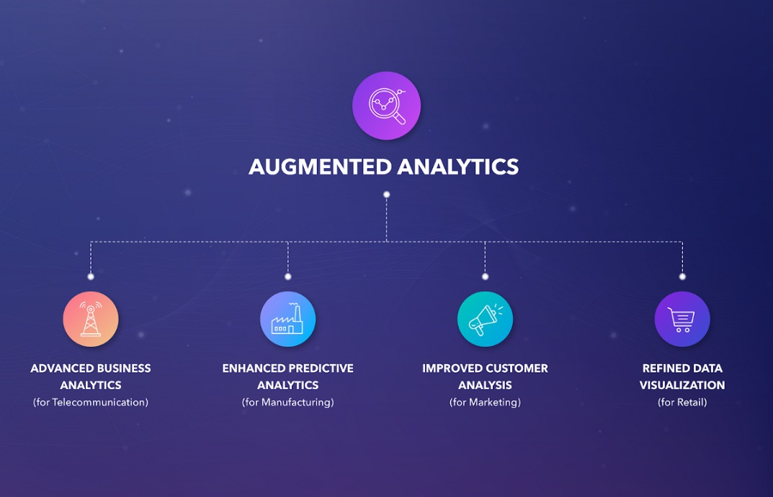
Figure 1: Augmented analytics
Source: (Gupta, 2022)
In business, augmented analytics is used for receiving exceptional value from data. It helps in finding more relevant data, uncovering insights quickly, and offering the best solutions in a business context. Business users can analyse data usefully without possessing deep expertise. There are many benefits of using augmented analytics in a business (Anusha and Kiruthika, 2022, p. 141). Agility is one such advantage that a business can derive from augmented analytics as it accelerates insight search. It also helps in making the most relevant and informed decisions by tallying all data. Process automation is another feature that augmented analytics offer via machine learning and automation reducing process costs and speeding up decision-making.

Mobile BI
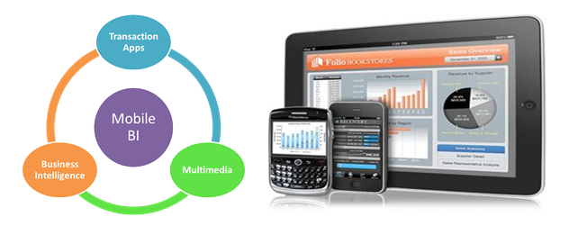
Figure 2: Mobile BI
Source: (e-Zest Solutions Inc., 2022)
According to Adeyelure et al., (2018, p. 717), mobile BI is access to data or information through mobile devices. The use of mobile devices in business has been increasingly visible, especially in management positions. Mobile BI has been helping in bringing analytics and intelligence closer to users when done appropriately. Mobile BI allows the consumption of information at any place in the train, airport, or meetings. There are many advantages of using Mobile BI for users. For instance, users can access information via mobile devices at any point in time and at any location. Hence, response to a situation can be given more quickly as mobile BI speeds up the process of distributing and accessing information. Moreover, integrating Mobile BI into the operational processes of a business maximises BI penetration within the company and benefits the firm by delivering additional information (Adeyelure et al., 2018, p. 721). By extending information and curbing the time a business spends searching for information, the decision-making procedure is sped by Mobile BI. Availing real-time data access and visualisation, operations within the business become more efficient and it further enforces organisational collaboration. Overall, Mobile BI enhances information availability, quickens the speed of reaction, makes work more efficient, and improves internal communication while shortening the flow of work.

Collaborative Business Intelligence
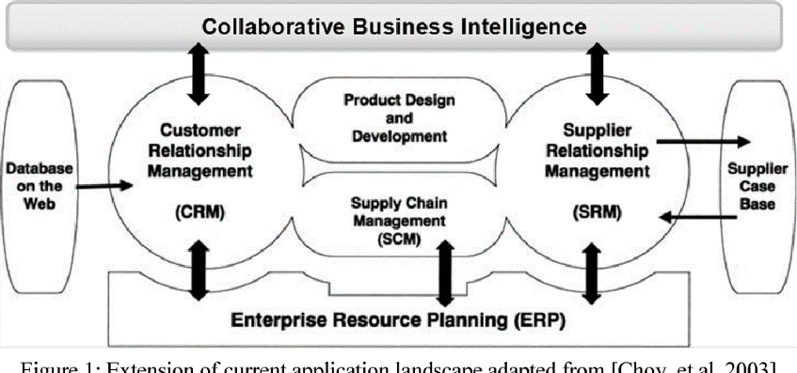
Figure 3: Collaborative Business Intelligence
Source: (Mettler and Raber, 2022)
Collaborative BI refers to the merged business intelligence software with tools for collaboration that includes technologies of Web 2.0 and social technologies supporting decision-making driven by data (Lokeshkumar et al., 2018, p. 410). Tools of Collaborative Business Interaction are SAP BusinessObjects, Dundas BI, Domo, Oracle BI, and Geckoboard. Collaborative BI is also known as Social BI which impacts organisational interactions and works. Sing the tools for collaboration and social tools, businesses have the opportunity to leverage the experience and knowledge of the whole workforce in problem-solving rather than depending on an individual team or person. Such tools allow workers in an organisation to receive information or data at different levels that could have been otherwise difficult to access. Collaborative BI can be used for report-centric decision making enabling business users to make a focused decision regarding particular dashboards and reports. Besides that, it also supports general discussion about issues by offering multiple reports. Collaborative BI is furthermore beneficial for annotations that are used for adding comments on certain sections of a report (Lokeshkumar et al., 2018, p. 414). Collaborative BI is useful in faster decision making and idea sharing increases the satisfaction of employees. Moreover, Collaborative BI makes the exchange of knowledge among diverse groups easier. Furthermore, this tool facilitates the involvement of shareholders in a business.

Artificial Intelligence
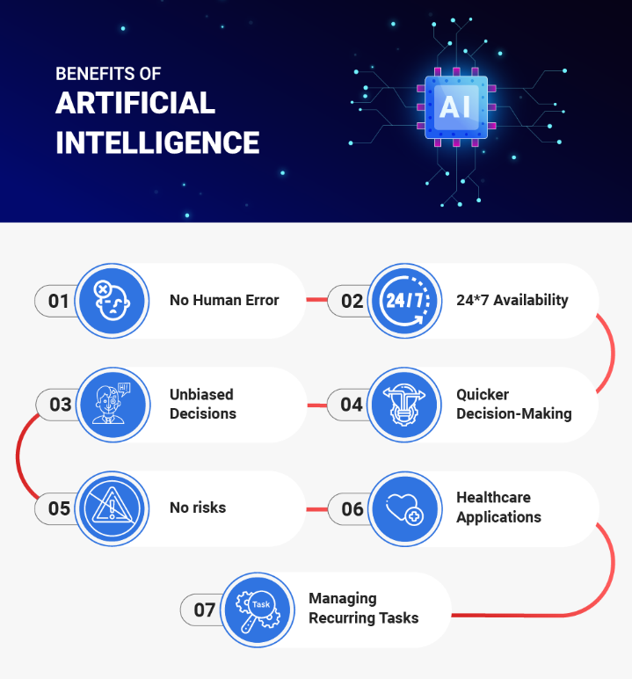
Figure 4: Artificial Intelligence
Source: (Oza, 2022)
In order to discuss business intelligence, artificial intelligence is important. AI is the most popular trend in the recent history of BI revolutionising the whole business systems and processes in all industries (Liang and Liu, 2018, p. 5). AI is applied in manufacturing, production, HR, marketing, supply chain, and all other areas of business. AI is combined with hyper-automation and engineering in businesses. AI algorithms as solutions in business analytics based on highly advanced neural networks offer greater accuracy in detecting anomaly as it acquires knowledge from historical patterns and trends. BI solution is an important feature offered by artificial intelligence that upscales the capability of insight generation. It analyses datasets completely in an automatic manner without requiring human effort. Demand for online data analysis software in real-time has increased with the emergence of IoT. Adaptive AI systems assist in decision-making models that focus on generating faster decisions while being flexible enough to adjust to arising issues (Liang and Liu, 2018, p. 7). These systems are advanced in the sense that they are capable of learning from patterns of behaviour which allows them to adjust to changes in the real-world making it more convenient to make quicker and improved decisions. However, a business needs to be conscious of ethics and measures of security during the implementation of AI in business intelligence analytics.

Self-service analytics
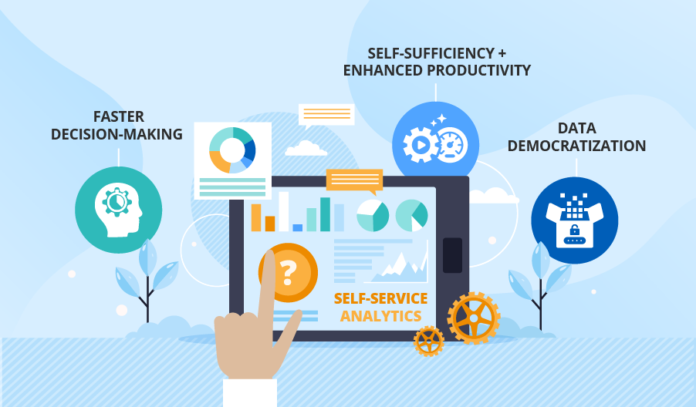
Figure 5: Benefits of self-service analytics
Source: (Chernik, 2022)
Self-service analytics is a BI form that enables line-of-business professionals encouraging them to conduct queries and produce reports by themselves with minimal support from IT (Daradkeh, 2019, p. 27). Self-service analytics is characterised by easy-to-use BI tools with simple analytic capabilities and underlying data models simplified and scaled down for straightforward and comprehensive access to data. In business, self-service analytics provides insights to differentiate customer experience for the company through analytics and data. The key driver that enables this BI tool in business is the need for gaining insights more quickly. The benefits of self-service analytics are quite broad apart from the process efficiency of data consumption. Self-service analytics has been found to be helpful in improving business users' and IT relationships by forming a symbiosis helping in better reliance (Daradkeh, 2019, p. 37). Principles of adopting self-service analytics for businesses include clean and correct data prioritisation for analysis, a model of formal federated analytics, empowered and qualified business users, and enabling collaboration between IT and users. Self-service analytics provides advantages such as discovering and governing strategic data easily, building a common language for business, innovating with intelligent SQL editor tools, cultivating tested data, and connecting BI to tools of data science.

Conclusion
To conclude, business intelligence has been found to be extremely useful for informed business decision-making. It is considered to be highly effective in generating and analysing valuable business insights that support strategic decisions. The study has effectively analysed five main trends in BI at present.

References
Adeyelure, T.S., Kalema, B.M. and Bwalya, K.J., 2018. Deployment factors for mobile business intelligence in developing countries small and medium enterprises. African Journal of Science, Technology, Innovation and Development, 10(6), pp.715-723. https://journals.co.za/doi/abs/10.1080/20421338.2018.1491137
Anusha, M. and Kiruthika, P., 2022. A Comparative Study on Augmented Analytics Using Deep Learning Techniques. In Ubiquitous Intelligent Systems (pp. 135-142). Springer, Singapore. https://link.springer.com/chapter/10.1007/978-981-16-3675-2_9
Božič, K. and Dimovski, V., 2019. Business intelligence and analytics for value creation: The role of absorptive capacity. International journal of information management, 46, pp.93-103. https://www.sciencedirect.com/science/article/pii/S0268401218301701
Chernik, M. (2022) Self-service analytics: When data 'speaks' to business users, Self-service Analytics, or Your Next Step Towards a Data-driven Company. ScienceSoft. Available at: https://www.scnsoft.com/blog/self-service-analytics (Accessed: December 17, 2022).
Daradkeh, M., 2019. Determinants of self-service analytics adoption intention: the effect of task-technology fit, compatibility, and user empowerment. Journal of Organizational and End User Computing (JOEUC), 31(4), pp.19-45. https://www.igi-global.com/article/determinants-of-self-service-analytics-adoption-intention/233828
e-Zest Solutions Inc. (2022) Mobile Business Intelligence, Digital Innovation & Technology Solutions Provider. Available at: https://www.e-zest.com/mobile-business-intelligence (Accessed: December 17, 2022).
Gupta, Y. (2022) The era of augmented analytics!, Medium. Data Science Simplified. Available at: https://medium.com/dssimplified/the-era-of-augmented-analytics-f34db14d833a (Accessed: December 17, 2022).
Liang, T.P. and Liu, Y.H., 2018. Research landscape of business intelligence and big data analytics: A bibliometrics study. Expert Systems with Applications, 111, pp.2-10. https://www.sciencedirect.com/science/article/pii/S0957417418303099
Lokeshkumar, R., Maruthavani, E. and Bharathi, A., 2018. A new perspective for decision makers to improve efficiency in social business intelligence systems for sustainable development. International Journal of Environment and Sustainable Development, 17(4), pp.404-416. https://www.researchgate.net/profile/Lokeshkumar-Ramasamy/publication/329633730_A_new_perspective_for_decision_makers_to_improve_efficiency_in_social_business_intelligence_systems_for_sustainable_development/links/5e786e46299bf1892c022029/A-new-perspective-for-decision-makers-to-improve-efficiency-in-social-business-intelligence-systems-for-sustainable-development.pdf
Mettler, T. and Raber, D. (2022) Developing a collaborative business intelligence system for improving delivery reliability in business networks: Semantic scholar, 2011 17th International Conference on Concurrent Enterprising. Available at: https://www.semanticscholar.org/paper/Developing-a-collaborative-business-intelligence-in-Mettler-Raber/ddb9d18ac6043866d59f1c4788e786fc3da79ceb (Accessed: December 17, 2022).
Oza, H. (2022) Importance and benefits of Artificial Intelligence: HDATA Systems, Data Science & Business Intelligence Company. Available at: https://www.hdatasystems.com/blog/importance-and-benefits-of-artificial-intelligence (Accessed: December 17, 2022).

