Module: Data Warehousing & Data Mining
Module Code: ACCA 6026
Submitted By: Md Gulam Hafiz
Student ID:2232603

Assignment 2 of Data mining
Data mining
Md Gulam Hafiz (2232603) | 4/10/26 | BSc applied computing

Table of Contents
Introduction: 2
1.1 Purpose, intention and implementation of Data mining: 2
Classification 3
Clustering 3
1.2 Data set Description and Analysis: 3
Fig: Attributes & data type in the provided data set. 4
Fig: Corrected missing value section in bmi attribute in the data set. 6
Figure: Graph stroke VS non-stroke distribution chart & histogram. 10
Fig: Random Forest and 10-fold-cross-validation. 16
Fig : output panel. By random forest and j48 17
1.5 Business Recommendations: 18
1.6 Reflective commentary: 19
Reference: 19

Introduction:
Data mining is a process to make the data workable from a raw set of data, analysis that according to the business need. In this assignment the specific data set (Healthcare data set) to analysis and produce report using Weka and Tableau. The following report will show before and after the data set has been analysis and all screen shots has been included.

1.1 Purpose, intention and implementation of Data mining:
Data mining is a process of getting statistics, machine learning, domain understanding, pattern and intention from a larger dataset. It is basically one of the processes of knowledge discovery in Databases (KDD) that includes selection, cleansing, transformation, modelling, valuation and explanation [1], [3].
Data mining is very important in real life because it is quite impossible for a human to analysis directly a huge amount of data that an organisation collect. Converting all raw data into useful information for decision making, planning and intervention, an analytical technique is needed. In health sector this technique is especially important because in this data there is a relationship between symptoms, behaviour, treatment history and future results are hidden in it [2],[11].
Current electronic health records in health sector, lab reports, diagnostics imaging system and wearable devices produce a lot of data. By using predictive analytics, it is possible to forecast the future risk from this data. To prevent strokes, it is very important because it does not generally happen for only one reason rather than age, heart disease. metabolic problems and lifestyles in combination [2], [7], [14].
Classification is widely used data mining process in health sector. Based on the levelised data it creates a new class of data. The main intention of this assignment task is to identify whether the patient will get stroke in the future or not. To keep a balance between interpterion and accuracy algorithms used like Decision tree, logistics regression and random forest [3], [6], [9].
Clustering is a different but important data mining process that can divide data into different groups without any level. It helps to divide the patients into different groups according to their risk factors, for example, young people are put in a less risk group, medium risks group, and elderly patients in a high-risk group [8], [10].
In a business point of view data mining helps to use resources wisely, cost minimisations and improve the quality of services [4], [11].
1.2 Data set Description and Analysis:
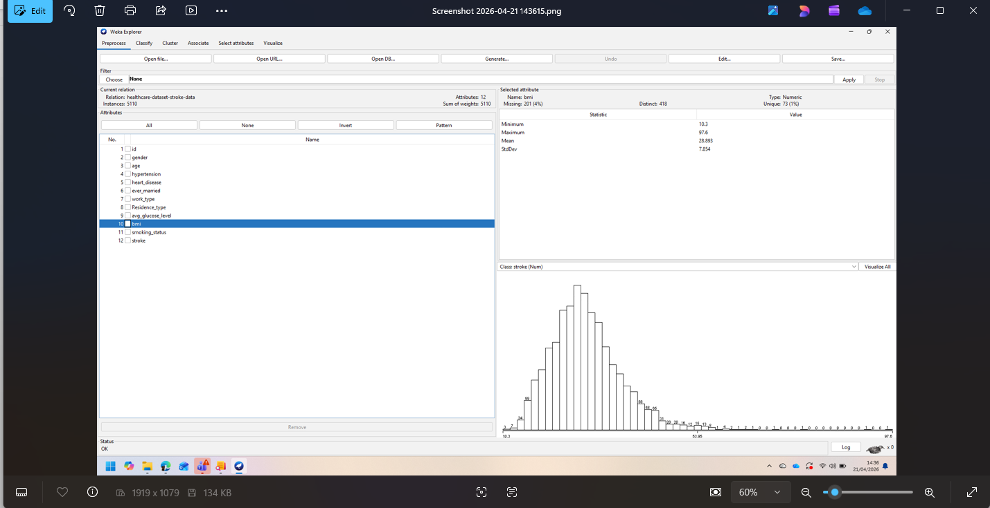
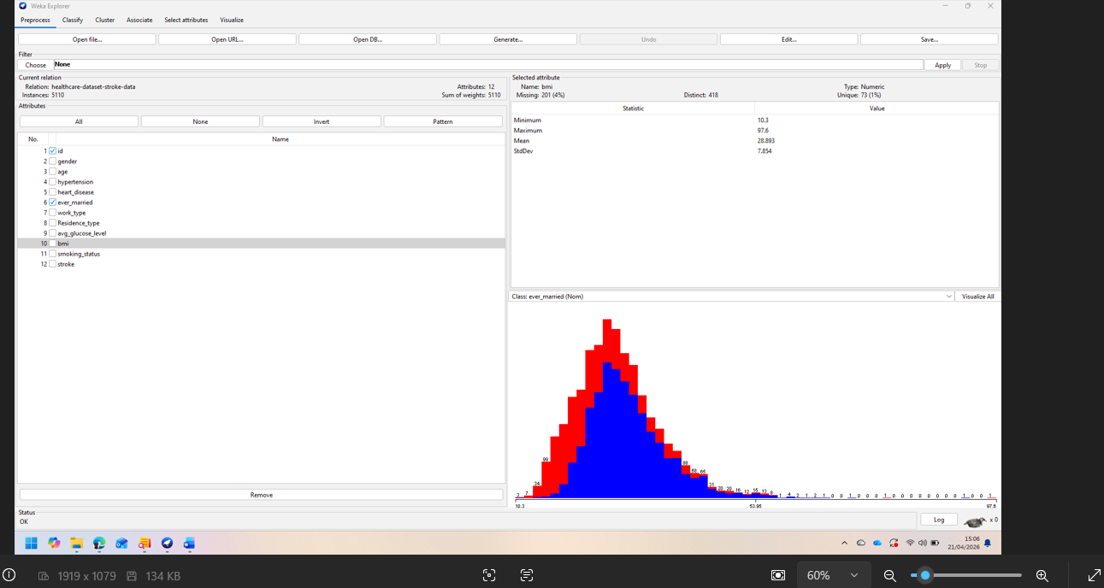

Fig: Attributes & data type in the provided data set.
5110 instances and 12 attributes of stroke prediction dataset are used in this research that includes combining demographic, medical history and lifestyle of the people have been taken into consideration related to stroke [4].
In these variables age, gender, marital status, work pattern, residence status, heart diseases, hypertension, average blood sugar, body mass index, smoking behaviour and the target variable stroke are included.
This dataset has also an id field that identify record very efficiently but does not provide any reliable predictive report due to the combination of both numerical and categorical data, it is perfect for different data mining process but before turning it into a modelling require more preprocessing approach carefully [3], [4].
These variables can be analysed using statistics like minimum, maximum, mean and standard deviation.
Among those binary variables includes high blood pressure, heart diseases and stroke on the other hand in nominal categories includes sex, marital status, works and residency etc.
Mix data set is very helpful because stroke is influenced by different elements of health risk factors, but this varieties of dataset make important contribution for cleansing and transformation process more important [5], [12].
During the primary explorations two important problems arises.
- First, body mass index contained around 201 missing values, representing about 3.9 percentage of the dataset [5]. Missing values cannot be ignored simply because to do so the size of the dataset may be limited and may introduce biasness if the missing cases are different from the complete ones.
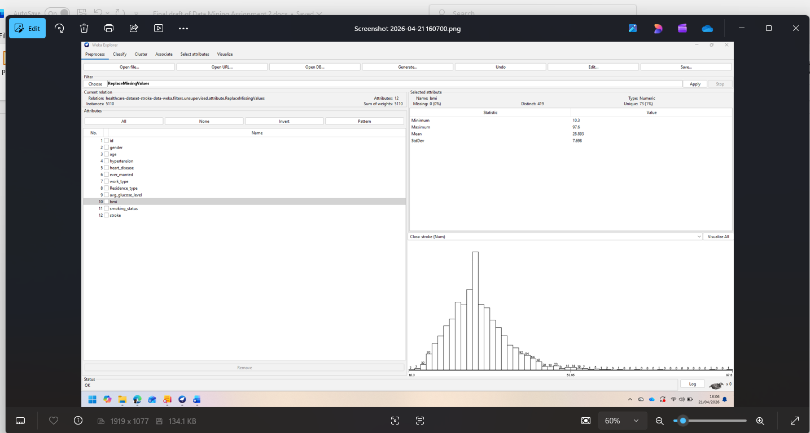

Fig: Corrected missing value section in bmi attribute in the data set.
- Secondly the dataset is highly imbalanced.
Because a small number of records are included in stroke class, most of them are non-stroke cases.
This means that a simple classifier could show the high accurate prediction showing on the majority class every time though it fails to show important health cases [6], [13].
Exploratory analysis indicates that age is one of the strongest predictors.
Strokes cases are seen among the adult class of the people which relevant with the public health research [1], [7].
High blood pressure and heart disease are more frequently associated with the stroke cases that reflects causes of the cardiovascular diseases [7], [14].
Average glucose level clearly indicates the different between two results that also indicates that metabolic health can be also important factor.
Body mass and smoking behaviour though relevant but comparing with the age, high blood pressure or heart disease it is continuously less influential.
The dataset should be analysis visually as well as numerically.
A class distribution chart can be useful to show the imbalance between stroke and non-stroke records.
Based on the result of strokes an age boxplot helps to show how the tendency of stroke is more occurs among the elderly patients.
Based on the results of stroke a similar boxplot can shows that weather average glucose levels are more in stroke patients or not.
taking in consideration of hypertension, smoke and heart disease using a stacked bar chart can be shown the differences between categories.
These visualisations provide evidence that before the algorithm is applied these datasets in the point of medical science is plausible structure.
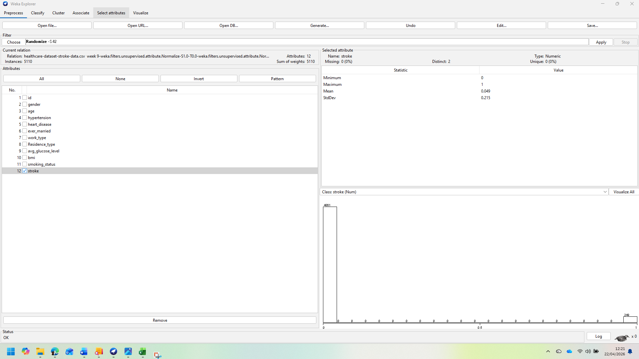
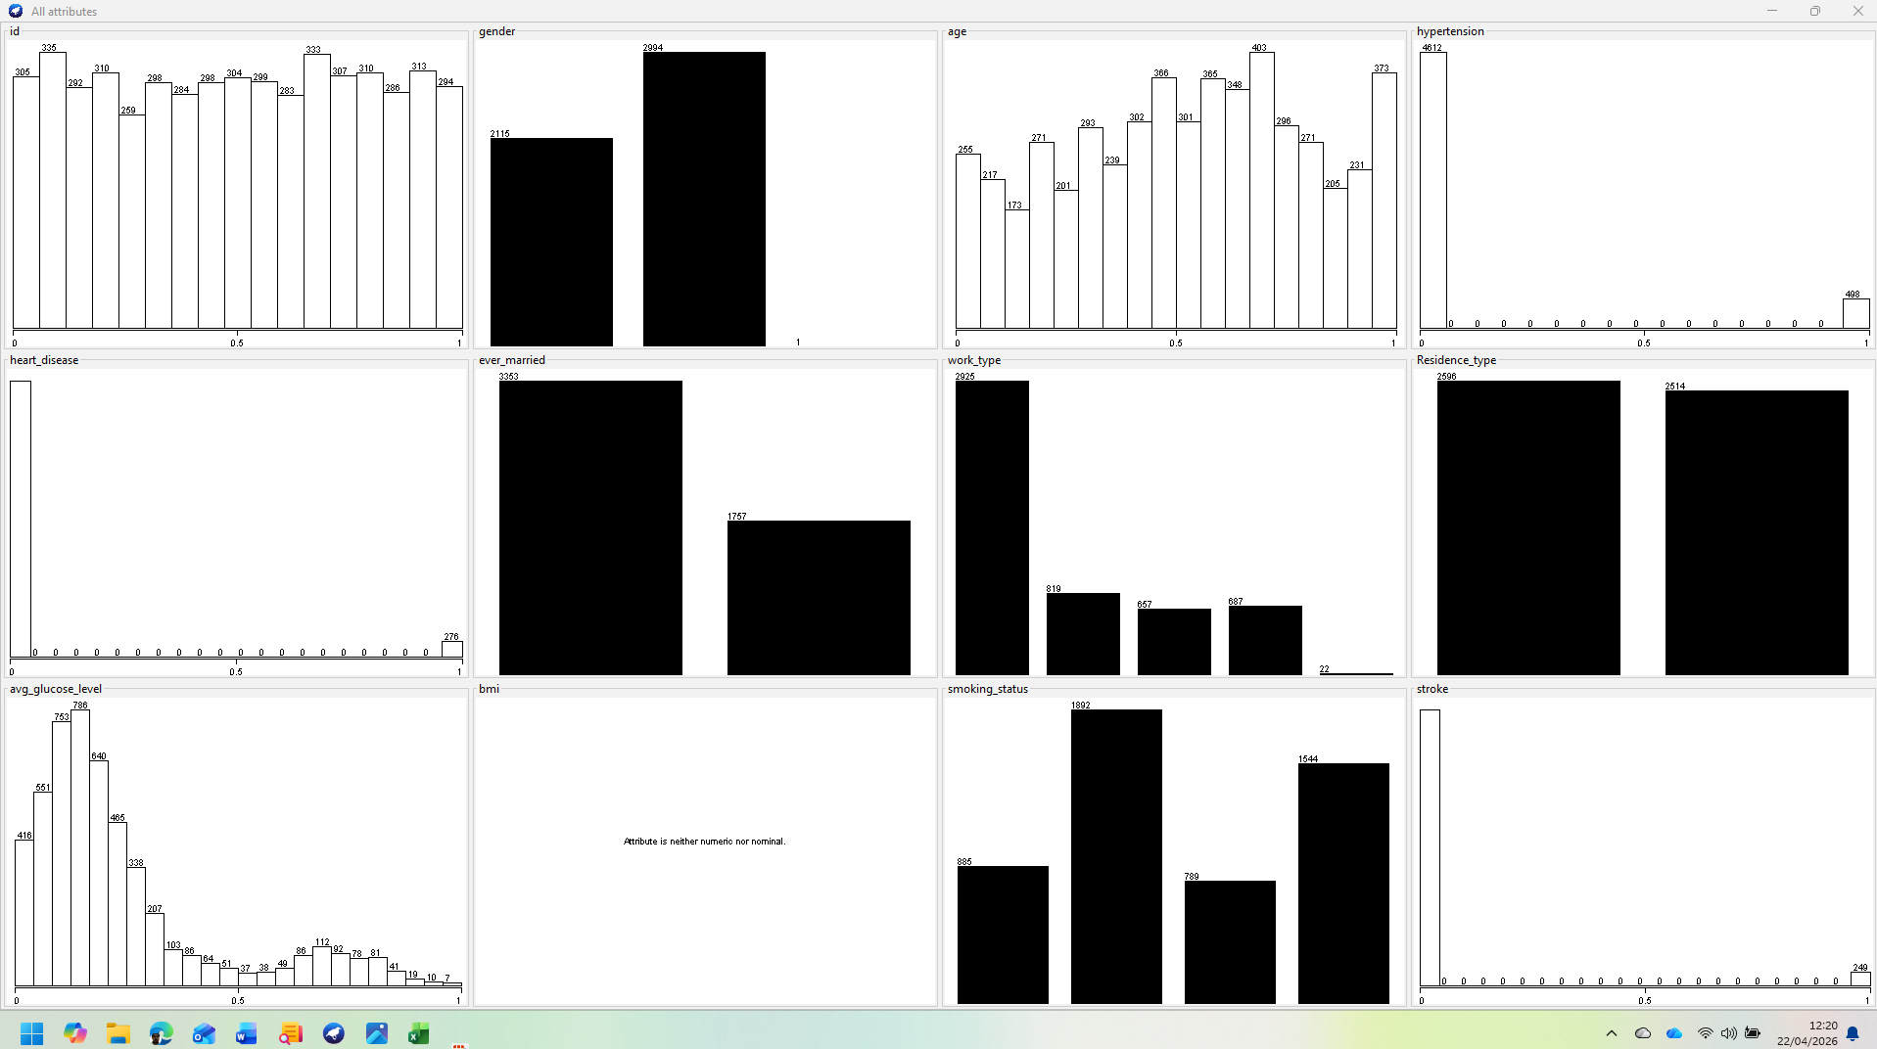
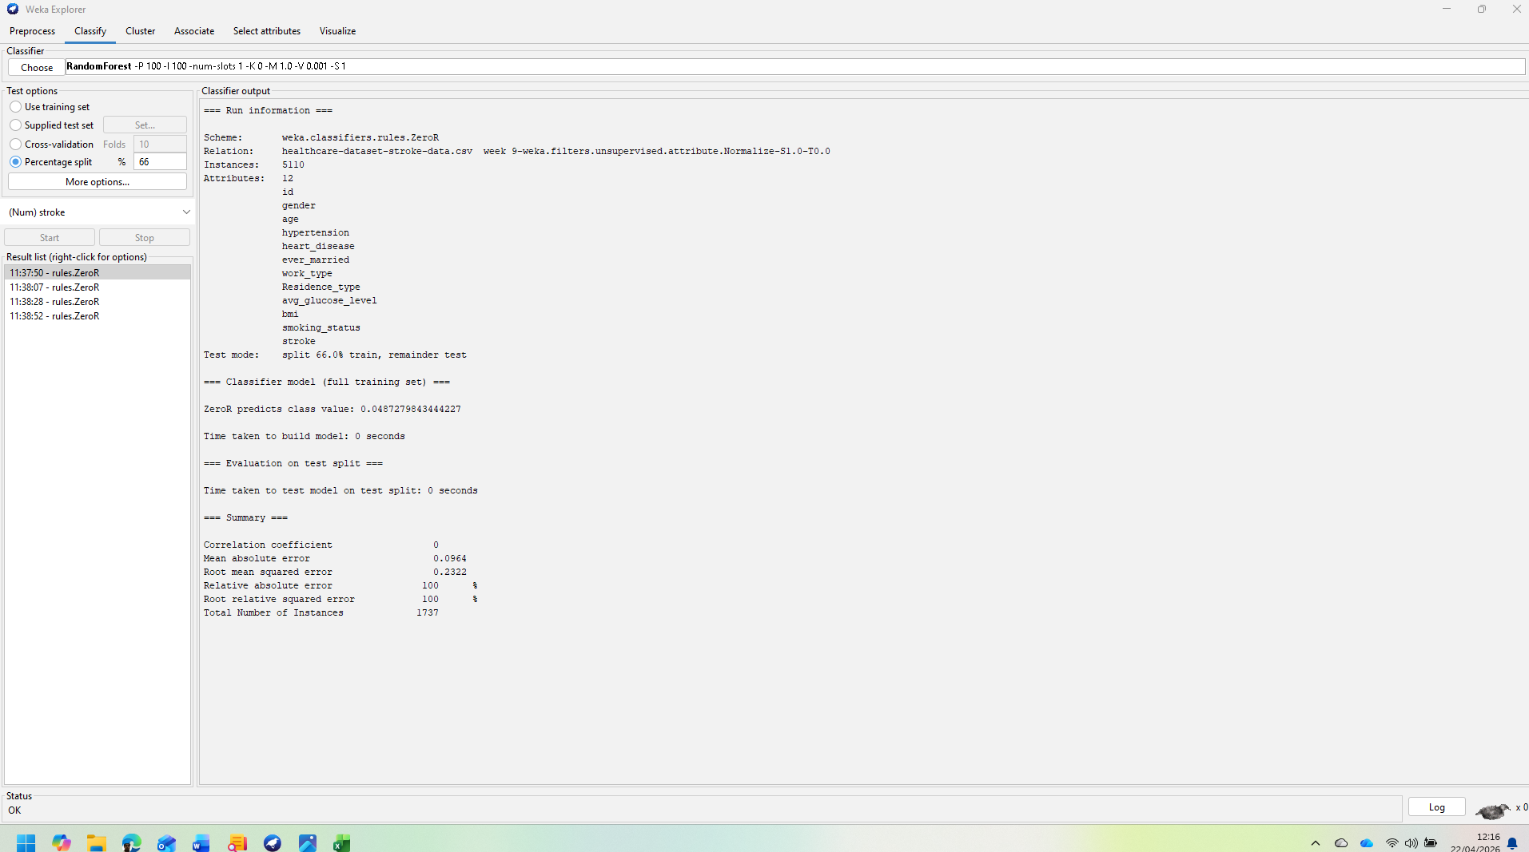
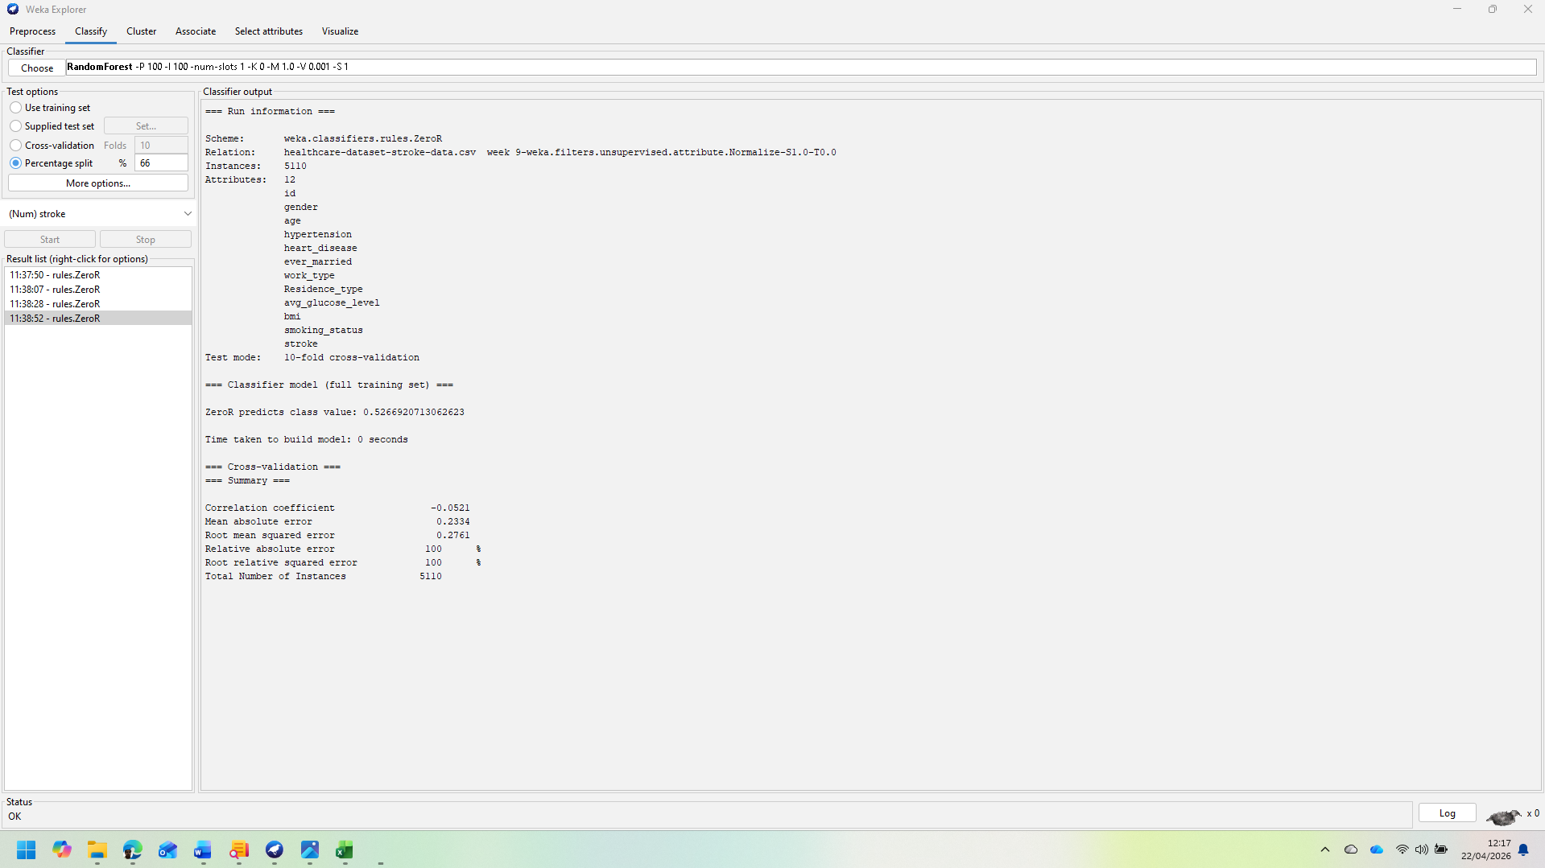

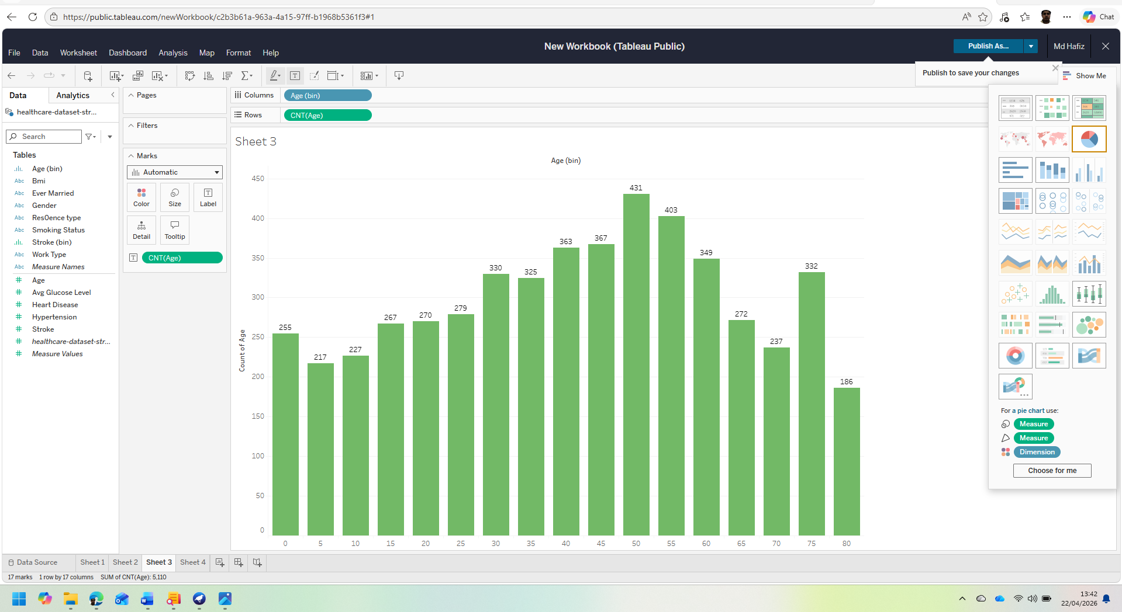
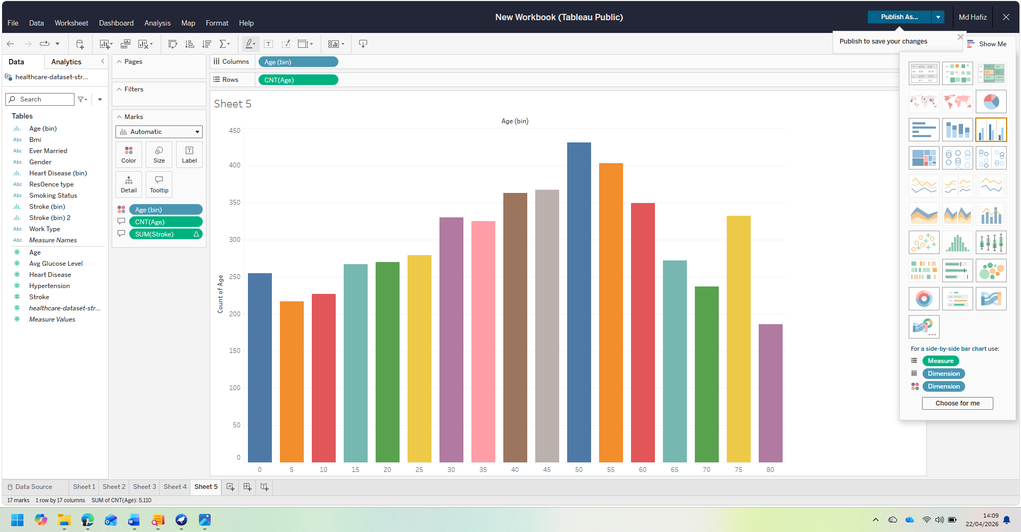
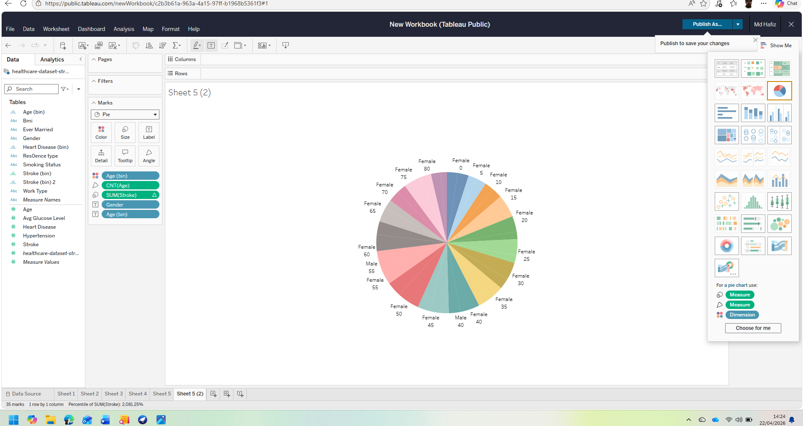

Figure: Graph stroke VS non-stroke distribution chart & histogram.

Exploration also supports the later analysis and interpretation in the report.
If in descriptive analysis age, high blood pressure and glucose levels is strongly related to stroke then in selecting the feature and model analysis it will reasonably get more priority.
In this investigative analysis is not a decorative step only, it directly influences the modelling strategies and increases the authenticity of the report[3],[11].

1.3 Data pre-processing and post processing:
Pre-processing was very important because it was not possible to turn the raw data into a reliable modelling.
In the first step the id attribute is removed. This field is used only to separate the record but there is no clinical importance. If it is kept will create the risk of adding unnecessary noise in the analysis which does not improve the prediction.
After removing the id column, the rest of the variables only represent probable characteristics of the relevant patients [3].
In second step handle the missing value of the body mass index.
As in the dataset there were nearly 201 missing entities that’s why a replacement technique was needed [5].
Mean imputation keeps all the record together that’s why it was selected because it can be implemented in Weka by using replace missing value filter.
This process is very simple and transparent also helpful for educative work.
Though the more developed imputation process slightly gives more realistic distribution but still if its limitation taken into considerations there is still acceptance of mean replacement [5], [12].
The small number of stroke positive cases would be smaller if the incomplete record is removed then the class imbalance would be worse.
Categorical variables are also needed more attention.
Weka can manage lot of nominal variables like 48, Random Forest but it very important that all the attributes are rightly identified.
If any categorical variable is mistakenly identified as numeric then the model can be misleading.
For the logistic regression and clustering some transformation or parameter may need to be checked carefully.
So, ensuring the correct data processing is an important part of data preprocessing that cannot be considered as minor technical matter [3], [6].
The most important problem of preprocessing was class imbalance because stroke class is very minimum so that many algorithms naturally show the biasness towards no stroke class.
Apparently, this can show high accuracy, but the identification of stroke cases may be weaker.
To overcome this problem SMOTE (Synthetic Minority Oversampling Technique) was applied to create an artificial minority-class based on the existing stroke record [6], [13].
Intention to use of SMOTE is not to create a false certainty but to train to learn meaningful decision boundaries by making the classifier expose with many minority examples during training.
Feature selection was selected based on the information gathered or in Weka using similar technique.
Possibility of getting more ranking for variables like age, high blood pressure, heart disease and high blood sugar level because in analysis and medical research and journal articles suggest that stroke is strongly linked with stroke [7], [14].
Feature selection is helpful because it makes the modelling easier, reduce unnecessary noises and increase volume of interpretations but it should be applied blindly.
Moderate statistically influence variable is still acceptable because that may clinically important.
So, for decision making it should consider both algorithmic evidence and logic of medical science.
Post processing was equally important.
After running the model, the output has been explained by using confusion matrix, class-specific precision and recall, ROC curve.
These outputs become meaningful when they are explained in the medical perspectives.
For example, a model can perform well in majority class but misses many stroke cases are not good for screening.
Similarly, the result of a clustering is meaningful when after analysing the clustering as meaningful patient groups are explained not only by presenting like cluster 0, cluster 1 or cluster 2.
So, post processing make alignment with the technological output with the understanding of the real world and attached with the decision-making process [3], [6], [10].

1.4 Sample run and Analysis Methods:
Weka has been used as a main data mining tool because it creates an easy environment for preprocessing, classification and clustering more over it has suggested by the assignment brief.
The analysis should be recorded in such a way that the sample run not only give result but also it will show selection of used process and evidence of software use.
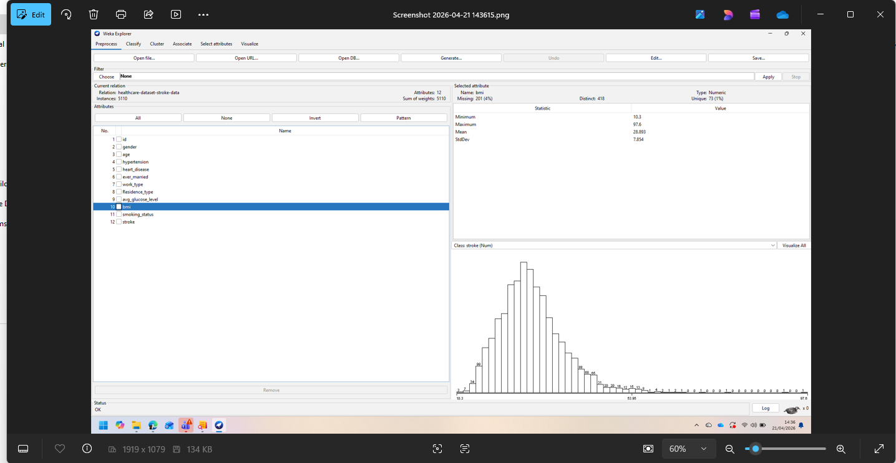

Figure: All attribute with missing value of bmi from weka
Process tab is very important because it is a quantity of instances, name of the attributes, types of data and ensure missing BMI standard.
It also shows the implemented filters, like Replace Missing Values and SMOTE.
This screen shot indicate that this dataset is analysed not only by importing but also created automatically.
The first classification should run by using ZeroR as baseline.
Zero only predicts the majority class and does not use any predictor variables.
In this dataset ZeroR can give high accuracy because in most of the instances does not have stroke case but it will provide 0 re-call for stroke class.
This an important learning because it proves that imbalance health dataset in not an only one matrix of accuracy [6], [13].
Include ZeroR means setting up a base line with whom another model can be compared.
The second run should use J48 distribution. J48 is effective because it creates an explanatory rule.
In dataset, TreeT probably will firstly divide them by age, high blood pressure, average sugar level or heart disease.
This model can be easily explained to non-technical users. For example, a branch can tell that the elderly patient those have high blood pressure and excess glucose levels are more in risk for stroke.
This transparency is important because physicians like explanatory model.
The weakness or limitation of the J48 is that it might be impatience and may overfit in training data [3], [5].
The third run should perform by using logistic regression. Logistic regression is a simple benchmark for binary prediction. It helps to identify the possibility and using co-efficiency can explain the relationship. It is important when classifications and variables are needed to be understood.
It assumes the simple relation but in case of critical or non-linear case it may reduce the performance [3], [9].
In this project the strongest classification process is probably Random Forest. Random Forest create many distribution trees and combine the result together.
It usually reduces the overfittings and gives good generalisation [9].
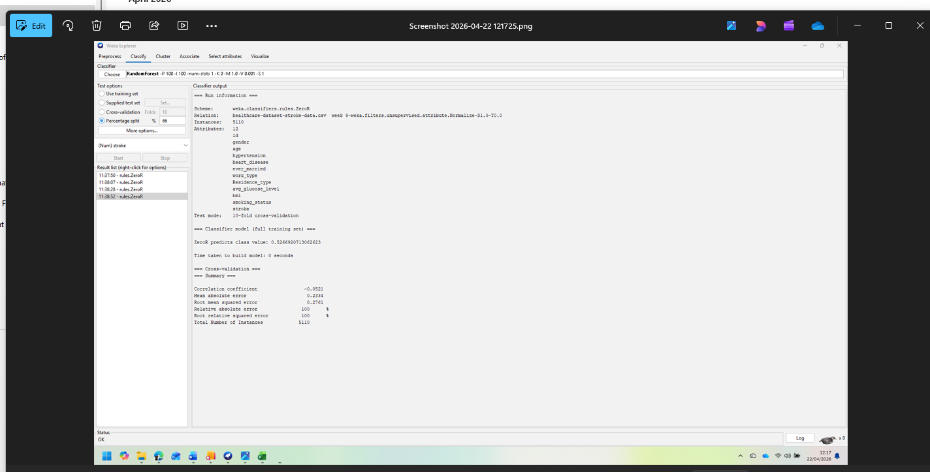

Fig: Random Forest and 10-fold-cross-validation.
For this dataset 10-fold cross-validation is the best validation process.
Dataset is being divided into 10 times and each time 1 part is used as a test set.
Last result is the combination of all performance. It is more trustworthy than a single split [3], [6].

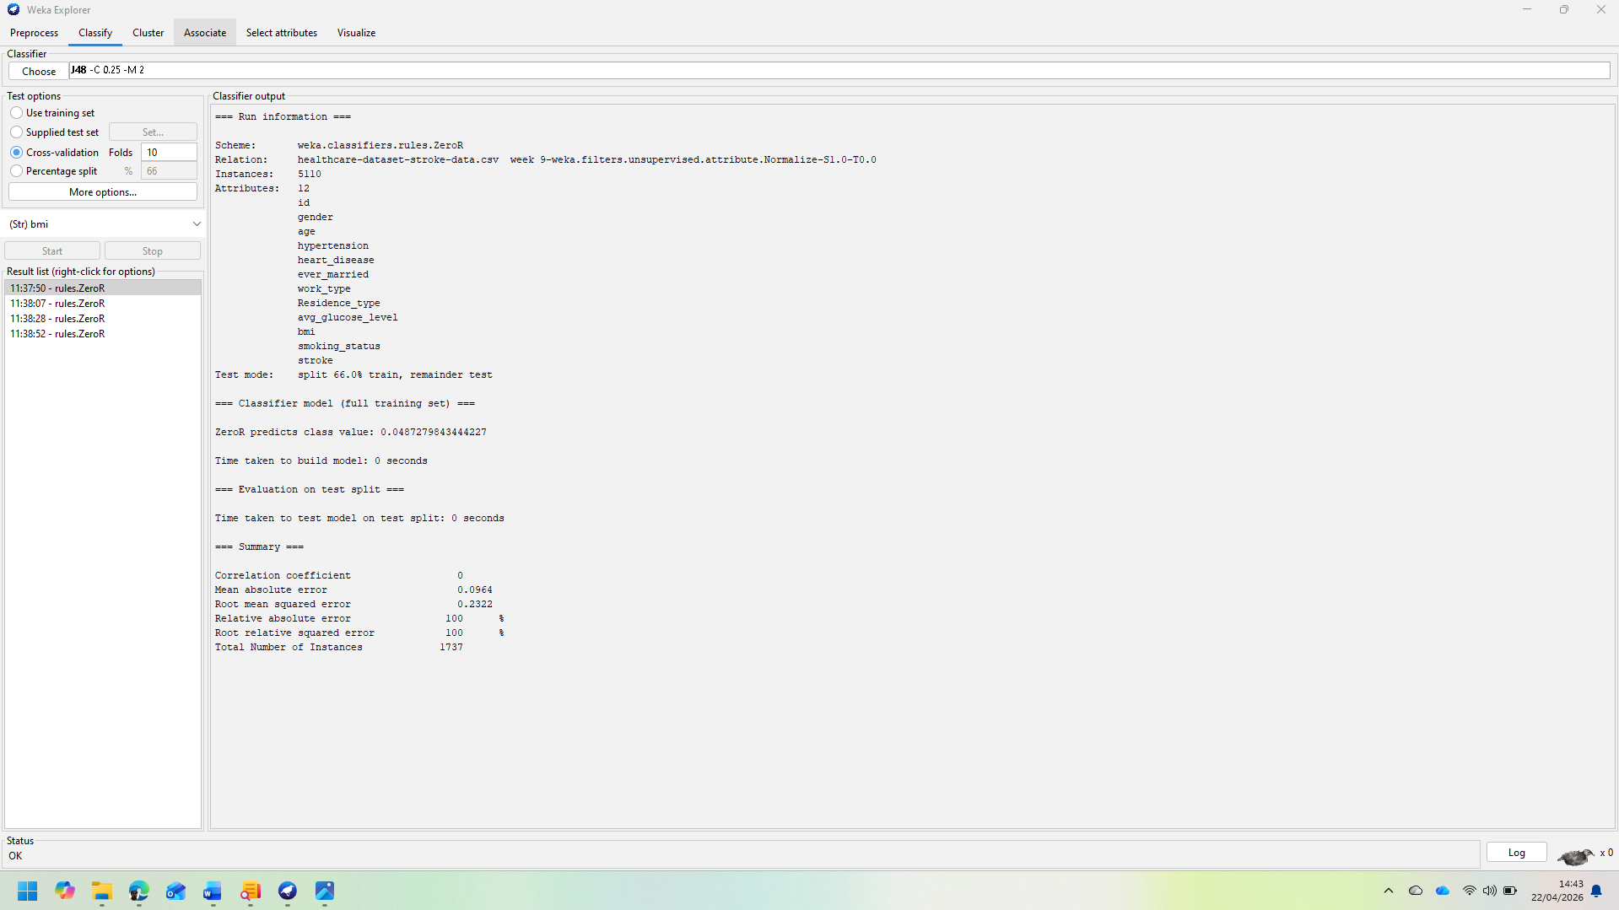

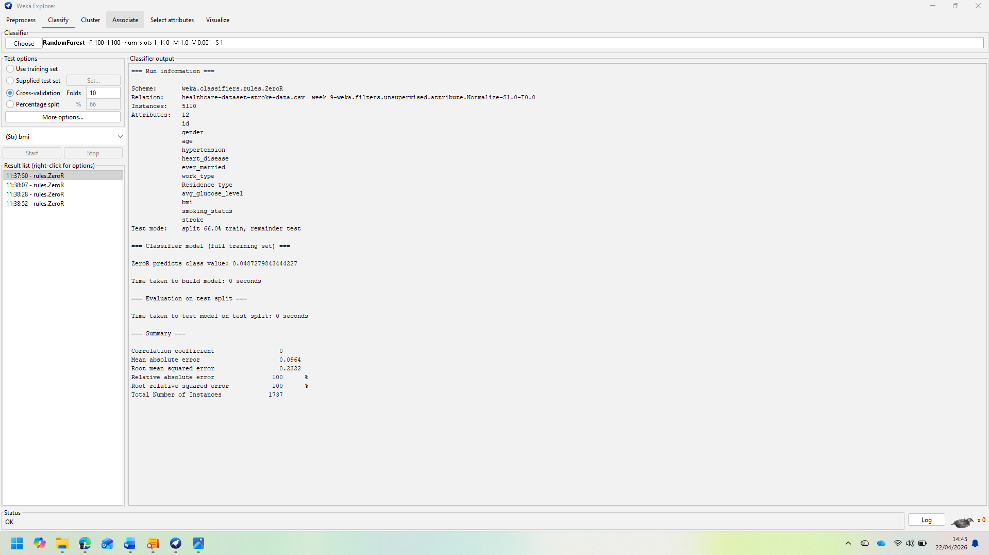

Main valuation matrixes are accuracy, precision, recall, F1-score and AUC.
Accuracy measures the ratio of all accurate classifications. But in this dataset, this is not the most important because class imbalance can mislead it.
In precision measurement show the ratio of correctly predicted stroke case.
Recall measure shows how many stroke cases correctly been identified.
In health sector Recall is very important because it could be dangerous if a patient is mistakenly missed [2], [7].
F1-score keep the balances between Recall and precision.
The power to make difference among the models is AUC.
Confusion matrix should be analysed without only doing copy.
A model becomes more effective when it can identify real stroke cases.
If Recall increase, then false positive may increase too, but for stroke it is acceptable because missing the patient is riskier [2], [7]. In clustering part K-means has been used, it helps to divide the patient in different groups. Use 3 clustering is logical because one can be less risky, one can be medium risky, and one can be high risky. Clustering is used not to do direct prediction, but it is used to identified based on pattern [8], [10]. At the it can be said that used process should be used logically.
ZeroR gives baseline, J48 gives capabilities of explanation, Logistic Regression set the medical benchmark, Randon Forest provide high performance and K-means find out the pattern.

1.5 Business Recommendations:
Some important recommendations have been suggested in this analysis.
Firstly, predictive models should be used as screening tools, not for diagnosis purposes only. Random Forest can help to find out the high-risk patients. It is especially important for limited resources [4], [11].
Secondly using the result of clustering should plan the targeted treatment. Highly risky patients should be observed regularly.
Food and exercise can be given to medium risky patients and for the less risky patient awareness advice can be provided. This process is more effective [8], [10].
3rdly, importance should be given both accuracy and recall because it is more dangerous to miss the patient and
Lastly, using this information public health planning should be done.
Based on the reasons of the risk’s awareness activities can be taken [2], [11].

1.6 Reflective commentary:
In this analysis shows that data mining is effective in predicting stroke.
Random Forest works better but other models help to do explanation [6], [9].
Among the limitations are data imbalance, missing data and the lack of clinical variables.
In future for big dataset and explainable AI should use [9], [14].

Reference:
[1] J. Han et al., Data Mining: Concepts and Techniques, 2012.
[2] WHO, Stroke Fact Sheet, 2023.
[3] Witten et al., Machine Learning Tools, 2016.
[4] Kaggle Stroke Dataset, 2020.
[5] Hossain et al., Missing Data Handling, 2024.
[6] Chawla et al., SMOTE, 2002.
[7] Stroke Statistics, 2019.
[8] Clustering Research, 2006.
[9] Breiman, Random Forest, 2001.
[10] K-Means Algorithm, 1967.
[11] Healthcare Data Mining, 2015.
[12] Missing Data Methods, 2003.
[13] Imbalanced Data Learning, 2009.
[14] Stroke Epidemiology, 2021.

