Programme: BA Hospitality and Hotel Management
Module name: Operating Hotel Facilities
Module code: BMIH5011
Lecturer: Lisa Bassler, Daniel Payne
Student name: Nicoleta Andreea Rosca
Student number: 2009573

“I confirm that I have not used any AI tools in the research and creation of this assignment. I confirm that I have not presented any AI generated materials as my own work. I confirm I have copies of my drafts, notes, and other resources I used, which I may be asked to provide in evidence.”

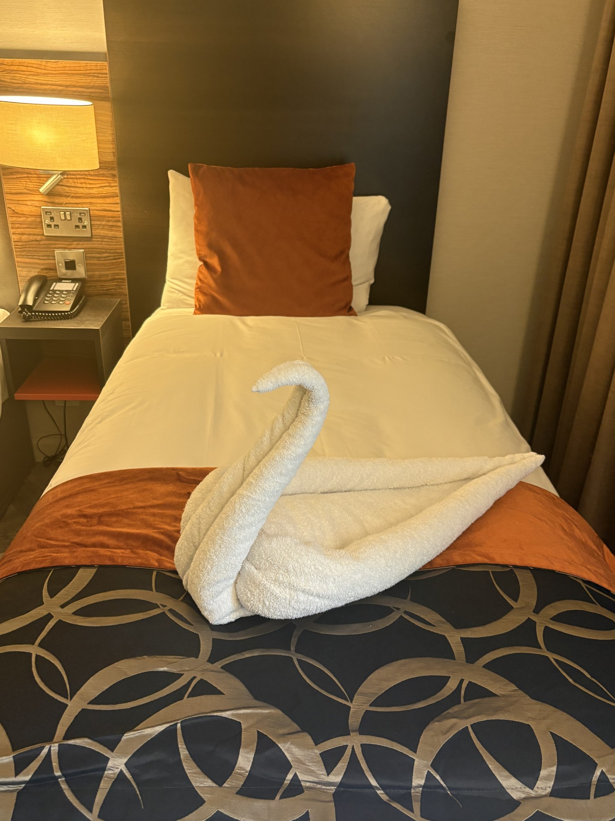
portfolio-six elements

Contents
Part 1: Reflective Writing Using Gibbs’ Model 2
Introduction 2
Main body 2
Gibbs’ Reflective Cycle 2
Description 2
Feelings 3
Evaluation 3
Analysis 4
Conclusion 4
Action plan 5
Part 1- References 6
Part 2- Hotel Mentor Feedback 7
Part 3: Placement Tutor Feedback 8
Part 4: Reflection on Hotel and Placement Tutor Feedback 11
Introduction 11
Main body 11
Understanding the Feedback 11
Impact of feedback 12
Action Steps for Growth 13
Conclusion 14
Part 4: References 14
Part 5: Presentation on Placement Experience 15

Part 1: Reflective Writing Using Gibbs’ Model

Introduction
This reflective report presents a critical analysis of my placement experience within the operating hotel facilities at the Clayton Hotel Cardiff city centre. Due to the hotel’s operational layout, moving from restaurant to function spaces and then the guest rooms, spread across different floors (Clayton Hotels, 2026), my daily tasks often shifted between front of house and back of house support. During my placement I gained practical experience in the food and beverages and housekeeping departments, while also supporting function room setups and assisting with basic building maintenance coordination. To structure my reflection, I will be using Gibbs’ Reflective Cycle Model (Adeani et al, 2020) which will guide me through its steps: description, feelings, evaluation, analysis, conclusion, and action planning. Overall, the placement allowed me to develop first hand insight into hotel and teamwork operations.

Main body

Gibbs’ Reflective Cycle

Description
During my placement, for the Operating Hotel Facilities Module, I spent the majority of my time working within housekeeping department. First, the team make me familiar with the daily procedures required in maintaining high standards in order to meet guest expectations. My main responsibility was to prepare guests rooms after check-outs. This involved changing linen, cleaning bathrooms, dusting the furniture, mopping floors, hoovering the carpets, and refilling amenities such as tea trays, drinks, toiletries, and towels. These tasks demanded strong attention to detail to ensure that the rooms met the hotel’s quality standards.
Also, the team put me up to date about the wider responsibilities that the housekeeping team have, how the head of housekeeping allocated daily tasks to room attendants and how the room inspections were used to monitor performance (Almanza et al, 2015). I was introduced to additional duties such as managing lost properties, checking stock levels, reporting maintenance issues (broken lights, damaged fixtures, and so forth), and supporting the preparation of staff rotas to ensure adequate cover at all times (Pitakaso et al, 2025)

Feelings
At the beginning of my placement in housekeeping department, I felt quite anxious and unsure about myself, even knowing that I am working in hospitality for a long time. The pace of work, the physical demands, and the responsibility of preparing rooms to a high standard all feel overwhelming. I worried about making mistakes or slowing the team down. This made me feel second guessing even simple tasks.
As I was settling into my role, and my colleagues ensure me that everyone makes mistakes, but this is a way to learn, my feelings gradually shifted. I became more comfortable with the routine and started to trust more in my ability to work efficiently. The physical work was still challenging, but I began to enjoy the sense of rhythm that came with it. Positive interaction with colleagues and small moments of progress helped me feel more capable and more at ease.
By the end of the placement, my confidence had grown significantly, I started to feel proud of the skills I had developed and more motivated. I gain a clear understanding of my own strengths and how housekeeping contributes to overall success and excellence in guest experience.

Evaluation
Looking back at my placement period, I can see clear strengths as well as areas that challenged me. One of the most positive aspects was the opportunity to rotate between the food and beverage and housekeeping departments, which helped me build a broader understanding of how the hotel operates, in food and beverage constant interaction with guests strengthened my communication and service skills, and working through busy breakfast shifts improved my ability to multitask under pressure. In housekeeping, I developed stronger attention to detail and better time management skills. The supportive teamwork in both departments made the workload feel more manageable (Apdua & Chavez, 2026). Effective communication between departments also helped maintain smooth operations that lead to the possibility of offering customer satisfaction (Azhar et al, 2024).
However, there were also difficulties. At the beginning, managing my time in housekeeping was stressful, especially when trying to meet room deadlines. Managing this level of detail while working quickly was difficult, and I sometimes worried about missing insignificant things that could affect the hotel’s standard. Another challenge for me was learning about how to report maintenance issues accurately and keep track of stock levels, as these responsibilities were new to me.

Analysis
Reflecting on my experience in the housekeeping department, I can clearly see how several hospitality management concepts connected to my daily work. The idea of service quality (Kalnaovakul & Promsivapallop, 2023) became very real to me, as the standard of cleanliness in each room directly shaped how guests felt about their stay (Ojha et al, 2025). Every detail, from how neatly the bed was made to whether the toiletries were fully stocked, played a part in the guest’s overall impression. I began to understand that even small oversights could affect satisfaction.
Teamwork (Mullins & Dossor, 2013) and interdepartmental coordination (Mullins & Dossor, 2013) are also role keys. For example, when I reported maintenance issues, the speed and clarity of communication with the maintenance team determined how quickly a problem was resolved (Thompson, 2018). This showed me how much the hotel relies on departments supporting one another.
Time management (Forsyth, 2023) is another major theme. `working within room cleaning deadliness, especially during peak check-out hours, pushed me to organise my tasks more efficiently. Also, I realised how important attention to detail (Sok et al, 2018) is for housekeeping department, as guests notice every little wrong thing, about which we sometimes do not think. Through this experience, I gained a deeper understanding of how these concepts shape everyday hotel operations and how my own performance contributed to the customer satisfaction.

Conclusion
Reflecting on my placement as a whole, I can see how much I have grown both personal and in my work like. At the start, I felt unsure of myself and overwhelmed by the pace and expectations within the housekeeping department. However, as I became more familiar with the routines and the standards required, my confidence steadily increased. I learned that many of the skills I developed, such as attention to detail, time management, and clear communication, are essential not only for housekeeping but for wider hotel operations.
The experience helped me to understand how closely service quality, teamwork, and different team coordination are linked to guests’ satisfaction. I realised that even small tasks contribute to the hotel overall success. By the end of my placement period, I felt more capable, motivated, and aware of my strengths. This reflection has shown me that all then challenges I faced were important steps in my development and are preparing me for future roles in hospitality industry.

Action plan
Goal | Specific Action | Measures of Success | Time limit
Improve the time management. | -Practice completing housekeeping tasks efficiently  -Prioritise duties during shifts | Gain the ability to complete cleaning within 30 minutes consistently | Within next placement
Strengthen the communication. | -Engage actively with all team members and other departments members  -Participate in briefings | Improve coordination and fewer communication errors | Ongoing
Develop the technical knowledge. | -Learn hotel systems such as maintenance reporting and housekeeping schedules | Ability to perform tasks independently | Within 3-6 months
Gain the broader experience. | -Seek exposure to multiple departments in future placement | Improved understanding of hotel operations | During Level 6 placement

Part 1- References
Adeani Ikin Syamsudin, R. Bunga Febriani and Syafryadin Syafryadin (2020) “USING GIBBS’ REFLECTIVE CYCLE IN MAKING REFLECTIONS OF LITERARY ANALYSIS,” Indonesian EFL journal (Online), 6(2), pp. 139–148. Available at: https://doi.org/10.25134/ieflj.v6i2.3382 [Accessed 05 April 2026].
Almanza, B.A. et al. (2015) “How Clean Are Hotel Rooms? Part II: Examining the Concept of Cleanliness Standards,” Journal of environmental health, 78(1), pp. 14–19.
Apdua E.Q. and Chavez C. (2026) “Work Engagement and Employment Relationship: Keys to Elevating Job Performance among Hotel Personnel,” JPAIR, 64(1), pp. 175–214. Available at: https://doi.org/10.7719/jpair.v64i1.991, [Accessed 05 April 2026].
Azhar, A. et al. (2024) “Employer branding: A strategy to enhance organizational performance,” International journal of hospitality management, 116. Available at: https://doi.org/10.1016/j.ijhm.2023.103618, [Accessed 06 April 2026].
Clayton Hotels, (2026), Welcome to Clayton Hotel Cardiff, Available at: https://www.claytonhotels.com/cardiff/, [Accessed 05 April 2026].
Forsyth, P. (2023) Successful time management: how to be organized, productive and get things done. Sixth edition. London, United Kingdom; Kogan Page.
Kalnaovakul, K. and Promsivapallop, P. (2023) “Hotel service quality dimensions and attributes: An analysis of online hotel customer reviews,” Tourism and hospitality research, 23(3), pp. 420–440. Available at: https://doi.org/10.1177/14673584221145819, [Accessed 06 April 2026].
Mullins, L.J. and Dossor, P. (2013) Hospitality management and organisational behaviour. Fifth edition. Harlow: Pearson.
Ojha, U.R.S. et al. (2025) “Exploring the Impact of Quality Housekeeping Services on Customer Satisfaction and Revisit Intentions: A Study of Luxury Hotels in Uttar Pradesh,” International review of management and marketing, 15(6), pp. 314–328. Available at: https://doi.org/10.32479/irmm.20235, [Accessed 06 April 2026].
Pitakaso, R. et al. (2025) “Embracing open innovation in hospitality management: Leveraging AI-driven dynamic scheduling systems for complex resource optimization and enhanced guest satisfaction,” Journal of open innovation, 11(1). Available at: https://doi.org/10.1016/j.joitmc.2025.100487, [Accessed 05 April 2026].
Sok, P. et al. (2018) “The Complementarity of Frontline Service Employee Creativity and Attention to Detail in Service Delivery,” Journal of service research: JSR, 21(3), pp. 365–378. Available at: https://doi.org/10.1177/1094670517746778, [Accessed 07 April 2026].
Thompson, N. (2018) Effective communication: a guide for the people professions. Third edition. Basingstoke, Hampshire: Palgrave Macmillan.

Part 2- Hotel Mentor Feedback
Student Name: Nicoleta Rosca
Placement Hotel: Clayton Hotel Cardiff
Did the Student complete the required hours of 16h per week?
Yes
Operating Hotel Facilities: Including Housekeeping, Maintenance, Events, Leisure Club.
Cleanliness and/or attention to detail: Did the student follow cleaning protocols and/or maintain high attention to detail standards?
She understood our floor service requirements and was able to deliver on these standards across the business operations. She will be able to see how her housekeeping work links directly to reception and the guest journey to the F&B areas of the hotel.
Time management and efficiency: Was the student able to complete Housekeeping, Maintenance, Events or Leisure Club tasks within the allocated time?
Housekeeping is her comfort zone but during her time here she was able to see life on the other side of this departments. The management planning and day to day problem solving that is required to manage a 216-bedroom bed stock.
Interaction with guests and handling special requests: Did the student show professionalism when dealing with guest requests or complaints?
Yes, this is where she does excel. She naturally goes above and beyond for the guests that she interacts with. She understands the importance of delivering great guest interaction and satisfaction and also the importance of problem solving quickly so the guest has a resolution to whatever their issue/concern is.
Meeting/Events or Leisure club departments as relevant.
She has grown in confidence in the housekeeping department and now understands the complexity that housekeeping management is.

Part 3: Placement Tutor Feedback

“Time Management
Nicoleta began her placement slightly later than expected due to the hotel’s scheduling requirements. Despite this, she has made steady progress and has currently completed approximately 112 hours, demonstrating a clear commitment to meeting the overall placement requirements.

Her working pattern has been set by the hotel, consisting primarily of Tuesday mornings and Thursday afternoons. While this has allowed her to maintain consistency, it does limit her exposure to the full range of operational activities within the hotel. However, as Nicoleta is also employed within the housekeeping department at the same hotel, she has additional opportunities to observe the operation on other days, which supports her overall understanding.

Nicoleta has shown good awareness of her remaining hours and has been proactive in tracking her progress to ensure she meets the required total. This level of organisation is a positive aspect of her approach.

From a tutor’s perspective, Nicoleta has attended all scheduled meetings and maintained consistent communication. Moving forward, continuing to balance her placement hours alongside the academic requirements will be important to ensure successful completion of all elements.

Communication

Nicoleta has demonstrated strong and consistent communication throughout her placement. She has maintained regular contact via email, ensuring that updates are shared and any queries are addressed promptly.

She has attended all scheduled meetings and has been clear and professional in her communication. While she has asked fewer questions in relation to the academic assignment, she has shown initiative by requesting to submit a draft for feedback, which is a positive step towards improving her work.

Within the workplace, Nicoleta has received positive feedback from both the General Manager and HR team, who have highlighted her friendly and approachable nature. Her positive attitude and ability to engage well with others are strong attributes within the hospitality environment.

Looking ahead, continuing to build confidence in asking questions, particularly in relation to her academic work, will further support her development.

Behaviour

Nicoleta has demonstrated a highly positive and professional attitude throughout her placement. She is a hardworking, friendly, and approachable individual, which has been reflected in the positive feedback received from the hotel team.

As this is her first placement, Nicoleta has shown good adaptability in moving between departments, including Housekeeping and Food & Beverage, and is due to begin experience within Reception. Initially, she expressed some concern about transitioning into Food & Beverage; however, she has since grown in confidence and is now more comfortable within this area. This development is particularly encouraging and highlights her ability to step outside of her comfort zone.

Nicoleta has engaged well with the placement overall and has shown enthusiasm in her role. Moving forward, continuing to build confidence across different departments will further strengthen her ability to adapt and succeed in a variety of hospitality settings.

Problem-Solving
Nicoleta has begun to develop her problem-solving skills throughout her placement, particularly as she gains exposure to different departments. Her willingness to move into new areas, despite initial uncertainty, demonstrates a positive approach to learning and development.

As Nicoleta continues to gain experience, developing greater confidence in unfamiliar situations and taking more initiative in asking questions or seeking clarification will further enhance her problem-solving abilities.

Looking ahead, it may be beneficial for Nicoleta to consider undertaking her Level 6 placement in a different hotel environment. This would allow her to gain a broader perspective of the industry and further develop her skills in a new setting.

Nicoleta should take confidence from the positive feedback she has received and the progress she has made so far. By continuing to build her confidence, maintaining her strong work ethic, and placing greater focus on the academic element alongside her placement, she will be well positioned for future success within the hospitality industry.”

Tutor: Daniel Payne
Signature: Daniel Payne
Date: 19th March 2026

Part 4: Reflection on Hotel and Placement Tutor Feedback

Introduction
This section of my portfolio examines the feedback I received throughout my operating hotel facilities placement at Clayton Hotel Cardiff, focusing on how it shaped my professional growth across housekeeping, maintenance, leisure club and meeting and events operations. Feedback has played a significant role in helping me understand my strong skills set, recognise where I need to change things to get better and develop the confidence needed to work effectively in a busy hotel environment. Both my hotel mentor and the placement tutor offered me insights that combined practical expectations with academic perspectives, allowing me to discover my achievements from different angles. Their comments point out my positive attitude, communication skills, willing of growing confidence and problem-solving abilities. Their advice was to fortify my time management skills and my academic engagement. By reflecting on this feedback, I realised that now I understand where, how much and how I progressed. My next step will be to create strategies to continue improving, both on operational competencies and academic knowledge.

Main body

Understanding the Feedback
The feedback I received during my operating hotel facilities placement made me aware of how I performed across the core operational departments: housekeeping, meeting and events, maintenance, and leisure club. My mentor noted that I was able to meet the hotel’s cleanliness expectations (Jayanti, 2023) and floor service standards (Ojha et al, 2025). That I was showing strong awareness of cleaning protocols and mindfulness, this being an important require for housekeeping, where my work directly influences the guests staying experience. I also formulate a different idea of how housekeeping connects with reception and other departments, reinforcing the importance of operational flow in full-service hotel (Sotiriadis, 2018).
Time management was another key area discussed. While housekeeping felt familiar to me, the placement exposed me to the logistical challenges behind managing a high-capacity hotel operating 216 rooms. Seeing how maintenance issues, room readiness and events setups interact (Raghubalan & Raghubalan, 2023) opened my eyes about how complex and difficult the daily operations are. My mentor also recognised my natural ability to oversee guest interactions, noting that I always go beyond expectation when dealing with special requests or customer concerns. This is making my confidence to rise in problem solving and communication skills development.
From the tutor perspective, my steady completion of placement period, consistent communication and initiative-taking organisation are considered as positive aspects of my progress. All together encouraged me to continue balancing my academic knowledge with the placement duties to build experience and increase my confidence. To ask questions where needed and help when something is going on the wrong direction to perfect my work etiquette and deepen my learning.
All these insights revealed not only that I did well, but also how I can continue to develop across different operational areas.

Impact of feedback
The feedback that I received had a major influence on how I approached my work and understood my role within the wider hotel operations. My mentor’s comments on cleanliness standards and meticulousness made me more conscious of how housekeeping tasks influence the guests staying period, from the moment they first enter in the hotel and then to their room to their full experience along with other departments such as food, beverage, and leisure. Realising that I was part of this amazing operational flow that make a customer journey feeling special, I encouraged myself to be more consistent in applying correctly the cleaning protocols, to respect the health and safety requirements, and to check twice even the small details that may affect their staying.
The feedback on time management also had a strong impact. Although housekeeping was familiar to me, understanding the planning, paperwork and managing the large quantity of room stock, helped me appreciate the operational pressure faced by the supervisors. This pushed me to work more efficiently and anticipate tasks rather than simply responding to them. My mentor’s recognition of my guest interaction skills motivated me to maintain my professionalism always and to respond quickly to concerns, reinforcing the importance of decision making in maintaining guest satisfaction.
The tutor’s feedback added an academic dimension by highlighting the need to balance the practical work with reflective thinking. Their comments on my organisation, communication, and steady progress encouraged me to continue tracking and analysing my hours and to corelate with more confidence my experiences with the academic knowledge. This combination of operational and academic feedback strengthened my understanding of how technical skills, interpersonal abilities, and reflective practice work together in hospitality roles.
Overall, the feedback shaped a new me, more developed, with a refined performance, and more aware of the competencies needed to progress in hospitality line of work.

Action Steps for Growth
Building on the feedback received from both my hotel mentor and placement tutor, several clear actions can support my continued development in hospitality operations and future placements. Strengthening my time management skills is a priority, particularly during peak housekeeping periods where tasks must be completed within strict time schedule. As Baytok et al (2023) suggest, learning to prioritise tasks more effectively will have improve my efficiency. More productivity when I will prepare rooms, support events or assist with maintenance related duties.
Another major step is deepening my understanding of housekeeping standards and operational procedures. Gaining more knowledge about inspection processes, cleaning protocols and facility maintenance will help me to deliver work that consistently aligns with professional hotel expectations. Research shows that improving communication systems and operational procedures can enhance housekeeping performance (Armstrong, 2017). Continuing to improve my communicating skills and use them to communicate with the maintenance, reception and events teams will be an essential part of my development plan.
Shaping up greater ability and technical confidence is also necessary, especially when supporting maintenance tasks or working in leisure clubs. Hospitality employees and implicitly the placement students as me, increasingly need versatile skills to manage the vast contemporary operational demands (Neves et al, 2021). Building these abilities will help me respond more effectively to unexpected issues and increase my competences across hotel departments.
Finally, enhancing my reflective and analytical skills will support both my academical and professional progression. Engaging more deeply with feedback and ask frequently for critical and constructive reviewing, will give me the opportunity to identify more learning paths to enrich my knowledges and strengthen my decision-making skill. Adapting my mindset to recognise opportunities and follow up to feedback on ongoing bases will guide my perseverance and long-term progression in hospitality industry roles.

Conclusion
Reflecting on all feedback received provided me with an accurate understanding of how my skills, behaviours and knowledge have change throughout my spending time in Clayton hotel Cardiff student placement. The mentor’s insights helped me recognise my practical strengths that I displayed in housekeeping practice, maintenance support, and guest interactions. Also, he highlighted areas such as time management and attention to detail, that I need more time to develop and require more focus on. On the other hand, the tutor’s perspective added an important academic side, encouraging me to use more reflection, put in practice organisational skills, and add more confidence in engaging with theoretical concepts. A cumulation of all these viewpoints have shaped a balanced awareness of what effective work in hotel industry involves, and how the operational competences are combining with academic facts. This feedback revealed my actual and real abilities and guided me to create my next steps planning to continue my growth. It reinforced my commitment to developing both technical and people skills essential if I want a future in this industry.

Part 4: References
Armstrong, M. (2017) Armstrong’s handbook of management and leadership for HR: developing effective people skills for better leadership and management. Fourth edition. London, England; Kogan Page.
Baytok, A. et al. (2023) Leadership approaches in global hospitality and tourism. Edited by A. Baytok et al. Hershey, PA: Business Science Reference, an imprint of IGI Global. Available at: http://dx.doi.org/10.4018/978-1-6684-6713-8, [Accessed 10 April 2026].
Jayanti, J. (2023) Hotel housekeeping management: changing trends and developments. Oxford: Goodfellow Publishers. Available at: https://ezproxy.uwtsd.ac.uk/login?url=https://www.vlebooks.com/product/openreader?id=TrinityStD&accId=8886856&isbn=9781911635567&uid=^u, [Accessed 10 April 2026].
Neves, C., Silva, S. and Martins, D. (2021) “The Competences in the Digital Era in the Tourism and Hospitality Sector,” in International Conference on Tourism Research. Academic Conferences International Limited, pp. 423–VIII. Available at: https://doi.org/10.34190/IRT.21.103, [Accessed 10 April 2026].
Ojha, U.R.S. et al. (2025) “Exploring the Impact of Quality Housekeeping Services on Customer Satisfaction and Revisit Intentions: A Study of Luxury Hotels in Uttar Pradesh,” International review of management and marketing, 15(6), pp. 314–328. Available at: https://doi.org/10.32479/irmm.20235, [Accessed 10 April 2026].
Raghubalan, G. and Raghubalan, S. (2023) Hotel housekeeping: operations and management. Fourth edition. New Delhi, India: Oxford University Press.
Sotiriadis, M. (ed.) (2018) The Emerald handbook of entrepreneurship in tourism, travel, and hospitality: skills for successful ventures. First edition. Bingley: Emerald Publishing.

Part 5: Presentation on Placement Experience

Slide 1
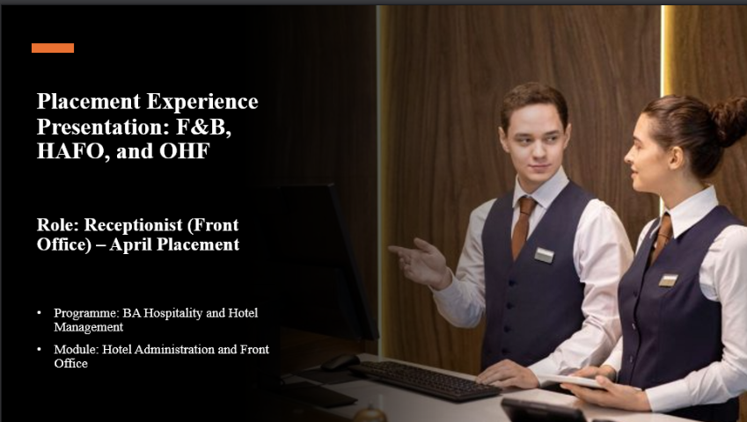

Slide 2
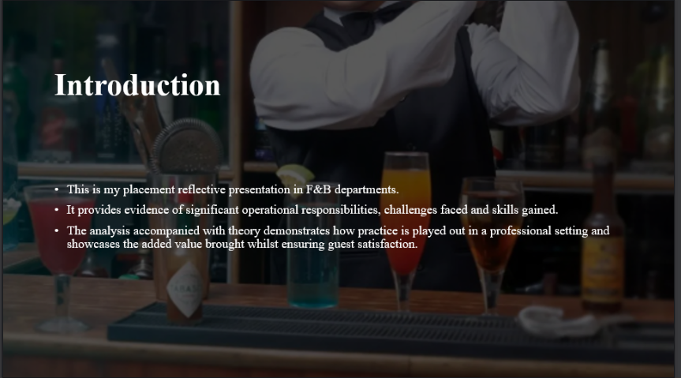

Slide 3
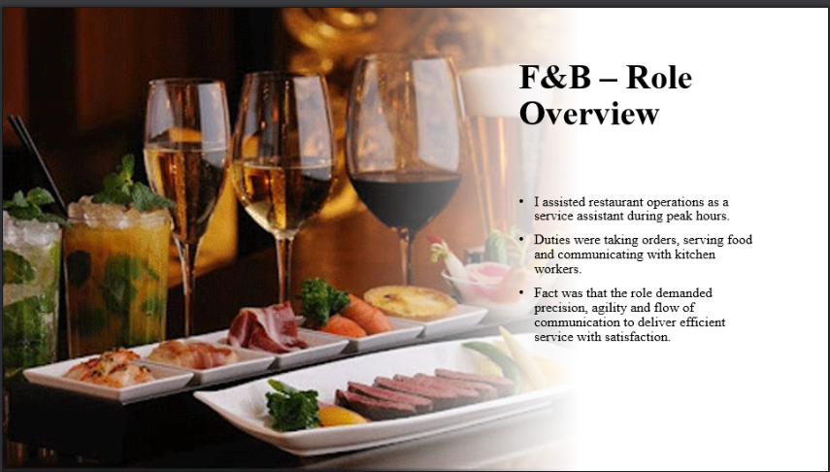

Slide 4
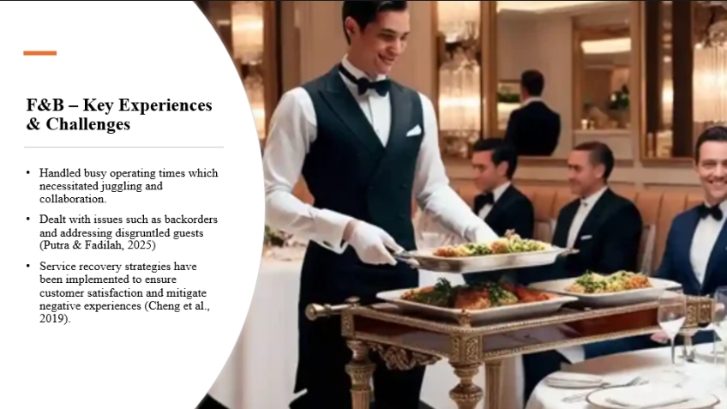

Slide 5
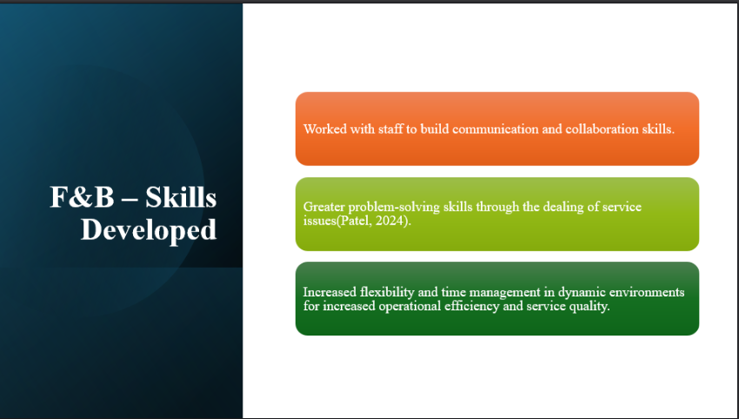

Slide 6
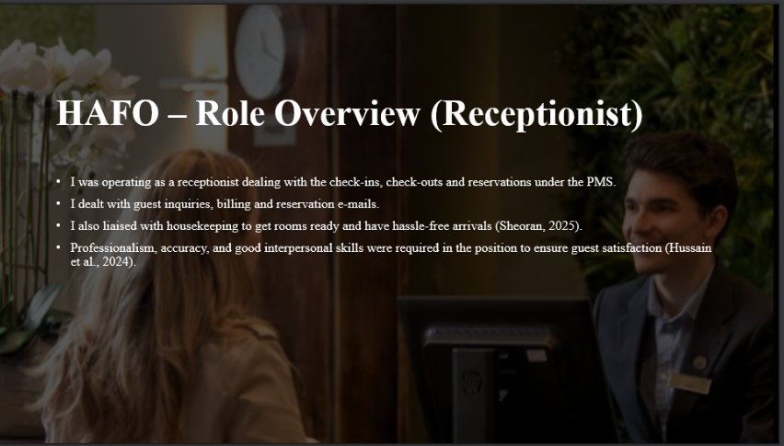

Slide 7
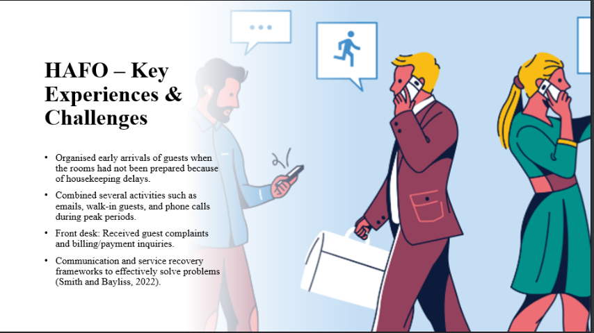

Slide 8
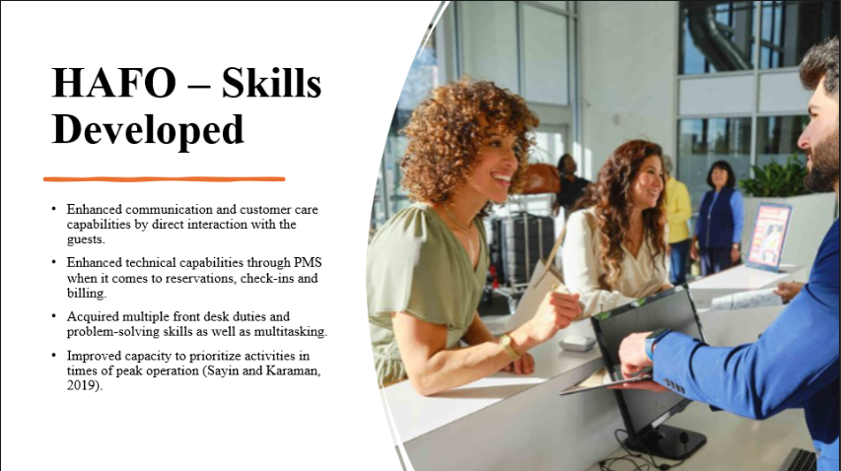

Slide 9
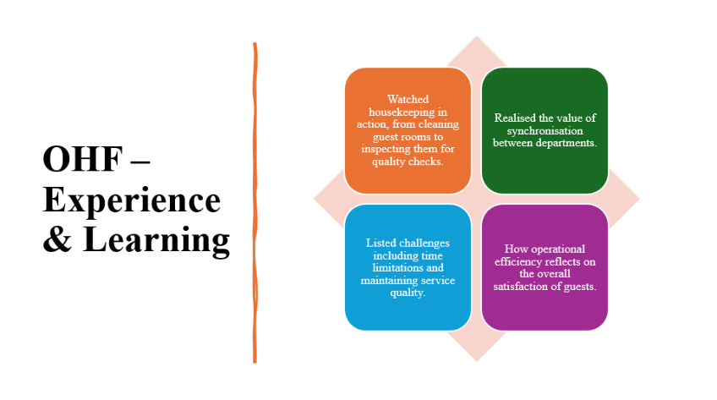

Slide 10
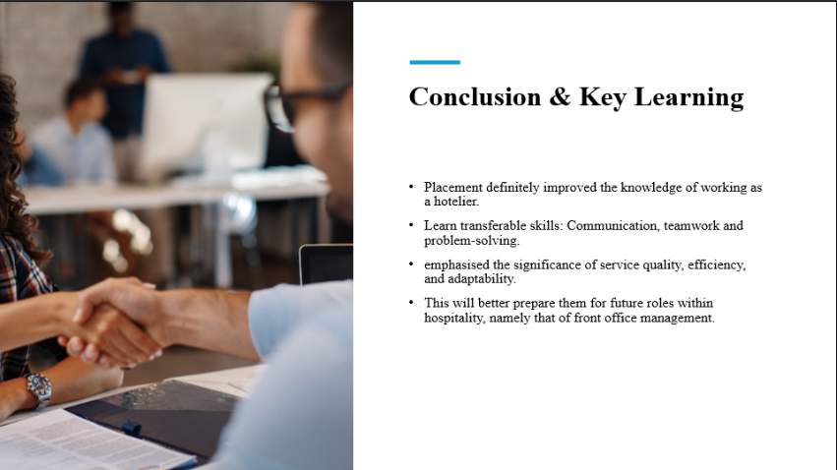

Slide 11


