An Exploration into the socio- cultural impacts of a local community sports event – a case study of the Nos Galan Road Race.

Chapter 1.

Introduction

This research has been designed to provide an insight into small community events and what are the socio – cultural impacts that occur. The dissertation research will hopefully uncover a better understanding of the community’s perceptions towards community events and what socio-cultural benefits can be obtained from the event itself.

Rationale

Community – based events are an important aspect of everyday life that help encourage people to play a more active part in society (Gov, 2017). Characteristically, they originate within the community in response to a need or desire to celebrate their unique identity (Douglas et al., 2001). They are defined as “themed public occasions designed to occur for a limited duration that celebrate valued aspects of a community`s way of life” (Douglas et al., 2001). All events have direct social and cultural impact on their participants and sometimes on their wider host community as outlined by Hall (1989) and Getz (1997) (Bowdin et al.,2006). Community events are usually small in scale and attendance and represent the point “where community and its outward manifestations of image and identity collide” (Derrett, 2000).

Among event organisers there is a growing recognition of the need to measure social impacts of the event as host community dissatisfaction threatens their long- term success. It has been suggested by Small (2005) that as result of the unique interaction between visitors, and a destination area and its population that socio-cultural impacts occur. This research of study will look deeply into the social-impacts that occur at a small community event. Measuring and monitoring the perceptions and expectations of both the community, participants and the spectators who engaged with the event. Examining whether the event contributes to the well-being of a community. The primary goal of this research is to meet its aims and objectives, which are tied to this field of study.

Aims and Objectives

The aim of this study is to identify whether the Nos Galan Road Race has socio-cultural benefits for its participants and spectators.
There are three objectives to this field of study:
- To examine whether the event can contribute to the well- being of the community
- To analyse the capacity of the event for building skills and community networks
- To determine if there are distinct subgroups in the community whose feelings differ towards the event.

Background and literature review

Nos Galan Road Race is a community-based event which has been organised for the past 60 years to celebrate the life achievements of the Welsh runner Guto Nyth Brân whose statue stands within the town centre (Nos Galan, 2018). Nos Galan Road Race was founded in 1958 by local runner Bernard Baldwin. The 5km track that the event is based on runs around Mountain Ash town centre (Nos Galan, 2018). Attracting 1,700 participants from all over Britain, the event also attracted 10,000 spectators last year creating a huge impact on this small community (Nos Galan, 2018).
The event is organised by Mountain Ash Committee and supported by Rhondda Cynon Taff (RCT) Welsh Athletics, Trivallis, and Amgen Cymru (Nos Galan, 2018). With a population of around 7.374 residing within the Mountain Ash, this event has a major impact on the community and the surrounding areas (Census, 2011). (RCT) is predominately a day visitor destination the ongoing challenge is to encourage a tourism environment to achieve the vision set for 2020 (Welsh Gov, 2015).
As Mountain Ash is an economically deprived area (RCT) aim is to develop the historical side of the event to further enhance reputation (RCT, 2015). Building a positive external reputation to develop Rhondda Cynon Taff as a collaboration of quality visitors experience (Welsh Gov, 2015) Raising the profile and credibility of (RCT) on the UK tourism map. Also developing an effective partnership working within the tourism industry (Welsh Gov, 2015). Promoting through traditional and particularly modern methods as part of wider Lower Cynon interest (RCT,2015). With a strategy to enhance the well-being of the community within this area (RCT) aim to work closely with the event to improve local facilities and help bind a community. The purpose of this chapter is to conduct a review of available literature concerning the benefits of small community events.

2 Research design

2.1 Methodology

Saunders has defined research as something that people undertake to find out things in a systematic way, thereby increasing their knowledge (Saunders, et al., 2007). “Systematic “suggests that research is based on logical relationships and not just beliefs (Ghauri and Grønhaug, 2005). Research will involve an explanation of the methods that will be used to collect the data, and why the results are meaningful, and will explain all the limits that are associated to them.
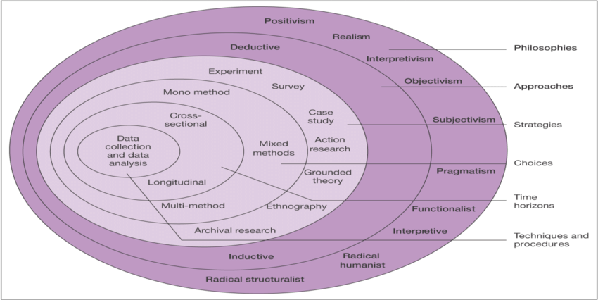
Figure 1: Research Onion by Saunders (2007: p 102).
The research onion contains important differences which will influence the way research is undertaken. This will provide an effective progression through which the research methodology can be designed, proposed by Saunders (2007). Using the research onion quantitative and qualitative data will be conducted. This mixed methods approach will provide collection of large samples which is linked to positivism which approaches the study of society, and small sample which is linked to phenomenological observing how human beings experience a certain phenomenon which creates triangulation (Saunders et al., 2007).

3.0 Primary Research

3.1 Questionnaires

Quantitative research will have a deductive approach which is linked to positivism that leads to the gathering of facts that provide the basis for subsequent hypothesis testing. Testing in whole or part, leading to the development of theory which will then be tested by further research (Saunders et al., 2007).
A survey using large samples will be conducted for the research. Each respondent will be asked the same questions to complete the statistical analysis when collecting data. Advantage of collecting the data is to keep the questionnaire uncomplicated so it is not time consuming this will have a more efficient effect on the analysis. Disadvantages of collecting data is the accuracy of what the respondents say this depends on their honesty and fundamentally on the format of the questions included in the questionnaire (Veal, 2006). Contents of the questionnaire will consist of open questions, but mostly closed questions as this will save time when collecting data.
This method provides an efficient way of collecting responses from a large sample prior to quantitative analysis. According to Bell (2005) it is far harder to produce a good questionnaire the researcher needs to ensure that it will collect the precise data that is required to answer the question and achieve the objectives. The design of the questionnaire will affect the response rate and the reliability and validity of the data collected (Saunders, et al., 2007). Piloting a small sample premilitary study will help to evaluate feasibility, time and cost correcting any issues before the major study.

3.2 Sampling

Random sampling will be conducted on every third person for the purpose of the questionnaire. The sample must be large enough to ensure that if some of the very old or young (extreme) members of the population are chosen to be in the sample, they do not affect any results from the sample more than they should (Collis & Hussey, 2003). The large the sample chosen, will give greater affect and will represent the population better as a whole.
A sample from the population which has been chosen to be random and is large enough should turn out to be completely unbiased (Collis & Hussey, 2003). An unbiased sample will give the views of each section of the population in a balanced way and should be made up of different members from each section of the population. Data collected will be converted into SPSS this computer data will transform the data information into number values. Unless the variables are measured research will not be able to test the hypothesis (Turk et al, 2011)
(Look at Appendix 1 sample questionnaire)

3.3 Interviews
Qualitative research will be conducted with “singular interviews” collecting rich data this will give an inductive approach which is linked to phenomenology using smaller samples. This approach will aim to build theory to add to the body of that knowledge within the area gaining an understanding of human attachment to the event. People who will be interviewed will consist of RCT, Committee Members of the Nos Galan Road Race and the Events Management Team. There will be a total of 5 interviews conducted each timing will consist of 20 minutes. The interviews will be audio-recorded and subsequently transcribed.
One of the disadvantages of using this research method will mean transcribing interviews will be time consuming and are not always cost effective. Advantages is that this method will give a more accurate screening as the individual cannot provide false information when asked demographic questions (Defranzo S, 2014). This data collecting will give a greater understanding on how organisers feel that it contributes to the well-being of a community and how social benefits are enhanced from the event itself.

3.4 Sampling

Purposive sampling will be used as a framework for collecting data. Purposeful sampling is the most common sampling strategy for the collection of small samples. This data analysis will help to select cases to answer the research questions and to meet the objectives. This format will help with the collection of data when collecting cases that are particularly informative. Concern about reliability in these types of interviews related to bias where there could be a threat of employment (Saunders et al., 2007). When conducting interviews, care should be taken when analysing data (Saunders et al., 2007). A matrix table will be used to display data in a more user-friendly manner (Look at Appendix 2 Matrix Table).

4.0 Secondary Data

All secondary data will be collected from academic journals and books that relate to the research itself. This will be gathered from a wide range of sources identified by the literature review. There is a paucity of academic theory, relating to small community events, suggesting there is a gap in the academic understanding of what social benefits occur.

5.0 Identifying risks

5.1 Ethics Form

Ethics of research design will be considered when collecting data. Consent needs to be given by all participants as not to lead to legal proceedings being under taken. Research ethics have important implications for the negotiation of access to people and organisations when collecting data (Saunders et al., 2007). Research design will need to be considered when collecting data to make participants aware that they are the subject of research (Saunders et al., 2007)

5.2 Reliability

Robson (2002) asserts that there may be four threats to reliability. The first of these is subject or participant error. This could result in the questionnaire having a different result if generated at different days of the week (Saunders et al., 2007). The research in this area will be carried out towards a more `neutral` timing. Similarly, there may be interview bias participants might say what they think their organisation want them to say and have false accuracy towards this field of study (Saunders et al., 2007). Observational error can occur if there are more than one interviewer as there are different ways of asking questions to elicit answers (Saunders et al., 2007). Finally, there may have been observer bias as there are different ways in interpreting answers.

5.3 Validity

Validity is generated from a piece of research Measurement validity applies to quantitative research essentially it is to do with the question of whether a measure reflects the right concept that it is supposed to be denoting (Brynman & Bell, 2003).

6.0 Conclusion

Research will be carried out in a systematic way using a mixed methods approach this will give the research a triangular field of study. Quantitative research that has already been completed in this field of study will be updated to the new data that will be provided from this research method. Qualitative data will provide new information in this field of study updating analysis content. New information may contribute to generating new ideas to enhance the well-being of a community. (Look at Appendix 3 Gantt Chart).

7.0 Appendices

7.1 Appendix 1

Nos Galan Road Race

Question Title

1. Do you give consent for the data to be published
Yes
No

2. DO you live within the community?
Yes
No

3. How old are you?
18-24
25-34
35-44
45-54
55-64
65+

4. Are you a spectator or participant?
Yes
No

5. What are your thoughts about community events?
Exceeded expectations
Met expectations
Below expectations

6. Do you feel the event contributes to the well-being of the community?
Yes
No

7. Do you think that the event enhances community development?
Yes
No
OK

8. Do you think the event creates a sense of pride within the community?
Yes
No

9. How likely are you to recommend the event to a friend?
Extremely likely
Very likely
Somewhat likely
Not so likely
Not at all likely

10. Do you think there are too many neighborhood events, too few neighborhood events, or the right amount of neighborhood events?
Far too many
Too many
The right amount
Too few
Far too few

7.2 Appendix 2 Matrix Table

Ask relevant Questions for the purpose of the data collection | Questions | Answer  Describe what answers the interviewees have said for the data collection | ACTION  Describe what you did, how you did it, and tools you used | RESULT  Explain the outcome of your actions, and quantify the results
QUESTION 1 | What relationships do you build with the community when constructing the event?
QUESTION 2 | What are some of the ways you measure event success?
QUESTION 3 | How do you measure social and cultural impacts?
QUESTION 4 | How does the event enhance community development?
QUESTION 5 | Do you feel the events brings well- being to the community?
QUESTION 6 | How does the event build skills and enhance community networks?

7.3 Appendix 3 Gantt Chart

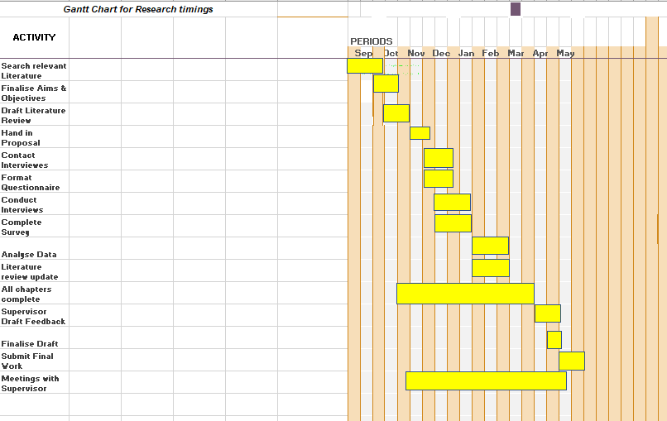

8.0 References

Bowdin, G. &. A. J., (2006). . The inpacts of events. In: G. &. A. J. Bowdin, ed. Events Management. . Great Britain.: John Wiley & Sons. , p. 37.
Bryman, A. &. B. E., (2003). . Business Research Methods.. 1st (Ed). ed. Oxford. : Oxford University Press. .
Collis, J. &. H. R., (2003). . Business Research: A pratical guide for undergraduate and postgraduate Student. 2nd(Ed) ed. Basingstoke: Palgrave Macmillian .
Defranzo, S., (2014). . Face to Face Data Collection.. [Online]
Available at: http://www.snapsurveys.com
[Accessed Tuesday 6th November (2018). ].
Derret, R., (2000). . Can festivals brand community cultural development and cultural tourism simultaneously?. In: J. Allen, ed. Events Beyond 2000: Setting the Adenga, Proceedings of Conference on Event Evaluation, Research and Education . Australian : Australian Centre for Event Management, pp. 120-129.
Douglas, N. &. D. R., 2001. Special Interest tourism: context and cases.. (Eds) ed. Austraila : John Wiley and Sons.
Getz, D., (2005).. Event Management & Event Tourism.. 2nd (Ed) ed. New York: Cognizant Communtication Corporation.
Getz, D., (2007).. Events Studies: Theory, research and policy planning for plannned events.. 1st (Ed) ed. Burlington: Elsevier Ltd.
Ghauri, P. &. G. K., (2005).. Research Methods in Business Studies: A Practical Guide.. 3rd (Ed) ed. Harlow: Financial Times Prentice Hall .
Government, W., (2017).. Wales Destination Management. [Online]
Available at: https://businessgov.wales/dmwales/wales-destination
[Accessed Tuesday 6th November 2018].
Office., C., (2011). . UK Census Data , Mountain Ash. : UK, Government. .
Rhondda, C. T., (2018). . Nos Galan Road Race. [Online]
Available at: https://www.rctcb.gov.uk/en/events/NosGalan
[Accessed Thursday 8th November (2018). ].
Saunders, M. &. L. P., (2007).. Understanding Your Research Philosophy . In: M. &. L. P. Saunders, ed. Research Methods for Business Students. . Harlow: Pearson Education Limited, p. 105.
Saunders, M. &. L. P., (2007). The credibility of research findings . In: (Eds), ed. Research Methods for Business Students.. Harlow: Pearson Education Limited , pp. 140-153
Small, K. E. D. &. S. L., (2005). . A Flexible Framework For Evaluating The Socio-Cultural Impacts Of A (Small) Festival.. International Journal Of Event Management Research. , 1(1), pp. 66-74.
Taff., R. C., (2015). . The Lower Cynon Destination. [Online]
Available at: https://www.rctcbe.gov.uk
[Accessed Thursday 8th November (2018). ].
Turk., E. U. M. H. W. &. V. J., (2011). . Measurement of Variables. . In: E. U. M. H. W. &. V. J. Turk., ed. Research Methods for Leisure, Recreation and Tourism. . Oxfordshire. : Cab International , p. 56.
Turk, E. &. U. M., (2011). . Research Methods for Leisure, Recreation and Tourism.. 1st (Ed) ed. Wallingford: Cab International.
Veal, A., (2006). . Questionnaire Surveys. . In: (Eds)., ed. Research Methods For Leisure And Tourism; A Practical Guide. . Harlow: Pearson Education Limited , pp. 231-232.
Yeoman, I., (2013). . A futurist`s thoughts on consumer trends shaping future festivals and events.. International Journal of Event and Festival Management. , 4(3), pp. 249- 260 .

