
PROJECT MANAGEMENT PLAN
Little Explorers Childcare

student: mariana GRIGORITA (2014974)
lecturer: sujeewa herath
Module: BMSW5104

Table of Contents
Introduction 2
Project management approaches 2
Scope 3
Project deliverables 3
Stakeholder analysis 4
Allocation of resources 7
Work breakdown structure and Gantt Chart 8
The project life cycle 8
Project success criteria 11
Constraints 12
Conclusion 13
References 14

Introduction
The report is based on the structure of the project management plan in view of the childcare in the nursery and the opportunity the entrepreneurial business will provide. The structure will also involve the factors of the approach of project management. It will also discuss the role of the stakeholders in the organisation and the responsibilities they hold in the nursery units of childcare. The report will also involve the planning process and the scope that the organisation offers in the growth of the organisation. The planning will require an understanding of resource adaptability and the work breakdown structure with a Gantt chart provided in the planning of the project including the approach in the development of the WBS method. It will also comprise the success of the project with the deliverables of the projects and the constraints of the project in the project management plan. The structure will also comprise the project life cycle process and the communication network through chain management of communication.

Project management approaches
The project management plan in nursery care settings is enacted through conducting the procedures and setting objectives for the accomplishment of the entrepreneurial business. The project comprises the involvement of the team who help in the success of the project by developing a plan for the benefits of the childcare services provided in the nursery (Hjärpe, 2022). After the thorough enduring process of the development of the plan, the entrepreneur of the nursery organisation executes the process of the plan with proper reinforcement of the plan and the process. As an entrepreneurial business, the entrepreneur must necessitate initiating a plan to execute the enhancement of the childcare nursery with proper modes of interacting with children and educating them in the basic knowledge of ethics and skills. The motive of the organisation is to support and motivate the staff who take proper care of the children and emphasise the nurturing ways of the children.

Scope
The wide scope of the management plan is to set boundaries as it will offer precise details in the childcare nursery for the children (Gitz-Johansen, 2020). The organisation will develop an understanding of the appropriate behaviour of the children and the caregivers in the entrepreneurial organisation which will serve as an opportunity for the organisation (O'Malley et al., 2021). The mandating rules and ethics which are practised in the childcare nursery will let in the success of the organisation. For the execution of the project management plan, the organisation will endeavour a great deal in maintaining the protocols of childcare and offering proper benefits to the children.
The aim of the enhancement of the childcare nursery will enable in achieving the goals to ensure the parents are being offered a great source of childcare environment. This will work in benefit for the organisation as it will deliver in the enhanced scope of the organisation. Another scope for the active childcare nursery is to offer emotional, mental, physical and social support and needs to the children as they will be able to share their feelings and thoughts regarding their problems in the environment. Children are unable to share thoughts but through an appropriate environment, they will be able to cope with the nursery. The on-time success of the project which is undertaken by the entrepreneur will offer the fast execution of the plan which is a wider scope for the organisation (Pace, 2019). The resources utilised in the whole process of the project management plan will involve cost-effective methods which will result in lower economic expenses in the organisation initiated by the entrepreneur and the stakeholders.

Project deliverables
The approach of project deliverables focuses on the outputs that are intangible and tangible in nature and are utilised in the project's management scope. The project deliverables are required to execute in planning the phase to frame expectations and offer resources and the completion of the project. In the childcare nursery, the project deliverables are linked with the team members for the methods of collaborating in the project. It involves the necessities of designing the structure of the plan, time consumed in finalising the report, setting of budgets for the report and the update and the progress on the report of the project management plan. The process delivery of the project is estimated on two variables which consist of product and process deliverables (Mbiru et al., 2020). The strategy input of the project enables the findings and the analysis of the report. The framing of the budget report assists in analysing the budget plan for allocating the cost factors on resources and infrastructure process in the childcare nursery. The results of the report findings in the success of the project offer the successful accomplishment of the project.
In the process of delivery of the report bug report united to develop the functioning of the software deliverables. A Gantt chart is exercised to entail the details of the flow of the project. The delivery of the project onboarding checklist is necessitated for the enhancement of the project (Sagar et al., 2022). In the project management plan, a design for the management of the project is maintained for the customers and the stakeholders to review the plan. The strategies which are implemented in the procedure serve in the best delivery of the project through thorough research on childcare necessities. With this plan, the necessity of a communication plan is also enacted, and the performance report is based on the nursery implementation plan for the entrepreneur.

Stakeholder analysis
The stakeholders play a significant role in the maintenance of the project management plan and then overview the plan and work in managing those plans. The entrepreneur's ways of engaging with the stakeholders of the organisation will offer great benefits to the successful completion of the project planning in the childcare nursery. The stakeholders of the organisation indulge in the process of making and analysing decisions and influence the actions and activities of the organisation so that it will meet the criteria of the plan of the project management. The significant role of the stakeholders in the childcare settings will offer requirements and limitations depending on the necessary information based on the depths of the organisation (Lloyd et al., 2019). This enables the management team of the organisation to analyse the risks that come along with the project viewing positive and negative approaches and the limitations. The entrepreneurs engage the stakeholders in the organisations to reduce the potential risks of the project.
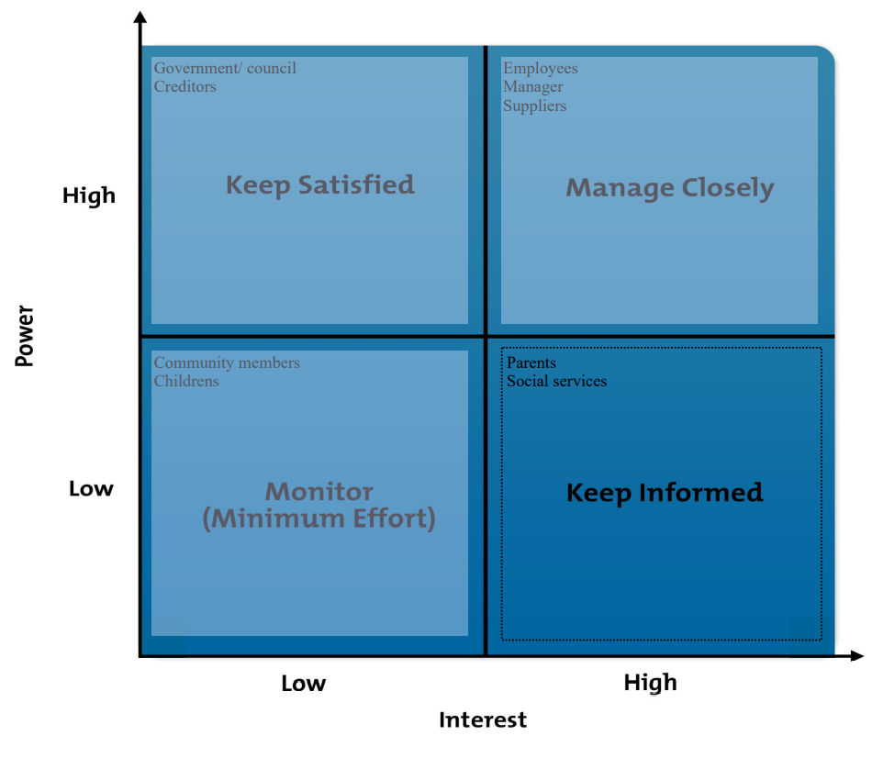
Table 1: Power/ Interest Grid
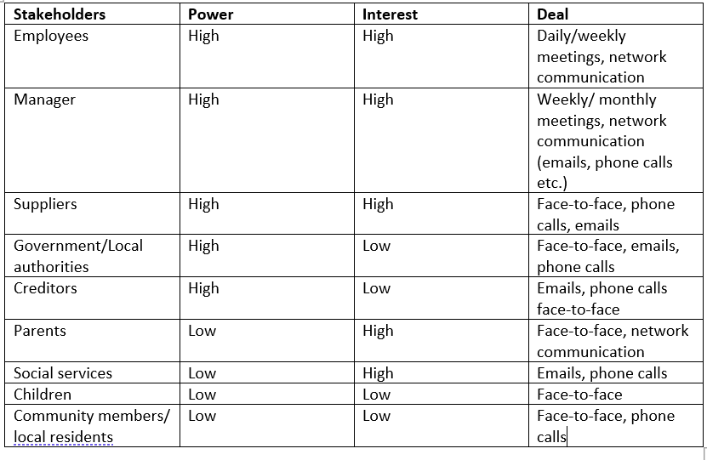
Table 2: Stakeholders analysis
The crucial stakeholders in the entrepreneurial organisation are the significant role of the parents, the children, and caregivers, members of the board of directors, organisational administrators, teachers and the providers of social service. They assure that the children get the accessible services of the success of childcare in the nursery. For the entrepreneurial organisation of the childcare nursery, collaboration plays a crucial role as it helps the entrepreneurs to project in the analysis of the team so that the team takes significant decisions and assists approval in the childcare nursery (Chen and Bradbury, 2020). This assists in putting much emphasis to obtain support for the objectives of the project and assure adjustment to the strategies of the childcare nursery. The regulatory bodies of the nation also act as a part of stakeholders in the entrepreneurial organisation of childcare and various NGO organisations also emphasise their role in the success of the organisation.

Allocation of resources
The resources used in the project management plan enables relevant findings of acute and proper information in the organisation depending on the function of childcare nursery. In framing the infrastructure of the organisation certain necessary resources are required which will develop the structure of the organisation. The resources are categorised into various segments which consist of security in the organisation (Sandstrom et al., 2018). The enabling modes of security will let the caregivers know the privacy methods of the children in the nursery. The learning resources of the children are also a major part as it indulges the children to play and use their time in the process. These factors will let the parents trust the entrepreneurial organisation to send their children to the childcare nursery. The project management plan initiates proper planning for the initial phase of the products and services. They plan and organise suppliers based on the requirements which are required for the children and the nursery for import of the products in the organisation.
The next step consists of thorough research of the product as it is significant for the staff of the business to assure that the products meet the criteria and the requirements of the children. The maintenance of communication and other technologies regarding the safety of the children is also ensured in the whole process of the management plan. The other step of the plan is to check the quality regarding the durability of the resource. The staff members of the nursery ensure that the resources are safe and offer proper accreditation and that the resources are recycled to motivate the childcare towards recycling. The other stakeholders also work in analysing the terms and conditions and work in checking the value of the resource and delivery of the product (Anantatmula and Rad, 2018). The entrepreneurial organisation must ensure that the organisation maintains the inventory process and must analyse the usage of wasteful resources and observe the use of those resources. The last process comprises the purchasing power which assists the staff to overlook the suppliers to assure that the value proposition is maintained, and the resources are cost-effective.

Work breakdown structure and Gantt Chart

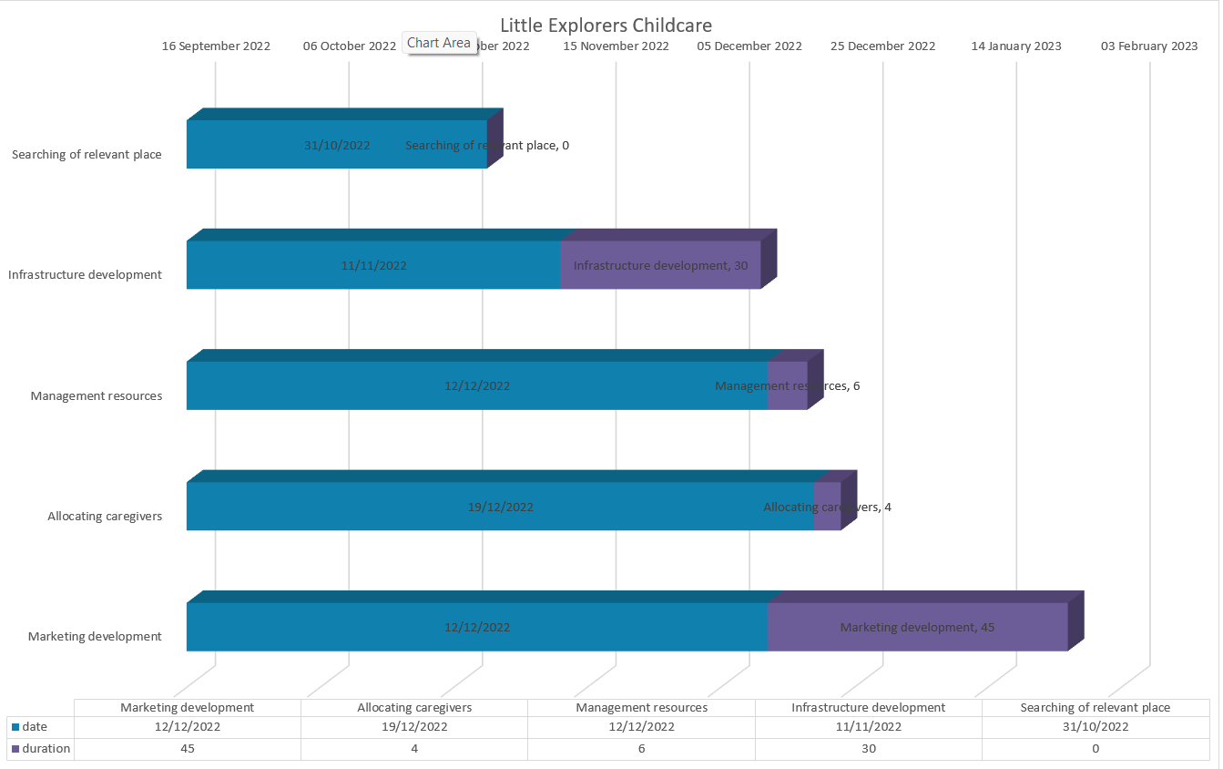
Table 3: Gantt Chart

The project life cycle
The cycle of the project discusses the steps in which the project is being implemented and developed. This cycle is significant in mandating the project as it offers guidance on the planning and proper execution of the project plan through proper care in the plan. The steps are illustrated below and the importance of each step in the process of the childcare nursery project.

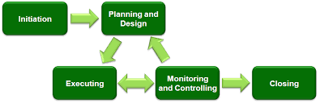
Figure 1: The project life cycle

Defining
In the project planning process, the planning by the management ensures the defining of the project plan based on the childcare nursery. The entrepreneurial business initiates the goals of financial growth, stability in their customer region and development of childcare and the children by gaining the trust of the parents. The specifications of the business comprise the process of how childcare nurseries can develop the future and safety of the children. This will be achieved through understanding the requirements of the resources, communicating with the stakeholders and maintaining time durability in the process. The responsibilities of the business must be undertaken by the stakeholders and other authorities who are managing the business.
Planning
While analysing the project plan, the management must ensure the schedules which are to be maintained at the time of initiating the business. For instance, they should plan on the set-up, time duration of the setup, and target the audience which will be done on a scheduled basis. The budget plan of the project is emphasised by the role of the stakeholders as they necessitate the financial plan in the business. The resources required while initiating the business of the childcare nursery organisation are discussed in the planning process. In this process, the management also plans the risks which might come along in the process and implements the criteria of caregivers in the business plan.
Executing
After the initiation of the project plan regarding the childcare nursery the business is still in its initial phase as they are attracting its target audience and relocating resources which are required for the children. With this, the business also understood and necessitated certain changes in the policies and methods of the business for the growth of the organisation. The quality of the childcare nursery is being enriched after the commencing face which creates a great impact on the organisation (Haass and Azizi, 2020). The project plan emphasises some predictions in the business which might be utilised in the business in the future.
Delivering
After the competition of setting goals, planning the process, and executing the process the project management plan consists of delivering the best output to the caregivers, parents and children. In this process, the management appoints caregivers and trains them to emphasise great behaviour and role. The transferring reports and documents regarding the plan are delivered to the stakeholders so that they can invest in the business. Collecting and delivering resources is a crucial attribute in this process.
Communication network
The network of communication emphasises the flow and the structure of the level of communication and the knowledge which is shared among the individuals presented in the planning and execution process. The entrepreneurial business maintains the chain process of communication flow with the authorities and the customers (Foote et al., 2019). In the process, the communication is served through the role of stakeholders, the managing authorities, the suppliers of the resources and the target audience.

Project success criteria
The success of the project depends on the efficiency of the time and durability of the project. There are three criteria for the success of the project which comprises scope, cost methods and time. Through effective reach on time and within budget, the project will successfully accomplish the childcare nursery in a short amount of time. The success and the framing of the cost pattern of the entrepreneurial business will be dependent on the funding of the stakeholders offered to analyse the cost factors. The durability of the time factor is also a criterion for the success of the project as it will lead to the delivery of the project in the right amount of time (Bilir, 2022). The scope of the project management plan offers a great notion of the ways to implement the process for accomplishment. This will let in the growth of the organisation and will let the parents accommodate the idea of the nursery.
The offerings on the safety of the children will have the overall trust of the parents in the nursery. The strategies initiated in the project management plan will necessitate the success of the project as it will frame the idea of the organisational structure providing an opportunity for the organisation to grow. The maintenance and the use of resources are other significant motives for the success of the childcare nursery (Kothuru Chinnadurai, 2020). The use of resources enables the children to get adapted to the resources which will keep them engaged in the process. The goals of the execution process of the management plan must be ensured so that the childcare nursery reaches its heights (Burghate, 2018). Another significant criterion for the success of the nursery will be to satisfy and motivate the stakeholders so that they can engage in the thorough process of the project and their support and assistance will lead to the growth of the organisation. The escalating procedure of the project management plan will offer a great deal in the structure of the childcare nursery.

Constraints
There are several constraints in the project which serve as limitations in the project which the organisation necessitates during the process of the project cycle. In view of this, the factor of cost methods is constrained to fix and analyse the budget plan for the project. The constraint is based on the timeline and the duration for the completion of the project. Analysing the scope which is based on the project before it initiates to establish the outcomes of the report. This is performed by the managers who plan the management which observes the factors based on external and internal factors. The limitation based on the quality aims at the elements of the deliverables of the services and the resources necessitated in the process of childcare nursery.

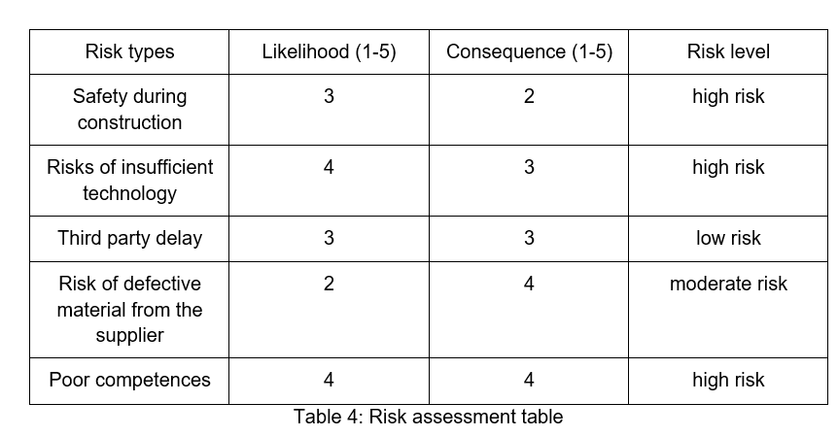

Conclusion

The project management plan has discussed the approaches which are necessitated in the plan for the entrepreneurial business to see growth in the business structure. It has discussed a thorough analysis of the approach and the ways to implement the process in the adaptability of the project planning. A structure of work down through the Gantt chart has been provided with the success criteria of the project and comprising the approaches to develop WBS. In conclusion, the report has also included the limitation in the management plan of the project and the project deliverables in the project. The planning has also included planning on the process of the project life cycle and communication networks.

References
Anantatmula, V.S. and Rad, P.F., 2018. Role of organizational project management maturity factors on project success. Engineering Management Journal, 30(3), pp.165-178.
Bilir, C., 2022. Project success criteria, critical success factors (CSF), and agile projects. Contemporary challenges for Agile project management, pp.52-72.
Burghate, M., 2018. Work breakdown structure: Simplifying project management. International Journal of Commerce and Management, 3(2), pp.453-461.
Chen, H. and Bradbury, A., 2020. Parental choice of childcare in England: Choosing in phases and the split market. British Educational Research Journal, 46(2), pp.281-300.
Damij, N. and Damij, T., 2021. An Approach to Optimising Kanban Board Workflow and Shortening the Project Management Plan. IEEE Transactions on Engineering Management.
Daradkah, M., Al Jounidy, E. and Qusef, A., 2018, June. Top-down vs. bottom-up in project management: A practical model. In Proceedings of the Fourth International Conference on Engineering & MIS 2018 (pp. 1-5).
Foote, J., Shaw, A. and Hill, B.M., 2019. Communication networks do not explain the growth or survival of early-stage peer production projects.
Gitz-Johansen, T., 2020. Childcare in uncaring times: emotional processes in a nursery and their political context. Journal of Psychosocial Studies, 13(3), pp.263-276.
Haass, O. and Azizi, N., 2020. Challenges and solutions across project life cycle: A knowledge sharing perspective. International Journal of Project Organisation and Management, 12(4), pp.346-379.
Hjärpe, T., 2022. Measurable time is governable time: Exploring temporality and time governance in childcare social work. Time & Society, p.0961463X211059022.
Kothuru Chinnadurai, B., 2020. Analysing Agile Project Success Criteria from a Practitioner Perspective.
Lloyd, C.M., Kane, M., Seok, D. and Vega, C., 2019. Examining the feasibility of using home visiting models to support home-based childcare providers. Child Trends.
Mbiru, J., Wickham, M.D. and Ayentimi, D.T., 2020. Introducing an entrepreneurial project management model. The Journal of Modern Project Management, 7(4).
McQuaid, R. and Webb, A., 2018. Developing a strategic action plan for skills among low qualified people in the Early Learning and Childcare sector.
O'Malley, D., Owens, K. and Clark, D., 2021. Cost of the nursery day: financial pressures and barriers in the early learning and childcare setting.
Pace, M., 2019. A correlational study on project management methodology and project success. Journal of Engineering, Project, and Production Management, 9(2), p.56.
Sagar, G., Raghunandan, K. and Babu, R.M., 2022, September. Identification of Constraints in small construction projects. In IOP Conference Series: Materials Science and Engineering (Vol. 1255, No. 1, p. 012011). IOP Publishing.
Sandstrom, H., Coffey, A., Henly, J., Bromer, J., Spalding, A., Thomas, W., Greenberg, E. and Derrick-Mills, T., 2018. Learning from Child Care Providers Across Settings.

