Votive inscriptions
Here you find an overview of religious/votive inscriptions for your essay. These inscriptions should give you an insight into the cults, the nature of the cults and the cultores/dedicants of four different cities in Roman Gaul: Glanum, Nîmes, Vienne and Lyon. It is obviously important that you acquire a certain background knowledge on these four cities. These inscriptions should help you to identify inter alia the deities, especially non-Roman deities, the status and identity of the dedicants, and many more. I have not given you all the inscriptions mentioning priesthoods in these cities, like sacerdos, flamen, pontifex, augur, sevir Augustalis, etc. – If you have no access to a good library you can look them up on www.manfredclauss.de (also available in English).
By the time I upload this document, we have not done the relevant lecture yet. You need a certain knowledge of religion in the Roman provinces, the problem of “interpretatio Romana”, etc. – I will upload more resources soon; let me know if you need help.
N.B. I included some photos of inscriptions when available online.
For some general introduction to “Gallo-Roman” cults, cf. some of my papers online:
On recognising “indigenous”, “Celtic” religion, cf. http://www.academia.edu/2291125/How_to_identify_Celtic_religion_s_in_Roman_Britain_and_Gaul (I will also upload a paper on “interpretatio romana/indigena”)
On the importance of “civic” and “non-civic” cults, for example in Nimes, cf. my paper: http://www.academia.edu/1904783/Beyond_polis_religion_and_sacerdotes_publici_in_Southern_Gaul

GLANUM / Glanon / Saint-Rémy-de-Provence
AE 1924, 59
Silvano // Silvanus
CAG-13/2, p. 305 = AE 1955, 00111b = AE 1956, 00162 = AE 1961, 00328
[Val]etudini M(arcus) Agrippa
CAG-13/2, p. 305 = AE 1958, 307b
Valetudini
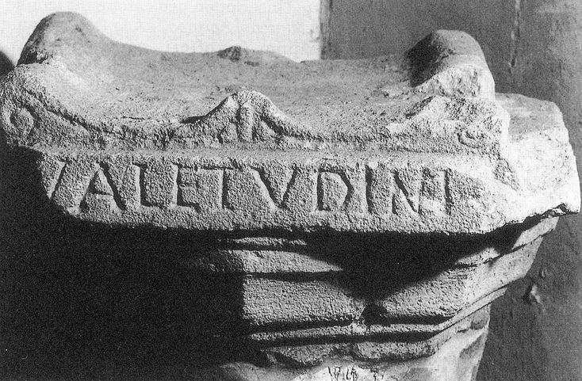
CAG-13-02, p 308 = AE 1954, 00101°
M(arcus) Decumius / Marcellinus / Herculi / v(otum) s(olvit) l(ibens) m(erito)
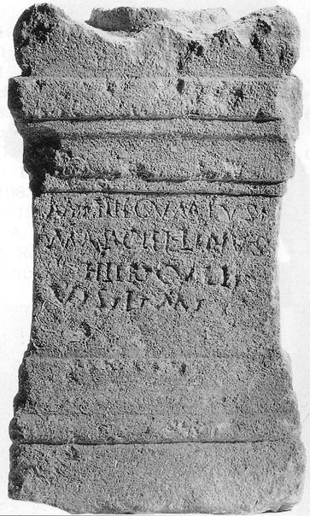
CAG-13-02, p 308 = AE 1954, 101b
M(arcus) Vinicius / Herculi / v(otum) s(olvit)
CAG-13/2, p 308 = AE 1954, 101c
Hercu/li Marcel/linus / v(otum) s(olvit) l(ibens) m(erito).
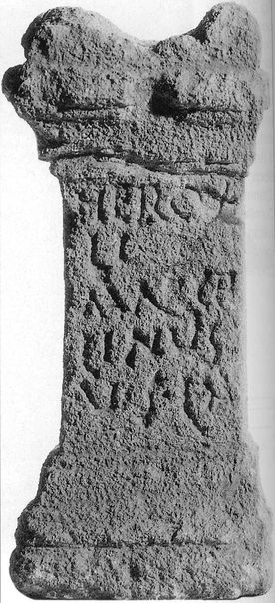
CAG-13/2, p 308 = AE 1954, 101d = AE 1997, 1043
Herculi / L(ucius) C(ornelius) V(alentinus) / et rog(atus) Valer(iani) / ex volunta/ti l(ibentes) m(erito)
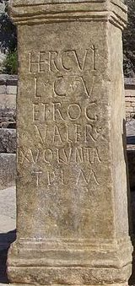
CAG-13/2, p 309
Matto Kass[1]or / [3] v(otum) s(olvit) l(ibens) a(nimo)
CAG-13/2, p. 309 = AE 1954, 00101e
Herculi / f(ecit) AIROG / et Rog() eius / voto
CAG-13-02, p 309 = AE 1954, 00101e = AE 1997, 1044
Herculi / F() A() I() rog(ator) / et rog(atus) eius / voto
CAG-13/2, p 309 = AE 1997, 1045
Hercu/li / L(ucius) Corneli/us Valen/tinus et Co/rnelia Luci/na v(otum) s(olverunt) l(ibentes) m(erito) // Roge nes
CAG-13-02, p 319 = AE 1958, 00307a
Numini Sil/vani Sanct(o) / T(itus) Quadri[nius(?)] / Valerianus / v(otum) s(olvit) l(ibens) m(erito)
CAG-13/2, p 328 = AE 1992, 1186 = AE 1993, 1108
Imp(eratori) Caes(ari) Luc(io) Septimio / Severo Pert<i=E>naci / Aug(usto) / Arabico Adiabenico / Parthico pontifici / maximo / tribuniciae pot(estatis) / imp(eratori) III co(n)s(uli) II / p(atri) p(atriae) / Glanienses
CAG-13/2, p. 342 = AE 1958, 304
Duvia v(otum) / s(olvit) l(ibens) m(erito) PN / suo
CAG-13/2, p. 342 = AE 1958, 305
P]eregri[na] / Iunonibus / v(otum) s(olvit) l(ibens) m(erito)
CAG-13/2, p. 352= AE 1946, 156
Dendro/fori / Glanici
CAG-13/2, p. 354 = AE 1946, 00153 = AE 1949, 139 = AE 1958, 36 = AE 1998, 887
Auribus / Loreia Pia / ministra
CAG-13/2, p. 354 = AE 1946, 154
Attia Musa Dom(i)nae ministra posuit
CAG-13/2, p. 355 = AE 1946, 151
Ex m(onitu) (H)ippo(nae) / L(ucius) C() Viator / (a)ed(ituus) dis omn[i]/bus
CAG-13/2, p. 355 = AE 1946, 152
Sex(tus) Tib(erius) Ver() missici/us aureum / Marti pos[uit] / [i]n ara ad pri[m]/as heius PICLV
CAG-13/2, p 355 = AE 1946, 155
Vinicia Euty/chia Bon(a)e Dea(e)
CAG-13/2, p. 356
Silvan/o
CAG-13/2, p. 356
M(a)tri[s(?)]
CAG-13/2, p. 356 = AE 1946, 157
Opibus / Optata / v(otum) s(olvit) l(ibens) m(erito)
CAG-13/2, p. 356 = AE 1946, 158
Parcis / tr<i=E>bus / sororibus
CAG-13/2, p. 359
Sev(erus?) / v(otum) s(olvit) l(ibens) m(erito)
CAG-13/2, p. 360
[E]pona
CAG-13/2, p. 377 = AE 1937, 143 = AE 1946, 159
Abian/o / Caeci[li]/us Firm/us / v(otum) s(olvit) l(ibens) m(erito)
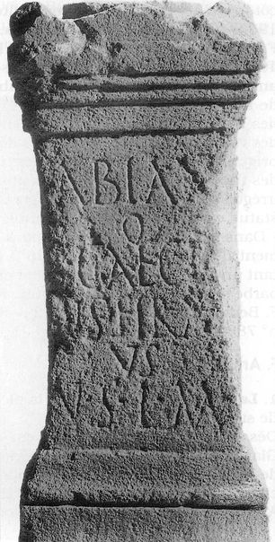
CAG-13/2, p. 394
Silvan/o v(otum) s(olvit) l(ibens) a(nimo) / Q(uintus) Iul(ius) Si[l]/[ic]ia[nus(?)
CAG-13/2, p. 395 = AE 1938, 57
Prima / P(h)ilemae / f(ilia) v(otum) s(olvit) l(ibens) m(erito)
CAG-13/2, p. 396 = AE 1946, 160
Meldio v(otum) s(olvit) / Silanus / Lutevi f(ilius)
CAG-13/2, p. 397
Silv[ano]
CAG-13/2, p. 397
Silvano / [6] / [6] / v(otum) s(olvit) l(ibens) m(erito)
CAG-13/2, p. 397
Silvano
CAG-13/2, p. 397
Silva/no / G(aius!) I() S() / vo(tum) s(olvit)
CAG-13/2, p. 397
Silvan/o v(otum) s(olvit) l(ibens) m(erito) / T(itus) C() S()
CIL XII *333 = CAG-13/2, p. 207 = AE 1946, 159
[T]errae Tellur(a)e / [T]erraeq(ue) Man[3] / [T]erraeq(ue) Fertili/tati aram Con[st]/antius Patrici/[us] v(ir) p(erfectissimus) posuit.
CIL XII 991 = CAG-13/2, p. 265
Apol(l)i/ni
CIL XII 993 = CAG-13/2, p. 397
B(onae) F(ortunae) / voto / Carsia Udia
CIL XII 994 = CAG-13/2, p 397
I(ovi) O(ptimo) M(aximo) / Con/serva[t(ori)] / D(ecimus) A() / Attia/nus
CIL XII 995 = CAG-13/2, p. 256
I(ovi) O(ptimo) M(aximo) / Conservatori / Sext(us) Iul(ius) Luto / voto dicavit
CIL XII 996 = CAG-13/2, p. 393
Iovi O(ptimo) M(aximo) / Iunoni / Minervae / [3] v(otum) s(olvit) l(ibens) m(erito)
CIL XII 997 = CAG-13/2, p. 397
Lunae / Luciferae / Attia An(a)tol(ia?)
CIL XII 998 = CAG-13/2, p. 272
Sex(tus) Valeri[us] / Lutevi f(ilius) Samicu[s] / Minervae v(otum) s(olvit) l(ibens) m(erito)
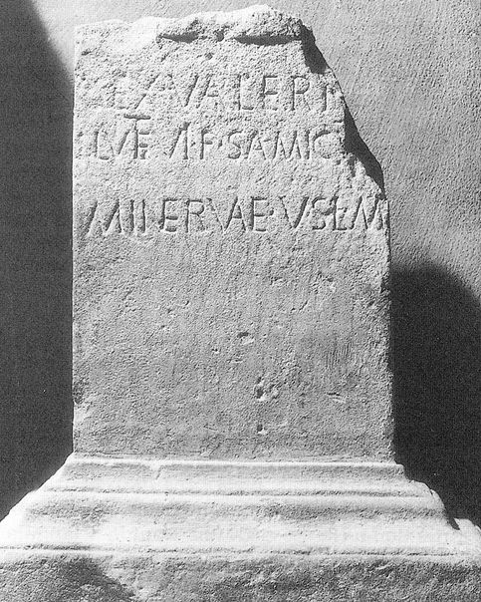
CIL XII 1000
Silvano / A(ulus) A() A() / v(otum) s(olvit) l(ibens) m(erito)
CIL XII 1002 = CAG-13/2, p. 397
Silvano / L(ucius) Vibius Mo/ntanus / v(otum) s(olvit) l(ibens) m(erito) / pro Amerimno / lib(erto)
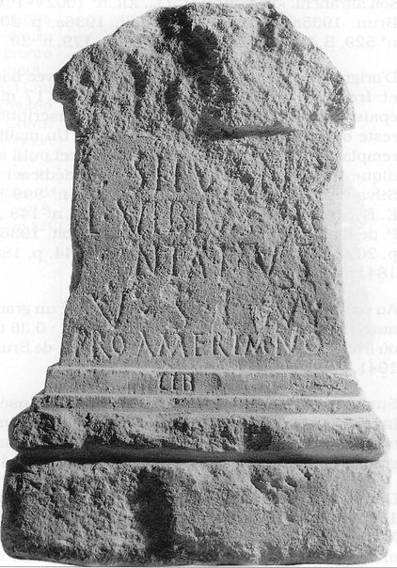
CIL XII 1003 = CAG-13/2, p. 397
Soli / Invicto / D(ecimus) A() Eudaem(on?)
Esperandieu 8686 = CAG-13/2, p. 307 = AE 1954, 102 = AE 1964, 146a = AE 1999, 1022 = AE 2001, 1322
]essi[3]co[1] / [3]es / votum suscept(um) / Herculi Victori pro / salute et reditu G(ai!) Licini / Macri trib(uni) et centurio/num et militum Glanico/rum qui sub vex{s}illo fue/runt Cn(aeus) Pomp(eius) Cornutus / opt(io) / ex stipendi(i)s et hono/rario quod ei d(onum) const(ituerat) / l(ibens) m(erito)
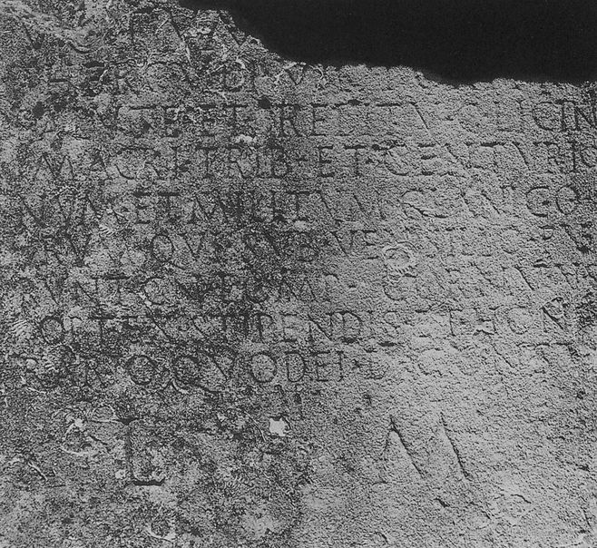
Esperandieu 8687 = CAG-13/2, p 296 = AE 1954, 103
Glani et Glanica/bus et Fortunae / Reduci M(arcus) Licinius / Claud(ia) Verecundu[s] / vet(eranus) leg(ionis) XXI Rapacis / v(otum) s(olvit) l(ibens) m(erito)
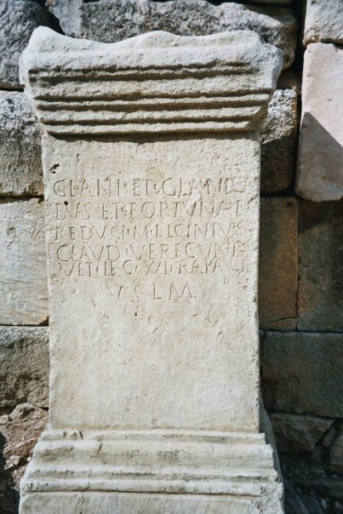
Esperandieu 8727 = CAG-13/2, p. 308 = AE 1954, 101f
Herculi / M(arcus) U() Zmar/agdus v(otum) / s(olvit) l(ibens) m(erito)
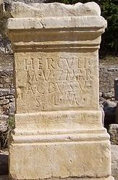
ILGN 145 = CAG-13/2, p. 338 = AE 1925, 35
] / Merc[urio] / v(otum) s(olvit) m(erito) l(ibens)
ILGN 146 = CAG-13/2, p. 338 = AE 1925, 33
Silvan<o=U> / L(ucius) Vale(rius) / Voco
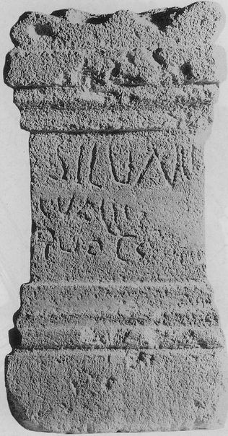
ILGN 147 = CAG-13/2, p 338 = AE 1925, 34
[De]o Silvan[o] / [3]ius Silanus / [ex] voto
ILGN 149 = CAG-13/2, p. 379
V(otum) s(olvit) l(ibens) m(erito) / dibu(s) / de(a)b[u(s?)]
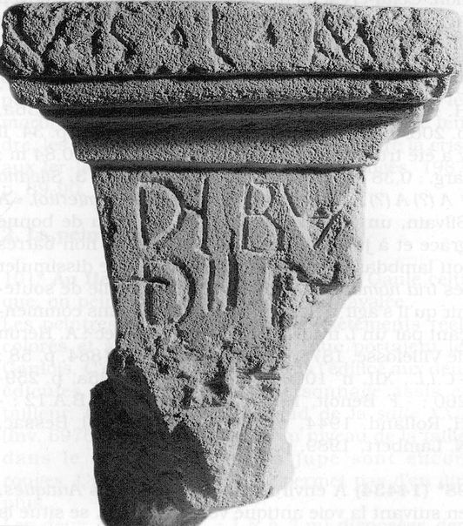

Nimes / Nemausus
AE 1955, 106 = AE 1959, 192
Marti Melov[io] / L(ucius) Senecius / Martialis / L(ucius) Senecius / Maternus / v(otum) s(olverunt) l(ibentes) m(erito)
AE 1990, 686
Numerius / v(otum) s(olvit) l(ibens) m(erito)
AE 1990, 700
Marti suo / Peregrina / v(otum) s(olvit) l(ibens) m(erito)
CIL 12, 3042
L(ucius) Cornelius Adgu/billi f(ilius) Adgubioun(i) / Aesc<u=O>lapio v(otum) s(olvit) l(ibens) m(erito)
CIL 12, 03044
] Cn(aei) f(ilio) Lepo[3] / [Apolli]ni(?) v(otum) s(olvit) l(ibens) m(erito) // ANTEN [
CIL 12, 3045 = ICalvet 11
Fatis votum / s(olvit) l(ibens) m(erito)
CIL 12, 3046
Fatis / T(itus) Pomponius / ex voto
CIL 12, 3059 = SIRIS 729 = RICIS-2, 00605/0102
Isidi / Cinnamus / v(otum) s(olvit) l(ibens) m(erito)
CIL 12, 3060 = SIRIS 00730 = RICIS-02, 00605/0106
Isidi Aug(ustae) Q(uintus) Senius Eupius Primi lib(ertus) v(otum) s(olvit) l(ibens) m(erito)
CIL 12, 3061 (p. 834) = SIRIS 00731 = RICIS-02, 00605/0103
T(itia) Savinis / ornatr(ix) f(ani?) / {H}Isidi v(otum) s(olvit) l(ibens) m(erito)
CIL 12, 3067 = ILS 3121
Iunonib(us) / Montan(is) / Cinnamis / v(otum) s(olvit)
CIL 12, 3068
[Iunoni] / Re[ginae] / Q(uintus) Val[erius] / Dona[tus] / v(otum) s(olvit) l(ibens) m(erito)
CIL 12, 3069 = ILGN 406
] Iovi votum [3] / [3 A]urelius Alban[us
CIL 12, 3070 (p. 834) = ILS 4844
Iovi et Nemaus(o) / T(itus) Flavius Herm(es) / exactor oper(is) / basilicae mar/morari(i) et lapi/dari(i) v(otum) s(olvit).
CIL 12, 3072 = ILGN 406 = ILS 4288
I(ovi) O(ptimo) M(aximo) Heliopolitan(o) / et Nemauso / C(aius) Iulius Tib(eri) fil(ius) Fab(ia) / Tiberinus p(rimi)p(ilaris) domo / Beryto votum solvit
CIL 12, 3073
I() N() P() / Verus / v(otum) s(olvit) l(ibens) m(erito)
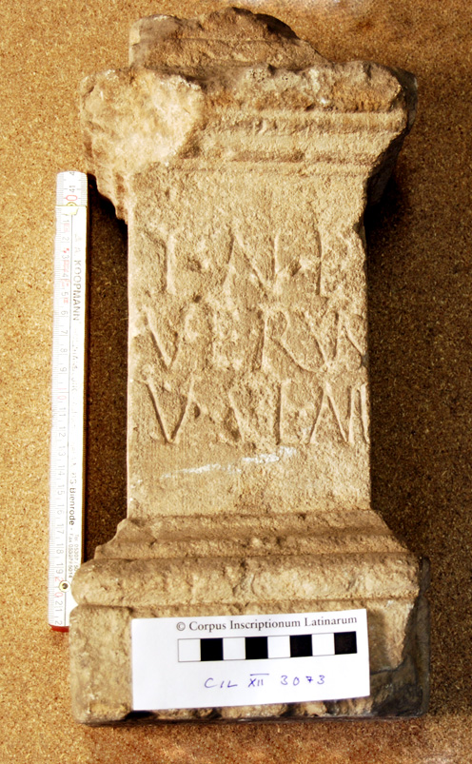
CIL 12, 3077 (p 834) = ILGN 406 = ILS 4846
[L]aribus Aug(ustis) / sacrum et / Minervae / Nemauso / Urniae / Avicanto / T(itus) Cassius T(iti) l(ibertus) / felicio(!) exs(!) / vot(o)
CIL 12, 3080 = ILGN 406 = ILS 4768
Rufina / Lucubus / v(otum) s(olvit) l(ibens) m(erito)
CIL 12, 3082 (p 834) = ILS 4548
Aug(usto) Marti Brito/vio [3] Salvius / Secundini fil(ius) / ex voto
CIL 12, 3083 = ILGN 406
Ma[rti 3] / Brito[vio 3] / Valerius A(uli) [1] / Martial[is] / v(otum) s(olvit) l(ibens) m(erito)
CIL 12, 3085
Matris / L(ucius) Classius / v(otum) s(olvit) l(ibens) m(erito)
CIL 12, 3086 = AE 1967, 292 = AE 1995, 1057
Mercurio Augusto / M(arcus) Pullius Celsus et / L(ucius) Domitius Sedulus / ex voto
CIL 12, 3087
Mercurio Aug(usto) / T(itus) Valerius Gratus / ex voto / Valeriae patronae suae
CIL 12, 3090 = CAG-30/2, p 307
] / v(otum) s(olvit) l(ibens) m(erito)
CIL 12, 3091
] / [v(otum)] s(olvit) l(ibens) m(erito)
CIL 12, 3092 (p 834)
]cus / Minervae / v(otum) s(olvit) l(ibens) m(erito)
CIL 12, 3093 = ILS 4842
C(aius) Andolatius / Nemauso v(otum) s(olvit) l(ibens) m(erito)
CIL 12, 3095 (p 834)
Q(uintus) Iuliu[s 3] / Bucca A[3] / Nemauso v(otum) s(olvit) [
CIL 12, 3096
Nemaus[o] / v(otum) s(olvit) l(ibens) m(erito) / Sex(tus) Iul(ius) Severu[s
CIL 12, 3099 (p. 834)
Virrius A[3] / Nem(auso) v(otum) s(olvit)
CIL 12, 3102 (p. 834) = ILS 4843
Nem(auso) Aug(usto) / censor / Iugarius / ex voto SI / [f]ilia superstit(a) / decessisset
CIL 12, 3108 (p. 834)
Nymphis / Aug(ustis) sac(rum) / [3]C[3]I[3] / Severina / v(otum) s(olvit) l(ibens) m(erito)
CIL 12, 3111 = ILS 3765
Parcis / L(ucius) Valerius Hybr[ida] / v(otum) s(olvit) l(ibens) m(erito)
CIL 12, 3114 (p. 835) = ILS 4771c
Prox(imis) / Bituka / v(otum) s(olvit) l(ibens) m(erito)
CIL 12, 3115 (p. 835)
Calv/ina P(roximis?) / suis / v(otum) s(olvit) l(ibens) m(erito)
CIL 12, 3117 (p. 835) = ILS 4771
Proxumis(!) / Gratus / Celeris f(ilius) / v(otum) s(olvit) l(ibens) m(erito)
CIL 12, 3118
Hosela / Soliarion(is) / filia / Prox{s}um(is) / v(otum) s(olvit) l(ibens) m(erito)
CIL 12, 3119 (p 835) = ILS 4771a
Laliae / Primulae / prox{s}umis / suis <v=N>(otum) s(olvit)
CIL 12, 3120 (p. 835)
Paterna / Cari f(ilia) Prox(umis) / v(otum) s(olvit) l(ibens) m(erito)
CIL 12, 3121
[P]ro[x]u[m(is!)] / suis / Phronimus / v(otum) s(olvit) l(ibens) m(erito)
CIL 12, 3122
Prox{s}umi[s] / Pollento / v(otum) s(olvit) l(ibens) m(erito)
CIL 12, 3123
Pompeia / Pompulla / prox{s}umis / v(otum) s(olvit) l(ibens) m(erito)
CIL 12, 3124
Proxumis / M(arcus) Porcius / Iuvenalis / v(otum) s(olvit) l(ibens) m(erito)
CIL 12, 3127 (p. 835) = ILS 4771b
Urassia / P(roxumis) s(uis) v(otum) s(olvit) l(ibens) m(erito)
CIL 12, 3128 (p. 835)
[Ro]mania(?) / [P]roxumis(!) / suis / [v(otum)] s(olvit)
CIL 12, 3129 = ILGN 406 = ILS 4031
Quartane votum red/det libens / merito / Byrria Se/verilla
CIL 12, 3135 = ILS 3294
Severa Nigri f(ilia) // Volcano et Ventis / v(otum) s(olvit) l(ibens) m(erito)
CIL 12, 5890 = AE 1986, 474
[E]scingil/[l]us Valta/ci Parcabu[s] / v(otum) s(olvit) l(ibens) a(nimo)
CIL 12, 5891
Cn(aeus) Ro[3] / Niger a[edil(is) col(oniae)] / Aug(ustae) Nem(ausi?) V[ictoriae?] v(otum) s(olvit) [l(ibens) m(erito)]
CIL 12, 5894
Augusto sacr(um) / vicus Arcevoturua[rum
AE 1995, 1067
Q(uinto) Calete/do Prox(umis) / v(otum) s(olvit) l(ibens) m(erito) / pro Quin/tae(!)
ILGN 408 = AE 1900, 202
Mercurio / Depulsorio / Lais Lucretia / v(otum) s(olvit) l(ibens) m(erito)
ILGN 409
[P]roxum[is] / [p]ro salu[te] / [A]tili Ru[fi]/[ni] Clu[vi]a A/[vi]lla v(otum) s(olvit) l(ibens) m(erito)
ILGN 413
Silvano / v(otum)
CIL 12, 3224 (add. p 836) = SIRIS 00732 = RICIS-02, 00605/0104
Marcus Gessius / Augur et Tettia / Cresce(n)s uxor / Isidis sacerdos in / suo sibi posuerunt / mon<u=I>mentum n<e=I> / heredem sequatur.
CIL 12, 3058 = SIRIS 00728 = RICIS-02, 00605/0101
Isis] ex [HS 3] / Serapis Vestae Dianae Somni [ex] / HS n(ummum) VI(milibus) et phialas II chrysen[g]l[yptas(?)] / [et si]gna deorum argentea castrensia [3 quae in] / domo habebat item [3] / dedicatione templi Isis et Serapis dec[uri]/onibus Nemausensium / et ornamentar[iis] / singulis |(denarios) V ita ut / in publico vescerentur / distribui iussit inque eius domus [tu]/telam HS n(ummum) X(milia) reliquit / item [3 im]/aginem Martis argenteam ex [3] / [S]amnagensibus dedit / [hui]c ordo Bitur[igum
AE 1937, 26
[D]omitius Ver/res / proxumis
AE 1995, 1062
Proxumis / [
AE 1995, 1063
Prox[u]/m[is
CIL 12, 3112 (p. 834)
[Pr]oxxumis(!) / [
CIL 12, 3116 (p 835)
Proxumis suis / Cornelia Cupita
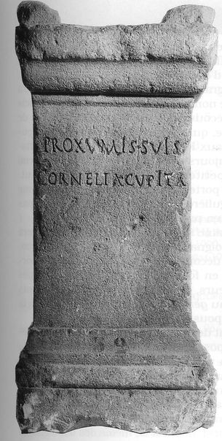

CIL 12, 03125 (p 835)
Prox/umis(!) / Quin/tina / et Ve()
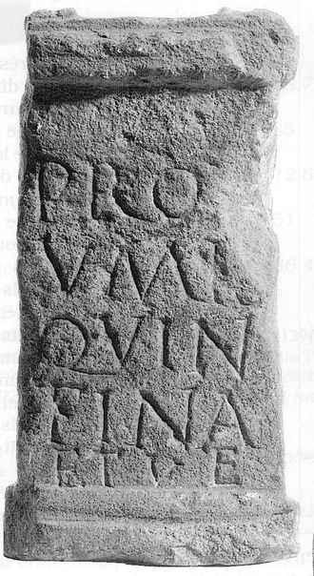
CIL 12, 3126
Proxumis(!) Tertia
ILGN 410 = AE 1895, 96
Ianua[ria] / Prox[u]/mis [su]/is // XVIII
ILGN 411
Prox/umis / Rest/ituti
ILGN 412
Viria / [A]gathe Prox(umis) su/is.
AE 1954, 194
]DO[3] / Caesaris / vil{l}icus XX her(editatium) / sanctissimo / deo Silvano / aram d(onum) d(edit)
CIL 12, 3043 = ILGN 406 = ILS 4419 = SIRIS 00734 = RICIS-02, 00605/0107
A(ulus) Iulius Leonas do/num quod promi/serat Anubiacis Do/mestica libert(a) d(e) s(ua) p(ecunia)

Vienna / Vienne

City of Vienne
CIL 12, 1809 = ILN-5.1, 1
Apollini / sacrum ex voto / C(aius) Virius Victor / et / L(ucius) Virius Vitalis / s(olverunt) l(ibentes) m(erito)
CIL 12, 1810 = ILN-5.1, 2
Apollini Aug(usto) / sacrum / Nattia Soilli fil(ia) / Severa / ex voto
CIL 12, 1813 = CIL 13, *299 = ILN-5.1, 5
Fortunae / ex voto / L(ucius) Terentius / Sabinus
CIL 12, 1818 = ILN-5.1, 9
I(ovi) O(ptimo) M(aximo) / ex vot(o) / L(ucius) Crep(e)r(e)i(u)s / Mar(i)nus
CIL 12, 1819 = ILN-5.1, 25
I(ovi) O(ptimo) M(aximo) // Veneri Aug(ustae) / L(ucius) Rufius / Rufinus / v(otum) s(olvit) l(ibens) m(erito)
CIL 12, 1824 = ILN-5.1, 14
Matris / Augustis / D(ecimus) Dimarius / Messulus / restituit / ex voto
CIL 12, 1825 = ILN-5.1, 15
[M]a[t]ris [A]ug[ustis] / [C]n(aeus) P[o]mp(eius) Quar[tus] / v(otum) s(olvit) l(ibens) m(erito)
CIL 12, 1830 = ILN-5-1, 17
Mercurio / Aug(usto) sac(rum) / voto suscep[t(o)] / T(itus) Laetorius Duel/[l]us / Antestianus et / [1] Laetorius Numida / Antestianus / p(ater) d(ant) f(ilius)
CIL 12, 1833 = ILN-5-1, 19
[Dis(?)] Plutoni et Proserp(inae) / [3]cilia G(ai!) f(ilia) Cornelia / ex voto
CIL 12, 1834 = ILN-5.1, 20
Silvano Au[g(usto)] / Primigeniu[s] / Victoris s(ervus) v(otum) [s(olvit)]
CIL 12, 1836 (p 828) = ILN-5.1, 22
Deo Sucello / Gellia Iucund[a] / v(otum) s(olvit) l(ibens) m(erito)
CIL 12, 1851 = ILN-5.1, 42
Imp(eratori) Cae[sari] / M(arco) Aurel(io) [Severo] / Antoni[no Pio Feli]/ci Aug(usto) Pa[rthico max(imo)] / Britann[ico maximo] / German[ico maximo] / fortissi[mo Invictis]/simo pon[tifici ma]/ximo tri[b(unicia) potest(ate) X3] / imp(eratori) III c[o(n)s(uli) IIII proco(n)s(uli)] / p(atri) p(atriae) Fe[licissimo] / indulge[ntissimoque] / prin[cipi] / C(aius) Vlatt[ius 3] / sacerd[os Rom(ae) et Aug(ustorum)] / devotus [numini] / maiestat[ique eius] / civis Se[gusiavus]

Vienne’s territory 1
CAG-05, p 145 Sainte-Colombe / Vienna
I(ovi) O(ptimo) M(aximo) / Sex(tus) Pomp(eius) / Silvanu(s)/ v(otum) s(olvit) l(ibens) m(erito)
CIL 12, 1817 = ILN-5.1, 8 = CAG-69-1, p 309 Sainte-Colombe / Vienna
[I]ovi / ex voto / Sentius Sabinus / et Sentius / Amabilis
CIL 12, 1826 = CIL 13, *299 = ILN-5.1, 16 = CAG-69/1, p 334 Sainte-Colombe / Vienna
Matris / Augustis / C(aius) Titius / Sedulus / ex voto
CIL 12, 1828 = ILN-5.1, 287 = CAG-69/1, p. 517 Simandres / Vienna
[Me]rcurio / sacrum / L(ucius) Taietius / Chresimus / IIIIIIvir Aug(ustalis) / ex voto
CIL 12, 2194 = ILN-5.2, 327 = CAG-38/1, p. 128 Chatte / Vienna
Maiae / Aug(ustae) sacr(um) / T(itus) Eppius D(ecimi) f(ilius) / Iullinus / ex voto
CIL 12, 2195 = ILN-5.2, 329 = CAG-38/1, p. 128 Chevrieres / Vienna
Mercur(io) / Aug(usto) sacr(um) / T(itus) Eppius D(ecimi) f(ilius) / Iullinus / ex voto.
CIL 12, 02196 = ILN-5.2, 328 = CAG-38/1, p. 128 Chatte / Vienna
Mercur(io) / Aug(usto) sacr(um) / T(itus) Eppius D(ecimi) f(ilius) / Iullinus / ex voto
CIL 12, 2199 = ILN-05.2, 341 = CAG-38/1, p 108 Beaucroissant / Vienna
Mercurio / Aug(usto) Artaio / sacr(um) / Sex(tus) Geminius / Cupitus / ex voto
CIL 12, 2200 = ILN-5.2, 342 = CAG-38/1, p. 108 Beaucroissant / Vienna
Mercurio / sacrum / C(aius) Atisius Sedulus / ex voto
CIL 12, 2213 (p 829) = ILN-5.2, 333 = CAG-26, p. 550 Saint-Martin-le-Colonel / Vienna
Mercurio / Aug(usto) / Dannia / Martina / ex voto
CIL 12, 5859 = CIL 12, *299 = ILN-5.1, 313 = CAG-07, p. 339 Saint-Desirat / Vienna
Ap[ollini] / Au[g(usto)] / C(aius) Iul(ius) M(arci) [fil(ius) 3] / C(aius) Iul(ius) C(ai) fi[l(ius) 3] / et Iulia [3] / ex vo[to 3]
CIL 12, 2410 = ILN-5.2, 595 = CAG-38/2, p. 112 Aoste / Vicus Augusti
Iovi O(ptimo) M(aximo) / Augusto / sacrum / Q(uintus) Valerius / Senecio ex / voto s(olvit) l(ibens) m(erito)
CIL 12, 2386 = ILN-5.2, 592 = CAG-38/2, p. 111 Aoste / Vicus Augusti
Asclepio / Aug(usto) / M(arcus) Pennius / Apollon(ius)
CIL 12, 2387 = ILN-5.2, 593 = CAG-38/2, p. 111 Aoste / Vicus Augusti
[3] Iunoni /[3]ius Severianus
CIL 12, 2387a = ILN-5.2, 594 = CAG-38/2, p. 111 Aoste / Vicus Augusti
Iovi / Dom(ino?) / sacrum
CIL 12, 2388 = ILN-5.2, 596 Aoste / Vicus Augusti
Matris Aug(ustis) ex{s} stipe annua |(denariorum) XXXV et D[3]
CIL 12, 2389 (p. 830) = ILN-5.2, 599 = CAG-73, p .185 Aoste / Vicus Augusti
Victoriae Augusti / T(itus) Flaminius Secundus / T(itus) Flamini<us=O> T(iti) f(ilius) [3] / T(itus) [3]MAM[3]A / MATC[3]M / Cn(aeus) T Pis[3]OILISIT / Cn(aeus) F Romanus F[3] / de suo pon(endum) curaverunt.
CIL 12, 2390 = ILN-5.2, 601 = CAG-38/2, p. 111 Aoste / Vicus Augusti
Sacrum / Imp(eratore) Com(modo) II / P(ublio) Martio / Vero II co(n)s(ulibus) / [
CIL 12, 2391 = ILS 5550 = ILN-5.2, 600,1 = CAG-38/2, p. 109 Aoste / Vicus Augusti
Pro salute Imp(eratoris) / Caes(aris) M(arci) Aur(eli) Anto/nini Aug(usti) tectum / porticus / cum suis columnis et / paenul(is) duabus et oper(e) tecto(rio) / Sex(tus) Vireius Sextus decur(io) / d(e) s(ua) p(ecunia) d(edit) Pollione II et Apro II co(n)s(ulibus).
CIL 12, 2392 = ILN-5.2, 600,2 = CAG-38/2, p. 110 Aoste / Vicus Augusti
Pro salute Imp(eratoris) / Caes(aris) M(arci) Aur(eli) An/tonini Aug(usti) / tectu[m] porticus / cum s[uis] [co]lumnis et / paenu[lis du]abus [et] / opere [tector]io / S[e]x(tus) [Vireius Sex]tu[s] dec(urio) / d(e) s(ua) p(ecunia) d(edit) Pollione II et Apro II co(n)s(ulibus)
CIL 12, 2413 = ILN-5.3, 619 = CAG-73, p. 126 Belmont-Tramonet / Vicus Augusti
I(ovi) O(ptimo) M(aximo) / [---]
CIL 12, 2414 = ILN-5.3, 620 = CAG-73, p. 125 Belmont-Tramonet / Vicus Augusti
Iovi O(ptimo) M(aximo) / Sex(tus) Cornel(ius) Pollio / suo et L(uci) Corneli / Corbulonis fra/tris sui nomine
CIL 12, 2415 = ILN-5.3, 621 = CAG-73, p. 186 = CAG-38/2, p. 275 Le Pont-de-Beauvoisin / Vicus Augusti
Marti Aug(usto) / C(aius) Betutius Hermes / IIIIIvir Aug(ustalis) / t(estamento) p(oni) i(ussit)
CIL 12, 2426 = ILN-5.3, 625 = CAG-73, p. 157 Les Echelles / Vicus Augusti
Lex rivi Ul[3] / si quis in eo m/ix{s}erit spurcit(iam) / fecerit in temp(lum) / Iovis D(omestici?) |(denarium) d(ato) de/l(atoris) pars dim(idia) esto / n<i=E>si l(ongius) p(assibus) V
ILGN 346 = ILS 5456 = ILN-5.2, 598 = CAG-38/2, p. 112 Aoste / Vicus Augusti
Victoriae / Aug(usti) / C(aius) Virrius / Quartio / t(estamento) p(oni) i(ussit) / basis ex stipe.
ILGN 347 = ILN-5/2, 597,1 = CAG-38/2, p. 110 Aoste / Vicus Augusti
Numini Aug(usti) / M(arcus) Verrius Man/suetus suo et / Mansoni fratris / nomine / t(estamento) p(oni) i(ussit)

Vienne’s territory 2. Cularo/Grenoble
CIL 12, 2222 = ILN-5.2, 454 La Terrasse / Cularo / Gratianopolis
Mercurio / Aug(usto) / L(ucius) Divius Rufus / ex voto / s(olvit) l(ibens) m(erito)
CIL 12, 2318 = ILN-5.2, 459 = CAG-73, p. 188 La Rochette / Cularo / Gratianopolis
Apollini ex voto / Iustus Mercuri / et Cereris ser(vus)
ILN-5.2, 364 = CAG-38/1, p. 132 = AE 1938, 58 Sassenage / Cularo / Gratianopolis
Viamae d(eae) / Craxo v(otum) s(olvit) l(ibens) / m(erito) voto excep(to)
ILN-5.2, 463 = AE 1984, 636c = CAG-73, p 144 = AE 1993, 1152 = AE 1999, 1027 Chateauneuf / Cularo / Gratianopolis
] v(otum) a(nimo) l(ibens) m(erito) [s(olvit?)] / Neroni / Limet[o]
ILN-5.2, 466 = CAG-73, p. 144 = AE 1993, 1113 = AE 1999, 1027 Chateauneuf / Cularo / Gratianopolis
Publi[u]s Attius Firmus / votum feci Mer<c=Q>ur[i]o / <c=Q>um primum [3]NV bene conti[ngit mihi(?)] / hic profano do[num] per NOM et DRO[3] / mulsi e[t] pie D[3]D RO <c=Q>um [3] / et t[e]r [3]V[3] / IC[3]M FONAI[3]
ILN-5.2, 472 = CAG-73, p. 145 = AE 1993, 1122 = AE 1999, 1027 Chateauneuf / Cularo / Gratianopolis
[Vi]ginti / [Mer]cur(i)o et M[aiae] / [v(otum) s(olvit) l(ibens?)] m(erito?)
ILN-5.2, 474 = CAG-73, p. 146 = AE 1984, 636b = AE 1993, 1146 = AE 1999, 1027 Chateauneuf / Cularo / Gratianopolis
Romae / v(otum) s(olvit) l(ibens) m(erito)
ILN-5.2, 476 = CAG-73, p. 146 = AE 1993, 1114 = AE 1999, 1027 Chateauneuf / Cularo / Gratianopolis
Di diae(!) / v(otum) [s(olvit) l(ibens) m(erito)]
ILN-5.2, 478 = CAG-73, p. 146 = AE 1993, 1117 = AE 1999, 1027 Chateauneuf / Cularo / Gratianopolis
V(otum) s(olvit) l(ibens) m(erito)
ILN-5.2, 481 = CAG-73, p. 146 = AE 1993, 1130 = AE 1999, 1027 Chateauneuf / Cularo / Gratianopolis
Vo[tum(?)] / [6]
ILN-5.2, 486 = CAG-73, p. 146 = AE 1993, 1149 = AE 1999, 1027 Chateauneuf / Cularo / Gratianopolis
Caes(ari) / v(otum) s(olvit) l(ibens)

Vienne’s territory 3: Geneva
CIL 12, 2587 = ILN-5.3, 821 Geneve / Genava
Deo Invicto / Genio loci / Firmidius Se/verinus mil(es) / leg(ionis) VIII Aug(ustae) P(iae) F(idelis) / C(onstantis) C(ommodianae) stip(endiorum) XXVI aram / ex voto pro salute / sua v(otum) s(olvit) l(ibens) m(erito) posita / Muciano et Fabiano co(n)s(ulibus)
CIL 12, 2594 = ILN-5.3, 830 Geneve / Genava
Mercurio / Aug(usto) / M(arcus) Attius Birr[3] / v(otum) s(olvit)
CIL 12, 2597 = ILN-5.3, 838 = AE 2007, 884 Geneve / Genava
Deo Silva/no pro salu/[t]e ratiarior(um) / superior(um) a/micor(um) suor(um) / pos(u)it L(ucius) Sanct(ius) / Marcus civis Hel(vetius) / v(otum) s(olvit) l(ibens) m(erito) / d[e] suo d(edit)
CIL 12, 5878 = ILS 2412 = ILN-5.3, 836 Geneve / Genava
Deo Neptun(o) / C(aius) Vitalinius / Victorinus / mil<e=I>s / leg(ionis) XXII / a curi(i)s / v(otum) s(olvit) l(ibens) m(erito)
ILGN 358 = ILN-5.3, 826 Geneve / Genava
Maiae / Q(uintus) Servilius / Severus / item aedem / et porticus / ex voto d(edit)
ILGN 359 = ILN-5.3, 831 Geneve / Genava
[Mercu]rio Aug(usto) / [3]s Marcus et / [3]linus filius / [ex] voto

Lyon
CAG-69/2, p. 501
Vene/ri et Tu/tel(a)e vo/tum.
CAG-69/2, p. 511 = AE 1976, 425
Mercur(io) Aug(usto) / Sex(tus) Veratius / Sodalis pos<u=I>it / Sex(tus) Veratius Ma/turus restituit / v(otum) s(olvit) l(ibens) m(erito).
CIL 13, 1717 = CAG-69/2, p. 386
]ALIQ[3] / [3 sacerd(os?)] ad aram C[aes(aris) n(ostri) 3] / [3] q(uaestor) eiusd(em) co[rporis(?)] / civ<i=E>s Veliocassis(?) / v(otum) s(olvit) l(ibens) m(erito)
CIL 13, 1727 = CAG-69/2, p. 528
Apollini Augusto / Appianus / v(otum) s(olvit)
CIL 13, 1728 = CAG-69/2, p. 658
Deo Apollini / Augusti(!) / Q(uintus) Asi/cius Norbanus / v(otum) s(olvit) l(ibens) m(erito)
CIL 13, 1729 = CAG-69/2, p. 466
Apollini / sancto / Iulius Silva/nus Melanio / proc(urator) Aug(usti) / v(otum) s(olvit)
CIL 13, 01730 = CAG-69-02, p 716
Numinib(us) August(orum) / deo Apollini / C(aius) Nonius Eupo/sius ex voto / muro et scan/dula cinxit
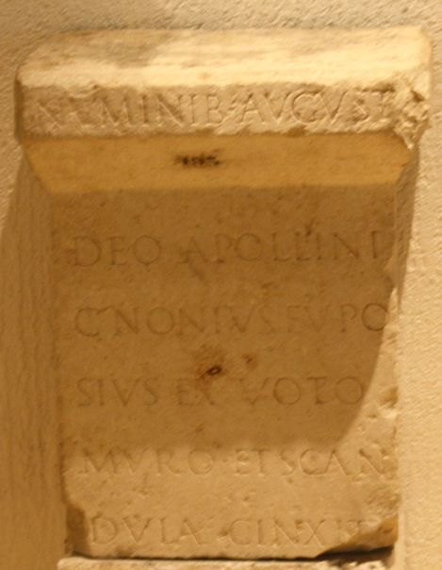
CIL 13, 1738 = SIRIS 00745 = RICIS-02, 00607/0102 = CAG-69/2, p. 583
Isidi Aug(ustae) / Q(uintus) Obellius Euan/gelus signum / Fortunae v(otum) s(olvit) / l(ibens) m(erito) l(ocus) d(atus) d(ecreto) d(ecurionum)
CIL 13, 01742 (4, p 24) = CAG-69-02, p 480
I(ovi) O(ptimo) M(aximo) et n(uminibus) / Aug[g(ustorum)] T(itus?) / v(otum) s(olvit) l(ibens) m(erito)
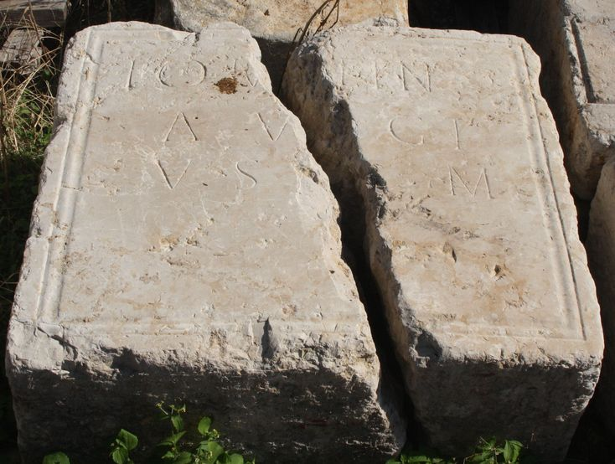
CIL 13, 1744 = CAG-69/2, p. 546
] Numini[b(us) Augg(ustorum)] / et Iovi Optimo / Maximo / Aurelia [Z]otica / ex voto / v(otum) s(olvit) l(ibens) m(erito)
CIL 13, 01749 = EAOR-05, 00059 = CAG-69/2, p. 331
Deo Mar/ti Aug(usto) / Callimo/rphus secunda / rudis / v(otum) s(olvit) l(ibens) m(erito)
CIL 13, 01753 = D 04133 = CAG-69-02, p 481 = CCCA-05, 00392
Pro salute Imp(eratoris) L(uci) Sep/timi Severi Pertina/cis Aug(usti) et D(ecimi) Clodi / [[[Septimi Albini Caes(aris)]]] / domusq(ue) divinae et statu c(oloniae) c(opiae) C(laudiae) Aug(ustae) Lug(udunensium) / taurobo/lium fecerunt Aufustia / Alexandria et Sergia / Parthenope ex voto / praeeunte Aelio Castren/se sacerdote tibicine Fl(avio) / Restituto inchoatum est / sacrum VII Idus Mai(as) con/summatum V Id(us) easdem / [I]mp(eratore) L(ucio) Septimio Severo Pertinac(e) Aug(usto) / [[[D(ecimo) Clod(io) Sept(imio) Albino Caes(are)]]] / II co(n)s(ulibus) / [l(ocus)] d(atus) [d(ecreto) d(ecurionum)]
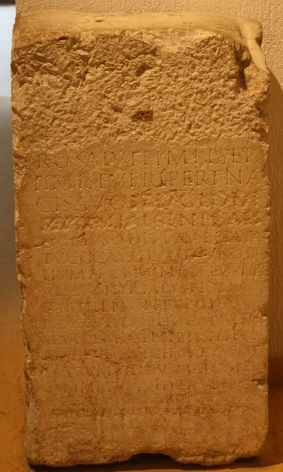
CIL 13, 1760 (2,p 33*) = CIL 12, *172,5 = CAG-69/2, p. 798
Matris Aug(ustis) / Mastonia / Bella / v(otum) s(olvit) l(ibens) m(erito)
CIL 13, 1761 = CAG-69/2, p. 521
Matr[is] / P(ublius) Mattius Quar[tus] / L(ucius) Mattius Satto / C(aius) Mattius Vitalis / ex voto
CIL 13, 1763 = CAG-69/2, p. 472
Sappiena / Lychnis / Matris v(otum) s(olvit) l(ibens) m(erito)
CIL 13, 1766 = ILS 4794 = CAG-69/2, p. 467 = AE 1961, 3 = AE 2005, 123
Pro salute dom(ini) / n(ostri) Imp(eratoris) L(uci) Sept(imi) Severi / Aug(usti) totiusq(ue) domus / eius Aufanis Ma/tronis et Matribus / Pannoniorum et / Delmatarum / Ti(berius) Cl(audius) Pompeianus / trib(unus) mil(itum) leg(ionis) I Min(erviae) / loco exculto cum / discubitione et tabula / v(otum) s(olvit)
CIL 13, 01769a = D 03208 =CAG-69-02, p 598
Mercurio Augusto / et Maiae Augustae / sacrum ex voto / M(arcus) Herennius M(arci) l(ibertus) Albanus / aedem et signa duo cum / imagine Ti(beri) Augusti / d(e) s(ua) p(ecunia) solo publico fecit
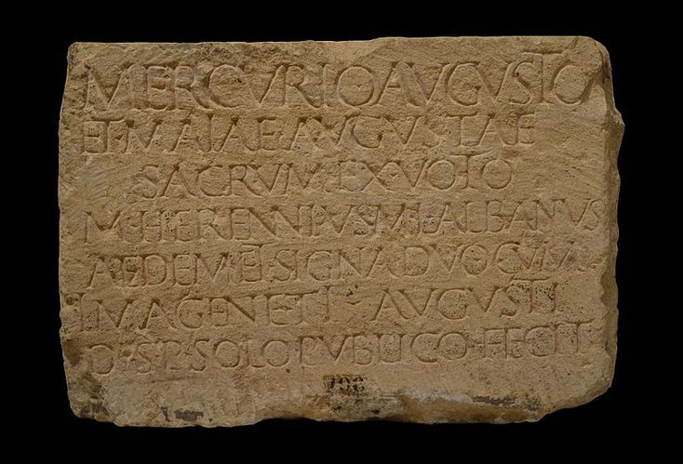
CIL 13, 1769b
Mercurio Augusto et Maiae Augus[tae] / sacrum ex voto / M(arcus) Herennius M(arci) l(ibertus) Albanus / aedem et signa duo cum / imagine Ti(beri) Augusti / d(e) s(ua) p(ecunia) solo publico fecit
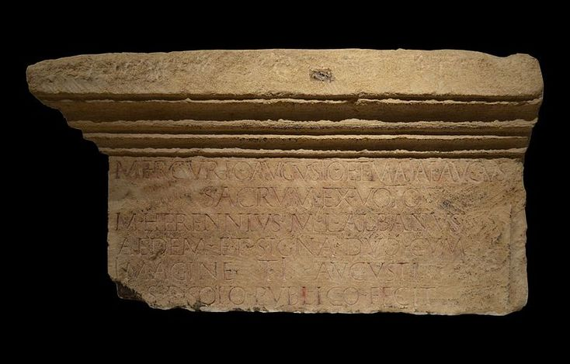
CIL 13, 01769c
Mercurio Augusto / et Maiae Augustae / sacrum ex voto / M(arcus) Herennius M(arci) l(ibertus) Albanus / aedem et signa duo cum / imag<i=E>ne Ti(beri) Augusti / d(e) s(ua) p(ecunia) solo publico fecit
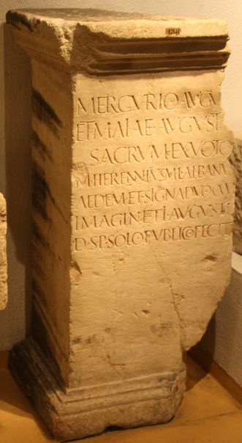
CIL 13, 1771 = CIMRM-01, 00908 = CIMRM-02, p 42 = CAG-69/2, p. 658 = AE 2000, 951
Deo Invicto / Aur(elius) Secundi/nius Donatus / frument(arius) Au/g(usti) et comment(ariensis) / v(otum) s(olvit) l(ibens) m(erito)
CIL 13, 1777 = AE 2000, 950
Numinibus / Aug[g(ustorum) 3] / ex voto [aram cum] / signis [3] / Hygi[ae(?)3] / Cornif[icius
CIL 13, 1780 = ILS 3549 = CAG-69/2, p. 618
Deo Silvano / Aug(usto) / Tib(erius) Cl(audius) [C]hres/tus clavic(ularius) / carc(eris) p(ublici) Lug(uduni) / aram et sig/num inter / duos arbo/res cum ae/dicula ex vo/to posuit
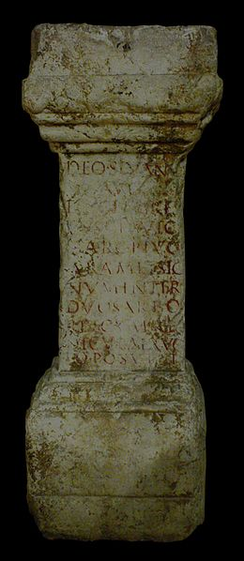
CIL 13, 1930 = CAG-69/2, p. 799
V(otum) s(olvit) [3] / [3 Vienne[ns(is?) 3] / [3] ornam[entis 3] / [de]ae Rom[ae(?)
CIL 13, 11176 = CAG-69/2, p. 439
[Ma]tris Aug(ustis) / [ut]i vovi[t] / aram / et specularia / v(otum) s(olvit) l(ibens) m(erito)
ILTG 228 = CAG-69/2, p 546 = AE 1961, 69
M(arcus) Licinius Rari f(ilius) / Rufus / murum et sedilia Mercurio / vot(um) so[l(vit)] lib(ens) mer(ito)


