Resonance

Name : Nick Regan
Student Number : p1803871

Module: Electrical and Electronic Principles
ACDB4002

University of Wales Trinity St. David

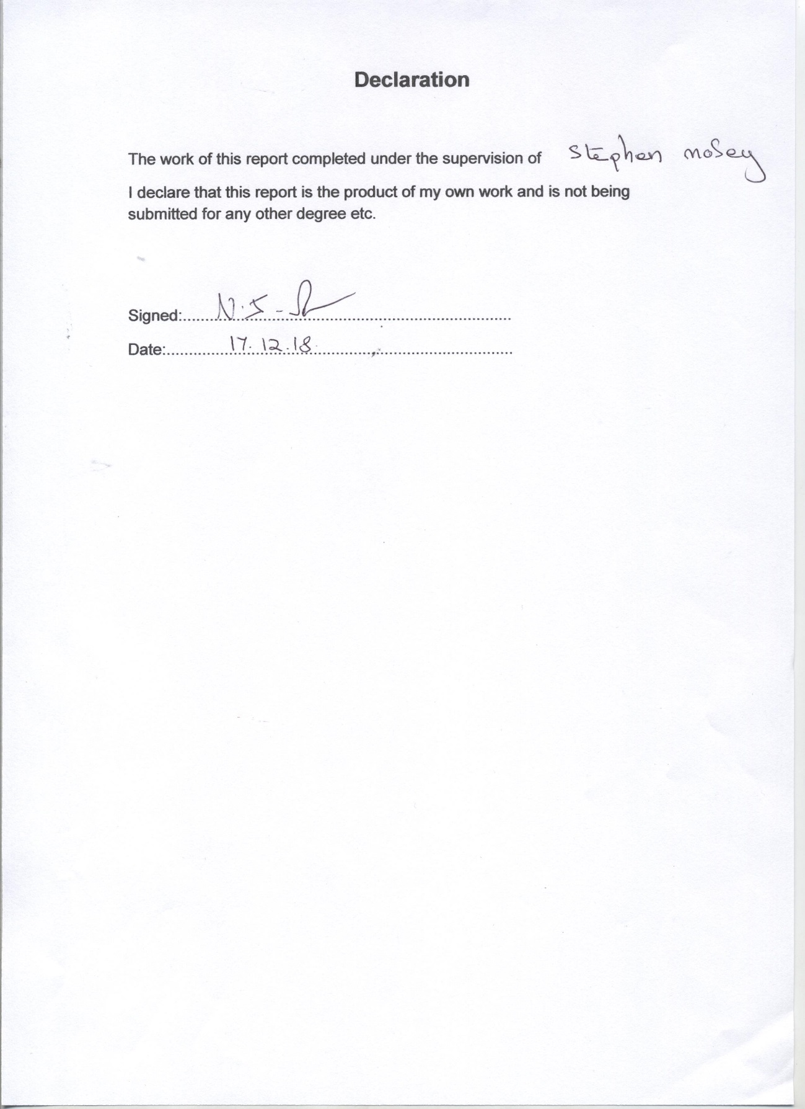

Abstract
This assignment explores the subject of resonance. In this assignment an exercise was carried out measuring the voltage across a R.L.C series ac circuit. Then calculating the resonance frequency and Q factor. This exercise developed practical skills and data analysis.
Two methods were used for this experiment: using components in a software simulation and a practical experiment using real components in a laboratory.
The methods used for each is described followed by the results of each method separately followed by the explanation of the results. It was found that the results were different even though the same criteria was input. Therefore exercises using software simulation do not match the results of real life equipment.

Figure 1 Circuit Design using Proteus Design Suite 8 software by Labcenter Ltd.
Figure 2 Graph designed in excel

Contents

Page Number

Introduction 1
Background Research 2
Method 7
Results 8
Discussion 9
Conclusion 10

Introduction

This assignment covers a laboratory exercise which develops practical measurement skills and data analysis. This exercise is based on software simulation and practical experiment using real equipment.
This exercise will involve building an AC circuit using Proteus simulator, measuring the voltage across the circuit with a signal generator output of 12 VRMS at 5KHz. This will then be repeated for a range of frequencies up to a maximum of 18KHz. An AC circuit will then be constructed onto a breadboard and again measurements will be taken using the same frequency.
Then a graph will be created showing the capacitance against frequency using spreadsheet. The resonant frequency and “Q” will be determined and compared with that determined from the basic theory.
The assignment will cover the method of the above exercise, discussion of the results and conclusion.

Background Research

This assignment is based on an exercise measuring electrical resonance using an RLC series AC circuit, in contrast with a simulated software method.

DC and AC Currents
There are two types of electrical current; Direct Current (DC) is a current travelling in the same direction and having a voltage with the same constant polarity. Batteries are DC, also dry cells and solar cells.
Also there is a current known as Alternating Current. Kuphaldt explains that “AC is naturally produced voltages alternating in polarity, reversing positive and negative over time. Either as a voltage switching polarity or as a current switching direction back and forth, this “kind” of electricity is known as Alternating Current (AC).” [1]. In other words the current changes direction periodically. This type of current is used for household heating and lighting for example.

RLC Series AC Circuit
In the exercise for this assignment an RLC series AC circuit was chosen. This circuit consists of a resistor, (R), an inductor, (L), and a capacitor (C), connected in series, hence the letters RLC. These are known as the three components.

Resistor
The resistor, as part of the RLC circuit, will impede and resist the flowing current. Resistance was discovered by Georg Simon Ohm in 1827 and “is the ratio between voltage and current.” [2]. Poole describes resistance as “a hindrance to flow of electrons in material.” [3]. He explains that there are many types of resistor with different properties and they are made of a material that does not conduct electricity. A measurement unit of electrical resistance is called an ‘Ohm’. If a number of resistors are paced in a series, then the overall total of resistance value is a total of all of them. (E.g. if there are three; 1Kohm, 2Kohm and 3Kohm, then the total would be 6Kohm).
Also Sinclair explains: “Electrical resistance causes a current to dissipate….resistance is measured by the amount of potential difference needed per unit of current moved.” [4 p45]
With a resistor present, the total energy is no longer constant. Ott explains that “the oscillations of charge, current and potential decrease with amplitude.” [5] This is called ‘dampening’. An external source of e.m.f. is then needed to make up what has been lost by the action of the resistor.

Inductor
An inductor is based on the principle of inductance and creates a magnetic field. Energy can be stored in a magnetic field. In [6] it is explained that an inductor in an electrical circuit is a ‘mass’ in that it does not do anything until a change is made to it, (in this case an electrical current). When this happens, the inductor resists it. An inductor resists change, known as ‘inductance’. Poole adds: Inductance is caused by the magnetic field generated by electric currents flowing within the electrical circuit.” [2]
Sinclair also adds: “An inductor has an opposite effect on an alternating current because alternating current is a changing current, a back e.m.f. is induced when alternating current flows through an inductor.” [4 p49]. (e.m.f. is am abbreviation of electromotive force). When an an A.C.current is reduced by the inductor it is known as “inductive reactance”. [2].

Capacitor
A capacitor, the third component of an RLC circuit and continually charges and then discharges so the current flows through the rest of the circuit. Sinclair describes a capacitor as “two conductors which are insulated and isolated from each other and have an electric field between them”. When this occurs it is known as capacitance.[4 p49]. A capacitor also stores energy, but it can only store a certain amount depending on its surface area. When it becomes full, it impedes or resists the flow of current. This is known as “capacitive reactance”. The measurement of the reactance is made in Ohms.
To sum up, “An inductor concentrates and stores magnetic energy while a capacitor concentrates charge and thereby stores electric energy.” [6].

Resistor Inductor and Capacitor Together
In a series circuit the same amount of current flows through all three of these components. Ott explains that if an inductor and capacitor are connected in a series, the charge, current and potential difference will ‘oscillate’. [5]. Also Sinclair notes:
- The voltage across the resistor is in phase with the current.
- The voltage across the inductor is 90deg ahead of the current.
- The voltage across the capacitor is 90deg behind the current. [4 p53]
Each of these three components when acting separately will impede current, however when all three appear together, as in the RLC series circuit, the result is different. BC Campus Open Education Department explain that this is due to the fact that an inductor and capacitor behave in opposite ways and therefore more or less cancel each other out. [7].
The inductive reactance and the capacitive reactance and the effect they have on the voltage vs current result in significant features in the resonance. “The combined effect of resistance, ( R ) inductive reactance, (XL) and capacitive reactance, (XC) is defined as impedance.” [7]. Impedance can be understood by remembering that “An inductor resists changes to the current and the capacitor resists changes to the voltage” [8].
Tutors from the Physics Department of Clemson University USA, describe the flow in the circuit : “ The energy flows clockwise to the capacitor, then to the inductor, then back to the capacitor, but the polarity of the capacitor has now reversed….The current now reverses itself and flows back to the inductor, then returns to the capacitor to start all over again.” [6]

Resonance
Authors from the Electronics Tutorial Team [8], explain that “the circuit forms a harmonic oscillator for current and resonates similar to an LC circuit.....In a series RLC circuit there becomes a frequency point where the inductive reactance of the inductor becomes equal in value to the capacitive reactance of the capacitor.” This then produces what is called a series resonance.
An information document written by the U.S. Government describes resonance as: “Electrical resonance occurs when an electric current at a particular resonant frequency when the impedance or admittance of circuit elements cancel out each other.” [9] When a voltage is applied to a circuit the circuit presents an opposition to the current. This is called impedance. When resonance occurs, the series impedance of both elements is at its minimum and the parallel impedance is maximum.
Electrical resonance is a condition that comes about in the following situation: In an electrical circuit when the inductive reactance and the capacitive reactance are equal in magnitude but cancel each other out because they are 180deg apart in phase.” [2]. When this happens, electrical energy will oscillate between the magnetic field of the inductor and the electric field of the capacitor.
Resonance has different levels of quality, strength or performance (or in simple terms, how long it ‘rings’ when excited). This can be determined by calculating it’s “Q” Factor. It is the ratio of reactive power to average power. Or: “The quality factor relates the maximum or peak energy stored in the circuit, (the reactance) to the energy dissipated, (the resistance) during each cycle of oscillation.” [8].
There is a formula to calculate the “Q” factor. Q=X/R. X is the capacitive or inductive reactance at resonance, and R is Series resistance. [3] It is important to find the “Q” Factor as certain tasks depend on a particular level of “Q”. The higher the level the lower or smaller the bandwidth is. Resonance is useful in transmitting and receiving wireless communications, radio and mobile phones.

Method

For the laboratory exercise there were two methods of testing carried out: a simulation in Proteus Design Suite 8 and an experiment using a breadboard. The components used for this exercise were a 3.3Ω resistor, a 1uF capacitor and a 1mH inductor.
Firstly an AC circuit was constructed in Proteus Design Suite 8. The components were connected to the signal generator and the oscilloscope. The signal generator was used to set the output and frequency and the oscilloscope was used to measure the voltage across the circuit. Once the measurements were taken the results were put into a table using excel.
Fig 1 Circuit Designed in Proteus

Secondly the AC circuit was constructed onto a breadboard. Once the components were placed into the breadboard correctly and in series, the circuit was connected up to the signal generator and oscilloscope and the simulator the measurements were taken and then put into the same table. A graph was then created showing the results, as will be shown in the next section of the report

Results

Fig 2 Graph designed in excel

As it can be seen in the graph for the simulation, the voltage stays at 4V from 100 to 2000Hz of frequency then slowly decreases to 0V at 5032Hz. The voltage then slowly increases back to 4V at 10000Hz where it stays the same up to 20000Hz. For the experiment the graph shows that at 100Hz there is 3.7V which decreases down to 0.03V at 5032Hz. This then increases slowly up to 0.74V at 20000Hz. The graph also shows that for the simulated the point at 70.7% is 2.828 (series 3) and the point for the experimental at 70.7% is 2.616 (series 4).

Discussion
The graph shows that the simulated data has a sharp peak at resonance and the experimental data has a much wider peak at resonance. The resonant frequency was calculated at 5032.921Hz.
From the graph the simulation data shows a high Q factor as its peak is much sharper while the experimental data shows a low Q factor as the peak is much wider, so the experiment has a bigger resistance across the circuit and the simulation has a smaller resistance. Using the component values, the Q factor calculated at 0.303030303 which is closer to the experiment than the simulated.
The graph shows that the simulated data has a narrow bandwidth of 600, while the experimental data doesn’t show a bandwidth as it is larger than 20kHz with a lower frequency. Which also proves that the experimental data has a lower Q factor than the simulated data.
The reason the two sets of results are different is because the simulation has pure components which is made up of one component and the experimental uses real components which are made up of different components, this could affect the value of the components.
Another reason for the two being different could be that “all passive components have initial tolerances, ….the list of tolerances includes initial tolerance, temperature drift, aging, vibration, stress.” [10].

Conclusion
In this assignment two experiments were carried out to measure the voltage across a circuit. A simulation of the circuit in proteus and a construction of the circuit on a breadboard. The results were then put into a table and a graph. These were results were different.
The simulated data shows a sharp peak at resonance and a narrow bandwidth of 600. This proves that it has a high Q factor due to a small resistance.
The experimental data shows a much wider peak, unfortunately the bandwidth was not clear as it was larger than 20kHz with a lower frequency. This proves that the experimental data had a low Q factor due to a bigger resistance.
The Q factor was calculated at 0.303030303 which is a lot closer to the Q factor of the experimental data than the simulated data, this proves that experimental data is more accurate.
A reason the two results are different could be because the simulation uses pure components which are just made up of that component where as the experimental uses real components which are made up of different components and this could affect the value of the components.
Another reason for the difference in results could be the components tolerances (e.g. temperature, age) as previously mentioned.

References

[1] T. Kuphaldt, (under Design Science License), article title: Alternating Currents and Direct Currents, 2003 , Available online at: https://www.allaboutcircuits.com/textbook/alternating-current/chpt-6/q-and-bandwidth-resonant-circuit/ , accessed on 10th Dec 2018.
[2] I. Poole, article title: RLC Series Circuit, 2006, available online at: https://www.electronics-notes.com/articles/basic_concepts/, accessed on 10th Dec 2018.
[3] Anon Author, Text available under Creative Commons Attributions/Share-Alike Licence, article title: Electrical Resistance, 2016, available online at: www.simple.m.wikipedia.org, accessed on 16th Dec 2018.
[4] I.R. Sinclair, Electrical and Electronic Principles, London, Butterworth, 1979.
[5] B. Ott,article title: Lab 12 A.C. Circuits RLC Circuit, 2014, available online at: https://science.iit.edu>files>phy>pdfs , accessed on 10th Dec 2018.
[6] T.K. Rogers, Physics Dept. Clemson University, U.S.A. article title: The Physics of Resonance, 1996, available online at: http://intuitor.com/resonance/circuits.html , accessed on 11th Dec 2018.
[7] Anon Author, Physics Dept.,BCCampus Open Education, article title: RLC Series AC Circuit, 2012 Available online at: https://opentext.bc.ca/physicstextbook2/chapter/rlc-series-ac-circuits/, accessed on 11th Dec 2018.
[8] Anon Author, Electronics Tutorials Team,article title: AC Circuits Series Resonance, 2018, available online at: https://www.electronics-tutorials.ws/accircuits/series-resonance.html, accessed on 13 Dec 2018.
[9] General Services Administrator’s Document of the Federal Standard 1037C, U.S. Government, article title: Electrical resonance, 2018, available online at: https://en.wikipedia.org/wiki/Electrical_resonance, accessed on 13.Dec 2018.
[10] R. Mancini, article title: Texas Instruments Understanding Basic Analog-Passive Devices, 1999, available online at: http://www.ti.com.cn/lit/an/sloa027.pdf, accessed on 17th Dec 2018

Bibliography

J. Bird, Electrical and Electronic Principles and Technology, 4th ed., New York, Routledge, 2010.
C.R. Robertson, Further Electrical and Electronic Principles, 3rd ed., Burlington MA, Elsevier 2008.
L.A..A. Warnes, Electronic and Electrical Engineering Principles, Basingstoke, Macmilln, 1994.
P. Horowitz, W. Hill, The Art of Electronic 3rd ed., New York, Cambridge University Press, 2015.

