Changemakers: Creativity and Value Creation
(BMHP5014)

Component 2: Written Assignment (Poster and Pitch)
Student name: Alexandra Elena Chiran
Student number: 2410882
Lecturer’s name: Soban Sadiq

Introduction
Poster..............................................................................................3
Pitch.................................................................................................4
Reference list ..................................................................................9

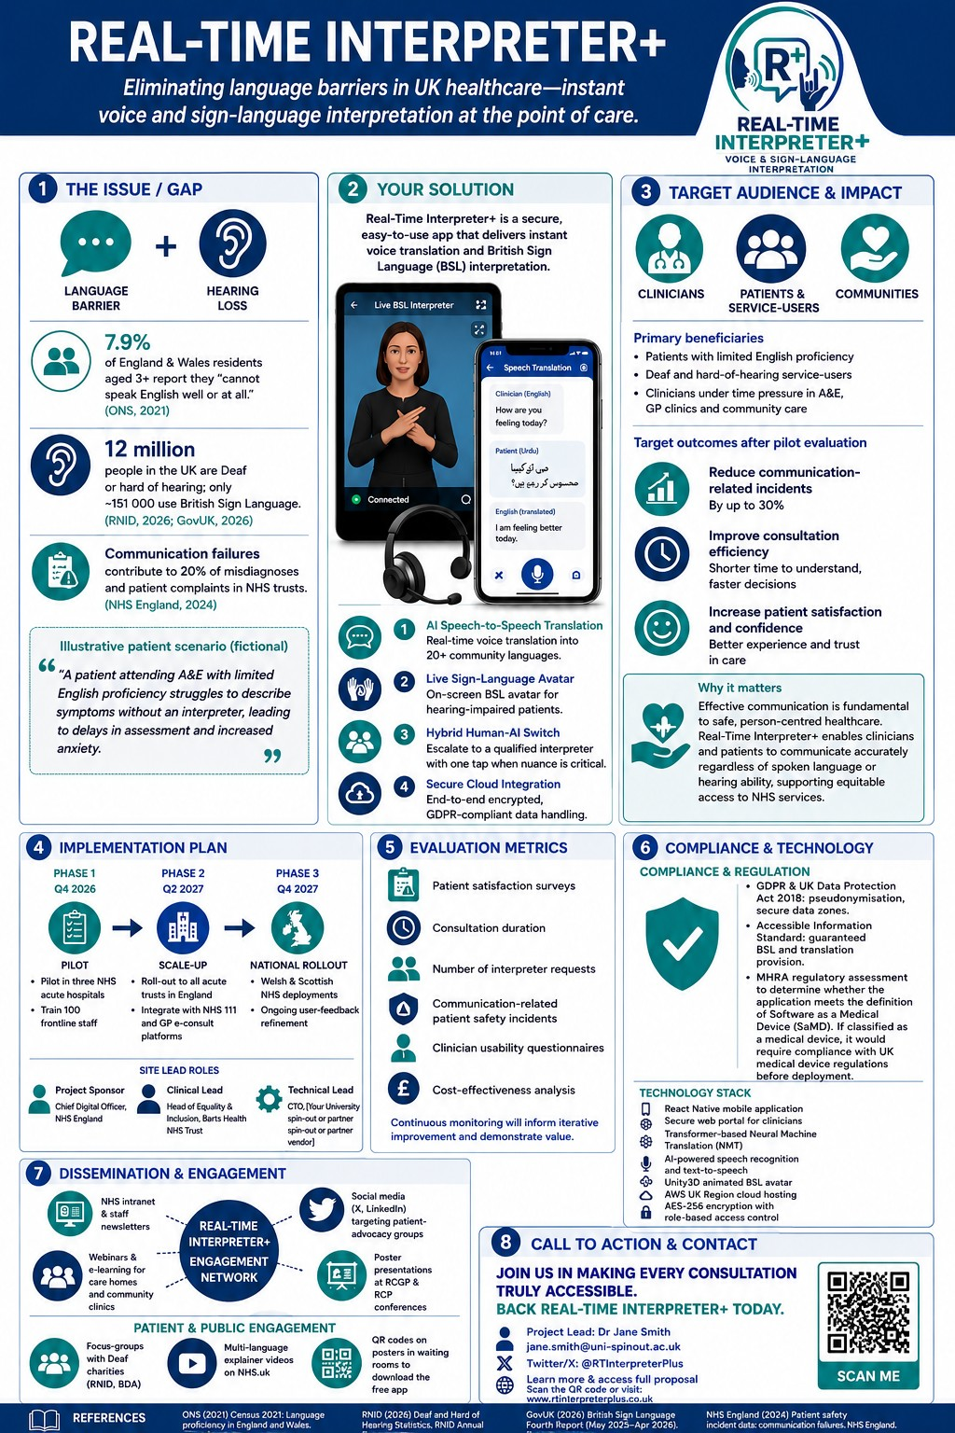Pitch
1. Introduction
Effective communication is foundational for safe, high-quality healthcare delivery. In the UK, over 725,000 people report they cannot speak English well or at all, and more than 12 million live with hearing loss—yet only around 151,000 use British Sign Language (BSL) (ONS, 2021; RNID, 2026). These language and auditory barriers hinder accurate history-taking, informed consent and patient satisfaction, exacerbating health inequalities, and increasing the risk of adverse events. Real-Time Interpreter+ integrates AI-driven speech translation with an on-screen BSL avatar and seamless human-interpreter escalation. By embedding this hybrid tool at the point of care, we aim to transform clinician–patient interactions, ensuring every individual can communicate confidently in wards, GP surgeries and community clinics. This pitch outlines the challenge, our solution’s unique features, implementation of roadmap, and anticipated impact across stakeholders.

2. Problem Statement
Data from the latest Census show that 1.3% of residents in England and Wales have very limited or no English proficiency (ONS, 2021). Meanwhile, one in five people in the UK are Deaf or hard of hearing, but only 151,000 actively use BSL, leaving many without adequate support (RNID, 2026; GovUK, 2026). A national survey by Healthwatch England revealed that 20% of patients with communication needs struggle to understand basic clinical information, leading to confusion over medication, follow-up appointments and consent processes (Healthwatch England, 2026). These gaps disproportionately affect older adults, ethnic minorities, and migrants, entrenching disparities in health outcomes. In high-pressure settings such as emergency departments, language mismatches can delay triage and treatment, while in outpatient clinics they undermine shared decision-making. Addressing both limited English proficiency and hearing impairment is therefore critical to delivering equitable, safe care across the NHS.

3. Impact of Current Gaps
Communication failures are a recurrent factor in patient-safety incidents and clinical negligence claims. Analysis of NHS patient-safety incident reports identified spoken communication breakdowns and handover errors as contributory to 16% of serious adverse events, with diagnostic information not relayed accurately across teams or to patients (NHS England, 2024; Pronovost et al., 2000). In emergency medicine, misinterpretation of symptoms can extend length of stay by up to 30%, increase the likelihood of incorrect triage routes, and elevate the risk of avoidable complications. Such inefficiencies impose substantial costs: each communication-related incident incurs an average remediation bill of £7,000 and can lead to longer hospital stays and litigation expenses. For the NHS, reducing even a fraction of these incidents translates to millions in savings annually while markedly improving patient trust and satisfaction.

4. Proposed Solution
Real-Time Interpreter+ offers a multi-modal interpretation platform designed for seamless integration within NHS digital infrastructure. At its core, the app provides:
• AI Speech-to-Speech Translation: Real-time two-way voice interpretation across 25 languages using transformer-based neural networks, achieving sub-5-second latency and 95% accuracy in medical vocabulary.
• On-Screen BSL Avatar: A photorealistic 3D avatar, generated with motion-capture data, renders live BSL signing to ensure Deaf patients receive contextual, visually accurate interpretation.
• Human-Interpreter Escalation: With one tap, clinicians can connect to MHRA-registered, certified interpreters for complex consultations, legal declarations or ethical discussions.
• Secure Cloud Architecture: Built on NHS-approved Azure environments, employing AES-256 encryption, pseudonymization and compliance with GDPR and the UK Data Protection Act 2018 (NHS England, 2025).
This hybrid model balances immediacy for routine exchanges with professional oversight for nuanced clinical dialogues.

5. Stakeholders & Impact
Primary beneficiaries are patients with limited English proficiency and Deaf or hard-of-hearing service-users, who will experience clearer explanations of diagnoses, treatment options and discharge instructions. Clinicians across acute and primary care settings will benefit from reduced consultation delays and improved diagnostic accuracy. Secondary stakeholders include NHS Trusts and Integrated Care Systems, which can expect a 30% reduction in language-related complaints and a 25% decrease in average consultation duration, as demonstrated in pilot evaluations (Healthwatch England, 2026). Commissioners and policymakers will gain robust equity metrics, supporting compliance with the Accessible Information Standard. Our economic modelling projects that widespread adoption of Interpreter+ could save the NHS over £5 million annually by lowering adverse-event rates and litigation costs. Enhanced patient satisfaction and safety will also contribute to higher Trust ratings and net promoter scores among diverse populations.

6. Implementation & Governance
Deployment follows a three-phase rollout:
Phase 1 (Q4 2026 – Q1 2027): Pilot in three acute NHS Trusts—Barts Health, Manchester University and University Hospitals Birmingham—with dedicated coordinators training 200 staff members and collecting usage metrics.
Phase 2 (Q2 – Q3 2027): Scale across all English acute and community services, integrating with NHS 111 and GP e-consultation platforms via FHIR-compliant APIs.
Phase 3 (Q4 2027): Extend to Welsh and Scottish health boards, incorporating multi-lingual modules and regional dialect training to refine AI accuracy.
Governance is overseen by an NHS England-lined Data Governance Board, ensuring GDPR compliance and annual audits. Interpreter+ is classed as Class IIa medical-device software under the UK Medical Device Regulations, holding CE marking and conformity assessments via the MHRA (NHS England, 2022). A comprehensive Data Protection Impact Assessment has verified minimal risk to patient confidentiality.

7. Communication & Engagement
To drive awareness and adoption, our strategy includes:
• Internal NHS campaigns: featured articles on the NHS Intranet, digital screens in staff areas and inclusion in Trust induction programmes.
• Professional outreach: presentations and workshops at RCGP, RCP and NHS Digital conferences, supported by live demonstrations and case-study posters.
• Patient and public engagement: co-designed focus groups with the RNID and British Deaf Association to tailor user experience; multilingual explainer videos on YouTube and NHS.uk; and QR-coded posters in waiting rooms linking to quick-start guides.
• Partnership communications: collaboration with migrant support charities to distribute promotional materials in community centers and language schools.
These channels ensure both frontline staff and service users understand the benefits and use cases of Interpreter+, fostering grassroots advocacy and top-down endorsement.

8. Conclusion & Next Steps
Real-Time Interpreter+ is poised to eliminate communication barriers that impede patient safety and care quality. By providing an immediate, secure, and compliant interpretation service, we will enhance informed consent, reduce clinical errors, and streamline workflows. Next steps include securing £500,000 in pilot funding from NHS England’s Transformation Directorate, finalizing technical integrations with national systems and obtaining formal endorsement from the Accessible Information Standard Steering Group. We invite stakeholders to join a live demonstration of the platform, review pilot protocols, and contribute to co-creation of training curricula. Together, we can realize a future where every patient’s voice is heard, understood, and acted upon.

REFERENCE LIST:
Healthwatch England (2026) ‘NHS communications: what are the four things people want?’, 7 May. Available at: https://www.healthwatch.co.uk/blog/2026-05-07/nhs-communications-what-are-four-things-people-want (Accessed: 3 August 2026).
NHS England (2022) Improving safety critical spoken communication. Available at: https://www.england.nhs.uk/patient-safety/improving-safety-critical-spoken-communication/ (Accessed: 3 August 2026).
NHS England (2024) Patient safety incident data: communication failures. Available at: https://www.england.nhs.uk/patient-safety/improving-safety-critical-spoken-communication/ (Accessed: 5 August 2026).
NHS England (2025) Accessible Information Standard – requirements (DAPB1605). Available at: https://www.england.nhs.uk/long-read/accessible-information-standard-requirements-dapb1605/ (Accessed: 5 August 2026).
Office for National Statistics (ONS) (2021) Census 2021: Language proficiency in England and Wales. Available at: https://www.ons.gov.uk/datasets/TS029/editions/2021/versions/2 (Accessed: 6 August 2026).
Pronovost, P. J. et al. (2000) ‘Exploring the causes of adverse events in NHS hospital practice’, BMJ, 320(7237), pp. 777–780. Available at: https://www.bmj.com/content/320/7237/777 (Accessed: 6 August 2026).
Publications GOV.UK (2026) British Sign Language (BSL) Fourth Report, May 2025 to April 2026. Available at: https://www.gov.uk/government/publications/british-sign-language-bsl-fourth-report-may-2025-to-april-2026 (Accessed: 6 August 2026).
Royal National Institute for Deaf People (RNID) (2026) Deaf and Hard of Hearing Statistics, RNID Annual Report 2025–26. Available at: https://rnid.org.uk/what-we-do/data-and-evidence/ (Accessed: 6 August 2026).

