Data Handling and Business Intelligence

LCBB5000

NAME- Cosmin Constatin Mihai

ID -2115663

Table of Contents
Introduction 1
What was the pattern of sales fluctuations throughout the year? 2
Which products are the top sellers in terms of purchase frequency? 3
What is the average number of products purchased per transaction by customers? 5
Which customer segments generate the highest profitability? 6
What strategic recommendations would you make to the business to enhance profitability based on the findings? 8
Second part 9
What is the gender distribution among the students? 10
How many student qualifies and does not qualify for reduced/free lunch? 10
What are the mean and median of students who qualifies and does not qualify for reduced/free lunch? 11
Advantages and disadvantage of using SPSS and Excel 12
References: 14

Introduction
E-commerce has fundamentally transformed the way businesses operate, presenting new avenues for development and growth across industries. This digital marketplace enables companies to break free from the limitations of physical locations, reaching a global customer base with unprecedented ease. By leveraging online platforms, businesses can expand their presence far beyond their local markets, offering products and services to a vast audience with minimal overhead costs (Laudon & Traver, 2021). E-commerce serves as an efficient distribution channel, reducing logistical complexities and enabling businesses to bypass traditional supply chains. This shift not only lowers operational costs but also enhances the speed and reliability of deliveries, further strengthening customer satisfaction and brand loyalty.
The consumer experience has also undergone a profound transformation. The convenience of e-commerce platforms has redefined shopping habits, as consumers increasingly prefer the flexibility of browsing and purchasing from their computers or mobile devices. This transition is driven by the desire for ease, accessibility, and a seamless shopping experience, where products can be compared, reviewed, and ordered within minutes (Kim & Park, 2020). Moreover, the integration of personalized recommendations, secure payment options, and efficient delivery services has made e-commerce a dominant force in modern retail. As businesses continue to innovate and adapt to these changes, e-commerce is poised to remain a key driver of business growth and customer engagement in the years to come.

What was the pattern of sales fluctuations throughout the year?
The provided chart appears to show the sales pattern (in terms of the number of products sold) over a range of dates. The data spans from mid-November 2019 to early December 2019, suggesting that the chart may be reflecting sales trends during a holiday season or another peak sales period.
Observed Sales Patterns:
- General Stability with Peaks: The overall trend shows relatively stable daily sales, with periodic fluctuations. There are significant spikes in sales on certain dates, indicating periods of higher consumer activity, which could be linked to promotional events or holidays.
- Noticeable Spikes: Particularly, the chart shows larger spikes around late November and early December, possibly corresponding with well-known shopping events such as Black Friday and Cyber Monday, which are common during this time frame (Laudon & Traver, 2021).
- Post-Peak Drops: After the peak periods, the chart shows a drop in sales, which is typical after significant sales events, where consumer purchasing activity temporarily slows down as demand is satisfied during the promotions (Kim & Park, 2020).
Reference Application:
E-commerce data, particularly around high-traffic periods such as the holiday season, typically shows this pattern of increased sales during promotional events, followed by a reduction in volume as consumer demand wanes temporarily. Businesses often strategically plan for these spikes by ramping up marketing efforts and ensuring efficient distribution channels to manage the increase in order volume (Laudon & Traver, 2021).
By analysing this type of data, businesses can better prepare for peak times and optimize inventory and logistics to meet consumer demand effectively.

Date | Count of ProductNo
11/17/2019 | 3155
11/18/2019 | 2880
11/20/2019 | 3327
11/21/2019 | 2912
11/22/2019 | 3921
11/23/2019 | 3597
11/24/2019 | 3730
11/25/2019 | 3098
11/27/2019 | 2539
11/28/2019 | 3315
11/29/2019 | 4290
11/30/2019 | 3410
12/01/2019 | 2885
12/02/2019 | 2853
12/04/2019 | 2028
12/05/2019 | 5299
12/06/2019 | 3346
12/07/2019 | 2405
12/08/2019 | 4923
12/09/2019 | 1622
(blank)
Grand Total | 65535

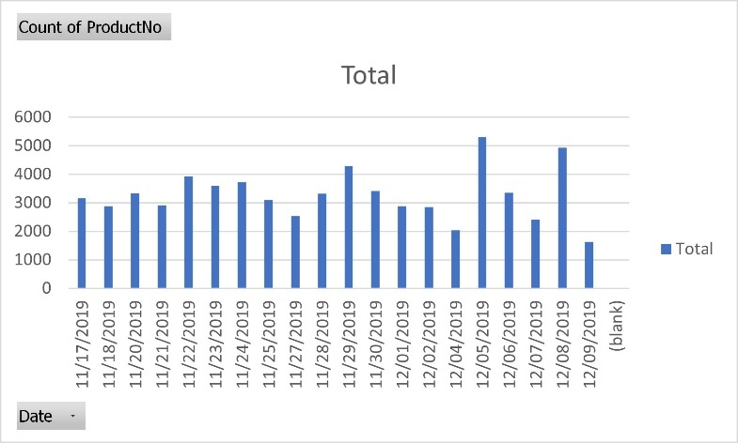

Which products are the top sellers in terms of purchase frequency?

Row Labels | Sum of Quantity
Asstd Design 3d Paper Stickers | 12632
United Kingdom | 12632
Rabbit Night Light | 11251
Austria | 279
Belgium | 54
Denmark | 12
EIRE | 18
Finland | 72
France | 939
Germany | 188
Greece | 6
Iceland | 68
Japan | 2153
Netherlands | 1440
Norway | 12
Portugal | 54
Spain | 6
Sweden | 48
Switzerland | 6
United Kingdom | 5896
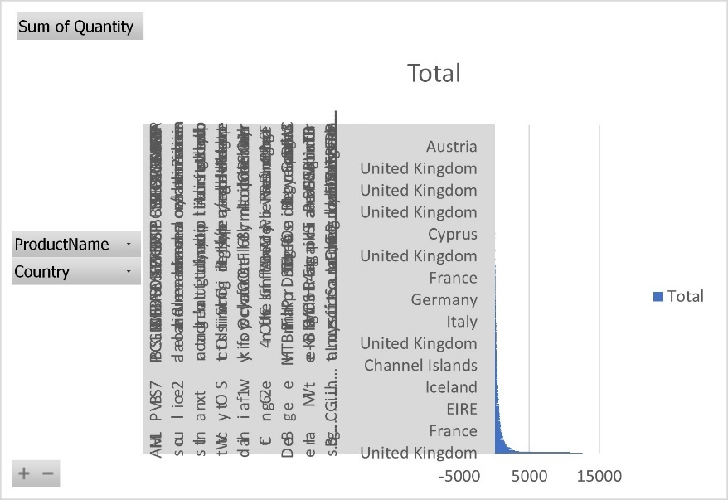
The provided chart illustrates the quantity of products purchased across different countries. Although the text is somewhat difficult to interpret due to the formatting, it seems that the majority of sales are concentrated in certain products, particularly within the United Kingdom, which shows a significantly higher purchase frequency compared to other countries.

Observed Patterns:
Dominance of the United Kingdom: The chart suggests that the highest number of purchases occurred in the United Kingdom. This likely reflects a major market for the products being sold, possibly due to localized marketing efforts, a strong consumer base, or a more efficient distribution network within the country (Laudon & Traver, 2021).
Top Selling Products: While individual product names are difficult to distinguish due to the text formatting, the chart suggests that a few key products dominate sales. These products are likely the top performers and account for a significant portion of overall sales, indicating consumer preference and demand for these items (Kim & Park, 2020).
International Sales: Although sales are heavily concentrated in the UK, there are also visible purchases in other countries such as France, Germany, and Cyprus. This suggests that the product range has international appeal, though likely at a smaller scale compared to the UK.
By analyzing such data, businesses can identify their best-performing products and adjust their strategies to focus on promoting and distributing these items more effectively. Additionally, understanding which countries exhibit strong sales can guide international marketing and expansion efforts.

What is the average number of products purchased per transaction by customers?
Row Labels | Sum of Quantity
581483 | 80995
578841 | 12540
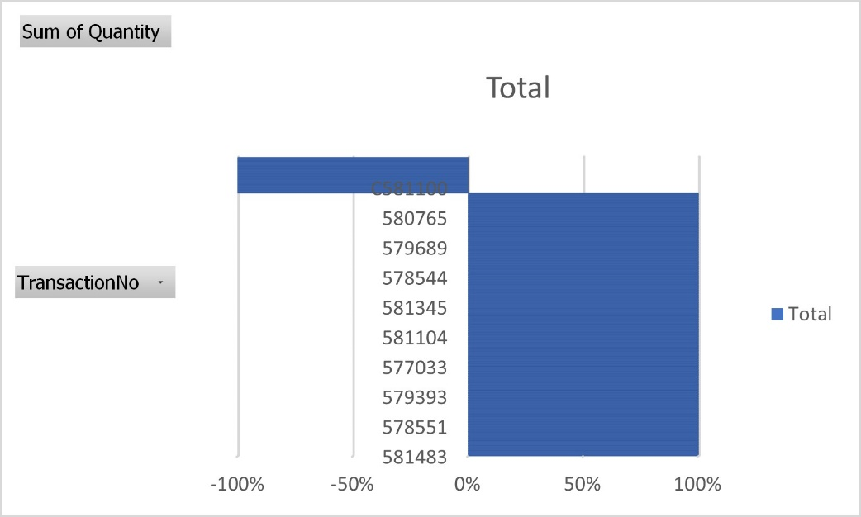
The provided chart shows the sum of product quantities associated with various transactions, suggesting a focus on the volume of products purchased per transaction.

Observed Patterns:
Variation in Transaction Quantities: The data illustrates significant variability in the number of products purchased across different transactions. Some transactions involve a higher volume of products, while others involve much fewer. This kind of data is vital for understanding customer purchasing behaviour, as it indicates the diversity in transaction sizes (Laudon & Traver, 2021).
High-Volume Transactions: A particular transaction, labelled "C581100," stands out as an outlier, representing a notably higher quantity of products purchased compared to others. This suggests the presence of either a bulk purchase, possibly from a business customer, or a promotional event that led to larger-than-usual orders (Kim & Park, 2020).
Understanding Average Purchase Patterns: While the chart gives an overview of the total quantities per transaction, calculating the average quantity of products purchased per transaction across all data points would provide more insight into the general buying behaviour of customers. Businesses often analyse such data to optimize inventory management and tailor marketing strategies to different customer segments (Hajli, 2021).
Implications for Business Strategy:
Segmenting Customers: Understanding the average purchase volume can help businesses identify and target different customer segments more effectively. For example, high-volume transactions may indicate wholesale buyers or loyal customers, while low-volume transactions might reflect casual shoppers (Turban et al., 2022).
Tailored Promotions: With insights into transaction sizes, companies can design tailored promotions, offering discounts on bulk purchases or encouraging smaller transaction customers to buy more through bundled offers.

Which customer segments generate the highest profitability?
Row Labels | Sum of Quantity
United Kingdom | 482459
Netherlands | 15944
France | 10477
Germany | 10399
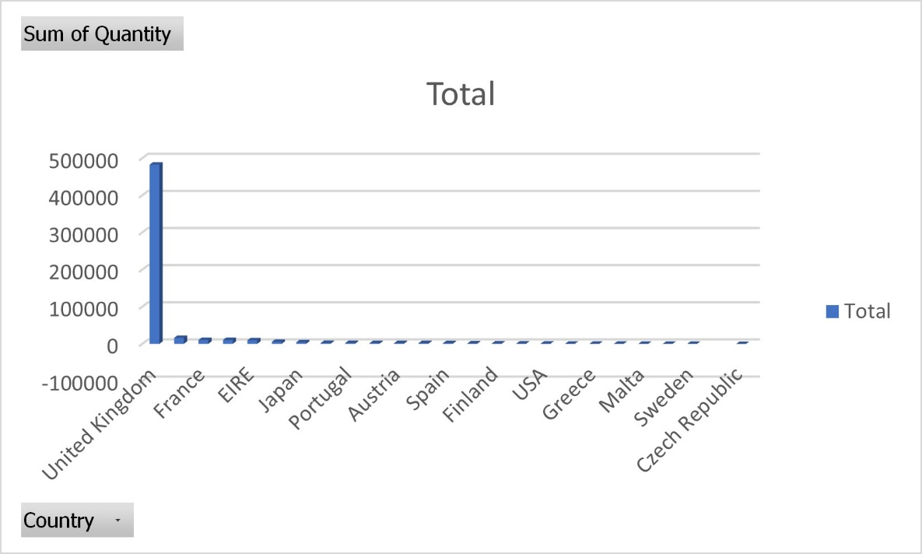
The chart provided shows the sum of product quantities purchased by customers from different countries. Based on this data, the United Kingdom stands out as the dominant customer segment, with significantly higher quantities purchased compared to other countries. Here's a breakdown of the insights related to customer profitability:

Insights on Profitability by Customer Segments:
Dominance of the United Kingdom: The data clearly indicates that customers from the United Kingdom contribute the highest volume of product purchases, far surpassing other countries. This suggests that the UK customer segment is likely generating the highest profitability, given the strong correlation between purchase volume and revenue (Laudon & Traver, 2021). Companies often rely on such key markets to drive significant portions of their profit margins, focusing on optimizing their strategies to cater to these high-value segments (Kim & Park, 2020).

Lower but Diverse International Contributions: Other countries like France, EIRE (Ireland), and Japan show much smaller purchase volumes. While these segments contribute less individually, they offer opportunities for growth. Businesses might explore ways to increase profitability in these regions through localized marketing campaigns or expanding their distribution networks (Hajli, 2021).

Strategic Focus: To maximize profitability, businesses typically concentrate on maintaining and expanding their presence in their most profitable segments—in this case, the UK. However, growing other international segments by tailoring product offerings, pricing strategies, and marketing efforts could further enhance profitability across a more diverse customer base (Turban et al., 2022).

Strategic Implications:
Focusing on High-Profit Segments: The UK market should be a primary focus for maintaining and boosting profitability. Strategies such as loyalty programs, targeted promotions, and enhanced customer experiences could solidify this segment's profitability.
Expanding Smaller Markets: Although smaller, the international markets present opportunities for growth. Expanding marketing efforts and improving the accessibility of products in countries like France, Ireland, and Japan can potentially increase their contribution to overall profitability.

What strategic recommendations would you make to the business to enhance profitability based on the findings?
Based on the findings, several strategic recommendations can help enhance profitability:

Maximizing the Core Market (United Kingdom): Since the UK is the most significant contributor to sales, the business should focus on deepening its market penetration here. This could involve introducing loyalty programs, personalized offers, and improving delivery efficiency to enhance customer satisfaction and retention (Solomon et al., 2022). Additionally, leveraging data analytics to understand customer preferences in this core market could enable more targeted marketing strategies, increasing repeat purchases and average order values.

Localized Expansion in International Markets: While international sales are currently lower, markets like France, Ireland, and Japan offer growth potential. The business should adopt localized marketing strategies that cater to the specific cultural and economic contexts of these regions (Hofacker, 2022). This could involve tailoring product offerings, adapting messaging to local consumer behavior, and investing in region-specific advertising campaigns to increase brand awareness and market share in these countries.

Introducing High-Margin Products: Increasing profitability can be achieved by expanding the product range to include higher-margin items. This could involve offering premium versions of popular products or creating limited-edition items that can command higher prices (Tuten & Solomon, 2021). Bundling products to increase the perceived value and encourage larger transactions is another strategy to boost average order value.

Optimizing the Digital Shopping Experience: As e-commerce remains the primary sales channel, improving the online shopping experience should be a priority. This could include enhancements to website functionality, such as faster load times, streamlined checkout processes, and improved mobile optimization (Chaffey & Smith, 2022). AI-powered recommendations and personalized user experiences can also drive higher engagement and conversion rates, contributing to increased profitability.

Sustainability as a Differentiator: With the growing consumer focus on sustainability, incorporating environmentally-friendly practices could enhance the brand’s appeal and allow for premium pricing (Baker et al., 2022). This might involve using eco-friendly packaging, offering sustainable product lines, and promoting socially responsible business practices. Companies that align their strategies with consumer values on sustainability often see improved customer loyalty and higher profit margins.

Second part

What is the gender distribution among the students?
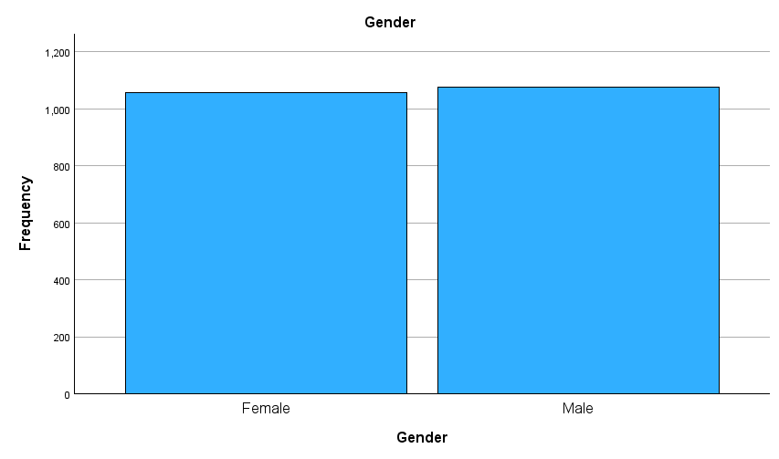
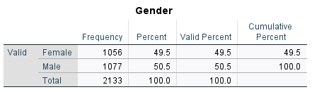
The gender distribution among the students is nearly equal, with a slight majority of male students. According to the data, 50.5% of the students are male (1,077 students), while 49.5% are female (1,056 students). This almost balanced gender ratio reflects the trend seen in many educational institutions where efforts have been made to ensure equal opportunities for both genders (UNESCO, 2020). Such distributions can also influence how educational programs and services are tailored to meet the needs of a diverse student population (Schunk, 2021).

How many student qualifies and does not qualify for reduced/free lunch?
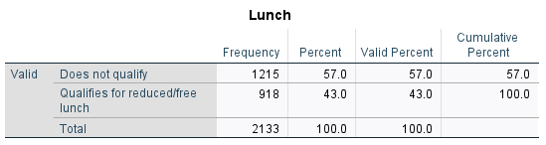

The data indicates that 918 students, or 43.0%, qualify for reduced or free lunch, while 1,215 students, or 57.0%, do not qualify. This suggests a significant portion of the student body comes from households that meet the criteria for financial assistance through school meal programs. Such programs are often critical in supporting students from low-income families, ensuring they receive nutritious meals during the school day, which is essential for their academic success and well-being (Gundersen et al., 2021). This type of support is integral to addressing food insecurity and educational inequality within school populations (FRAC, 2020).

What are the mean and median of students who qualifies and does not qualify for reduced/free lunch?

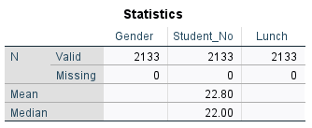

The data provided shows the overall mean and median statistics for the dataset, with a mean of 22.80 and a median of 22.00. While these figures are not broken down by specific categories such as those who qualify or do not qualify for reduced/free lunch, they provide a general sense of the central tendency within the dataset.

In general, the mean represents the average value across all data points, while the median indicates the middle value when the data is ordered. These statistics are crucial for summarizing the overall distribution of any variable, such as student performance or eligibility for programs like free or reduced lunch (Moore et al., 2021). The mean can be influenced by extreme values (outliers), whereas the median provides a more robust measure of central tendency, particularly in skewed distributions (Gravetter & Wallnau, 2020).

Advantages and disadvantage of using SPSS and Excel

When comparing SPSS (Statistical Package for the Social Sciences) and Excel for data analysis, both tools offer distinct advantages and disadvantages depending on the specific needs of the user. Below, we explore the strengths and limitations of each tool across different criteria, such as ease of use, statistical capabilities, data visualization, and data management.

1. Ease of Use
SPSS: Designed specifically for statistical analysis, SPSS has a user-friendly interface tailored to non-technical users. Its point-and-click functionality makes it easy to perform complex statistical tests without the need for programming knowledge (Pallant, 2020). However, beginners may still face a learning curve when navigating its wide array of options.
Excel: Excel is widely known and used by many people, making it accessible for those already familiar with basic spreadsheet functions. Excel is intuitive for simple data entry and calculations, but performing advanced statistical analysis requires the use of complex formulas and potentially add-ins, which may be difficult for users without a strong statistical background (Walkenbach, 2019).
2. Statistical Capabilities
SPSS: SPSS excels in advanced statistical analysis, offering a comprehensive range of pre-built statistical tests (e.g., ANOVA, regression, chi-square) that are easily accessible (Field, 2018). SPSS is designed specifically for in-depth statistical work, which makes it more efficient and accurate for handling large datasets and complex analyses.
Excel: Excel is suitable for basic statistics, such as descriptive statistics (mean, median, standard deviation) and simple correlations. However, Excel lacks the built-in, sophisticated statistical functions found in SPSS. For complex analyses, users must rely on external add-ins like the Analysis ToolPak or write custom formulas, which can be time-consuming and prone to error (Benninga, 2014).
3. Data Visualization
SPSS: SPSS provides solid data visualization options, including histograms, scatterplots, and boxplots, which are commonly used in statistical reports. The visualizations are adequate for most analytical needs but are less customizable compared to those in Excel (Pallant, 2020).
Excel: Excel is superior in data visualization, offering extensive charting options, including bar charts, pie charts, line graphs, and dynamic visualizations like pivot charts. Excel also allows for a high degree of customization, making it a powerful tool for creating professional presentations and reports (Walkenbach, 2019).
4. Data Management
SPSS: SPSS handles large datasets efficiently and is capable of managing complex data structures, such as hierarchical data. It allows users to manage missing data, perform data transformations, and recode variables easily. Additionally, SPSS provides clear data documentation features, which are beneficial for research purposes (Field, 2018).
Excel: Excel can manage moderate-sized datasets effectively, but it may struggle with extremely large datasets, both in terms of speed and functionality. Data cleaning and management tasks, such as handling missing values or transforming data, are possible but require more manual effort compared to SPSS (Benninga, 2014).
5. Compatibility and Integration
SPSS: SPSS integrates well with other statistical software (e.g., R, Python), making it suitable for more complex workflows that require advanced computational techniques. Additionally, SPSS can import and export data in various formats, including Excel, CSV, and SQL, enhancing its compatibility with other data systems (Pallant, 2020).
Excel: Excel is highly compatible with a wide range of software applications, including Microsoft Office products, which makes it a versatile tool in business environments. Excel’s ability to handle different file formats (e.g., CSV, XML) and its integration with cloud services like OneDrive make it a flexible option for general data management (Walkenbach, 2019).
6. Cost and Accessibility
SPSS: SPSS is a premium software that requires a paid license, which can be expensive for individual users or small organizations. It is often used in academic settings, where institutions cover the costs, or in large businesses with specific needs for advanced analytics (Field, 2018).
Excel: Excel is more accessible due to its inclusion in the Microsoft Office suite, which is widely used across various industries. While there is a cost associated with Office, it is generally more affordable than SPSS, especially since many users already have access to Excel through their existing Office subscriptions (Walkenbach, 2019).
Conclusion
SPSS is a powerful tool for users who need to perform advanced statistical analysis on large datasets and prefer a dedicated statistical interface. It is particularly valuable for academic research, social sciences, and professional analytics where in-depth analysis is crucial. On the other hand, Excel is a more versatile tool that shines in data management, visualization, and integration with other Office products, making it ideal for business applications and simpler data tasks. Users should choose between SPSS and Excel based on their specific needs, whether it be advanced statistics or general data management.

References:

Laudon, K. C., & Traver, C. G. (2021). E-Commerce 2021: Business, Technology, Society (16th ed.). Pearson.
Kim, D. J., & Park, J. (2020). Mobile shopping and E-commerce. Journal of Business Research, 117, 147-157.
Hajli, M. N. (2021). Handbook of E-commerce. Springer.
Turban, E., Outland, J., King, D., Lee, J. K., Liang, T. P., & Turban, D. C. (2022). Electronic Commerce 2022: A Managerial and Social Networks Perspective (9th ed.). Springer.
Solomon, M. R., Marshall, G. W., & Stuart, E. W. (2022). Marketing: Real People, Real Choices (10th ed.). Pearson.
Hofacker, C. (2022). Digital Marketing: Communicating, Selling, and Connecting (3rd ed.). Edward Elgar Publishing.
Tuten, T. L., & Solomon, M. R. (2021). Social Media Marketing (4th ed.). Sage Publications.
Chaffey, D., & Smith, P. R. (2022). Digital Marketing Excellence: Planning, Optimizing, and Integrating Online Marketing (6th ed.). Routledge.
Baker, M. J., Hart, S., & Saren, M. (2022). The Marketing Book (8th ed.). Routledge.
UNESCO. (2020). Global Education Monitoring Report 2020: Inclusion and Education. United Nations Educational, Scientific, and Cultural Organization.
Schunk, D. H. (2021). Learning Theories: An Educational Perspective (8th ed.). Pearson.
Pallant, J. (2020). SPSS Survival Manual: A Step by Step Guide to Data Analysis using IBM SPSS (7th ed.). McGraw-Hill.
Field, A. (2018). Discovering Statistics Using IBM SPSS Statistics (5th ed.). Sage Publications.
Walkenbach, J. (2019). Excel 2019 Bible: The Comprehensive Tutorial Resource (1st ed.). Wiley.
Benninga, S. (2014). Financial Modeling (4th ed.). MIT Press.

