Syntyche Ndikita
Student ID: 2228869
Module: International Meetings Management
Lecturer: Kathryn Flynn
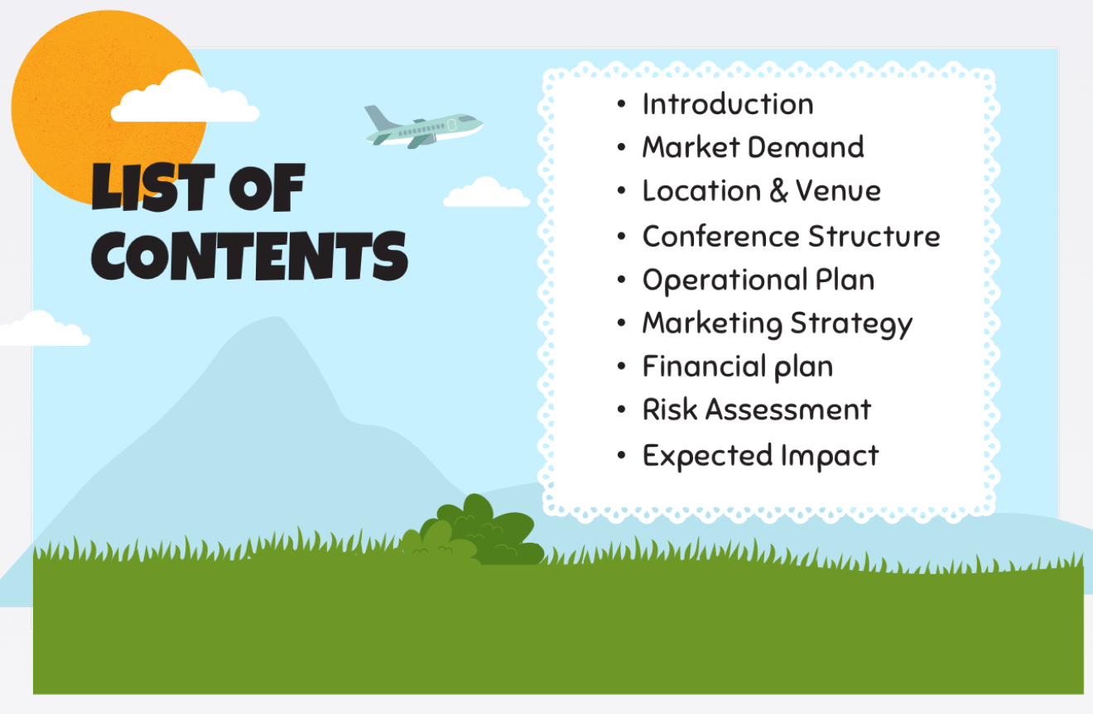
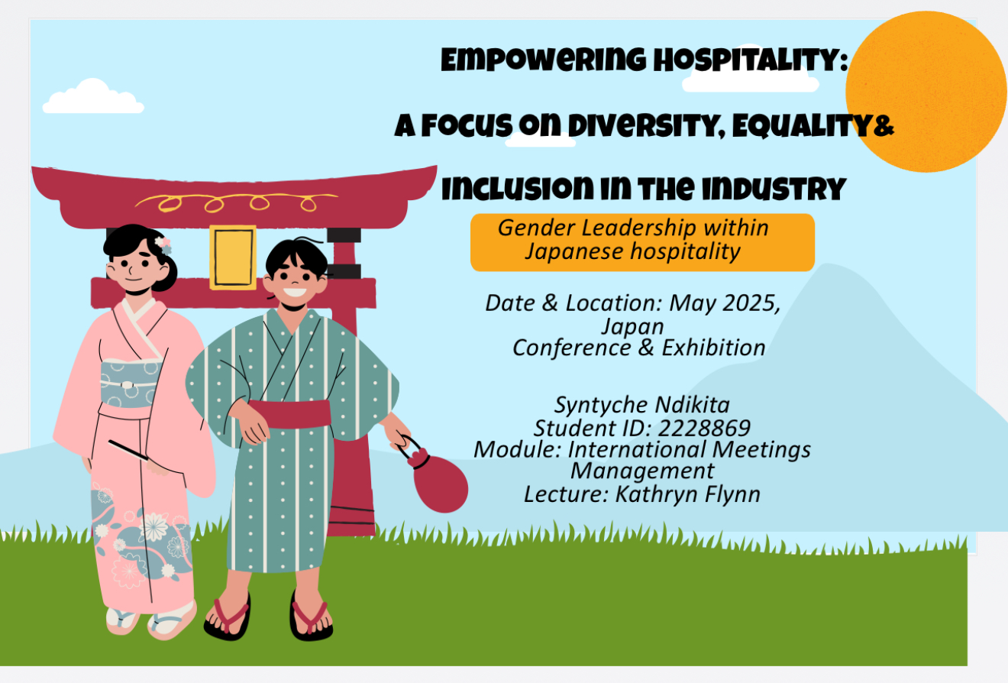
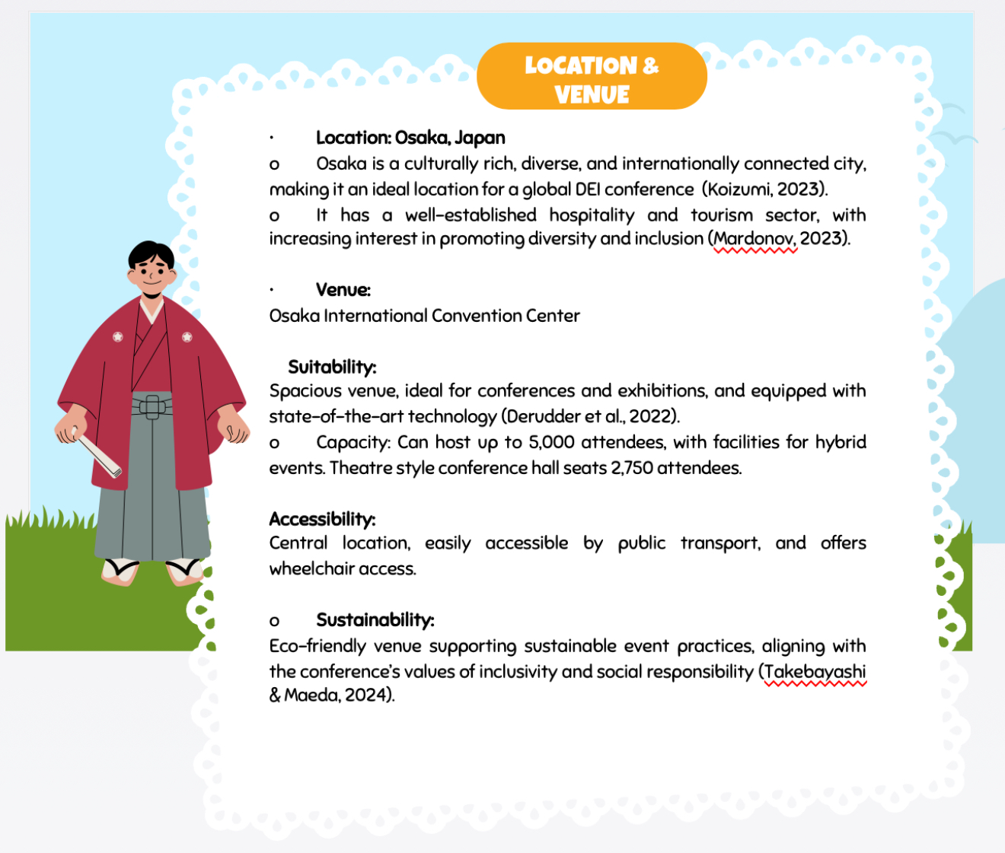
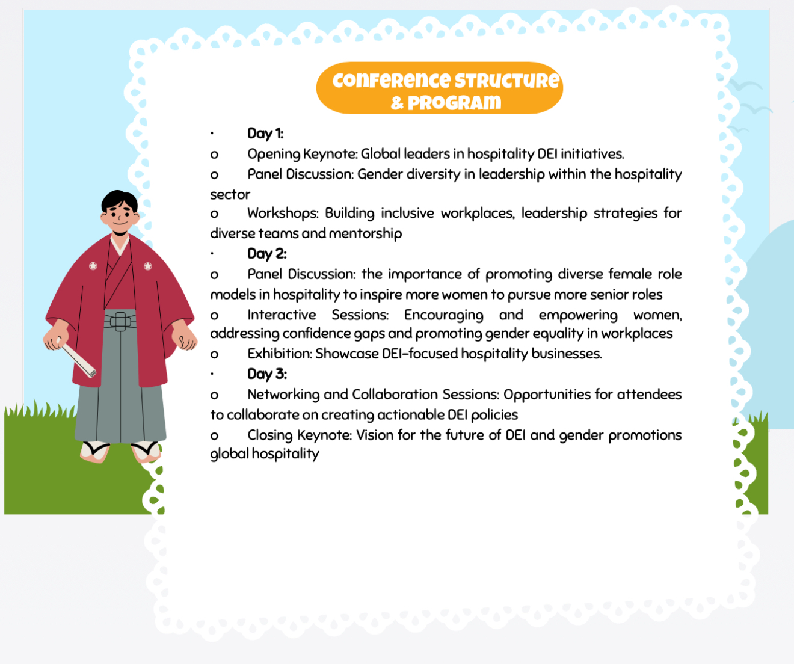
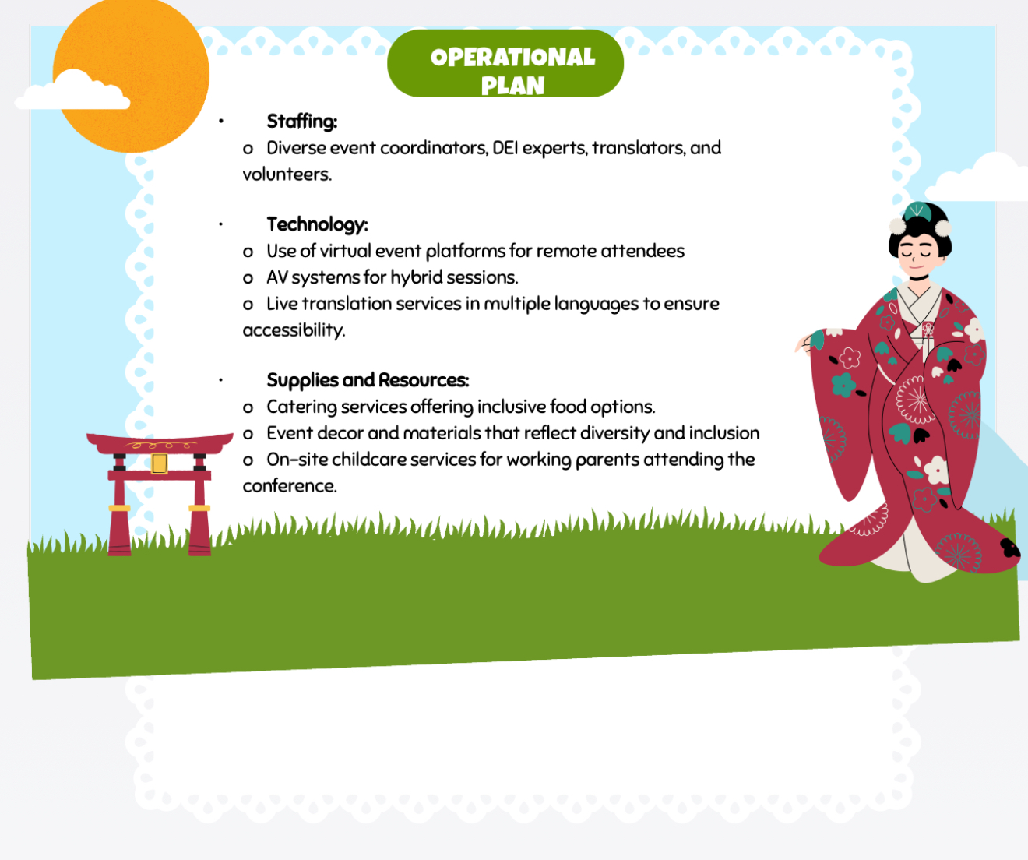
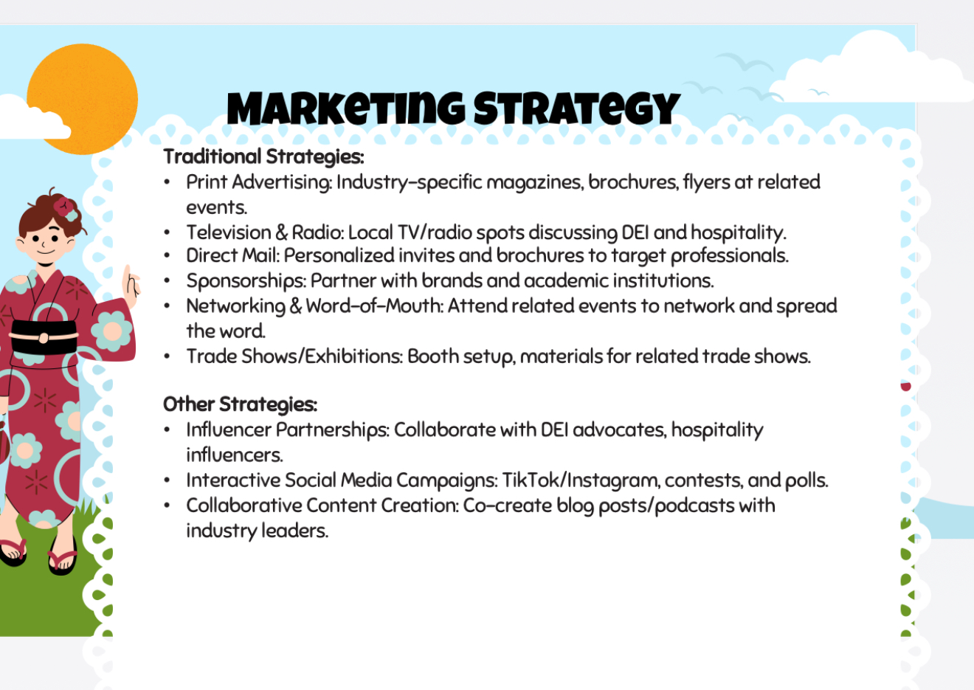
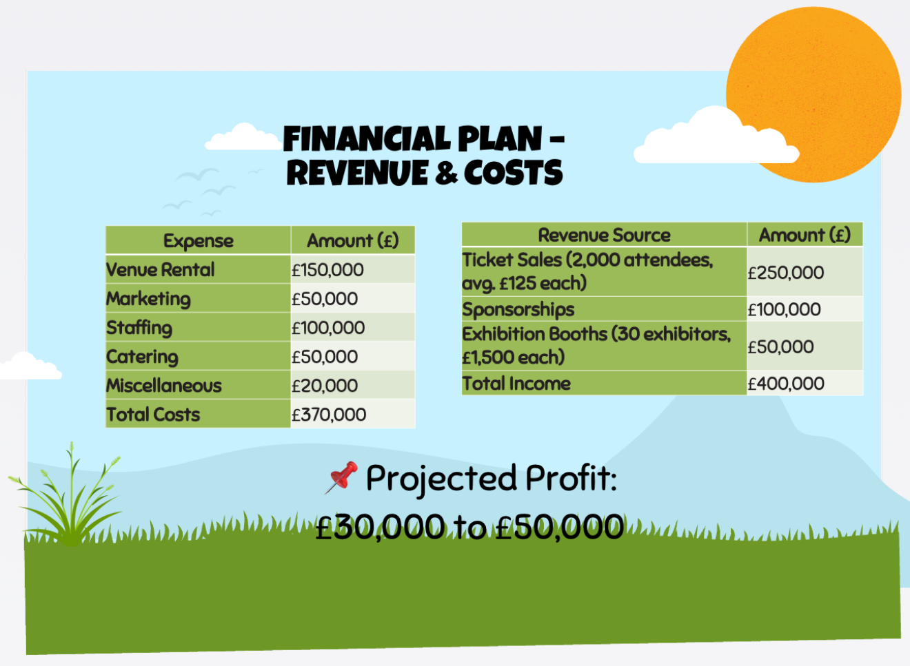
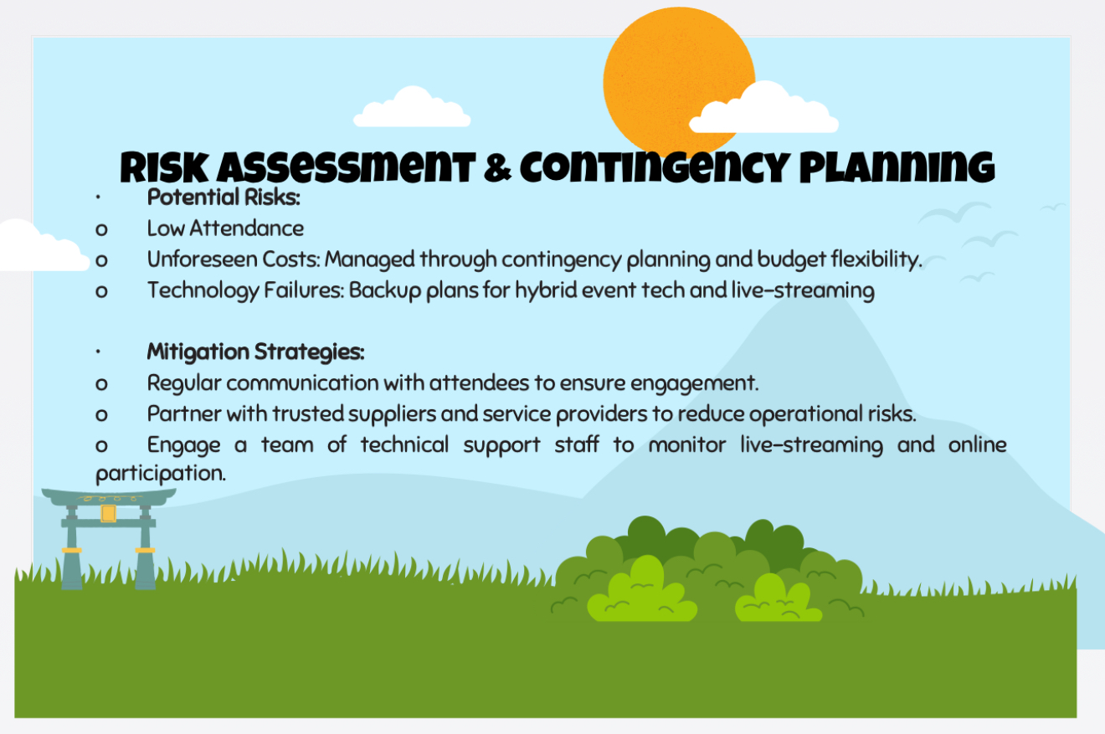

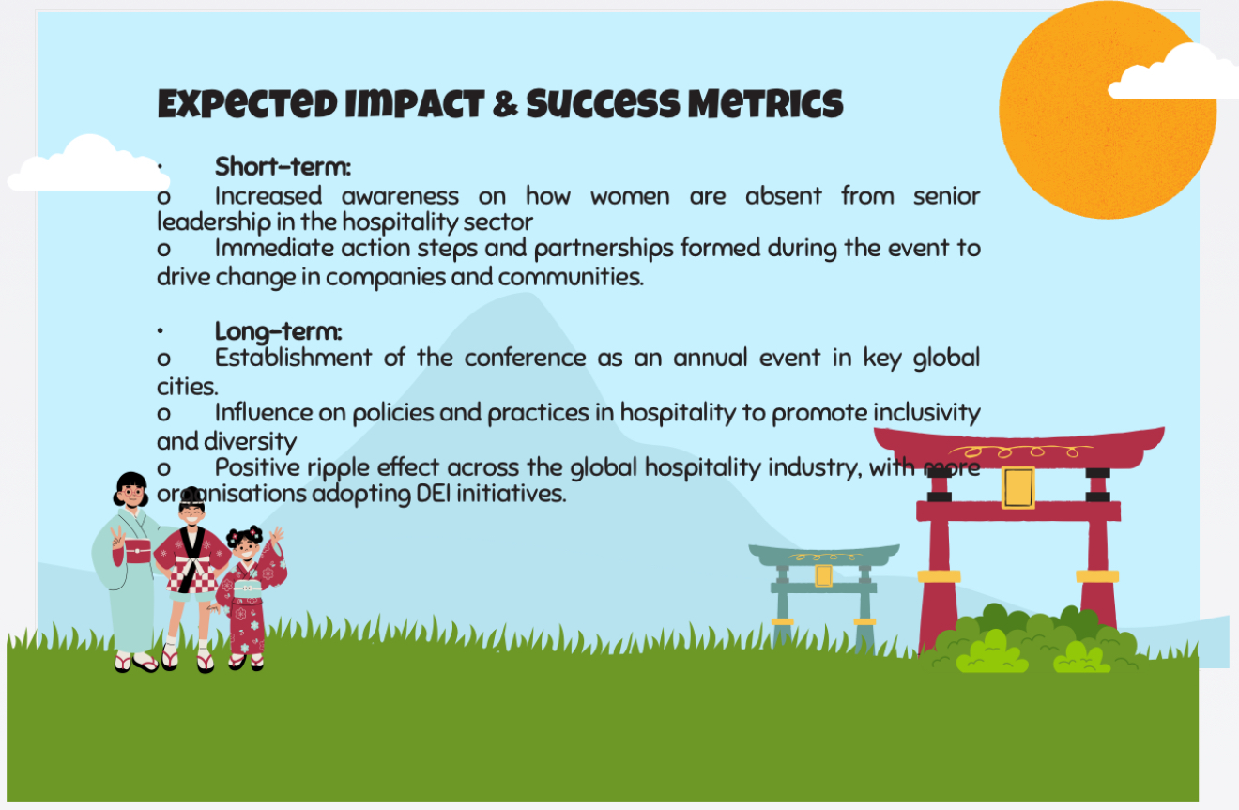

References

Ballester, P., 2024. World Expo and Sustainable Development Goals (SDGs). EXPO OBSERVE, pp. pp-29.
Bernauer, V.S., Bhati, A. and Thirumaran, K., 2023. Guest editorial:(In) equalities in hospitality and tourism–exploring diversity and equity issues. Equality, Diversity, and Inclusion: An International Journal, 42(4),
pp.465-468.
Boi, J.M., Widespread Hospitality as a form of sustainable tourism.
Brummer, C. and Strine Jr, L.E., 2022. Duty and diversity. Vand. L. Rev., 75, p.1.
Carlson, J.A., 2021. Hospitality in the House of God: Deconstructing Habit and Building Missio Dei.
Derudder, B., Feng, X., Shen, W., Shao, R. and Taylor, P.J., 2022. Connections between Asian and European world cities: Measurement, analysis, and evaluation. Land, 11(9), p.1574.
Faishal, M., Mathew, S., Neikha, K., Pusa, K. and Zhimomi, T., 2023. The future of work: AI, automation, and the changing dynamics of developed economies. World Journal of Advanced Research and Reviews, 18(3), pp.620-629.
Galeone, A. and Sebastiani, R., 2021. Transformative service research in hospitality. Tourism Management, 87, p.104366.
Gonzalez Basurto, G., 2023. Mega-events and Public Economics in Japan: Tokyo 2020, Osaka 2025, and Sapporo 2030 (Doctoral dissertation, Kansai GaidaiUniversity).
I'm, J. and Chung, Y.K., 2023. Exploring diversity, equity, and inclusion in hospitality and tourism firms through the organizational justice and stakeholder theories. Tourism Management, 95, p.104662.

Kim, H., Shin, Y.H. and Severt, K., 2024. Inclusive Leadership and Positive Outcomes Through Hotel Employees' Perceptions of Inclusion. International Journal of Hospitality & Tourism Administration, pp.1-21.
Koizumi, R., 2023. Mega-events and urban socio-economy: Urban development through Tokyo 2020 and Osaka 2025. In Political Economy of the Tokyo Olympics (pp. 67-89).Routledge.
Lewis, L., 2023. What is the point of an expo in today's world? Opinion Asia. The Financial Times, pp.16-16.
Madera, J.M., Manoharan, A. and Singal, M., 2024. The future of diversity, equity, and inclusion research in hospitality. In The Routledge Handbook of Diversity, Equity, and Inclusion Management in the Hospitality Industry (pp. 406-414). Routledge.
Manoharan, A., Madera, J.M. and Singal, M. eds., 2024. The Routledge handbook of diversity, equity, and inclusion management in the hospitality industry. Routledge.
Mardonov, S.S.U., 2023. THE EVOLUTION OF TOKYO AND OSAKA AS MEGA-AGGLOMERATIONS. International scientific journal of Biruni, 2(3), pp.28-36.
Ponting, S.S.A. and Dillette, A., 2023. Diversity, equity, and inclusion practices: a Delphi study to build a consensus in hospitality and tourism organizations. International Journal of Contemporary Hospitality Management, 35(11), pp.3764-3786.
Ryu, K., 2024. In search of spirituality for intercultural mission: Hospitality, solidarity and marginality. Transformation, p.02653788241244541.
Takebayashi, H. and Maeda, N., 2024. Effects of adaptation measures to extreme heat throughout medium and high temperature periods, case study at the Osaka expo site. Scientific Reports, 14(1), p.5914.

Tracey, J.B., Le, V., Brannon, D.W., Crystal-Mansour, S., Golubovskaya, M. and Robinson, R.N., 2023. The influence of diversity management initiatives on firm-level diversity: evidence from the restaurant and foodservice industry. International Journal of Contemporary Hospitality Management, 35(11), pp.4010-4030.
Walters, T. and Higgins-Desbiolles, F., 2024. Opportunity lost addressing DEI in academic conference design practices. International Journal of Event and Festival Management.
Zallio, M. and Clarkson, P.J., 2022. Designing the metaverse: A study on inclusion, diversity, equity, accessibility, and safety for digital immersive environments. Telematics and Informatics, 75, p.101909.
Japan meetings and events (2025) Osaka International Convention Centre
Available at: https://www.japanmeetings.org/plan-your-event/search/venue-detail/970.html
(Accessed 20th Jan 2025)
WIT by NORTHSTAR (2024 Y S Hoon) let's talk proudly about women and LGBTQ+ travellers in Japan
Available at: https://www.webintravel.com/lets-talk-proudly-about-women-and-lgbtq-travellers-in-japan/
(Accessed 20th Jan 2025)

