

University of Wales Trinity Saint David
Technical Authoring

Ordnance, Munitions and Explosives Bachelor of Engineering Programme (BEng)

Academic Year: 2021 - 2026

Craig Maclellan

The performance of the longbow against plate armour at the Battle of Agincourt

Supervisor: Gareth Collett
Associate Supervisor: David Holley
December 2023

This thesis is submitted in partial fulfilment of the requirements for the degree of Ordnance, Munitions and Explosives (Safety)

© UWTSD 2023. All rights reserved. No part of this publication may be reproduced without the written permission of the copyright owner.

Academic integrity declaration
I declare that:
- the thesis submitted has been written by me alone.
- the thesis submitted has not been previously submitted to this university or any other.
- that all content, including primary and/or secondary data, is true to the best of my knowledge.
- that all quotations and references have been duly acknowledged according to the requirements of academic research.
I understand that to knowingly submit work in violation of the above statement will be considered by examiners as academic misconduct.

Abstract
The Battle of Agincourt was a pivotal event in medieval warfare and has been historically celebrated for the strategic brilliance of King Henry V and the prowess of the English Longbow. However, this report seeks to delve beyond the conventional narrative, meticulously exploring the multiple factors that shaped the battle's outcome. From the famed English Longbow to the innovative Needle Bodkin Arrow, the report examines historical weaponry.
Through an in-depth analysis of tactical strategies, terrain conditions, and the logistical intricacies of medieval warfare, this report presents a non-biased perspective. It challenges the notion of the Longbow as the sole determinant of victory, unravelling the complexities that contributed to the English victory. The discussion encompasses the evolution of armour, the logistical challenges of arrow supply, and the geographical context of the battle, casting scepticism on established narratives.
Navigating the mathematics of arrow flight, the report explores the efficiency of bows and the complexities of arrow motion. It emphasizes the synergy of different arms on the battlefield, urging a comprehensive understanding of Agincourt. By scrutinizing historical records, quirks, and stories, the report offers a holistic view of this historic clash, encouraging a revaluation of the factors that truly influenced the Battle of Agincourt.

Table of Contents
Academic integrity declaration i
Abstract ii
List of Figures iv
List of Equations v
1. Introduction 1
2. Analysis of Historical Battle Equipment 2
2.1 Legacy and Lethality of the English Longbow 2
2.2 Impact and Design of Needle Bodkin Arrow 4
2.3 Evolution and Impact of Armour in Battle 5
2.4 Rondel Dagger 6
2.5 Type XVa Sword 6
3. Context and Significance of Battle of Agincourt 7
3.1 Exploring the Geographical Location of Agincourt 9
4. Arrow Reckoning 10
4.1 Navigating the Mathematics of Kinetic Energy and Precision 11
5. Assessing Challenges in Command 13
6. Discussion 14
7. Conclusion 15
References 16

List of Figures
All text is hyperlinked to source of figures.
Figure 1 – Drawing of archers at Agincourt using English Longbow
FIGURE 2 – THE ENGLISH LONGBOW - Sourced from Medieval Longbow, Medieval Britain
Figure 3 – Drawing of Needle Bodkin Arrow - Sourced from MEDIEVAL ARROWHEADS DATABASE, GREX LUPORUM
FIGURE 4 – A selection of fifteenth century arrowheads discovered during the Towton Battlefield Archaeological Survey (Near Agincourt) - Sourced from THE BATTLE OF AGINCOURT:AN ALTERNATIVE LOCATION? TIMOTHY SUTHERLAND.
FIGURE 5 – Figure of arrows against knight in armour. - Sourced from Tod's Workshop
FIGURE 6 – 15th Century English Rondel Dagger - S
FIGURE 7 – Type XVa Sword - Sourced from My Armoury, Mark Mattimore
FIGURE 8 – The Two Armies Assemble
- Sourced from The History of England, Cerdic
FIGURE 9 – English archers at The Battle Of Agincourt - Sourced from My Armoury, Alexi Goranov
FIGURE 10 – Map of the fields between Agincourt, Tramecourt and Maisoncelle showing the location of artefacts recorded during the archaeological survey. - Sourced from THE BATTLE OF AGINCOURT:AN ALTERNATIVE LOCATION? TIMOTHY SUTHERLAND.
FIGURE 11 – Elements of Archers Paradox - Sourced from Understanding Archery
FIGURE 12 – Sheaf of arrows - Sourced from Endeavour Archery, Geoff
FIGURE 13 – Charles, Duke of Orleans (left), Charles d’Albert, Constable of France (middle), Jean le Meingre, dit ‘Boucicaut; Marshal of France (right) - Sourced from Osprey Publishing

List of Equations
EQUATION 1 – Kinetic Energy Equation
$$E_{k}= \frac{1}{2}x m x V^{2}$$
$$E_{k}=\frac{M x (V^{2})}{450,240}$$

Introduction
In examining the Battle of Agincourt, a critical event in medieval warfare, it is imperative to explore the multiple factors that contributed to the overall outcome. While the English Longbow is often glorified as a formidable weapon that played a significant role in shaping the narrative of the battle, it is essential to approach this report with a non-biased perspective. This report seeks to unravel the complexities surrounding the Battle of Agincourt and to assert that the English Longbow, while undoubtedly influential, may not have been the sole determining factor in the outcome. Through examination of various contributing elements such as tactical strategies, terrain conditions, and the interplay of different arms, this report aims to provide a comprehensive understanding of the dynamics that unfolded on the historic battlefield.
The Battle of Agincourt was a significant clash between England and France during the Hundred Years' War that occurred on October 25, 1415, near the town of Agincourt in northern France. This battle is well-known not only for its historical importance but also for the strategic brilliance and optimism exhibited by King Henry V who outmanoeuvred the larger French army, ultimately leading his army to victory. Amid the prolonged conflict of the Hundred Years' War, where the English and French fought for control over crucial territories in France, Henry V, aiming to assert his claim to the French throne, commanded an English army to face considerable odds against the larger French forces led by the Constable Charles d'Albret as well as the Duke of Orleans and Marshal or France.

Analysis of Historical Battle Equipment

Legacy and Lethality of the English Longbow
The English Longbow is an iconic weapon associated with medieval warfare that gave way to more modern technologies. Sources believe that the Welsh was the first to develop the tactical use of the longbow which has gone to earn a lofty status in historical narratives, particularly in its portrayal of the Battle of Agincourt. Known for its long-range capabilities and reputed armour-piercing arrows, the Longbow has often been cast as the key factor that tilted the balance in favour of the English forces.
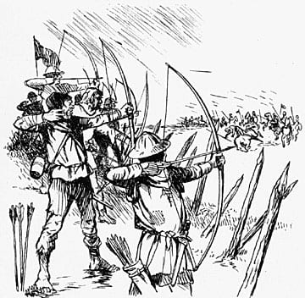
Figure 1 – Drawing of archers at Agincourt using English Longbow
Its depiction as a decisive factor in Agincourt has been fuelled by tales of devastating volleys, contributing to a prevailing perception that attributes the English victory primarily to the Longbow. This perception, while not entirely unfounded, warrants a closer examination, as historical events are seldom determined by a singular weapon alone. Delving into the complexities of the battle requires a degree of understanding of the broader context, encompassing strategic decisions, the interplay of various arms, and the environmental conditions that collectively shaped the outcome at Agincourt [1].
The last recorded use of the Longbow by the English during battle was by ‘Mad Jack’ Churchill in 1940 at Dunkirk [1]. Jack was believed to have killed German soldiers with his longbow but in a later interview he stated that his longbow was in fact ran over and crushed by a lorry [2].
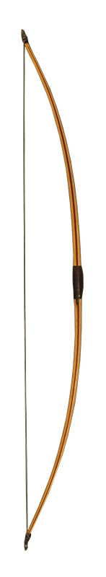
Figure 2 – The English Longbow
Although an iconic weapon, there are also some fun facts / myths associated with the Longbow, one being the swearing with two finger hand gesture that is believed to have originated from the Battle of Agincourt when the French threatened to cut off the fingers off any English archer so the English, jokingly, stuck their fingers up at the French [3]. Lastly, the rule of thumb is also thought to have derived from the archers measuring the space between their bows and string to make sure the string was not slack.

Impact and Design of Needle Bodkin Arrow
The needle bodkin arrow, characterized by its narrow, pointed tip [Fig.03] specifically designed for armour-piercing, emerged as a crucial innovation in medieval archery.
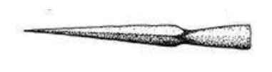
Figure 3 – Drawing of Needle Bodkin Arrow
This specialized arrowhead, finely crafted to penetrate armour with precision, revolutionied the capabilities of archers on the battlefield. Unlike conventional arrows, the Bodkin arrow prioritized penetrating power over a broadhead design, making it highly effective against armoured opponents [5].
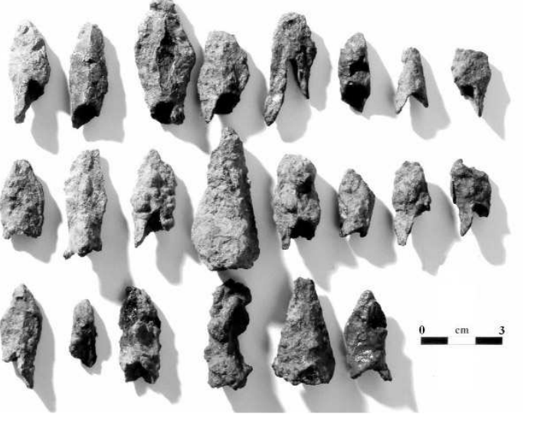
Figure 4 - A selection of fifteenth century arrowheads discovered during the Towton Battlefield Archaeological Survey (Near Agincourt)

Evolution and Impact of Armour in Battle
During the medieval period, the French presented a diverse composition, comprising both heavily armoured knights [Fig.05] adorned in a plate or chain mail and men-at-arms with varying degrees of protective gear. The knights, characterized by their imposing armour, were often equipped with plate or chain mail, offering formidable defence on the battlefield. In contrast, men-at-arms exhibited a range of protective measures, reflecting the diverse socio-economic backgrounds within the military ranks. The effectiveness of armour in countering projectile attacks, such as arrows, was exemplified by the weight and construction of the armour itself.
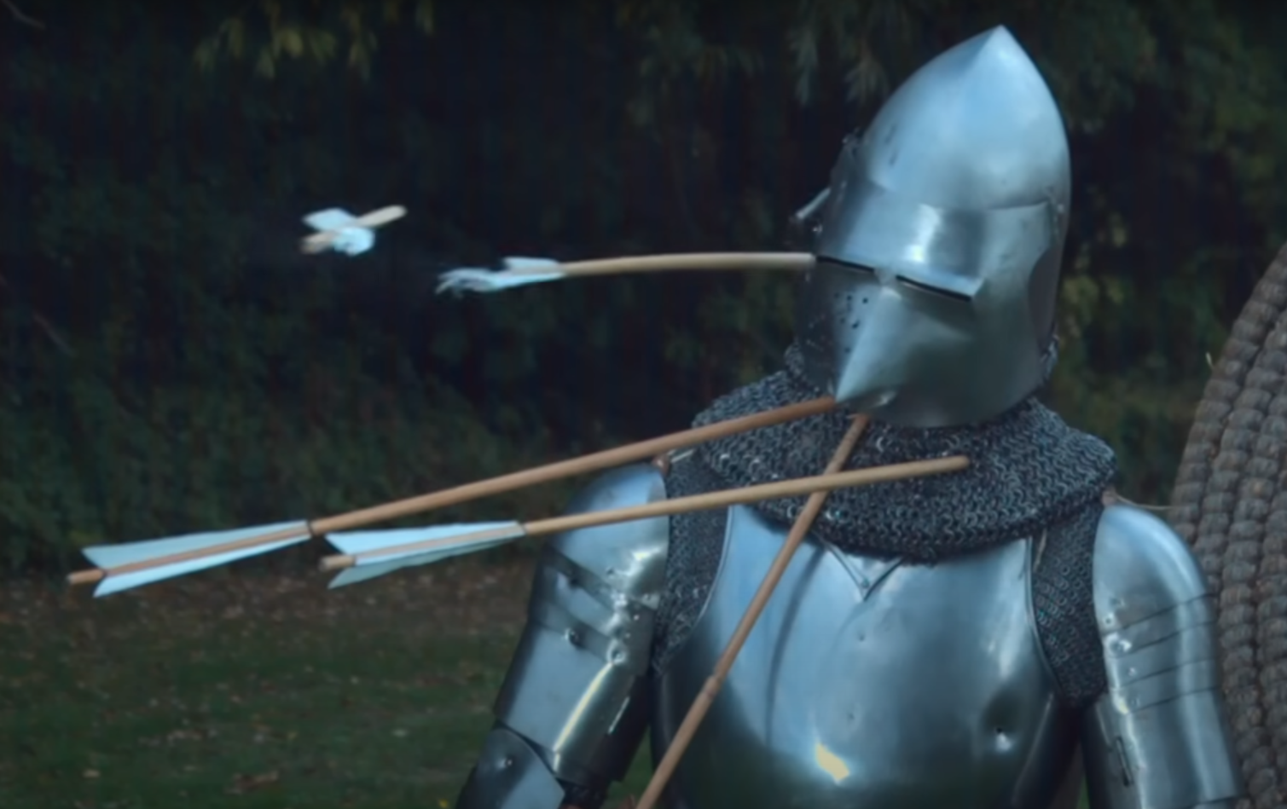
Figure 5 – Figure of arrows against knight in armour.
A breastplate of moderate quality, correctly fashioned and weighing between 50 to 60 pounds (23 to 27 kg), posed a formidable barrier against arrows. The design and weight of such armour, coupled with the use of traditional bows with substantial draw weights, created a scenario where an arrow of true weight and construction, when shot from a powerful bow, would not easily penetrate a well-crafted breastplate. These dynamic highlights the intricate interplay between the offensive capabilities of archers and the defensive strength of armoured forces in medieval warfare [7].

Rondel Dagger
The 15th-century rondel dagger [Fig.06] served as a secondary weapon in situations where close combat rendered primary weapons impractical. These daggers, featuring exceptionally sturdy cross-sections, were crafted with the purpose of inflicting harm and penetrating armor. Capable of navigating through mail by splitting rings, they could effectively breach openings in plate armor when combat was close [8].
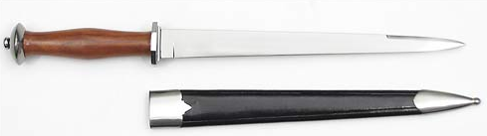
Figure 6 - 15th Century English Rondel Dagger

Type XVa Sword
One big trend back in medieval times was the use of cutting-focused swords that were more about cutting stuff. This style of sword was dominant until around the middle of the 14th century. The design of these swords were linked to the armour they were up against.
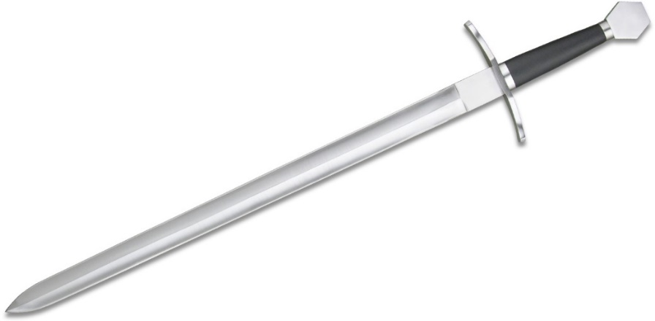
Figure 7 - Type XVa Sword

Context and Significance of Battle of Agincourt
The Battle of Agincourt comes with scepticism regarding what the actual numbers where on the day of the battle as multiple sources will say a different number. Figure 6 gives a good representation of what the formations looked like on the day, but the numbers are arguably a bit farfetched when compared to other honourable sources.
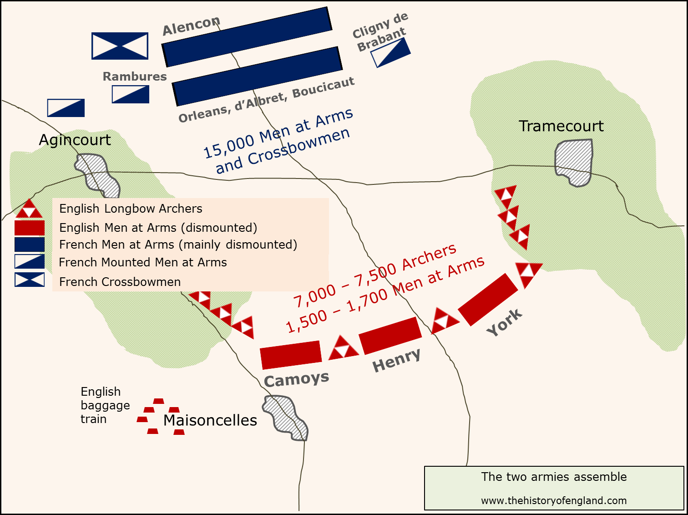
Figure 8 – The Two Armies Assemble
The composition of the two armies was very different. The French army, believed to have been about 15,000 or less, was dominated by heavily armoured Men at Arms, both mounted and on foot. There are reports of the French employing crossbowmen, but they weren’t as prominent as the English archers. The English used the narrow nature of the battlefield and muddy conditions to lead the French into a choke point. The weapons that gotten There were three detachments; two to sweep away the English archers on the wings, and one to gather the locals and cause a distraction by attacking the baggage train. The baggage train was outside nearby Maisoncelles where henry spent the night of 24th October.
The English archers at the Battle of Agincourt were employed to draw their longbows repeatedly, shooting arrows at a desirable rate of around 10 per minute for maybe 10 minutes at a time. Archers were a prominent force as they were the medieval artillery. Most damage was done by indirect fire i.e. there was no enemy in mind when aiming, the target was the masses of enemy soldiers. The idea was to fire an abundance of arrows such that it creates a cloud of arrow, showering over the enemies, disrupting their tactics with distractions from above as they advance towards the English. In some degree, the more random the flight of the arrows were, the better. Although a lack of certainty with aiming, the archers, equipped with needle bodkin arrows, still wanted to inflict maximum damage to the French calvary. The arrows were fired at a high trajectory, gaining a considerable amount of energy, presenting a threat for the French.
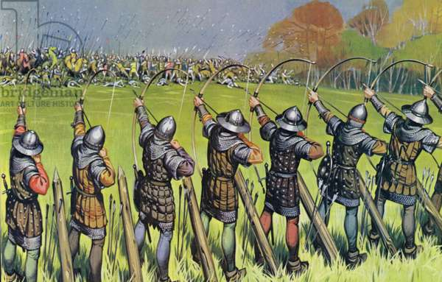
Figure 9 - English archers at The Battle Of Agincourt
Archers were reputed to be able to fire their bodkin arrows through the visors or joints of suits of armour. Even if the arrows could not penetrate good armour at short range, archers would certainly impede the enemies’ progress by shooting their horses. It is likely that horses would be armoured in front but vulnerable to attack from the sides. A warhorse presents a big target so it would not require a great deal of accuracy to damage one. It is impossible to comprehend the full horror of what happened at the battlefield, with dead horses and men creating obscene obstacles. The mud would have been a huge impediment to surviving the heavy armoured knights, making them easy prey to archers.

Exploring the Geographical Location of Agincourt
It has not been archaeologically confirmed where the site of the battle of Agincourt lies. In 2004, Robert Hardy proposed construction for a wind farm in Agincourt close to the battlefield which provoked an outcry, that the historic location was at risk. The response to this was that the location had not been confirmed so the land cannot be protected. Anne Curry states in one of her books ‘There is no dispute about the location of the battle’. This proves the lack of clarity around the Battle of Agincourt mainly due to a lack of evidence [8] [9].
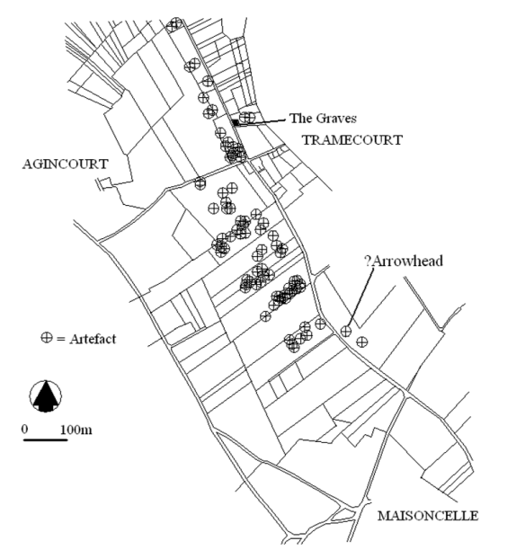
Figure 10 - Map of the fields between Agincourt, Tramecourt and Maisoncelle showing the location of artefacts recorded during the archaeological survey.

Arrow Reckoning
Bow efficiency plays a crucial role in the dynamics of archery, influencing the transformation of potential energy stored in the bow into kinetic energy imparted to the arrow upon release. As the bowstring is loosed, the elastic properties of the bow contribute to the arrow's acceleration, translating stored energy into forward motion. However, the process is not entirely efficient, and some energy is lost in the transfer.
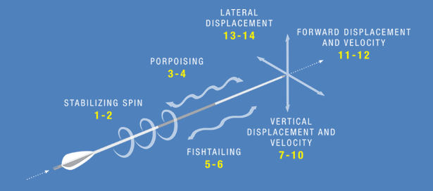
Figure 11 - Elements of Archers Paradox
The complex nature of arrow motion adds another layer to the intricacies of archery. The Archer's Paradox, a phenomenon where the arrow flexes around the bow upon release due to the arrow's natural oscillation, is just one aspect of this complexity. There are at least 14 modes of movement associated with an arrow in motion, each contributing to the overall trajectory and behaviour of the projectile. Understanding these intricate dynamics is essential for archers seeking to optimise their technique and enhance the efficiency of arrow flight.

Navigating the Mathematics of Kinetic Energy and Precision
$$E_{k}=\frac{M x (V^{2})}{450,240}$$
$$E_{k}=\frac{1800 x ({175}^{2})}{450,240}$$
$$E_{k}=122.29 J$$
Equation 1 – Form of Kinetic Energy Equation: M = Mass (grains), V = Velocity (fps)
Archers use Equation 1 to calculate the kinetic energy of their arrows. This is important because kinetic energy is an indicator of the arrow's penetration power and effectiveness in reaching and impacting the target. By understanding and optimising the kinetic energy, archers can tailor their equipment, including the bow and arrow specifications, to achieve the desired performance for their intended use. The factor 450,240 helps in providing a meaningful and practical measure of kinetic energy in the context of archery [10].
In medieval arsenals, each archer was equipped with a sheaf, a bundle containing enough arrows to fill a quiver or fulfil each archer's allotment. Arrows were typically acquired or issued in sheaves of 24, although some historical references suggest that sheaves might have contained only 12 arrows each. It was common for archers to carry two or three sheaves, thereby ensuring a formidable arsenal of 48 to 72 arrows per archer. This extensive supply not only reflected the strategic foresight of medieval military commanders but also emphasised the critical role that archers, armed with specialized Bodkin arrows, played in combating armoured adversaries on the medieval battlefield [6].
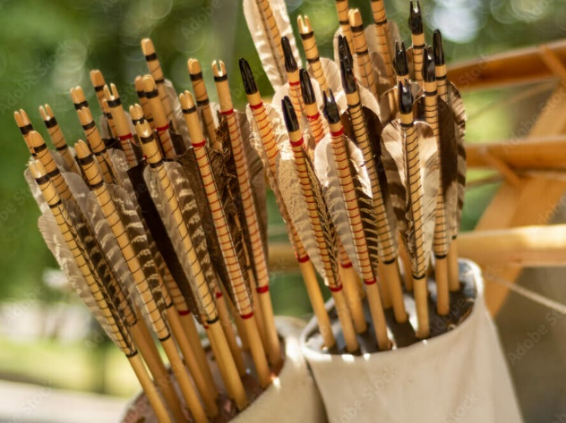
Figure 12 – Sheaf of arrows
Anne Curry's estimates indicate that the English, comprising approximately 8,680 soldiers, included a substantial force of 5,000 archers. Anne Curry based these figures off an incomplete sick list which isn’t the most liable source. Each archer, armed with sheaves of 72 arrows, carried a formidable arsenal that could weigh 5 to 6 kilograms. The logistical challenge of transporting such vast quantities of arrows is underscored by the suggestion that arrows could have been conveyed on wagons. Using calculations based on the number of archers and their arrows, the potential barrage of arrows fired in the battle becomes staggering. If all archers unleashed their entire complement of 72 arrows, it would result in a formidable 360,000 arrows. Even with a more conservative estimate considering the lower end of the number, approximately 120,000 arrows would have been discharged. The Battle of Agincourt, therefore, emerges as a testament not only to strategic awareness but also to the meticulous planning and execution of logistics that sustained the English army's formidable archers [7].

Assessing Challenges in Command
A height of strategic and tactical errors, coupled with an underestimation of the longbow's impact, inadequate adaptation to battlefield conditions, and an overconfident approach, collectively led to critical mistakes by the French leadership during the Battle of Agincourt. These factors intricately effected the narrative of the battle, resulting in a decisive defeat for the French at the hands of the English. Although the French leadership's failure to grasp the longbow's potency, more importantly, the inability to adjust tactics to the muddy terrain, proved detrimental. Additionally, an overconfident demeanour further exacerbated their predicament, contributing significantly to the unfavourable outcome. In essence, a combination of missteps in strategy, tactics, and battlefield adaptation, paired with an underestimation of the longbow's prowess and overconfidence, delineates the chain of errors that marked the French leadership's approach at Agincourt, ultimately sealing their fate in a resounding defeat against the English forces.
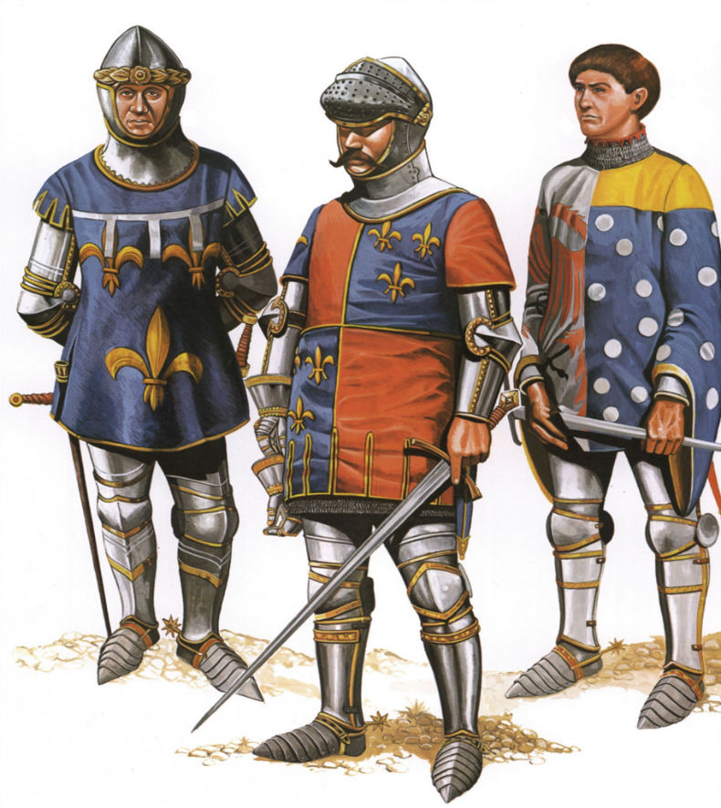
Figure 13 - Charles, Duke of Orleans (left), Charles d’Albert, Constable of France (middle), Jean le Meingre, dit ‘Boucicaut; Marshal of France (right).

Discussion
In exploring the performance of the longbow against plate armour at the Battle of Agincourt, the report acknowledges its iconic status and reputation for armour-piercing capabilities. However, it urges a careful examination into other strategies.
The report further delves into the Needle Bodkin Arrow, highlighting its innovative design and contribution to medieval archery. A detailed discussion on the logistics of arrow supply, the potential number of arrows unleashed in battle, and the weighty implications of such quantities.
Examining the evolution and impact of armour in battle, the report sheds light on the varied composition of the French army, emphasising the defensive strength armour provided against arrows. The discussion on breastplates and their resilience against the arrows underscores that the arrows weren’t that effective. The dagger was the weapon that got the most kills followed by the sword.
Geographical context becomes a focal point, questioning the archaeological confirmation of the battlefield's location, creating scepticism regarding the battle's actual numbers, and adding a layer of uncertainty. It is not unthinkable to believe that the English army praised themselves upon return and claimed to have fought a bigger battle than the one that occurred. What if the English Longbow was never used?
Section 4 - Arrow Reckoning navigates the intricate mathematics of kinetic energy, emphasising its role in optimising arrow performance. The Archer's Paradox and the complexity of arrow motion are highlighted, offering insights into the challenges faced by archers seeking precision and efficiency.

Conclusion
In conclusion, the report asserts that Agincourt's outcome is a testament to strategic awareness, logistical planning, and the combined efforts of various arms. By unravelling the complexities surrounding this historic battle, the report encourages a holistic understanding, moving beyond oversimplified narratives and recognising the multiple factors that shaped the course of Agincourt to conclude that the English Longbow was not the deciding factor.

References

References

[1] | E. Castelow, “The Longbow,” Historic UK, 4 March 2016. [Online]. Available: https://www.historic-uk.com/HistoryUK/HistoryofEngland/The-Longbow/. [Accessed 2023 October 2023].
[2] | C. Oord, “‘Mad’ Jack Churchill – The Only Man to Dispatch a German Soldier With a Longbow in WW2,” 9 December 2018. [Online]. Available: https://www.warhistoryonline.com/instant-articles/jack-churchill-carry-a-sword.html. [Accessed November 2023].
[3] | J. Owen, Winning World War II Behind Enemy Lines, Ballantine Books, 2015.
[4] | Reuters, “False claim: “Middle finger” gesture derives from English soldiers at the Battle of Agincourt in 1415,” 14 May 2020. [Online]. Available: https://www.reuters.com/article/idUSKBN22Q2MU/. [Accessed November 2023].
[5] | Longbow Archers, “Arrowheads,” Longbow Archers, 2016. [Online]. Available: https://www.longbow-archers.com/arrowheads.html. [Accessed November 2023].
[6] | Medieval Histories, “Arms and Armour from the Age of Agincourt,” NATURE HISTORY HERITAGE, 22 October 2015. [Online]. Available: https://www.medieval.eu/arms-and-armour-from-the-age-of-agincourt/. [Accessed October 2023].
[7] | M. Mattimore, “Windlass Steelcrafts 15th Century English Rondel Dagger,” My Armoury, 2003-2023. [Online]. Available: http://myarmoury.com/review_mrl_rondel.html#:~:text=The%20rondel%20dagger%20of%20the,deliver%20a%20coup%20de%20gr%C4%81ce.. [Accessed December 2023].
[8] | A. Curry, The Battle of Agincourt: Sources and Interpretations, Rochester: Boydell & Brewer Ltd, 2000.
[9] | T. Sutherland, The Battle of Agincourt: An Alternative Location?, 2005.
[10] | Robert, “PENETRATION,” The Bowyers Den, 2014.
[11] | Country Life, “How the English won the day at the Battle of Agincourt,” Country Life, 25 October 2017. [Online]. Available: https://www.countrylife.co.uk/out-and-about/bring-me-my-bow-of-burning-gold-a-day-in-the-life-of-an-english-archer-167183#:~:text=After%20three%20hours%20of%20inactivity,two%20sheaves%20of%2024%20arrows.. [Accessed November 2023].
[12] | A. Curry, in Agincourt: A New History, ‎The History Press, 2006, p. 129.
[13] | B. Trowbridge, “War cries and clashing steel: the Battle of Agincourt,” 27 October 2015. [Online]. Available: https://blog.nationalarchives.gov.uk/war-cries-clashing-steel-battle-agincourt/#:~:text=English%20archers%20marching%20within%20range,caused%20by%20earlier%20wet%20weather.. [Accessed November 2023].
[14] | King John, “The Longbow and its Impact on the Battle of Agincourt,” 2 July 2015. [Online]. Available: https://kingjohnshouse.org.uk/the-longbow-and-its-impact-on-the-battle-of-agincourt/. [Accessed November 2023].

Choke Point: Also spelled as "chokepoint," this is a narrow stretch of land (such as a defile, pass, or canyon), water (a strait, for example), or a connector (e.g., a bridge) that can be constricted ("choked off") by those seeking a tactical advantage in a conflict.
"The more commonly used equation for muzzle energy is weight in grains times velocity squared, divided by 7000 (to convert grains to pounds) times twice the gravitational constant. So, for a pellet weighing 7.9 grains with a muzzle velocity of 875 fps, we divide this by 7000 X 2G or 450,430* to get an energy of 13.4 foot pounds. 7.9 X 875 X 875 / 450430 = 13.4 The commonly used (but still incorrect) number is 450240 because of a typo that occurred in a UK magazine that Beeman later copied and published in one of their catalogs. The TRUE divisor is 450430, using the international standard for gravity (at Paris France).” - Russell Best

